Screen specification

Home Menu Bar

Eco Bike Rental |  | Date of creation | Person in charge
Screen specification | Home Menu Bar | 07/11/2020 | Nguyễn Xuân Hoàng
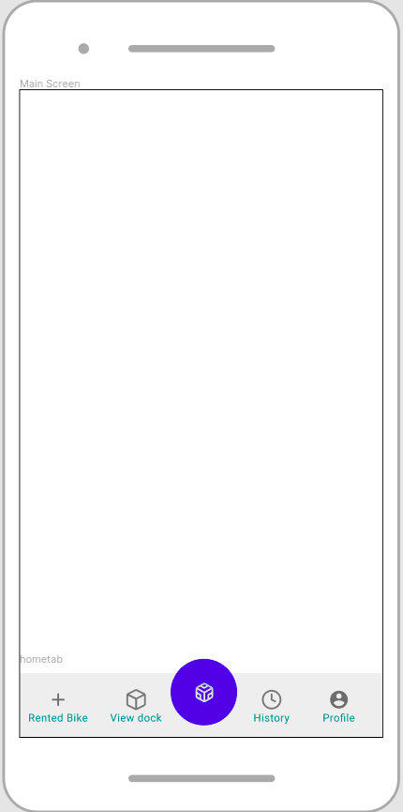 |  | Control | Operation | Function
 |  | Area for viewing Rented Bike | Click | View rented Bike
 |  | Area for viewing dock | Click | View docks
 |  | Area for viewing renting history | Click | View History
 |  | Area for viewing profile | Click | View Profile
 |  | Area for displaying Renting Bike Screen | Click | Request to rent a Bike

Rent Bike Screen

Eco Bike Rental |  | Date of creation | Person in charge
Screen specification | Rent Bike Screen | 07/11/2020 | Nguyễn Xuân Hoàng
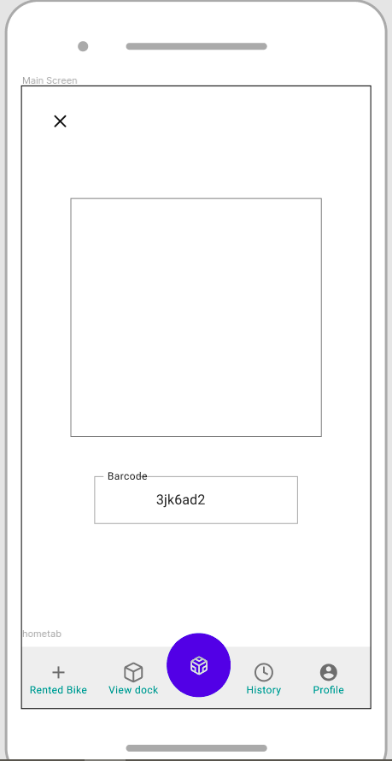 |  | Control | Operation | Function
 |  | Area for Scanning Barcode | Initial | Scanning Bike’s Barcode
 |  | Area for inputting barcode | Focus | Getting barcode if scanning not working
 |  | Area for Escape Screen | Click | Escape the screen

Defining the field attributes

Screen name | Rent Bike Screen
Item name | Number of digits | Type | Field attribute | Remarks
Barcode | 8 | String | Black | center-justified

Confirm Return Bike Screen

Eco Bike Rental |  | Date of creation | Person in charge
Screen specification | Confirm Return Bike Screen | 07/11/2020 | Nguyễn Xuân Hoàng
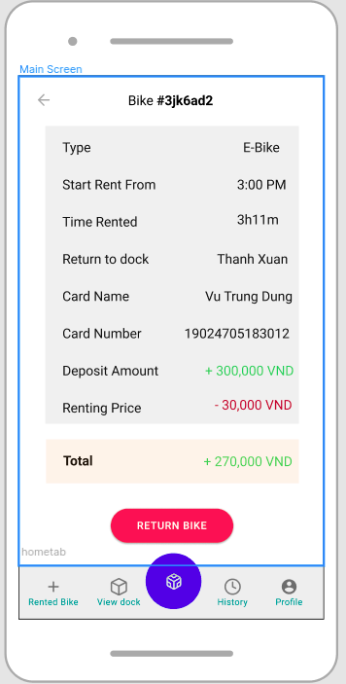 |  | Control | Operation | Function
 |  | Area for displaying Bike barcode | Initial | Displaying Bike barcode
 |  | Area for displaying Renting Information | Initial | Displaying Reting Information
 |  | Area for displaying total price for renting | Initial | Calculating amount of money for renting
 |  | Return Bike button | Click | Displaying Invoice Screen
 |  | Escape Button | Click | Cancel the Return Bike Screen

Defining the field attributes

Screen name | Confirm Return Bike Screen
Item name | Number of digits | Type | Field attribute | Remarks
Bike’s Barcode | 8 | String | Black, bold | center-justified
Bike’s Type | 10 | String | Black | Right-justified
Start Renting Time | 10 | Time | Black | Right-justified
Time Rented | 10 | Time | Black | Right-justified
Return to Dock | 50 | String | Black | Right-justified
Card name | 50 | String | Black | Right-justified
Card Number | 16 | Number | Black | Right-justified
Deposit Amount | 50 | String | Green | Right-justified
Renting Bike | 50 | String | Red | Right-justified
Total | 50 | String | Green | Right-justified

Invoice Screen

Eco Bike Rental |  | Date of creation | Person in charge
Screen specification | Invoice Screen | 07/11/2020 | Nguyễn Xuân Hoàng
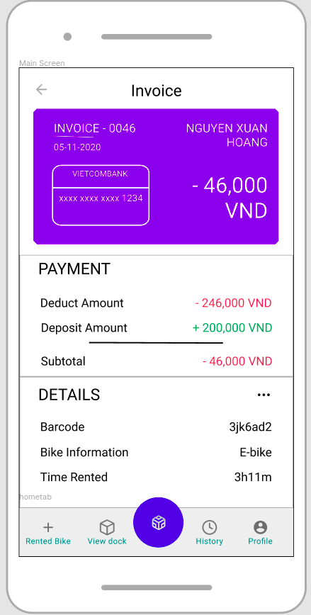 |  | Control | Operation | Function
 |  | Area for displaying customer Information | Initial | Displaying customer Information
 |  | Area for payment Information | Initial | Displaying payment Information
 |  | Area for displaying rented bike | Initial | Displaying details information about rented bike
 |  | Escape Button | Click | Cancel the Return Bike Screen
Defining the field attributes

Screen name | Invoice Screen
Item name | Number of digits | Type | Field attribute | Remarks
Bike’s Barcode | 8 | String | Black, bold | center-justified
Bike’s Type | 10 | String | Black | Right-justified
Card name | 50 | String | White | Left-justified
Card Number | 16 | Number | White | Left-justified
Deposit Amount | 50 | String | Green | Right-justified
Renting Bike | 50 | String | Red | Right-justified
Subtotal | 50 | String | Green | Right-justified
Customer’s Name | 50 | String | White | Left-justified
Created Date | 20 | Date | White | Left-justified

Choose payment method screen

Eco Bike Rental |  | Date of creation | Person in charge
Screen specification | Home Menu Bar | 07/11/2020 | Nguyễn Trung Nghĩa
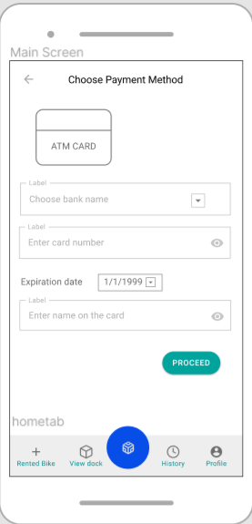 |  | Control | Operation | Function
 |  | Area for choosing bank name | Click – choose from a list | View list bank
 |  | Area for entering card number | Click | Fill in card number
 |  | Area for choosing date | Click – choose from lists | Fill in expiration date
 |  | Area for entering name on the card | Click | Fill in name on the card
 |  | Area for sending the form | click | Send the form

List dock stations screen

Eco Bike Rental |  | Date of creation | Person in charge
Screen specification | Rent Bike Screen | 07/11/2020 | Nguyễn Trung Nghĩa
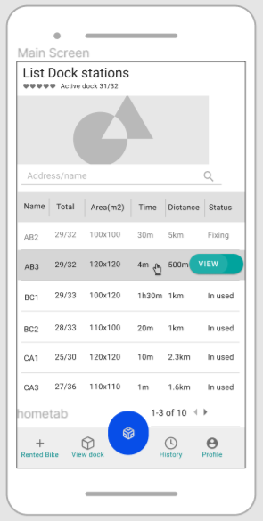 |  | Control | Operation | Function
 |  | Area for search dock station | Click | Find dock by address or name
 |  | Area for view bike detail | Click | View detail information of bike in station
 |  | Area for viewing next or previous page of table | Click | View table
 |  | Area for displaying the name of dock | Initial | displaying the name of dock
 |  | Area for displaying number of bike in dock | Initial | displaying number of bike in dock
 |  | Area for displaying area of the dock | Initial | displaying area of the dock
 |  | Area for displaying min time to walk to the dock | Initial | displaying min time to walk to the dock
 |  | Area for displaying distance from current position to the dock | Initial | displaying distance from current position to the dock
 |  | Area for displaying status of the dock | Initial | displaying status of the dock

Defining the field attributes

Screen name | Rent Bike Screen
Item name | Number of digits | Type | Field attribute | Remarks
Search bar | many | String | Black | Left-justified

View bike in dock station screen

Eco Bike Rental |  | Date of creation | Person in charge
Screen specification | Confirm Return Bike Screen | 07/11/2020 | Nguyễn Trung Nghĩa
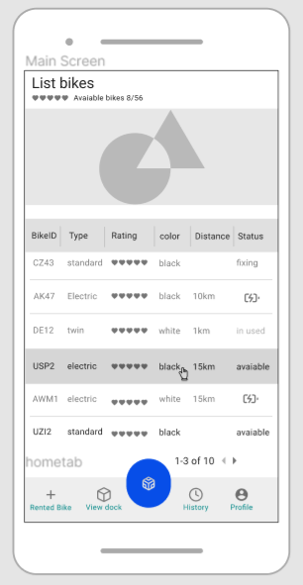 |  | Control | Operation | Function
 |  | Area for displaying the bikeID or bike code | Initial | displaying the bikeID or bike code
 |  | Area for displaying bike type | Initial | displaying bike type
 |  | Area for displaying rating for that bike | Initial | displaying rating for that bike
 |  | Area for displaying color of the bike | Initial | displaying color of the bike
 |  | Area for displaying battery status of the bike | Initial | displaying battery status of the bike
 |  | Area for viewing pages of tables | Click | viewing pages of tables
 |  | Area for displaying maximum distance the bike can go (e-bike) | Initial | displaying maximum distance the bike can go (e-bike

Defining the field attributes

Screen name | Confirm Return Bike Screen
Item name | Number of digits | Type | Field attribute | Remarks
Bike’s ID | 8(max) | String | Black | Left-justified
Bike’s Type | 10(max) | String | Black | Left-justified
Bike’s rating | 10(max) | String | Black | Left-justified
Bike’s status |  | String or image | Black | Left-justified
Distance | 10(max) | String | Black | Left-justified

View Bike Screen

Eco Bike Rental |  | Date of creation | Person in charge
Screen specification | View Bike Screen | 07/11/2020 | Nguyễn Ngọc Quý
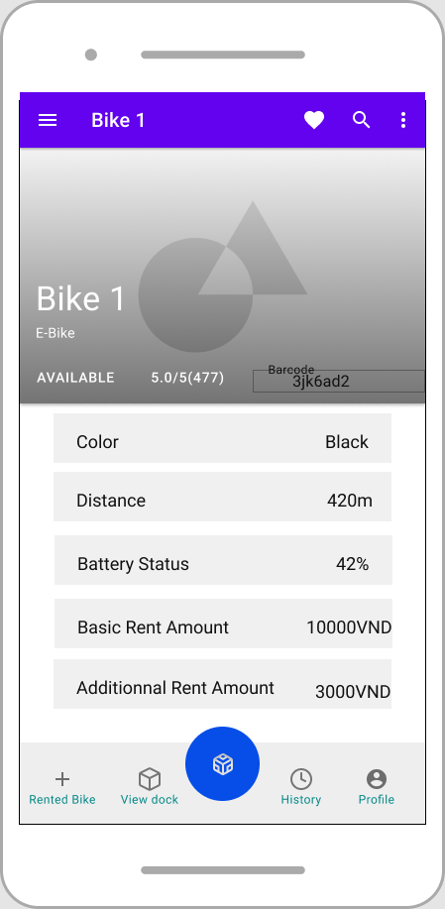 |  | Control | Operation | Function
 |  | Area for viewing bike | Initial | Display bike Information
 |  | Area for bike barcode | Initial | Display bike barcode

Defining the field attributes

Screen name | Rent Bike Screen
Item name | Number of digits | Type | Field attribute | Remarks
Barcode | 8 | String | Black | center-justified
Bike Name | 10 | String | Black | Left-justified
Bike Type | 10 | String | Black | Left-justified
Bike Availability | 10 | String | Black | Left-justified
Bike Rating | 10 | Float | Black | Left-justified
Bike Color | 10 | String | Black | Right-justified
Bike Distance | 10 | Float | Black | Right-justified
Bike Battery Status | 10 | Float | Black | Right-justified
Basic Rent Amount | 10 | Float | Black | Right-justified
Additional Rent Amount | 10 | Float | Black | Right-justified

View Rented Bike Screen

Eco Bike Rental |  | Date of creation | Person in charge
Screen specification | View Rented Bike Screen | 07/11/2020 | Nguyễn Ngọc Quý
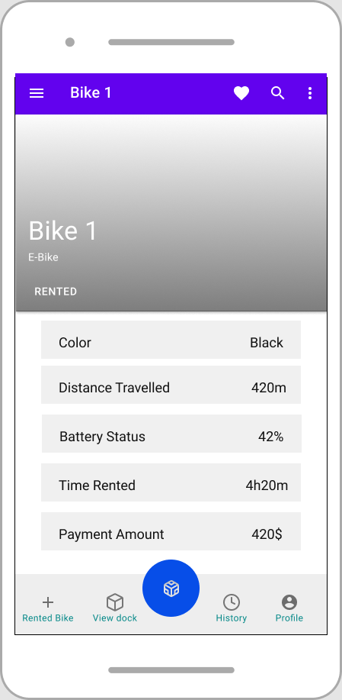 |  | Control | Operation | Function
 |  | Area for viewing Rented Bike | Initial | View rented bike

Defining the field attributes

Screen name | Rent Bike Screen
Item name | Number of digits | Type | Field attribute | Remarks
Bike Name | 10 | String | Black | Left-justified
Bike Type | 10 | String | Black | Left-justified
Bike Color | 10 | String | Black | Right-justified
Bike Distance Traveled | 10 | Float | Black | Right-justified
Bike Remaining Battery Status | 10 | Float | Black | Right-justified
Bike Rented Time | 10 | Float | Black | Right-justified
Payment Amount Estimated | 10 | Float | Black | Right-justified

