# Pycharm instruction

### Installation

1. Install PyCharm Community Edition

<https://www.jetbrains.com/products/compare/?product=pycharm&product=pycharm-ce>

2 Install Anaconda <https://www.anaconda.com/download>

### Creation of the interpreter

1. In PyCharm press Ctrl + Alt + S

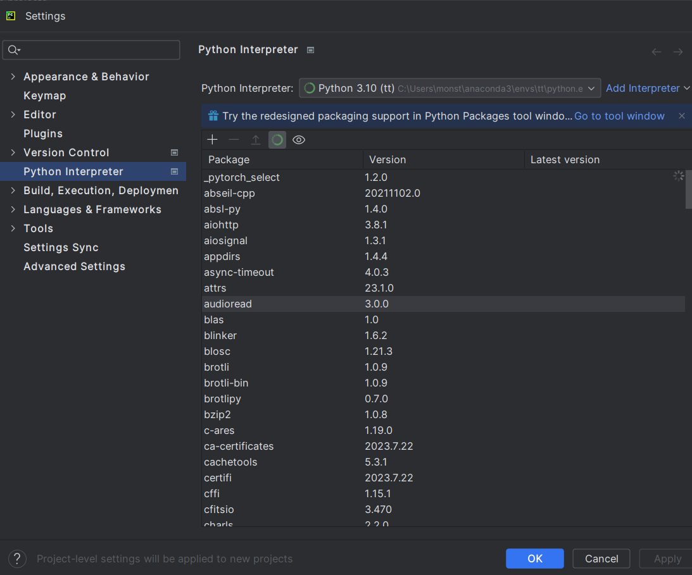

1. Click *Add Interpreter*

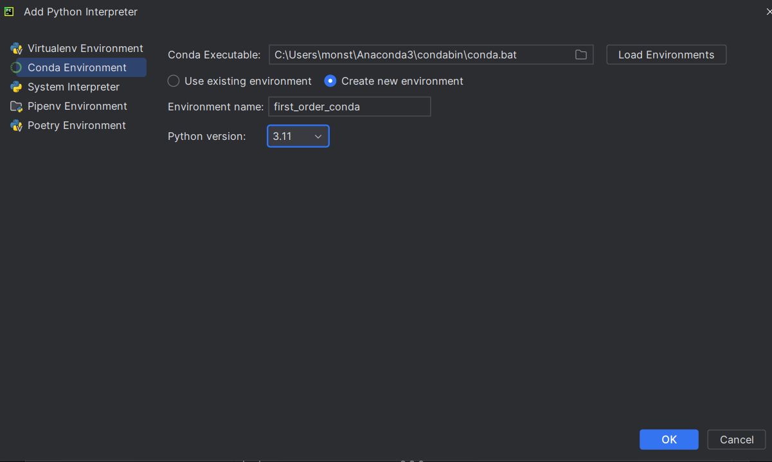

In result one has

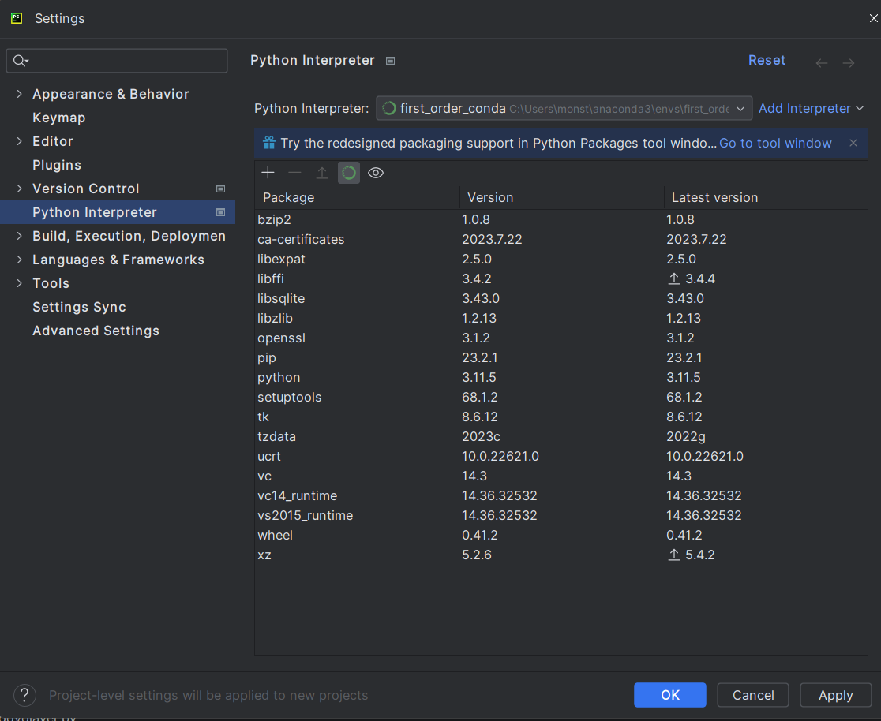

### Creation of a project

1. Click *New Project*

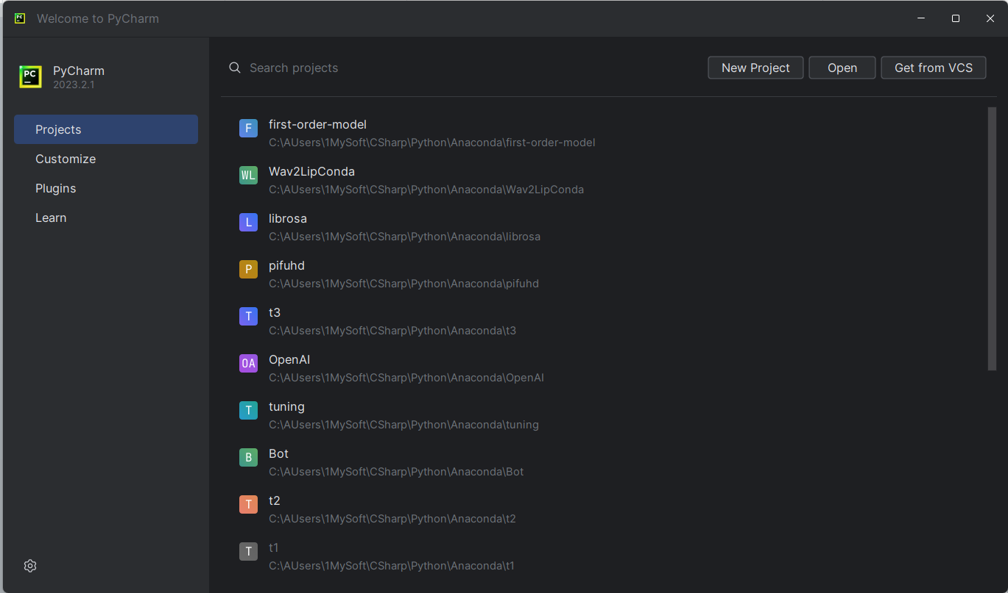

1. Select a directory

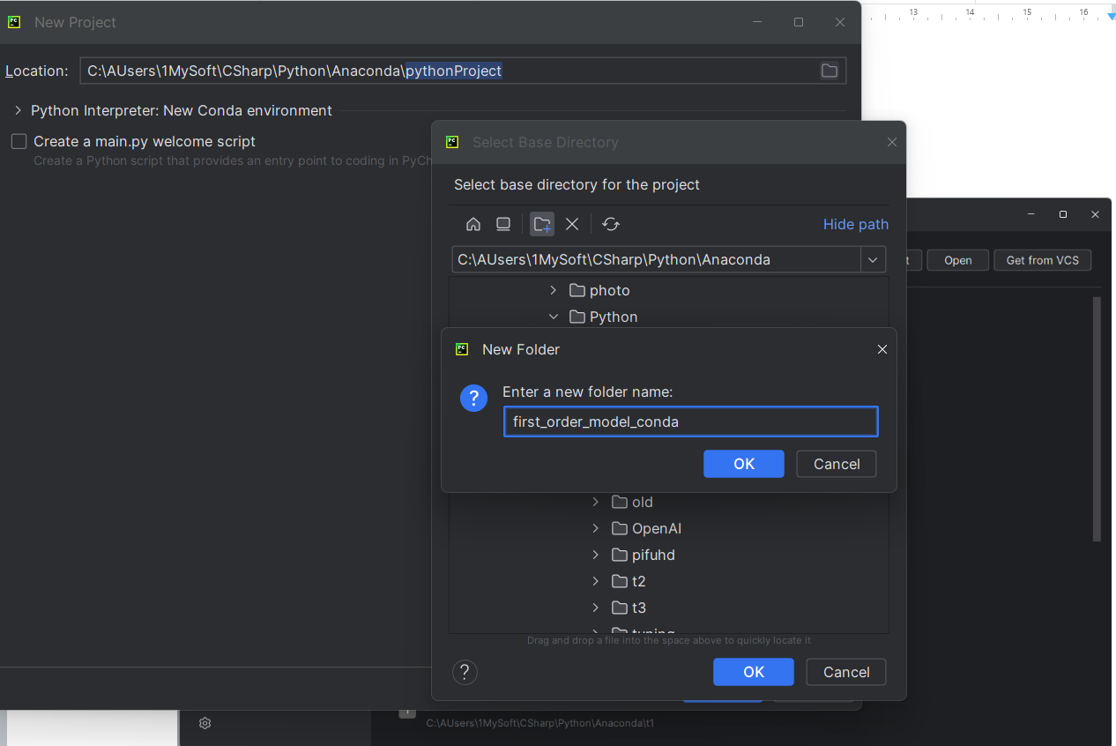3. In result one has. Click *Create*.

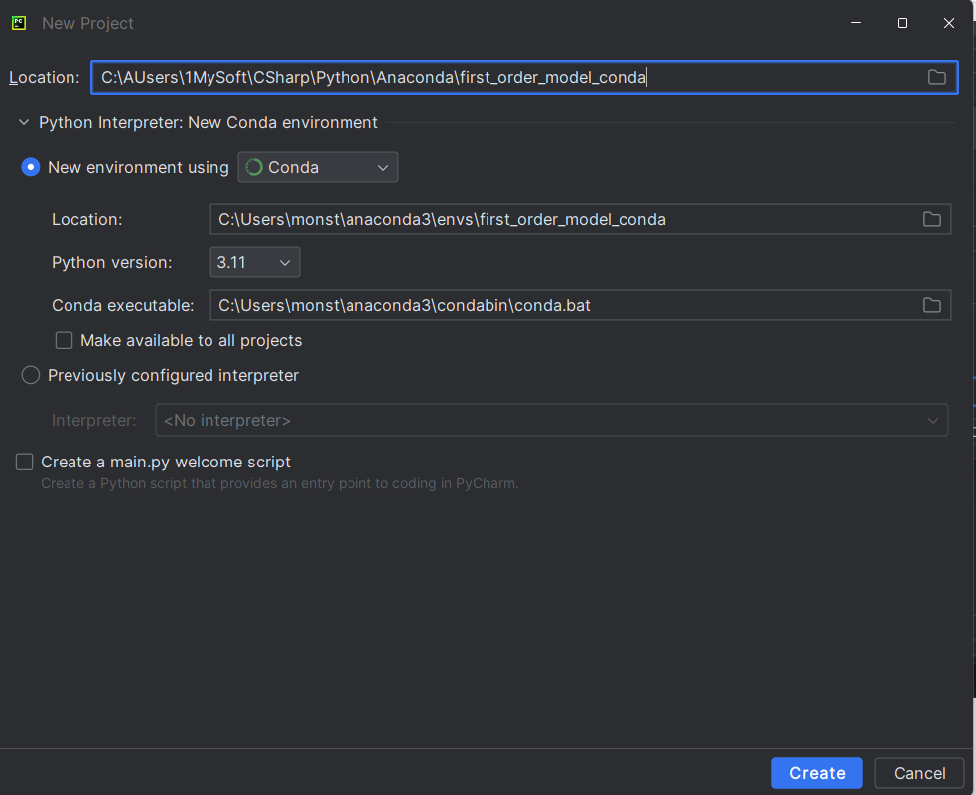

### Install software

1. Copy downloaded files to the project directory
2. Select *requirements.txt* and click *Install requirements.*

### 

### 5. Run setup

1. Click *Main menu*

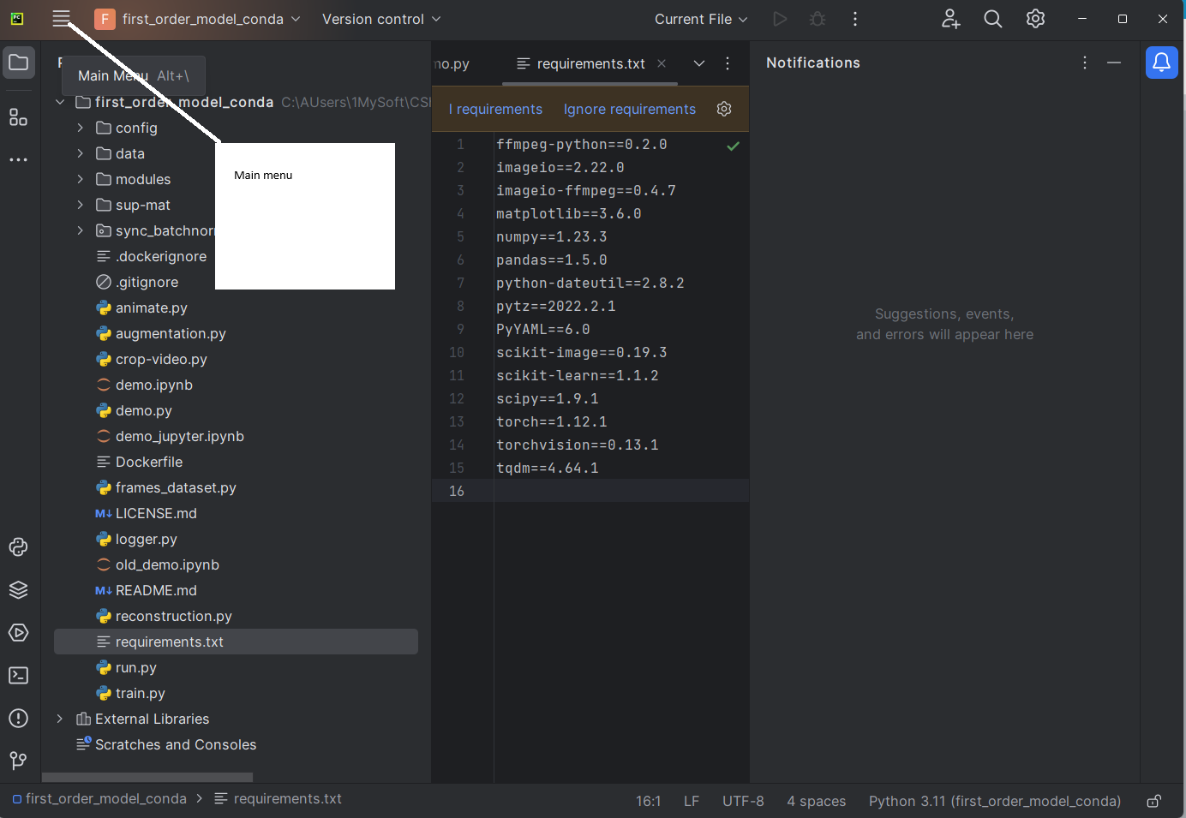

2 *Run, Edit Configurations*

