XoptFoil Airfoil Optimization Example
Daniel Prosser
January 12, 2016

Table of contents
1. Purpose ….……………………………………………………………………………………………1
2. Input file ………………………………………………………………………………………………1
a. Optimization options ………………………………………………………………………………..2
b. Operating conditions ………………………………………………………………………………..3
c. Constraints …………………………………………………………………………………………..6
d. Particle swarm and simplex settings ………………………………………………………………..8
e. XFoil settings ……………………………………………………………………………………….9
3. Running the case …………………………………………………………………………………….10
4. Results and outputs ………………………………………………………………………………….13
5. Example case 2: optimizing flap deflection …………………………………………………………15
a. Changes to the input file …………………………………………………………………………...15
b. Running the new case ……………………………………………………………………………..17
c. Comparison with first optimized airfoil …………………………………………………………...19

1. Purpose
The purpose of this document is to detail the process of optimizing an airfoil with XoptFoil for a realistic design case. Appropriate program settings will be explained to optimize an airfoil given a specific set of design conditions. Use of the various output files and additional tools will also be described.
2. Input file
XoptFoil is a program that runs from the command line. Because a large number of inputs are required, they are read from an input file. The default input file is called 'inputs.txt' (a different name can also be used by supplying command-line arguments at runtime – see the section labeled “Running XoptFoil” in the user guide, or section 5 in this document for an example). The input file uses Fortran namelist format, which is explained in the user guide. Most of the rest of this document will be spent explaining which settings to select in each section of the input file. For reference, the settings used in this example are available in the doc/example_case directory of XoptFoil. The first one that is covered in this guide is called 'inputs.txt', and the second one is called 'inputs_with_flap.txt'.
2.a. Optimization options
The optimization options namelist groups the high-level settings for the optimization: which optimization algorithms to include, which seed airfoil to use, how to deform the seed airfoil to make new airfoils, etc. The settings that will be used for this example are given below:
&optimization_options
search_type = 'global_and_local'
global_search = 'particle_swarm'
local_search = 'simplex'
seed_airfoil = 'four_digit'
airfoil_file = '../sample_airfoils/clarky.dat'
naca_digits = '3410'
shape_functions = 'hicks-henne'
min_bump_width = 0.1
nfunctions_top = 4
nfunctions_bot = 4
initial_perturb = 0.025
write_designs = .true.
/
search_type: This input specifies which types of optimization to apply. Particle swarm and genetic algorithms are global optimization techniques, meaning that they are better at finding the best overall design. Simplex search and gradient-based methods are local optimization techniques, which means that they are good at finding the best design that is already close to the starting point. Global search techniques are usually more expensive – meaning they require more computing time and memory – than local search methods. For airfoil optimization, there are many “local” optimum designs, so the global search is most useful. However, once the global search has found a good design, the local search can often still improve on it. For this reason, we select 'global_and_local' as the search type. This means that the global search will be used first, and then the local search will be used after that.
global_search: This input sets the algorithm used for the global search. Currently, particle_swarm is the only option.
local_search: This input sets the algorithm used for the local search. Currently, simplex is the only option.
seed_airfoil: Tells XoptFoil how the seed airfoil will be supplied. The seed airfoil is the starting design for the optimizer, which it will deform during optimization to try to improve the performance. We select 'four_digit' for this input, which means a NACA 4-digit airfoil will be generated by XoptFoil as the seed airfoil. XoptFoil can also read in a seed airfoil from a file instead of generating a NACA airfoil. To get the best results, you should use a seed airfoil that is already well-suited to your application.
airfoil_file: Path to the airfoil file to read in if 'from_file' is chosen for the previous input. For our case, this input is not used since we chose to have XoptFoil generate a NACA airfoil as the seed.
naca_digits: Four-digit code for NACA airfoil. Enter '3410' for this input, which means the seed airfoil will have 3% camber, with the max camber location at 40% of the chord, and with 10% thickness. This input would not have been used if we had chosen to read the seed airfoil from a file.
shape_functions: XoptFoil uses shape functions to deform the seed airfoil in order to generate new designs. These functions look like bumps with different widths and at different locations. There are two choices here: 'hicks-henne' and 'naca'. Hicks-Henne functions generally seem to work best, so we select them here.
min_bump_width: The minimum bump width allowed for Hicks-Henne functions. (This input is not used for NACA shape functions.) If the minimum width is too small, the optimizer is more likely to find a “bumpy” optimal design. We'll set this input to 0.1, which means the minimum bump width is 10% of the chord.
nfunctions_top and nfunctions_bot: Number of shape functions to use on the top and bottom surface of the airfoil. For Hicks-Henne functions, each shape function has a magnitude (i.e., height), a location, and a width that are all variable by the optimizer. NACA functions only have a variable magnitude; their location and width are prescribed. This means that fewer Hicks-Henne functions are needed to get the same flexibility in generating new airfoils compared to NACA functions. 4 Hicks-Henne functions on both sides of the airfoil usually work well. That means there will be 24 design variables associated with the shape functions, because each Hicks-Henn function has three design variables associated with it (magnitude, location, and width). With NACA functions, 10-12 shape functions would be needed, giving roughly the same number of design variables.
initial_perturb: How much perturbation of the seed airfoil (above and below the surfaces) when generating the initial candidate designs. The final airfoil can have greater perturbation than this if the optimizer decides it is beneficial. A value of 0.025 (2.5%) is reasonable and usually works pretty well.
write_designs: Tells the optimizer whether to write out airfoil coordinates and polars (at the specified operating conditions) each time a better design is found. By default, this data will be written to files called optfoil_design_coordinates.dat and optfoil_design_polars.dat, unless a different output prefix is supplied to xoptfoil as a command line argument (see the user guide for more information on command line arguments). There's not much reason to disable this feature unless you don't care to review the optimization progression later on. Set this input to .true. to enable this feature.
2.b. Operating conditions
The operating conditions namelist tells the optimizer which flight conditions to optimize for. Flight conditions include Reynolds number, Mach number, angle of attack or lift coefficient, and flap setting. This is probably the most important part of the input file, because using the wrong operating conditions will result in an airfoil that is not optimized for your application. This section also takes the most work from the user's perspective, because you need to figure out what conditions are required for the aircraft you are designing. The details of how to select the appropriate operating conditions are not going to be covered here, but some example conditions are provided and explained. The settings that will be used for this example are given below:

&operating_conditions
noppoint = 5
use_flap = .false.

op_mode(1) = 'spec-cl'
op_point(1) = -0.3
optimization_type(1) = 'min-drag'
reynolds(1) = 0.9E+05
mach(1) = 0.08
weighting(1) = 0.20

op_mode(2) = 'spec-cl'
op_point(2) = 0.0
optimization_type(2) = 'min-drag'
reynolds(2) = 1.5E+05
mach(2) = 0.10
weighting(2) = 0.20

op_mode(3) = 'spec-cl'
op_point(3) = 0.3
optimization_type(3) = 'min-drag'
reynolds(3) = 0.9E+05
mach(3) = 0.08
weighting(3) = 0.20

op_mode(4) = 'spec-cl'
op_point(4) = 0.8
optimization_type(4) = 'min-drag'
reynolds(4) = 8.0E+04
mach(4) = 0.04
weighting(4) = 0.20

op_mode(5) = 'spec-cl'
op_point(5) = 1.2
optimization_type(4) = 'min-drag'
reynolds(5) = 7.0E+04
mach(5) = 0.03
weighting(5) = 0.20
/

noppoint: The number of operating points to consider when optimizing. If you use only 1 or 2, the final optimized airfoil will likely perform very poorly at other flight conditions. Here, we will use 5 operating points.
use_flap: Whether a flap deflection will be used at any of the operating points. Flap deflections can be important for getting acceptable performance over a wide range of operating conditions. Here, no flap will be used, so enter .false. for this input. Later on in this document, we will compare the results with one where a flap deflection is selected for some operating points and optimized for others.
The remaining settings in this section tell the optimizer which operating points to consider. During the optimization process, XoptFoil will generate many airfoil and use XFoil to evaluate them all the the operating points you specify. The performance (for example, the drag) for each point will be added together to get a single value called the objective function. The optimizer attempts to minimize this function by evaluating many airfoils and progressively modifying them so that features which reduce the objective function are kept, while features that increase the objective function are discarded. At some point this process should converge (meaning it stops making further progress in reducing the objective function), at which point the best design is considered to be the optimal design and code execution stops.
Since we chose to use 5 operating points, we must specify the conditions at each of the 5 points. Notice that each of the inputs below use_flap has a (#) after it – this number indicates which operating point the value corresponds to. Most of these inputs are self-explanatory (and they are also described in detail in the user guide). For example, each operating point has a Reynolds number and Mach number specified (note that in XFoil the Mach number can be 0 – it means that the flow is treated as incompressible), as well as an angle of attack or lift coefficient specified. Some of the less obvious inputs are explained below.
op_mode: Indicates whether the operating point will have a specified lift coefficient or specified angle of attack ('spec-cl' or 'spec-al'). Most of the time, it is more useful to specify a lift coefficient than an angle of attack, but sometimes specifying the angle of attack can be useful; for example, if you wanted to maximize the lift at a high angle of attack to minimize your plane's landing speed.
op_point: Either the lift coefficient or angle of attack for the operating point, depending on what was selected for op_mode.
optimization_type: Tells the optimizer what to optimize for this point. The available options are drag minimization ('min-drag'), sink minimization ('min-sink'; maximizes Cl^{3/2}/Cd), glide slope maximization ('max-glide'; maximizes Cl/Cd), or lift maximization ('max-lift'). The last one can only be used if the angle of attack is specified instead of the lift coefficient. Furthermore, if the lift coefficient is specified, the first three types are all equivalent to minimizing drag, because Cl is fixed.
weighting: It was mentioned earlier that the performance for all the operating points are combined into a single value. By default, each point is given equal weighting when they are combined together. If you want to give certain points a higher relative weighting, you can use the weighting input. For example, if you want point 1 to be twice as important to the optimization as point 3, you could make the weighting value for point 1 double the one for point 3. Note that weights are automatically normalized by XoptFoil so that they add up to 1; you don't have to worry about making them add up to 1 yourself.
The operating points selected represent a pretty broad range of lift coefficients from -0.3 to 1.2. We can expect the final airfoil to have pretty good drag characteristics over this broad range, but it won't have as low drag as an airfoil that was specifically optimized just for low Cl.
2.c. Constraints
After the operating conditions, constraints are probably the next most important things that the user needs to think about. XoptFoil allows you to constrain a number of geometric and aerodynamic parameters so that your final airfoil is actually usable. For example, you can specify a minimum thickness constraint so that your final airfoil doesn't come out too thin. You can also set pitching moment constraints for each operating point so that all the hard work the optimizer did in minimizing drag isn't nullified by requiring a large load on the stabilizer in order to trim. The constraints settings that are used for this example are given below:
&constraints
seed_violation_handling = 'stop'
min_thickness = 0.06
max_thickness = 1000.0
min_te_angle = 5.0
check_curvature = .true.
max_curv_reverse = 2
curv_threshold = 0.10
symmetrical = .false.

moment_constraint_type(1) = 'use_seed'
moment_constraint_type(2) = 'use_seed'
moment_constraint_type(3) = 'use_seed'
moment_constraint_type(4) = 'none'
moment_constraint_type(5) = 'none'
min_moment(1) = -0.11
min_moment(2) = -0.11
min_moment(3) = -0.11
min_moment(4) = -0.11
min_moment(5) = -0.11
/

seed_violation_handling: Before starting to optimize, XoptFoil first checks to make sure that the seed airfoil you supplied passes all the constraints you set. If it doesn't, it's possible that the final optimized airfoil will actually appear to perform worse than the seed airfoil! That's because, in that case, the seed airfoil would have an unfair advantage because it doesn't have the same constraints applied to it as the optimized airfoil did. This input tells XoptFoil what to do when the seed airfoil violates a constraint. By default, the program will stop when this happens and tell you which constraint was violated. If you don't care that the seed airfoil violates a constraint, you can change it to 'warn' instead of 'stop', in which case XoptFoil will notify you which constraint was violated but then keep going anyway.
min_thickness: The minimum value of airfoil max thickness that is allowed, in t/c. This constraint is usually set for structural reasons.
max_thickness: The maximum value of airfoil max thickness that is allowed, in t/c. Usually we don't care about this, so by default it is set to a very large number that would never be reached (1000 in this case).
min_te_angle: Sets a minimum wedge angle for the trailing edge. Without this constraint, the optimizer often finds optimal airfoils with a very thin cusped trailing edge that would be hard to build. We'll set a value of 5 degrees here.
check_curvature: One finicky part about airfoil optimization in general is that small little “wiggles” in the surface often are present in the final design. This is because the little wiggles might improve performance slightly at one of the operating points you selected, or because it helps it satisfy a constraint (for example, a little wiggle could help an airfoil “just barely” meet the minimum thickness requirement). XoptFoil tries to minimize this naturally as much as possible by using a relatively small number of smooth shape function and allowing the user to specify a minimum bump width for the shape functions, but it's still not totally immune to this problem. To combat the problem, it is possible to impose a constraint on the number of times the curvature of the airfoil reverses direction. Set this input to .true. if you want to apply a curvature reversals constraint. Experience has indicated that this constraint is needed more when optimizing for low Reynolds numbers; if all your design points are above a Reynolds number of about 100,000, you might not need this check at all.
max_curv_reverse: The number of times airfoil curvature is allowed to reverse, if check_curvature is enabled. This should probably be at least 1, or else you will restrict the shape of your airfoil too much. In this case, we'll use a value of 2.
curv_threshold: The magnitude of curvature above which a detected curvature reversal will actually be flagged as violating the constraint. Don't set this to 0, because otherwise XoptFoil might flag false reversals that are actually numerical artifacts. We'll set this input to 0.1 in this case. (For a sense of scale, a curvature of 0.1 corresponds to a circle with a radius of 10. XoptFoil always scales airfoils to have a chord length of 1, so the diameter of this hypothetical circle is 20 times larger than the airfoil's chord.)
symmetrical: If you want the optimizer to only generate symmetrical airfoils, enable this. In this case, we don't want to do that.
moment_constraint_type: Specifies how to constrain the pitching moment for each of your operating points. Options are 'none', 'specify', or 'use_seed'. 'none' means there will be no moment constraint applied at the specified operating point. 'specify' means that you will set a minimum (usually negative) pitching moment constraint. 'use_seed' means that the pitching moment for the operating point from the seed airfoil will be used as the constraint during optimization. We need 5 of these since we set 5 operating points.
min_moment: The minimum moment allowed at each operating point (only used if moment_constraint_type is 'specify' for the particular operating point). We need 5 of these since we set 5 operating points.
2.d. Particle swarm and simplex settings
These namelist give inputs for the optimization algorithms. The particle_swarm namelist settings are given below:
&particle_swarm_options
pop = 40
pso_speed_tol = 0.005
pso_convergence_profile = 'standard'
pso_maxit = 300
pso_feasible_init = .true.
pso_feasible_limit = 50000.0
pso_feasible_init_attempts = 1000
/
pop: The number of designs searching the design space. In particle swarm optimization (PSO), a “swarm” of designs moves around the design space to evaluate potential designs. To “move” in this sense means that their characteristics are varied in a continuous, progressive fashion. Individual particles are drawn towards the best solution that they have seen as well as the best overall solution that has been found. This method allows the optimal solution to be found reliably even when there are many local optima. A population of 40 has been found to produce good results while also not being too computationally expensive.
pso_speed_tol: A tolerance that is used to determine when the PSO algorithm has converged. When the speed of every particle is below this fraction of the initial speed, the optimization will stop. We'll set this to 0.005, or 0.5% of the initial speed.
pso_convergence_profile: The standard profile usually works pretty well. The other option is called 'exhaustive', which usually finds a little bit better airfoils but takes much longer to converge.
pso_maxit: Maximum number of particle swarm iterations allowed before it stops. If the optimizer reaches this number of iterations without converging, a warning will be printed to the screen.
pso_feasible_init: The PSO algorithm requires an initial swarm of particles. These are placed at random throughout the design space. However, placing designs at random can result in some very bad-looking airfoils that either don't meet one or more of the constraints or that don't converge in XFoil. Enabling the feasible initialization feature will cause the optimizer to reinitialize any designs in the initial swarm that have an objective function value higher than some number you set. Though this takes more time, it is a good idea because it gives the PSO algorithm better information to start with.
pso_feasible_limit: The objective function value below which the initial designs are considered feasible. Any time a design violates a constr[3] Monitor an ongoing optimization
aint or fails to converge in XFoil, a large penalty proportional to 10⁶ is added to the objective function, telling the optimizer to steer clear of designs like that. Setting this value to 50000 ensures that the initial designs probably only violate 1 or 2 constraints, and only by a small amount, which is okay for the purposes of initialization.
pso_feasible_init_attempts: The number of times XoptFoil will try to reinitialize a particle that doesn't make the pso_feasible_limit cut. If it fails this many times, it will be kept anyway. The default is 100, but this case has a range of operating points that are difficult to converge, so we'll increase it to 1000.
The simplex search namelist just has 2 inputs, which are given below:
&simplex_options
simplex_tol = 1.0E-06
simplex_maxit = 1000
/
simplex_tol: A convergence tolerance parameter. Optimization is considered converged when the mean simplex “diameter” is less than this value. (Note: this is the same algorithm and convergence criterion as the fminsearch function in Matlab.)
simplex_maxit: Maximum number of simplex iterations allowed before it stops. If the optimizer reaches this number of iterations without converging, a warning will be printed to the screen.
2.e. XFoil settings
The last two namelists give settings for XFoil, including settings for aerodynamics, numerical algorithms, and paneling. The settings used in the example case are given below:
&xfoil_run_options
ncrit = 9.0
xtript = 1.0
xtripb = 1.0
viscous_mode = .true.
silent_mode = .true.
bl_maxit = 100
vaccel = 0.01
fix_unconverged = .true.
reinitialize = .true.
/

&xfoil_paneling_options
npan = 160
cvpar = 1.0
cterat = 0.15
ctrrat = 0.2
xsref1 = 1.0
xsref2 = 1.0
xpref1 = 1.0
xpref2 = 1.0
/
Most of these settings are covered in sufficient detail in the user guide, so they won't be explained a second time here. There are just a couple that should be noted:
silent_mode: Suppresses XFoil messages. You want to set this to .true. for optimization. Otherwise there will be tons of information that you don't care about flying past way too quickly to read, and it will slow XoptFoil down too.
fix_unconverged: If XFoil calculations don't converge, this option will attempt to reinitialize the boundary layer variables at a new point that is further away from stall, and then attempt to reanalyze the operating point. Sometimes this will allow XFoil to converge on the second try. It's a good idea to enable this, because designs are penalized heavily by the optimizer when XFoil calculations don't converge, but sometimes the airfoil shape is valid, and it's best for the optimizer not to throw out these designs.
reinitialize: Whether to reinitialize the boundary layer variables at each operating point. It is generally more robust (more likely for XFoil to converge) when this is enabled, so it is recommended.
3. Running the case
Save the namelist input file as “inputs.txt” and put it in the same directory where the XoptFoil executable is located. You're now ready to run the case. From the command line, type “xoptfoil.exe” (on Windows) or “./xoptfoil” (on Mac or Linux). (You can also look at the user guide for other ways to run it.) XoptFoil will first echo the options that have been set either from the input file or by default (for inputs that we didn't include in the input file). Next, you will see the following appear on the screen:
Generating seed airfoil: NACA 3410 ...
Optimizing for requested operating points.
Checking to make sure seed airfoil passes all constraints ...
The first line notifies you that it is generating the seed airfoil we requested. If you had instead chosen to have the airfoil read from a file, it would say it is reading the seed airfoil from the file you specified instead. The second line is kind of self-explanatory. The third line notifies you that XoptFoil is checking to make sure that the seed airfoil satisfies all the constraints that you set. If it doesn't, by default XoptFoil will let you know and then quit. (See the information in Section 2.c. labeled “seed_violation_handling” if you don't want it to stop when the seed airfoil violates a constraint.) In this case, the seed airfoil doesn't violate any of the constraints. If it does in some other case you run, that suggests that you may want to either change the seed airfoil or change the constraints. Next, the initial airfoil designs will be generated. You will see lines like the following appear on the screen:

Checking initial designs for feasibility ...
(using a max of 1000 initialization attempts)

Design 1 is feasible.
Design 31 was initially infeasible but was fixed after 8 reinitialization attempts.
Design 21 was initially infeasible but was fixed after 141 reinitialization attempts.
Design 22 was initially infeasible but was fixed after 53 reinitialization attempts.
Design 11 was initially infeasible but was fixed after 105 reinitialization attempts.
Design 12 was initially infeasible but was fixed after 103 reinitialization attempts.
Design 23 was initially infeasible but was fixed after 187 reinitialization attempts.
Design 24 was initially infeasible but was fixed after 138 reinitialization attempts.
Design 25 was initially infeasible but was fixed after 25 reinitialization attempts.
Design 32 was initially infeasible but was fixed after 271 reinitialization attempts.
…
Since we have a PSO population of 40, there will be 40 of these messages. The number of reinitialization attempts was set in the particleswarm options namelist. You'll notice above that the designs are out of order in these messages. That's because I compiled the code with the parallel option enabled, and the particle initialization step runs in parallel, so there's no reason for the different threads to finish initializing the designs in order. If you were running the serial version of the code, these messages would be printed out in order.
You'll notice that, while design 1 was feasible from the beginning (which it should be, because it is the seed airfoil), some of the designs took quite a few attempts to fix. The initialization process is random, so for difficult cases it might take awhile for it to initialize all 40 of the designs in the feasible space. It was a good idea for us to change the number of attempts from the default 100 to 1000, because many of the designs required more than 100 attempts. If you want, you can reduce the number of attempts or even disable reinitialization altogether. That is not recommended, though, because it's better to have an initial population of feasible designs for the optimizer to start from.
Next, you will see the optimization progress:

Particle swarm optimization progress:
Iteration: 1 % Improvement over seed: 3.7219549525541740
Writing coordinates for design number 1 to file optfoil_design_coordinates.dat ...
Writing polars for design number 1 to file optfoil_design_polars.dat …

Iteration: 2 % Improvement over seed: 3.7219549525541740
Iteration: 3 % Improvement over seed: 3.7219549525541740
Iteration: 4 % Improvement over seed: 3.7219549525541740
…
Simplex optimization progress:
…
The actual numbers you see will not be exactly the same as what is shown above. That is because the particle swarm algorithm employs randomness both in the initialization of the particles and, to some extent, in their subsequent movement through the design space. In the same vein, the final optimized airfoil might not be exactly the same from one trial to the next (even with the same input file), though the performance will probably be similar. Eventually, both the particle swarm and simplex optimizers will finish, the XoptFoil will print out a summary of the optimized airfoil's performance, which will look something like this (again, the actual numbers you get will probably be different):

Optimal airfoil performance summary
----------------------------------------------------------
Operating point 1
Reynolds number: 9.000E+04
Mach number: 0.08000
Lift coefficient: -0.30000
Drag coefficient: 0.01693
Moment coefficient: -0.04662

Operating point 2
Reynolds number: 1.500E+05
Mach number: 0.10000
Lift coefficient: -0.00000
Drag coefficient: 0.01183
Moment coefficient: -0.06158

Operating point 3
Reynolds number: 9.000E+04
Mach number: 0.08000
Lift coefficient: 0.30000
Drag coefficient: 0.01377
Moment coefficient: -0.06310

Operating point 4
Reynolds number: 8.000E+04
Mach number: 0.04000
Lift coefficient: 0.80000
Drag coefficient: 0.02130
Moment coefficient: -0.06142

Operating point 5
Reynolds number: 7.000E+04
Mach number: 0.03000
Lift coefficient: 1.20000
Drag coefficient: 0.02978
Moment coefficient: -0.04599

Objective function improvement over seed: 20.4975%
You can see that XoptFoil was able to improve the performance at the selected operating points by 20.5% compared to the seed airfoil. In the next section, we'll look at the airfoil, polars, and discuss how to use the other output files.
4. Results and outputs
When XoptFoil finishes a run, it writes out several files:
- optfoil.dat: the coordinates of the optimized airfoil
- optfoil_performance_summary.dat: the performance summary that we saw above (also written to screen)
- optfoil_design_coordinates.dat: airfoil coordinates for each progressively better design. The first one is the seed airfoil, and the last one is the final optimized airfoil. Each airfoil is separated by a line that starts with the text 'zone t= …'
- optfoil_design_polars.dat: airfoil polars (lift and drag) at the requested operating points for each progressively better design. Each set is also separated by a line that starts with the text 'zone t= …'
The seed airfoil and optimized airfoil for this case are shown in Fig. 1. The optimized airfoil has become a little thicker than the seed airfoil, with the max thickness moved forward, and a cusp shape on the lower surface near the trailing edge. Running it in XFoil, the thickness is reported as 11.4% (the seed airfoil was 10%), and the camber is about 2% (the seed airfoil was 3%). Note: plots similar to this can be generated using the provided design_plotter.py Python tool. This tool can be used either during an optimization to monitor the progress or afterwards. See the User Guide for more information on using it.
Figure 2 shows how the optimized airfoil performs compared to the seed airfoil at our operating points. The drag is reduced considerably at all the operating points, except for one (C_{l} = 0.8). Remember that the optimizer assigns a single objective function to each design based on a weighted sum of the performance at all the operating points, so it's not guaranteed that it will outperform the seed airfoil at every operating point. Optimization is a game of trade-offs, so the optimizer traded off the performance at that point in order to get better performance at the others. If we really wanted to improve the performance at the operating point C_{l} = 0.8, we could assign a higher weight to it. However, overall this airfoil performs significantly better than the seed NACA3410 seed airfoil at the operating points that were chosen. In the next section, we'll discuss how to improve the performance even more by allowing flap deflections at the higher lift coefficients.
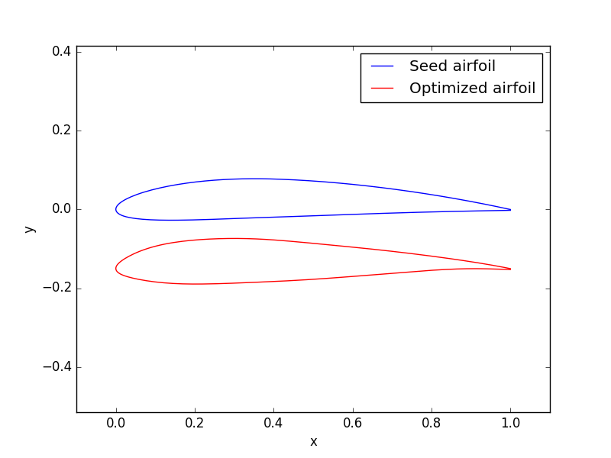Figure 1: Seed airfoil and optimized airfoil

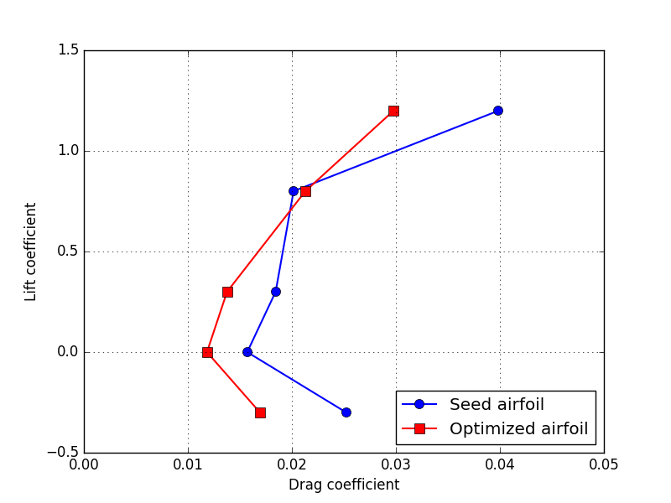Figure 2: Polars for the seed airfoil and the optimized airfoil

5. Example case 2: optimizing flap deflection
As of XoptFoil version 1.5.0, the XFoil analysis engine incorporated in XoptFoil supports flap deflections. In version 1.6.0 and later, XoptFoil is able to optimize the flap deflection for any of the operating points. Using a flap can deliver huge performance gains, because it means the optimizer doesn't have to make as many tradeoffs in order to achieve good performance at all the design points. As we'll see, in the previous case, the optimized airfoil had to be fairly thick and cambered in order to be efficient at the higher lift coefficients. If a flap could be deployed instead, the airfoil could be thinner for improved performance at the lower lift coefficients while still doing well at higher lift. In this section, we will see how to use XoptFoil to optimize an airfoil and its flap deflection.
5.a. Changes to the input file
To use flap deflections, we just have to change the operating conditions and constraints namelists. Everything else will be the same. Below are the settings in the operating conditions namelist, with changes shown in red:
&operating_conditions
noppoint = 5
use_flap = .true.
x_flap = 0.75
y_flap = 0.0

op_mode(1) = 'spec-cl'
op_point(1) = -0.3
optimization_type(1) = 'min-drag'
reynolds(1) = 0.9E+05
mach(1) = 0.08
flap_selection(1) = 'specify'
flap_degrees(1) = 0.0
weighting(1) = 0.20

op_mode(2) = 'spec-cl'
op_point(2) = 0.0
optimization_type(2) = 'min-drag'
reynolds(2) = 1.5E+05
mach(2) = 0.10
flap_selection(2) = 'specify'
flap_degrees(2) = 0.0
weighting(2) = 0.20

op_mode(3) = 'spec-cl'
op_point(3) = 0.3
optimization_type(3) = 'min-drag'
reynolds(3) = 0.9E+05
mach(3) = 0.08
flap_selection(3) = 'specify'
flap_degrees(3) = 0.0
weighting(3) = 0.20

op_mode(4) = 'spec-cl'
op_point(4) = 0.8
optimization_type(4) = 'min-drag'
reynolds(4) = 8.0E+04
mach(4) = 0.04
flap_selection(4) = 'optimize'
flap_degrees(4) = 0.0
weighting(4) = 0.20

op_mode(5) = 'spec-cl'
op_point(5) = 1.2
optimization_type(4) = 'min-drag'
reynolds(5) = 7.0E+04
mach(5) = 0.03
flap_selection(5) = 'optimize'
flap_degrees(5) = 0.0
weighting(5) = 0.20
/

A description of the inputs in red are given below:
use_flap: Set this to .true., which tells the optimizer that flaps will be used at each operating point.
x_flap: The x-coordinate for the flap hinge point (between 0 and 1 since airfoils are normalized to a unit chord length).
y_flap: The y-coordinate for the flap hinge point.
flap_selection: For each operating point, the optimizer has to whether the flap deflection will be specified or optimized. The options are 'specify' or 'optimize', accordingly. If you choose 'specify', it means that each operating point will be run with the flap deflection that you set in the next input. If you choose 'optimize', it means that the optimizer will try to vary the flap deflection to find the best one. In our case, we are going to specify the flap deflection for the first three operating points and optimize the last two.
flap_degrees: The flap deflection, in degrees, at each operating point. A positive deflection means the flap is deflected downward. If flap_selection for this operating point is 'specify', then this flap deflection will be run for each design that the optimizer evaluates. On the other hand, if flap_selection for this operating point is 'optimize', then this input is only used for the flap deflection of the seed airfoil. In our case, we will set all the flap deflections to zero, so the seed airfoil will have no flap deflection at each of the operating points, and the optimizer will pick the best deflection for the last two operating points in the optimized airfoil.
In the constraints namelist, we just have to set two inputs: the maximum and minimum allowable flap angles. These are highlighted in red:
&constraints
seed_violation_handling = 'stop'
min_thickness = 0.06
max_thickness = 1000.0
min_te_angle = 5.0
check_curvature = .true.
max_curv_reverse = 2
curv_threshold = 0.10
symmetrical = .false.

max_flap_degrees = 15.0
min_flap_degrees = -5.0

moment_constraint_type(1) = 'use_seed'
moment_constraint_type(2) = 'use_seed'
moment_constraint_type(3) = 'use_seed'
moment_constraint_type(4) = 'none'
moment_constraint_type(5) = 'none'
min_moment(1) = -0.11
min_moment(2) = -0.11
min_moment(3) = -0.11
min_moment(4) = -0.11
min_moment(5) = -0.11
/

The minimum value is negative, which means at most a 5-degree upward deflection is allowed. The maximum value says that a 15-degree downward deflection is allowed. These are the default values, so if you don't set them in the input file, it won't matter (when the code runs, look at the print-out of the settings to see all the parameters being used, including default ones that were not set in the input file). Be careful about allowing too large flap deflections in XoptFoil, because the XFoil engine probably isn't accurate for extreme flap angles.

5.b. Running the new case
First, save the modified input file as inputs_withflap.txt so that the original input file isn't overwritten. Then, from the command line, type “xoptfoil.exe inputs_withflap.txt optfoil_withflap” (on Windows) or “./xoptfoil inputs_withflap.txt optfoil_withflap” (on Mac or Linux). The first command line argument after the executable name tells XoptFoil that the input file has a different name than the default 'inputs.txt'. The second command line is the prefix for output files. In our case, the output airfoil will be called 'optfoil_withflap.dat' and the performance summary will be called 'optfoil_withflap_performance_summary.dat'.
Other than adding a couple command line arguments, running the case is exactly the same as before. You will see the optimization progress on the screen, and when it is done, you a performance summary on the screen similar to the following:
Optimal airfoil performance summary
----------------------------------------------------------
Operating point 1
Reynolds number: 9.000E+04
Mach number: 0.08000
Flap setting (degrees): 0.00000 (specified)
Lift coefficient: -.3000
Drag coefficient: 0.01467
Moment coefficient: -0.02556

Operating point 2
Reynolds number: 1.500E+05
Mach number: 0.10000
Flap setting (degrees): 0.00000 (specified)
Lift coefficient: -.0000
Drag coefficient: 0.00873
Moment coefficient: -0.01735

Operating point 3
Reynolds number: 9.000E+04
Mach number: 0.08000
Flap setting (degrees): 0.00000 (specified)
Lift coefficient: 0.3000
Drag coefficient: 0.01223
Moment coefficient: -0.03262

Operating point 4
Reynolds number: 8.000E+04
Mach number: 0.04000
Flap setting (degrees): 8.72879 (optimized)
Lift coefficient: 0.8000
Drag coefficient: 0.01532
Moment coefficient: -0.10671

Operating point 5
Reynolds number: 7.000E+04
Mach number: 0.03000
Flap setting (degrees): 14.99938 (optimized)
Lift coefficient: 1.2000
Drag coefficient: 0.02688
Moment coefficient: -0.14035

Objective function improvement over seed: 35.3106%

Again, due to randomness in the optimizer, your airfoil's performance probably won't be exactly the same, but it will probably be similar. Notice that the performance improvement over the seed airfoil is 35.3%, which is much better than the 20.5% improvement that was achieved without the flap enabled. You'll also notice that this file gives us information about the flap settings, whereas in the previous case it didn't; that's because the use_flap input was set to .false. before, and we enabled it for this run. The optimizer settled on a flap deflection of 8.7 degrees for operating point 4 and 15 degrees (the maximum we allowed in the input file) for point 5.

5.c. Comparison with first optimized airfoil
How does the new optimized airfoil compare with the first one and with the seed airfoil? Figure 3 shows a plot of all three. The newest airfoil is much sleeker than the first two; Xfoil reports that the max thickness is 8.9% and the camber is 1%. Apparently, using a flap deflection at the higher lift coefficients has allowed the airfoil to become thinner and less cambered, essentially focusing on the lower-Cls when optimizing the basic shape and relying on the flap to achieve good performance at higher lift coefficients. The back half of the top surface is pretty flat, while the lower surface is a bit more curved on the back half.
Figure 4 depicts the lift and drag polars for all three airfoils at the selected operating points. The final airfoil is by far the most efficient at all operating points. However, remember that Cl = 0.8 and 1.2, this airfoil has a flap deflected, whereas the other two don't (so it's not a completely fair comparison). This results shows how beneficial a using a flap can be if the goal is to optimize the performance over a wide range of operating conditions. This capability will be especially useful for thermaling sailplanes, which need to glide fast at low lift coefficients while hunting for thermals and also have low drag at higher lift coefficients while in a thermal.

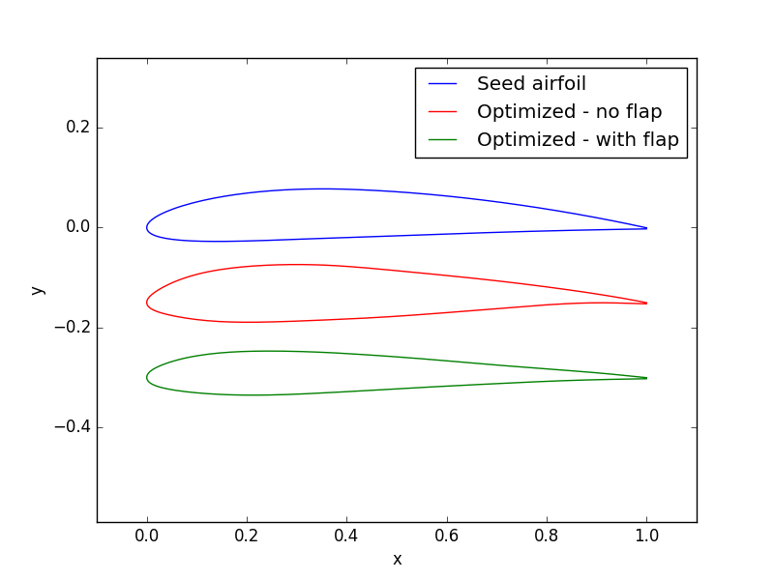Figure 3: Seed airfoil, and two optimized airfoils

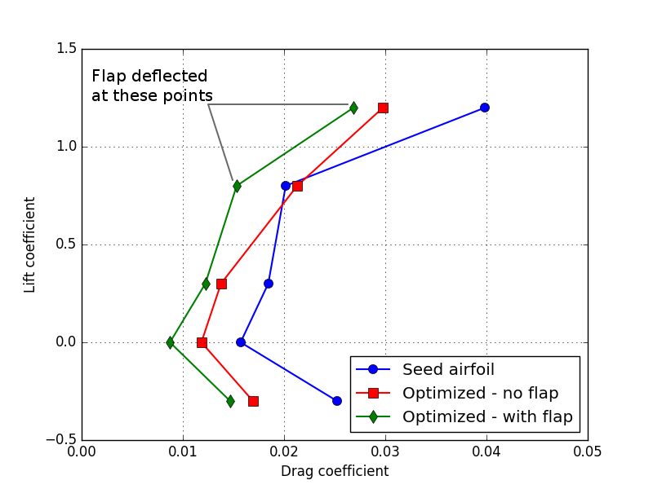Figure 4: Polars for the seed airfoil and two optimized airfoils

