{{PROPERTY_NAME}}
{{PROPERTY_ADDRESS_STREET}}
{{PROPERTY_ADDRESS_CITY}},{{PROPERTY_ADDRESS_STATE}} {{PROPERTY_ADDRESS_ZIP}}
{{PROPERTY_WEBSITE}}
{{NOTICE_SENT_DATE}}
MAINTENANCE NOTICE

Dear Residents,

This email is to inform you that our maintenance team will be conducting a HVAC filter replacement in your unit {{$fromMillis($toMillis($split(WORK_EXPECTED_DATE, "/")[[2]] & "-" & $split(WORK_EXPECTED_DATE, "/")[[0]] & "-" & $split(WORK_EXPECTED_DATE, "/")[[1]]), "[FNn], [MNn] [D], [Y]")}}, between the hours of 8AM and 4PM.

Please ensure that the superintendent is able to enter your unit on the above listed date. Please also secure any service animals and to clear any items out of the area where the work is to be completed.

If you have any questions or concerns, please contact the front office at your convenience.

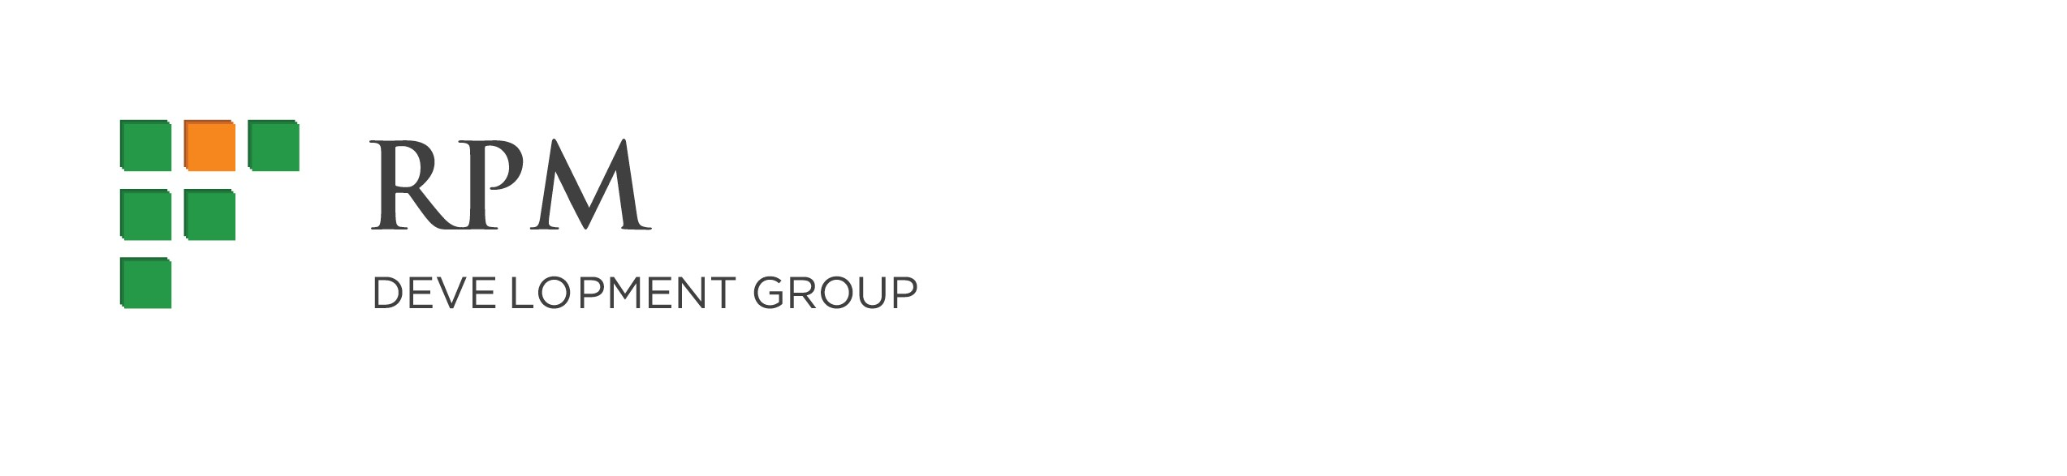
Thank you for your cooperation.

Thank you!


Brandi Morris
RPM DEVELOPMENT GROUP

Phone: (571) 989-1705
Fax: (732) 543-7499
Email: bmorris@rpmdev.com
Meetings now available for scheduling!

Office Hours: Monday – Friday 8:00am – 4:00pm

