**Homework #2**

“Forced oscillations”

Mathematical Modelling

Dmytro Tkachenko

19/05/2024

**Task 1**

From equation: $τ = -L*F$ and $F =mgsin(ϕ)$

We have: $τ= -L*m*g*sin(ϕ)$

Also: $τ=I\ddot{ϕ}$ where $I=mL^{2}$

Put everything together: $m*L^{2}*\ddot{ϕ}=- m*g * L*sin\left(ϕ\right)$

Result:

$$L *\ddot{ϕ}+g*sin\left(ϕ\right) = 0$$

**Task 2**

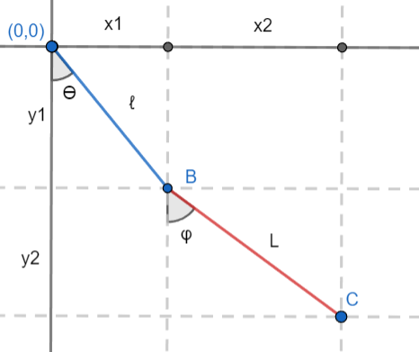

$$x=lsin\left(θ\right)+Lsin\left(ϕ\right) \\ y=- lcos\left(θ\right) - Lcos\left(ϕ\right)$$

Conditions: $l=L=1$:

Result:

$$x=sin\left(θ\right)+sin\left(ϕ\right) \\ y=- cos\left(θ\right) - cos\left(ϕ\right)$$

**Task 3**

$$ω=\dot{ϕ}$$

$$L\dot{ω}+gsin\left(ϕ\right)=-l\ddot{θ}cos\left(θ-ϕ\right)+l\dot{θ^{2}}sin\left(θ-ϕ\right)$$

**References**

1. Wikipedia. Differential Equation: https://en.wikipedia.org/wiki/Differential_equation
2. Wikipedia. Runge–Kutta methods: https://en.wikipedia.org/wiki/Runge%E2%80%93Kutta_methods
3. Wikipedia. Pendulum:

https://en.wikipedia.org/wiki/Pendulum