C1: .1811 C2:2.456 w:0.406

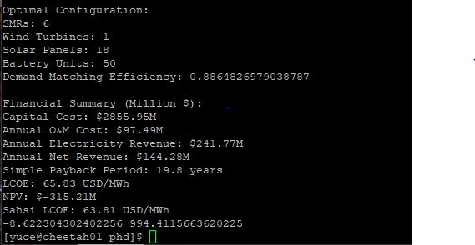

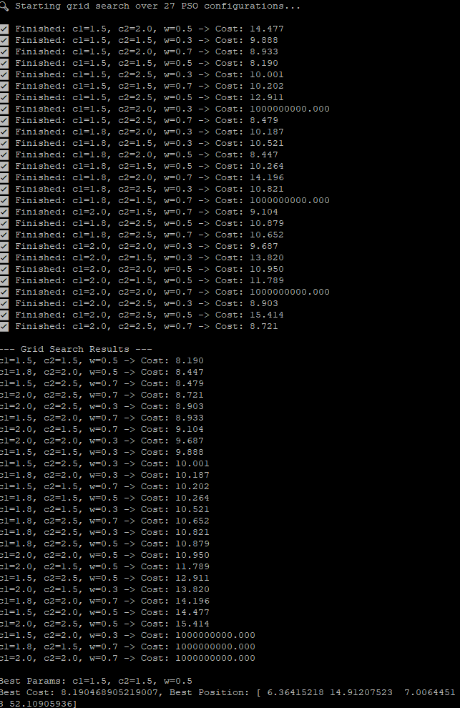

return -profit + 1000 * penalty

Optimal Configuration:

SMRs: 6

Wind Turbines: 1

Solar Panels: 13

Battery Units: 1

Demand Matching Efficiency: 0.8863882232666982

Financial Summary (Million $):

Mean Electricity price: $61.75M

Capital Cost: $2819.47M

Annual O&M Cost: $96.77M

Annual Electricity Revenue: $240.64M

Annual Net Revenue: $143.86M

Simple Payback Period: 19.6 years

LCOE: 65.19 USD/MWh

NPV: $-263.01M

[yuce@cheetah01 phd]$ python3 pso_mpc.py --hydrogen

No PPA is present, using day-ahead market prices

2025-06-20 14:20:15,905 - pyswarms.single.global_best - INFO - Optimize for 100 iters with {'c1': 1.5, 'c2': 1.5, 'w': 0.5}

pyswarms.single.global_best: 100%|██████████████████████████|100/100, best_cost=681

2025-06-20 17:09:07,141 - pyswarms.single.global_best - INFO - Optimization finished | best cost: 681.0399005074164, best pos: [ 7.55075424 149.11751341 140.18565761 180.01519552 33.57251464]

Optimal Configuration:

SMRs: 8

Wind Turbines: 149

Solar Panels: 140

Battery Units: 180

Hydrogen Units: 34

Demand Matching Efficiency: 0.05240190589766991

Financial Summary (Million $):

Mean Electricity price: $61.75M

Capital Cost: $4717.36M

Annual O&M Cost: $145.20M

Annual Electricity Revenue: $11.73M

Annual Hydrogen Revenue: $669.58M

Annual Net Revenue: $536.11M

Simple Payback Period: 8.8 years