USB Copy Pro
Version 3

Quickstart Guide
(Windows Version)

Last Updated: 2020-09-03

Here’s how to create, test, and deploy encrypted content to a USB drive using USB Copy Pro.

1. Launch the application from the start menu.

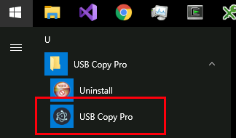

2. Input the Vendor ID (VID), Product ID (PID), and leading digits of the serial number.
- VID and PID are numbers in hexadecimal representation, and are not case-sensitive.
- Serial number is a string stored on the drive, and IS case sensitive.

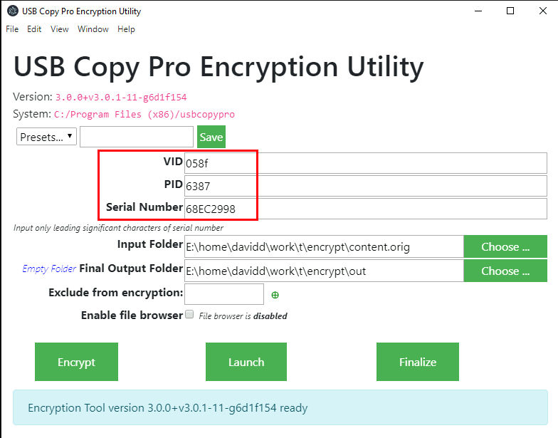

3. Select the folder that contains the root of the web application to be encrypted.
- NOTE: the application must not reference files present on the local machine, but outside of the root folder.
- The web app should not access internet resources, e.g. the jQuery CDN. Those resources should be downloaded and saved prior to encryption.

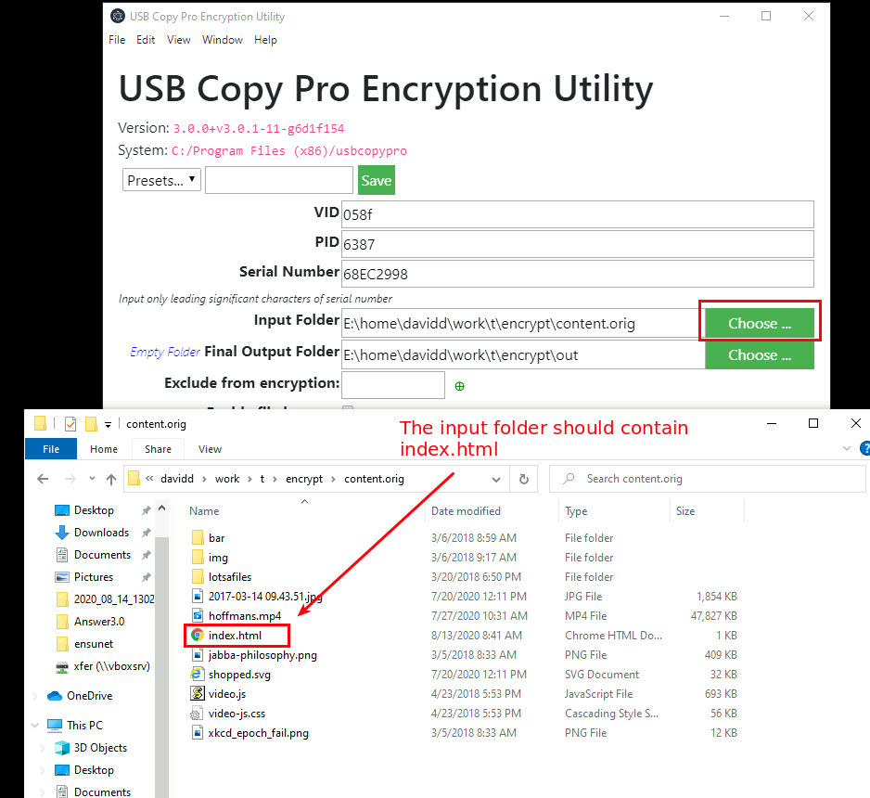

4. Select the output folder.
- It is possible to make this output folder the root of the USB drive itself, but doing so may result in long encryption times. It is often faster to set the output folder to a temporary location and then manually copy things into the drive later.

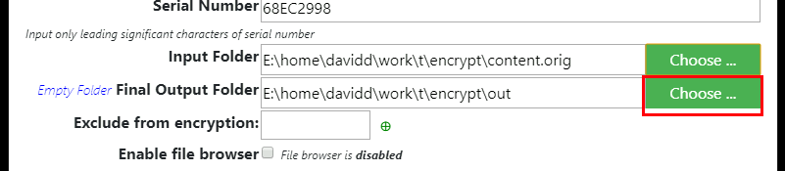

5. Click “Encrypt”

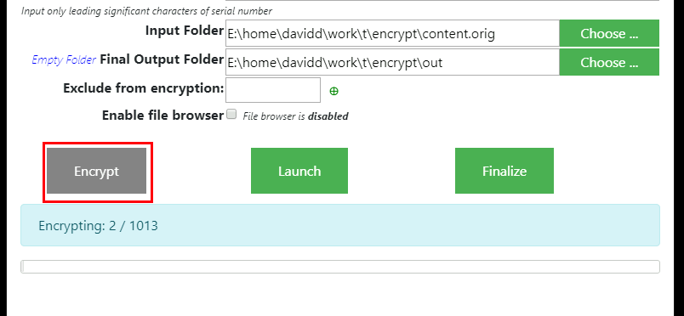

6. On successful encryption, you can click “Launch” to test out your app.
- The dev tools window will automatically open up to allow for debugging of the application.

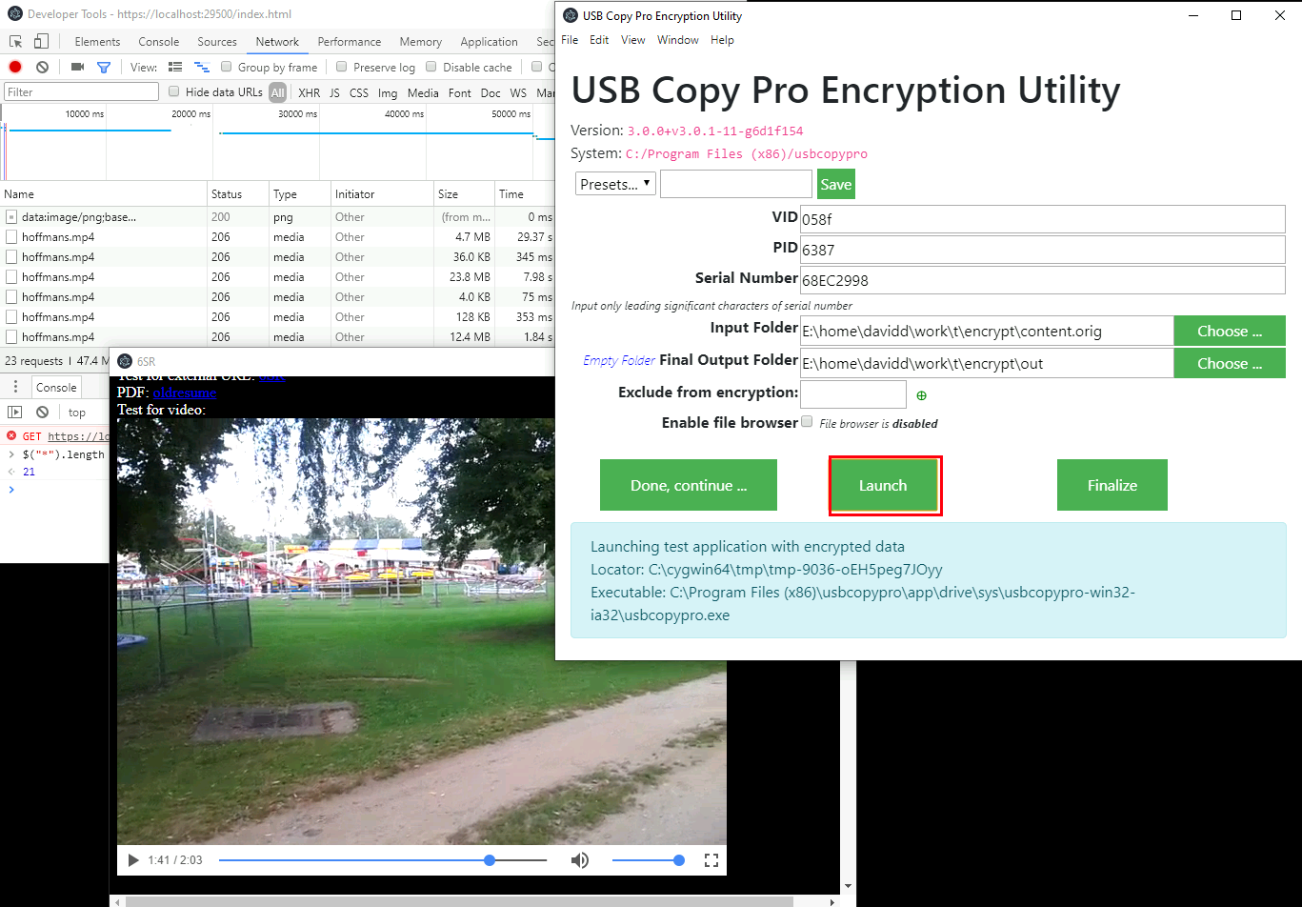

7. If everything looks good, click “Finalize” to copy the system to the output folder.

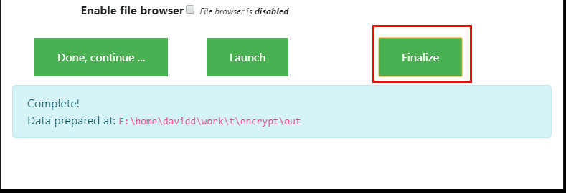

8. With the USB drive unplugged, open the output folder and click the “Start for Windows” shortcut. This should show the “locked” screen.

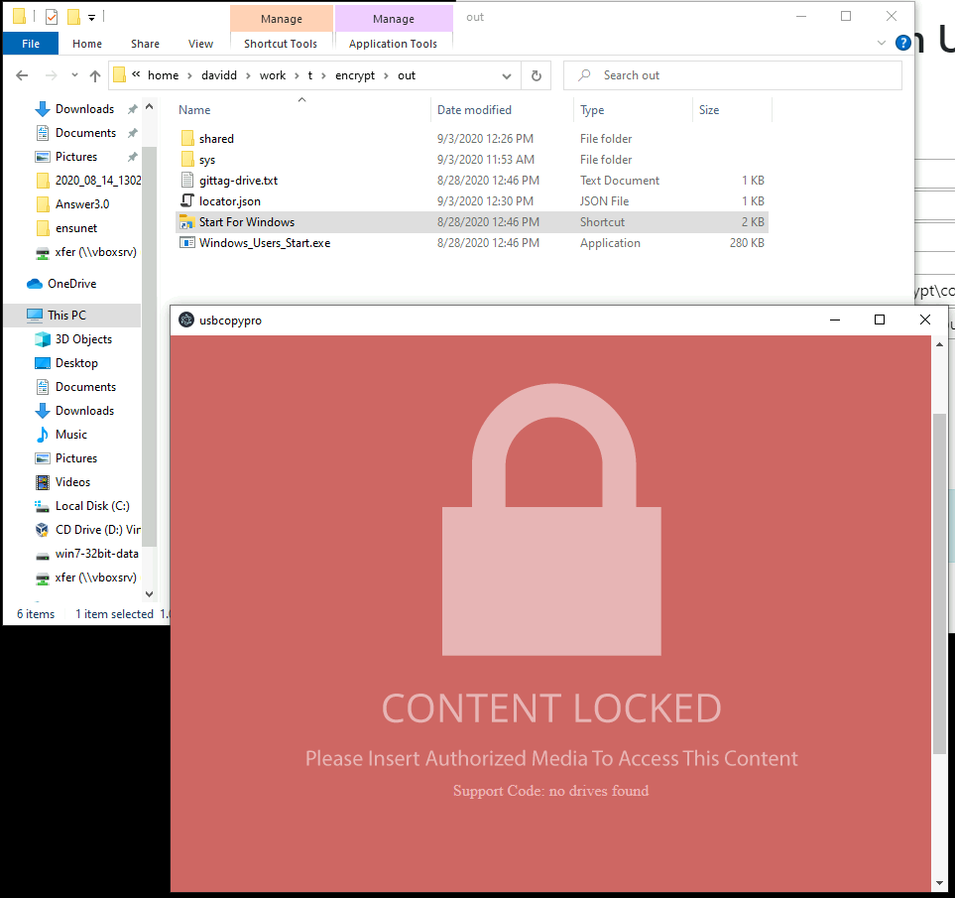

8. Plug the USB drive into the machine, and run “Start for Windows” shortcut again. The app should authenticate and load.

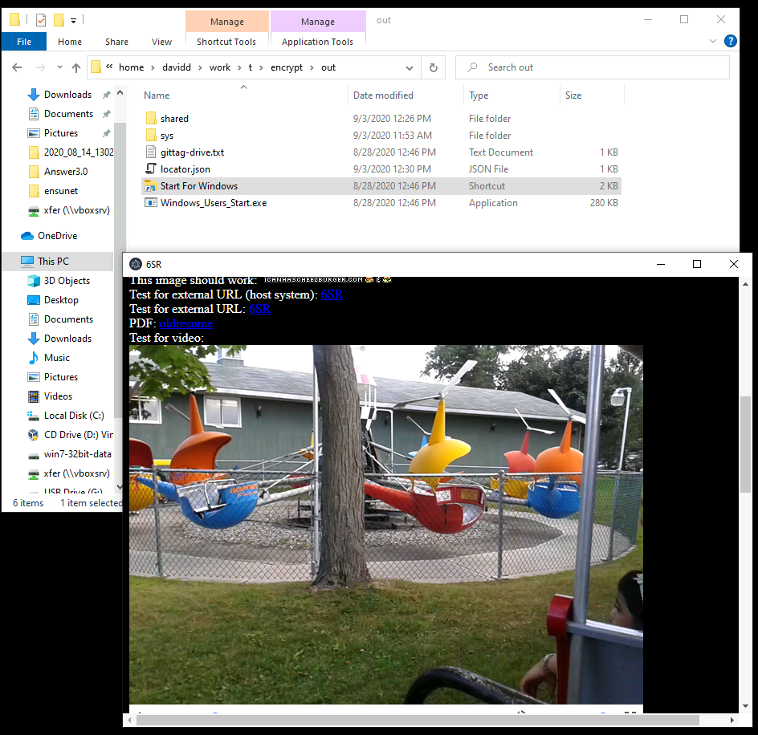

9. Copy all the files in the output folder to the root of the drive, and you’re DONE! You now have an executable encrypted web app that is accessible only when the drive is plugged in!

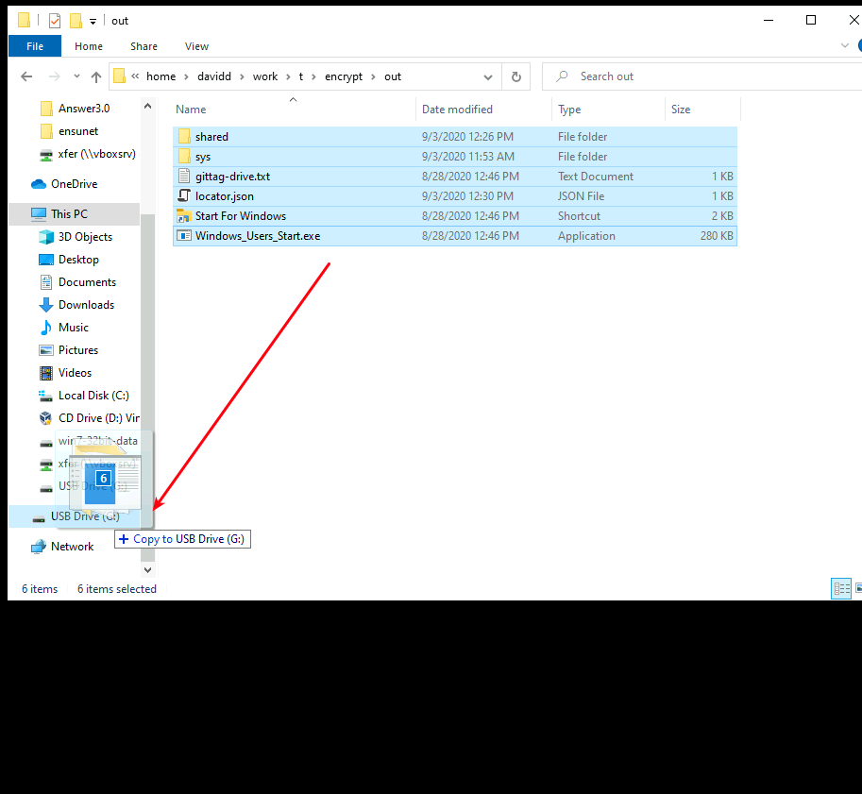

ENJOY!

