
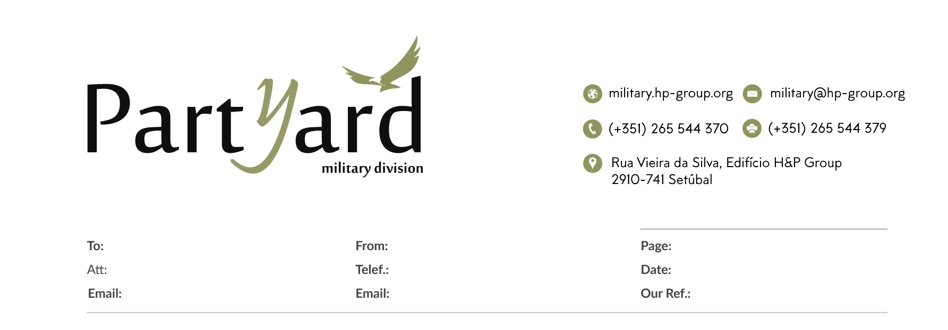

INQUIRY

15-07-2025

