Los indomables

CATHEDRAL TERRA

“Los Indomables”

1. Name of the Project: CATHEDRAL TERRA
2. Team: “Los Indomables”
3. Countries/ Subregion: Cd. Obregón, Sonora, México.
4. Period of Execution: April 2**8** – May 05, 2017
5. Category: Ideate and create.
6. Challenge: Small spaces, big ideas!
7. Introduction

Humankind is always moving forward, towards the future and new solutions for every kind of possible problems. Some of those problems don’t require a lot of reasoning or time, but there’re some that involve all our energy, intelligence and passion; those challenges that drive us beyond our imagination, challenges so peculiar that make us think different and out of the box. Problems and challenges that let our imagination bloom.

People; Humanity can reach anywhere there’s no limit, but only if we are determined. As any process, reaching our goals implies a long road where most of the work lies. Our next goal and one of our hardest challenges is reaching Mars.

The objective of NASA program called “Space Apps Challenge” consists on searching for innovative solutions to NASA’s problems that concern space and global problematics that affect everyone on an equal scale, like global warming and deterioration of the ecosystems, besides making information accessible to the student community, familiarize them with international-level projects and promote a critical thinking on global matters.

The project tries to satisfy and solve thoroughly aspects of the problematics by creating and innovating a workspace and housing for a team of astronauts with the intention of applying it to a future mission of exploration and pre-settling on the planet Mars. The work is done according to the guidelines specified by NASA and is denominated as the design of a habitat.

1. Current situation

HI-SEAS (Hawai’i Space Exploration Analog and Simulation) is a Habitat on an isolated Mars-like site on the Mauna Loa side of the saddle area on the Big Island of Hawaii at approximately 8200 feet above sea level. The HI-SEAS Habitat is semi-portable, low-impact, and designed to have all the desirable analog features specified in Keeton et al (2011). It has a habitable volume of ~13,000 cubic feet, a usable floor space of ~1200 square feet, and small sleeping quarters for a crew of six, as well as a kitchen, laboratory, bathroom, simulated airlock and ‘dirty’ work area.

1. Background

The HI-SEAS site has Mars-like geology which allows crews to perform high-fidelity geological field work and add to the realism of the mission simulation. The Martian regolith examined by the CheMin instrument (Blake et al. 2012) is very similar to the weathered basaltic materials found in this part of Hawaii. The site is a former cinder rock quarry on the side of a spatter cone. It is surrounded by relatively recent lava flows with very little plant or animal life present. None of the sparse flora or fauna is rare which mitigates the likelihood of adverse environmental impact due to mission activities. The flows include a wide variety of volcanic features to explore, such as lava tubes, skylights, channels, and tumuli.

The HI-SEAS site is visually isolated, yet accessible by a dirt road, and a hospital and other emergency services are within a one hour driving distance (much less by helicopter). It has a cool, dry climate that varies very little over the year, enabling long-duration missions.

The habitat, based on a dome supplied by Pacific Domes International with internal two-story structure designed by V. Paul Ponthieux of Envision Design, was built by the Blue Planet Foundation of Honolulu, Hawaii. The geodesic dome is 36 feet in diameter, enclosing a volume of 13,570 cubic feet. The ground floor has an area of 993 square feet (878 square feet usable) and includes common areas such as kitchen, dining, bathroom with shower, lab, exercise, and common spaces. The second floor loft spans an area of 424 square feet and includes six separate staterooms and a half bath. In addition, a 160 square foot workshop converted from a 20-foot high steel shipping container is attached to the habitat. Annexed I

1. Project justification

Our project seeks to solve the need for a design of a dome for 6 people who can properly enjoy a house with an efficient structure in which effective materials are implemented to survive on Mars and at the same time be kind to people who will experience To be able to live in this dome, in the same way we can investigate the human conditions of life on another planet in conjunction with the soil study offered by our research clinic integrated in our dome.

This project aims to solving the problem of efficiency regarding the work realized inside the habitat and the process of construction and maintenance of the same to diminish the costs of production and to accelerate its construction, besides providing a general wellness of the team with a balance between leisure and work, to promote a healthy and professional coexistence inside the habitat to avoid disagreements and possible negative behaviors that could affect the efficiency of the team.

The subject that addresses the design of the project has to see with important aspects in the development of the technology and advances in manned space missions such as the improvements in safety parameters and stability of structures, the appropriate interpersonal communication, sending and receiving precise and clear information and the work environment of the stations. It’s important to pay attention to topics that include the advance in scientific matters like the astronautics and the improvements in the capacities of used materials and not only in spatial models, but in terrestrial models of buildings, mechanisms and electronic devices.

1. Goals:

Our main objective is to create and innovate a habitat where you will be able to live a team of 6 people that adapts to the needs of each member and of the specific mission in question besides completely covering the specific roles given by NASA:

• A laboratory room for crewmates to conduct personal research, providing isolation between lab materials (eg microbes) and regular crew activity

• A clinical station to collect data on each of the crewmates

• Personal rooms for sleeping

• Bathrooms

• A kitchen for cooking meals

• A common area for eating, exercising, and socializing.

One of the most important points we had in mind before starting the design process was the psychological factor that tremendously influences the well-being and performance of team members. More than a space to live and conduct research, it should be a space in which you can feel at home, even if isolated from society. A place that does not become a tedious monotonous routine and allows the inhabitants to develop in a healthy environment and foster strong and healthy interpersonal relationships.

1. Summary:

Our project consists on the design and simulation of a dome-shaped dwelling for 6 people on two floors (upper and lower floor) and between the floor of the upper floor and the roof of the lower floor are 30 cm of space to store things, on the lower floor are bedrooms Individual for 6 people satisfying the basic needs (wardrobe, bed, desk) inside this floor there is also an entertainment area, living room, kitchen and bathroom. On the top floor is the research laboratory, nurseries with controlled temperature considering as technological progress of hydroponics, equipment for soil analysis and small plant cultivation.

1. Design

* Laboratory
* Hydroponics: The term hydroponics originates from the ancient Greek "hydros", meaning water, and "ponos", meaning work. It can sometimes be mistakenly referred to as aquaculture, or aquiculture, but these terms are really more appropriately used for other branches of science that have nothing to do with gardening.

Hydroponics is a subset of hydroculture, the method of growing plants without soil, using mineral nutrient solutions in a water solvent. Terrestrial plants may be grown with only their roots exposed to the mineral solution, or the roots may be supported by an inert medium, such as perlite or gravel. The nutrients in hydroponics can be from fish waste, duck manure, or normal nutrients.

As the population of our planet soars and arable land available for crop production declines, hydroponics will offer us a lifeline of sorts and allow us to produce crops in greenhouses or in multilevel buildings dedicated to agriculture. Already, where the cost of land is at a premium, crops are being produced underground, on rooftops and in greenhouses using hydroponic methods.

Perhaps you'd like to start a garden so that you can grow your own vegetables, but you don't have the space in your yard, or you're overwhelmed by pests and insects. This article will arm you with the knowledge you need to successfully set up a hydroponics garden in your home and provide suggestions of plants that will grow readily without a big investment.

ANNEXED

* Exercise area
* Bike Washing Machine: The new device designed by students from the Chinese University of Dalian Nationalities has the same curves when you finish training, but at least you will have the clothes clean. The invention carries the explicit name of "Washing Machine" («Bike Washing Machine »Or« Bi-Wa ») and makes our pedaling a powerful centrifuge. The wheel of this static bike becomes a washing machine drum in which we will put our clothes, so that we can spinning and losing those unwanted calories while we do the laundry. According to its creators, the operation is as simple as it seems: « When pedaling, the movement causes the drum to rotate and, at the same time, electricity is generated that can be used to start the monitor or store it for future use. Important limitation: the small size of the drum. But in what some may see as a problem, others might argue that it is just an opportunity to do even more exercise. ANNEXED
* Entertainment area
* Olympus 360-degree HD camera and projector: The camera company -- long known to bring the goods on the picture-takin' end -- has just created the first 360-degree, 1080i camera and projection solution. Utilizing a proprietary system based around an "axisymmetric free-form-surface lens," the camera can shoot video at horizontal and vertical viewing angles of 360-and-50-degrees, respectively; the images can then be projected in the same range by a separate unit. ANNEXED
* Folding walls

MILT folding walls allow you to quickly divide a larger space into smaller premises. The walls in question are suspended from a roof rail and the panels simply move through the bearings. The folding walls meet high requirements in terms of design and sound proofing. The folding wall suspension system has one or two points. Various parking possibilities for each segment, adapted to the layout of the space. The control is manual, semi-automatic and automatic. Noise test - from 44 to 59dB. The surface is of laminate, metal, plywood board, etc. We manufacture folding walls with a height of up to 8m. ANNEXED

XI. Materials

Because it’s a big project that takes in consideration many important aspects such as the flexibility of materials or the lifespan of structures that could put in risk the safety of the team and the integrity of the structure, the materials must be used cautiously and efficiently. A deep research on materials was made about the usage of different types of structures and cheaper material alternatives, much more feasible than the materials of normal construction, to reduce the costs of the project, to increase its life span and the general performance throughout the years.

The walls of the habitat must resist the effects of cosmic radiation and isolate the interior environment of the exterior to avoid heat loss or leakage in the ventilation system. The external layer serves as a barrier so it must be thick enough and made of a material resistant to corrosion and to Mars' atmosphere like reinforced Titanium, covered with a cap of Martian cement done from a compound of the Martian soil and Sulphur (see bibliography for more details). The internal layer works as extra protection and as insulating layers; a layer of Aerogel followed by a sheet of Titanium or Aluminum, then another layer of Aerogel and for more protection an additional layer of top quality Graphene and finally a thicker cap of Titanium or Aluminum.

The foundations of the habitat will be made from the compound of Martian cement and the principal supports of the structure of the dome. The floor of the interior sections will be made of Titanium plates to assure a suitable resistance and a support for the building’s weight, the instruments and the crew.

1. Related and / or complementary projects:

* ICE HOUSE

The “Mars Ice Home” is a large inflatable dome that is surrounded by a shell of water ice. NASA said the design is just one of many potential concepts for creating a sustainable home for future Martian explorers. The idea came from a team at NASA’s Langley Research Center that started with the concept of using resources on Mars to help build a habitat that could effectively protect humans from the elements on the Red Planet’s surface, including high-energy radiation.

The advantage of the Mars Ice Home is that the shell is lightweight and can be transported and deployed with simple robotics, then filled with water before the crew arrives. The ice will protect astronauts from radiation and will provide a safe place to call home, NASA says. But the structure also serves as a storage tank for water, to be used either by the explorers or it could potentially be converted to rocket fuel for the proposed Mars Ascent Vehicle. Then the structure could be refilled for the next crew.

Other concepts had astronauts living in caves, or underground, or in dark, heavily shielded habitats. The team said the Ice Home concept balances the need to provide protection from radiation, without the drawbacks of an underground habitat. The design maximizes the thickness of ice above the crew quarters to reduce radiation exposure while also still allowing light to pass through ice and surrounding materials.

* 3D printers

MIT Lincoln Laboratory staff are printing in a new dimension, using 3D printers to transform 3D designs into tangible objects. More formally known as additive manufacturing, 3D printing is a process that assembles conventional manufacturing materials, such as plastics and metals, in successive layers along the Z axis (i.e., top down or bottom up). The Laboratory has invested in several 3D printers, ranging in size and capability from industrial-scale, top-of-the-line models to desktop, home-hobbyist models. Located in the Rapid Hardware Integration Facility (RHIF)—the Laboratory's dedicated rapid prototyping area—and in the Technology Office Innovation Laboratory (TOIL)—a newly opened space for prototyping and tinkering—the Laboratory's 3D printers are being utilized to complete work on sponsored programs and to explore preprogram ideas. "3D printing enables staff to pursue a variety of programs and activities," says Andy Vidan, associate technology officer, Technology Office. ANNEXED

1. Self-management and sustainability:

* Energy

The energy consumption is one of the key points at the moment of coming up with the design of any building, since it has to be considered the wired up of the electrical system, the consumption ranges per hour and the location of the sockets to optimize and diminish the energetic consumption.

The International Space station (ISS) was used as a base and reference for the information relating energy sources of the dome, which are mostly photovoltaic panels that if calculated in a terrestrial environment would be distributed in 4 arrays of 6 panels per array with a total of 24 panels. Each panel generates about 435Wp with an efficiency of 17% (The dimensions of the photovoltaic commercial panels vary from 1 square meter to 3 square meters with a general thickness of 40mm; a monocrystalline panel with dimensions close to 2.5 square meters with a thickness of 40mm at an efficiency of 15%-16.5% can generate between 390-425 Wp) that in total would add up to 10440W in the terrestrial surface. Only the 43.1% of solar radiation gets to the Martian surface compared to Earth so it would be necessary around the double of photovoltaic arrays to obtain a similar performance, which would be 6 arrays of 9 panels each one with a total of 54 panels, generating about 10125W, enough to cover the regular consumption of the habitat.

In comparison to the ISS, the new habitat uses about 1/8 of the energy since it does not use a complex electrical system and does not use complex mechanisms such as the robotic arm on the ISS or Earth monitoring devices. One of the similarities would be the communication system, since it needs a great power to successfully transmit the information all the way to Earth; to simplify the model, communication was left off the main structure and calculations were left for general adjustments to future projects of the NASA.

* Water Recovery System (WRS)

The water regeneration system introduced in the ISS, is part of the set of life support systems that receives the generic ECLSS (regenerative environmental control and life support system). The WRS was designed by the Marshall Center of NASA in collaboration with the company Hamilton Sundstrand Space Systems International. He moved to the ISS in November 2008 and after several problems began to be operational from March 2009.

The estimate that this system of water regeneration was installed in the International Space Station contemplated a reduction of 6.8 tons per year in the transportation of water and fuel, in addition to offering the possibility of increasing the number of crew in the ISS.

The WRS is divided into two frames and is composed of two subsystems: the urine processor (UPA) and the water processor assembly (WPA). The first one, the UPA, has the function of distilling the urine of the crew in a rotary distillation unit, to compensate for the absence of gravity in the station. Then, the water recovered in the UPA subsystem is carried along with the rest of the water without fish and are treated together in the WPA. Here gases and solids are removed through a series of filtration units and subsequently remove remaining microorganisms and other contaminants by high temperature catalysis. Purified water in this way meets the highest quality criteria for drinking water. However, the challenge remains: to obtain lighter, less voluminous and highly effective water recovery systems. ANNEXED

* Smartflower

The intelligent all-in-one solar system is automatic and extremely efficient thanks to its remarkable design and perfectly matched components. Innovative smart features achieve maximum yield and more efficient use of the power generated. Thanks to smart tracking, the smartflower POP folds out automatically every morning and tracks the sun during the day with its 2-axis controller. This raises yield by up to 40% compared to a roof mounted system which only points at the right angle to the sun for only a few hours a year. Smart cleaning and smart cooling also prevent the usual losses caused by heat and contamination accumulation by up to 15%. ANNEXED

* MOXIE — short for Mars OXygen In situ resource utilization Experiment —

Was selected from 58 instrument proposals submitted by research teams around the world. The experiment, currently scheduled to launch in the summer of 2020, is a specialized reverse fuel cell whose primary function is to consume electricity in order to produce oxygen on Mars, where the atmosphere is 96 percent carbon dioxide. If proven to work on the Mars 2020 mission, a MOXIE-like system could later be used to produce oxygen on a larger scale, both for life-sustaining activities for human travelers and to provide liquid oxygen needed to burn the rocket fuel for a return trip to Earth. According to Hecht, a long-term plan for getting humans to Mars — and back — would look something like this: First, a small nuclear reactor would be sent to the Red Planet along with a scaled-up version of the MOXIE instrument. Over a couple of years, its oxygen tank would fill up in preparation for human visitors. Hecht adds that producing oxygen on the Martian surface is likely the simplest solution for a number of reasons. It would, for example, eliminate the difficulty and expense of sending liquid oxygen stores to Mars. To be sure, MOXIE won’t be the only instrument aboard the Mars 2020 mission. It will occupy valuable space on a rover that will also conduct other important scientific experiments — such as searching the Martian soil for signs of life. So why do scientists and engineers need to demonstrate that they can produce oxygen on the surface. ANNEXED

* Ecological washing machine.

For a washing machine to be considered ecological, it must comply with a series of guidelines, both in its manufacture and its operation. You should consume at most 15 liters of water per kilo of clothing in a long cycle (cotton) in hot water. The energy saving should be 0.23 KW / hour per kilo of laundry in a washing cycle. It is important to take into account also the material of which the washing machine is made, being able to use bioplastics for its manufacture, that allow to reduce the CO2 emissions and in addition to being degradable 100% its environmental impact is very low. ANNEXED

* The Pavegen technology

It’s a multifunctional custom flooring system. As people step on the tiles, their weight causes electric-magnetic induction generators to vertically displace, which results in a rotatory motion that generates off-grid electricity. Additionally, each tile is equipped with a wireless API that transmits real-time movement data analytics, whilst directly producing power when and where it is needed. Pavegen is also able to connect to a range of mobile devices and building management systems. From climate change to rapidly expanding cities, we face complex environmental and social challenges. This technology enables people to directly engage with clean energy, to increase their understanding of sustainability issues, and to connect purposefully with brands. Technology alone won’t make cities perform more efficiently. It’s about changing behaviors. Pavegen’s combination of physical interactivity and rich data is helping to bring smart cities to life.

ANNEXED

1. Annexes

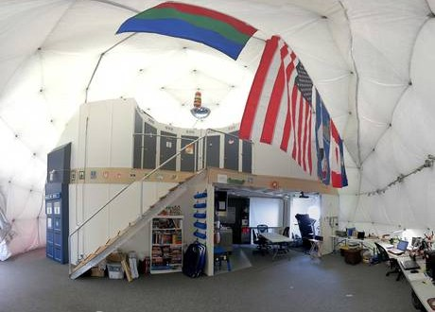I.- HI-SEAS

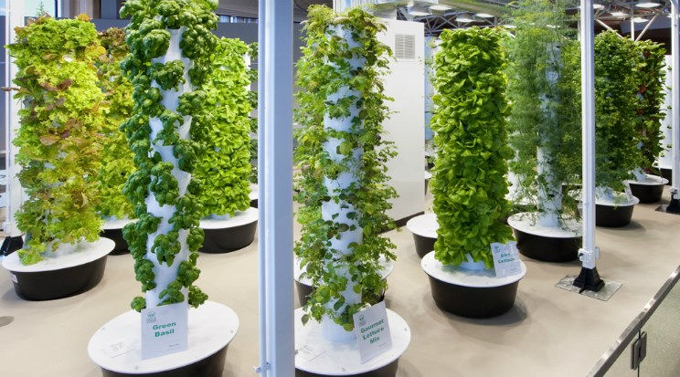Hydroponics

Smartflower

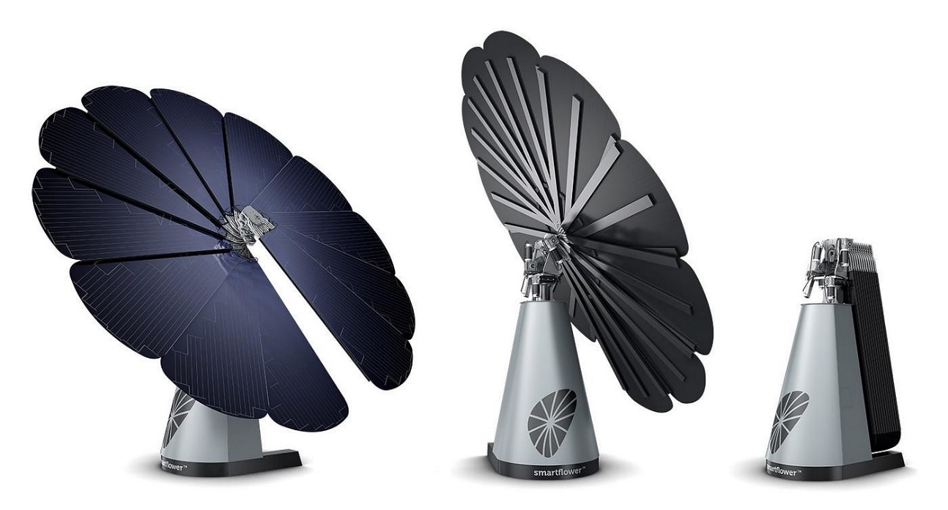

MOXIE

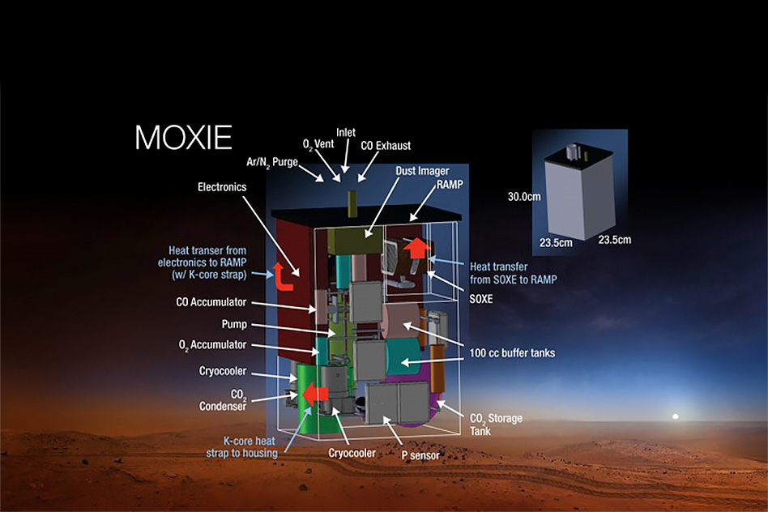

Ecological washing machine.

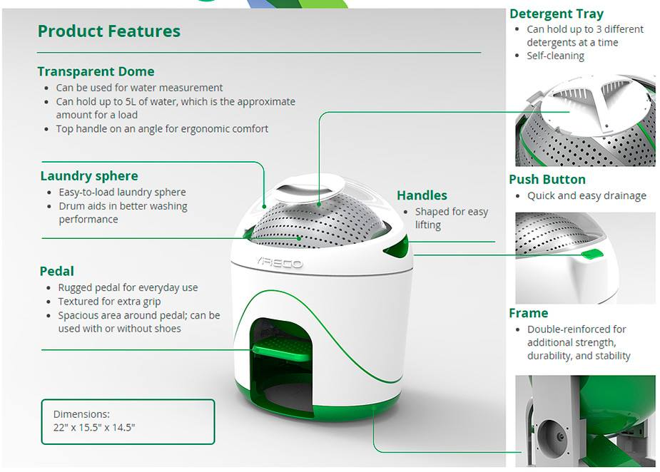

Pavegen

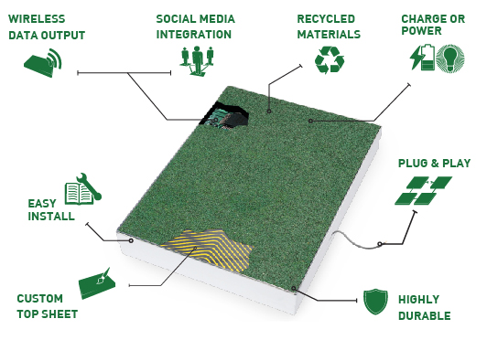

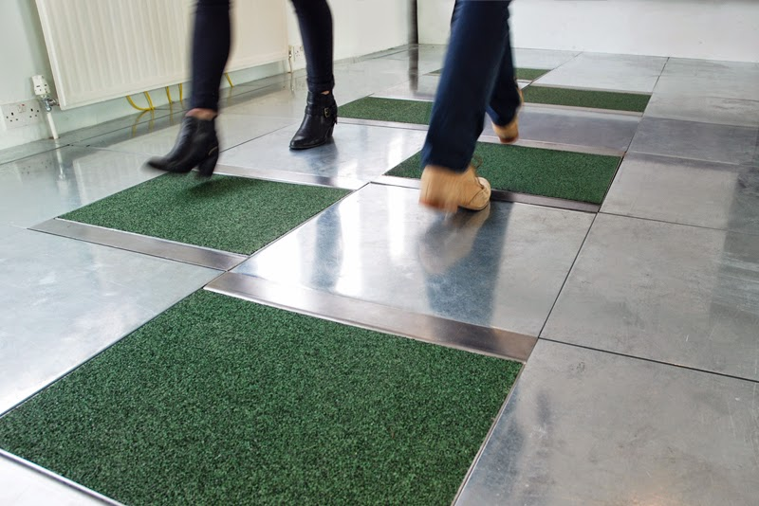

Bike Washing Machine

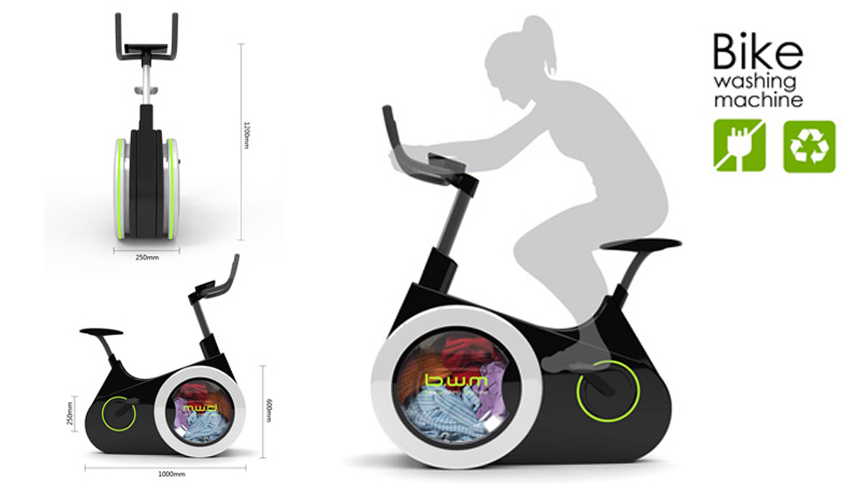

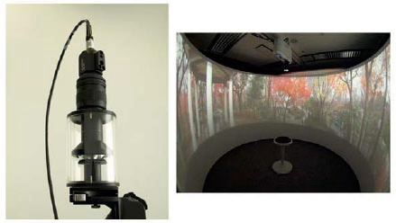Olympus 360-degree HD camera

Folding walls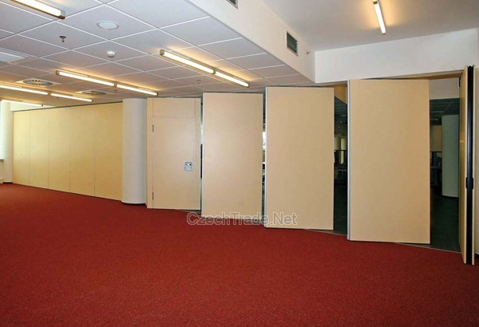

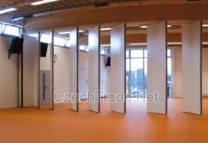

ICE HOUSE

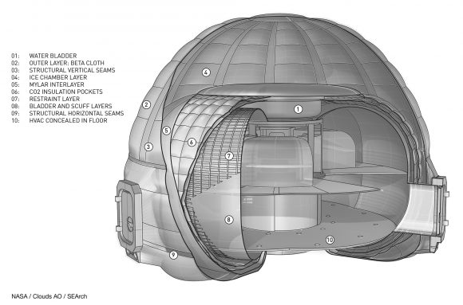

1. Bibliography

<https://mars.nasa.gov/news/mars-2020-rovers-pixl-to-focus-x-rays-on-tiny-targets>

<http://www.europapress.es/ciencia/misiones-espaciales/noticia-sistema-respirar-marte-oxigeno-reciclado-20150220175708.html>

<http://www.ibtimes.co.uk/mit-invents-breakthrough-3d-printer-that-can-print-10-different-materials-simultaneously-1517149>

<http://www.lavozdegalicia.es/noticia/sociedad/2015/04/28/lavadora-bici-quemar-calorias-colada/00031430248927099814845.htm>

<https://www.nasa.gov/centers/ames/spanish/news/04_104AR.html>

<http://blog.is-arquitectura.es/2016/01/13/5-sistemas-para-generar-energia-en-casa/>

<https://2017.spaceappschallenge.org/challenges/ideate-and-create/small-spaces-big-ideas/details>

<https://hi-seas.org/>

<https://hi-seas.org/?p=1278>

<https://mars.nasa.gov/allaboutmars/facts/#?c=inspace&s=distance>

<https://mars.nasa.gov/allaboutmars/extreme/>

<https://en.wikipedia.org/wiki/Colonization_of_Mars>

<https://nssdc.gsfc.nasa.gov/planetary/factsheet/marsfact.html> <https://arxiv.org/pdf/1512.05461v1.pdf>

<https://www.cnet.com/news/high-tech-aerogels-wrap-homes-with-insulation/>

<https://catalog.data.gov/dataset/graphene-for-space-project>

<https://es.wikipedia.org/wiki/Energ%C3%ADa_solar_fotovoltaica> <https://es.wikipedia.org/wiki/Constante_solar> <https://www.youtube.com/watch?v=0c4xk5dB014>

<http://daprose.net/energia/?p=33>

<https://www.nasa.gov/feature/facts-and-figures> <https://www.nasa.gov/sites/default/files/atoms/files/np-2015-05-022-jsc-iss-guide-2015-update-111015-508c.pdf> <https://en.wikipedia.org/wiki/International_Space_Station>

<https://phys.org/news/2016-06-dutch-crops-grown-mars-soil.html> <https://phys.org/news/2016-03-tomatoes-peas-harvested-mars-moon.html> <http://danielmarin.naukas.com/2011/03/23/la-radiacion-en-el-espacio/>