MJ Payroll

Contents

2. Preview
3. Exporting from Creative Energy
4. Upload File
5. Search by Name and/or Terminal
7. Weekly Breakdown
9. Driver Totals & Terminal Totals
10. Print
11. Footwear Bonus
12. Totals
13. Editing Cells
14. Save

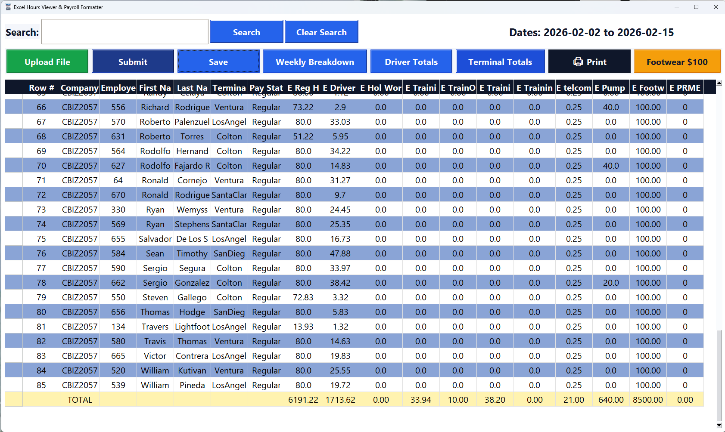
Exporting from Creative Energy
To export the required file from Creative Energy:
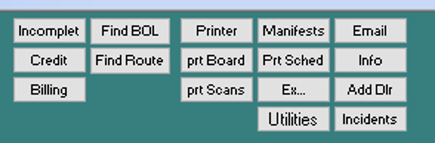
- Log into Creative Energy.
- Click on the “Utilities” button.
- Set the desired date range.
- In the bottom-left corner, click “DRS Export.”
2
- Press “OK.”
An Excel file will generate and open automatically.
- Click Save As and save the file to a shared folder accessible by both your Remote PC and Local PC (for example, OneDrive).
- Go to your Local PC.
- Open the Payroll Program.
- Upload the downloaded file.
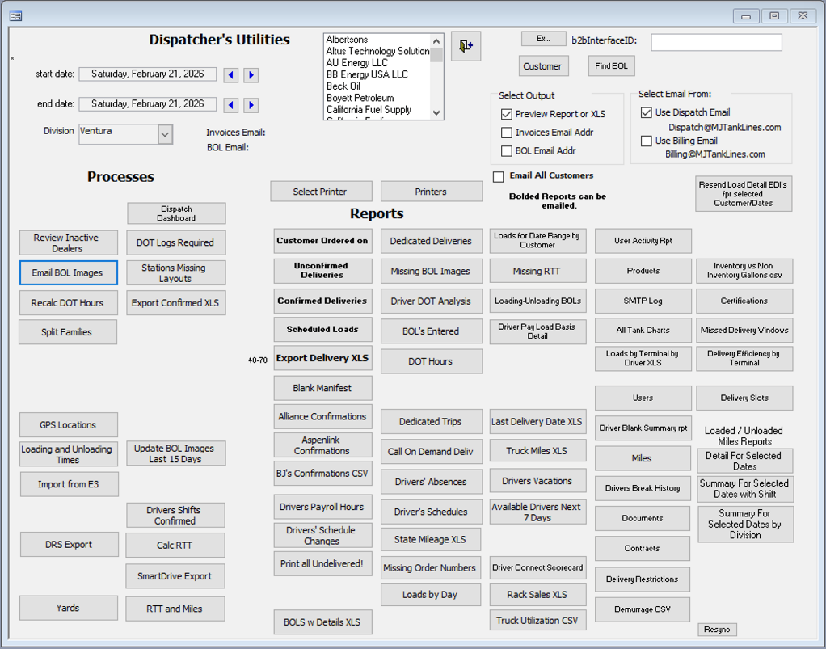
3

4

Upload File

To upload a file downloaded from Creative Energy:
- Click Upload.
- Select the file from your computer.
- Click Submit.
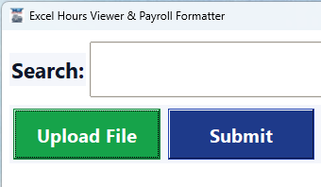
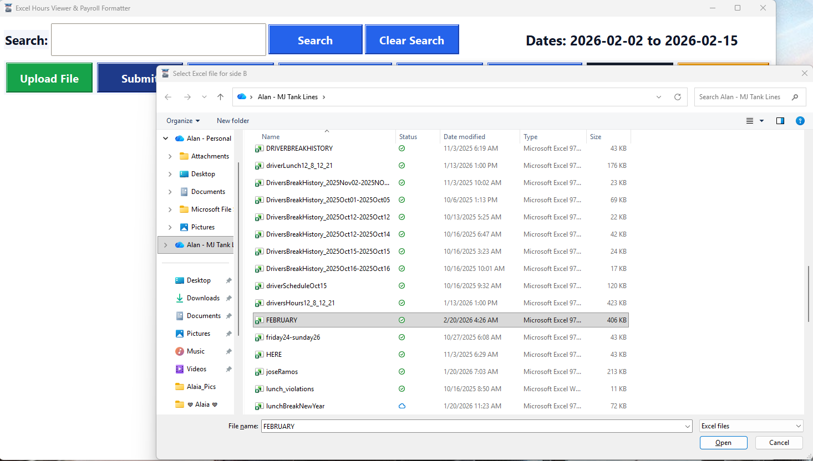
Search by Name and/or Terminal
The Search Bar lets you search by Employee Name, Employee ID, Terminal Name, or any combination of these. To use multiple filters, separate them with commas and click Search.
To reset the table and view all entries again, click Clear Search.
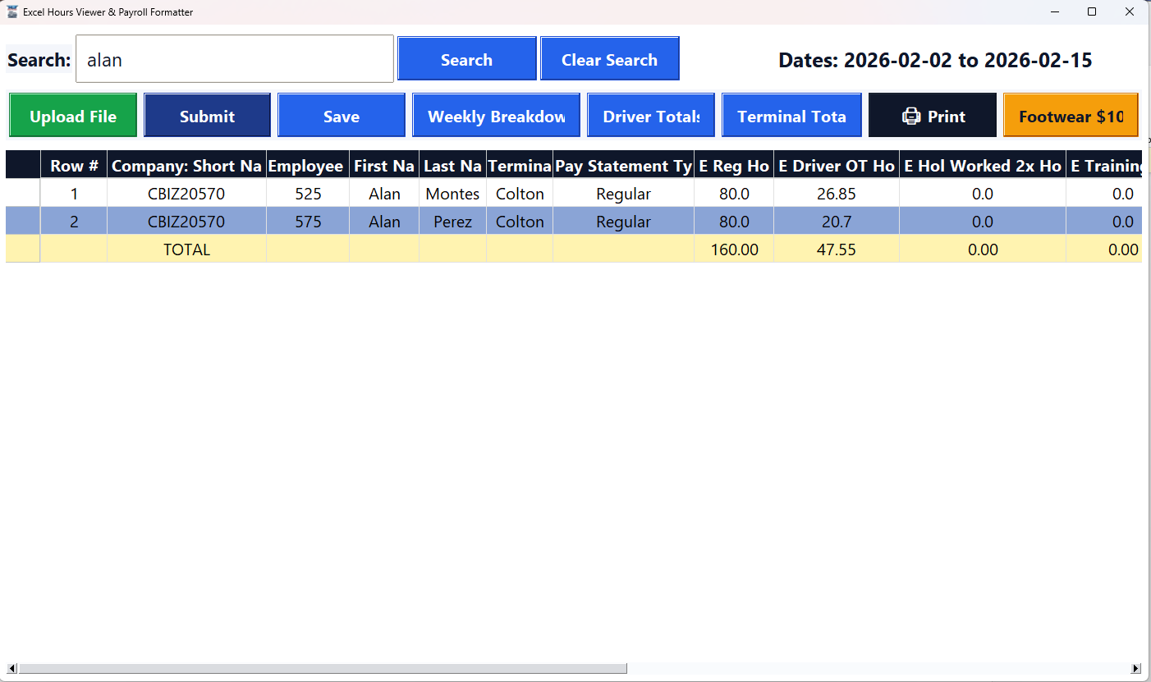
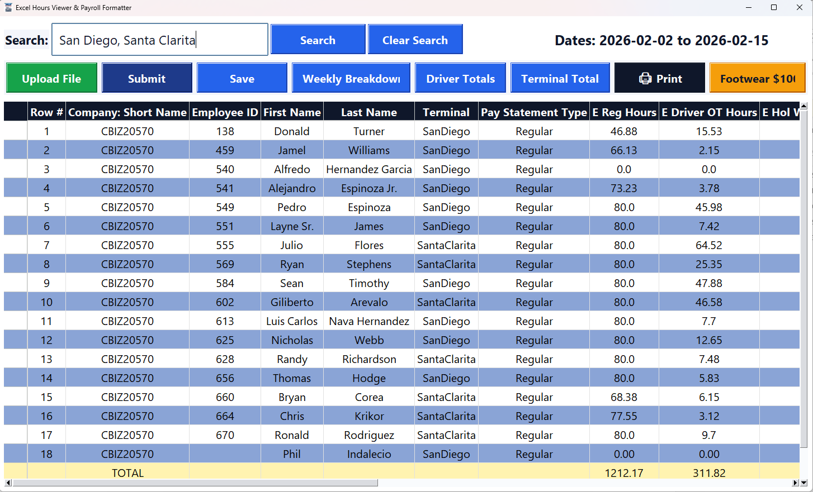

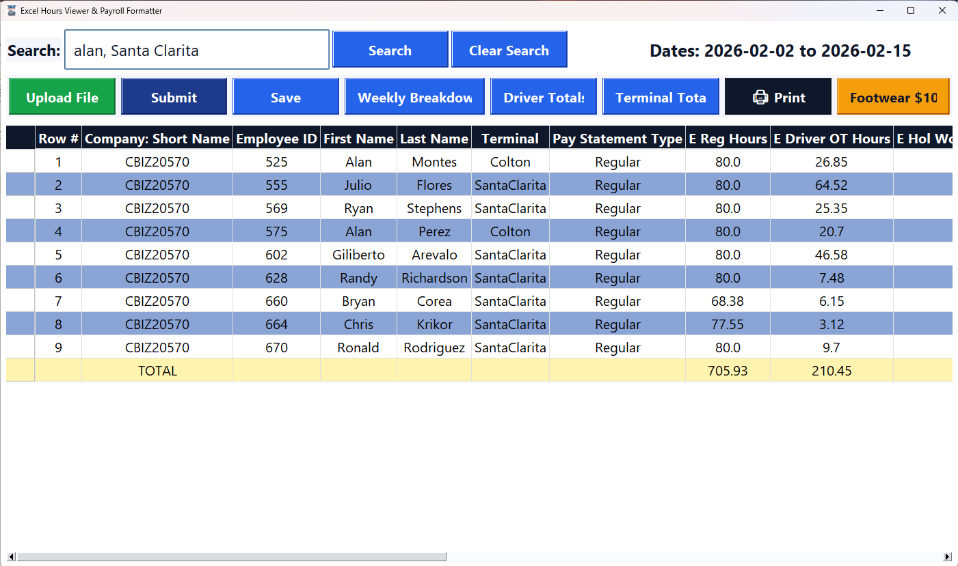
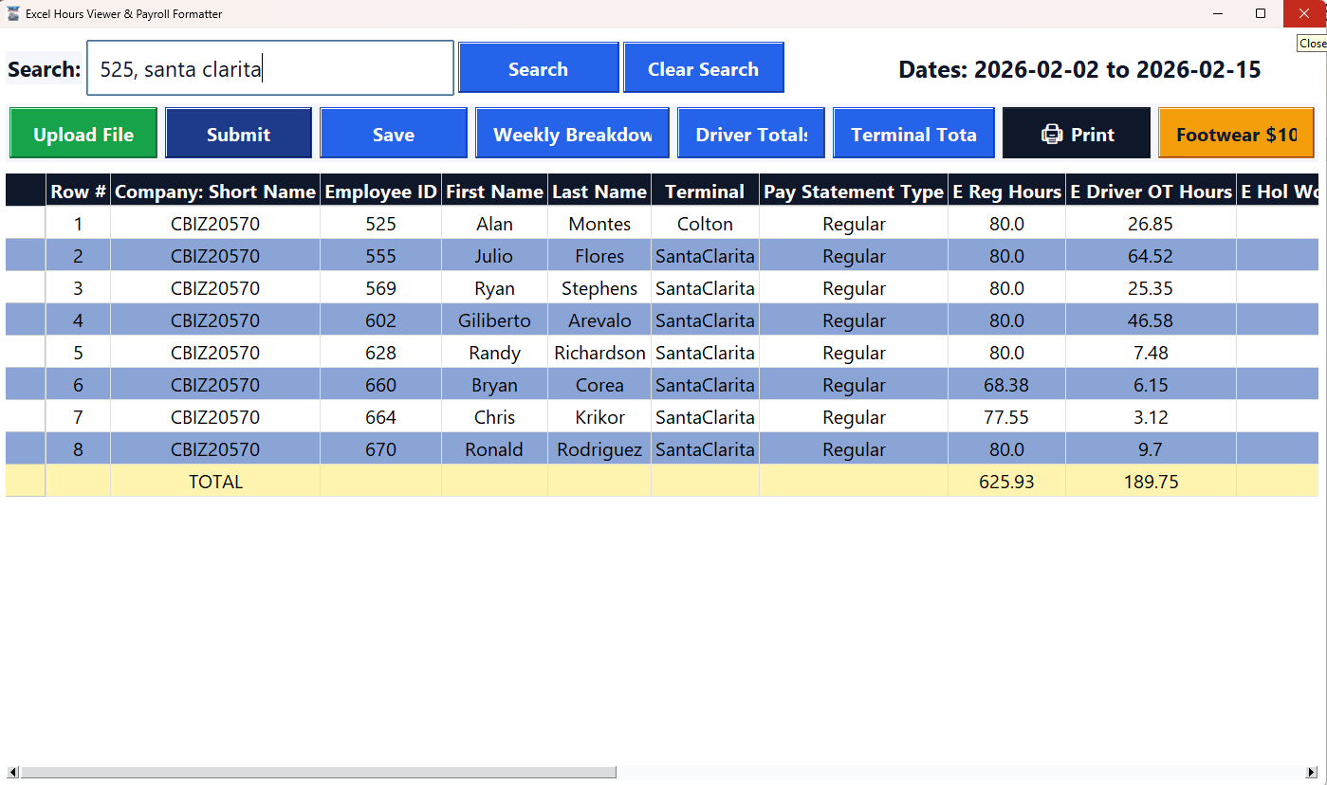
Weekly Breakdown
The Weekly Breakdown button organizes all employee shifts by day within a selected pay period. After clicking the button, you can search for or select an employee’s name at the top to view their specific shifts.
The top section displays a weekly summary of the employee’s shifts, while the bottom section provides a detailed daily breakdown. If a driver appears in multiple rows in the top section, this indicates that they worked multiple weeks within that file.
Because Creative Energy occasionally does not register clock-out times, you can use the “Missing Clock-Out Times” checkbox to identify potential issues. When selected, the system highlights in red (in the bottom section) the names of employees whose clock-out times were not recorded. This allows you to review and verify whether the employee properly clocked out.
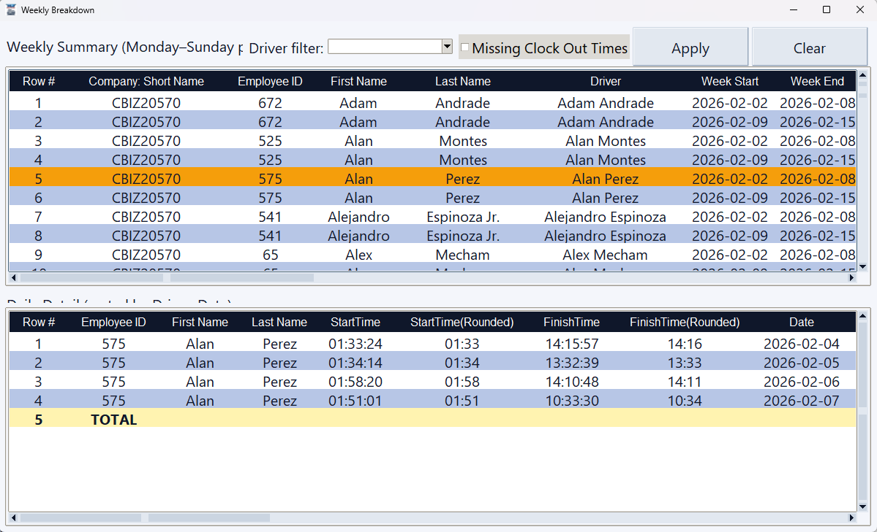
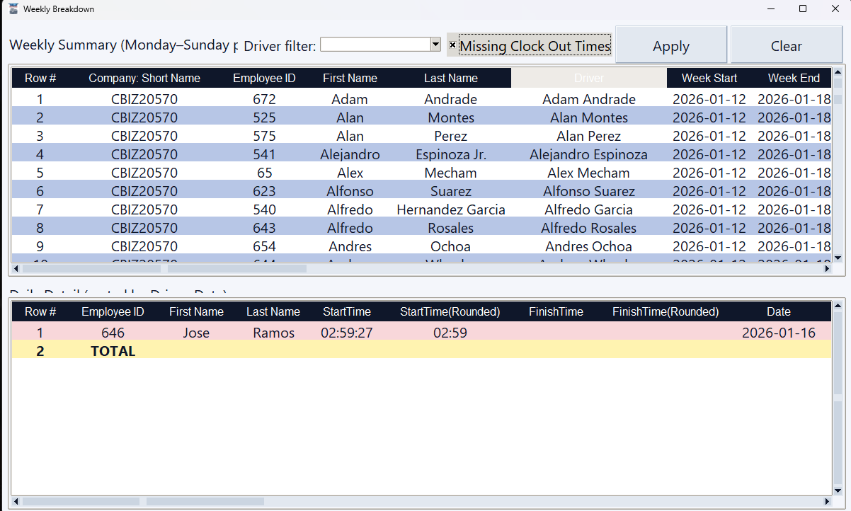

Driver Totals & Terminal Totals
The Driver Totals and Terminal Totals buttons provide a summary of total hours worked within the selected pay period or the date range specified in the uploaded file.
- The Driver Totals button displays the total hours worked by each driver.
- The Terminal Totals button displays the total hours worked by each terminal based on the same date range.
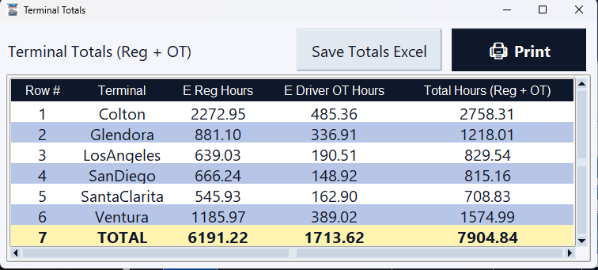
This allows you to quickly review and compare total hours by driver or by terminal for the selected period.
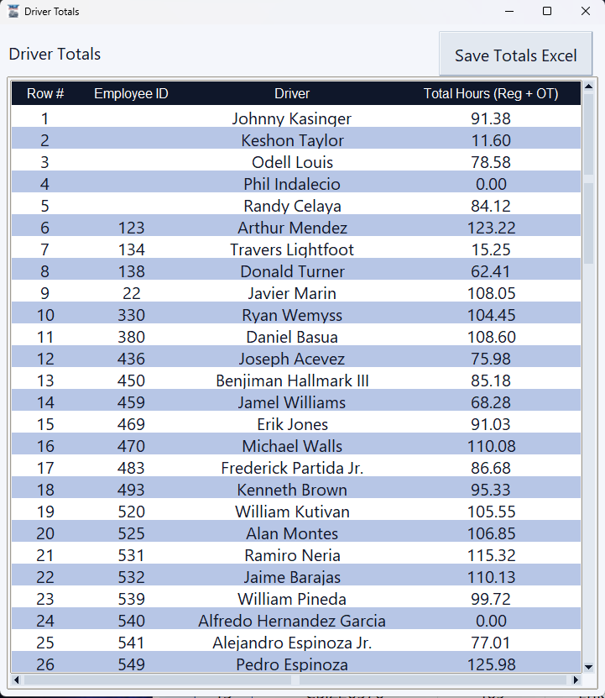

Print
The Print button allows you to print the data displayed on the main screen. After selecting the desired filters or arranging the table in the correct order, click Print. The data will be formatted in a table view as a PDF, ready for printing.
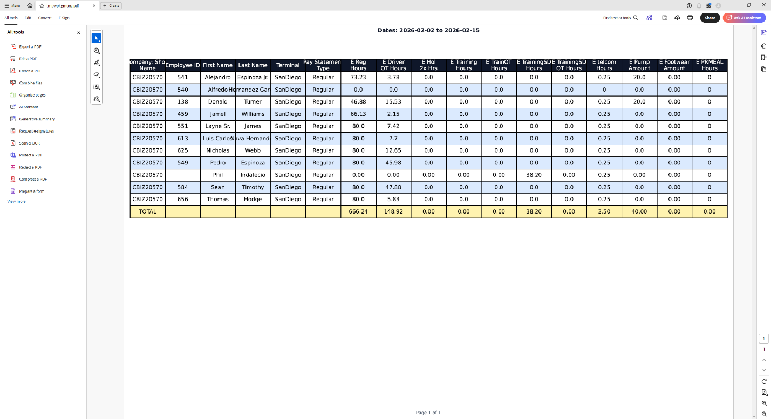
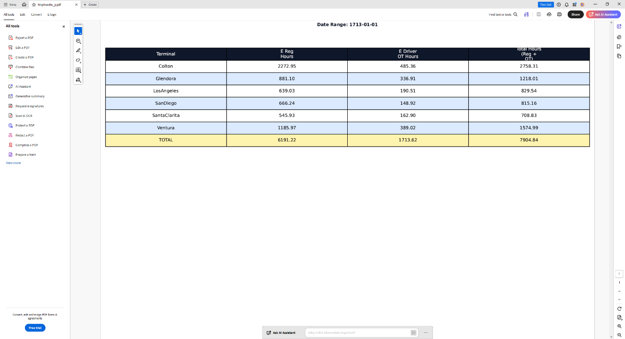
Footwear Bonus
To add the extra $100 for footwear at the beginning of the year, press the “Footwear $100” button. This will automatically add $100 to each row.
If a new employee is added during the year, you can manually add the $100 to their row by right-clicking the corresponding cell and selecting Edit, then entering the amount.
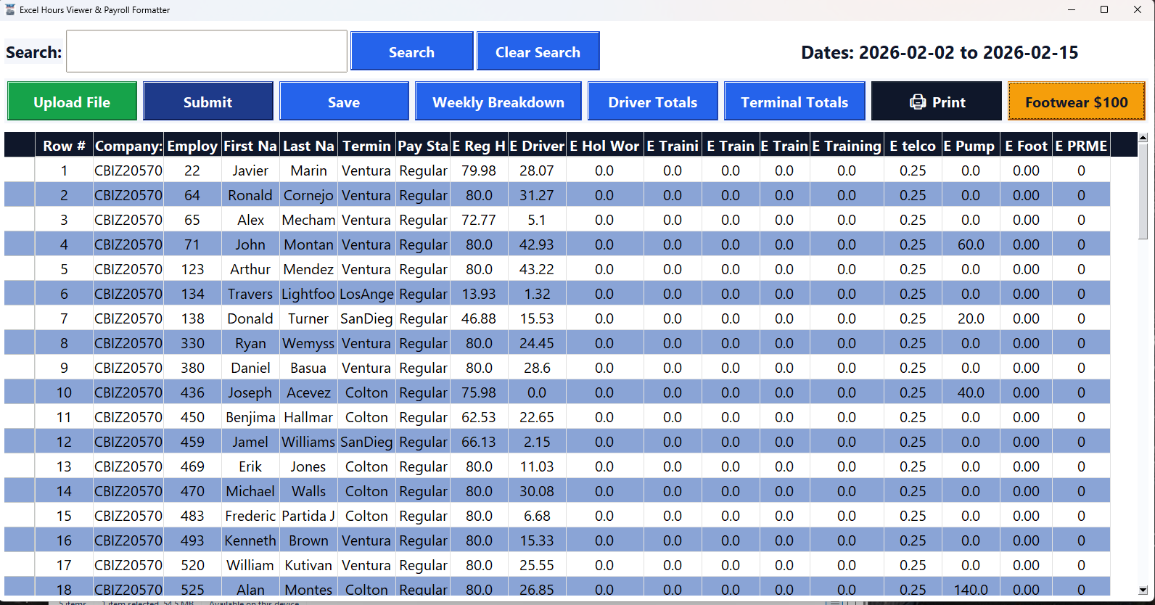
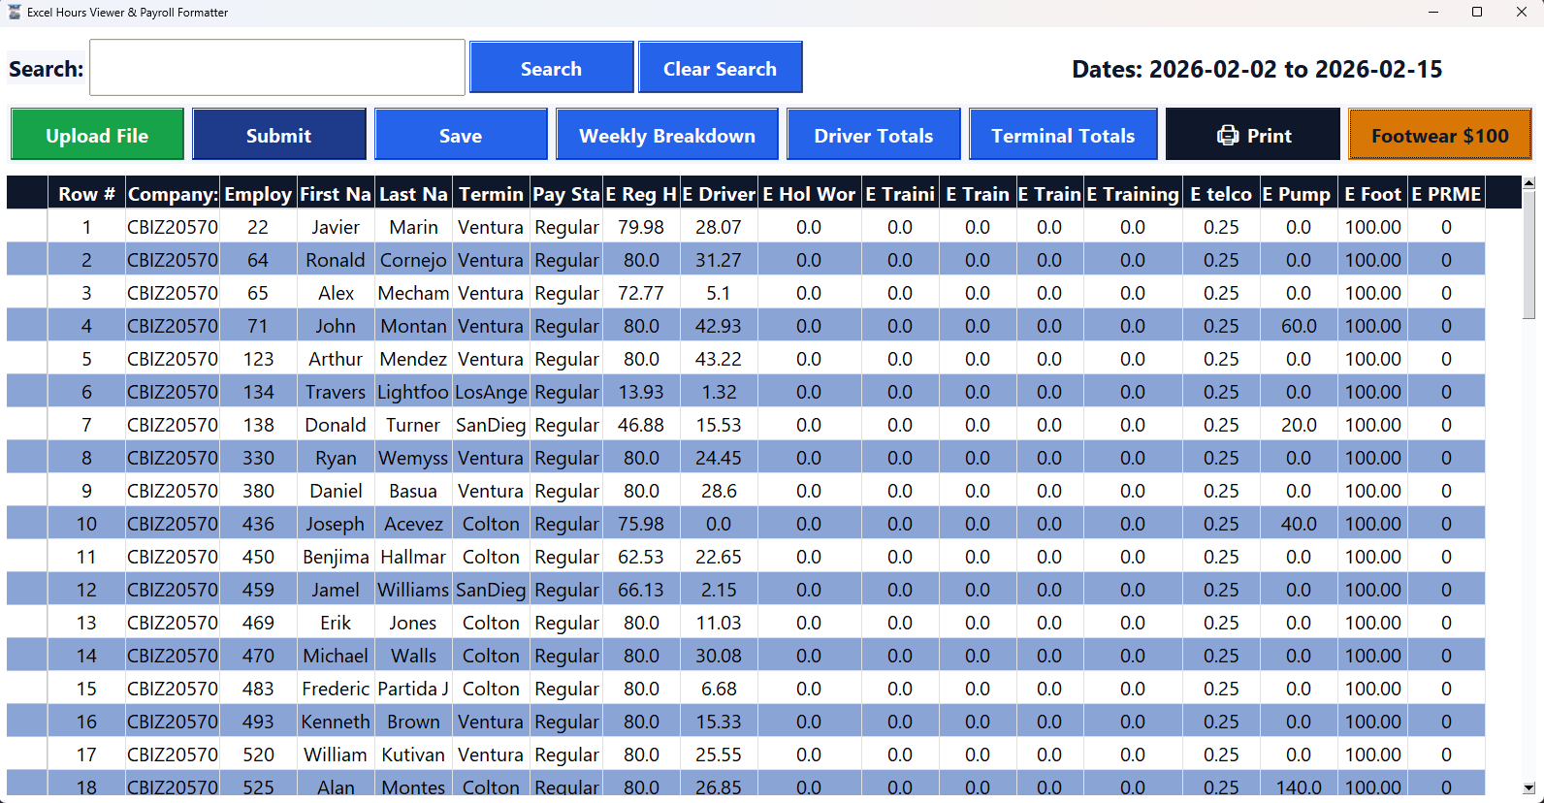
Totals
Every window displays a total at the bottom of all addable columns. If a cell is edited, the total will automatically update each time a value is changed.
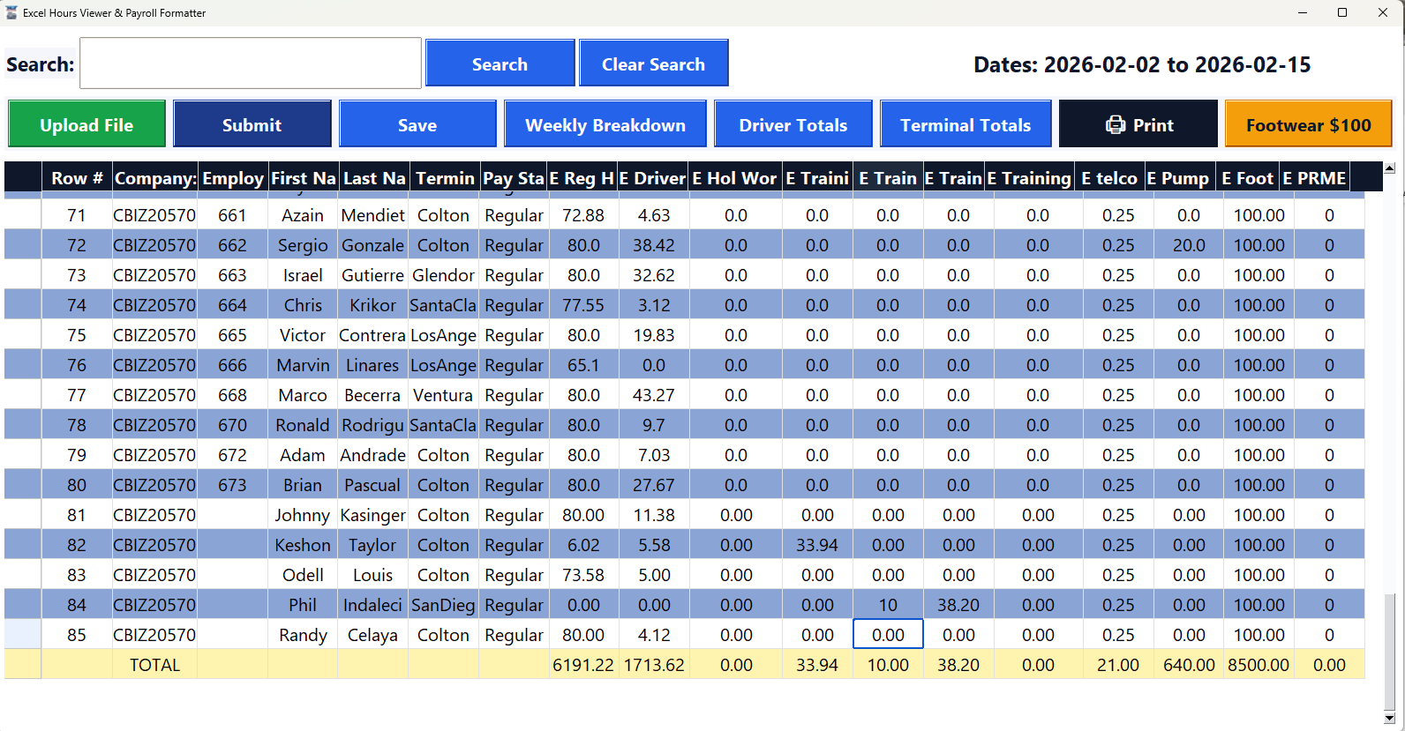

Editing Cells
To edit a cell, right-click on the desired cell and select Edit.
Any changes you make will automatically sync to the Excel file, and the total at the bottom of the column will update instantly in the Total row.
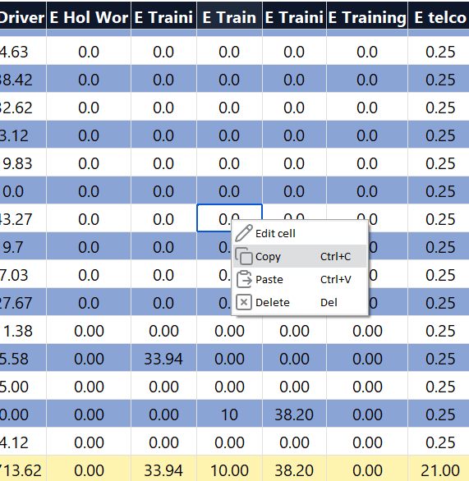

Save
After all edits have been made, click the “Save” button to save the file. Once saved, it will generate an Excel file ready to submit to Payroll.
You can also save the file based on the filters currently applied. For example, if you are displaying a specific terminal or driver on the main screen, only those rows will appear in the saved Excel file. If all employees are displayed in the main window, then all rows will be included in the exported Excel file.
