Argus System Review (IPO)

CHAPTER 3 — THEORETICAL AND

CONCEPTUAL FRAMEWORK

3.1 Theoretical Basis for Behavioral Cue Analysis
ARGUS analyzes observable behavioral cues from recorded examination sessions to assess whether a participant's behavior appears suspicious or non-suspicious. Because these cues are only indirect indications of a condition that cannot be observed directly, this study is grounded in two complementary theories. Brunswik's Theory of Probabilistic Functionalism, represented by the Lens Model, explains how observable cues relate to an unobservable condition and why that relationship is probabilistic rather than certain. Signal Detection Theory then explains what happens when such imperfect cues are combined into a single decision and compared against a threshold. Together, these theories provide the conceptual basis for treating ARGUS as a system that highlights behavior for human review rather than one that establishes misconduct.

3.1.1 Brunswik's Lens Model
The Lens Model describes human judgment as an inference drawn from observable cues whose relationships with the condition being assessed are imperfect (Brunswik, 1955). In the model, an observer cannot access the true state of interest directly and must instead rely on cues that are scattered, partly redundant, and only partially informative. Judgment therefore involves looking through these cues, as if through a lens, to estimate a condition that itself remains hidden.
Two properties are central to the model. Cue validity refers to how strongly a cue is actually related to the condition being judged, whereas cue utilization refers to how much weight an observer places on that cue when forming a judgment. These two properties do not necessarily match. An observer may rely heavily on a cue that has weak validity, or may underuse a cue that is genuinely informative. The accuracy of a judgment therefore depends on how closely cue utilization corresponds to cue validity.
A key implication is that the relationship between any single cue and the underlying condition is probabilistic and ambiguous. A cue may be present when the condition is absent and absent when the condition is present, so no individual cue guarantees a correct judgment. The model instead treats judgment as the combination of several uncertain cues, each of which shifts the estimate of the condition without determining it.
Applied conceptually to ARGUS, the Lens Model implies that behaviors such as gaze deviation, head movement, or a shift in posture are cues rather than proof. Each may be associated with suspicious behavior, but each can also arise from ordinary examination activity such as thinking through a question, adjusting one's position, or reacting to the surrounding environment. ARGUS should therefore not assume that an observed behavior automatically indicates suspicious behavior; because the cues carry limited validity, they must be interpreted probabilistically rather than treated as definitive evidence of misconduct.

3.1.2 Signal Detection Theory
While the Lens Model explains how individual cues relate to an underlying condition, it does not describe what happens once those cues are combined into a single decision. Signal Detection Theory addresses this second step by describing how a decision-maker distinguishes a signal from noise when the evidence for the two overlaps (Green & Swets, 1966). The signal corresponds to the condition the observer is trying to detect, while noise corresponds to the ordinary variation that can resemble that condition. Because both the signal and the noise give rise to evidence, the decision is never made under perfect certainty.
The theory separates two properties that are easily confused. Discriminability refers to how well the available evidence actually separates the signal from the noise, and reflects the quality of the evidence itself. The decision criterion, or threshold, is the point along that evidence at which the decision-maker chooses to respond. Two observers presented with identical evidence can reach different decisions simply because they place their criterion at different points, independent of how discriminable the evidence is.
Because the evidence for signal and noise overlaps, no single criterion can remove error entirely. A lenient threshold captures more genuine signals but also produces more false positives, in which noise is mistaken for signal. A stricter threshold reduces false positives but increases false negatives, in which genuine signals are missed. Any choice of threshold therefore involves a trade-off between these two kinds of error rather than the elimination of one without cost to the other.
For ARGUS, this framework clarifies the central difficulty of distinguishing suspicious-looking patterns from ordinary examination behavior. A participant who is anxious, distracted, or simply restless can produce behavioral evidence that resembles the evidence associated with genuine misconduct, so the two distributions overlap rather than separating cleanly. Consequently, wherever ARGUS effectively draws its threshold, it cannot avoid the possibility of flagging ordinary behavior as suspicious or of overlooking genuinely suspicious behavior. This is a principled reason for positioning the system to support human review rather than to render a final judgment.
Taken together, the two theories address different parts of the same problem. The Lens Model explains why individual behavioral cues are imperfect and probabilistic indicators of an underlying condition, while Signal Detection Theory explains the consequences of combining those cues into a decision and applying a threshold to it. This theoretical basis also frames how the results of the study should be interpreted, since measures such as precision and recall describe the discriminability and criterion behavior of ARGUS rather than the validity of any single behavioral cue.

3.2 Multimodal Behavioral Representation
ARGUS represents examination behavior using three groups of visual features: head and facial orientation, eye gaze, and upper-torso posture and movement. These groups are referred to as behavioral modalities in this study, although they are all extracted from the same webcam recording. Each provides different observable information that may be incomplete when considered independently.
Combining these modalities allows the system to examine whether observations occur together or provide additional context for one another. For example, a gaze deviation can be considered alongside head orientation and upper-torso position rather than interpreted independently. Related examination studies have investigated coordinated movements and the integration of multiple visual features for behavioral analysis (Ferdosi et al., 2023; Liu et al., 2024). However, combining cues does not automatically establish suspicious behavior or guarantee improved classification; its effectiveness remains subject to evaluation.

3.2.1 Head and Facial Orientation
Head and facial orientation represents the estimated direction and positioning of the participant’s head and face relative to the camera. In ARGUS, head orientation is expressed through yaw, pitch, and roll, corresponding to horizontal turning, upward or downward rotation, and sideways tilting. The module also records face presence, position within the frame, approximate face size, and mouth-opening activity. These additional measurements provide visual context but do not constitute facial-expression or emotion recognition.
Head orientation is relevant to examination behavior because it describes changes in how the participant is positioned relative to the recording device. Potentially informative patterns include repeated head turns, sustained orientation away from the camera’s forward direction, and changes in head direction across a session. Where the camera is positioned near the examination screen, these observations may help identify periods for closer review. Nevertheless, the code’s head-offscreen flag is based on an estimated yaw threshold and does not directly establish whether the participant is viewing something outside the screen.
Head orientation alone cannot determine the participant’s visual target or the reason for a movement. A participant may turn while thinking, stretching, or responding to a distraction, and the eyes can move without a corresponding head turn. Camera placement and pose-estimation errors can also affect the measurements. ARGUS therefore considers head orientation alongside gaze, posture, and temporal information rather than treating it as an independent indication of suspicious behavior.

3.2.2 Eye Gaze
Eye gaze represents an estimate of the direction in which the participant’s eyes are oriented. ARGUS derives a horizontal gaze estimate from the position of the iris relative to eye landmarks. Its outputs include a numerical angle proxy and coarse categories such as centre, left, right, and offscreen. These measurements do not identify an exact point on the screen or the object being viewed.
Gaze direction may provide information relevant to apparent visual attention during an examination. Examination-monitoring research has used head and gaze estimates to identify departures from screen-directed attention for subsequent review (Indi et al., 2021). In ARGUS, relevant observations include changes between gaze categories, sustained offscreen classifications, and the recurrence of deviations across time. The system also records when gaze measurements are unavailable, which must be distinguished from a detected deviation.
Gaze deviation alone cannot establish suspicious behavior because looking away can occur during ordinary examination activities. Moreover, the interpretation depends on the examination format, permitted materials, camera position, and measurement quality. A detected deviation therefore describes a condition defined by the extraction rules rather than a confirmed departure from legitimate examination activity.
Gaze and head orientation provide related but distinct information. The eyes may shift while the head remains relatively stationary, or the head may turn while the eyes remain directed elsewhere. ARGUS considers their simultaneous occurrence when summarizing behavioral cues. However, both estimates rely on facial observations from the same recording, so agreement between them should not be treated as fully independent confirmation.

3.2.3 Upper-Torso and Posture
The upper-torso modality describes visible upper-body position, shoulder configuration, hand-related positions, and movement between sampled frames. ARGUS uses pose landmarks to estimate shoulder tilt, apparent shoulder width, and the location of the shoulder midpoint relative to the frame centre. It also records wrist proximity to the estimated mouth position, hand elevation relative to the shoulders, and changes in the shoulder midpoint over time.
These features provide complementary information because some body-position changes may not be adequately represented by head or gaze measurements. For example, a participant may shift their upper body while maintaining a similar head direction. Upper-torso observations can therefore provide additional context when examined alongside facial and gaze cues. Their contribution is descriptive and does not establish the purpose of the movement.
The implementation distinguishes posture-related position from movement between frames. The upper-torso posture-shift flag can be activated by uneven shoulders, an off-centre shoulder midpoint, or narrow apparent shoulder width. Consequently, a participant who remains stationary in an off-centre position may continue to trigger this flag. A separate movement measure describes changes in the shoulder midpoint between sampled frames.
Posture is limited as an independent indicator because ordinary seating adjustments, stretching, camera framing, and partial visibility can affect the extracted features. Wrist proximity to the mouth does not confirm contact, communication, or object use. Likewise, missing or unreliable landmarks do not establish the absence of movement. ARGUS therefore interprets posture information together with its visibility conditions, other modalities, and temporal context.

3.2.4 Temporal Behavioral Patterns
ARGUS retains the temporal structure of extracted behavioral observations rather than interpreting each frame independently. MBIE groups timestamped measurements into one-second windows and summarizes the available face/head, gaze, and posture features. This creates a common temporal representation for subsequent analysis.
The implementation tracks the persistence of selected conditions, including offscreen gaze, head deviation, and face absence, across consecutive aggregated seconds. It also identifies selected cue combinations within the same second and groups consecutive seconds meeting a cue-strength threshold into notable windows. These windows describe the duration and composition of elevated cue activity, rather than confirmed episodes of suspicious behavior.
Isolated, sustained, repeated, and co-occurring behaviors describe different temporal characteristics. An isolated observation is brief and separate from other relevant observations, while a sustained condition persists across consecutive intervals. Repeated behavior recurs across distinct intervals, whereas co-occurring cues appear within the same interval. ARGUS directly represents selected sustained conditions and cue combinations, while its LLM prompt requests interpretation of isolated and recurring patterns from the supplied summaries.
Temporal aggregation reduces the volume of frame-level information and provides structured context for LLM assessment. However, it can conceal variation within a second, and the system does not implement a dedicated repetition detector for every behavior. The resulting temporal summaries support interpretation but do not establish the cause of an observation or confirm misconduct.

3.3 Multimodal Fusion and Behavioral Inference
The behavioral cues described in the previous section provide different types of information about a participant’s visible actions during an online examination. Examining each cue separately may provide limited context because the same observation can have different explanations. For example, an estimated gaze deviation may be interpreted differently depending on whether it occurs with a head turn, a change in upper-torso position, or no other observable change.
Multimodal fusion refers to combining information from several behavioral modalities to form a structured representation of observed behavior. In ARGUS, the modalities are face and head orientation, estimated eye gaze, and visible upper-torso posture and movement. Each modality describes a different aspect of the recording, allowing the system to consider relationships among cues rather than relying on a single observation.
A single modality may be ambiguous. A participant may look away while thinking, turn their head because of a distraction, or shift their posture during a long examination. An off-centre upper-torso position may also result from camera placement or ordinary seating posture. These possibilities mean that an individual cue cannot be treated as sufficient evidence of suspicious behavior.
The three ARGUS modalities provide complementary information. Gaze features describe estimated horizontal eye direction, while face and head features describe estimated head orientation, face presence, and face position. Upper-torso features describe visible body position, shoulder configuration, hand-related positions, and movement. For example, a gaze deviation occurring together with a head turn and upper-torso movement provides a broader description of the participant’s visible behavior than the gaze observation alone.
Related examination studies have also examined behavioral information across multiple cues and over time. Ferdosi et al. (2023) considered coordinated head, eye, and lip movements, while Liu et al. (2024) combined gaze, head, facial, posture, and other visual features through spatiotemporal modeling. These studies provide methodological support for examining relationships among behavioral observations, but they do not validate ARGUS’s specific fusion rules or final assessments.
In ARGUS, the Multimodal Behavior Inference Engine (MBIE) serves as the integration component between feature extraction and subsequent analysis. It aligns timestamped observations from the available modalities and organizes them into a structured multimodal behavioral representation. This representation includes summarized behavioral features, temporal information, cue combinations, and information about modality availability and data quality.
MBIE also applies predefined rules to identify selected sustained conditions and combinations of cues. Its cue-strength value is a heuristic index used to summarize and organize behavioral information for further examination. It is not a probability, a measure of model confidence, or a final classification of cheating.
The resulting representation is provided to a separate large language model stage for behavioral inference. In this context, behavioral inference refers to examining the available multimodal representation to determine whether an observed pattern may warrant contextual review. The LLM is instructed to consider sustained, repeated, and co-occurring cues, as well as data quality and possible benign explanations.
Multiple cues occurring together may provide additional behavioral context, but they should not automatically be treated as independent evidence. Several cues may arise from the same ordinary action, and agreement between modalities may also be affected by camera position or shared detection errors. Multimodal fusion therefore increases the information available for assessment without guaranteeing that the resulting interpretation is accurate.
The purpose of MBIE is consequently to organize observations rather than assign a definitive meaning to every movement. ARGUS uses the fused representation to classify a session as “Suspicious behavior,” “Non-suspicious behavior,” or “Not evaluable.” A suspicious-behavior classification indicates that the available pattern may warrant human review; it does not establish that cheating or academic dishonesty occurred.

3.4 ARGUS Conceptual Framework
The conceptual framework presents ARGUS-Lite as a behavioral-suspicion decision-support system. It begins with observable examination behaviors, including head and facial orientation, eye gaze, and upper-torso or posture movement. These cues are considered across modalities and over time because an isolated behavior may have multiple possible explanations. The resulting behavioral pattern is interpreted as suspicious, non-suspicious, or not evaluable, while the final judgment remains subject to human review. The framework does not represent cheating detection or autonomous determination of academic dishonesty.
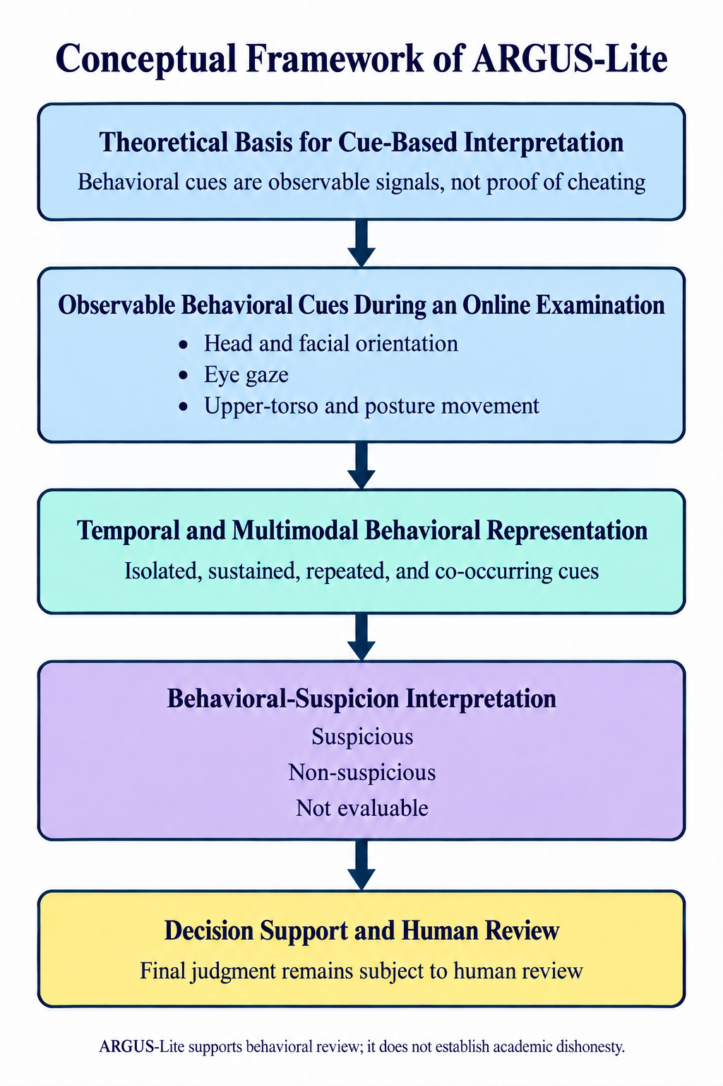

3.5 Behavioral Risk Report and Decision Support
The Behavioral Risk Report is the final human-readable output of the ARGUS-Lite workflow. It is generated after the OpenAI o3 model receives the compact MBIE JSON and the fixed ARGUS-Lite prompt. The report converts structured behavioral observations into a time-organized summary that can assist a reviewer in deciding which parts of the original examination video require closer inspection.
The report begins with a data-quality summary. This section identifies the analyzed duration, available and missing modalities, modality coverage, quality scores, and warnings. These details are included because an interpretation is limited when a feature stream is unavailable, has poor coverage, or contains unreliable observations.
The report then provides a session behavioral summary. It separates direct observations from possible interpretations and benign alternatives. Direct observations may include sustained head deviation, estimated gaze deviation, posture-shift cues, or multimodal corroboration. The interpretation explains why these observations may warrant review, while the benign-alternative section acknowledges explanations such as reading, thinking, stretching, fatigue, or camera positioning.
Detected behavioral events are represented in a time-stamped review-events table. Each event includes a time range, observed fused cues, available modalities, a possible interpretation, a benign alternative, and a review priority. The events are selected from the structured MBIE representation and are limited to timestamps supported by the input JSON.
Timestamps provide a link between the generated report and the original examination video. They allow a reviewer to locate the relevant portion of the recording instead of watching the entire session without guidance. A timestamp identifies a period for inspection, but it does not prove that the reported behavior occurred for a particular reason or that misconduct occurred.
The LLM-generated interpretation provides a contextual explanation of the structured observations. It is instructed to distinguish direct measurements from interpretations, consider sustained or repeated patterns, examine cue co-occurrence across modalities, and account for data quality and possible benign explanations. The LLM does not receive the scripted ground-truth label or participant role, and its evidence-strength category is ordinal rather than a calibrated probability.
The assessment uses one of three session-level labels. “Suspicious behavior” means that the available pattern may warrant contextual human review. “Non-suspicious behavior” means that the remaining observations do not provide a sufficient above-baseline pattern for a suspicious assessment under the prompt’s decision procedure. “Not evaluable” is used when missing modalities, inadequate coverage, or data-quality limitations prevent a defensible assessment.
The report also contains a machine-readable evaluation record. This record stores the examination identifier, assessment label, ordinal evidence strength, reviewability, key timestamps, available and missing modalities, and the manual-review recommendation. The JSON record supports consistent evaluation across sessions, while the PDF report provides the human-readable explanation.
The Behavioral Risk Report is intended to support human decision-making by reducing the time needed to locate potentially relevant events and by documenting the observations that led to the assessment. It does not replace review of the original video, establish intent, or determine that cheating or academic dishonesty occurred. The final interpretation remains the responsibility of an authorized human reviewer under the applicable examination policy.
Example for behavioral risk report below:

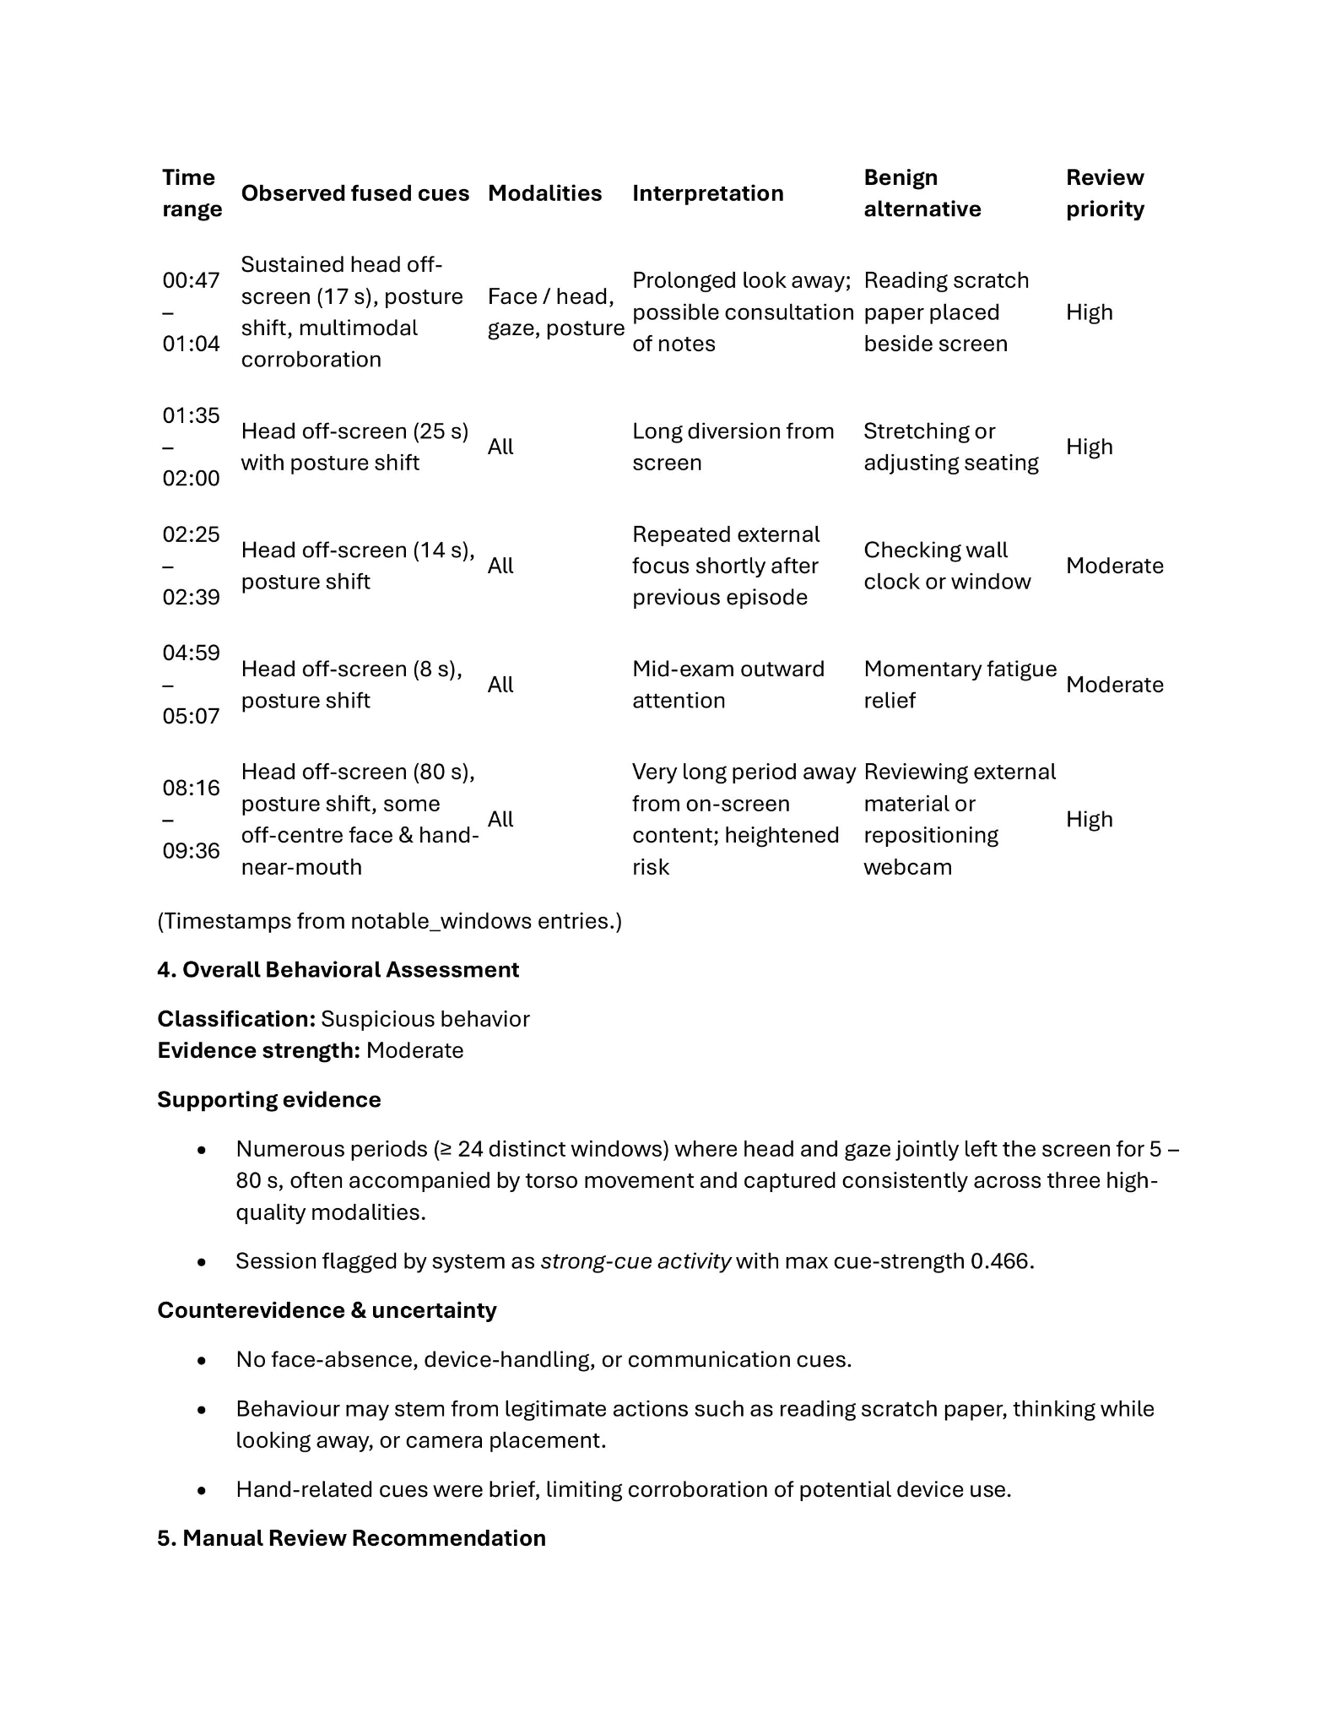

3.6 Role and Boundaries of ARGUS
ARGUS is developed as a proof-of-concept behavioral-suspicion classification system for online examinations. It analyzes observable behaviors in recorded webcam videos, particularly head and facial orientation, eye gaze, and upper-torso or posture movement. These cues are extracted, temporally organized, and combined through the Multimodal Behavior Inference Engine (MBIE) to produce a structured behavioral representation for subsequent LLM-based analysis.
ARGUS does not determine whether academic dishonesty actually occurred. Its output indicates whether the observed behavioral pattern is classified as suspicious, non-suspicious, or not evaluable under the conditions of the study. A suspicious classification means that the corresponding session or timestamped events may warrant further human review; it does not constitute proof of cheating.
This limitation is necessary because gaze deviation, head turning, posture adjustment, and upper-body movement can occur during legitimate examination behavior. A participant may look away while thinking, change sitting position, or move outside the camera’s ideal view. Therefore, an individual cue should not be interpreted as sufficient evidence of academic dishonesty.
ARGUS considers relationships among behavioral cues and their occurrence over time. The extracted head and facial orientation, eye-gaze, and upper-torso observations are combined by MBIE and represented as timestamped behavioral events. The LLM then interprets this structured representation according to the study’s analysis prompt. Because this interpretation is model-generated, it should be treated as decision-support information that requires contextual human review.
The Behavioral Risk Report summarizes the detected events, their timestamps, and the resulting behavioral-suspicion assessment when available. These timestamps can help a reviewer locate relevant portions of the examination recording for closer inspection. ARGUS therefore assists the reviewer by organizing observable evidence and directing attention to potentially relevant moments, while leaving the final judgment to a human.
ARGUS is also limited by the visual information available in the recorded webcam video. Behaviors outside the camera’s field of view and forms of academic dishonesty that cannot be observed through the available visual data cannot be reliably assessed. In addition, the suspicious and non-suspicious labels used in the experiment correspond to the study’s scripted evaluation conditions and should not be presented as independently verified instances of actual cheating.
Overall, ARGUS functions as a decision-support tool for analyzing behavioral suspicion. It identifies and organizes observable patterns that may deserve further attention, but it does not autonomously adjudicate misconduct or establish that academic dishonesty occurred.

CHAPTER 4 — METHODOLOGY

4.1 Research Design

This study used a simulation based experimental design to develop and evaluate ARGUS as a proof of concept system for analyzing behavioral cues during online examinations. The evaluation was conducted offline using recorded mock examination sessions rather than through a live online proctoring setup. This allowed the researchers to process the same recordings through the different stages of the ARGUS pipeline and examine how behavioral observations were extracted, combined, and analyzed.

The experiment was conducted in a controlled setting where participants performed simulated examination activities under two scripted conditions: a simulated cheating condition and a simulated non cheating condition. The simulated cheating condition represented behaviors intended to resemble suspicious examination activity, while the simulated non cheating condition included normal examination behavior and actions that could potentially appear suspicious even when no cheating was intended. Using both conditions allowed the study to examine how ARGUS responded to different types of observable behavior.

The completed dataset consisted of eleven recorded mock examination sessions. Six sessions were assigned to the simulated cheating condition and five sessions were assigned to the simulated non cheating condition. The recordings were divided into 154 one-minute or final partial-minute processing segments. Of these segments, 81 came from sessions assigned to the simulated cheating condition and 73 came from sessions assigned to the simulated non cheating condition. Each segment inherited the scripted condition label of the session from which it came.

Three levels of experimental units were considered in the study: the participant, the recording or session, and the processing segment. The participant represents the person who performed the mock examination. A recording or session represents one complete mock-examination video under an assigned experimental condition. A segment represents a portion of a recording that was processed by the feature extraction and multimodal analysis pipeline. Segment level data were used to generate and examine behavioral features, while the main classification evaluation was performed at the session level. This distinction was important because multiple segments came from the same recording and therefore could not be treated as independent participants.

The reference labels used in the evaluation represent the scripted condition assigned to each session. They should not be interpreted as independently verified labels indicating that cheating actually occurred at a particular point in a recording. Since every segment inherited the label of its source session, the 154 segments were not independently annotated for the occurrence, type, or exact timing of suspicious behavior. The study also included limited qualitative checking of extracted behavioral observations, but comprehensive multimodal behavioral annotation was not completed.

The overall research workflow followed the actual ARGUS processing pipeline. Recorded examination videos were first prepared and divided into processing segments. Each segment was then processed by the behavioral feature-extraction modules for head and facial orientation, eye gaze, and upper-torso or posture related behavior. The resulting observations were stored as structured data and aligned for multimodal processing. The Multimodal Behavior Inference Engine (MBIE) then combined the extracted behavioral information into a structured representation. This representation was subsequently provided to the LLM-based reasoning stage, which generated an interpretation and contributed to the final Behavioral Risk Report.

The study therefore evaluated the system at several stages rather than treating the final classification as the only outcome. The feature extraction stage was examined to determine whether the recorded videos could be converted into usable behavioral measurements. The multimodal stage was examined to determine whether observations from the different modalities could be aligned and represented together. Finally, the conventional baseline and LLM based reasoning outputs were evaluated at the session level to examine their ability to distinguish between the two scripted experimental conditions.

Because the experiment used simulated behaviors in a controlled environment, the results are intended as preliminary proof of concept evidence. The design allowed the researchers to examine the operation of the ARGUS pipeline under controlled conditions, but it does not reproduce all of the variation that may occur during authentic online examinations. In addition, the scripted condition labels describe the experimental setup and should not be treated as direct evidence of academic dishonesty. The purpose of the evaluation was to determine how the implemented system processes and interprets observable behavioral patterns, with its outputs intended to support further human review rather than independently establish that cheating occurred.

4.2 Dataset Construction and Experimental Setup

The dataset used in this study was created from controlled mock examination recordings designed to provide video data for the ARGUS behavioral analysis pipeline. The recordings were intended to represent both potentially suspicious examination behavior and ordinary examination behavior. This allowed the system to be tested under controlled conditions while also including behaviors that could naturally occur during an examination and potentially be mistaken for suspicious activity.

4.2.1 Participants and Recording Setup

The completed study consisted of eleven recorded mock examination sessions. These sessions were not equivalent to eleven unique participants because some participants contributed recordings under more than one scripted condition. This distinction is important when interpreting the evaluation because recordings from the same participant may share individual characteristics such as movement patterns, posture, and gaze behavior.

The recordings were collected using a single ASUS TUF Gaming F15 laptop and its built-in webcam. Videos were recorded at a resolution of 1280 × 720 pixels and stored in MP4 format. The webcam was positioned in a fixed frontal arrangement, with the laptop placed on a desk and the camera centered above the display at approximately eye level. This setup provided a view of the participant's face and upper torso, which were the main areas required by the feature extraction modules. Environmental conditions, including lighting and background, were kept as consistent as reasonably possible across the recording sessions.

The recorded videos varied in their actual capture rates and durations. The capture rate ranged from approximately 15 to 30 frames per second, while recording durations ranged from 4 minutes and 6 seconds to 18 minutes and 42 seconds, with an average duration of approximately 13 minutes and 22 seconds. The variation in recording length and capture rate reflects the actual collected dataset rather than a fixed recording duration imposed on every session.

Participants completed the same general mock-examination setup while following the assigned behavioral condition for the session. The examination environment was designed to resemble an online examination in which the participant remained in front of the computer and was recorded through the webcam. The mock examination materials used for the sessions are documented in the study's supplementary materials.

- how many participants were invited to participate?
- what are the profile of these participants?
- how were the participants selected? (what are their attributes/characteristics)
- how many sessions did each participant contribute?
- did each participant contribute to both conditions (simulated-cheating/non-cheating)?

suggest to use a table, where participant/session mapping is shown

4.2.3 Reference Labels and Qualitative Review

Each recorded session was assigned a reference label according to its predetermined scripted condition: simulated cheating or non-cheating. The labeling was therefore performed at the session level. The 154 processing segments generated from the recordings inherited the label of their corresponding session.

These labels should not be interpreted as independently verified ground truth for cheating or suspicious behavior. A segment labeled as simulated cheating indicates that the recording came from a session assigned to that experimental condition; it does not mean that a specific cheating event was independently confirmed at that exact timestamp. Similarly, a non-cheating label represents the assigned experimental condition rather than proof that no suspicious-looking behavior occurred within the segment.

The researchers also conducted limited manual review of selected recordings to examine the relationship between reported system events and visible behavior. ELAN 7.0 was initially considered for comprehensive time aligned annotation of the behavioral modalities. However, complete annotation of gaze, head orientation, hand activity, and upper-torso behavior across the entire dataset was not completed because of the amount of frame-by-frame manual work required.

Instead, ELAN was used for limited qualitative spot checking. A single EyeGaze annotation tier was created using the categories CENTER, LEFT, RIGHT, UP, and DOWN. Selected system generated timestamps were then compared with the corresponding portions of the recordings to determine whether the reported gaze behavior was visually plausible. This review was not intended to provide comprehensive event level ground truth or formal validation of the feature extraction modules.

There is no 4.2.2 (?) Mock Examination Scenarios and Experimental Conditions

In this subsection, explain:
- what exactly were participants asked to do?
- what constitute simulated-cheating condition?
- what constitute non-cheating condition?
- were specific behavior scripted?
- which behaviors were expected to activate gaze/head/posture cues?
- did the non-cheating condition deliberately contain potentially suspicious-looking but benign behavior?
- did the same participant perform both (simulated-cheating/non-cheating) conditions?
- how were conditions assigned?
- in what order were they performed?
- was the examination content identical?

this section is very important and needs to be discussed with enough detail so that other researchers can replicate the procedure when needed.

ideally, use a tabular form to discuss this section, e.g.,

column 1 - condition (simulated cheating/non-cheating)
column 2 - scenario/instructions given to participants
column 3 - expected behavior
column 4 - intended modality/cue

4.2.4 Video Segmentation

After the recordings were collected, each video was divided into processing segments before being passed through the behavioral feature extraction pipeline. The purpose of segmentation was to divide longer recordings into manageable time intervals while preserving the timing information needed to relate extracted behaviors back to the original video.

The completed dataset produced 154 processing segments. Most segments represented one minute of video, while the final segment of a recording could be shorter when the remaining video duration was less than one minute. The resulting dataset contained 81 segments from sessions assigned to the simulated cheating condition and 73 segments from sessions assigned to the simulated non-cheating condition.

Each segment retained information linking it to its source recording and its position within the original video. This allowed the feature extraction modules to produce timestamped observations while maintaining the connection between individual behavioral measurements and the corresponding examination session.

The segments served as the primary processing units for the feature extraction stage. Head and facial orientation, eye gaze, and upper-torso or posture observations were generated from the corresponding video intervals and stored as structured outputs. These outputs were later aligned and combined during multimodal processing. Although the behavioral features were generated at the segment level, the main classification evaluation was conducted at the session level so that multiple segments from the same recording were not treated as independent participants.

Overall, the dataset construction process produced a controlled collection of mock examination recordings that could be processed consistently by ARGUS. At the same time, the use of scripted conditions, a single recording setup, and a limited number of sessions means that the resulting dataset represents a development and proof of concept corpus rather than a representative sample of real online examinations.

4.3 System Architecture and Processing Pipeline

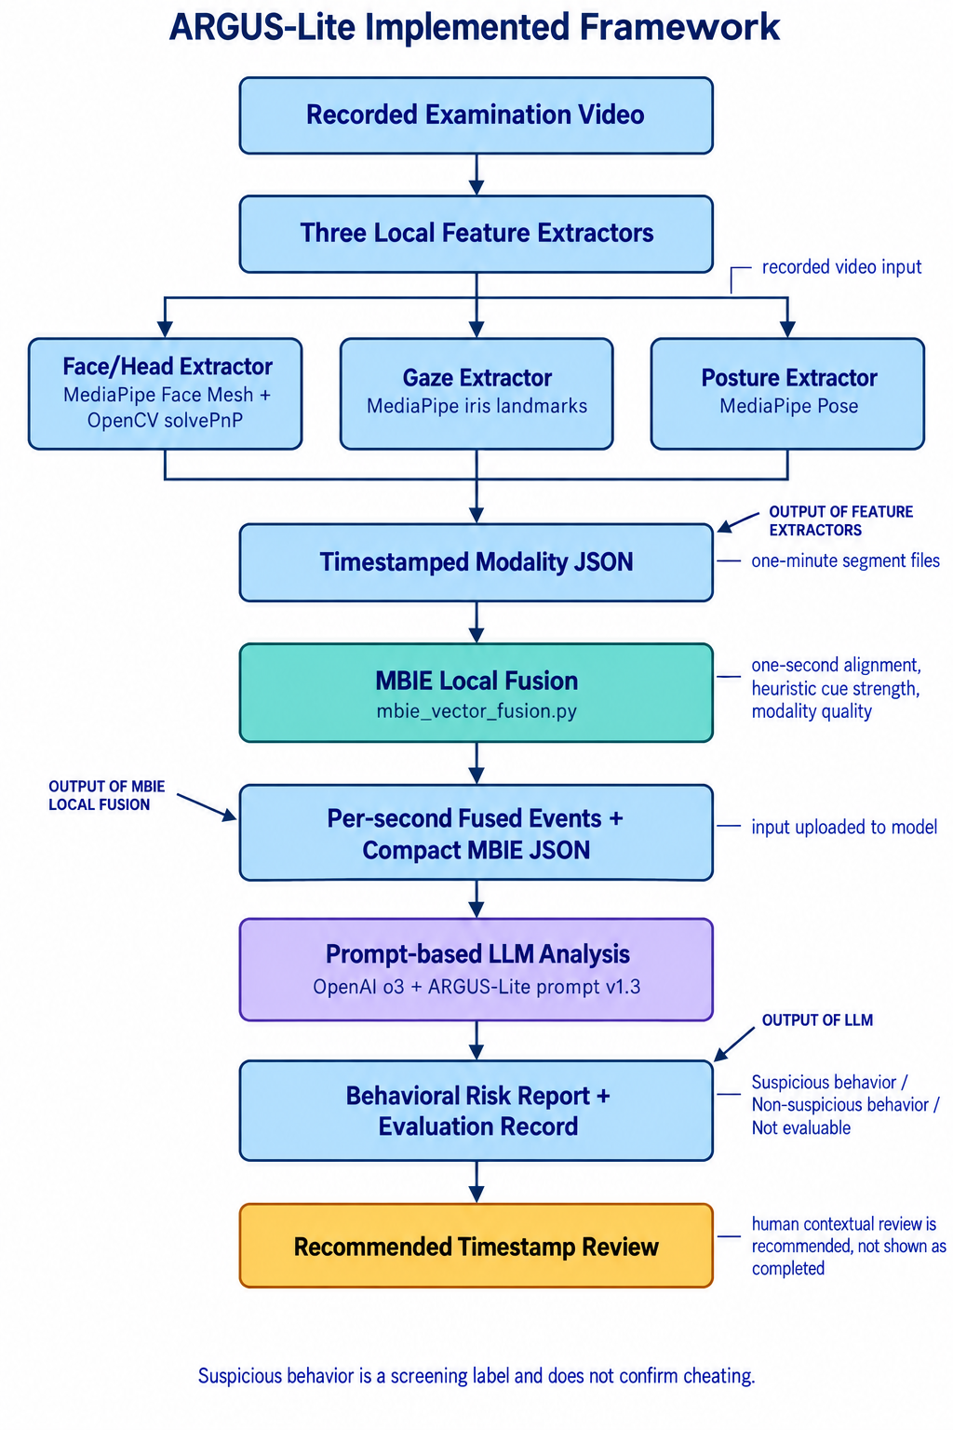

The implemented ARGUS-Lite system follows a sequential processing pipeline that converts recorded examination video into structured behavioral data for multimodal analysis. The pipeline was designed around three visual behavior modalities: head and facial orientation, eye gaze, and upper-torso posture and movement. Rather than sending the raw video directly to the language model, the system first extracts measurable behavioral features from the video and stores them as timestamped JSON data. These outputs are then passed to the Multimodal Behavior Inference Engine (MBIE), where the different behavioral streams are aligned and combined for further analysis.

The implemented workflow can be summarized as:

Recorded Examination Video → Video Preprocessing and Segmentation → Parallel Feature Extraction → Structured JSON Outputs → MBIE → Behavioral Analysis and Risk Report

The processing stages are separated into independent feature-extraction modules so that each behavioral modality can be processed using a method appropriate to the type of visual information being measured. All three modules operate on the same segmented examination recordings and preserve timestamps so that their outputs can later be aligned by MBIE. The extraction modules use a nominal processing target of 15 frames per second, while the original recordings themselves were captured at varying frame rates.

4.3.1 Video Input and Preprocessing
NOTE: 4.3.1 should describe computational processing

this section should talk about
- how is mp4 loaded?
- how is the frame rate detected?
- how do videos recorded at 15-30 fps become the nominal 15-fps processing strteam?
- is every nth frame selected?
- are frames resize? resolutions changed?
- how are timestamps computed?
- what happens when a frame cannot be decoded?
- what metadata is generated?
- how are output files names/linked to segments?

The pipeline begins with the recorded mock-examination videos collected using the standardized recording setup described in Section 4.2. The recordings were captured using the built-in webcam of an ASUS TUF Gaming F15 laptop at 1280 × 720 resolution and stored in MP4 format. The camera was positioned directly in front of the participant, with the webcam centered above the display at approximately eye level. This framing allowed the system to observe the participant's face and upper torso throughout the examination session.

Before feature extraction, each recording is divided into approximately 60 second processing segments. A final segment may be shorter when the total recording duration does not divide evenly into one minute intervals. Each segment retains information identifying its source video, segment identifier, start and end timestamps, and target processing frame rate. This allows outputs from the individual feature extraction modules to remain traceable to their original location in the examination recording.

The segmented videos are then processed by the three feature-extraction modules. The modules operate independently on the same video intervals and generate timestamped observations rather than immediately making a final classification. This separation is important because the purpose of preprocessing is to transform visual information into structured behavioral measurements that can be combined later by MBIE.

Each module produces structured JSON output containing the extracted measurements and relevant processing metadata. The outputs preserve the temporal information of the original video, allowing observations from different modalities to be associated with the same point or interval in the examination session.

4.3.2 Head and Facial Orientation Feature Extraction
Need details on the ff:
- which 6 facial landmarks are identified/used?
- what 3d reference points?
- how exactly is normalized mouth aperture computed?
- ema euqation
- how is face position computed?
- what exactly happened during the “pilot testing” that produced 25degrees?

if you used trial-and-error to find the values, say it.

Head and facial orientation is extracted using MediaPipe FaceMesh together with an OpenCV Perspective-n-Point (PnP) solver. MediaPipe FaceMesh provides the facial landmarks required to estimate the position and orientation of the participant's face. A six-point facial model is then used to establish correspondences between detected two-dimensional facial landmarks and predefined three-dimensional facial reference points. These correspondences are processed using the PnP method to estimate the participant's head orientation.

The resulting orientation is represented using Euler angles for yaw, pitch, and roll. These measurements provide information about how the participant's head is positioned relative to the camera. For example, yaw represents side-to-side head rotation, while pitch and roll describe other changes in head orientation. The system also records the participant's face position within the frame, providing additional spatial information that can be used during multimodal analysis.

To reduce frame-to-frame fluctuations caused by small landmark movements, the estimated Euler angles are smoothed using an exponential moving average with a smoothing factor of 0.4. This allows the system to retain meaningful head movements while reducing minor detection noise.

The module also measures mouth activity using the relative distance between selected mouth landmarks. A normalized mouth-aperture threshold of 0.03 is used to identify noticeable mouth movement. In addition, an off-screen head-orientation flag is generated when the absolute yaw exceeds 25 degrees. This threshold was selected during pilot testing to capture substantial head turns while allowing normal head movement associated with reading and examination activity.

The module processes each sampled frame independently and writes the resulting measurements directly to the corresponding segment output. Each observation is timestamped, allowing head-orientation events to be aligned with gaze and posture observations during later fusion. When the facial landmarks cannot be reliably detected or the pose calculation fails, the corresponding measurement is recorded as unavailable rather than being treated as a valid behavioral observation.

4.3.3 Eye-Gaze Feature Extraction

Need to include:
- equation to compute normalized eye width and conversion to angular measurement
- what does “empirical selected” mean? maybe better to use the words “researcher-defined”or determined via trial-and-error approach, but what criteria did you use to say that it is already good/acceptable? describe your procedure

Eye-gaze estimation uses the iris landmarks provided by MediaPipe FaceMesh with landmark refinement enabled. The system estimates horizontal gaze direction by locating the center of each iris and comparing it with the center of the corresponding eye region. The left and right iris centers are calculated from their respective iris landmark sets, while the eye boundaries are obtained from facial landmarks surrounding each eye.

The horizontal displacement of the iris relative to the eye region is normalized by eye width and converted into an angular measurement. The resulting gaze angle provides a continuous estimate of how far the participant's gaze has moved from the defined center reference. The system also retains separate measurements for the left and right eyes, together with the calculated eye ratios used during the estimation.

The estimated angle is converted into categorical gaze regions using two thresholds. A gaze within 7 degrees of the center is classified as center, while angles beyond this range are classified toward the left or right. When the absolute gaze angle exceeds 12 degrees, the system marks the gaze as offscreen. These thresholds were empirically selected and are treated as configurable parameters rather than universal measures of suspicious behavior.

The gaze module focuses on horizontal gaze. Vertical gaze is not estimated because the implemented geometric approach does not provide a sufficiently reliable vertical gaze measurement without a more complex three dimensional eye model. This limitation is important when interpreting gaze related results because looking upward or downward cannot be represented with the same angular measure used for horizontal gaze.

Unlike a simple frame level flag, the gaze module also maintains a cumulative off-screen duration across consecutive off-screen observations. This allows the generated output to retain information about sustained gaze deviation rather than only recording whether a single frame exceeded the threshold. The resulting JSON contains timestamped gaze observations, continuous gaze angles, categorical gaze regions, detection status, and off-screen duration information.

The gaze features are written to the segment output at the target sampling rate without removing the individual frame level observations. Preserving these observations gives MBIE access to the temporal sequence of gaze behavior and allows it to determine whether gaze deviations occur briefly, repeatedly, or for sustained periods.

4.3.4 Upper-Torso and Posture Feature Extraction

again, need to explain and give details how the features are calculated.

for every posture feature listed in this section, provide what formula/computation was used, how normalization is done, what threshold was used, what is the resluting flag/value.

Upper-torso and movement features are extracted using MediaPipe Pose. The implemented configuration uses the pose model to obtain body landmarks that describe the participant's upper-body position and movement. From these landmarks, the system derives several behavioral indicators and continuous measurements related to posture, shoulder movement, arm position, and hand location.

One of the implemented indicators is hand-near-mouth proximity, which uses a normalized distance threshold of 0.20 to identify when a hand is positioned close to the mouth. The module also evaluates changes in upper-torso posture using relationships among the shoulders, hips, and torso center. Changes in shoulder tilt, hip tilt, torso-center position, shoulder width, or hip width can contribute to a posture-shift indication.

Additional indicators include elevated hands and high movement. Elevated hands are identified by examining the position of the wrists relative to the shoulders, while movement is determined from changes in the torso center between consecutive sampled frames. The system also calculates continuous measurements such as torso angle, forward lean magnitude, and arm asymmetry. These measurements provide more detailed information than a simple binary suspicious/non-suspicious flag and allow the downstream fusion stage to examine the degree and persistence of a movement.

A torso center tracker with exponential smoothing is maintained across frames to provide a more stable reference point and reduce the effect of short term detection changes. The implemented forward lean measure should also be interpreted according to the actual system design: it represents lateral torso displacement relative to the horizontal screen center rather than a calibrated three-dimensional depth measurement.

As with the other extraction modules, posture observations are generated for each sampled frame and stored in the corresponding segment JSON. The output contains both the frame-level measurements and segment level summaries, including ratios for selected behavioral flags. This structure preserves the temporal information needed by MBIE while also providing compact summaries that can be used during subsequent behavioral analysis.

A limitation of this module is that MediaPipe Pose depends on sufficient visibility of the upper body. Occlusion of important landmarks, particularly around the shoulders or hips, can cause pose detection to fail. In such cases, the absence of a valid pose measurement cannot by itself be interpreted as a neutral or suspicious behavior. The posture indicators are also threshold-based and were implemented as interpretable heuristics rather than learned behavioral classifiers.

Taken together, the three feature extraction modules transform the original examination video into three complementary streams of structured behavioral observations. The head/facial module describes face position, head orientation, and mouth activity; the gaze module describes horizontal visual attention and off-screen duration; and the posture module describes upper-torso position and movement. Because all three outputs retain timestamps and segment identifiers, they can be brought together in the next stage of the pipeline, where MBIE performs temporal alignment and multimodal fusion.

4.4 Multimodal Behavior Inference Engine (MBIE)
After the three feature-extraction modules produce their structured JSON outputs, the Multimodal Behavior Inference Engine (MBIE) combines them into a single time-aligned representation of the participant's behavior. MBIE does not re-process the video; it operates entirely on the timestamped observations generated by the head and facial orientation, eye-gaze, and upper-torso modules. Its role is to align these separate streams in time, assemble a fused feature vector for each interval, and compute a heuristic cue-strength value that summarizes the behavioral information available at that moment. The result is a sequence of per-second behavioral vectors that is passed to the subsequent reasoning stage.

4.4.1 Temporal Alignment and One-Second Aggregation
MBIE aligns the three modalities using a one-second temporal resolution. Each timestamped observation is assigned to an integer-second bucket based on its timestamp, so that all samples occurring within the same second are grouped together. When more than one sample from a modality falls within the same second, the most recent sample in that second is retained. MBIE then forms the union of all one-second buckets present in any modality, so that a fused vector is produced for every second in which at least one modality supplies an observation.
For each one-second bucket, MBIE assembles a fused feature vector by drawing the relevant fields from whichever modalities are available. From the gaze module it takes the off-screen duration, gaze angle, and gaze region; from the head and facial module it takes head yaw, mouth activity, and the face off-screen flag; and from the upper-torso module it takes the hand-to-mouth, suspicious-posture, elevated-hands, high-movement, and forward-lean indicators, together with continuous measures such as torso angle. The timestamp assigned to the fused vector is the mean of the timestamps of the contributing modalities, expressed in minutes and seconds. Because the fused vector is built only from the modalities present in a given second, MBIE preserves information about which modalities were available rather than assuming a fixed set of measurements.

4.4.2 Cue-Strength Computation
For each fused one-second vector, MBIE computes a heuristic cue-strength value, referred to in the implementation as a risk weight, using a set of predefined additive rules. The value begins at zero and is increased by fixed contributions from the individual cues. Sustained off-screen gaze contributes 0.02 for each second of accumulated off-screen duration, capped at 0.4, and head yaw contributes in proportion to its magnitude up to a maximum of 0.2. Mouth activity adds 0.15, a hand-to-mouth position adds 0.20, a suspicious-posture flag adds 0.15, a significant forward lean adds 0.10, high movement adds 0.10, elevated hands add 0.05, and an unnatural-head flag adds 0.05. The accumulated value is then clipped to the range from 0 to 1.
The resulting cue-strength value is a heuristic index used to summarize and organize behavioral information for the reasoning stage. It is not a probability, a measure of model confidence, or a final classification of cheating. The predefined weights determine how strongly each cue influences the summary value, but they are interpretable design choices rather than parameters learned from labeled data. MBIE stores the fused vectors together with their cue-strength values as a per-second risk vector, which provides the structured, time-ordered representation used by the subsequent large language model stage.

give detail on what the LLM eventually receve as input. show one real example.

4.5 LLM-Based Behavioral Inference
The structured representation produced by MBIE is passed to a separate large language model (LLM) stage, which is responsible for behavioral inference. In this context, behavioral inference refers to examining the fused per-second vectors and their cue-strength values to determine whether the observed pattern may warrant contextual human review. Separating this stage from feature extraction and fusion keeps the numerical measurement of behavior distinct from its interpretation.
The LLM is instructed to interpret the supplied summaries rather than individual frames. It is asked to consider sustained conditions that persist across consecutive seconds, repeated behaviors that recur across the session, and co-occurring cues that appear together within the same interval. It is also asked to take into account data quality and the availability of each modality, and to consider possible benign explanations for the observed behavior rather than treating any single cue as decisive.
[TODO: Confirm and add the actual LLM details — the model used, the exact prompt text given to the LLM, and the output format it returns.]
Based on this interpretation, the LLM stage assigns one of three outcomes to a session: “Suspicious behavior,” “Non-suspicious behavior,” or “Not evaluable.” A suspicious-behavior outcome indicates that the observed pattern is considered to warrant contextual human review; it does not establish that cheating or academic dishonesty occurred.

4.5.1 LLM Input Representation
Before discussing the model, explain exactly what it receives:
- complete MBIE JSON or compact representation?
- one segment at a time or complete session?
- how are multiple segments combined?
- are cue-strength values included?
- timestamps?
- missing-modality indicators?
- any summary statistics?
- is the scripted condition label withheld? It must be clear.

4.5.2 ARGUS-Lite Prompt
Explain:
- prompt version;
- role/system instructions;
- what the model is told to examine;
- required output;
- definitions of suspicious/non-suspicious/not evaluable;
- instruction to consider benign explanations;
- whether prompt is identical across models.

Show an example of full prompt

4.5.3 LLM Models and Inference Configuration
Document both Qwen3.7-Plus and OpenAI o3.
Include:
- exact model;
- access method;
- inference parameters where applicable;
- whether outputs were deterministic;
- number of runs per session;
- whether the same prompt/input was used.

4.5.4 Behavioral Risk Report Generation
Describe actual output schema.

4.5.5 Not-Evaluable Decision Procedure (below)

4.5.1 Not-Evaluable Decision Procedure
ARGUS treats insufficient or unreliable measurement as a distinct outcome rather than forcing a suspicious or non-suspicious label. When facial landmarks are not detected, when pose estimation fails, or when a segment otherwise lacks reliable measurements, the available evidence does not meaningfully represent the participant's behavior. In these cases the corresponding observations are recorded as unavailable during extraction and fusion, and the reasoning stage returns a “Not evaluable” result for the affected material. This ensures that a classification is produced only when the underlying evidence is adequate to support it.

need to explain clearly what is the exact condition that causes “Not evaluable”?

check the actual implementation and explain here in this section

4.6 Experimental Evaluation
The outputs of ARGUS are evaluated at the session level against the scripted condition labels described in Section 4.2. Because every processing segment inherited the label of its source session, the evaluation compares each session's assigned condition, simulated cheating or non-cheating, with the outcome produced for that session, rather than treating individual segments as independent cases.
In addition to the LLM-based reasoning stage, the study includes a conventional baseline classifier to provide a point of comparison. The baseline is a logistic regression model trained on the fused behavioral features and evaluated using a leave-one-group-out procedure, in which the sessions belonging to one group are held out for testing while the remaining sessions are used for training, so that recordings from the same session are not used for both training and testing. The baseline produces its classification by comparing the model's output against a fixed decision threshold.
[TODO: Confirm the baseline specifics — the exact fixed decision threshold value, which fused features are used as inputs to the logistic regression, and what the leave-one-group-out “group” is (session or participant).]
The baseline and the LLM-based reasoning stage are assessed using precision, recall, and confusion matrices computed at the session level. Interpreting these measures within the framework established in Chapter 3, precision and recall describe the discriminability of the evidence and the effect of the decision criterion rather than the validity of any single behavioral cue. Material returned as “Not evaluable” is reported separately and is not counted as either a correct or an incorrect classification, so that the performance measures reflect only the sessions for which ARGUS produced a behavioral assessment.
[TODO: Confirm this matches how you actually scored the results — that “Not evaluable” sessions were reported separately and excluded from the correct/incorrect counts.]

CHAPTER 5 — RESULTS AND ANALYSIS
This chapter reports the outcomes of applying the implemented ARGUS-Lite pipeline to the collected mock-examination dataset and interprets what those outcomes mean for the system. Each result is presented together with an interpretation that considers what was observed, why it may have occurred, what evidence supports the explanation, and what it implies for ARGUS. The procedures that produced these results were described in Chapter 4; no new experimental procedure is introduced here. Consistent with the framing established in Chapter 3, the reported measures describe the discriminability of the behavioral evidence and the effect of the decision criterion rather than the validity of any single behavioral cue, and all quantitative estimates are preliminary because only eleven independent sessions were available.

5.1 Dataset and Experimental Outcome
The completed dataset consisted of eleven recorded mock-examination sessions. Six sessions were assigned to the simulated cheating (suspicious) condition and five to the simulated non-cheating (non-suspicious) condition. All eleven recordings were successfully processed through the full pipeline, from feature extraction to the generation of a behavioral assessment, so no session was lost to processing failure. The recordings were divided into 154 one-minute or final partial-minute processing segments, of which 81 came from sessions assigned to the suspicious condition and 73 from sessions assigned to the non-suspicious condition.
The recordings varied in length and capture rate, reflecting the actual collected dataset rather than a fixed recording protocol. Session durations ranged from approximately 4 minutes and 6 seconds to 18 minutes and 42 seconds, with a mean of approximately 13 minutes and 22 seconds. The number of segments per session therefore varied with recording length, from 5 segments for the shortest session to 19 segments for the longest. Source capture rates ranged from approximately 14.64 to 29 frames per second, while the extraction modules operated at a nominal processing target of 15 frames per second. A concise summary of the dataset is provided in Table 5.1.
Session | Condition (scripted) | Segments | Duration (mm:ss) | Source FPS
EXAM-P01 | Suspicious | 15 | 14:25 | 15
EXAM-P02 | Suspicious | 17 | 16:28 | 15
EXAM-P03 | Non-suspicious | 17 | 16:11 | 15
EXAM-P04 | Non-suspicious | 16 | 15:01 | 15
EXAM-P05 | Suspicious | 19 | 18:10 | 15
EXAM-P06 | Non-suspicious | 19 | 18:42 | 14.64
EXAM-P07 | Suspicious | 9 | 8:18 | 15
EXAM-P08 | Suspicious | 14 | 13:39 | 15
EXAM-P09 | Non-suspicious | 16 | 15:05 | 15
EXAM-P10 | Suspicious | 7 | 6:57 | 27
EXAM-P11 | Non-suspicious | 5 | 4:06 | 29
Total | 6 susp. / 5 non-susp. | 154 | mean 13:22 | 14.64-29
Table 5.1. Dataset summary by session. Conditions are scripted experimental assignments, not independently verified behavioral events.
All three modalities (face/head orientation, eye gaze, and upper-torso posture) were available for every session, and no session was recorded as having missing modalities in the evaluation records. There were therefore no sessions excluded for unusable data at the session level, although individual frames with failed face or pose detection were recorded as unavailable within the extractor outputs rather than being treated as valid observations. Classification performance is not interpreted in this section; the dataset summary is reported first so that later results can be read against the actual number of sessions, the class balance, and the variation in recording length.
Two characteristics of the dataset should be kept in view when reading the remainder of this chapter. First, the sessions are unevenly sized, so segment-level counts are dominated by the longer recordings and should not be read as participant-level evidence. Second, with only eleven independent sessions and an uneven split across conditions, every performance estimate carries wide uncertainty, which is quantified explicitly where confidence intervals are available.

5.2 Feature Extraction Results
This section reports the behavioral features produced by the three extraction modules and the patterns observed across the two scripted conditions. The descriptive statistics are computed from the per-session feature table, in which the one-minute segment features are averaged into one row per session so that longer recordings do not dominate the summary. Because the session is the independent unit, these distributions are presented as exploratory descriptions of the extracted features and not as statistically generalizable effects. The five continuous measurements summarized here are the same measurements later supplied to the conventional baseline: mean absolute head yaw, mean mouth-activity ratio, mean absolute gaze angle, mean upper-torso center shift, and mean torso-movement delta.
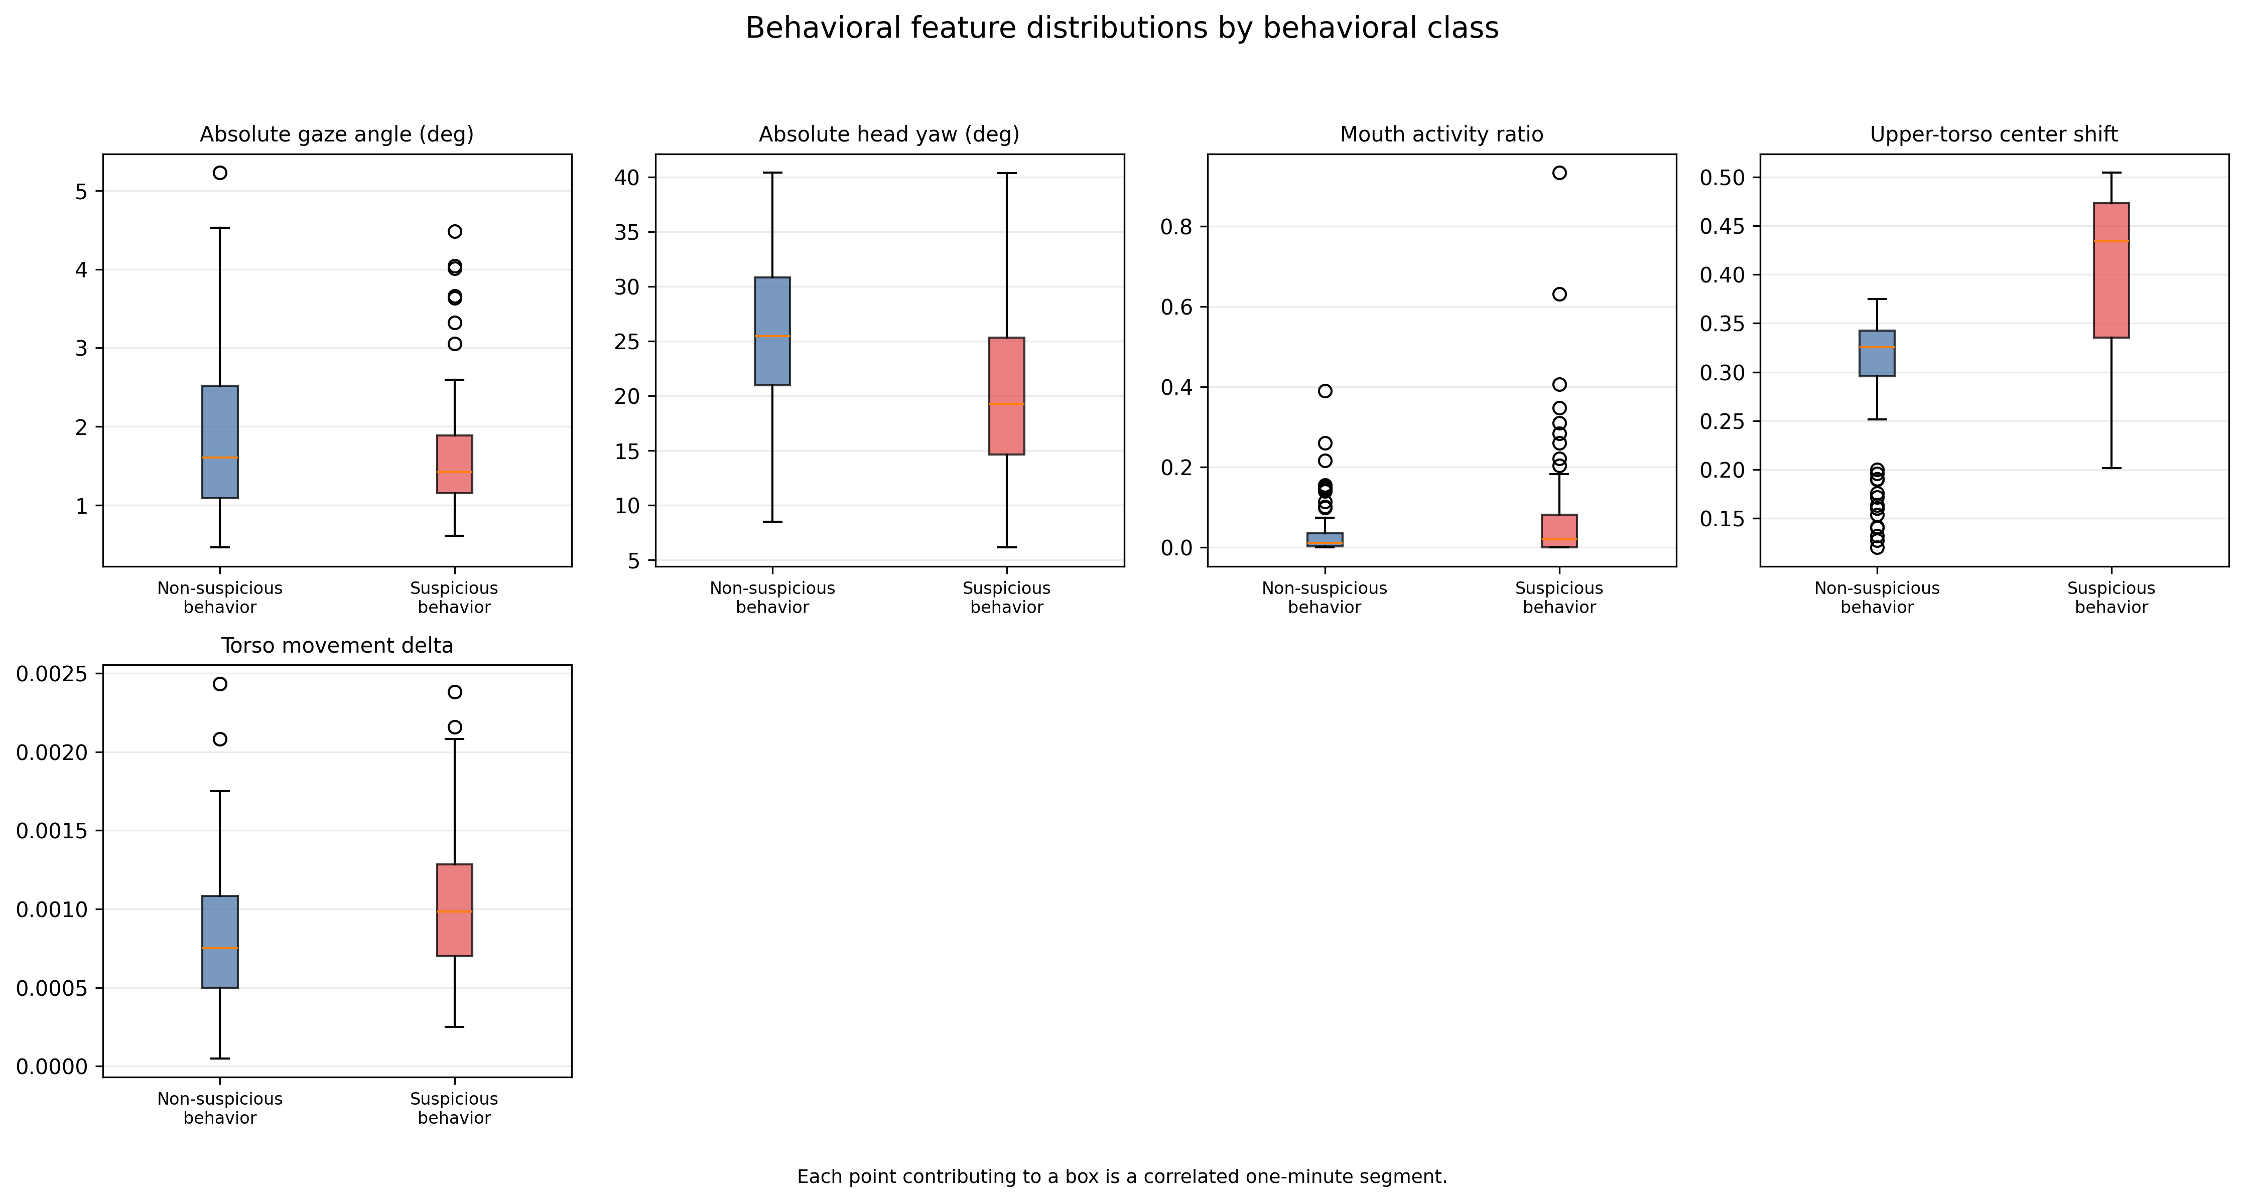
Figure 5.1. Exploratory distributions of five behavioral features by scripted class. Each point contributing to a box is a correlated one-minute segment, not an independent participant, so the figure describes feature behavior and must not be read as a participant-level effect.
Figure 5.1 presents the exploratory distributions of the five features by scripted class. Only the upper-torso center shift shows visible separation, with suspicious sessions tending higher, while absolute gaze angle, absolute head yaw, and mouth-activity ratio overlap substantially between the classes. This figure is exploratory: as its own caption notes, each contributing point is a correlated one-minute segment rather than an independent participant, so it describes how the features are distributed and must not be interpreted as a participant-level effect.

5.2.1 Head and Facial Orientation Results
The head and facial orientation module produced per-session mean absolute head yaw and a mouth-activity ratio for every recording. Mean absolute head yaw across sessions ranged from approximately 14.3 to 32.9 degrees. The values did not separate cleanly by condition: some non-suspicious sessions showed relatively high mean yaw (for example, EXAM-P04 at approximately 32.9 degrees and EXAM-P06 at approximately 27.7 degrees), while several suspicious sessions showed lower mean yaw (for example, EXAM-P05 at approximately 14.3 degrees and EXAM-P08 at approximately 14.5 degrees). Table 5.2 reports the per-session values for the head-orientation measurements alongside the other extracted features.
Session | Cond. | |Head yaw| (deg) | Mouth activity ratio | |Gaze angle| (deg) | Upper-torso center shift | Torso movement delta
EXAM-P01 | Susp. | 29.41 | 0.0204 | 2.496 | 0.2812 | 0.00091
EXAM-P02 | Susp. | 22.77 | 0.0314 | 1.538 | 0.4287 | 0.00129
EXAM-P03 | Non | 22.41 | 0.0581 | 1.997 | 0.3262 | 0.00078
EXAM-P04 | Non | 32.86 | 0.0972 | 2.821 | 0.3288 | 0.00103
EXAM-P05 | Susp. | 14.26 | 0.2404 | 1.547 | 0.4847 | 0.00094
EXAM-P06 | Non | 27.65 | 0.0120 | 1.660 | 0.3530 | 0.00097
EXAM-P07 | Susp. | 21.46 | 0.0547 | 1.223 | 0.3485 | 0.00166
EXAM-P08 | Susp. | 14.53 | 0.0145 | 1.444 | 0.4688 | 0.00071
EXAM-P09 | Non | 19.54 | 0.0077 | 1.256 | 0.1632 | 0.00048
EXAM-P10 | Susp. | 15.92 | 0.0116 | 1.276 | 0.3405 | 0.00072
EXAM-P11 | Non | 23.46 | 0.0009 | 1.022 | 0.2969 | 0.00105
Table 5.2. Per-session mean values of the five continuous behavioral features (one row per session).
The mouth-activity ratio was low for most sessions but showed one pronounced outlier: EXAM-P05, a suspicious session, had a mean mouth-activity ratio of approximately 0.24, far above every other session. The next highest value belonged to EXAM-P04, a non-suspicious session, at approximately 0.097. This indicates that elevated mouth activity, interpreted cautiously, was not confined to the suspicious condition and that a single session can strongly influence a feature's apparent association with a condition.
Interpreted against the Lens Model framing from Chapter 3, these observations show that head orientation and mouth-activity features behaved as weak, probabilistic cues rather than clean discriminators. Head orientation was captured consistently and reflects genuine differences in how participants positioned themselves, but the direction of the difference did not align with the scripted condition, which is expected because looking away and shifting posture occur during ordinary examination activity. The clearest limitation observed here is that mean yaw conflates deliberate turns with camera placement and seating differences, so a high mean does not by itself indicate suspicious behavior.

5.2.2 Eye-Gaze Results
The gaze module produced a mean absolute horizontal gaze angle for every session, ranging from approximately 1.0 to 2.8 degrees. These session means are small relative to the offscreen threshold of 12 degrees, which is consistent with participants spending most of the examination with gaze near the center reference and producing offscreen deviations only intermittently. As with head orientation, the mean gaze angle did not separate the two conditions: the highest session mean belonged to EXAM-P04, a non-suspicious session (approximately 2.82 degrees), while several suspicious sessions had lower mean gaze angles.
A more pointed limitation surfaced in the fused evidence. In the ambiguous suspicious session EXAM-P05, every one of the nineteen segment summaries reported zero gaze-offscreen seconds, meaning the gaze extractor contributed no sustained-offscreen evidence for that session even though it was a scripted cheating case. This indicates that the session-averaged gaze angle is a coarse descriptor and that averaging compresses brief, repeated glances into a small mean, so a session with occasional strong deviations can appear similar to a consistently centered session. The module's known restriction to horizontal gaze also means that upward or downward glances, such as looking down at a desk, are not represented in this angular measure, which limits what the gaze feature can reveal about certain behaviors.

5.2.3 Upper-Torso/Posture Results
The posture module produced a mean upper-torso center shift and a mean torso-movement delta for every session. Mean upper-torso center shift ranged from approximately 0.16 to 0.48 normalized frame units. The highest values occurred in suspicious sessions EXAM-P05 (approximately 0.48), EXAM-P08 (approximately 0.47), and EXAM-P02 (approximately 0.43), while the lowest value occurred in non-suspicious session EXAM-P09 (approximately 0.16). Mean torso-movement delta was small across all sessions, between approximately 0.0005 and 0.0017 normalized units per sampled interval, with the largest value in suspicious session EXAM-P07. This is the one feature that showed visible separation in Figure 5.1.
A systematic artifact in the posture features became apparent only after fusion and is important for interpreting the later results. The derived upper-torso posture-shift flag was active for almost the entire duration of nearly every session: for example, approximately 814 of 866 seconds in EXAM-P01, all 989 seconds in EXAM-P02, all 1,137 seconds in EXAM-P06, and all 418 seconds in EXAM-P10. Because the flag is driven by position relative to the frame center rather than by movement, a participant who simply sits off-center or is framed off-center triggers it continuously. A cue that is on almost all of the time carries little discriminative information, yet it contributes to the fused cue-strength value throughout the session. This near-constant posture-shift flag is revisited in the error analysis because it inflates cue activity in both conditions.

5.2.4 Cross-Modality Observations
Examined together, the three modalities provide complementary descriptions of the same recording rather than one dominant signal. No single feature separated the suspicious and non-suspicious sessions on its own, and the feature that most strongly distinguished one session (the elevated mouth-activity ratio in EXAM-P05) did not generalize to the other suspicious sessions. In several cases the modalities pointed in different directions within the same session: EXAM-P04, a non-suspicious session, combined the highest mean head yaw and the highest mean gaze angle with a moderate center shift, whereas EXAM-P05, a suspicious session, combined low mean head yaw with the highest center shift and by far the highest mouth activity.
The fused representation records how often cues co-occurred across modalities through its multimodal-corroboration cue, which is counted when at least two modalities support a cue in the same second. The amount of corroboration varied widely and did not track the scripted condition: it reached roughly 681 seconds in non-suspicious EXAM-P06 and 578 seconds in non-suspicious EXAM-P04, but only 11 seconds in suspicious EXAM-P08 and 111 seconds in non-suspicious EXAM-P09. The two sessions with the most cross-modality corroboration were therefore both non-suspicious, which is the opposite of what a clean cue would show.
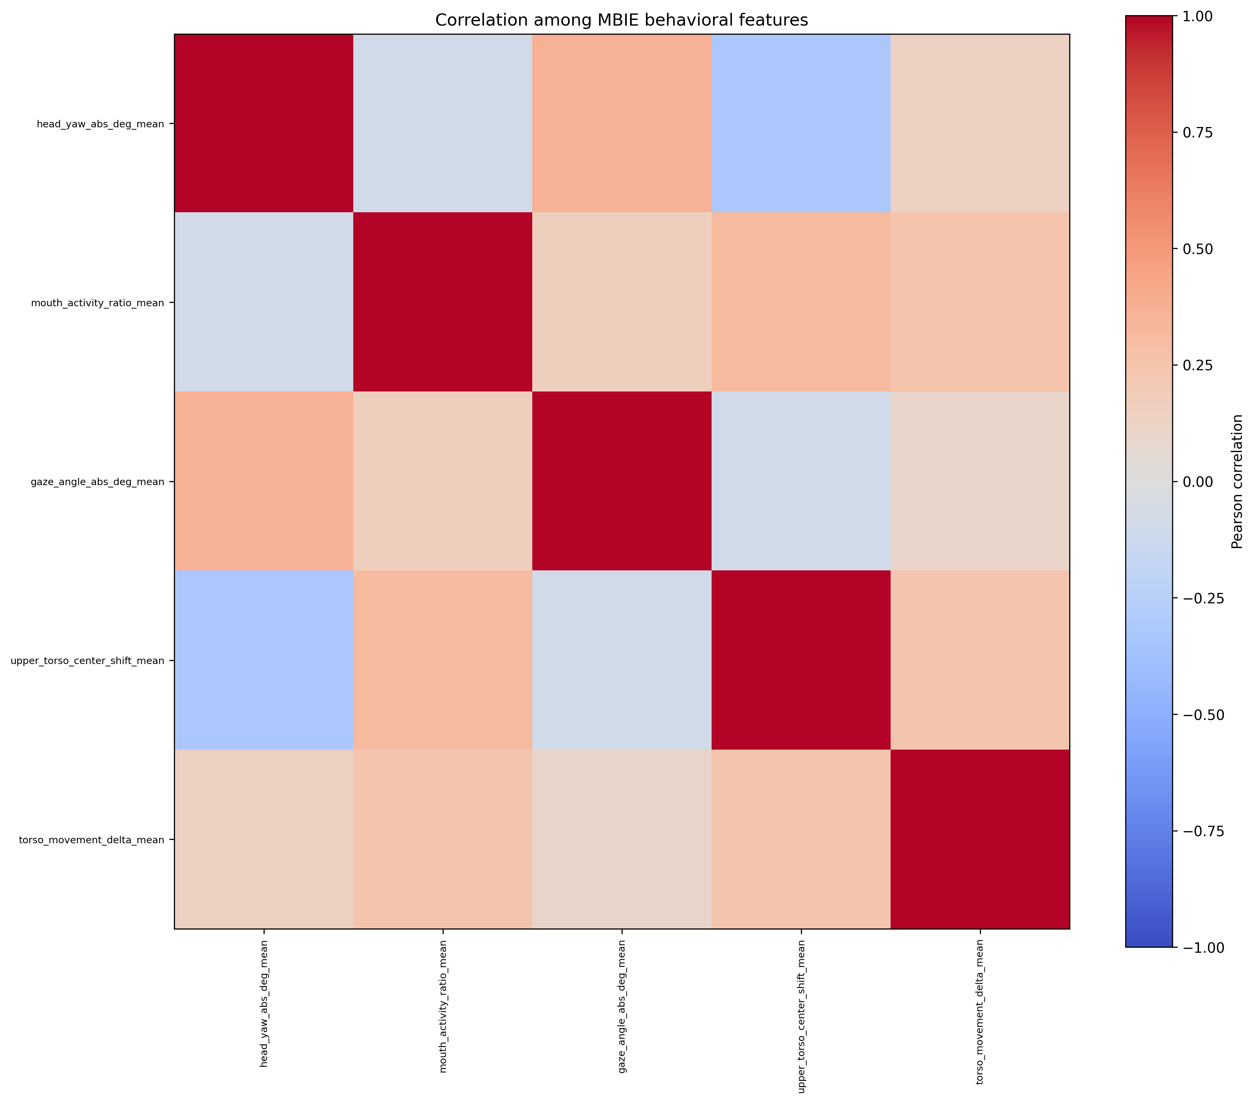
Figure 5.2. Exploratory correlation matrix of behavioral features. Relationships are computed over correlated one-minute segments and are used only to describe redundancy among features, not to establish effects.
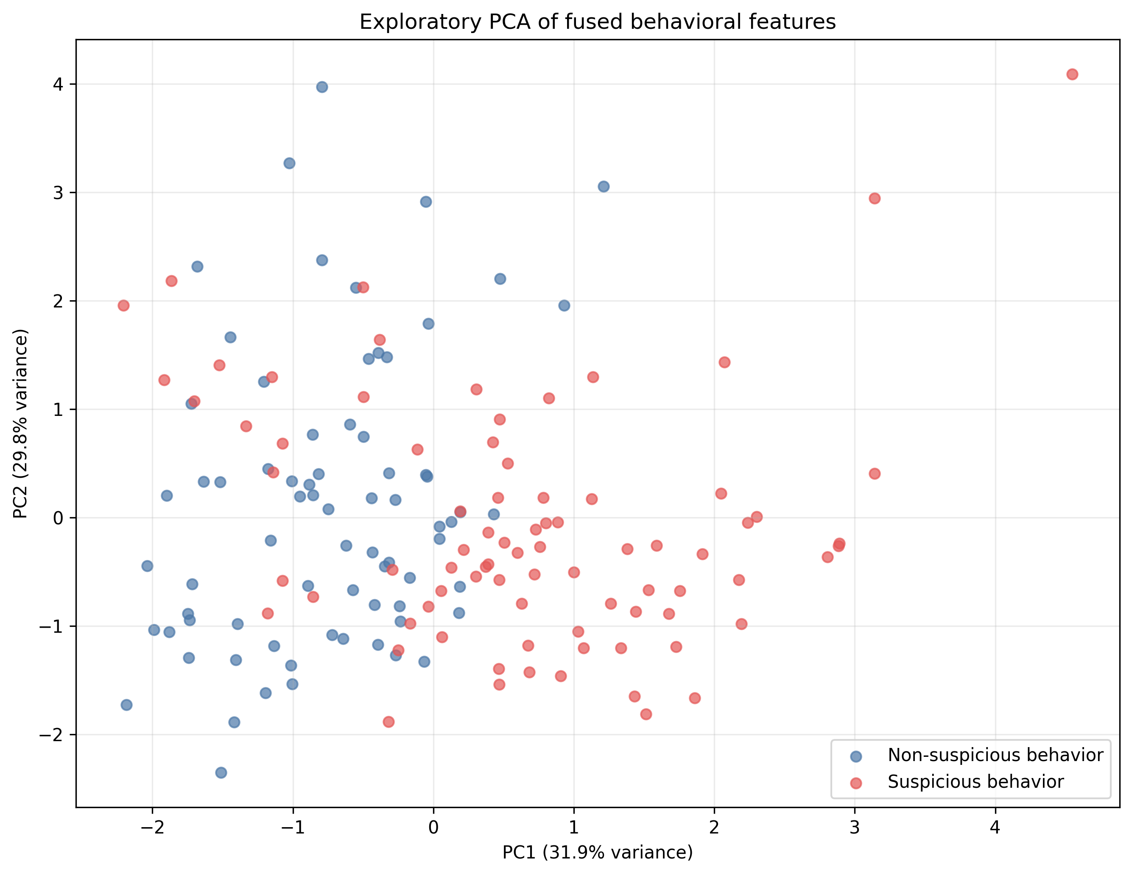
Figure 5.3. Exploratory principal-component projection of one-minute fused feature rows. Rows are correlated within a session; this visualization is not a participant-level accuracy result.
The exploratory correlation matrix in Figure 5.2 and the principal-component projection in Figure 5.3 are included to describe redundancy among the features and the overall spread of the one-minute rows. They are explicitly exploratory: both are computed over correlated one-minute segments rather than independent participants, so they illustrate relationships among features and must not be used to claim a sample size equal to the number of segments or a participant-level separation of the classes.
These cross-modality observations are consistent with the rationale for multimodal fusion presented in Chapter 3: because any single cue is ambiguous, combining cues was expected to provide broader context than one modality alone. At the same time, the observations show why combining cues does not guarantee separation of the conditions. The modalities frequently disagreed, the strongest corroboration appeared in non-suspicious sessions, and because all three streams derive from the same webcam recording, apparent agreement between them cannot be treated as fully independent confirmation. These differences between conditions are exploratory descriptions of eleven sessions and must be distinguished from statistically established effects; they indicate tendencies in this dataset, not generalizable discriminative power.

5.3 Verification of Extracted Behavioral Cues
Verification of extracted cues was qualitative spot-checking, not comprehensive validation. Using ELAN 7.0 as an auxiliary tool, selected system timestamps were located in the recording and the visible behavior compared with the extractor output.
A single EyeGaze annotation tier was created with the categories CENTER, LEFT, RIGHT, UP, and DOWN. It was used to judge whether reported gaze was visually plausible and whether the reported timestamp pointed to the relevant portion of the recording.
Comprehensive, frame-by-frame multimodal annotation of gaze, head orientation, hand activity, and upper-torso behavior across the whole dataset was not completed, because the manual effort required to build and maintain those tiers was substantial.
The main documented check involved EXAM-P01. The Behavioral Risk Report identified an event at approximately 02:07. When the recording was opened in ELAN, the cursor was positioned at approximately 02:06.835, about 0.165 seconds from the reported timestamp, and the EyeGaze tier classified the visible gaze direction at that point as DOWN. Table 5.3 summarizes this check.
Session / Timestamp | Human observation (ELAN) | ARGUS output | Agreement | Interpretation
EXAM-P01 / ~02:07 | Gaze directed DOWN at ~02:06.835 | Review event reported at ~02:07 | Timestamp traceable; gaze deviation plausible | Generated timestamp directed the reviewer to a relevant gaze-related behavior
Table 5.3. Documented ELAN spot-check for EXAM-P01.
This result demonstrates timestamp traceability and qualitative plausibility: the system directed a reviewer to a real, relevant moment with sub-second accuracy. It does not establish detection accuracy across the dataset, and it cannot by itself quantify missed detections, false triggers, or ambiguous cases, because the independent event-level annotations needed for that analysis were not produced.
A specific limitation is also visible here: the verified behavior was a downward gaze, which the horizontal-only gaze measure cannot represent angularly, so the event's traceability depended on the surrounding fused cues and timestamp rather than on the horizontal gaze angle alone. The verification is therefore best understood as confirming that the pipeline produces reviewable, correctly located events, while leaving formal accuracy validation to future work with complete annotations.

5.4 MBIE and Multimodal Behavioral Representation Results
This section shows what happens between feature extraction and the reasoning stage by tracing representative sessions through MBIE using the compact behavioral-cue summaries that the reasoning stage actually received. Each case reports the session's cue-review band, its mean, 95th-percentile, and maximum cue strength, the proportion of seconds reaching the notable threshold, and the most frequent cues with their durations. Four cases are presented: a clear suspicious session, a clear non-suspicious session, an ambiguous session on which the two models disagreed, and a false-positive case that shows how the rules can amplify benign behavior.

Case A — Scripted Suspicious Session (EXAM-P02)
EXAM-P02, a suspicious session of 17 segments, produced a cue-review band of strong cue activity, with a mean cue strength of 0.189, a 95th percentile of 0.40, and a maximum of 0.485. About 35 percent of its seconds reached the notable threshold and 72 seconds reached the strong threshold. Its most frequent cues were upper-torso posture shift (989 seconds), multimodal corroboration (257 seconds), sustained head offscreen (249 seconds), and elevated hands (214 seconds).
This is a session where the fused representation carried genuinely sustained, corroborated cue activity across modalities, not just the near-constant posture flag. Both models classified it as suspicious, which indicates that when MBIE surfaced coherent multimodal activity the reasoning stage reached the correct assessment.

Case B — Scripted Non-Suspicious Session (EXAM-P09)
EXAM-P09, a non-suspicious session of 16 segments, produced the lowest cue activity in the dataset. Its band was notable cue activity, with a mean cue strength of only 0.065, a 95th percentile of 0.35, a maximum of 0.35, about 12 percent of seconds at the notable threshold, and no seconds at the strong threshold. Notably, upper-torso posture shift was not among its leading cues; instead its most frequent cues were sustained head offscreen (189 seconds), hand near mouth (140 seconds), multimodal corroboration (111 seconds), and elevated hands (75 seconds).
This is the pattern expected for a benign session: low fused cue strength and no strong-cue seconds. Both models classified EXAM-P09 as non-suspicious, consistent with the sparse cue activity, so the representation behaved as intended for at least one non-suspicious session.

Case C — Difficult/Ambiguous Session (EXAM-P05)
EXAM-P05, a suspicious session of 19 segments, had the richest and most fragmented cue structure in the dataset: a strong-cue-activity band, mean cue strength 0.165, 95th percentile 0.40, maximum 0.54, 75 strong-cue seconds, and 92 separate notable windows. Its most frequent cues were upper-torso posture shift (all 1,110 seconds), multimodal corroboration (255 seconds), hand near mouth (164 seconds), off-center face with attention shift (117 seconds), sustained face absence (72 seconds), and sustained head offscreen (52 seconds).
Two features of this representation explain why it was ambiguous. First, although the posture-shift cue was present for the entire session, it was near-constant and therefore uninformative on its own. Second, the gaze extractor reported zero offscreen seconds for all 19 segments, so the suspicious-looking activity came from face absence, head orientation, and hand-near-mouth clusters rather than from gaze. The two models split on this session, which illustrates that even when MBIE preserves strong but fragmented cue activity, different reasoning models can weigh it differently.

Case D — Benign Session Amplified to a False Positive (EXAM-P04)
EXAM-P04, a non-suspicious session of 16 segments, is the clearest example of the fusion rules amplifying benign behavior. It produced a strong-cue-activity band with a mean cue strength of 0.26, the highest mean in the dataset, a 95th percentile of 0.39, and the single highest maximum cue strength of any session, 0.553. About 66 percent of its seconds reached the notable threshold. Its most frequent cues were upper-torso posture shift (all 904 seconds), multimodal corroboration (578 seconds), and sustained head offscreen (505 seconds).
A non-suspicious session therefore generated more cue-dense time than most suspicious sessions. Both models labeled it suspicious. This case shows the amplification concretely: the near-constant posture flag, combined with long head-offscreen periods that are indistinguishable from ordinary looking-away, drove the fused cue strength high even though the scripted condition was benign. The outline's concern that the rules may amplify benign behaviors is directly observed here, and it foreshadows the dominant false-positive pattern reported in Sections 5.6 and 5.7.
Across these four cases, MBIE preserved meaningful behavioral information and surfaced the modalities that were most active in each session, but two limitations are evident in the real data. The upper-torso posture-shift cue was active almost continuously and therefore added little discrimination while still contributing to cue strength, and the sessions with the greatest cue density were not reliably the suspicious ones. These observations directly inform the error analysis, because the same cue activity that supported correct suspicious decisions in Case A also drove the false positive in Case D.

5.5 Conventional Classifier Baseline Results
The conventional baseline was a strongly regularized L2 logistic regression (regularization strength C = 0.03) with balanced class weights and a fixed 0.5 decision threshold, trained on the five continuous per-session features and evaluated with leave-one-group-out cross-validation in which each participant/video session was the held-out group. Median imputation and standardization were fitted inside each training fold, and session-identifying fields, participant role, timestamps, and the MBIE cue-strength value were excluded to avoid leakage. The baseline classified 9 of the 11 sessions correctly, with 4 true negatives, 5 true positives, 1 false positive, and 1 false negative, as shown in Figure 5.4 and Table 5.4.
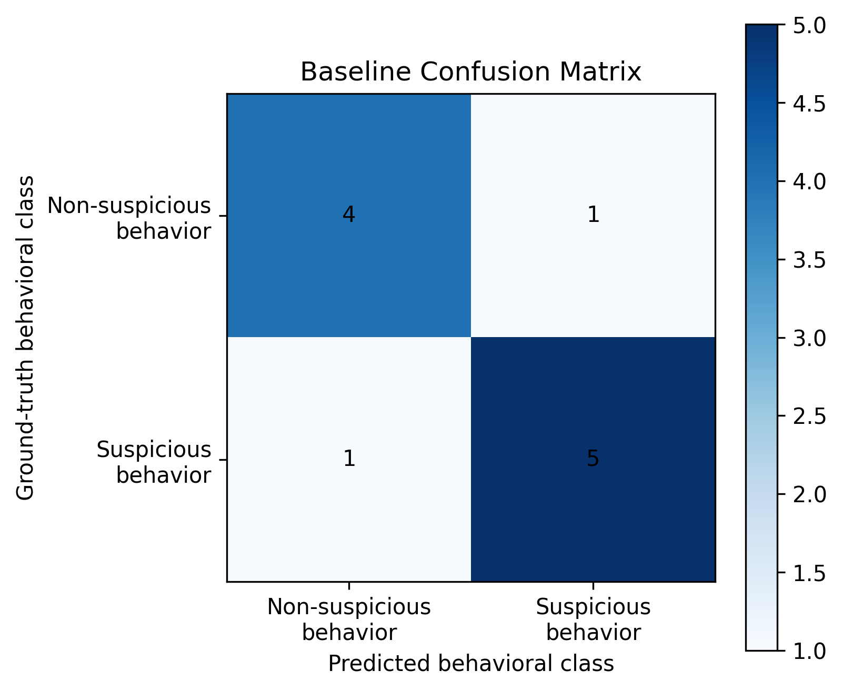
Figure 5.4. Session-level confusion matrix for the leave-one-group-out Logistic Regression baseline (rows: ground truth; columns: predictions).
 | Predicted Non-suspicious | Predicted Suspicious
Actual Non-suspicious | 4 (TN) | 1 (FP)
Actual Suspicious | 1 (FN) | 5 (TP)
Table 5.4. Conventional baseline confusion counts.
The corresponding metrics were accuracy 0.818, balanced accuracy 0.817, precision 0.833, recall 0.833, specificity 0.800, F1 0.833, and ROC-AUC 0.800. Because the logistic regression produces a continuous score, the per-session positive scores clustered closely around the 0.5 threshold, between approximately 0.42 and 0.53, which indicates that the model separated the classes only by a narrow margin even though its final labels were mostly correct.
The two errors are informative. The single false negative was EXAM-P01, a suspicious session that received a positive score of approximately 0.422, the lowest score among the suspicious sessions and the only one below the threshold. The single false positive was EXAM-P11, a non-suspicious session that received a positive score of approximately 0.505, just above the threshold; EXAM-P11 was also the shortest session (5 segments, about 4 minutes), so its averaged features were estimated from the least data. The errors therefore occurred at sessions whose scores sat nearest the decision boundary, which is the expected location of error for a thresholded classifier and matches the Signal Detection framing in Chapter 3. These associations describe which sessions were hardest for the baseline; they do not establish that any individual feature caused the error, and no causal claim is made from them.

5.6 LLM-Based Behavioral Analysis Results
Both language models were evaluated at the session level against the scripted condition labels using the fixed ARGUS-Lite prompt v1.3, which was confirmed identical across runs by its SHA-256 hash. A new conversation was used for each session, and the ground-truth labels and participant roles were withheld from the models during inference. Both models produced a decision for every session: coverage was complete, there were no abstentions, and neither model returned a Not evaluable outcome. Because evidence strength in these records is ordinal model wording rather than a calibrated continuous score, ROC-AUC is not reported for the models. The session-level confusion matrices appear in Figure 5.5.
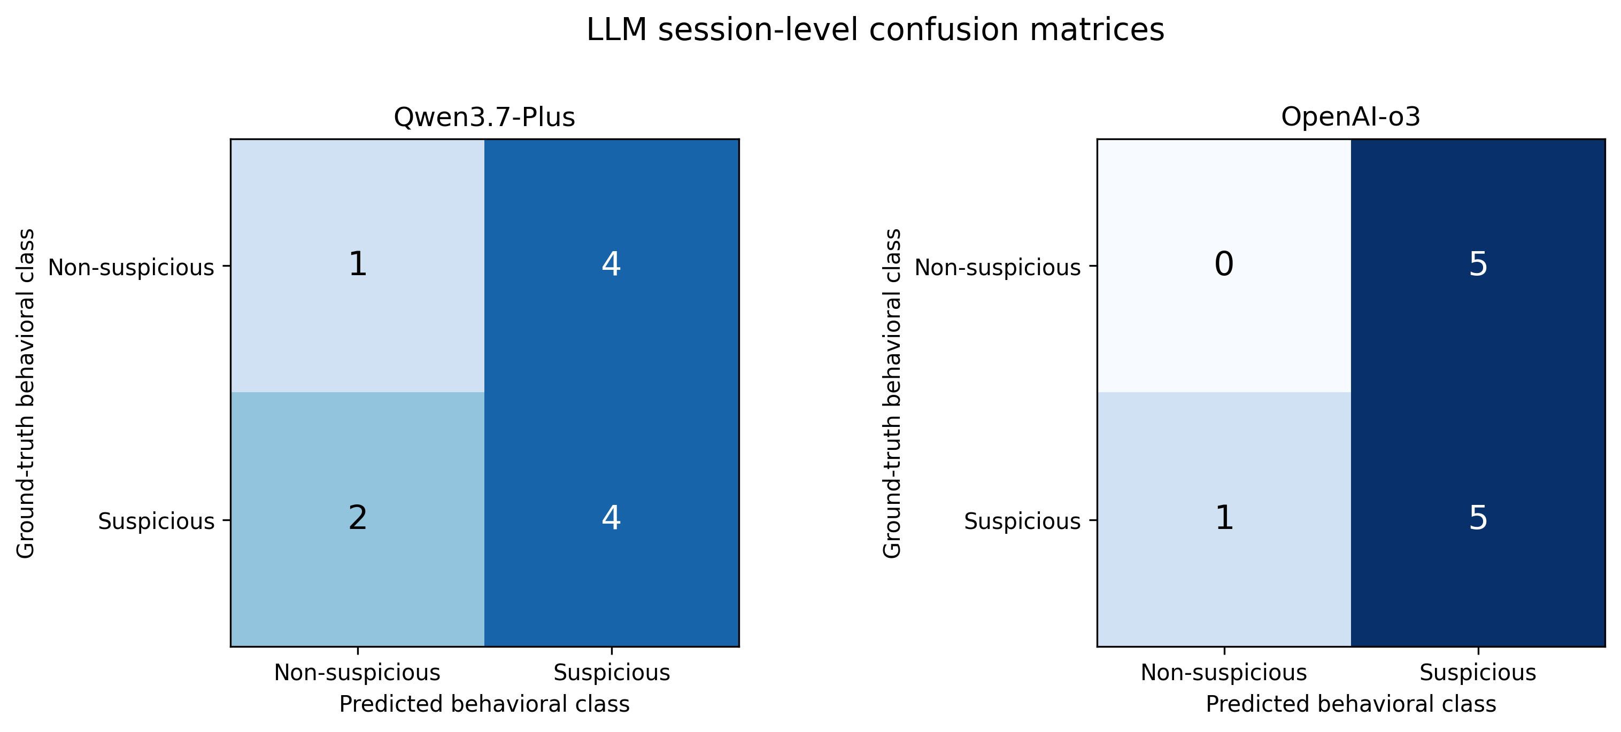
Figure 5.5. Session-level confusion matrices for Qwen3.7-Plus and OpenAI-o3 under the fixed ARGUS-Lite prompt v1.3 (rows: ground truth; columns: predictions).

5.6.1 Qwen3.7-Plus Results
Qwen3.7-Plus classified 6 of the 11 sessions in agreement with the reference labels, with 1 true negative, 4 true positives, 4 false positives, and 2 false negatives. Its metrics were accuracy 0.455 (95% Wilson confidence interval approximately 0.213 to 0.720), balanced accuracy 0.433, precision 0.500, recall 0.667, specificity 0.200, F1 0.571, false-positive rate 0.800, and Matthews correlation coefficient approximately -0.149. The negative correlation coefficient and the specificity of 0.200 together indicate that the model flagged four of the five non-suspicious sessions as suspicious.
A representative Behavioral Risk Report illustrates how the model reasoned. For EXAM-P01, correctly labeled suspicious with Moderate evidence strength, the report described sustained head-offscreen behavior and occasional hand-to-mouth movements, and it explicitly weighed benign alternatives:
“Upper torso posture shifts are highly ambiguous and can be readily attributed to normal fidgeting, adjusting seating position, stretching, or fatigue... The overall mean cue strength is low (0.2), indicating that strong cue activity is sparse.”
This excerpt is important for two reasons. The model did follow the prompt's instruction to consider benign explanations, and it even noted that the session's mean cue strength was low. Yet it still reached a suspicious label, which shows that the decision depended on isolated high-cue moments rather than on the overall level of activity.
The model's false negatives were EXAM-P05 and EXAM-P10. For EXAM-P10 the model assigned an evidence strength of High despite being incorrect, and its record contained no key timestamps, which suggests the model reached a non-suspicious decision without localizing supporting evidence.

5.6.2 OpenAI o3 Results
OpenAI o3 also classified 6 of the 11 sessions in agreement with the reference labels, but with a different error profile: 0 true negatives, 5 true positives, 5 false positives, and 1 false negative. Its metrics were accuracy 0.455 (95% Wilson confidence interval approximately 0.213 to 0.720), balanced accuracy 0.417, precision 0.500, recall 0.833, specificity 0.000, F1 0.625, false-positive rate 1.000, and Matthews correlation coefficient approximately -0.289. A specificity of zero means o3 labeled every non-suspicious session as suspicious; its single false negative was again EXAM-P10. The higher recall relative to Qwen is a direct consequence of flagging almost everything as suspicious rather than of better discrimination.
The o3 report for EXAM-P05 is notable because the model independently identified the posture artifact described in Section 5.2.3. It observed that the upper-torso posture-shift cue was present for all 1,110 seconds and concluded:
“Because it was nearly constant, it is best treated as a participant-, camera-, or extractor-level baseline rather than a localized behavioral change.”
The same report noted that all 19 segment summaries reported zero gaze-offscreen seconds, so the session contained no direct gaze evidence of sustained offscreen attention. That o3 correctly diagnosed the posture flag as a baseline, yet still produced five false positives overall, indicates that the positive-class bias was not simply a failure to notice weak evidence; it persisted even when the model reasoned carefully about data quality.
For the benign session EXAM-P04, which both models flagged, o3 assigned High evidence strength and interpreted long head- and gaze-offscreen windows as attention leaving the display, while listing a benign alternative in the same row of its review table:
“Prolonged diversion of visual attention away from screen” — benign alternative: “Turning to consult notes placed beside camera.”
The benign alternative it recorded is itself an ordinary examination action, which shows that the evidence available to the model did not distinguish the suspicious interpretation from a routine one, yet the suspicious label was still assigned.

5.6.3 Comparison of the Two LLMs
The two models reached the same accuracy (0.455) but through different error patterns. They agreed on 9 of the 11 sessions, with a prediction agreement rate of 0.818 and a Cohen's kappa of approximately 0.421, indicating moderate agreement beyond chance. An exact McNemar comparison of paired correctness gave p = 1.000; this does not establish equivalence, because the sample is far too small to detect a meaningful difference, but it does indicate that neither model was clearly better than the other on paired correctness in this dataset.
The models disagreed on exactly two sessions, EXAM-P05 and EXAM-P06, and each was correct on one of them. On EXAM-P05, the ambiguous suspicious session, o3 was correct (suspicious) and Qwen was not. On EXAM-P06, a non-suspicious session, Qwen was correct (non-suspicious) and o3 was not. The behavioral pattern of the errors is more informative than the shared accuracy: o3's tendency to assign the suspicious label captured EXAM-P05 but also caused it to miss every non-suspicious session, whereas Qwen's slightly more conservative behavior correctly spared EXAM-P06 but still produced four false positives. Both models therefore exhibited a strong positive-class bias, differing mainly in degree. The comparison is specific to this dataset and prompt and is not evidence that either model is generally superior.

5.7 Error Analysis
This section examines the model errors in detail, because the error pattern is more informative than accuracy alone on a dataset of this size. Figure 5.6 shows the ground truth and the session-level predictions of both models and the conventional baseline, and Table 5.5 lists the same predictions so the errors can be organized by outcome type and traced through the pipeline.
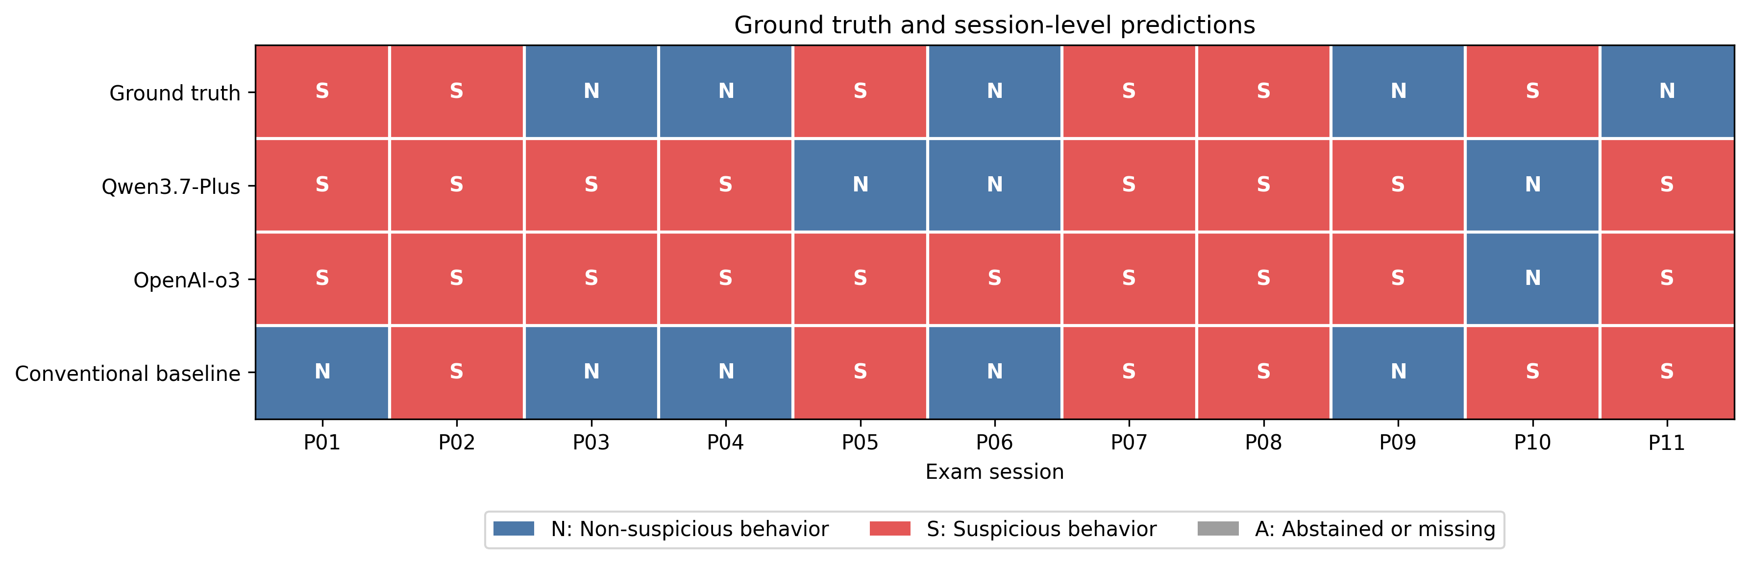
Figure 5.6. Ground truth and session-level predictions for both LLMs and the conventional baseline across all eleven sessions (S: suspicious; N: non-suspicious).
Session | Truth | Qwen | o3 | Baseline
EXAM-P01 | Susp. | Susp. (TP) | Susp. (TP) | Non (FN)
EXAM-P02 | Susp. | Susp. (TP) | Susp. (TP) | Susp. (TP)
EXAM-P03 | Non | Susp. (FP) | Susp. (FP) | Non (TN)
EXAM-P04 | Non | Susp. (FP) | Susp. (FP) | Non (TN)
EXAM-P05 | Susp. | Non (FN) | Susp. (TP) | Susp. (TP)
EXAM-P06 | Non | Non (TN) | Susp. (FP) | Non (TN)
EXAM-P07 | Susp. | Susp. (TP) | Susp. (TP) | Susp. (TP)
EXAM-P08 | Susp. | Susp. (TP) | Susp. (TP) | Susp. (TP)
EXAM-P09 | Non | Susp. (FP) | Susp. (FP) | Non (TN)
EXAM-P10 | Susp. | Non (FN) | Non (FN) | Susp. (TP)
EXAM-P11 | Non | Susp. (FP) | Susp. (FP) | Susp. (FP)
Table 5.5. Session-level predictions for both LLMs and the conventional baseline against ground truth.
True positives. Both models correctly identified the suspicious sessions EXAM-P01, EXAM-P02, EXAM-P07, and EXAM-P08, and o3 additionally identified EXAM-P05. The MBIE data helps separate two kinds of correct decision. EXAM-P02 reached a strong-cue-activity band with genuinely corroborated cues, so the correct label rested on substantial fused evidence. EXAM-P08, however, had the lowest cue activity of any suspicious session (mean 0.102, band notable, no strong-cue seconds, only 11 seconds of multimodal corroboration), yet both models still called it suspicious. The models were therefore right on EXAM-P08 for reasons the fused evidence does not strongly justify, which is a correct decision on weak grounds rather than a well-supported one.
True negatives. Correct non-suspicious decisions were rare for the models: Qwen produced one (EXAM-P06) and o3 produced none. This scarcity is the central weakness of the LLM stage.
False positives. The shared false positives were EXAM-P03, EXAM-P04, EXAM-P09, and EXAM-P11; o3 additionally flagged EXAM-P06. The MBIE data explains part of this pattern. The benign sessions EXAM-P03, EXAM-P04, and EXAM-P06 had very high notable-second ratios (about 0.65, 0.66, and 0.61 respectively), higher than several suspicious sessions, so the fused representation genuinely presented the models with cue-dense input for these benign recordings. For these sessions the error originated upstream, at feature extraction and fusion, which supplied benign-but-strong cue activity. EXAM-P09 is different: it had the lowest cue activity in the dataset (mean 0.065, no strong-cue seconds), yet both models still flagged it, so that error is better attributed to the interpretation stage over-reading modest cues.
False negatives. The models' false negatives were EXAM-P05 (Qwen only) and EXAM-P10 (both models). EXAM-P10 is instructive: its fused representation fell in the low-cue-activity band, with a mean cue strength of 0.107, a maximum of only 0.20, and just 2 notable seconds, so MBIE presented the models with almost no above-baseline activity. EXAM-P10 was also the second-shortest session (7 segments) and was recorded at 27 frames per second. The most likely origin of this error is therefore upstream: a short recording and a sparse representation left too little sustained cue activity for either model to flag.
Taken together, the errors separate, where the evidence allows, into feature-extraction and fusion effects (benign sessions with high cue density such as EXAM-P03, EXAM-P04, and EXAM-P06, and the sparse representation of EXAM-P10) and interpretation effects (the flagging of low-cue EXAM-P09). The near-constant posture-shift cue documented in Section 5.2.3 contributes to the fusion effect, because it keeps baseline cue strength elevated in every session regardless of condition. The dominant error across both models was the false positive, and the dominant cause was a tendency to interpret cue activity as suspicious even when the underlying features were modest or benign.

5.8 Comparison of LLM Reasoning and the Conventional Baseline
Table 5.6 and Figure 5.7 present the three approaches together on the same eleven sessions.
Measure | Logistic Regression | Qwen3.7-Plus | OpenAI o3
Accuracy | 0.818 | 0.455 | 0.455
Precision | 0.833 | 0.500 | 0.500
Recall | 0.833 | 0.667 | 0.833
Specificity | 0.800 | 0.200 | 0.000
F1 | 0.833 | 0.571 | 0.625
Table 5.6. Session-level metric comparison across the conventional baseline and the two LLMs.
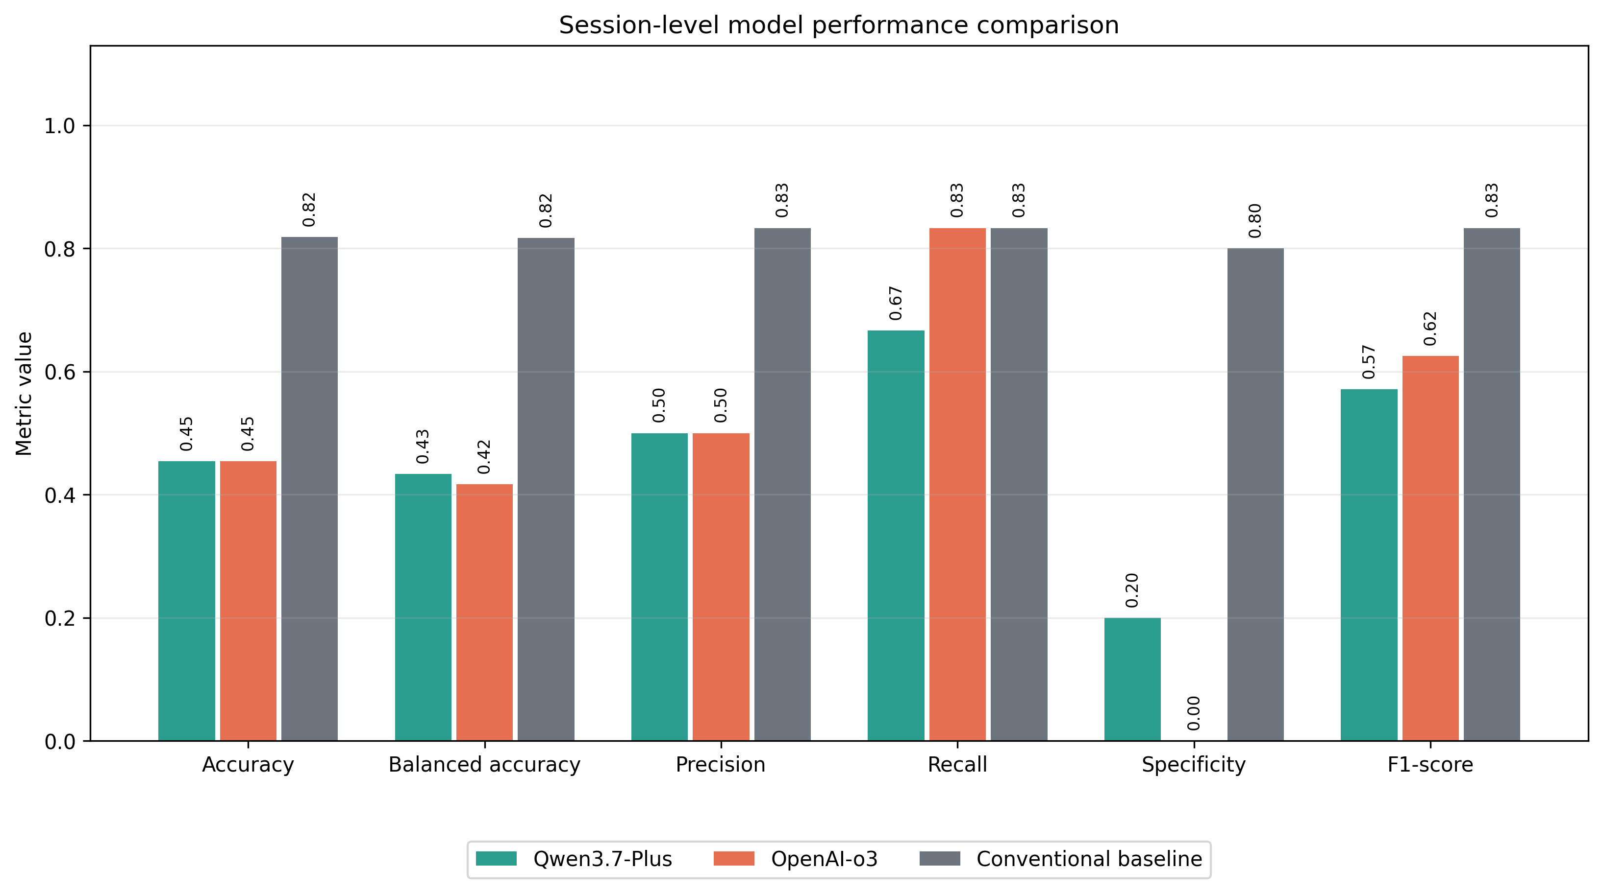
Figure 5.7. Session-level performance comparison of Qwen3.7-Plus, OpenAI-o3, and the conventional baseline. Results are preliminary because only eleven independent sessions were available.
The conventional baseline correctly classified 9 of 11 sessions, while each language model agreed with the reference labels on 6 of 11, and the models' specificity was far lower than the baseline's (0.200 and 0.000 against 0.800). The following explanations are consistent with the available evidence, but given eleven sessions they are offered as plausible accounts rather than established conclusions.
Why might the simpler baseline perform differently? The baseline was fitted on five continuous features with strong regularization and leave-one-group-out validation, so it learned a conservative decision boundary calibrated to the balance of the dataset. The language models instead applied a fixed interpretive prompt without any fitting to the class balance, so they had no mechanism to calibrate how much cue activity should correspond to a suspicious label. This difference in calibration, rather than a difference in access to the behavioral evidence, is the most plausible reason the baseline separated the classes more successfully.
What kinds of errors dominate the LLM outputs, and does the LLM appear overly sensitive to risk cues? The dominant error for both models was the false positive, and o3 flagged every non-suspicious session. This is strong evidence within this dataset that the models were overly sensitive to the cue activity presented to them. The EXAM-P09 case, in which both models flagged a session with the lowest cue activity in the dataset, and the EXAM-P04 case, in which a benign session produced the highest maximum cue strength, together show benign behavior being interpreted as suspicious at both low and high levels of cue density.
Is useful information lost or distorted between feature extraction and LLM input? The evidence here is mixed and cannot be settled with this dataset. The models did reach correct suspicious decisions when cue activity was strong, which indicates discriminative information survived fusion. However, two distortions are visible in the real data: the near-constant posture-shift cue keeps baseline cue strength elevated in every session, and the gaze stream contributed no offscreen evidence in a scripted suspicious session (EXAM-P05). These are plausible contributors to the false-positive pattern, and o3's own identification of the posture flag as a baseline supports the first of them.

5.9 Discussion According to the Research Objectives
This section returns to the four research objectives and discusses what the results establish for each.

5.9.1 Objective 1 — Dataset Construction and Annotation
The study successfully collected eleven mock-examination recordings under two scripted conditions and processed all of them into 154 segments without session-level loss. Session-level reference labels were assigned by scripted condition, and limited qualitative gaze checking was completed in ELAN. What was intended but not achieved was comprehensive, independent, frame-by-frame multimodal annotation of behavioral events, which was not completed because of the manual effort required. The consequence for interpretation is important: because the labels represent scripted conditions rather than independently verified behavioral events, the evaluation measures how well the system reproduces the condition assignment, not how accurately it localizes genuine misconduct in time.

5.9.2 Objective 2 — Multimodal Feature Extraction
The three modalities were implemented and produced usable, timestamped features for every session, with complete modality coverage across all eleven sessions and a confirmed sub-second timestamp traceability in the ELAN spot-check. The continuous head-orientation, gaze-angle, and posture-position measurements were produced consistently. However, the real outputs revealed concrete limitations: gaze estimation is restricted to the horizontal axis and contributed no offscreen evidence in a scripted suspicious session, and the derived upper-torso posture-shift flag was active almost continuously, making it non-discriminative. These are limitations of the extracted features themselves, not only of the downstream reasoning.

5.9.3 Objective 3 — Multimodal Fusion and LLM-Based Inference
The question of whether the pipeline was successfully implemented must be separated from the question of whether it classified sessions reliably. On implementation, the result is positive: MBIE aligned the three modalities, produced structured per-second representations and compact session summaries, and generated a complete Behavioral Risk Report for every session, and both models consumed that representation and returned a decision for every session with full coverage and no abstentions. On classification reliability, the result is weak: both models agreed with the reference labels on only 6 of 11 sessions and showed very low specificity. The pipeline therefore works as an integrated system, but its reasoning stage did not classify sessions reliably on this dataset.

5.9.4 Objective 4 — System Evaluation and Feasibility
The overall performance of the language-model stage was limited by a strong positive-class bias and a high false-positive rate, in contrast to the conventional baseline, which classified 9 of 11 sessions correctly with balanced specificity. The strengths established by the evaluation are the end-to-end feasibility of the pipeline, the reviewability of its timestamped output, and its ability to flag genuinely suspicious sessions when cue activity was strong. The weaknesses are the models' tendency to over-flag benign sessions, a near-constant posture cue that reduces discrimination, and the small, simulated dataset. What the experiment establishes is that ARGUS is a feasible proof-of-concept decision-support pipeline; what it does not establish is that the LLM reasoning stage is accurate enough for unsupervised use, or that any approach here would generalize to authentic examinations.

5.10 Overall Findings and Chapter Summary
Building and evaluating ARGUS showed that a multimodal behavioral pipeline for online examinations can be implemented end to end and can produce reviewable, timestamped behavioral risk reports, but that the accuracy of its language-model reasoning stage was limited on this dataset. The three feature extractors and the MBIE fusion stage worked as designed and preserved discriminative information, yet no single behavioral cue separated the scripted conditions, and one derived cue (upper-torso posture shift) was active almost continuously and therefore added little discrimination.
The clearest empirical finding is a contrast in decision behavior. The conventional logistic-regression baseline classified 9 of 11 sessions correctly with balanced specificity, whereas both language models classified only 6 of 11 correctly and exhibited a strong positive-class bias, flagging most or all non-suspicious sessions as suspicious. The models agreed with each other far more than they agreed with the reference labels, and in at least one case a model correctly diagnosed a data-quality artifact yet still produced false positives, which indicates a shared tendency to interpret cue activity as suspicious rather than a random difference between them.
For ARGUS, the practical implication is that the system is best positioned as a decision-support tool that directs human attention to specific moments, not as an autonomous classifier. Its demonstrated strength is traceability: it can point a reviewer to a relevant second of video. Its demonstrated weaknesses are calibration, since the reasoning stage raises too many false alarms to be trusted without human review, and a non-discriminative posture cue that should be revised in future work. All of these findings are preliminary, resting on eleven simulated single-camera sessions, and should be confirmed on newly collected, untouched participants before any stronger claim is made.

