Homework6

#### Nghia Quang Le

#### 11/9/2019

*problem 7.9*

set.seed(1)  
data <- arima.sim(list(order = c(0,0,1), ma = -0.8), n = 48)  
r1 <- cor(data[-1], data[-length(data)]) #lag 1 coef  
#method of moment estimate for MA model  
coef <- (-1+sqrt(1-4*(r1^2)))/(2*r1)  
print("Method of Moment Coefficient Estimate for MA(1): ")

## [1] "Method of Moment Coefficient Estimate for MA(1): "

print(coef)

## [1] 0.4408197

print("Conditional Least Square Estimate for MA(1): ")

## [1] "Conditional Least Square Estimate for MA(1): "

coef(arima(data,   
 order=c(0,0,1),  
 method='CSS')) #conditonal least square estimate for MA model

## ma1 intercept   
## -0.85015259 0.02554888

Comment: *Blank*

#Repeat simulation  
set.seed(6)  
data <- arima.sim(list(order = c(0,0,1), ma = -0.8), n = 48)  
r1 <- cor(data[-1], data[-length(data)]) #lag 1 coef  
#method of moment estimate for MA model  
coef <- (-1+sqrt(1-4*(r1^2)))/(2*r1)  
print("Method of Moment Coefficient Estimate for MA(1): ")

## [1] "Method of Moment Coefficient Estimate for MA(1): "

print(coef)

## [1] 0.8047859

print("Conditional Least Square Estimate for MA(1): ")

## [1] "Conditional Least Square Estimate for MA(1): "

coef(arima(data,   
 order=c(0,0,1),  
 method='CSS')) #conditonal least square estimate for MA model

## ma1 intercept   
## -1.12741928 0.02804241

Comment: *Blank*

*Problem 7.17*

set.seed(1)  
data <- arima.sim(model = list(ar = 0.7, ma = -0.4), n=72)   
coef(arima(data,   
 order=c(1,0,1),  
 method='CSS')) #conditonal least square estimate for ARMA(1,1) model

## ar1 ma1 intercept   
## 0.4468105 -0.2596554 0.1580484

coef(arima(data,   
 order=c(1,0,1),  
 method='ML')) #maximum likelihood for ARMA(1,1) model

## ar1 ma1 intercept   
## 0.30506574 -0.09192566 0.18867688

Comment: *Blank*

#Repeat simulation  
set.seed(2)  
data <- arima.sim(model = list(ar = 0.7, ma = -0.4), n=72)   
coef(arima(data,   
 order=c(1,0,1),  
 method='CSS')) #conditonal least square estimate for ARMA(1,1) model

## ar1 ma1 intercept   
## 0.6056419 -0.3406447 -0.1308622

coef(arima(data,   
 order=c(1,0,1),  
 method='ML')) #maximum likelihood for ARMA(1,1) model

## ar1 ma1 intercept   
## 0.55856797 -0.27269132 -0.07166902

Comment: *Blank*

*Problem 7.28*

setwd('C:/Users/nqlc2c/Documents/HW6Data')  
data <- read.table('deere3.txt', header = TRUE)  
data <- ts(data, start = 1, end = nrow(data), frequency = 1)  
plot(data)

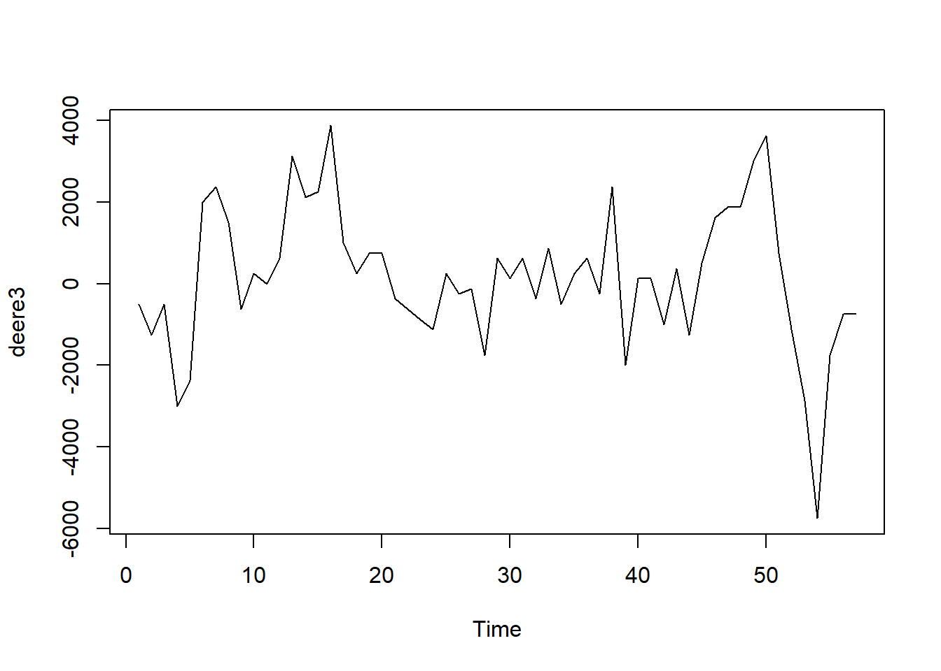

coef(arima(data,   
 order=c(1,0,0),  
 method='CSS')) #conditonal least square estimate for AR(1) model

## ar1 intercept   
## 0.5332044 160.0797248

coef(arima(data,   
 order=c(2,0,0),  
 method='CSS')) #conditonal least square estimate for AR(2) model

## ar1 ar2 intercept   
## 5.245848e-01 7.938728e-03 2.011876e+02

Comment: *Blank*

*Problem 7.29*

setwd('C:/Users/nqlc2c/Documents/HW6Data')  
data <- read.table('robot.txt', header = TRUE)  
data <- ts(data, start = 1, end = nrow(data), frequency = 1)  
plot(data)

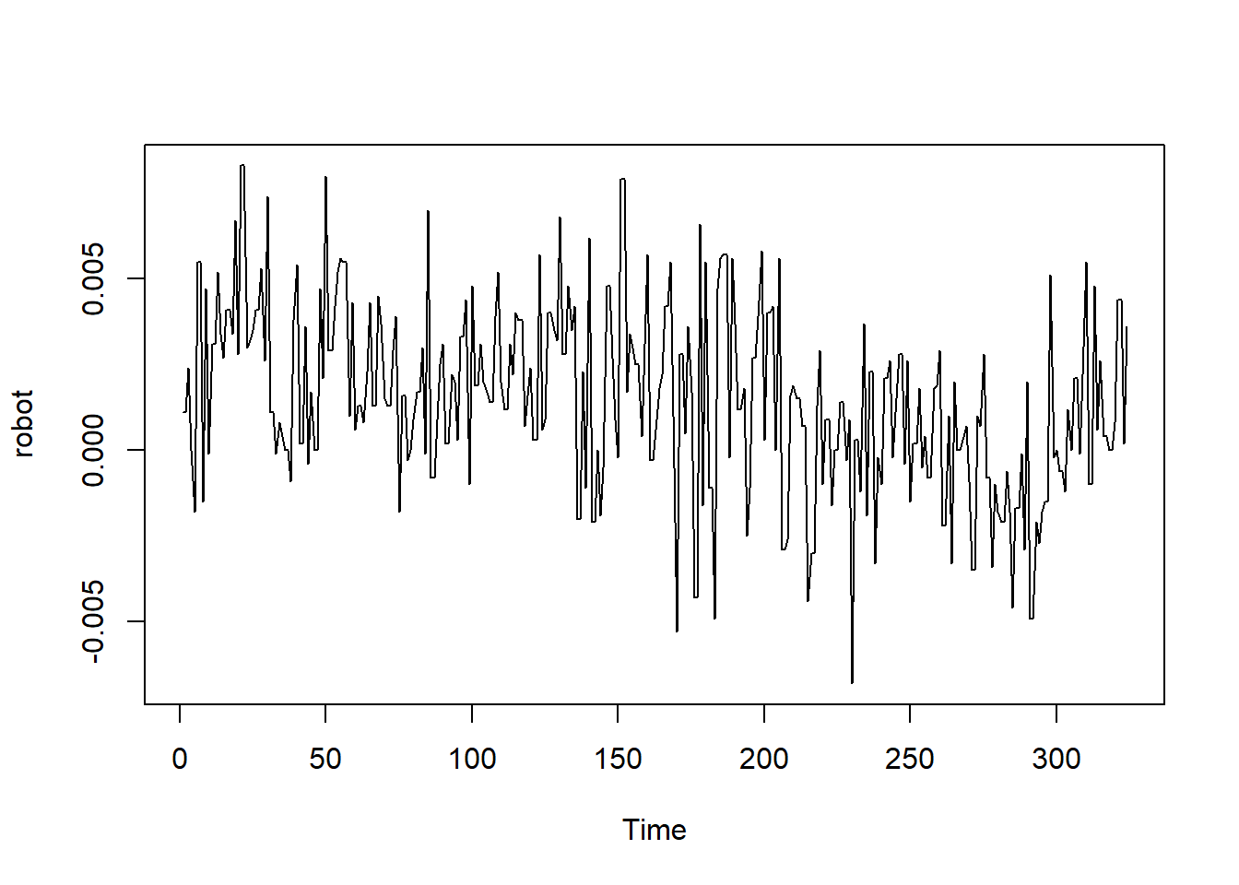

coef(arima(data,   
 order=c(1,0,0),  
 method='ML')) #maximum likelihood for AR(1) model

## ar1 intercept   
## 0.307574831 0.001452947

ar <- arima(data,   
 order=c(1,0,0),  
 method='ML') #maximum likelihood for AR(1) model  
coef(arima(data,   
 order=c(0,1,1),  
 method='ML')) #maximum likelihood for IMA(1,1) model

## ma1   
## -0.8712827

ima <- arima(data,   
 order=c(0,1,1),  
 method='ML') #maximum likelihood for IMA(1,1) model  
print('AR(1) AIC: ')

## [1] "AR(1) AIC: "

AIC(ar)

## [1] -2945.078

print('IMA(1,1) AIC: ')

## [1] "IMA(1,1) AIC: "

AIC(ima)

## [1] -2957.901

Comment: *Blank*

*Problem 7.30*

setwd('C:/Users/nqlc2c/Documents/HW6Data')  
data <- read.table('days.txt', header = TRUE)  
data <- ts(data, start = 1, end = nrow(data), frequency = 1)  
plot(data,  
 main = "Time Series Before Replacement")

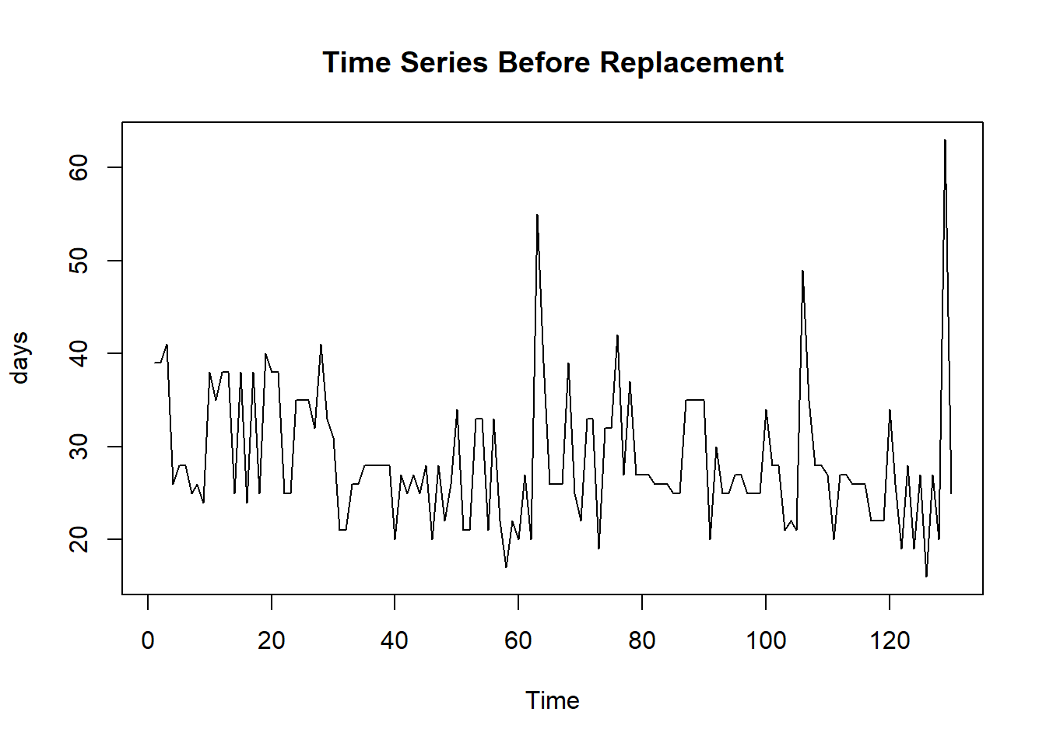

data[63] <- mean(data) #replace outlier with mean  
data[129] <- mean(data) #replace outlier with mean  
plot(data,  
 main = "Time Series After Replacement")

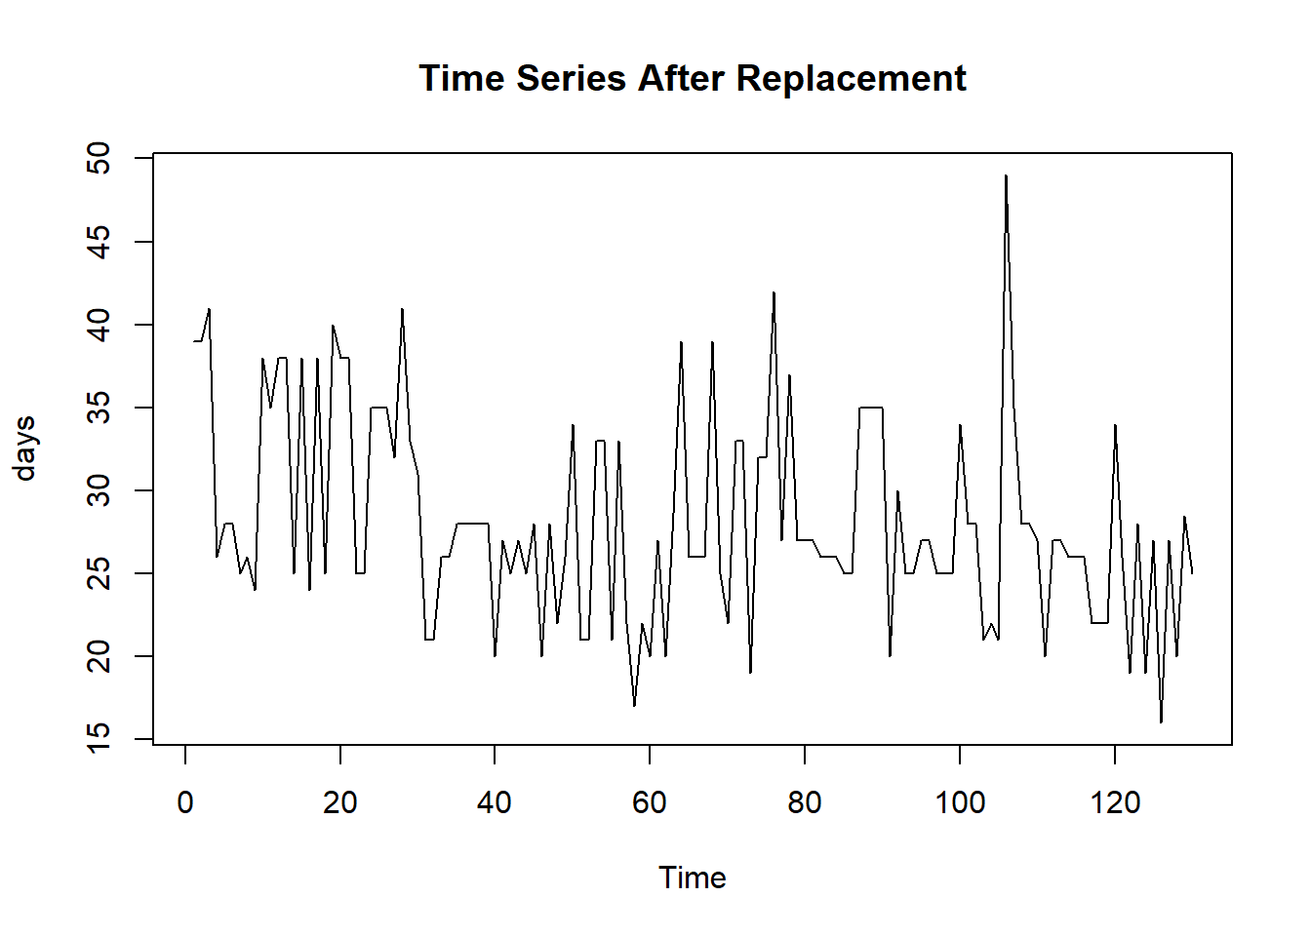

ma2 <- arima(data,   
 order=c(0,0,2),  
 method='ML') #maximum likelihood for MA(2) model  
coef(ma2) #coef of MA(2) model

## ma1 ma2 intercept   
## 0.1860801 0.1688048 28.1954246

ma5 <- arima(data,   
 order=c(0,0,5),  
 method='ML') #maximum likelihood for MA(2) model  
coef(ma5) #coef of MA(5) model

## ma1 ma2 ma3 ma4 ma5 intercept   
## 0.18999756 0.22521866 0.03382001 0.15023710 -0.09574906 28.22233179

print('MA(2) AIC: ')

## [1] "MA(2) AIC: "

AIC(ma2)

## [1] 841.8314

print('MA(5) AIC: ')

## [1] "MA(5) AIC: "

AIC(ma5)

## [1] 843.6589

Comment: *Blank*