**Smart Garbage Management System**

**Mini Project Report**

**Submitted to MIT ADT University, Pune**

**in partial fulfillment of the requirement for the award of degree of**

**Bachelor of Technology**

in

**Information Technology**

by

**Montukeshwar Vaishnaw (2175035)**

**Rajeev Sinha (2175047)**

Under the Guidance of

**Prof. Rekha Sungandhi**

****

**Department of Information Technology**

**MIT School of Engineering**

**MIT Art, Design & Technology University Pune**

**Off Pune Solapur Highway, Loni Kalbhor, Pune - 412201,**

**Maharashtra (India)**

**Month Year**

****

**MIT School of Engineering, Pune**

**CERTIFICATE**

This is to certify that Mini Project entitled **“Mini Project Title”** submitted by Montukeshwar Vaishnaw (2175035),Department of Information Technology in the partial fulfillment of the requirement for the award of degree B.Tech. Information Technology of MIT ADT University, Pune comprises only original work and due acknowledgement has been made in the text to all other material used.

**Date: 02 / 05 /2019**

|  |  |
| --- | --- |
| Guide  Guide Name | Head, Dept. of Information Technology  Prof. (Dr.) Rekha Sugandhi |
| Internal Examiner  Prof. | Principal  Prof. (Dr.) Kishore Ravande |

**ACKNOWLEDGEMENT**

Getting a project done reflects the proverbial saying “Success is a marathon and not a sprint”. Dedication and perseverance when supported by inspiration and guidance leads to success. We’re highly indebted to Guide Name for their guidance and constant supervision as well as for providing necessary information regarding the project & also for their support in completing the Mini Project work. In true sense it was privilege for us to have him as our guide and we felt highly honored working under him/her.

Prof.(Dr.) Rekha Sugandhi, Head, Dept. of Information Technology, has been a constant source of inspiration to us. Both are responsible for giving us the confidence and courage throughout execution.

We do not have words to express our sincere thanks to Prof. (Dr.) Kishore Ravande, Principal-MIT School of Engineering for their constant support and encouragement throughout the Mini Project work.

We also acknowledge the help of family, friends and all those who have encouraged and helped us directly or indirectly with our work but whose contribution we may have failed to mention inadvertently.

**Montukeshwar Vaishnaw (2175025)**

**Rajeev Sinha (2175047)**

**Kanak Chauhan (2175027)**

**ABSTRACT**

One of the main concerns with our environment has been solid waste managementwhich effects the health and environment of our society. The detection, monitoring and the management of wastes is one of the main problems of the present era. The old-style of manually monitoring the waste in waste bins is a heavy processwhich utilizes too much human effort, time and cost which can be easily avoided with our present technologies. This is our solution, a method by which waste management is automated.

## .

Table of Contents

|  |  |
| --- | --- |
| Contents | Page No. |
| Acknowledgement |  |
| Abstract | i |
| Table of Contents | ii |
| List of Tables | iv |
| List of Figures | v |

|  |  |  |  |
| --- | --- | --- | --- |
| Chapter 1: | Introduction | | 01-04 |
|  | 1.1 | Problem Statement | 02 |
|  | 1.2 | Objectives | 02 |
|  | 1.3 | Features | 03 |
|  | 1.4 | Organization of report | 04 |
| Chapter 2: | System Design | | 05-09 |
|  | 2.1 | Architecture or Block Diagram | 06 |
|  | 2.2 | Data Flow diagram | 06 |
|  | 2.3 | Activity Diagram | 08 |
|  | 2.4 | Use-case Diagram and Test cases | 08 |
|  | 2.5 | Database Design | 09 |
| Chapter 3: | System Implementation | | 10-11 |
|  | 3.1 | Technology | 11 |
|  | 3.2 | Results and Analysis | 11 |
| Chapter 4: | Applications | | 12-13 |
| Chapter 5: | Conclusion and Future Scope | | 14-15 |
|  | References | | 16 |

**LIST OF FIGURES**

|  |  |  |
| --- | --- | --- |
| **Figure No.** | **Caption** | **Page No.** |
| 2.1 | Block Diagram | 6 |
| 2.2 | Context diagram | 6 |
| 2.3 | Level 0 DFD | 7 |
| 2.4 | Level 1 DFD | 7 |
| 2.5 | Activity Diagram | 8 |
| 2.6 | Use-case Diagram | 8 |
|  |  |  |
|  |  |  |
|  |  |  |

**LIST OF TABLES**

|  |  |  |
| --- | --- | --- |
| **Table No.** | **Caption** | **Page No.** |
| 2.1 | Login | 9 |
| 2.2 | Student | 9 |

**Chapter 1:**

**Introduction**

**1. Introduction:**

IoT Garbage Monitoring system is an advanced way which will help in keeping the cities clean and healthy. The system monitors the garbage bins and informs about the level of garbage collected in the garbage bins through garbage monitoring mobile app. For this, the system uses ultrasonic sensors with each placed at the top of the bins to detect garbage level and compare it with the garbage bins depth. The system uses Raspberry pi 3, LCD screen, WIFI modem for sending data along with a firebase system to store collected runtime data. This system is powered by 12V batteries. The LCD screen is required to display status of the level of garbage that is collected in the bins. While the mobile application is built to show status to the user monitoring it. The mobile application gives a graphical view of the garbage bins and highlights the garbage collected in color so as to show the level of garbage collected. The LCD screen show the status of the garbage level. The system puts on a buzzer when the level of garbage collected crosses the specified limit. So, the system will help to keep the city clean by providing acknowledgement about the garbage levels of the bins by providing graphical image of bins.

## 1.1 Problem Statement:

To design and develop a web oriented application which allows us to access the whole information about the college, staffs, students, facilities etc.

**1.2 Objectives:**

1. Optimizes waste collection and its ultimately reduce the fuel consumption.
2. When the bin are placed at a particular position smartphone is required to detect its latitude and longitude.
3. This project will reduces the cost of overall system; as GPS will not be required then.

## Features:

1. The smart, sensor based trashbin will detect the level of waste in it and will send the message directly to municipal corporation.
2. It can sense all types of waste material no matter it is in the form of solid or liquid.
3. According to the filled level of dustbin, vehicles from municipal corporation will choose the shortest path with the help of the “TRANSPORTATION SOFTWARE” which will save a measurable time.
4. It highlights “DIGITAL INDIA”.
5. The system is simple, if there is any problem with any equipment in future, that part is easily replaceable with the new one without any difficulty or delay.

## 1.4 Organization of Report:

In the chapter 1, we introduced the problem in the existing system and explained the proposed system along with problem statement, objectives and features. Chapter 2 provides project system design. Chapter 3 consists of the technology and system implementation results and analysis. Chapter 4 comprises of system application. In the chapter 5, conclusion and future scope is provided.

**Chapter 2:**

**System Design**

**. System Design**

**2.1 Architecture or Block Diagram**

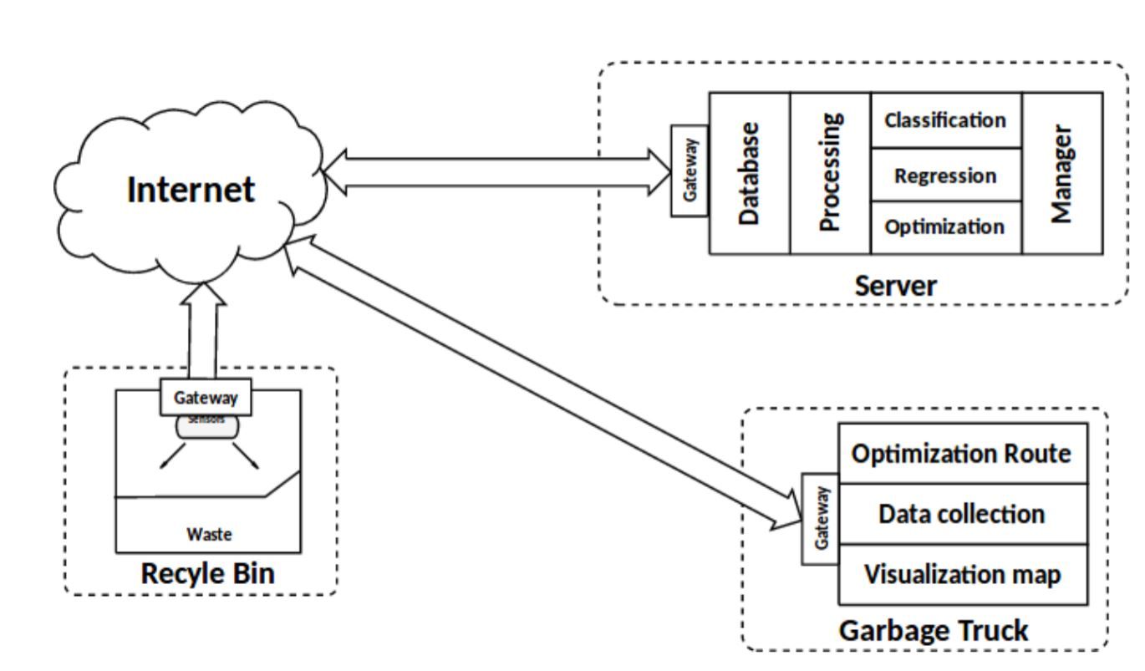

**Figure 2.1: Block Diagram**

**2.2 Data Flow diagram**

**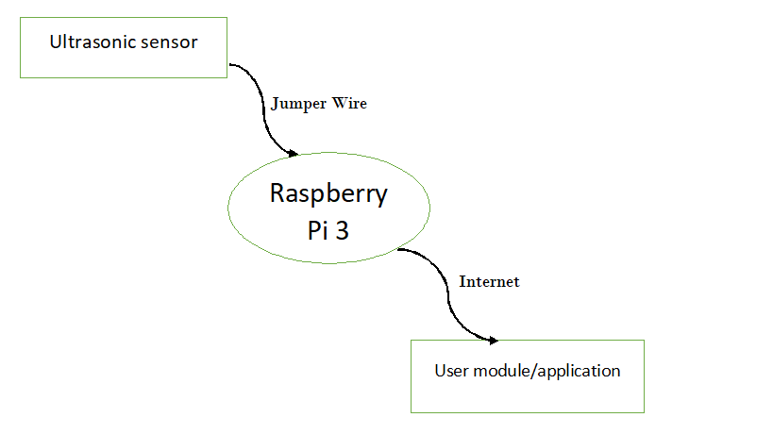**

**Figure 2.2: Context Diagram**

Ultrasonic Sensor

Trash Quantity

**Server**

Application

**Figure 2.3: Level 0 DFD**

Ultrasonic Sensor

Trash Quantity

**Server**

Application

**Figure 2.4: Level 1 DFD**

**2.3 Activity Diagram**

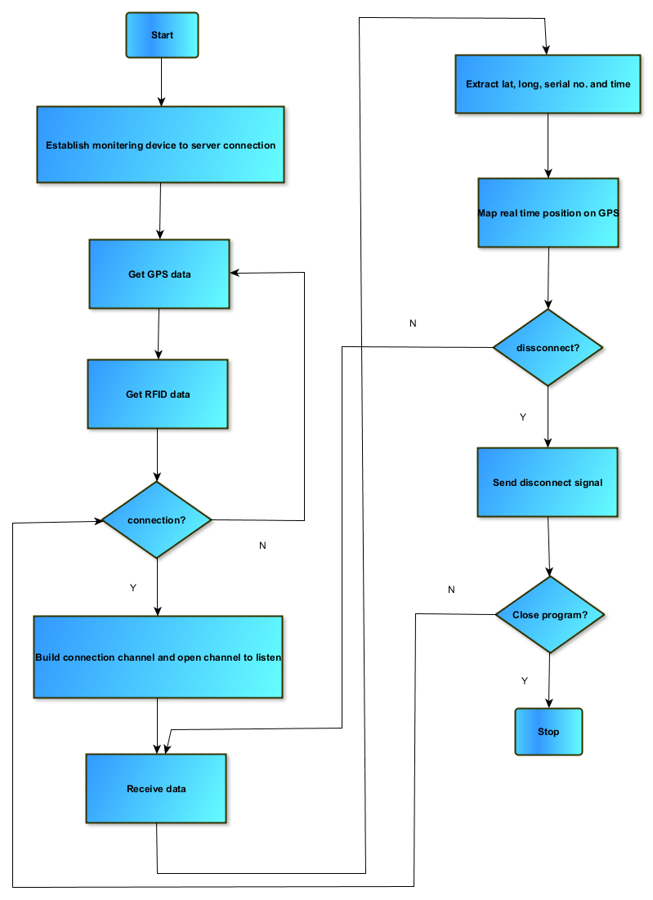

**Figure 2.5: Activity Diagram**

**2.4 Use-case Diagram and Test cases**

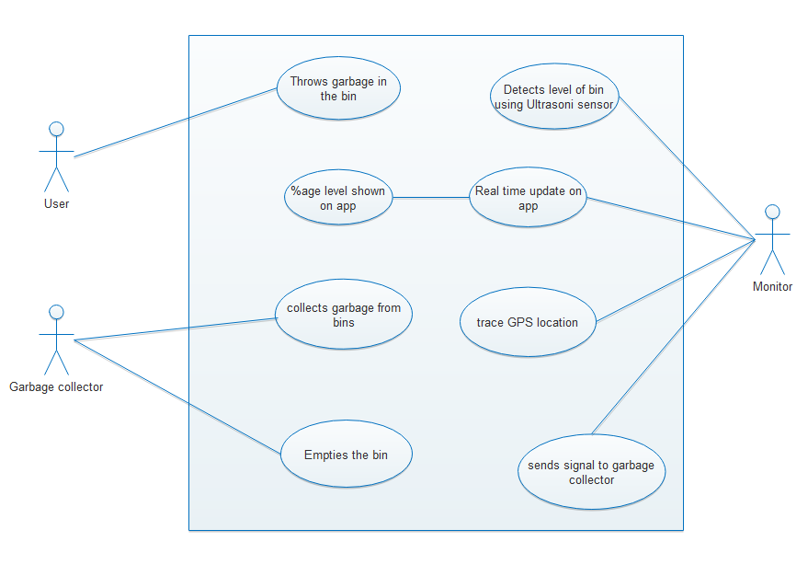

**Figure 2.6: Use-case Diagram**

**Test Case for ‘Login’ Use case:**

| **Test Cases** | **Steps** | **Expected Result** |
| --- | --- | --- |
| **A** | **Login –Normal flow** |  |
| 1 | Enter username | User can enter Username |
| 2 | Enter Password | User can enter Password |
| 3 | Click on Login | System gives User Login |

| **B** | **Login 2-Invalid Username** |  |
| --- | --- | --- |
| 1 | Repeat steps 1,2 and 3 of Login |  |
| 2 | Enter username | System displays Error message |

**2.5 Database Design**

|  |  |  |
| --- | --- | --- |
| Fields | DataType | Constraints |
| Username | Character | UNIQUE |
| Password | Character | UNIQUE |

Table 2.1: Login

**Chapter 3:**

**System Implementation**

**3. System Implementation**

**3.1 Technology**

**Platform :**Windows, Android, Linux

**Front End :** Blynk, Node red

**Back End :** Blynk Local Server, Java, Python, Node red

**Blynk :-** It is a hardware-agnostic IoT platform with customizable mobile apps, private cloud, rules engine, and device management analytics dashboard.

**Blynk Server** is an Open-Source [Netty](https://github.com/netty/netty" \t "_blank) based Java server, responsible for forwarding messages between Blynk mobile application and various microcontroller boards and SBCs (i.e. Arduino, Raspberry Pi. etc).

**Node-RED** is a flow-based development tool for visual programming developed originally by IBM for wiring together hardware devices, APIs and online services as part of the Internet of Things. Node-RED provides a web browser-based flow editor, which can be used to create JavaScript functions

**3.2 Results and Analysis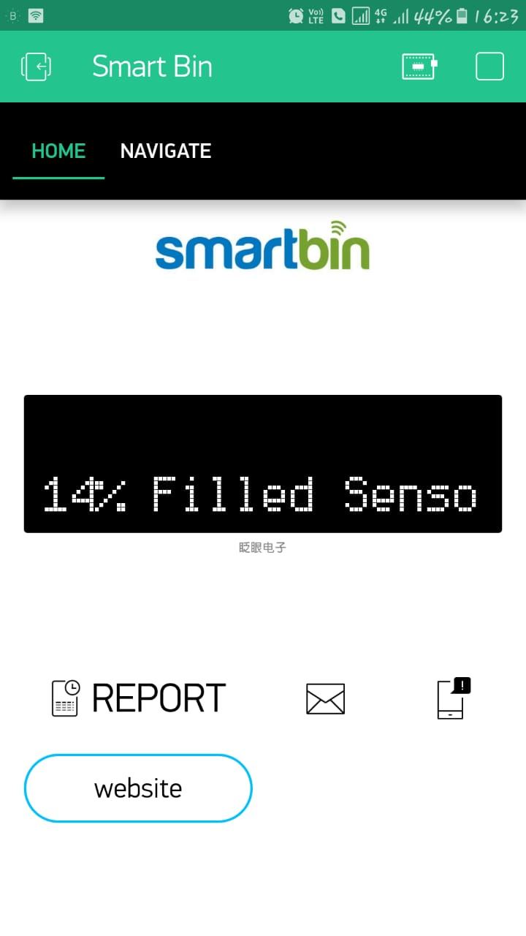**

Main Interface of the application to check the level of garbage in the Bin.

**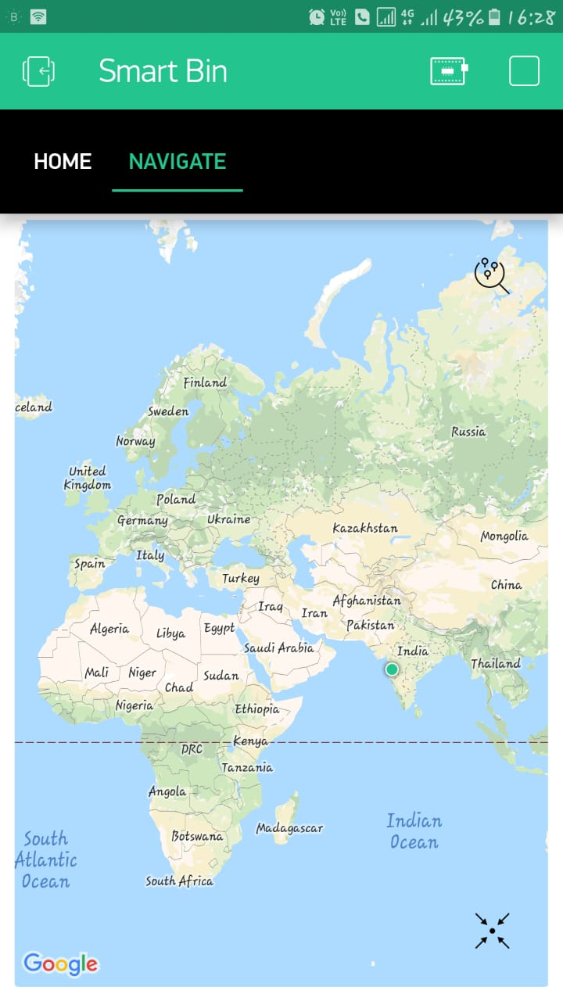 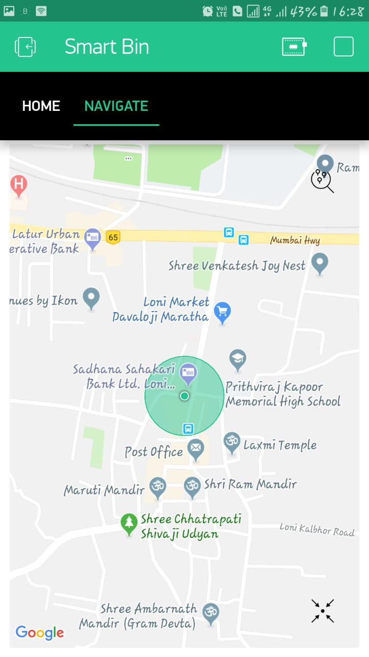**

Navigation Tab :- By clicking Navgating point on the map we can get the exact location of the bin and also we can get status the bin (Full or empty).

**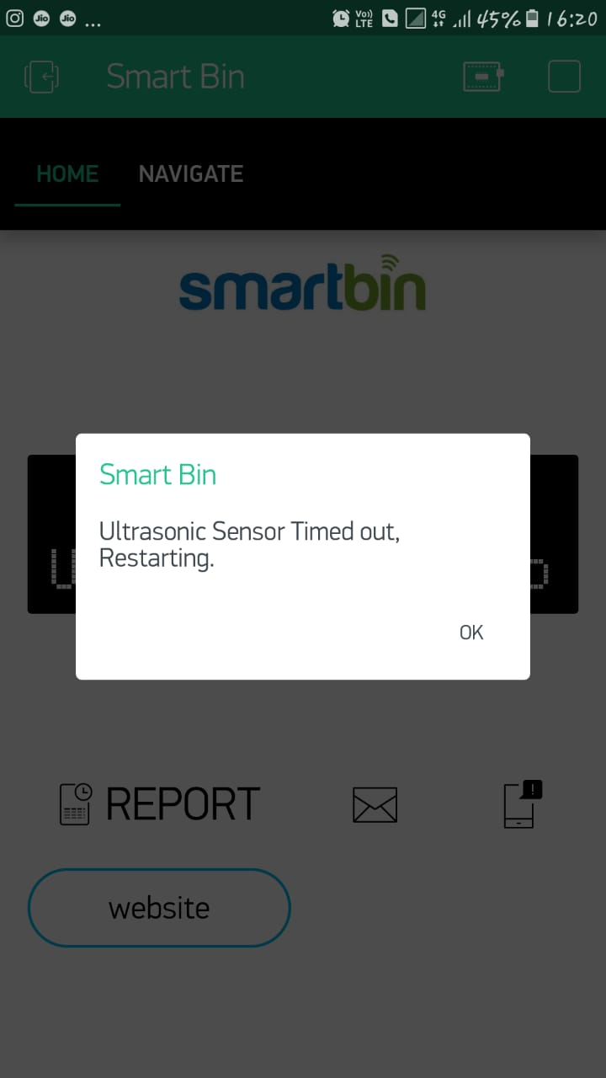**

Notification :- If the System goes down and needs to checkout the setup of hardware.

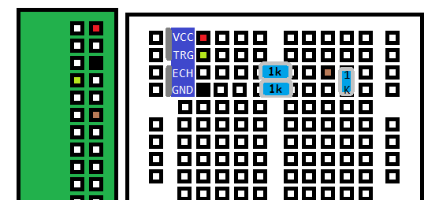

**Connection Between Raspberry pi and Ultrasonic Sensor**

**Chapter 4:**

**Applications**

**4. Applications**

i. This project can be implemented in Smart Cities.

ii. It will reduce the fuel consumption and time for collecting garbage.

iii. This project will help to maintain the cleanliness in the city in smart way.

**Chapter 5:**

**Conclusion and Future Scope**

**5. Conclusion and Future Scope**:

**SCOPE**

The scope of our project is not restricted to any particular geographic area as long as it has the required IoT infrastructure. This work of ours can be implemented in any city which is big enough to have problems regarding to waste management. A more advanced system can be implemented with the time stamp in which the real clock is used to display to the person at what time the dustbin is full and when the truck driver has collected the waste from the dustbin. This system also has a scope for citizen participation, wherein any grievances from citizens related to waste management is heard. The system can be implemented.

**CONCLUSION**

In this project, an integrated system IoT, GSM, Ultrasonic Sensor is introduced for efficient and economic garbage collection. The developed system provides improved database for garbage collection time and waste amount at each location. We analyzed the solutions currently available for the implementation of IoT. By integrating this project, we can avoid overflow of garbage from containers that are placed in residential area which all were previously either loaded manually or with some help of loaders in traditional trucks. It can monitor the garbage level automatically and send the information to the collection truck. All technologies which are used in this proposed system are good enough to guarantee the practical and perfect for solid garbage collection process monitoring and management for a green environment.

**References**

1. <https://pythonprogramming.net/>
2. <https://iotify.help/virtual-lab/smart-trash/>
3. <https://www.hindawi.com/journals/tswj/2014/646953/>