Caregiver Guide Book
Effective Date: 1 March 2026 | Version: 2.0 | Sample RAG Knowledge Base
This guide supports day-to-day delivery of safe, person-centred home care using HomeCare Scheduler. It must be used alongside each client's individual care plan, risk assessments, and current company policies. Where the care plan conflicts with this general guide, the care plan takes precedence.

Visit Flow Overview
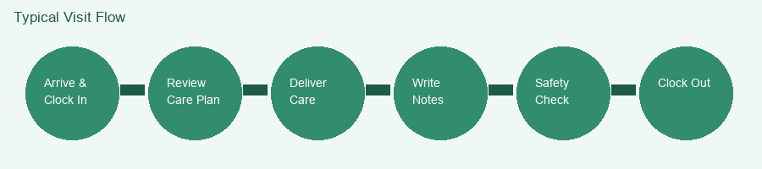

1. Person-Centred Care Principles
- Introduce yourself each visit; explain what you will do before starting care.
- Offer choices (e.g. wash first or breakfast first) where the plan allows flexibility.
- Respect privacy: close doors, use towels for dignity during personal care.
- Encourage independence; assist rather than take over when the client can participate.
- Observe and report changes in mood, appetite, skin integrity, mobility, or cognition.
- Respect cultural, religious, and dietary preferences documented in the care plan.

2. Standard Visit Workflow
Stage | Actions | App / Record | Time Tip
Arrive | Greet client; confirm wellbeing; wash hands | Clock in at door | Allow 2 min transition
Plan check | Review today's tasks & any alerts | Open care plan PDF | Before personal care
Care delivery | Personal care, meals, prompts, domestic tasks | Follow plan exactly | Stay within allotted time
Observation | Skin check, mood, hydration, pain cues | Note abnormalities | Continuous
Documentation | Factual notes; refusals & alternatives | Visit notes in app | Before clock-out
Safety exit | Call bell, drink, phone, locks, heating | Clock out | Never rush exit

3. Communication & Escalation
Situation | First Action | Then
Medical emergency | Call 112/999 | Notify office ASAP
Client not answering door | Follow no-reply protocol (wait, knock, call) | Phone office
Running late (>15 min) | Phone office with ETA | Update notes if tasks shortened
Care plan unclear | Do only documented safe tasks | Request plan clarification
Non-urgent clinical change | Record in notes objectively | Request care plan review
Safeguarding concern | Ensure immediate safety | Phone office + safeguarding pathway

4. Personal Care & Dignity
Prepare equipment before starting. Maintain warmth and privacy. Use correct PPE. Follow pressure area care as plan specifies. Record skin changes. For catheter or stoma care, only proceed if trained and authorised. Dispose of waste in client household bins per local policy or take clinical waste bags if supplied.

5. Meals, Fluids & Nutrition
Support meal preparation as plan allows. Encourage fluids unless fluid restriction documented. Note intake if required. Be aware of choking risk; follow SALT recommendations if present. Report weight loss or poor appetite over several days.

6. Medication Prompting
Do | Do Not | Record
Check right client, dose, time, route | Administer if client refuses without plan guidance | Time prompted; taken/refused
Use blister pack / MAR chart | Alter dose or crush tablets unless plan says so | Discrepancies immediately
Wash hands; use gloves if policy requires | Leave meds unattended | Who witnessed if required

7. Infection Prevention
- Hand hygiene before/after care and after glove removal.
- Use PPE as directed; change gloves between dirty/clean tasks.
- Do not attend work with vomiting, diarrhoea, or fever - call the office.
- Clean spillages with household disinfectant from client supplies or your kit.
- Laundry: follow plan for contaminated clothing; bag separately if required.

8. Documentation Standards
Write clear, factual, timely notes. Use client preferred name. Avoid judgemental language. Record refusals and what alternatives were offered. Never copy previous shift notes. Accurate documentation supports continuity, safeguarding, and billing integrity.

9. End-of-Visit Safety Checklist
Check | Done?
Client comfortable and positioned safely
Call bell / phone within reach
Drink available if appropriate
Medication stored & locked per plan
Doors/windows/ heating as client prefers
Hazards cleared (spills, cables)
Next visit time confirmed if known
Office informed of any concerns
Sample RAG document only. Always follow the live care plan and current company policies.

10. Domestic Tasks & Home Safety
Light housekeeping may be in the care plan: changing bed linen, laundry, vacuuming, meal preparation. Use client appliances safely; do not rearrange furniture without permission. Report trip hazards, faulty smoke alarms, or inadequate heating.
Task | Safety Note | Record If
Bed linen | Use correct technique if client in bed | Skin issues observed
Laundry | Separate soiled items per plan | Stains indicating illness
Meals | Follow IDDSI / diet texture if specified | Poor intake
Waste | Sharps in approved container only | Missing sharps bin

11. Night & Evening Visits
- Carry torch; park safely; lock car.
- Check lighting before entering; announce yourself.
- Falls risk higher at night - allow extra transfer time.
- Leave client with night light, call bell, and phone if used.
- Document sleep disturbances or confusion for care plan review.

12. End-of-Life & Sensitive Situations
Some clients receive palliative support at home. Follow the palliative addendum if present. Focus on comfort, dignity, and family wishes. Do not discuss prognosis unless trained and authorised. Escalate sudden changes via office immediately.

13. Quick Reference Card
Emergency | Number / Action
Medical emergency | 112 / 999
Office (day) | +353 1 555 0100
On-call (evenings) | See roster SMS
Safeguarding | Office then HSE pathway

