Leave Balances & Leave Policy
Effective Date: 1 March 2026 | Version: 2.0 | Sample RAG Knowledge Base
This policy explains how annual leave, sick leave, public holidays, and other absence types are calculated, requested, approved, and deducted from employee balances within HomeCare Scheduler. It applies to caregivers and office staff unless a separate contract states otherwise.

Sample Balance Snapshot
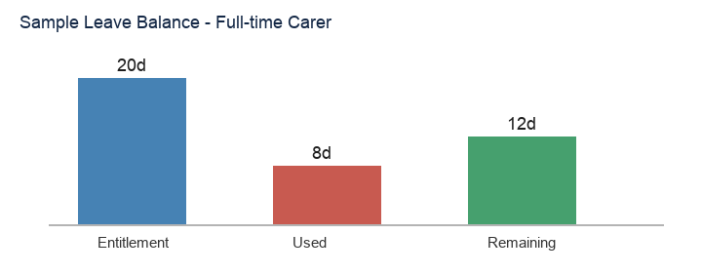

1. Leave Year & Entitlement
The leave year runs from 1 April to 31 March. Entitlements reset on 1 April except approved carry-over days (maximum 5 days with written Admin approval). Public holidays are tracked separately from annual leave.
Contract Type | Weekly Hours | Annual Leave | Public Holidays
Full-time caregiver | 39 | 20 days (156 hours) | 9 days
Part-time (20 hrs/week example) | 20 | Pro-rated (~10.3 days / 80 hrs) | Pro-rated
Office full-time | 37.5 | 20 days | 9 days
5+ years continuous service | As contracted | +2 additional days | As entitled

2. How Balances Are Calculated
Each approved leave request deducts hours from the remaining balance. For full-time caregivers, one standard day equals 7.8 hours. Half-days equal 3.9 hours. Where rosters vary day to day, the system deducts the scheduled hours for each requested date.
Request Type | Hours Deducted (FT) | Minimum Notice | Approver
Full day annual leave | 7.8 | 14 days for 3+ consecutive days | Admin
Half day annual leave | 3.9 | 7 days preferred | Admin
Single day annual leave | 7.8 | 7 days preferred | Admin
Sick leave (paid statutory) | Scheduled hours | Before shift where possible | Office + HR
Bereavement leave | Up to 3 days (23.4 hrs FT) | ASAP | HR / Admin
Unpaid leave | 0 paid / blocks roster | 14 days preferred | Admin

3. Requesting Leave in the App
- Open Leave Requests -> Create.
- Select leave type (Annual, Sick, Bereavement, Other).
- Enter start date, end date, and optional note.
- Submit. Status shows Pending until Admin acts.
- Do not assume approval from verbal conversation alone.
- For emergency sick leave (<48 hours notice), phone the roster office then log in the app same day.

4. Sick Leave & Medical Certificates
Statutory sick pay entitlements apply as per current Irish legislation; confirm the current rate and day count with HR. Absences of two or more consecutive working days require a medical certificate uploaded to HR within three calendar days of return.
Scenario | Certificate Required? | Action
1 day sick | No (unless policy update) | Log sick leave in app; phone office
2+ consecutive days | Yes | Upload cert within 3 days of return
Repeated short absences | May be requested | Welfare meeting may be scheduled
Infectious illness | Yes when applicable | Do not attend client visits until cleared

5. Carry-Over, Expiry & Public Holidays
Unused annual leave expires on 31 March unless up to 5 days are carried forward with written Admin approval. Public holidays worked attract either a paid day off in lieu or premium pay as per contract. Part-time staff receive pro-rated public holiday entitlement.

6. Worked Examples
Example A - Full-time carer (mid-year): Entitlement 20 days (156 hrs). Used 8 days (62.4 hrs). Remaining 12 days (93.6 hrs). Example B - Part-time carer 20 hrs/week: Entitlement ~10.3 days (80 hrs). Used 2 days (15.6 hrs). Remaining ~8.3 days (64.4 hrs). Example C - Half-day request: Deducts 3.9 hrs from balance; roster shows PM off only.

7. Disputes & Contact
If your balance appears incorrect, email hr@homecarescheduler.example with employee ID, dates in question, and screenshots from the app. Roster conflicts: operations@homecarescheduler.example.

8. Public Holidays & Premium Pay
Full-time staff are entitled to 9 public holidays per leave year. If you work on a public holiday, you receive either an additional day off in lieu within one month or premium pay as stated in your contract. Part-time staff accrue public holiday entitlement proportionally.
Public Holiday Worked | Option A | Option B
Scheduled visit on holiday | Paid day off in lieu (7.8 hrs FT) | Premium pay per contract
Office closed | Normal pay if salaried | N/A
Part-time worked holiday | Pro-rated lieu hours | Pro-rated premium

9. Parental & Family Leave (Summary)
Maternity, paternity, parent's, adoptive, and carer's leave follow current statutory entitlements in Ireland. Notify HR at least 8 weeks before intended start where possible. Statutory forms and certificates must be submitted to payroll. Unpaid parental leave may be available after qualifying service; roster cover must be confirmed before approval.

10. FAQ
- Can I cancel approved leave?
Contact Admin immediately. If roster cannot be covered, leave may stand.
- Does training day deduct leave?
No - mandatory company training is paid working time.
- What if I am sick on a public holiday?
Statutory rules apply; HR will advise case by case.
- Half-day AM or PM?
Specify in request notes; system blocks scheduled hours accordingly.

