MScDAFeb2025 - MSc in Data Analytics

Author: Joel Albert Montuya
e-mail: 2025040@student.cct.ie
Student ID: 2025040

Abstract
This study aims to develop a reliable forecasting model for predicting renewable energy outputs in the Republic of Ireland using various supervised machine learning algorithms. All datasets utilised in this research were validated to ensure adherence to the data usage policy, avoiding potential legal actions for misuse. In addition, energy-related discussions were gathered using the Reddit API to analyze sentiments, which were compared against those of other European countries using the Flair sentiment model and other text processing methodologies to generate insights. Algorithms, such as Artificial Neural Network (ANN), Seasonal Autoregressive Integrated Moving Average (SARIMA), and Tree-based models–specifically Random Forest and Extreme Gradient Boosting (XGBoost) were implemented and analyzed to find the best model suited for the study. The resulting forecasting model can assist in creating data-driven decisions and planning to improve energy infrastructure and development across Ireland.
Keywords: Ireland, renewable energy production, forecasting, neural networks, SARIMA, flair, XGBoost, random forest, sentiment analysis
Introduction
Renewable Energy makes a great contribution to economic development. Reducing dependencies on expensive fuel imports greatly cuts skyrocketing electricity bills for residential and business users. Since 2020, Irish wind farms have contributed to a third of the country’s electricity and have reduced the bills by an estimated €1.7 billion or about €320 per person. This demonstrates the country’s huge potential for developing sustainable energy, which will make electricity affordable and secure a stable energy supply throughout Ireland (Cunniffe, 2025).
Compared to other European Countries, Ireland ranked second in the most expensive electricity prices, just a little behind Germany. Irish consumers pay €500 or 30 per cent above the average cost in the EU (Pope, 2024). In terms of renewable energy usage, Norway topped the list with 75.8 percent, while Ireland has one of the lowest proportions of about 13.1 percent, indicating that it is way behind the target of 32 to 42.5 percent for 2030 under the EU’s Renewable Energy Directive (Hughes, 2024).
Forecasting on renewable energy assists in management and operations by reducing risk, boosting stability, and enhancing the reliability of the infrastructure. Electricity network operators can anticipate fluctuations in energy supply and demand, enabling them to make data-driven decisions on stability, resource allocation, and energy dispatch effectively (Qureshi, 2023). Thus, this research focuses on creating a reliable forecasting model with the use of Artificial Neural Networks (ANN) and Seasonal Autoregressive Integrated Moving Average (SARIMA).
Materials and Methods
The section provides detailed procedures and techniques used to implement an effective forecasting model.
- Data Preparation and Visualisation
1.1 Data Acquisition and Licensing Discussion
For this research, which focuses on forecasting renewable energy production in the Republic of Ireland, several data repositories were explored in search of a reliable dataset for this study including Central Statistics Office (CSO), the Sustainable Energy Authority of Ireland (SEAI) and European Union Repository (data.europa.eu).
The Central Statistics Office (CSO) has several datasets in regards to electricity production, import/export, and consumption. However, the dataset acquired only provides gross or yearly data, which is limited and provides poor seasonality in the data, compared to monthly, which generates lower forecasting errors, making yearly data less suitable for time-series forecasting (Weir, 2024). The datasets used for this research are licensed under Creative Commons Attribution 4.0 (CC BY 4.0), which permits the use of the data, provided appropriate attribution to the publisher as listed in the reference section.
The dataset used for forecasting was sourced from the Sustainable Energy Authority of Ireland (SEAI), which contains monthly data on indigenous energy produced. A notable concern is that an appropriate license was not provided on the website. To clarify the conditions, SEAI was contacted to request permission to use the dataset, and confirmed that the data is publicly available and attribution is sufficient for use.
For sentiment analysis, data were gathered using Reddit’s proprietary API and accessed with valid credentials, adhering to ethical compliance and usage policies. The API’s response is in JSON format. The comments and subcomments are nested deeply in the JSON, making the extraction complex. The JSON response was converted into a string format, where regular expressions (REGEX) were applied to find all patterns containing the information. The collected comments were then transformed into a dataframe and further processed to analyze sentiments using Flair and other word processing methodologies.
While private and public-sector provided datasets are relevant to this study, implications for improper citations may result in sanctions and fines for violating GDPR, which may cost up to €20 million or 4 percent of global revenue, and publishers may file for damages and seek compensation for misuse of data (Wolford, 2018). Thus, legal and ethical considerations were highly regarded in this research, ensuring that datasets are properly utilized and lawfully acquired.

1.2 Exploratory Data Analysis
The dataset utilised for forecasting contains data on indigenous energy produced in Ireland from the year 2010 to 2025. It contains features such as year, month, and energy sources such as coal, hydro, solar, wind, and other types.

Processes performed:
- As it is common for datasets to be incomplete, null checking was performed to detect any inconsistencies, which will help mitigate major issues before model training (Amat Rodrigo and Escobar Ortiz, 2022). All numerical features are of type float, indicating that there are no null and other forms of invalid values in the dataset. 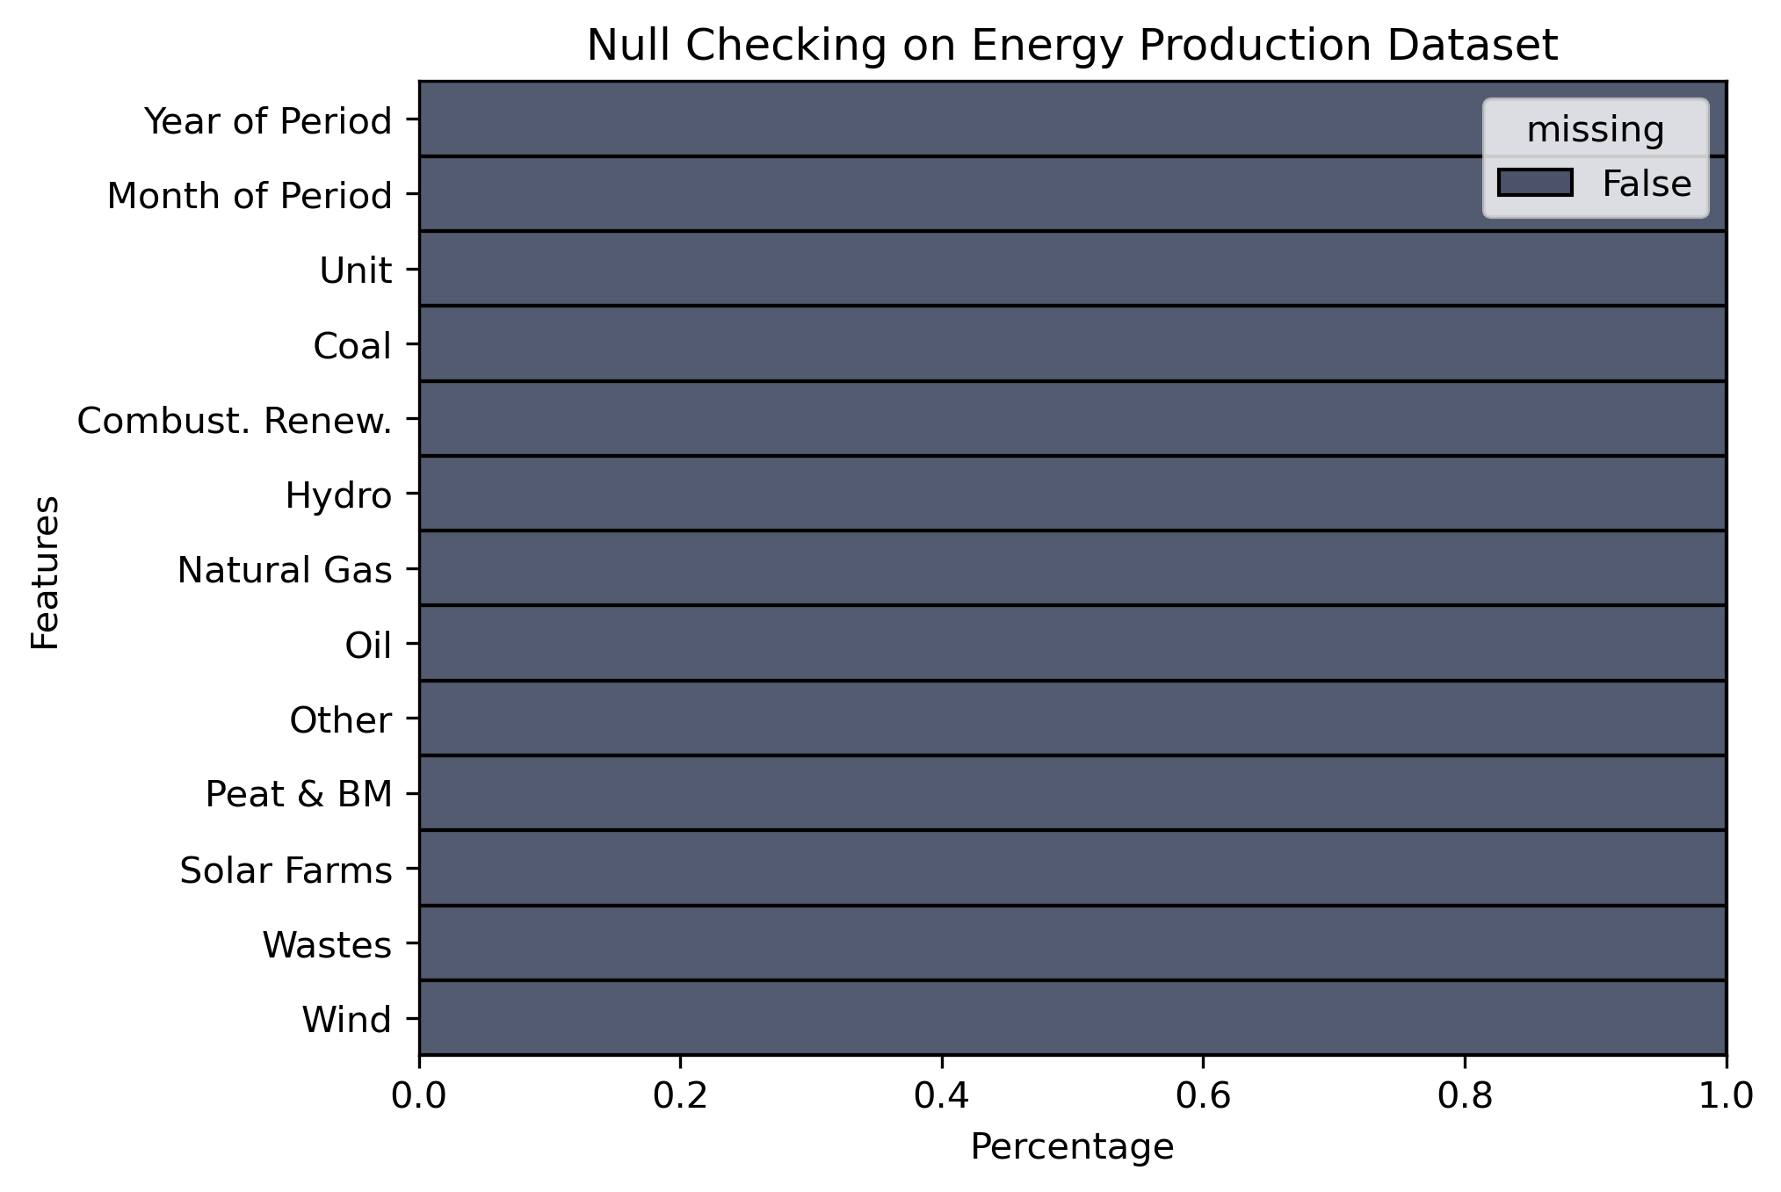
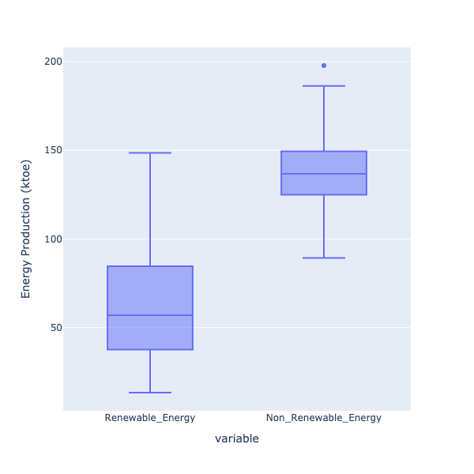
- The next step was to sum the values of renewable energy sources (e.g., solar, wind, hydro) and non-renewable energy (e.g., coal, natural gas, oil, peat), as implemented in EDA section 1.1.1.

- Outlier checking was also performed to avoid a negative impact on accuracy if not handled effectively, resulting in over- or under-fitting and biased results (Wijaya, 2020). Boxplots indicate that the non-renewable energy feature contains outliers. The IQR method was used to identify specific records with outliers and was interpolated, which is effective on time-series data, particularly for SARIMA, which is sensitive to sudden fluctuations (Wahir et al., 2018).

- Scatter plots aid in identifying the direction of the trend, the strength of correlation, and linearity (Yi, 2025). Implementing on renewable Energy feature, the trendline indicates an increase in production over time, and the points disperse more over time, indicating heteroscedasticity, making ANN and Tree-based algorithms suitable (Hayes, 2024).
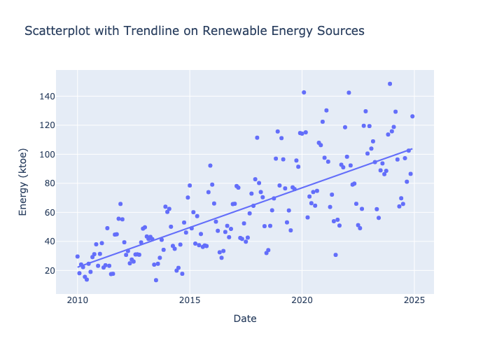

1.3 Feature Engineering and Scaling
Two different data preparation approaches were implemented, which are tailored to the specific requirements of the machine learning models utilized in this research.

- Artificial Neural Network (ANN):
The time-based features were added, which will aid as indicators for seasonal changes such as winter, spring, summer, autumn, and flags for the start and end of the year, as seen on EDA 1.3.5 (Gordon, 2023). Since ANN doesn’t have a built-in lag feature like SARIMA, manual incorporation into the dataset was made, as this aids in capturing seasonality and trends in the data (Gordon, 2023). MinMax scaling was employed since it helps the weights to converge fast in gradient descent and avoids the model from struggling if the target variable is on different scales (Brownlee, 2019).

- SARIMA:
Since Month and Year are in separate values, both are combined to create a date feature in ‘YYYY-mm-dd’ format and set as an index of the dataframe. Since SARIMA is a lag-based model, its Autoregressive component AR(p) uses target variables to create lagged values. Thus, manually adding lagged values will be redundant (Bajaj, 2022). Scaling is also not required in SARIMA, as it is not sensitive to the magnitude of data and does not rely on distance-based calculations.

1.4 Interactive Dashboard

Dashboard creation aimed to provide useful insights and transform complex data into an easier representation for non-technical stakeholders, promoting readability and engagement through interactivity (Statsig, 2024b). The renewable energy predictions, energy sources (renewable and non-renewable), European energy prices, and sentiment analysis were added to the dashboard, which is facilitated by Plotlydash for dashboard implementation (Plotly Technologies Inc., 2025). Tufte’s principles were also observed in the visual rendering process: Graphical Integrity was observed through all visualizations, ensuring clear and concise labeling to provide accurate interpretation of the information. Graphs follow a high data-ink ratio and avoidance of chartjunks by excluding unnecessary background elements, visual clutter, and overstyling, which may mislead viewers (Andrewtk, 2020).

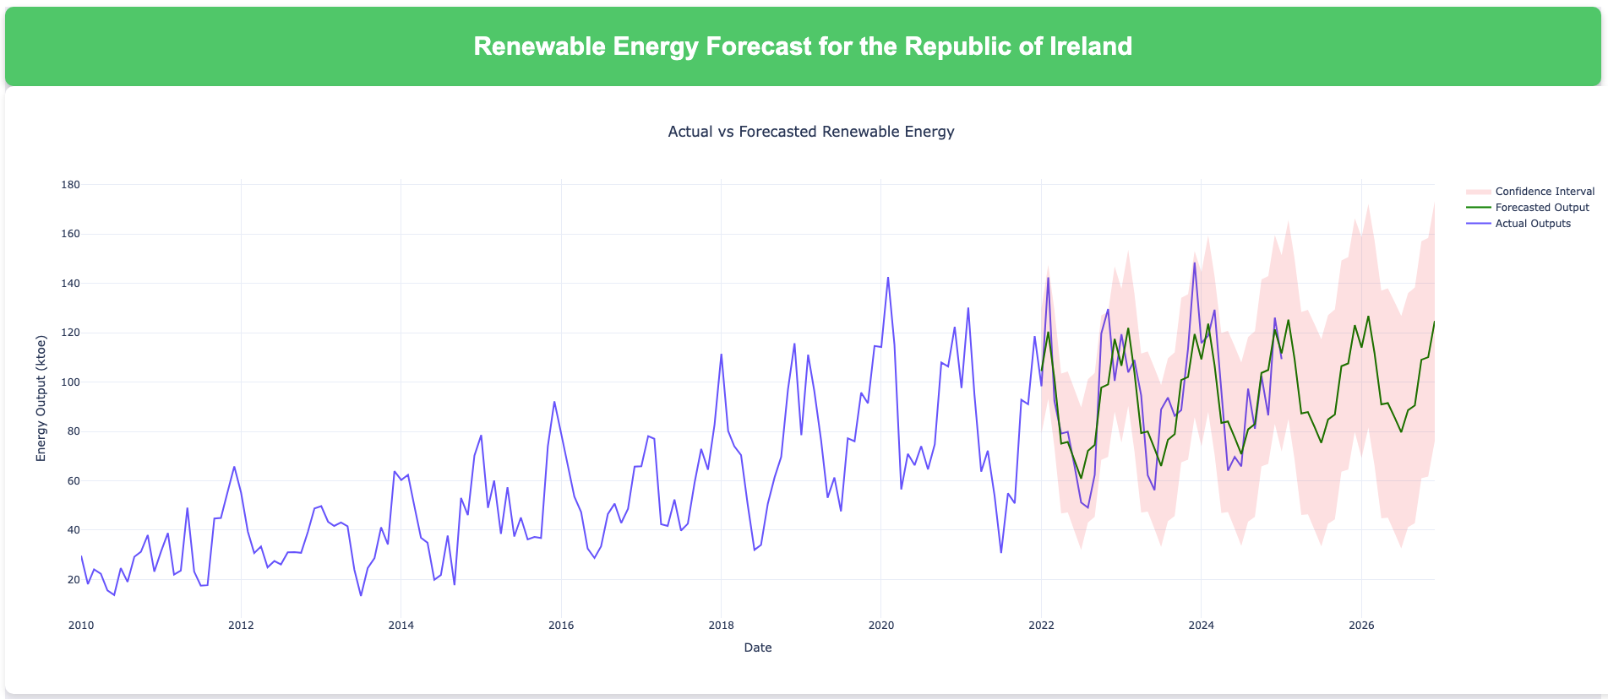

2. Statistics

2.1 Descriptive Statistics
The following section covers descriptive statistics of Ireland’s indigenous energy production dataset.

2.1.1 Measure of Central Tendency
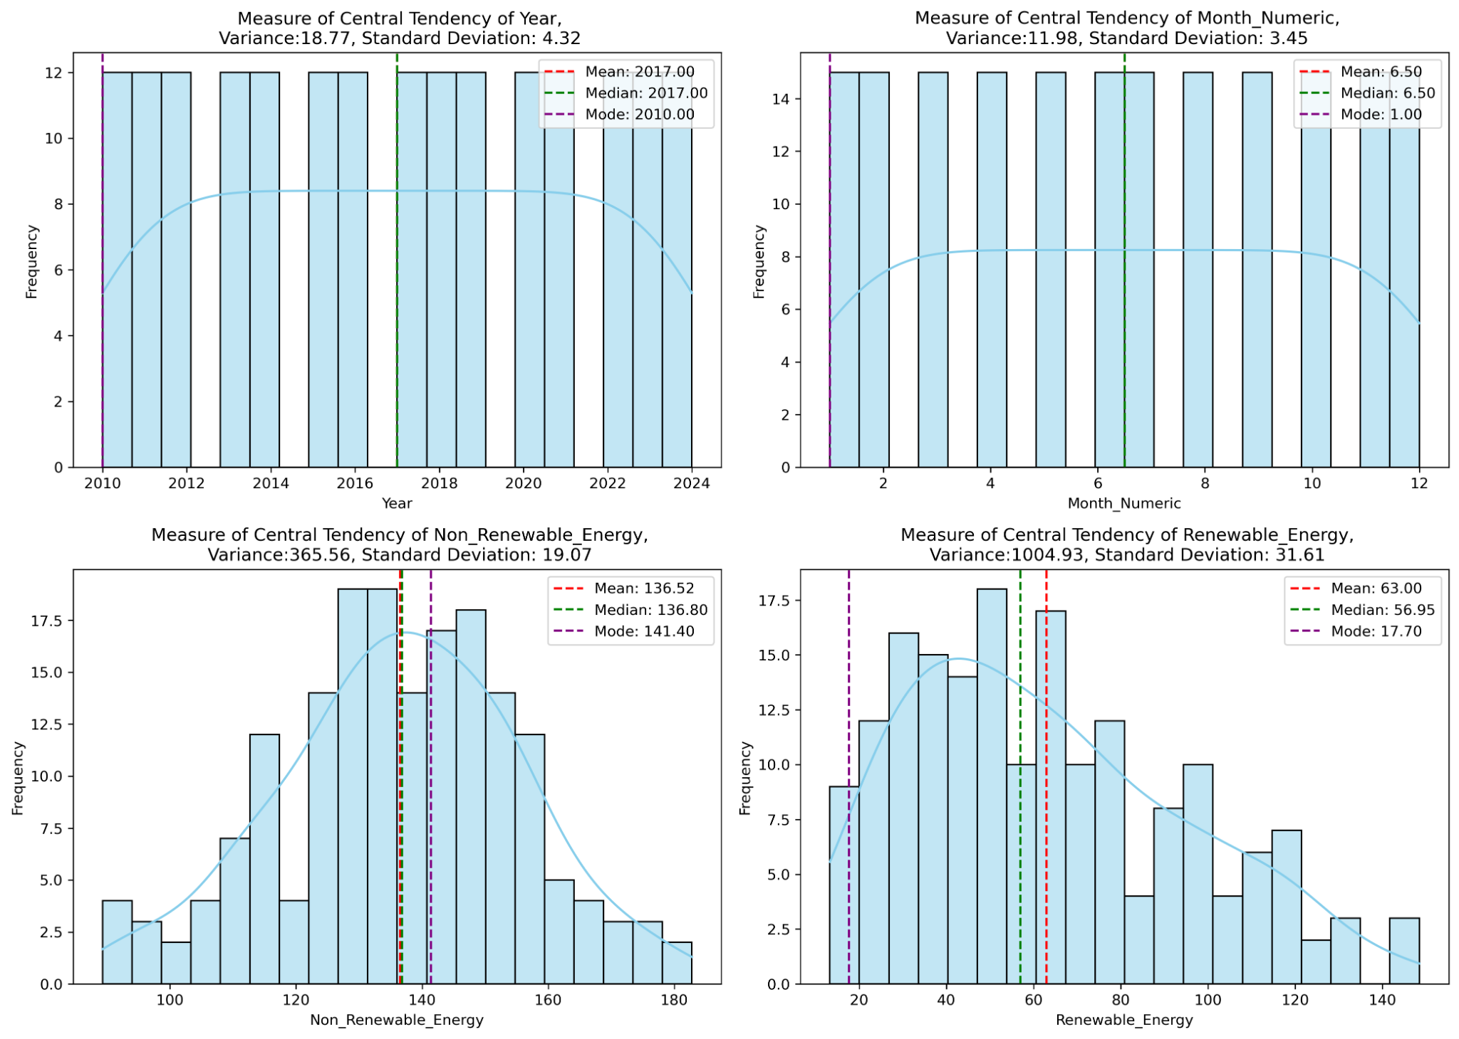
Analysis:

- Year:
Based on the first graph, the dataset covers from 2010 to 2024. The distribution of the year plot appears to be symmetric or uniform, as supported by the alignment of the mean and the median in 2017. Having a low variance of 18.77 and a standard deviation of 4.32 indicates a consistent distribution of yearly entries.

- Month Numeric:
The result shows a symmetric distribution as the mean and median are at 6.5, which indicates that the monthly data are consistent and do not have more than 1 record each month every year. The feature also shows low variance (11.98) and standard deviation (3.45), indicating an even spread of records.

- Non-renewable Energy:
The plot exhibits a nearly normal distribution, having the mean (136.5), median (136.8), and mode (141.4) close to each other. It also indicates that the non-renewable energy consumption is likely stable since there are no visible spikes or outliers in the graph. A variance of 365.5 suggests that the square deviation of the values is moderate, and the standard deviation of 19.07 denotes that the difference in consumption deviates mostly within +-19 values from the mean.

- Renewable Energy:
There is a significant difference between the mean (63), median (56.95), and the mode (17.70), indicating high variance (1004.93) in the data. The distribution is positively skewed, which suggests that some of the months had very high amounts of renewable energy produced. Data should be normalized before proceeding to model training.

2.1.3 Scatterplot with Regression Line
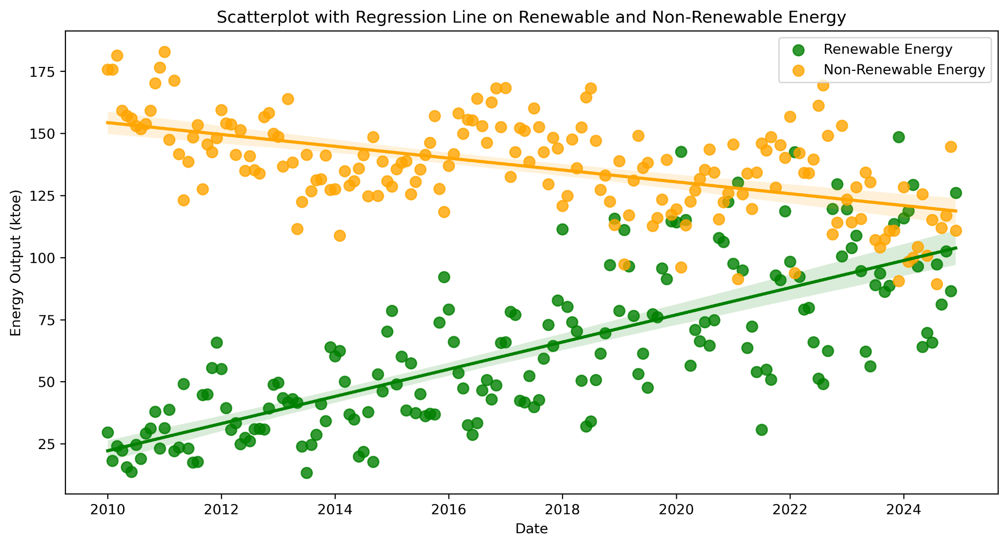
Based on the scatterplot above. The renewable energy trend is increasing consistently, which indicates a significant increase in production over the years, from an average of 25 ktoe in 2010 to 100 ktoe in 2024. On the other hand, Non-renewable energy shows a decreasing trend, indicating Ireland’s efforts to shift towards sustainable energy sources. The renewable energy points are concentrated in the early years with low energy outputs. From 2016 onwards. There is an observable increase in the spread of data or heteroscedasticity.

2.2 Inferential Statistics

Hypothesis testing plays a significant role in making decisions, lowering the risk of making incorrect conclusions, and avoiding misguided choices (Biswal, 2025). Therefore, this section applies hypothesis testing to support in identification of suitable machine learning algorithms for time series forecasting.

2.2.1 Hypothesis Testing on Renewable and Non-renewable Energy Features:

- Adfuller Test (Stationary):

The augmented Dickey-Fuller test determines if data is strongly defined by a trend. Identifying whether data is stationary ensures consistent statistical properties, resulting in a more reliable forecasting model (Bhattacharjee, 2023).

Null Hypothesis (H0): Data suggests the presence of a unit root or non-stationarity.
Alternate Hypothesis (H1): Data has no unit root or is stationary.

Results:
- Non-renewable Energy has a p-value of 0.0054, which is below 0.05. Thus, concludes that the data has no unit root or is stationary.
- Renewable energy is also below the significance level 0.05 with a p-value of 0.00, which indicates the data is stationary.

2. Kruskal-Wallis Test (Seasonality):

This test determines significance across multiple groups in the dataset, indicating a seasonality in a series by comparing the ranks of data points in different time intervals (Bhattacharjee, 2023). Results can support whether ARIMA/SARIMA is applicable.

Null Hypothesis (H0): There is no seasonality in the data.
Alternate Hypothesis (H1): Data exhibits seasonality.

Results:
- Renewable energy exhibits seasonality with a p-value score of 0.00.
- Non-renewable energy has a p-value of 0.47, which is above the significance level of 0.5. Thus, concluding that the data has no seasonality.

3. Shapiro-Wilk Test (Normality):

The Shapiro-Wilk test assesses whether the dataset is normally distributed. This is crucial to models like ARIMA, where it assumes that the residuals follow a normal distribution (Waples, 2025).

Null Hypothesis (H0): Data is in normal distribution.
Alternate Hypothesis (H1): Data exhibits non-normal distribution

Results:
- Renewable energy is not in a normal distribution based on the p-value of 0.00, which is below the significance level.
- Applying the cuberoot on renewable energy transformed the distribution to a nearly normal but still under the significance level with a p-value of 0.047.
- Non-renewable energy is in normal distribution with a p-value of 0.683.

2.2.3 Binomial Distribution

Statement of the Problem: Based on the monthly energy output, what is the probability that renewable energy output in a given month exceeds the overall average monthly energy production?
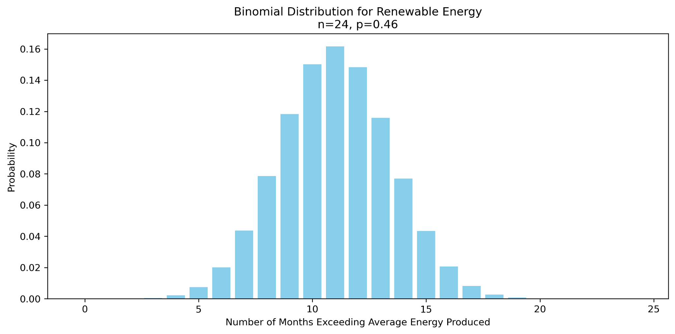

Analysis:
The graph shows that renewable energy exceeded the average energy output produced in 11 months out of 24 (2023-2024), with a chance of 46% that it will occur in any given month. Thus, we can consider that fluctuations in the output of renewable energy, especially wind and solar energy, might be influenced by seasonal and meteorological conditions. Grid distributors can explore other energy sources to strategize and compensate for in times of lower energy outputs, optimizing grid stability, and improving infrastructure in regards to renewable energy.

2.3 Hypothesis Testing on European Countries

Statement: Based on the latest population count in European countries, Ireland, Denmark, and Finland have comparable population sizes of 5.3 million, 6.0 million, and 5.6 million, respectively (Worldometer, 2025). With this, hypothesis testing is employed to assess whether there is a similar pattern in energy consumption among these countries or different despite the similarity in population sizes.

2.3.1 Shapiro-Wilk Test on Denmark and Ireland

Ho: Data is in normal distribution
H1: Data is not in normal distribution
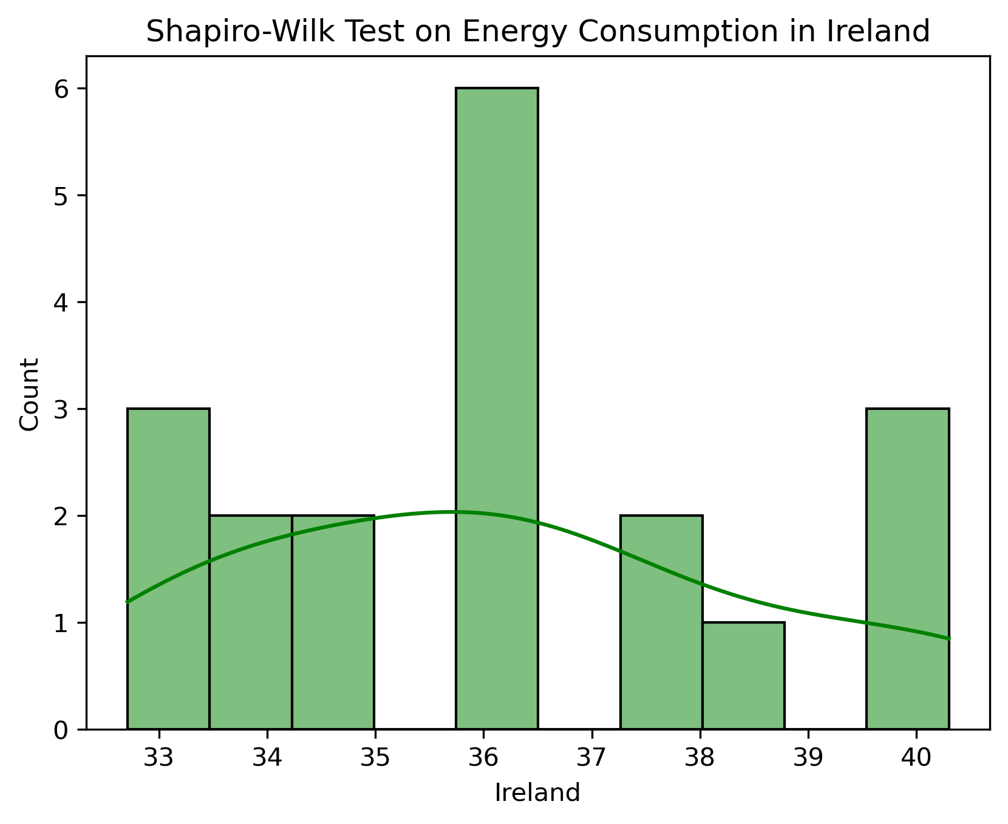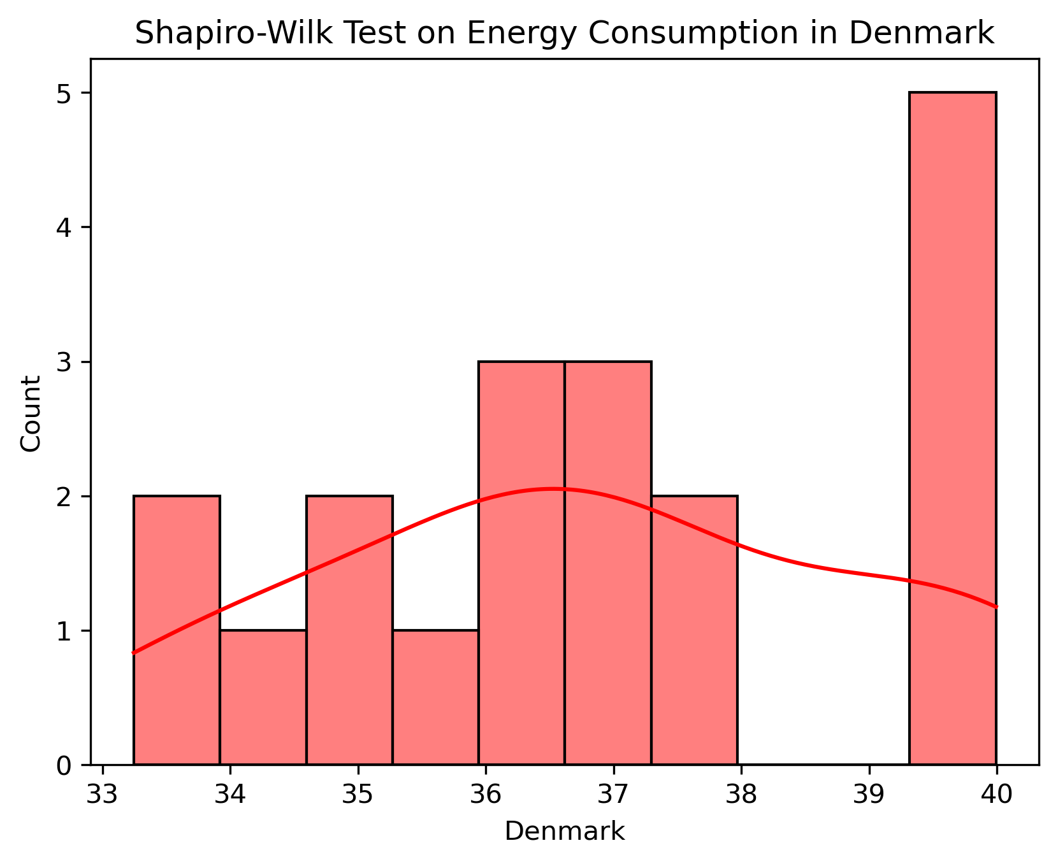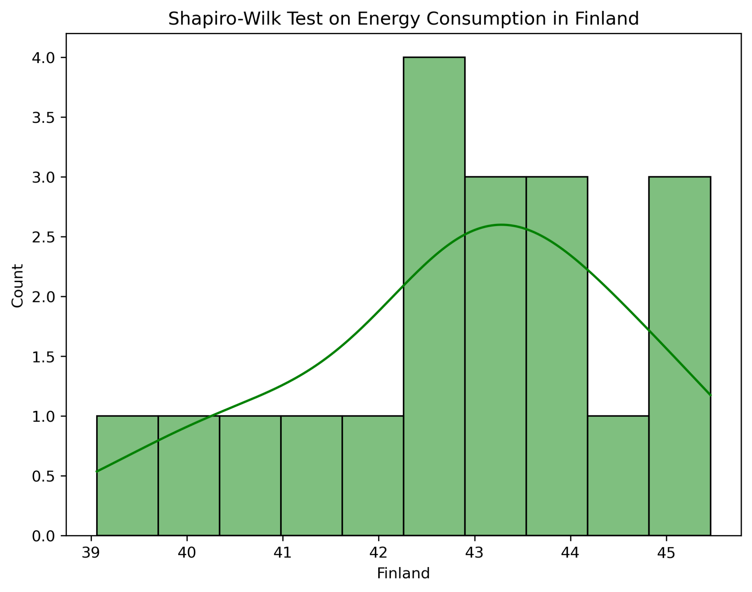
Based on the result, Ireland, Finland, and Denmark's energy consumption data are in normal distribution, having a p-value of 0.204, 0.614, and 0.294, respectively. Therefore, the energy consumption values in these countries are close to the average, which also indicates a stable usage of power. Since these datasets are in normal distribution, we can further employ parametric tests for hypothesis testing.
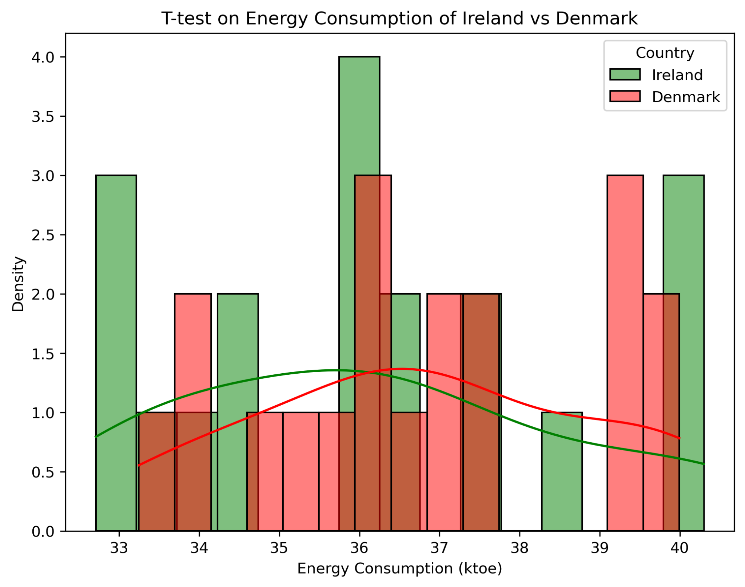
2.3.2 T-test

Ho: The average energy consumption is equal between Ireland and other European countries.
H1: The average energy consumption in Ireland differs from Denmark.

A t-test was applied to compare Ireland and Denmark’s consumption of energy. The result of the p-value of 0.37 concludes there is no statistical evidence to reject the null hypothesis. Therefore, there is no significant difference in the average energy consumption between the two countries.

2.3.3 Pearson Correlation

This test measures the linear relationship between two continuous variables (SciPy, 2022). This hypothesis testing was employed to assess whether an increasing population correlates with a corresponding rise in energy consumption.

Ho: There is no significant linear correlation between population and energy consumption.
H1: There is significant evidence of a linear correlation between population and energy consumption.

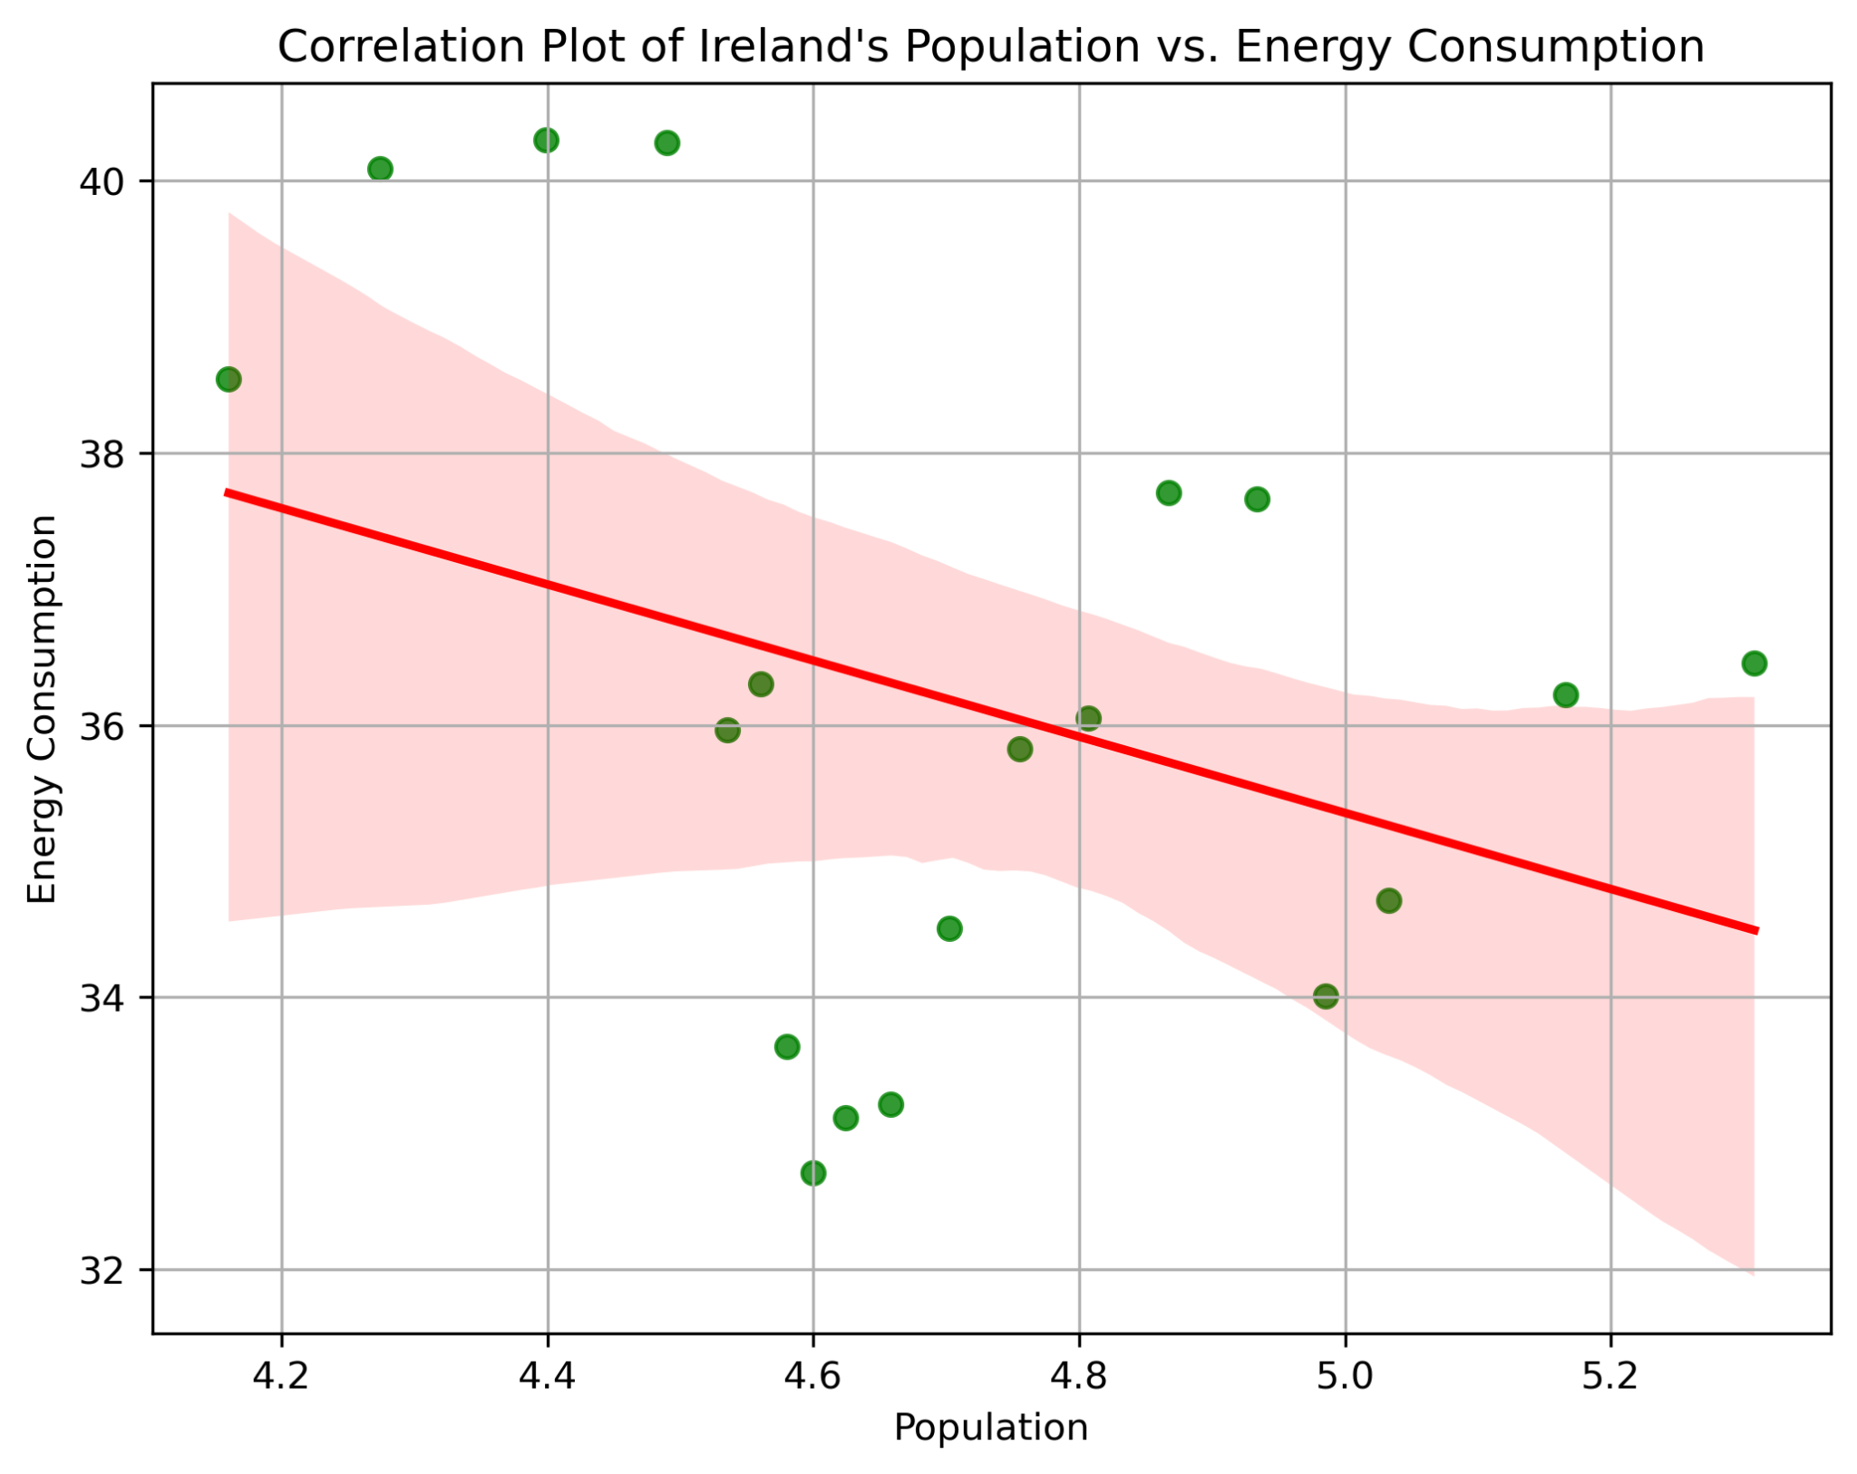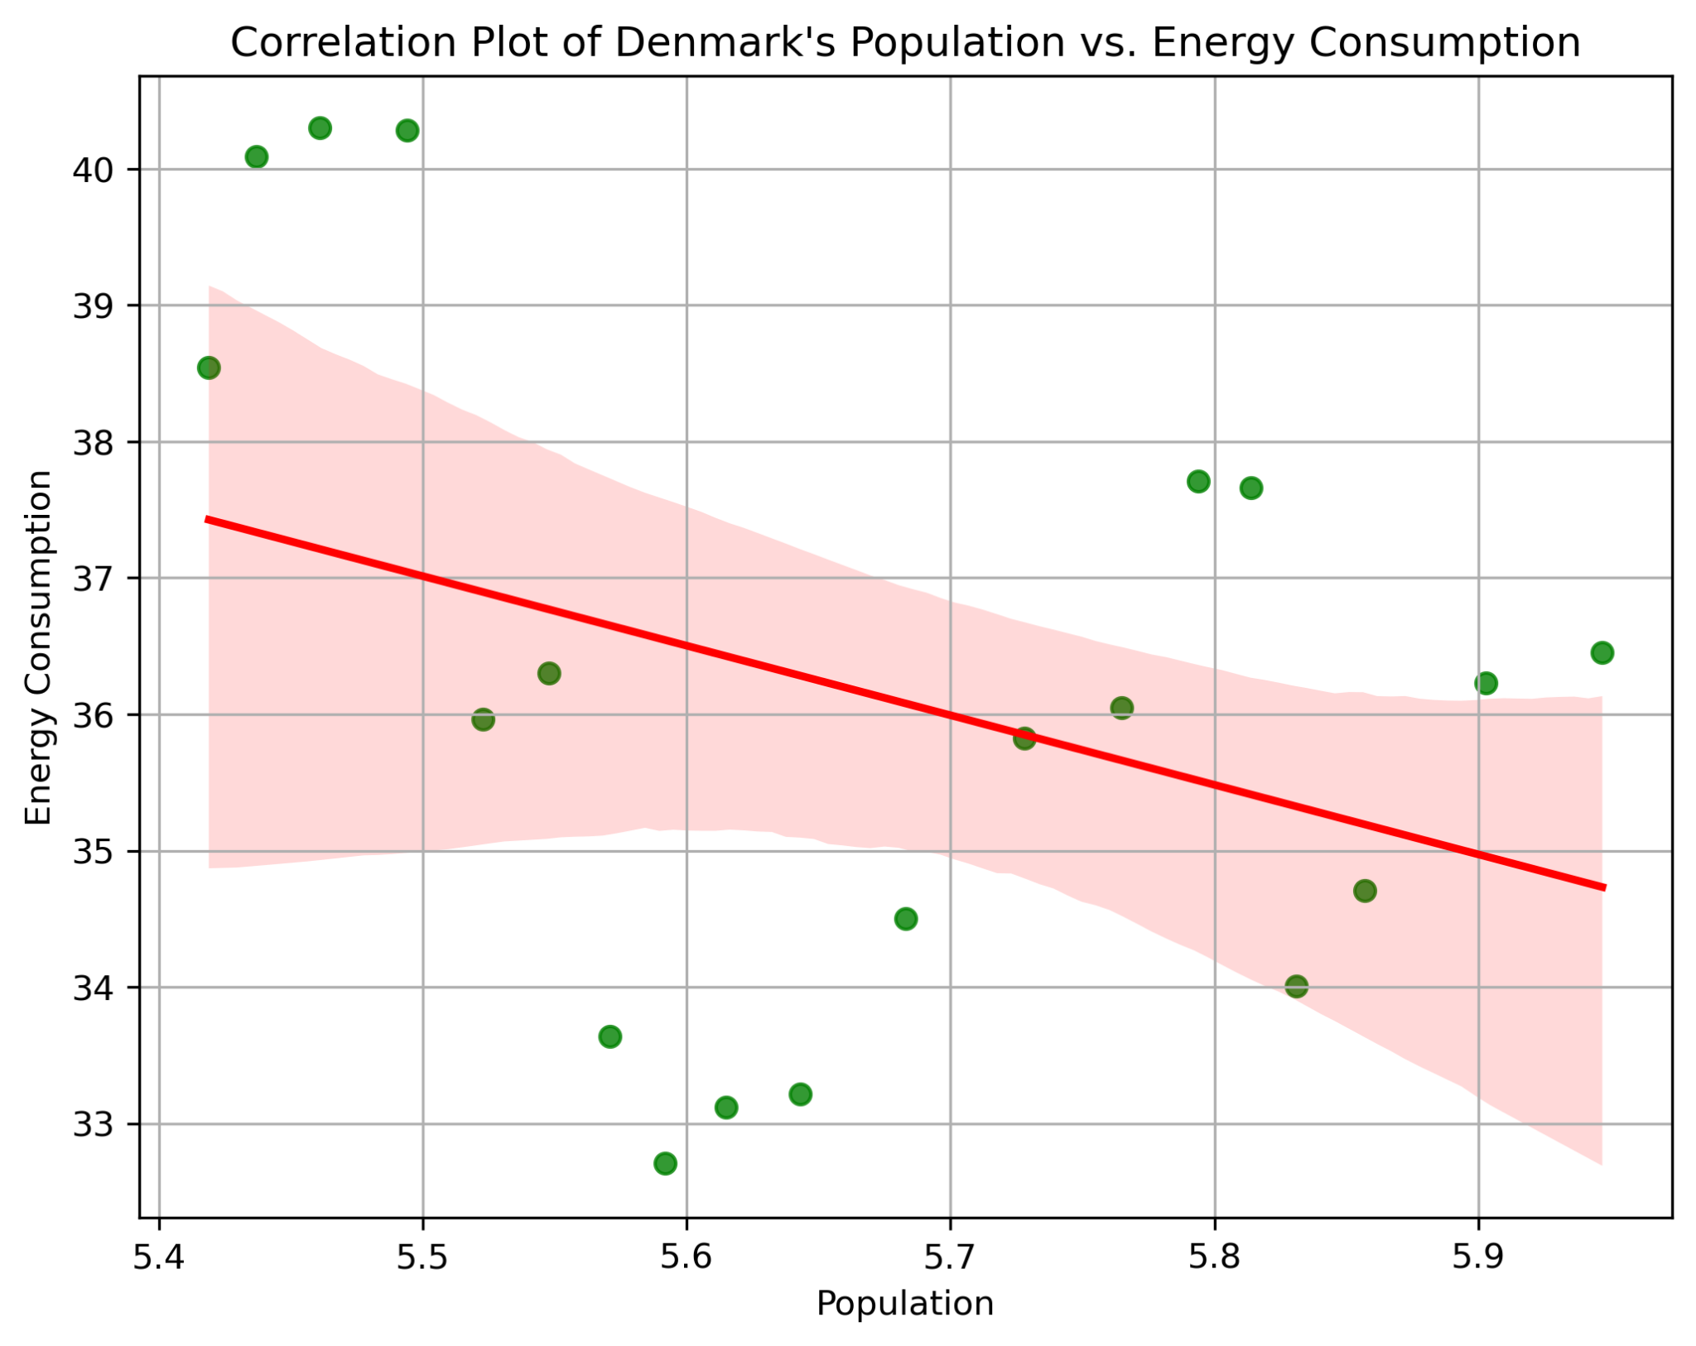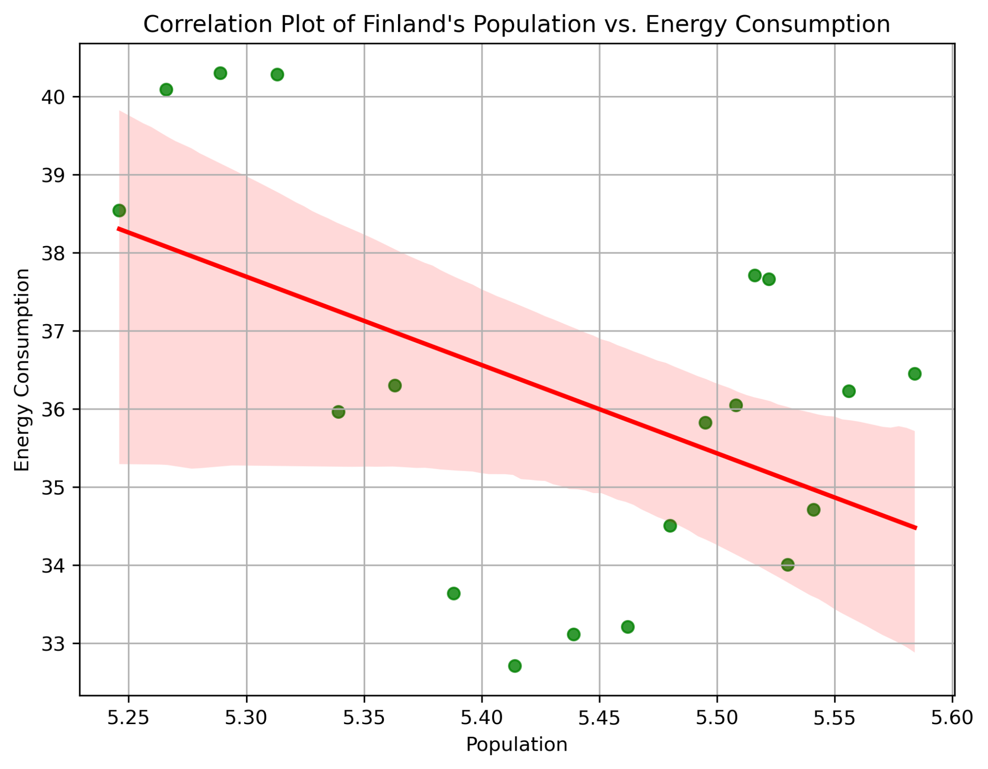
The result shows Ireland’s increase in population does not correlate with an increase in energy consumption, with a p-value of 0.155, which is above the significance level of 0.05. On the other hand, both Finland and Denmark have a significant linear correlation between the population and energy consumption, with the corresponding p-values of 0.17 and 0.00, respectively.

2.3.4 One-way ANOVA
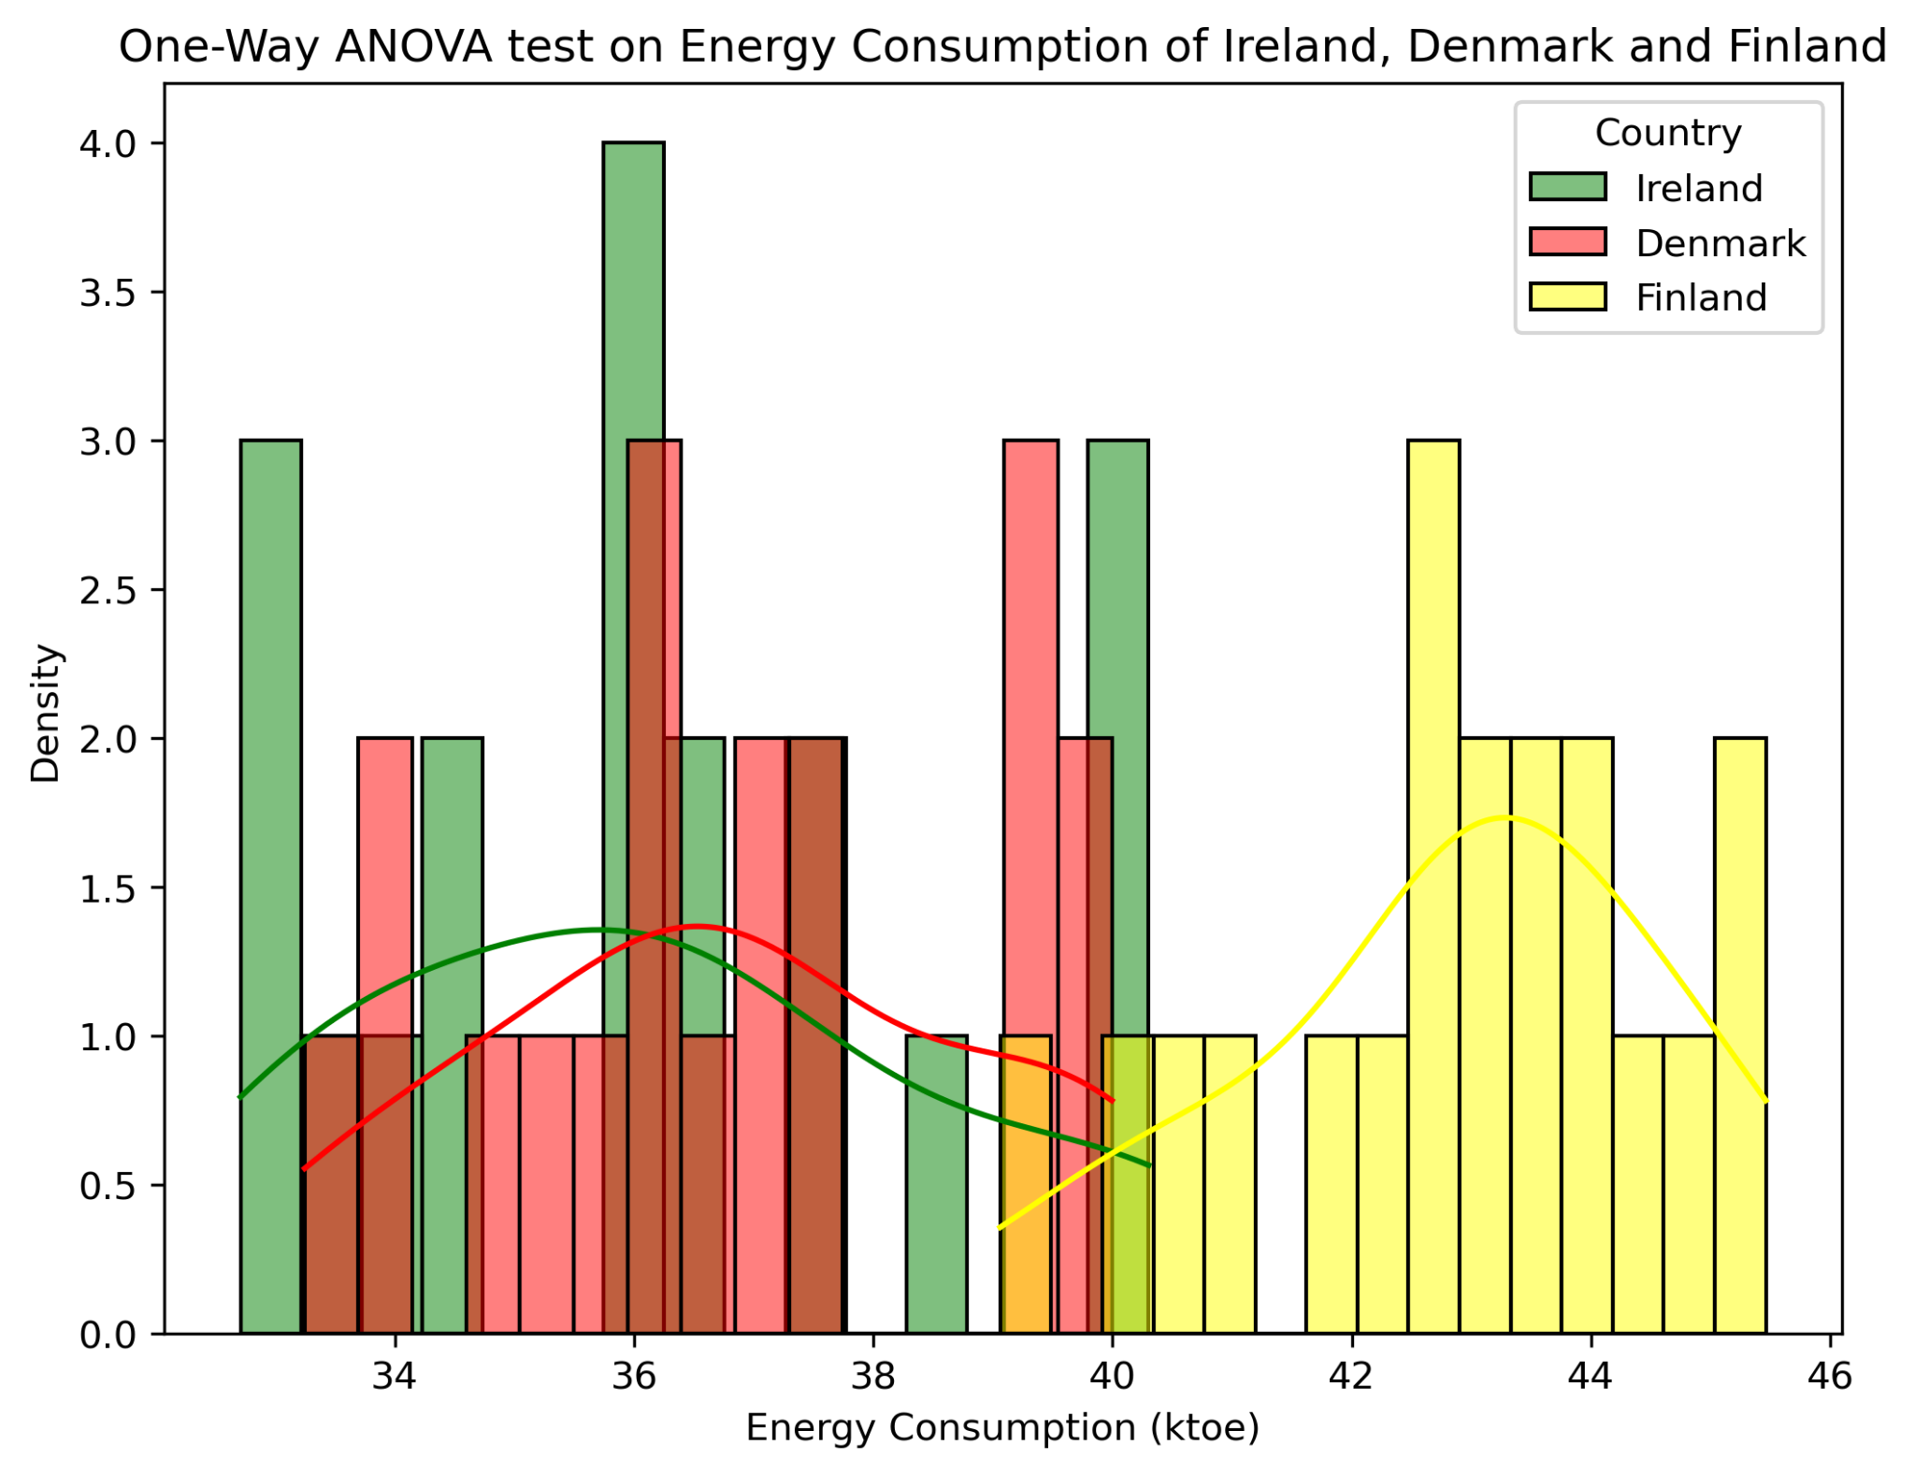

Results conclude that there is a significant difference between the average energy consumption despite having similar population sizes, where Ireland and Denmark peak at around 34 to 38 ktoe. On the other hand, Finland has higher energy consumption from 37 to 45 ktoe and peaks at 43.

Conclusion:
Overall, the results suggest Finland’s energy consumption is higher, which might be influenced by factors other than population, such as industrial demand or climate. In contrast, Ireland and Denmark show similarities in energy usage, which can be an opportunity to share policies and best practices to optimize energy usage, especially with more sustainable development that will help both countries.

2.4 Discussion and Justification of Model Choice

According to the findings collected from descriptive statistics and hypothesis testing of the target variable. The renewable energy data is suitable for a time series analysis based on the fact that the data is stationary and exhibits seasonality, which implies that even applying simpler models and statistical techniques will provide an accurate and reliable result for models like SARIMA (Santra, 2023). ANN, on the other hand, does not explicitly require seasonality, but can achieve better model performance with it (Adhikari and Agrawal, 2012). An issue was encountered where the target data exhibits skewness to the right, even though applying the cube root transformation made the data’s graph normally distributed, hypothesis testing verifies that the data is still not in a normal distribution, as indicated with a p-value of 0.04. Comparison of the transformed and actual data’s modelling output is conducted in the machine learning section.

3. Programming

This research was implemented using Python as a programming language and was facilitated through the Jupyter environment. Several advanced libraries were utilized: pandas and numpy for manipulation, seaborn and matplotlib for static visualisation, plotly and plotly dash for interactive visualisation and dashboards, other libraries such as Keras, Tensorflow, and statsmodels were employed for machine learning, and Flair for sentiment analysis.

Modular programming was highly applied, which greatly improved code readability and error isolation. Thus, eliminating repetitive and lengthy code as seen in the Statistics section 2.3.2, where the third test (Pearson correlation) was modularized to execute the analysis and visualisation by running a line of code. This has greatly improved efficiency and reduced complexity, which gives greater focus on the analysis (Macdonald, 2023). Other user-defined functions are located in custom function sections.

3.1 Data From Diverse Sources

Three datasets, which come in CSV and XLSX formats, were processed using the pandas and numpy libraries to be utilized in the main project file. Namely, indigenous energy production from SEAI, European energy consumption from Europa, and world population were sourced from the World Bank, which was utilized for machine learning and hypothesis testing comparing European countries on energy consumption, and other datasets were used to create the dashboard.

The data from sentiment analysis was sourced from Reddit through its proprietary API, which was securely authenticated using OAuth2, where credentials were used to request an access token to the authorization server (Auth0, 2025). The API returns a response in JSON format. However, some comment and their corresponding sub-comments are deeply nested within the JSON, which makes extraction complex. An alternative solution was made in which JSON was converted into a string, and comments were parsed with the use of REGEX. The extracted data from diverse Reddit forums related to energy in Ireland and other parts of the European Union was further processed to extract the sentiments and identify key topics using Flair and other text processing methodologies.

Credentials for the Reddit API were stored in an environment variable, which was accessed using the dotenv library to generate an access token that will be used for authentication. This approach promotes security in handling sensitive credentials, which also follows good coding practice (Acharya, 2024).

3.2 Optimisation

To guarantee efficient use of computational resources, several optimisation strategies were implemented throughout the project.

In the model training process, especially in Artificial Neural Network (ANN), an EarlyStopping was employed. This reduces unnecessary epochs since it monitors the validation loss and stops when it detects that there is no more improvement. Thus, it significantly improved time and resources (Kashyap, 2024). An observed decrease in runtime from approximately 12 seconds to 2 seconds if EarlyStopping was applied.

During data handling and manipulation, unused columns were dropped, which made the dataset cleaner and focused on relevant features for analysis. A custom function was also created, ‘delete_df()’, to remove dataframes after use to conserve memory, which also shows a summary of the cleared space in kilobytes.

A modularized function was applied throughout the project to simplify the analysis process and promote code reusability. The model training process can be run by one line of code, which will go through the processes, including train-test split, MinMax scaling for ANN, fitting the model, and showing the summary of results. Custom functions for the model training have configurable parameters to toggle features such as visualisations and pmdARIMA, which is also compute-intensive. Runtime tracking was also applied using a custom class to run and stop timers, which returns the total runtime wherever applied.

Overall, considerable effort was exerted to implement an efficient and reliable code, allowing a greater focus on the analysis of the project by minimizing code clutter and promoting scalable, maintainable, and easier implementation in terms of switching with models or datasets for experimentation. These optimizations contributed to enhanced performance and significantly improved processing time, reduced file size, and reduced computational cost when deployed (Sharmaraghav, 2025).

4. Machine Learning

This research implemented four supervised machine learning models to create a reliable forecasting model for the renewable energy output for the Republic of Ireland.

4.1 Rationale and Justification of Chosen Machine Learning Models
Artificial Neural Networks (ANNs) are a great fit for the study as this model is highly effective for time-series forecasting as it can detect complex patterns with seasonality and trends, which are both present in the target variable, as confirmed by the Kruskal-Wallis test with a p-value of 0.00 (Moreno, Pol and Gracia, 2011). Additionally, having the capability to capture both linear and non-linear relationships, ANNs are suitable for handling heteroscedastic data, such as the renewable energy feature in the dataset. Furthermore, its functionality to employ multiple features like seasonality indicators, weather variables, and lagged values enables the model to learn better and provide accurate results (Statsig, 2024a). Features such as EarlyStopping and Dropout can be implemented to avoid overfitting in the model (Lunartech, 2025). Based on these considerations, ANNs are a suitable choice for this study.

Another model implemented is Seasonal Autoregressive Integrated Moving Average (SARIMA), an extension of ARIMA. It is also a powerful model for time-series forecasting, where it can capture recurring patterns where seasonality is evident in the data. With the help of the pmdArima function, optimal hyperparameters–such as orders (p, d, q) and seasonal orders (P, D, Q, s)–are automatically identified in search of the best-fitting configuration (Kosaka, 2021). One of the most important requirements before implementing SARIMA is for the data to be stationary, which is also exhibited by the renewable energy feature verified by the Adfuller test (p-value: 0.00).

Tree-based models such as random forest and XGBoost regressors are also employed in this project. These models can capture both linear and non-linear relationships between variables. Feature engineering can be implemented, adding lag values, a rolling window, and seasonality indicators. One key advantage of both models is that they do not assume linearity and stationarity in the data. XGboost, in particular, applies gradient-boosting to correct errors successively, which is beneficial for time-series forecasting, as data must be analysed in sequential order (Wijaya, 2023). Alternatively, Random Forest is also capable of creating a reliable time-series forecasting model when incorporated with lagged features and ensemble learning. GridSearchCV was also employed to fit the best hyperparameter for these models.

Each model was carefully chosen in consideration of the target variable’s characteristics (renewable energy), aiming to produce an accurate and reliable forecasting model for Ireland’s renewable energy production.

4.2 Sentiment Analysis on Ireland’s Energy and Other European Countries
Sentiment analysis on energy-related topics was conducted using the data gathered from different Reddit forums using Reddit’s proprietary API.

4.2.1 Data Processing:
Thorough data cleaning steps were involved, including removing stopwords, special characters, and content with fewer than 10 words to get more informative content for analysis. Randomizing the selection of comments and applying WordLemmatizer to convert to base form, ready for tokenization.
4.2.2 Latent Dirichlet Allocation (LDA)
Latent Dirichlet Allocation (LDA) was employed to extract key topics present in the collected data.

Based on the results, the topics were generated based on 5 important words:

1. Free charging and electric prices
2. Renewable energy sources monitoring
3. Gas consumption policies
4. Estimated power consumption over time
5. Government and companies' investment
6. High consumption of fossil fuels
7. Looking for a piece of advice on monthly usage
8. Public's opinion on renewable energy policies
9. Battery storage & electricity use
10. Rising cost of energy per kWh

Topics generated by the model are related to energy consumption, policies, and pricing, providing an overview of the most important discussions on issues and sentiment related to energy consumption and costs.

4.2.3 Sentiment Analysis using Flair NLP
Flair is an unsupervised, pre-trained language and contextual embedding-based model that focuses on sentiment analysis, which performs better at a deeper understanding of sentence structures, thus providing more accurate predictions than Vader (Soshace, 2023).

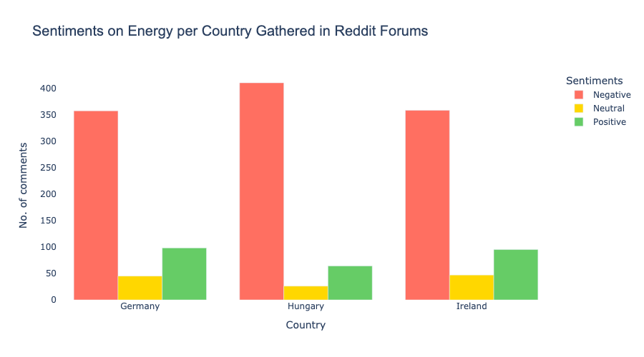
The results indicate that all three countries–Ireland, Germany, and Hungary show a high negative sentiment on energy-related topics. However, this is typical in this type of social media site like Reddit, where people can vent out their frustrations without any consequences (Rösner and Krämer, 2016). Interestingly, despite having one of the cheapest electricity rates in Europe, Hungary still has the highest negative comment count. This shows that users have high levels of dissatisfaction not only in regards to the cost but also other factors such as policies, service reliability, and other energy-related issues, which may be addressed by the government or the service providers.

4.3 Machine Learning Model Training and Implementation

Artificial Neural Networks (ANN):
To ensure that the data is suitable for ANN modeling, lagged features were added, which help the algorithm to capture the sequential patterns necessary for time series analysis (Gordon, 2023). Additionally, Min-Max scaling was applied to normalize values in the range of -1 to 1, helping the model to converge better, or where the model’s performance stabilizes (Brownlee, 2019).

The model was initialized with a sequential feed forward network with the first hidden layer’s dense value of 64 and ‘ReLU’ (Rectified Linear Unit) as activation function which can handle complex data patterns due to its nonlinearity, which is relevant to the target variable (heteroskedastic) and it is also computationally efficient (GeeksforGeeks, 2025). A dropout rate of 0.3, which randomly turns off 30% of neurons, avoids overfitting (Lunartech, 2025). Early stopping was also implemented with a patience value of 2, which will stop training the model if the loss does not improve for 2 epochs, resulting in saving computational cost and reducing the risk of overfitting (Kashyap, 2024).

SARIMA:
Calculating for order and seasonal order (Grannan, 2021):
Based on the Autocorrelation(ACF) graph, seen on ML section 3.2, there is a noticeable spike at lag 1 and gradually decays, similar to the Partial Autocorrelation Plot(PACF) plot. This suggests an AR and MA value of 1. Using the Adfuller test on first difference results in stationary data (I=1). Thus, order (p, d, q) = (1, 1, 1).

For the seasonal order calculations, values are in monthly data (s=12). Checking seasonal differencing (D) using the Adfuller test, the data indicates stationarity(D=1). Using ACF and PACF plots, P = 0, since the PACF plot does not show a significant seasonal spike, and Q was determined to be either 1 or 0, given that seasonal lags appear weak. Therefore, the seasonal order (P, D, Q, s) = (0, 1, [0,1], 2).

Training the model with values (1, 1, 1) and seasonal order of (1, 0, 1, 12), the root mean square error (RMSE) is at 15.53 ktoe with an R2 score of 0.63. However, tweaking order values to (1, 1, 5) results in an improved score of 15.10 ktoe for RMSE and 0.65 R2 score.

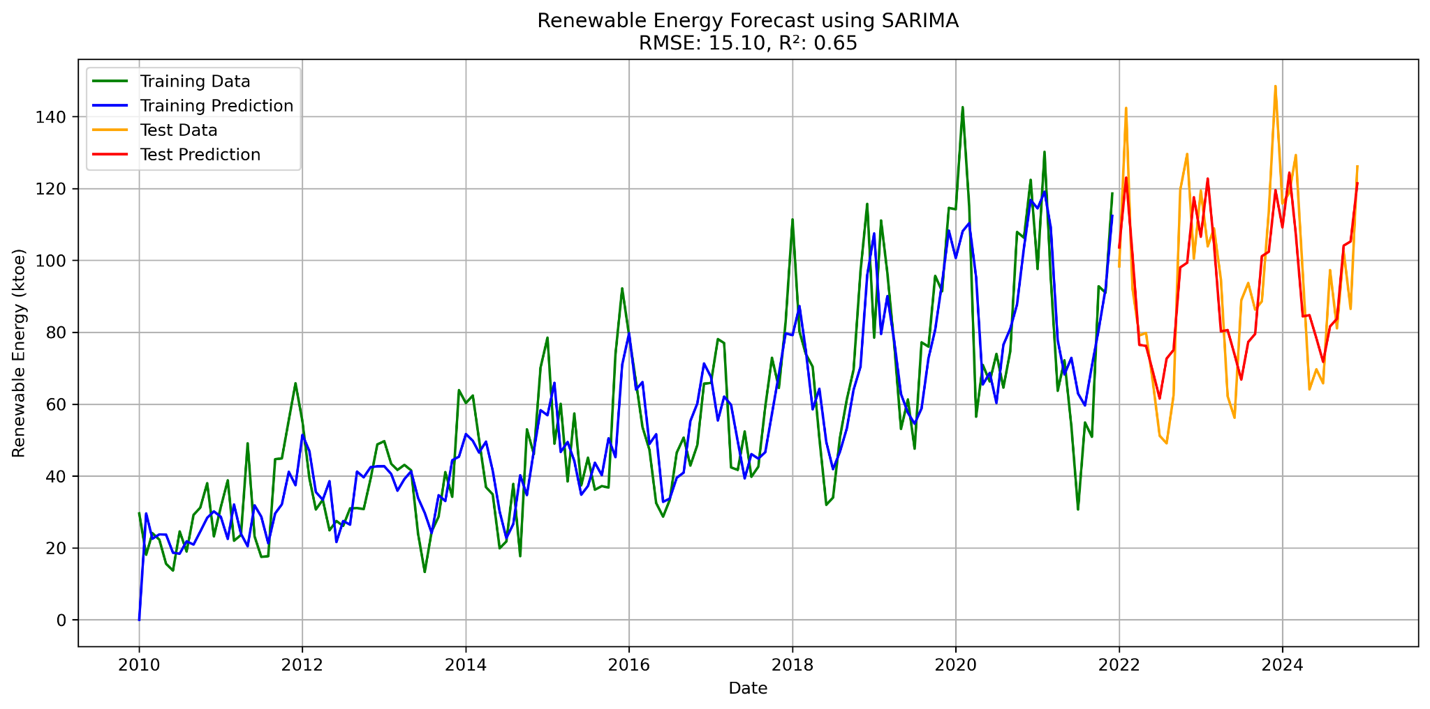

Additionally, the custom function to run SARIMA, parameter ‘use_pmdarima’ which can be toggled to True, will automatically search best order and seasonal order values, eliminating the need for tedious calculations of these hyperparameters and automatically apply values to the model.

Tree-based Algorithms (Random Forest and XGBoost):

Similar to Artificial Neural Network (ANN), lagged values were added to capture the seasonal pattern in the data. Additionally, tests were conducted to identify the optimal cross-validation (CV) value. A 3-fold CV value yielded the best result for the random forest of an R2 score of 0.60, even though 5-fold shows a similar result; higher CV value increases computational cost, as seen on the graph below.

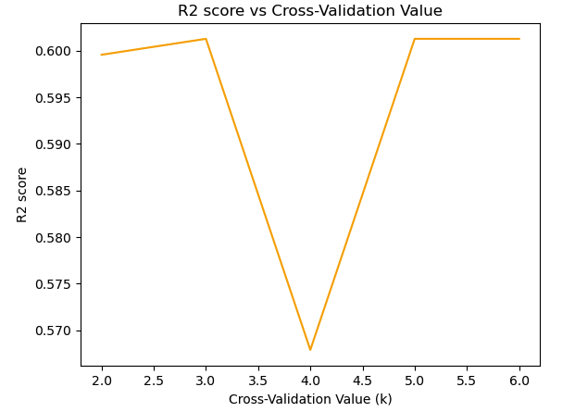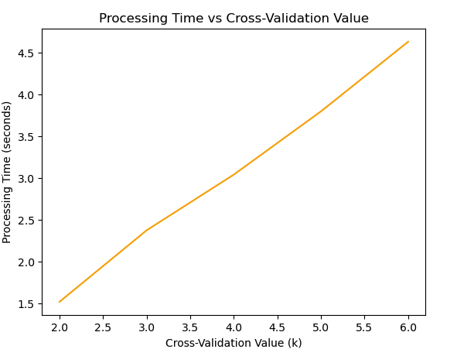

GridSearchCV was implemented to find the best-fitting hyperparameters for each model. The parameter grid implemented is outlined as follows (Fraj, 2017; Rathi, 2024):

Hyperparameter | Random Forest | XGBRegressor | Function
colsample_bytree |  | 0.6, 0.8 | Percentage features used for each tree or feature sampling
gamma |  | 0.1, 0.3 | Minimum loss reduction to make a split
learning_rate |  | 0.05, 0.01 | Step size shrinkage is used to prevent overfitting
max_depth | 4, 6, 8 | 2, 3 | Maximum depth of each tree
max_features | sqrt |  | Number of features for optimal split
min_samples_leaf | 2, 4 |  | Minimum number of samples in a leaf node
min_samples_split | 5, 10 |  | Minimum samples required to split an internal node.
n_estimators | 50, 100 | 100, 200 | Number of trees in the forest or boosting rounds
random_state | 0 | 0 | Seed for reproducibility
subsample |  | 0.6, 0.8 | Fraction of samples used for training each tree

Training the models with the use of GridSearchCV, results show that both models exhibit strong performance on the training data, but perform poorly in the test data, with an R2 train score of 0.91 and a test score of 0.60for the random forest, and a train and test score of 0.95, 0.52 for XGBoost, which indicates significant overfitting. Despite the hyperparameter tuning efforts, both models failed to generalize well to unseen data, concluding that these are not suitable for the study.

4.4 Results Discussion

The following graph compares actual values and forecasting outputs per model.
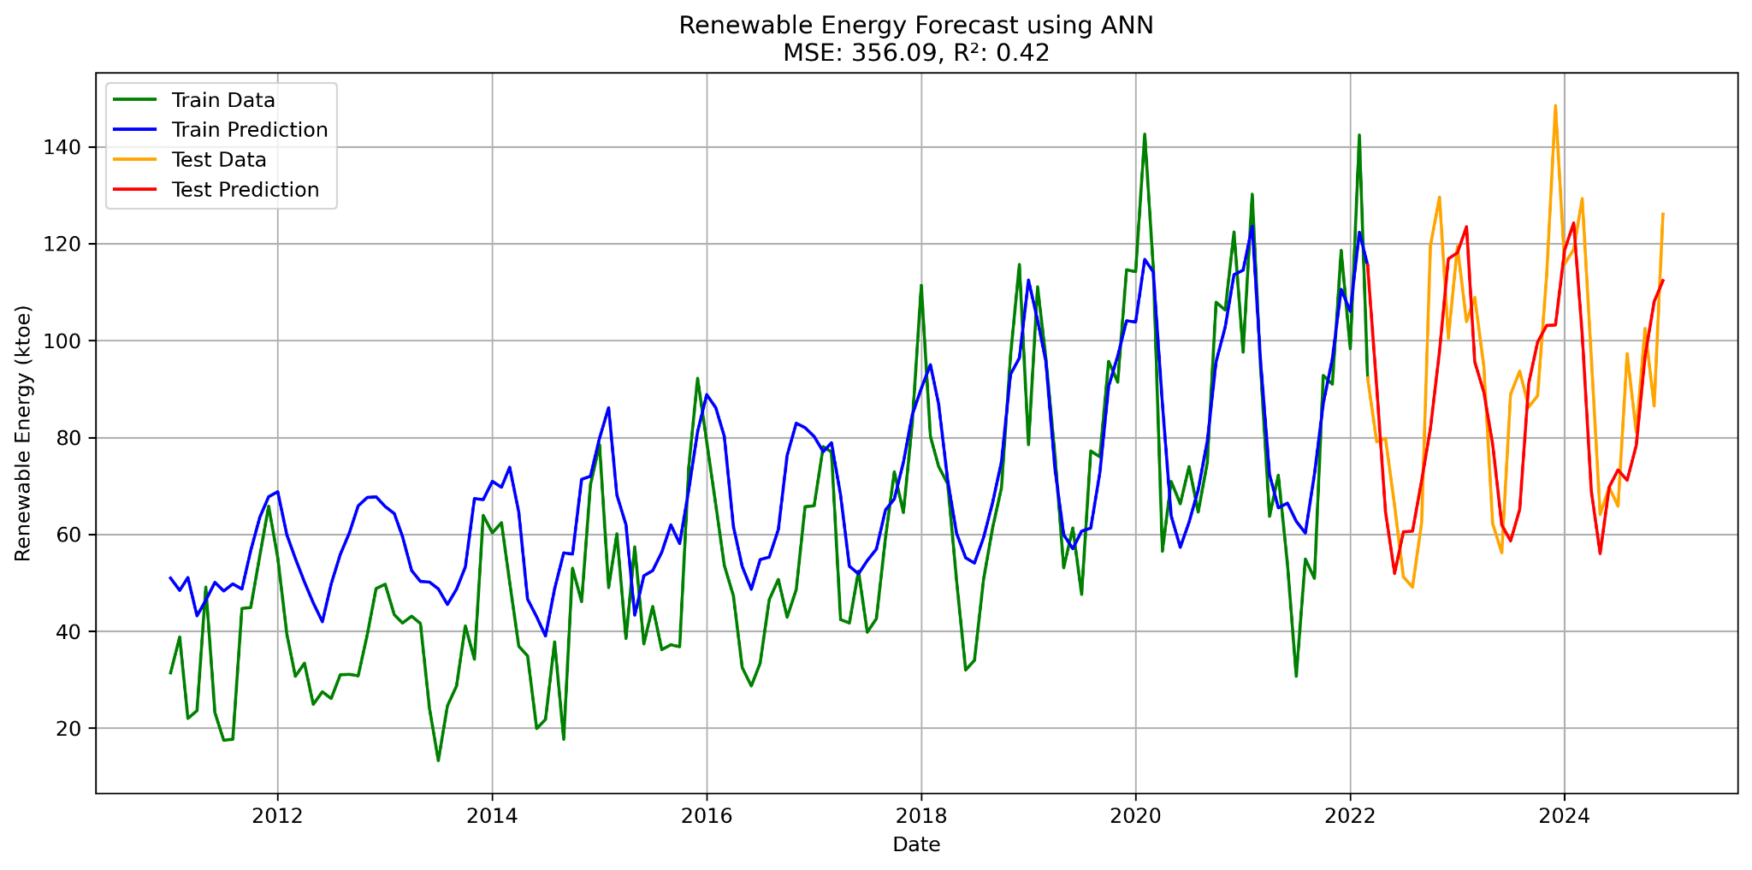
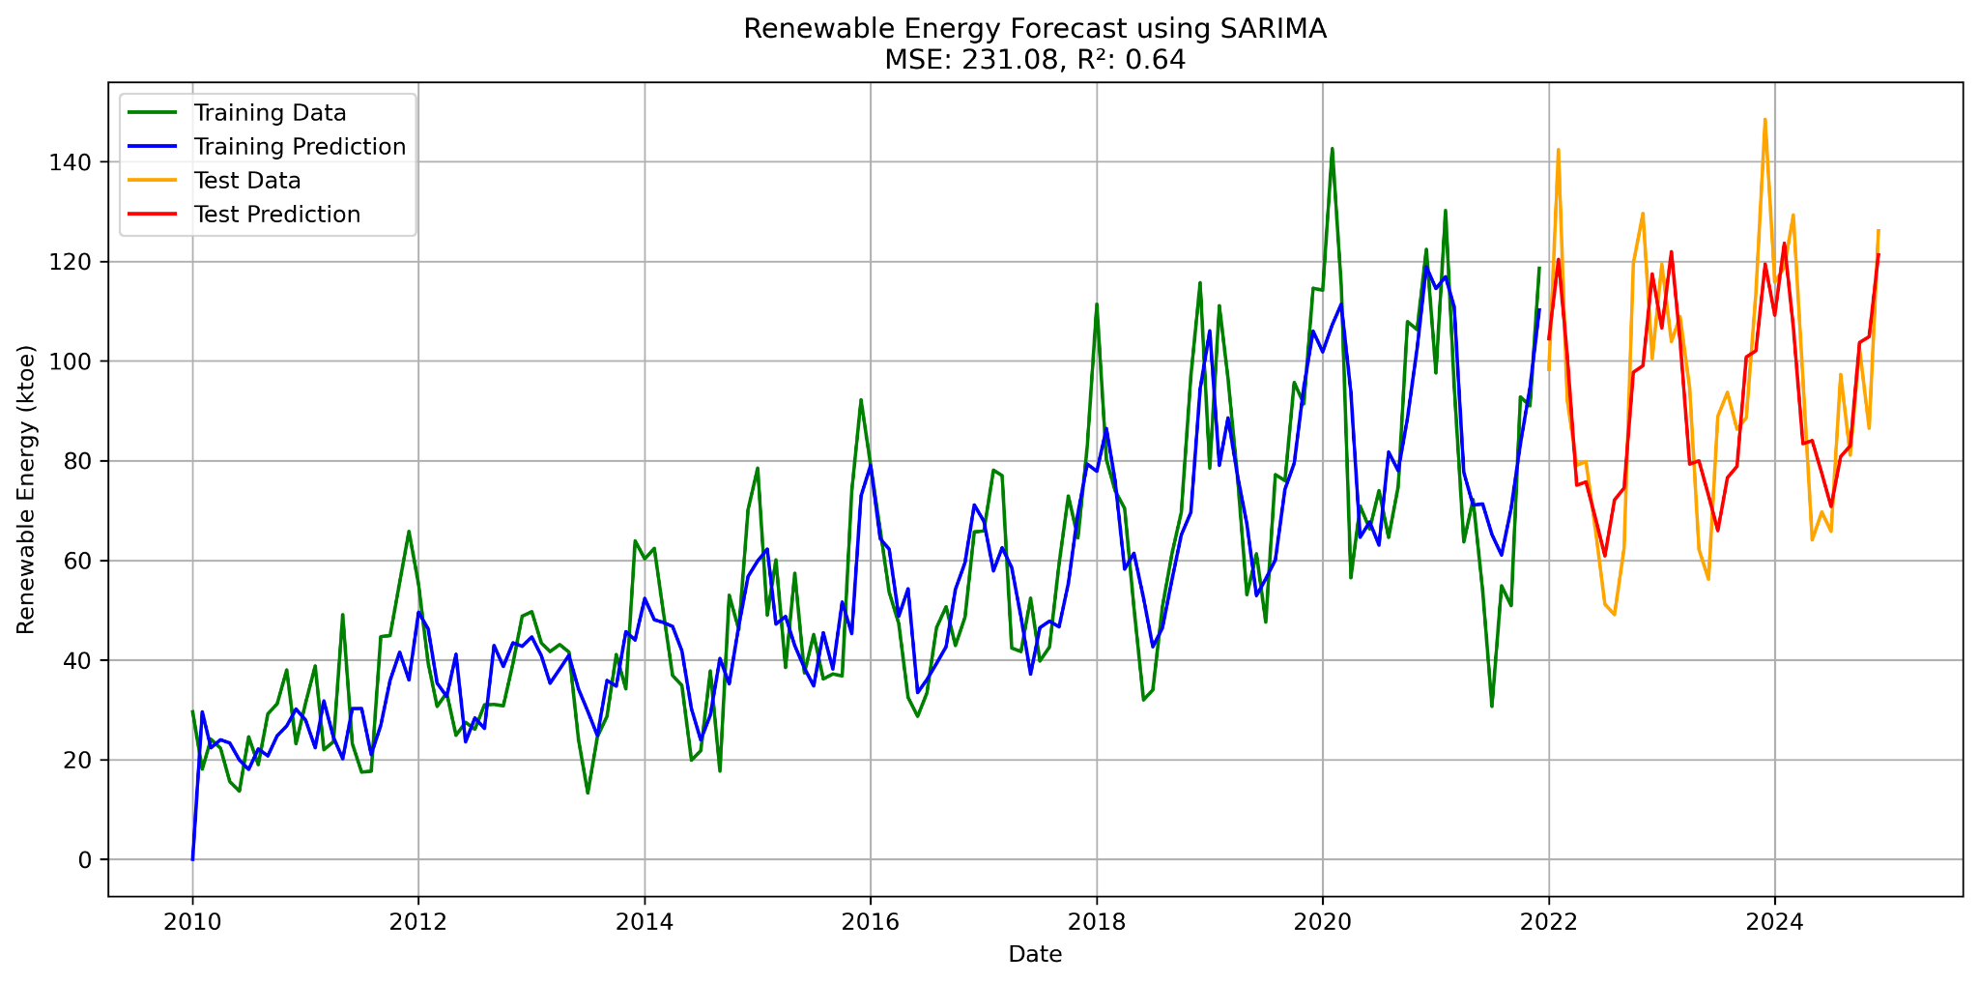
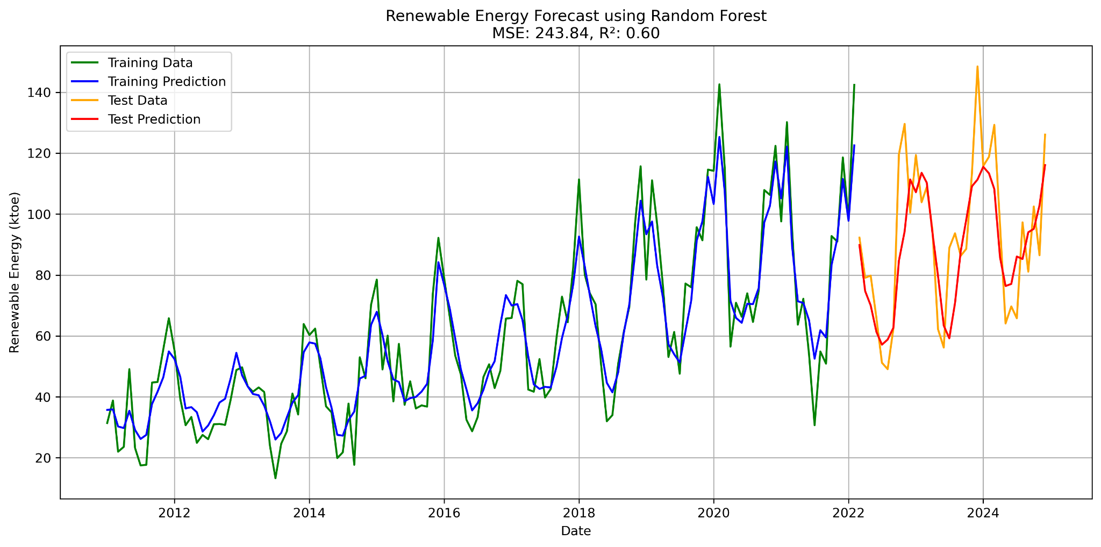

4.4 Results Discussion - Cont.

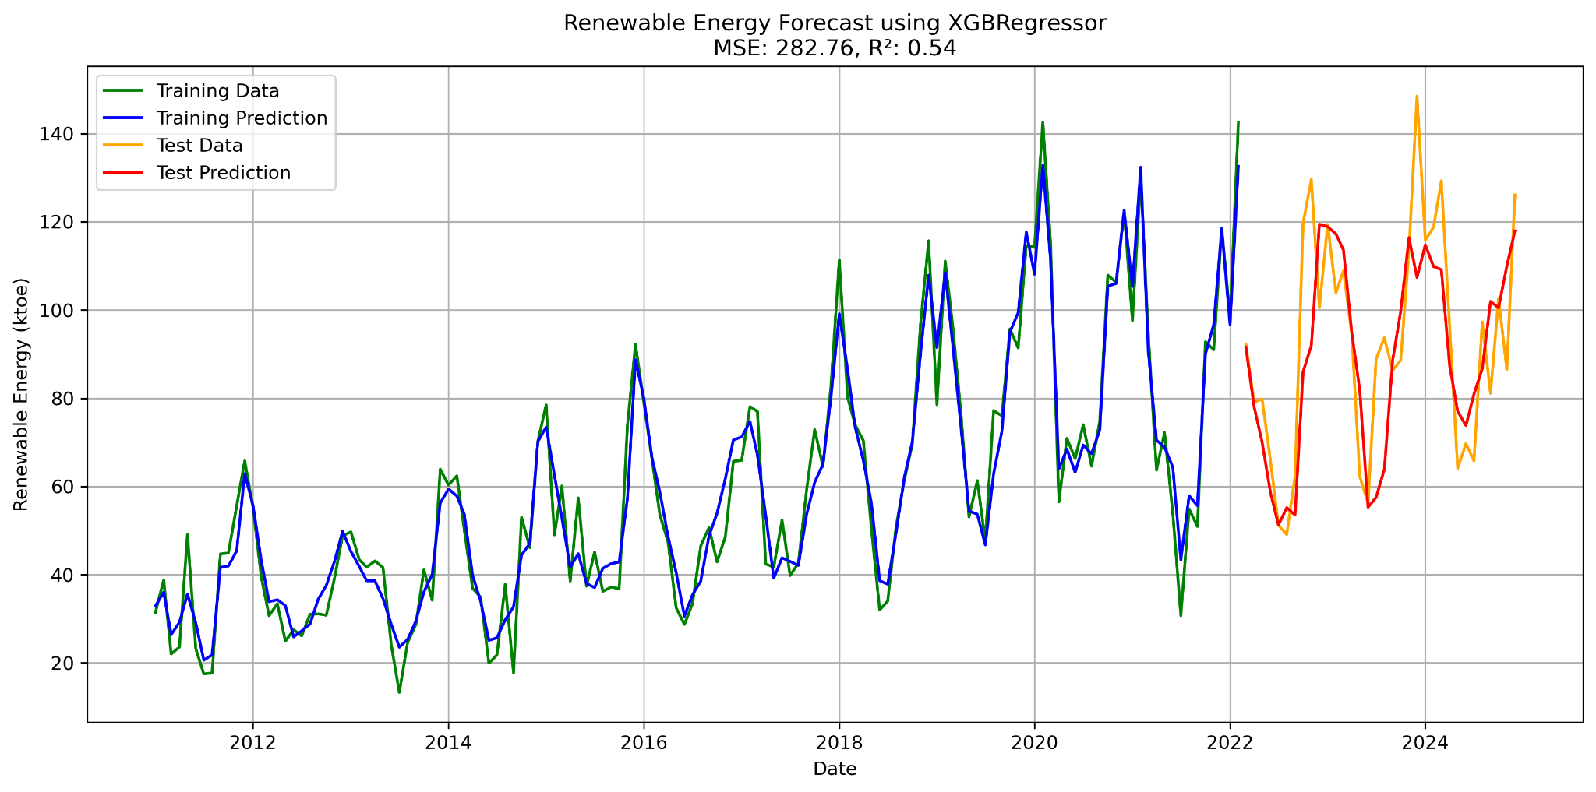

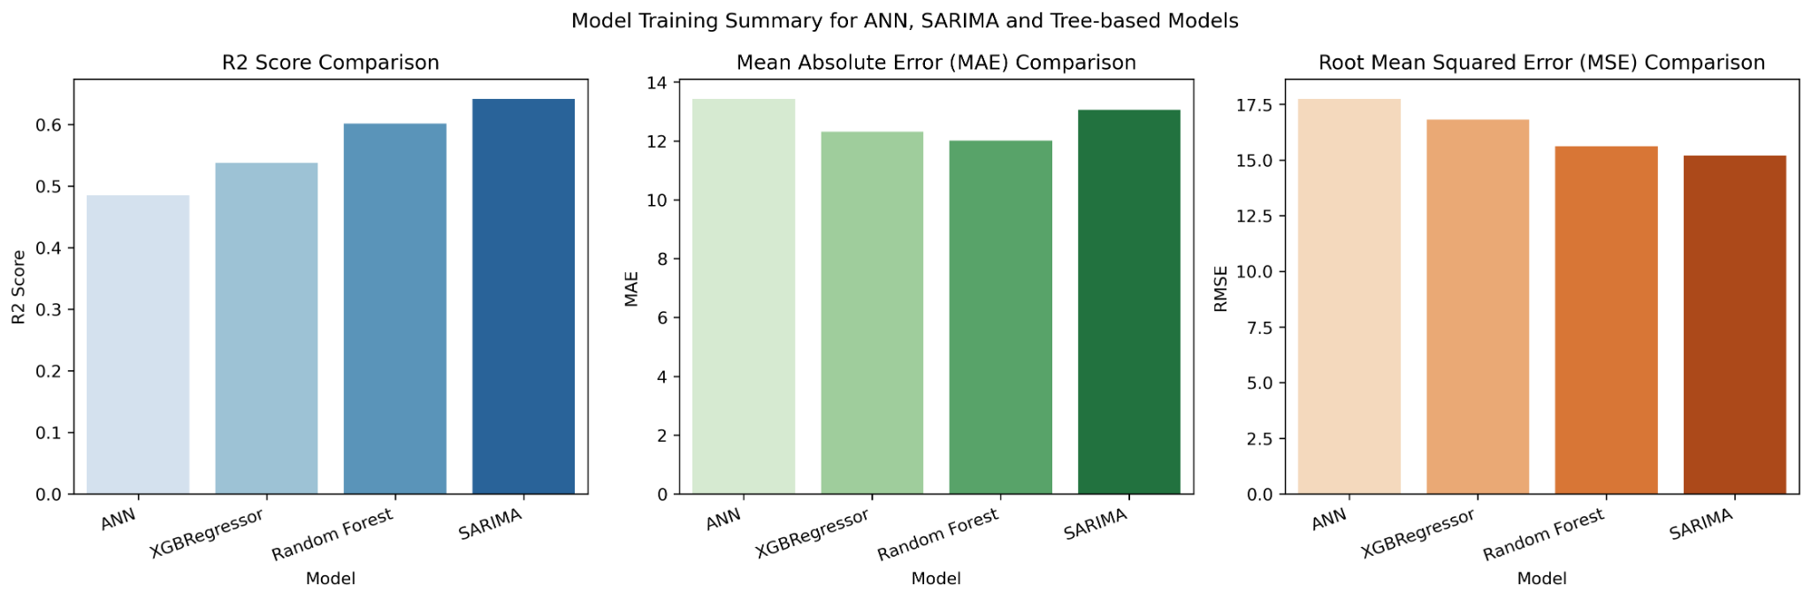
Based on the results, the ANN showed the weakest performance model among the models used, with a test R2 score of 0.42, scores also vary each execution, and it has the highest mean absolute error (MAE) and root mean square error (RMSE). Tree-based models, random forest, and XGBoost regressor outperform the other two models regarding MAE. However, the model generalized well in the training set, and underperformed in test set as there is a huge difference between the train and test R2 scores, with the train having 0.92 and the test 0.60 for Random Forest, and 0.95 with a test of 0.53 for XGBoost, which is a clear sign of overfitting as also observed in the graph above. Lastly, the SARIMA model reached an R2 score of 0.78 on training data and 0.65 on test data, which suggests good generalisation in both the training and test data, and it has the lowest MSE among the models. Thus, concluding that SARIMA is the best-suited algorithm for forecasting Ireland’s renewable energy production.

References

Acharya, V. (2024) ‘The Complete Guide to Environment Variables: Security, Implementation, and Best Practices’, Medium, 7 December. Available at: https://medium.com/@jinvishal2011/the-complete-guide-to-environment-variables-security-implementation-and-best-practices-8a5202afeca1 (Accessed: 9 May 2025).
Adhikari, R. and Agrawal, R. (2012) ‘Forecasting Strong Seasonal Time Series with Artificial Neural Networks’, Journal of scientific and industrial research, 71.
Amat Rodrigo, J. and Escobar Ortiz, J. (2022) ‘skforecast’. Zenodo. Available at: https://doi.org/10.5281/ZENODO.8382788.
auth0 (2025) What is OAuth 2.0 and what does it do for you?, Auth0. Available at: https://auth0.com/intro-to-iam/what-is-oauth-2 (Accessed: 9 May 2025).
Bajaj, A. (2022) ARIMA & SARIMA: Real-World Time Series Forecasting, neptune.ai. Available at: https://neptune.ai/blog/arima-sarima-real-world-time-series-forecasting-guide (Accessed: 6 May 2025).
Bhattacharjee, A. (2023) ‘Kruskal-Wallis Test: A Powerful Tool for Detecting Seasonality in Time Series Data using Python’, Medium, 10 September. Available at: https://medium.com/@avijit.bhattacharjee1996/kruskal-wallis-test-a-powerful-tool-for-detecting-seasonality-in-time-series-data-using-python-d827ef23d29e (Accessed: 8 May 2025).
Biswal, A. (2025) Hypothesis Testing: Types, Steps, Formula, and Examples, Simplilearn.com. Available at: https://www.simplilearn.com/tutorials/statistics-tutorial/hypothesis-testing-in-statistics (Accessed: 8 May 2025).
Brownlee, J. (2019) ‘How to use Data Scaling Improve Deep Learning Model Stability and Performance’, MachineLearningMastery.com, 3 February. Available at: https://www.machinelearningmastery.com/how-to-improve-neural-network-stability-and-modeling-performance-with-data-scaling/ (Accessed: 6 May 2025).
Chaudhary, S. (2024) 1.5 IQR Rule Explained, Built In. Available at: https://builtin.com/articles/1-5-iqr-rule (Accessed: 5 May 2025).
Fraj, M.B. (2017) ‘In Depth: Parameter tuning for Random Forest’, All things AI, 21 December. Available at: https://medium.com/all-things-ai/in-depth-parameter-tuning-for-random-forest-d67bb7e920d (Accessed: 15 May 2025).
GeeksforGeeks (2025) ReLU Activation Function in Deep Learning, GeeksforGeeks. Available at: https://www.geeksforgeeks.org/relu-activation-function-in-deep-learning/ (Accessed: 15 May 2025).
Gordon, J. (2023) Practical Guide for Feature Engineering of Time Series Data, dotData. Available at: https://dotdata.com/blog/practical-guide-for-feature-engineering-of-time-series-data/ (Accessed: 6 May 2025).
Grannan, C. (2021) ‘SARIMA Modeling’, Medium, 19 March. Available at: https://chrisgrannan.medium.com/sarima-modeling-42ff700af29 (Accessed: 15 May 2025).
Hayes, A. (2024) Heteroscedasticity Definition: Simple Meaning and Types Explained, Investopedia. Available at: https://www.investopedia.com/terms/h/heteroskedasticity.asp (Accessed: 5 May 2025).
Johansen, M. (2024) ‘Binomial distribution’, OneMoneyWay, 2 September. Available at: https://onemoneyway.com/en/dictionary/binomial-distribution/ (Accessed: 7 May 2025).
Kashyap, P. (2024) ‘Early Stopping in Deep Learning: A Simple Guide to Prevent Overfitting’, Medium, 30 October. Available at: https://medium.com/@piyushkashyap045/early-stopping-in-deep-learning-a-simple-guide-to-prevent-overfitting-1073f56b493e (Accessed: 10 May 2025).
Kosaka, M. (2021) ‘Efficient Time-Series Using Python’s Pmdarima Library’, TDS Archive, 3 March. Available at: https://medium.com/data-science/efficient-time-series-using-pythons-pmdarima-library-f6825407b7f0 (Accessed: 13 May 2025).
Lunartech (2025) Mastering Dropout: The Ultimate Strategy to Prevent Overfitting in Neural Networks - LUNARTECH. Available at: https://www.lunartech.ai/blog/mastering-dropout-the-ultimate-strategy-to-prevent-overfitting-in-neural-networks (Accessed: 13 May 2025).
Macdonald, M. (2023) Modular programming: Definitions, benefits, and predictions, Blog by Tiny. Available at: https://www.tiny.cloud/blog/modular-programming-principle/ (Accessed: 9 May 2025).
Moreno, J.J.M., Pol, A.P. and Gracia, P.M. (2011) ‘Artiﬁcial neural networks applied to forecasting time series’.
Rathi, D. (2024) ‘Regularization in XGBoost with 9 Hyperparameters’, Medium, 31 May. Available at: https://medium.com/@dakshrathi/regularization-in-xgboost-with-9-hyperparameters-ce521784dca7 (Accessed: 15 May 2025).
Santra, R. (2023) ‘Stationarity in Time Series’, Medium, 12 May. Available at: https://medium.com/@ritusantra/stationarity-in-time-series-887eb42f62a9 (Accessed: 9 May 2025).
SciPy (2022) scipy.stats.pearsonr — SciPy v1.9.3 Manual. Available at: https://docs.scipy.org/doc//scipy-1.9.3/reference/generated/scipy.stats.pearsonr.html (Accessed: 8 May 2025).
Sharmaraghav (2025) ‘Unlocking Cost Savings: How Mathematical Optimization Transforms AI Deployments’, Medium, 29 April. Available at: https://medium.com/@sharmaraghav644/unlocking-cost-savings-how-mathematical-optimization-transforms-ai-deployments-dc855abfa511 (Accessed: 10 May 2025).
Statsig (2024a) Feature engineering for time-series data. Available at: https://www.statsig.com/perspectives/feature-engineering-timeseries (Accessed: 13 May 2025).
Statsig (2024b) From data to decisions: How to communicate findings to non-technical teams, statsig. Available at: https://www.statsig.com/perspectives/from-data-to-decisions-how-to-communicate-findings-to-non-technical-teams (Accessed: 5 May 2025).
Wahir, N.A. et al. (2018) ‘Treatment of Outliers via Interpolation Method with Neural Network Forecast Performances’, J. Phys.: Conf. Ser. 995 012025 [Preprint]. Available at: https://iopscience.iop.org/article/10.1088/1742-6596/995/1/012025/pdf.
Waples, J. (2025) Standard Normal Distribution: What It Is and Why It Matters. Available at: https://www.datacamp.com/blog/standard-normal-distribution (Accessed: 8 May 2025).
Weir, 2024 (2024) Monthly vs Weekly Forecasting - How To Chose The right One, Slimstock. Available at: https://www.slimstock.com/blog/monthly-vs-weekly-forecasting/ (Accessed: 5 May 2025).
Wijaya, C.Y. (2020) Outlier - Why is it important?, Towards Data Science. Available at: https://towardsdatascience.com/outlier-why-is-it-important-af58adbefecc/ (Accessed: 5 May 2025).
Wijaya, C.Y. (2023) ‘Leveraging XGBoost for Time-Series Forecasting’, KDnuggets, 22 August. Available at: https://www.kdnuggets.com/leveraging-xgboost-for-time-series-forecasting (Accessed: 13 May 2025).
Wolford, B. (2018) What is GDPR, the EU’s new data protection law?, GDPR.eu. Available at: https://gdpr.eu/what-is-gdpr/ (Accessed: 5 May 2025).
Yi, M. (2025) Mastering Scatter Plots: Visualize Data Correlations, Atlassian. Available at: https://www.atlassian.com/data/charts/what-is-a-scatter-plot (Accessed: 5 May 2025).

Dataset’s Reference and Licenses:

World Bank, 2023. Population, total – Ireland. [online] Available at: https://data.worldbank.org/indicator/SP.POP.TOTL?end=2023&locations=IE&start=2005 [Accessed 16 May 2025].
Licensed under the Creative Commons Attribution 4.0 International (CC BY 4.0). See: https://datacatalog.worldbank.org/public-licenses#cc-by.

Sustainable Energy Authority of Ireland (SEAI), 2024. Monthly Electricity Data – Customizable Download. [online] Available at: https://www.seai.ie/data-and-insights/seai-statistics/monthly-energy-data/electricity-monthly [Accessed 16 May 2025].

Anon, 2025. Final energy consumption. Available at: http://data.europa.eu/88u/dataset/97ilnrrfofyslunrcgklzq [Accessed May 16, 2025].

Anon, 2025. Electricity prices by type of user. Available at: http://data.europa.eu/88u/dataset/o0kgq8bifnbvc85xzncga [Accessed May 16, 2025].

Sentiments:
Reddit Inc. (2025) 'Reddit API'. Available at: https://www.reddit.com/dev/api [Accessed 13 May 2025].

