MScDAFeb2025 - MSc in Data Analytics

Author: Joel Albert Montuya
e-mail: 2025040@student.cct.ie
Student ID: 2025040

Abstract

Introduction
Renewable Energy makes a great contribution to economic development. Reducing dependencies on expensive fuel imports greatly cuts skyrocketing electricity bills for residential and business users. Since 2020, Irish wind farms have contributed to a third of the country’s electricity and have reduced the bills by an estimated €1.7 billion or about €320 per person. This demonstrates the country’s huge potential for developing sustainable energy, which will make electricity affordable and secure a stable energy supply throughout Ireland (Cunniffe, 2025).
Compared to other European Countries, Ireland ranked second in the most expensive electricity prices, just a little behind Germany. Irish consumers pay €500 or 30 per cent above the average cost in the EU (Pope, 2024). In terms of renewable energy usage, Norway topped the list with 75.8 percent, while Ireland has one of the lowest proportions of about 13.1 percent, indicating that it is way behind the target of 32 to 42.5 percent for 2030 under the EU’s Renewable Energy Directive (Hughes, 2024).
Forecasting on renewable energy assists in management and operations by reducing risk, boosting stability, and enhancing the reliability of the infrastructure. Electricity network operators can anticipate fluctuations in energy supply and demand, enabling them to make data-driven decisions on stability, resource allocation, and energy dispatch effectively (Qureshi, 2023). Thus, this research focuses on creating a reliable forecasting model with the use of Artificial Neural Networks (ANN) and Seasonal Autoregressive Integrated Moving Average (SARIMA).

Materials and Methods

The section provides detailed procedures and techniques used to implement an effective forecasting model.
- Data Preparation and Visualisation
1.1 Data Acquisition and Licensing Discussion
For this research, which focuses on forecasting renewable energy production in the Republic of Ireland, several data repositories were explored in search of a reliable dataset for this study including Central Statistics Office (CSO), the Sustainable Energy Authority of Ireland (SEAI) and European Union Repository (data.europa.eu).
The Central Statistics Office (CSO) has several datasets in regards to electricity production, import/export, and consumption. However, the dataset acquired only provides gross or yearly data, which is limited and provides poor seasonality in the data, compared to monthly, which generates lower forecasting errors, making it less suitable for time-series forecasting (Weir, 2024). The datasets used for this research are licensed under Creative Commons Attribution 4.0 (CC BY 4.0), which permits the use of the data, provided appropriate attribution to the publisher as listed in the reference section.
The dataset used for forecasting was sourced from the Sustainable Energy Authority of Ireland (SEAI), which contains monthly data on indigenous energy produced. A notable concern is that an appropriate license was not provided on the website. To clarify the conditions, SEAI was contacted to request permission to use the dataset, and confirmed that the data is publicly available and attribution is sufficient for use.
While public-sector provided datasets are relevant to this study, implications for improper citations may result in sanctions and fines for violating GDPR, which may cost up to €20 million or 4 percent of global revenue, and the publisher may file for damages and seek compensation for misuse of data (Wolford, 2018). Thus, legal and ethical considerations were highly observed in this research, ensuring that datasets are properly utilized and lawfully acquired.

1.2 Exploratory Data Analysis
The dataset utilised for forecasting contains data on indigenous energy produced in Ireland from the year 2010 to 2025. It contains features such as year, month, and energy sources such as coal, hydro, solar, wind, and other types.

Processes performed:
- As it is common for datasets to be incomplete, null checking was performed to detect any inconsistencies, which will help mitigate major issues and improve accuracy when training the model, especially with time series (Amat Rodrigo and Escobar Ortiz, 2022). Numerical features are of type float, which means that there are no ‘N/A’ or ‘na’ in the dataset. There were no missing values or duplicates present in the dataset, as seen in the graph in the Data Preparation section 1.1.1.
- Outlier checking was also performed as it is also crucial in training machine learning models, which may impact accuracy if not handled effectively, resulting in over or under-fitting and biased results (Wijaya, 2020). Boxplots were employed to examine numerical features, which indicates that the renewable energy feature contains outliers as seen on EDA 1.3.1. The IQR method was used to identify specific records with outliers (Chaudhary, 2024) and was replaced using linear interpolation, which is effective on time-series data (Wahir et al., 2018).
- Visualizing through scatterplots and trendline will help analyze relationships between two numberic variables. This will aid to identify if the positive or negative trend, strong or week correlation and linearity (Yi, 2025). Thus, implementing on Renewable Energy feature as seen on the figure below, trendline is on positive slope indicating increase in production over time and scatterplot shows point follows the trendline but dispersed more over time which indicates heteroscedasticity (Hayes, 2024). This graph will also aid in choosing correct model depending on the linearity of the data.
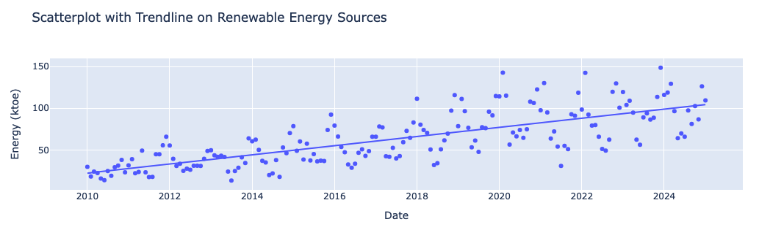

A graph of missing values was rendered for easier representation for non-technical stakeholders (Statsig, 2024)

References

Amat Rodrigo, J. and Escobar Ortiz, J. (2022) ‘skforecast’. Zenodo. Available at: https://doi.org/10.5281/ZENODO.8382788.
Chaudhary, S. (2024) 1.5 IQR Rule Explained, Built In. Available at: https://builtin.com/articles/1-5-iqr-rule (Accessed: 5 May 2025).
Cunniffe, N. (2025) Irish wind farms have cut electric bills by €320 EACH - it’s time to build more, The Irish Sun. Available at: https://www.thesun.ie/news/15154826/irish-wind-farms-electric-bills-build-more-green-power/ (Accessed: 5 May 2025).
Hayes, A. (2024) Heteroscedasticity Definition: Simple Meaning and Types Explained, Investopedia. Available at: https://www.investopedia.com/terms/h/heteroskedasticity.asp (Accessed: 5 May 2025).
Hughes, R.A. (2024) Which EU countries use the most - and least - renewable energy?, euronews. Available at: https://www.euronews.com/green/2024/01/03/sweden-portugal-luxembourg-which-eu-countries-use-the-most-and-least-renewable-energy (Accessed: 5 May 2025).
Pope, C. (2024) Ireland has most expensive net electricity prices in the EU, The Irish Times. Available at: https://www.irishtimes.com/ireland/2024/10/30/ireland-has-the-most-expensive-net-electricity-prices-in-the-eu/ (Accessed: 5 May 2025).
Qureshi, R. (2023) Accurate Forecasting’s Impact on Renewable Energy, Climavision. Available at: https://climavision.com/blog/harnessing-the-power-of-accurate-forecasting-for-the-renewable-energy-industry/ (Accessed: 5 May 2025).
Statsig (2024) From data to decisions: How to communicate findings to non-technical teams, statsig. Available at: https://www.statsig.com/perspectives/from-data-to-decisions-how-to-communicate-findings-to-non-technical-teams (Accessed: 5 May 2025).
Wahidna, A., Sookia, N. and Ramgolam, Y.K. (2024) ‘Performance evaluation of artificial neural network and hybrid artificial neural network based genetic algorithm models for global horizontal irradiance forecasting’, Solar Energy Advances, 4, p. 100054. Available at: https://doi.org/10.1016/j.seja.2024.100054.
Wahir, N.A. et al. (2018) ‘Treatment of Outliers via Interpolation Method with Neural Network Forecast Performances’, J. Phys.: Conf. Ser. 995 012025 [Preprint]. Available at: https://iopscience.iop.org/article/10.1088/1742-6596/995/1/012025/pdf.
Weir, 2024 (2024) Monthly vs Weekly Forecasting - How To Chose The right One, Slimstock. Available at: https://www.slimstock.com/blog/monthly-vs-weekly-forecasting/ (Accessed: 5 May 2025).
Wijaya, C.Y. (2020) Outlier - Why is it important?, Towards Data Science. Available at: https://towardsdatascience.com/outlier-why-is-it-important-af58adbefecc/ (Accessed: 5 May 2025).
Wolford, B. (2018) What is GDPR, the EU’s new data protection law?, GDPR.eu. Available at: https://gdpr.eu/what-is-gdpr/ (Accessed: 5 May 2025).
Yi, M. (2025) Mastering Scatter Plots: Visualize Data Correlations, Atlassian. Available at: https://www.atlassian.com/data/charts/what-is-a-scatter-plot (Accessed: 5 May 2025).

