A Deep Learning and Big Data Approach for Predictive Customer Targeting in Bank Marketing Campaigns
Joel Albert Montuya
College of Computing Technology Dublin
MSc in Data Analytics - Batch Feb 2025
Dublin, Ireland
2025040@student.cct.ie

Abstract—Marketing campaigns are essential business strategies which build brand awareness and drive revenue growth, however, inefficient customer targeting can lead to wasted resources and poor customer engagement resulting in large financial losses. Thus, this study develops a predictive customer targeting system for bank marketing campaigns by leveraging Hadoop Distributed File System (HDFS) and Artificial Neural Network (ANN). The USCI’s bank marketing dataset was utilized and an improvised sampling strategy was applied to address severe class imbalance, achieving a balanced F1 score of more than 80% for both classes. The ANN achieved 82.1% accuracy and was then benchmarked against Decision Tree, Random Forest, Logistic Regression and CatBoost. Even though Random Forest achieved the highest performance score of 82.6%, this marginal difference still resulted for ANN to be selected for its effectiveness in large-scale datasets and scalability in distributed computing environments. The trained model was deployed using the FastAPI framework, which created a production-ready microservice providing real-time prediction using the API endpoints. Results demonstrate that leveraging distributed file systems and deep learning models provides a practical and scalable solution for predictive customer targeting in marketing campaigns for the banking sector.
Keywords—Deep Learning, Customer Targeting, Artificial Neural Networks, HDFS, Predictive Analytics, Microservices, Model Deployment

Introduction
In recent years, companies have increasingly employed data-driven approaches and machine learning techniques to gather business and customer insights, enabling the development of efficient and competitive marketing strategies. According to McKinsey and Company (2013), this effort has led to an improved performance in productivity and profitability compared to competitors by 5-6% and a 15-20% increase in marketing return on investment (MROI). Data-driven technologies have become essential for businesses to survive and effectively adapt to a frequently changing market, driven by rapid technological growth (Sylvestre, 2024).

Big Data and Advancements of Technologies in Marketing

Big Data has emerged as large amounts of data being collected and stored due to the increase in digital connectivity. Social media posts, IoT devices, and the surge of other emerging data sources contribute to the growing pool of information. These datasets are processed to strengthen decision-making, customer satisfaction, and operational efficiency. Furthermore, technologies such as large language models (LLMs), generative AI, and machine learning models are implemented together with Big Data, which drive innovation and sustain a competitive edge amongst businesses (IBM, 2024).

Importance of Data-Driven Marketing Campaigns
Marketing campaigns are crucial to a business’s growth and success. By reaching the correct target audiences, they aid businesses in building brand awareness and driving revenue growth (Wan, 2023). The accurate execution of these campaigns can lead businesses to allocate resources effectively, promote customer retention, and gather customer insights to solidify future marketing strategies (Iragar, 2021). In contrast, a poorly executed campaign may lead to marketing waste, financial losses, poor customer engagement, and potential damage to the brand's reputation. Therefore, careful planning together with data-driven targeting will maximize marketing return on investment, develop customer loyalty, and ensure business sustainability.

Statement of the Problem
Marketing campaigns in the banking sector struggle in efficiently identifying or targeting relevant customers who are most likely to respond to promotional offers. Traditional methods result in low conversion rates, customer dissatisfaction and wasted resources (Moro et al., 2014). Although banks collect large volumes of data nowadays, its scale and complexity is poorly handled when traditional machine learning is applied, especially in handling severely imbalanced datasets that are biased towards non-responders which is impractical for production usage.

There is also a research gap towards integrating Big Data infrastructures and Deep Learning for a real-time targeting system. Previous studies focused more on traditional learning algorithms or deep learning models on Big Data systems with few details on end-to-end pipeline deployments.

Research Objective
This study aims to develop a predictive customer-targeting marketing campaign system by integrating Big Data and Deep Learning architectures. For storage and data processing, this project will utilize Hadoop Distributed File System (HDFS) and an Artificial Neural Network (ANN) model to classify the most appropriate customers. The generated model will be benchmarked against other traditional machine learning approaches, including Decision Trees (DT), Random Forests (RF), and any other applicable classification techniques to determine the most appropriate model for the study. The main focus of this research is to aid the bank in efficiently and effectively managing its marketing campaigns by improving the predictive power of customer targeting to those most likely to accept the marketing offer.

Overview & State of the Art
The aim of this is to build a campaign-targeting system that predicts the most suitable customers to contact, improving efficiency, and reducing wasted engagements. This focuses on creating an end-to-end pipeline from sourcing the dataset from HDFS, training the model using ANN and other machine learning models, and deploying a micro-service using FastAPI.

Research Question
- Does Artificial Neural Networks (ANN) and Hadoop Distributed File System (HDFS) provide a practical and workable approach in creating a system to predict customers with high-chances of accepting the marketing campaign?
- Does this setup provide accurate results, timely predictions and manageable daily business use?

C. State of the Art

Levering Big Data and machine learning methodologies has significantly transformed businesses on their approach to customer targeting in marketing campaigns. Recent advancements suggest a shift in traditional marketing strategies into a data-driven approach.

The research conducted by Moro, Cortez and Rita (2014) in regards to predictive modeling for telemarketing campaigns in the banking sector demonstrates the contribution of predictive analytics in improving customer targeting. This approach, driven by machine learning models suggest significant improvements on the campaign efficiency and success rates while contacting half of the customers. Their work serves a foundation for subsequent research, however, it is more focused on traditional machine learning algorithms than exploring deep learning architectures.

Big Data has become a trend in marketing analytics. Yang (2024) emphasized the growing adoption of businesses towards Hadoop-based systems. This allows them to process vast amounts of customer data for market analysis applications such as market trend forecasting, competition analysis and product development and innovation, which is inefficient to implement with conventional databases. However, common implementation utilizes batch processing rather than realtime prediction system, and few studies tackled end-to-end pipeline from data storage until model deployment( El-Sayed, Abougabal and Lazem, 2025).

In regards to Deep Learning (DL), specifically Artificial Neural Networks (ANN) shows significant results when predicting customer behaviour across various marketing applications. For instance, Khan et al. (2019) has successfully created a ANN-based model to predict customer churn in the telecommunication sector. Other applications such as fraud detection and forecasting students’ academic grades have further demonstrated the effectiveness of ANN. Despite this, there is a notable gap in research applications where both deep learning and distributed file systems are combined especially for bank marketing campaign applications.

Thus, this research aims to incorporate big data and deep learning by creating an end-to-end pipeline to achieve strong predictive performance, demonstrating practical application and deployment in real-world environments addressing the gap. By combining HDFS infrastructure, Artificial Neural Network (ANN) for classification, and microservices architecture, this research addresses the requirements of creating an efficient customer targeting system.

D. Proposed Approach

The project will employ the Hadoop Distributed File System (HDFS) for storage and processing, it is where the datasets will be stored and retrieved for model training using ANN and other machine learning algorithms. The rendered models and scalers will be automatically uploaded to the HDFS for portability and ease of deployment. A separate service is to be created to accommodate post requests from users, and the system will predict whether a customer is best suited for the campaign. Each result can be stored in HDFS for future retrieval. Different frameworks will also be utilized, such as Tensorflow, PySpark, and FastAPI, to streamline the development process.

Fig. 1 Proposed High-level Architecture
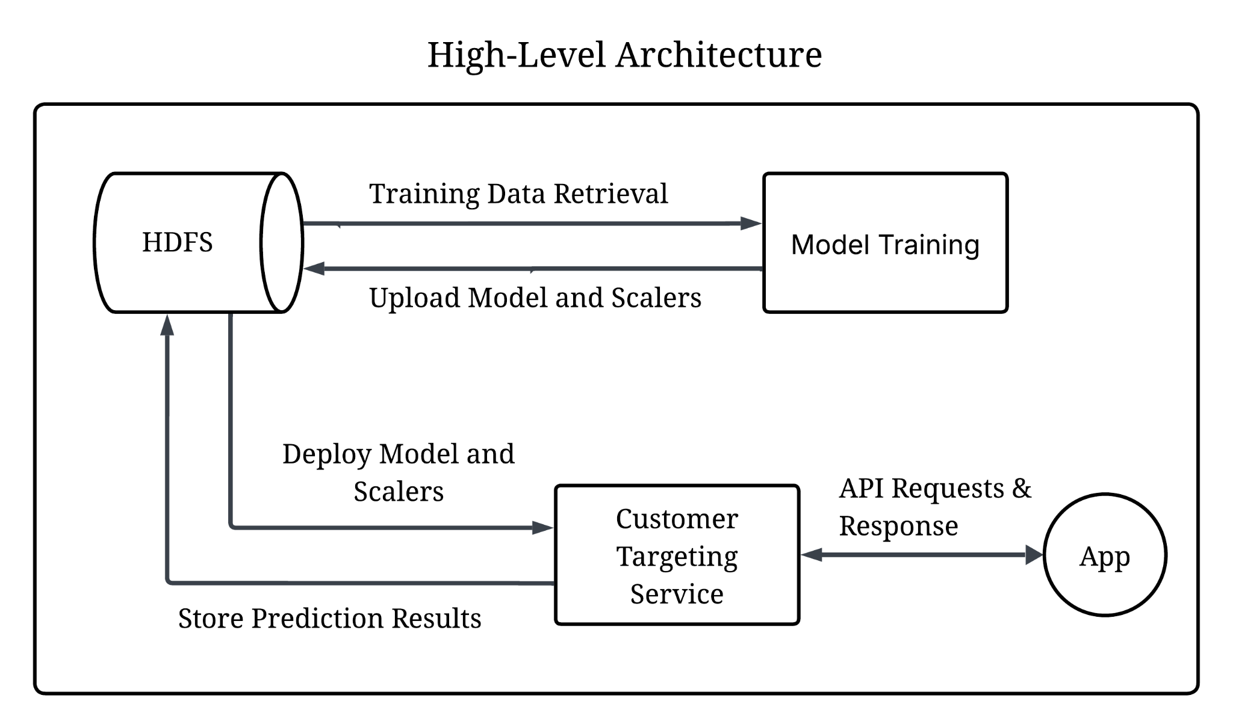
Model Training:

- The dataset was downloaded from HDFS using Apache Spark API, then went through data processing and Deep Learning using ANN and other traditional machine learning methods.

- The generated model and scalers are automatically uploaded directly to HDFS for deployment. A custom function was created to accommodate this functionality, utilizing packages such as HDFS InsecureClient for file transfer and the joblib package for extracting scalers.

Deployment: Customer Targeting Service

- The model can be deployed by using a custom function that pulls the image from HDFS using InsecureClient. The model was loaded using TensorFlow packages, and then the metrics. Similarly with the scaler was reutilized for processing data received from the API request.
- Users can send API Post Requests to the service containing the required customers' details for model prediction.
- The API will send a response to the user if the customer fits for the campaign. Results are also stored in HDFS in a table format using Spark SQL for future retrieval of the accumulated result.

E. Evaluation
This project will benchmark the results gathered from ANN against traditional machine learning methods, namely Decision Trees, Random Forests, Logistic Regression, and CatBoost. Metrics such as F1 and accuracy will be analyzed together with the precision and recall of each model, specifically in handling imbalanced data.

Review of Related Literature

Overview of Predictive Marketing

Marketing campaigns are a typical business strategy, often involving remote customer interaction. Companies use channels such as mobile or telephone to target specific customers to achieve a certain business goal. However, outbound contacts can be perceived as intrusive, which can pose issues and challenges. This can be addressed through predictive marketing strategies to accurately identify suitable customers for the campaign and maximize customer lifetime value (Moro et al., 2014).

Predictive marketing incorporates data-driven methods such as vast historical data and machine learning to forecast customer behavior, which allows to gather insights and make data-informed strategies to strengthen market advantage (Russel, 2025). Moro, Cortez and Rita (2014) introduced a data-driven approach for telemarketing using several machine learning algorithms to predict customers will subscribe to a term deposit. Their result suggests significant improvements in successful sales when implementing the proposed model and contacting half of the customer only. Similar studies verify application of this approach leads to better customer engagement and higher return on investment (ROI) (Al Khaldy et al., 2023).

Big Data and Distributed Computing in Marketing Applications

As enormous volumes of data are generated daily, Big Data plays a crucial role in storing consumer behavior and marketing data from diverse sources, which are valuable for the continuous transformation towards a data-driven industry (Lukosius & Hyman, 2018). The Hadoop Distributed File System (HDFS) and Apache Spark are an open source framework that can store data across multiple nodes and execute data processing in parallel, achieving high efficiency especially in handling large-scale dataset, real-time decision making and complex event processing. This technology drives innovative approaches for market analysis and business decision making, giving organizations new business opportunities and competitive advantage in a complex and rapidly evolving market (Yang, 2024).

Artificial Neural Network in Predictive Modeling

The major difference between Artificial Neural Network (ANN) and traditional machine learning models is their ability to handle complex and non-linear relationships in the data (Qamar and Zardari, 2023). ANN has wide applications, such as predicting students’ academic performance, where it was able to forecast students' final grades with 97% accuracy (Lateef & Adenubi, 2013), and predicting a building’s energy consumption based on historical data (Ferlito et al., 2015).
The predictive capability of an ANN allows for the development of marketing strategies, such as churn prediction. It enables early detection of loyal customers who have the intention to leave, which facilitates businesses to employ proactive actions to retain customers (Khan et al., 2019).
These applications demonstrate the power of Artificial Neural Networks (ANN) as a predictive modeling tool for organizations, allowing them to make data-driven decisions and accelerate business performance. Thus, ANN is considered the most suitable model for this research.

Leveraging Deep Learning and Big Data

Leveraging Deep Learning and Big Data has gained prominence with its application for businesses to analyze large-scale data, generate forecasts or predictions and create data-driven strategies. As ANN can handle complex non-linear data, it has become a preferred model for predictive applications across different industries (Qamar and Zardari, 2023). Meanwhile, HDFS offers scalability, fault tolerance, high throughput and flexibility in handling diverse datatypes, making this, together with Apache Spark, a preferred Big Data solution for businesses.

Recent studies verified the effectiveness of combining these technologies. West and Batacharya (2016) have successfully developed a credit assessment and fraud detection leveraging neural networks on big data platforms. Similarly, the work of Maciel Pondel et al. (2021) have achieved superior performance in customer churn prediction on retail applications. These findings demonstrate deep learning and big data solutions have made powerful contributions in solving real-world problems and became solid basis for this study.

Methodology

This section outlines the methodologies performed in this study that focus on employing a robust customer- targeting system using Big Data frameworks and deep learning techniques. The overall process consists of data acquisition, data processing, model development, evaluation and deployment of the application. Apache Spark and HDFS were utilized for distributed data and processing, while Artificial Neural Networks (ANN) and other traditional machine learning models will be benchmarked in search for the best performing model for the study. Lastly, the trained model will be deployed using FastAPI to implement real-time predictions to classify suitable customers for the campaign.

Dataset
The bank marketing dataset was sourced from the University of California, Irvine (UCI) repository. It contains records from a Portuguese bank institution running a telemarketing campaign for a term deposit. Each client interaction is labeled to indicate whether the customer subscribed to the offered service.
The dataset contains 45,211 client records and 18 features, including age, job, marital status, and other binary columns, such as whether a person has a pending loan. In regard to privacy, the dataset is fully anonymized and does not contain any direct identifiers (e.g., phone numbers, names, or account numbers).
In terms of licenses, the dataset is released under Creative Commons Attribution 4.0 (CC BY 4.0); in this study, the dataset was used solely for research purposes and properly cited in the Reference section.

Data Preparation
This section describes the end-to-end preparation of the raw dataset used for model development. The training dataset was stored in the HDFS which was retrieved using Apache Spark API. Data integrity test was executed to validate datatypes, null, and duplicate checking which is necessary to avoid errors during execution, improve accuracy of the model and reliability of the results (Chain and Alexander, 2023).

Fig. 2 Imbalance Distribution in the Target Variable
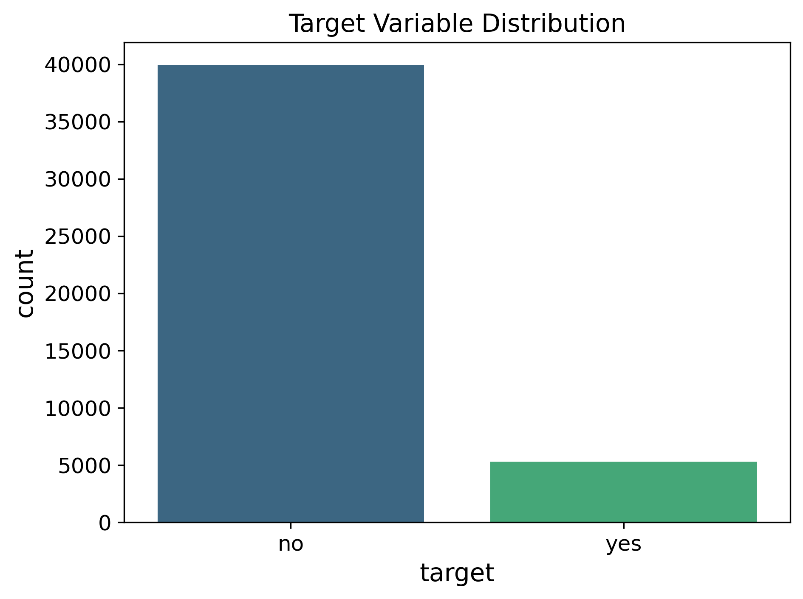
One observable issue is that there is a substantial class imbalance of the dependent variable in the dataset, as shown in Fig. 2. More people did not respond to the campaign than those who did. This imbalance can cause the model to be biased towards predicting the majority class and neglecting minority patterns, leading to a significant drop in precision and recall (Johnson and Khoshgoftaar, 2019). To address this, the Synthetic Minority Oversampling Technique (SMOTE) was applied to reduce class imbalance by expanding the number of minority classes, helping the model make better classification results (Elreedy and Atiya, 2019).

Other steps such as feature selection, scaling, and encoding were also performed to ensure stability by ensuring variables are suitable for model training.

Tools and Technologies
Apache Spark is a distributed computing framework that provides a unified engine to support diverse and large-scale data processing workloads. It simplifies the integration of HDFS and other storage systems into the data pipelines and analytical workflows through its APIs, SQL, machine learning, and structured streaming functionality (Zaharia et al., 2016). In this study, Apache Spark was utilized to retrieve the bank marketing dataset stored in HDFS and to facilitate model training.
FastAPI is a high-performance web framework for creating scalable, reliable, and scalable microservices. Its simple implementation and automatic data validation allows developers to accelerate development of RESTful API applications (Chen, 2023). Thus, FastAPI is particularly well suited for this study, providing an efficient and robust platform to integrate machine learning models and deploy a customer-targeting application.

Artificial Neural Networks for Classification

The Artificial Neural Network (ANN) was employed in this study as the main classification model for its capability in capturing non-linear relationships. The freedom to set up its architecture from input, hidden, and output layers gives flexibility in handling complex tasks such as classification and regression (Qamar and Zardari, 2023). The input and hidden layers employ the ReLU activation function, while the output layer uses sigmoid activation as the focus is on classification.
Rectified Linear Units (ReLU) were utilized in the input and hidden layers to introduce non-linearity, accelerate training, and mitigate the vanishing gradient problem, where the network’s weights become negligible during backpropagation, which is often observed with sigmoid and softmax activation functions. Thus, considering ReLU the most suitable activation function for the study (Luna, 2025).
Sigmoid Activation function outputs a probabilistic value between 0 and 1, which is suitable for binary classification tasks. Applying a sigmoid activation function on the output layer can be interpreted as probabilities, where we can utilize a threshold (e.g., 0.5) to distinguish positive and negative classes (Alzhrani, 2025).
Early Stopping was also utilized in this study to avoid overfitting, which is a common risk to deep learning models. This function observes the loss and stops if there are more improvements in the training process, and prevents the model from memorizing the data and poor generalization (Hussein and Shareef, 2024).

Comparison of Traditional Machine Learning Models
Different traditional machine learning models for classification were also employed for the study. The Decision Tree Classifier, Random Forest, Logistic Regression and CatBoost were benchmarked against ANN. GridsearchCV was utilized for parameter tuning for each model.
- Parameter Grid For Tree-Based
Model | Parameters
 | Max Depth | Random State | N Estimators
Decision Ttree | 2, 4, 6 | 0
Random Forest | 10, 20 | 0 | 50, 100

Logistic Regression, despite its name, is utilized as a classification algorithm as it outputs probabilities between 0 and 1. It can handle large datasets and avoid overfitting using regularizations.
TABLE 2. Parameter Grid For Logistic Regression
Model | Parameters
 | Penalty | Solver | l1_ratio | C | max_iter
Logistic Regression | l1, l2 | saga | 0.0, 0.5, 1.0 | 0.1, 1.0, 10 | 2000
CatBoost
TABLE 3. Parameter Grid For CatBoost
Model | Parameters
 | Iterations | learning_rate | depth | scale-pos_weight
Logistic Regression | l1, l2 | saga | 0.0, 0.5, 1.0 | 0.1, 1.0, 10

Micro-service Deployment
FastAPI was utilized to create API endpoints for customer-targeting applications. The POST /customer method was implemented that accepts customer details as JSON input, adds customers to the database, and a deep learning model was integrated to analyze whether the customer is likely to accept the campaign based on the provided information. The API then returns a response to the user providing an instant result of the analysis and allows integration with front-end systems and CRM applications for automation.

Critical Evaluation
This section analyzes major challenges encountered during model development and provides experimental approaches to resolve them. There are two primary issues identified: severe class imbalance in the dataset, as seen in Fig. 2, and finding the optimal neural network architecture fit for the study.

Imbalance in Class Distribution
One key issue with the bank marketing dataset is its imbalanced class distribution, where individuals who did not respond to the marketing campaign are significantly outnumbered those who did. To address this issue, the SMOTE and an improvised sampling strategy were executed and using ANN to validate the approach:
TABLE 4. SMOTE Testing with ANN
SMOTE | Parameters
 | Random State | Sampling Strategy | k_neigbors | f1 Score
 |  |  |  | 0 Label | 1 Label
Test 1 | 42 | 0.4 | 3 | 0.94 | 0.49
Test 2 | 0 | 0.3 | 2 | 0.92 | 0.51
Test 3 | 42 | 0.5 | 3 | 0.92 | 0.52

Despite the implementation of SMOTE, the approach failed to resolve the class imbalance, as evidenced by the F1 score of Class Label 1 at 50%, indicating that the prediction remained biased towards the majority class. This model will be unreliable in production, even if the Class Label 0 achieves a 90% F1 score range.

Therefore, an improvised approach was implemented by determining the total number of records of Class Label 1 and randomly selecting an equal number of test data from Class Label 0 to avoid bias. Results show improvements on the scores shown in the table below.
TABLE 5. Improvised Sampling Approach Testing with ANN
 | Parameters
 | Precision |  | Recall |  | f1 Score
 | 0  Label | 1  Label | 0  Label | 1  Label | 0 Label | 1  Label
Test 1 | 0.78 | 0.83 | 0.82 | 0.79 | 0..80 | 0.81
Test 2 | 0.81 | 0.84 | 0.83 | 0.81 | 0.82 | 0.83
Test 3 | 0.80 | 0.85 | 0.84 | 0.81 | 0.82 | 0.83

The improvised sampling strategy yielded a better classification performance of Class Label 1, from around 50% using SMOTE to above 80%. Performance of both classes now has a comparable F1 score of around 80% to 83%, suggesting that the impact of class imbalance was substantially reduced. Thus, this approach is preferred for this study.

Deploying Artificial Neural Networks (ANN)

Several ANN network structures have been evaluated to determine the most applicable configuration for the study. Each setup consists of varying depth of hidden layers, dense and dropouts. The following setups below are evaluated using accuracy and F1 scores yielding the following test results.

TABLE 6. Network Architectures For ANN
Setup 1 | Parameters |  |  | Score
 | Dense | Activation | Dropout
 |  |  |  | Accuracy | F1
Input Layer | 64 | relu | NA | 0.8151 | 0.8151
Hidden Layer 1 | 32 | relu | NA
Output Layer | 1 | sigmod | NA

Setup 2 | Parameters |  |  | Score
 | Dense | Activation | Dropout
 |  |  |  | Accuracy | F1
Input Layer | 64 | relu | 0.3 | 0.8231 | 0.8230
Hidden Layer 1 | 32 | relu | NA
Output Layer | 1 | sigmoid | NA

Setup 3 | Parameters |  |  | Score
 | Dense | Activation | Dropout
 |  |  |  | Accuracy | F1
Input Layer | 128 | relu | NA | 0.8188 | 08186
Hidden Layer 1 | 64 | relu | NA
Hidden Layer 2 | 32 | relu | NA
Output Layer | 1 | sigmoid | NA

Setup 4 | Parameters |  |  | Score
 | Dense | Activation | Dropout
 |  |  |  | Accuracy | F1
Input Layer | 256 | relu | 0.3 | 0.8218 | 0.8218
Hidden Layer 1 | 128 | relu | 0.3
Output Layer | 1 | sigmoid | NA
Among the tested network architectures, setup 2 demonstrated the better performance to the other configurations with a score of 82% for both accuracy and F1-score. Thus, this configuration will be employed and evaluated against other traditional machine learning models.

Deployment of Trained ANN using FastAPI
With the ANN model attaining an accuracy of 82.1% accuracy, it will be deployed using FastAPI framework to create a microservice that enables real-time customer targeting predictions. This section details the end-to-end process of implementing the proposed architecture.
To create an end-to-end pipeline, the three components namely, the HDFS, trained model and FastAPI framework were integrated to create the microservice that is deployable in real-world applications. The deployment process are detailed as follows:

Export and Uploading Trained Mode and Scaler:
Following the training process, a custom function was developed to export the trained model and preprocessed scalers using tensorflow’s save model function and joblib, respectively. These files will be automatically uploaded to HDFS with a designated filepath /marketing_campaign/models using HDFS InsecureClient library. This centralized storage approach allows ease of access and portability of the trained model to be deployed across multiple remote applications.

Loading the Model from HDFS:
Using a custom function, trained model and preprocessed scaler are retrieved from HDFS using HDFS InsecureClient. The trained model was loaded by tensorflow’s keras_load_model function and joblib’s load function for the scaler. This process ensures similar processing and transformation will be applied during training and deployment for maintaining the model's integrity and reliability.

Data Processing
A POST /customers API requests are implemented to enable users to submit customers’ information for prediction. Incoming data will undergo data processing extracting required features and applying the preprocessed scaler before fitting into the model.With FastAPI’s built in data validation mechanism ensures incoming request aligns with the expected schema, correct datatypes and required fields, this accelerates the development process and provides user with detailed information of the error.

Prediction
The processed data is fitted to the model for prediction. The result returns a probability which is rounded off with a threshold of 0.5 into values 0 and 1, representing likelihood of customers accepting the marketing campaign. Then, an API response will be returned to the customer containing the prediction result.

Results
All prediction results and customer identifiers will be stored automatically in the HDFS using APACHE Spark SQL. This feature logs historical records for future retrieval, it also enables for model monitoring, and allows for further analysis. The SQL data are stored in HDFS with filepath /marketing_campaign/sql_data and in a tabular format that can be queried for reporting or analytics.

This deployment demonstrates the successful integration of Big Data, Deep Learning models and modern API framework, creating a deployable solution for a real-time customer targeting application using the bank campaign data.

Results and Analysis

Comparison of ANN and Traditional Machine Learning Algorithms
This study has employed other traditional machine learning models such as Decision Tree (DT), Random Forest (RF), Logistic Regression and Categorical Boosting (CatBoost) to enable comparative evaluation against the results of ANN. This allows for the identification of the most suitable model to be deployed for this study.
The mentioned traditional machine learning algorithms were employed along with GridSearchCV and each corresponding parameter grid to automate testing and optimize model performance by finding the best hyperparameters. Contrary to the initial expectations, the Random Forest slightly outperformed the Artificial Neural Network with an accuracy and F1-scores of 0.826 and 0.825, respectively, while ANN obtained 0.821 for both metrics, which is fractionally lower to RF.

Fig. 3 Model Training Results
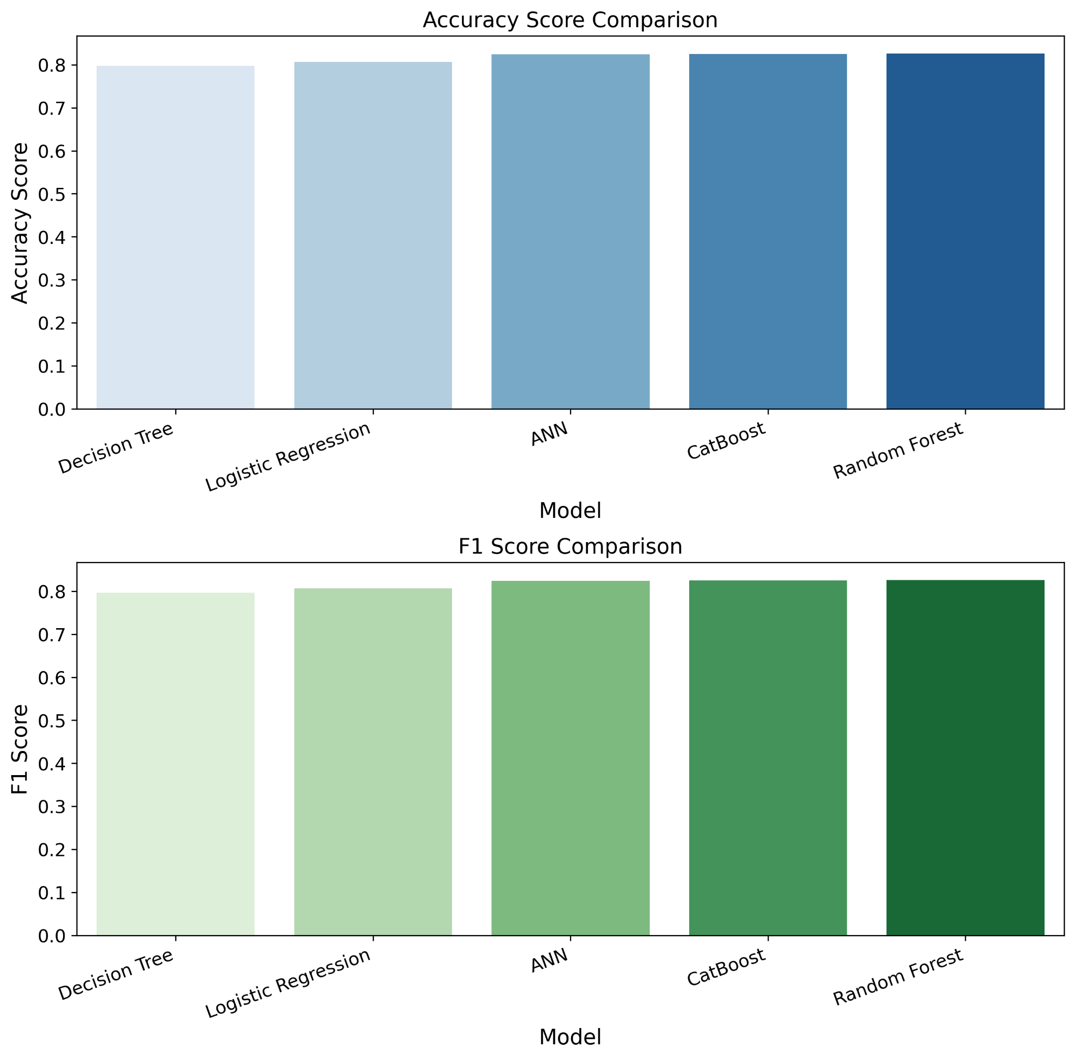
Fig. 3. Graph shows Random Forest and CatBoost outperformed ANN
TABLE 6. Performance Comparison of ANN And Traditional Machine Learning Models
Model | Performance
 | Precision |  | Recall |  | Accuracy | F1  score
 | 0  Label | 1  Label | 0  Label | 1  Label
ANN | 0.81 | 0.83 | 0.83 | 0.81 | 0.821 | 0.821
DT | 0.83 | 0.77 | 0.74 | 0.85 | 0.797 | 0.796
RF | 0.84 | 0.82 | 0.81 | 0.84 | 0.826 | 0.825
LR | 0.79 | 0.82 | 0.83 | 0.78 | 0.806 | 0.806
CatBoost | 0.83 | 0.82 | 0.81 | 0.84 | 0.825 | 0.824
The outcomes align with the findings of Grinsztajn, Oyallon, and Varoquax (2022), where, based on their research, tree-based models often surpass artificial neural networks, especially on tabular data. The tree-based models excel in learning irregular patterns and are robust to uninformative features where neural networks struggle. However, when it comes to large-scale datasets with more than 50,000 records, ANN may potentially outperform tree-based models (Drishti, 2022).
Even though Random Forest outperforms ANN by a fraction, ANN is still the preferred option for this study. Since we will leverage the Hadoop Distributed File System (HDFS), datasets might exceed 50,000 records when deployed in a real environment setup in which ANN may demonstrate better performance than Random Forest. Additionally, ANN is more suitable for Big Data applications since it offers scalability and parallelization capabilities within distributed computing environments like HDFS. Neural networks can efficiently utilize thousands of CPU cores spread across distributed computing clusters, thus significantly reducing training times (Dean et al., 2012)

Deployment of ANN Model Using Fast API

With the ANN model attaining an accuracy of 82.1% accuracy, it was deployed using FastAPI framework to create a microservice that enables real-time customer targeting predictions. This section evaluates the feasibility of proposed architecture.

Integration of HDFS, Model and Microservices

To create an end-to-end pipeline, Fast API, trained ANN model and HDFS was integrated and tested to validate their interoperability and deployability in real-world application.
- Model Loading:
The trained model and scaler was downloaded from the HDFS using a custom code and InsecureClient. The whole process including the initialization of the model has an average time of 100 ms.
- Data Processing:
Incoming API requests containing customer data are automatically processed and scaled using the same transformation done during training, ensuring consistency of the inputs and reliability of the results.
- Prediction:
The processed data is fitted to the neural network which returns a probability score indicating customers’ likelihood in accepting the campaign.
- Result:
Prediction results are automatically stored in HDFS using SparkSQL for future retrieval and analysis.

Constraints:
The average response time per API request is approximately 500 milliseconds. This might be as a result of conducting the testing in a linux-based virtual machine (VM), where the HDFS, deployed microservice, VM’s operating system and other processes were utilizing the same compute instance, leading to slower API response time compared to deploying in a distributed compute cluster.

2. Sample Prediction Outputs

The deployed application generates prediction results of the customers’ likelihood in accepting the campaign. The table 7 shows sample prediction results using different customer profiles.
TABLE 7. Sample Prediction Result with Different Customer Profiles
id | age | marital status | balance | default | loan | job | pred
001 | 28 | single | 10,000 | false | false | student | 1
002 | 40 | married | -150 | true | true | unemployed | 0
003 | 30 | single | 2,000 | false | true | blue collar | 1
004 | 70 | married | 5,000 | false | true | retired | 0
005 | 50 | single | 200 | true | false | maid | 0
006 | 18 | single | 170 | false | true | student | 0

The result returns binary value, with ‘1’ indicating that customer is highly likely to accept the campaign, and ‘0’ otherwise. The predicted probability can be also used to identify best threshold (currently at 0.5) or classify the low, mid, and high-confidence customers, allowing business users to adjust targeting aggressiveness depending on their objectives.

Overall, the deployment demonstrates a successful integration of Hadoop Distributed File System (HDFS) with Artificial Neural Network. This application can be applied to automate customer targeting in bank marketing campaigns and achieve the research objectives of developing an accurate, real-time and manageable prediction system deployable in business operations.

Conclusions
The research successfully demonstrates the integration of Hadoop Distributed File System (HDFS) and Artificial Neural Networks (ANN) for developing an efficient predictive customer targeting system for bank marketing campaigns. The HDFS enabled centralized storage for training data, exported models, scalers, and API results; this ensures the system's high scalability and seamless accessibility across distributed systems, enabling efficient deployment service and even for remote applications. On the other hand, ANN has achieved 82.1% accuracy with the use of an improvised sampling strategy to address the severe class imbalance in the training data, resulting in a balanced F1-score of exceeding 80% for both classes. Even though Random Forest has outperformed ANN by a margin with an 82.6% accuracy, after reviewing other related literature, the ANN was still chosen for deployment as it is more effective, especially in its high scalability in distributed computing environments and effectiveness in handling large-scale datasets. The FastAPI was utilized for deployment and facilitated a production-ready microservice, enabling API endpoints for real-time prediction and automated storage of results in the HDFS for future analysis.

The implementation of this architecture for the banking sectors could reduce customer contacts by up to 82%. This reduction would significantly improve return on investment (ROI) on marketing campaigns through efficient allocation of resources, while targeted outreach could enhance customer satisfaction by delivering more relevant campaigns. Future work should explore integration of this backend system to a front-end or customer relationship management (CRM) application for full automation of the targeting system, investigate optimization techniques to reduce latency per API request, reevaluate system performance when deployed at an enterprise scale, and continuous model training by recording success per contact and retraining the model.

This study thus contributes to bridging the gap between Big Data Infrastructures and Deep Learning architectures in predictive customer-targeting in bank marketing campaigns. By demonstrating an end-to-end pipeline, from data storage through model training and up-to microservices deployment, this study provides a replicable framework for businesses aiming to optimize their customer targeting strategies, leading to a maximized marketing ROI and data-driven competitive advantage.

References

McKinsey & Company (2013) Big Data, Analytics And The Future Of Marketing And Sales, Forbes. Available at: https://www.forbes.com/sites/mckinsey/2013/07/22/big-data-analytics-and-the-future-of-marketing-sales/ (Accessed: October 6, 2025).

Sylvestre, C.E. (2024) (PDF) The Role of Data-Driven Decision Making in Business Strategy, ResearchGate. Available at: https://www.researchgate.net/publication/383552085_The_Role_of_Data-Driven_Decision_Making_in_Business_Strategy (Accessed: October 6, 2025).

IBM (2024) What is Big Data? | IBM. Available at: https://www.ibm.com/think/topics/big-data (Accessed: October 6, 2025).

Wan, Y. (2023) “Investigating the Impact and Effectiveness of Digital Marketing on Brand Awareness, Sales and Customer Engagement,” ResearchGate [Preprint]. Available at: https://www.researchgate.net/publication/376131896_Investigating_the_Impact_and_Effectiveness_of_Digital_Marketing_on_Brand_Awareness_Sales_and_Customer_Engagement(Accessed: October 6, 2025).

Moro, S., Cortez, P. and Rita, P. (2014) “A data-driven approach to predict the success of bank telemarketing,” Decision Support Systems, 62, pp. 22–31. Available at: https://doi.org/10.1016/j.dss.2014.03.001.

Chain, Z. and Alexander, D. (2023) (PDF) Data Integrity Challenges and Solutions in Machine Learning- driven Clinical Trials, ResearchGate. Available at: https://www.researchgate.net/publication/373214664_Data_Integrity_Challenges_and_Solutions_in_Machine_Learning-_driven_Clinical_Trials (Accessed: October 13, 2025).

Johnson, J.M. and Khoshgoftaar, T.M. (2019) “Survey on deep learning with class imbalance,” Journal of Big Data, 6(1), p. 27. Available at: https://doi.org/10.1186/s40537-019-0192-5.

Elreedy, D. and Atiya, A.F. (2019) “A Comprehensive Analysis of Synthetic Minority Oversampling Technique (SMOTE) for handling class imbalance,” Information Sciences, 505, pp. 32–64. Available at: https://doi.org/10.1016/j.ins.2019.07.070.

Zaharia, M. et al. (2016) “Apache Spark: a unified engine for big data processing,” Communications of the ACM, 59(11), pp. 56–65. Available at: https://doi.org/10.1145/2934664.

Chen, J. (2023) “(PDF) Model Algorithm Research based on Python Fast API,” ResearchGate [Preprint]. Available at: https://doi.org/10.54691/fse.v3i9.5591.

Luna, J.C. (2025) A Beginner’s Guide to the Rectified Linear Unit (ReLU). Available at: https://www.datacamp.com/blog/rectified-linear-unit-relu (Accessed: October 13, 2025).

Alzhrani, K.M. (2025) “From Sigmoid to SoftProb: A novel output activation function for multi-label learning,” Alexandria Engineering Journal, 129, pp. 472–482. Available at: https://doi.org/10.1016/j.aej.2025.06.013.

Hussein, B.M. and Shareef, S.M. (2024) “An Empirical Study on the Correlation between Early Stopping Patience and Epochs in Deep Learning,” ResearchGate [Preprint]. Available at: https://doi.org/10.1051/itmconf/20246401003.

Qamar, R. and Zardari, B.A. (2023) “(PDF) Artificial Neural Networks: An Overview,” ResearchGate [Preprint]. Available at: https://doi.org/10.58496/MJCSC/2023/015.

Russel, M. (2025) AI Will Shape the Future of Marketing - Professional & Executive Development | Harvard DCE. Available at: https://professional.dce.harvard.edu/blog/ai-will-shape-the-future-of-marketing/#Predictive-Analytics-and-Forecasting (Accessed: October 15, 2025).

Al Khaldy, M., Al-Obaydi, B.A. and Shari, A.J. (2023) “The Impact of Predictive Analytics and AI on Digital Marketing Strategy and ROI,” in ResearchGate. Available at: https://doi.org/10.1007/978-3-031-42455-7_31.

Lukosius, V. and Hyman, M.R. (2018) Big data in marketing research, ResearchGate. Available at: https://www.researchgate.net/publication/323664305_Big_data_in_marketing_research (Accessed: October 15, 2025).

Yang, Y. (2024) “(PDF) Applications and Challenges of Big Data in Market Analytics,” ResearchGate [Preprint]. Available at: https://doi.org/10.62051/77dhvn60.

Lateef, U.O. and Adenubi, A. (2013) Artificial Neural Network (ANN) Model For Predicting Students’ Academic Performance, ResearchGate. Available at: https://www.researchgate.net/publication/275644377_Artificial_Neural_Network_ANN_Model_For_Predicting_Students'_Academic_Performance(Accessed: October 15, 2025).
West, J. and Bhattacharya, M. (2016) “Intelligent financial fraud detection: A comprehensive review,” Computers & Security, 57, pp. 47–66. Available at: https://doi.org/10.1016/j.cose.2015.09.005.

Ferlito, S. et al. (2015) “Predictive models for building’s energy consumption: An Artificial Neural Network (ANN) approach,” in 2015 XVIII AISEM Annual Conference. 2015 XVIII AISEM Annual Conference, Trento, Italy: IEEE, pp. 1–4. Available at: https://doi.org/10.1109/AISEM.2015.7066836.

Khan, Y. et al. (2019) “Customers Churn Prediction using Artificial Neural Networks (ANN) in Telecom Industry,” ResearchGate [Preprint]. Available at: https://doi.org/10.14569/IJACSA.2019.0100918.

Grinsztajn, L., Oyallon, E. and Varoquaux, G. (2022) “Why do tree-based models still outperform deep learning on tabular data?” arXiv. Available at: https://doi.org/10.48550/arXiv.2207.08815.

Drishti (2022) “Do Tree-based Models Outperform Deep Learning Models on Tabular Data?,” Analytics Vidhya, 1 August. Available at: https://www.analyticsvidhya.com/blog/2022/08/do-tree-based-models-outperform-deep-learning-models-on-tabular-data/ (Accessed: October 16, 2025).

Dean, J. et al. (2012) “Large Scale Distributed Deep Networks,” ResearchGate [Preprint]. Available at: https://www.researchgate.net/publication/266225209_Large_Scale_Distributed_Deep_Networks (Accessed: October 16, 2025).

El-Sayed, A., Abougabal, M. and Lazem, S. (2025) “Practical big data techniques for end-to-end machine learning deployment: a comprehensive review,” Discover Data, 3(1), p. 11. Available at: https://doi.org/10.1007/s44248-025-00029-3.

Maciel Pondel et al. (2021) “Deep Learning for Customer Churn Prediction in E-Commerce Decision Support,” ResearchGate [Preprint]. Available at: https://doi.org/10.52825/bis.v1i.42.

Dataset

Moro, S., Rita, P. and Cortez, P. (2014) Bank Marketing. UCI Machine Learning Repository. Available at: https://doi.org/10.24432/C5K306 (Accessed: 19 October 2025). Licensed under Creative Commons Attribution 4.0 International (CC BY 4.0),

