רטוב 1 – ספרתיות

**יבש**

**2.1 – mux 2->1**

|  |  |  |  |
| --- | --- | --- | --- |
| S | D0 | D1 | Z |
| 0 | 0 | 0 | 0 |
| 0 | 0 | 1 | 0 |
| 0 | 1 | 0 | 1 |
| 0 | 1 | 1 | 1 |
| 1 | 0 | 0 | 0 |
| 1 | 0 | 1 | 1 |
| 1 | 1 | 0 | 0 |
| 1 | 1 | 1 | 1 |

ביטוי לZ: z=[((s nand s) nand d0) nand (s nand d1)]

**טבלת אמת**

**טבלת זמנים**

|  |  |  |  |  |
| --- | --- | --- | --- | --- |
| Path | D0 | D1 | Sel | Tpd |
| D0G2G4 | 0to1 | 0 | 0 | 7 |
| D0G2G4 | 1to0 | 0 | 0 | 7 |
| D1G3G4 | 0 | 0to1 | 1 | 7 |
| D1G3G4 | 0 | 1to0 | 1 | 7 |
| SG1G2G4 | 1 | 0 | 0to1 | 13 |
| SG1G2G4 | 1 | 0 | 1to0 | 8 |
| SG3G4 | 0 | 1 | 0to1 | 7 |
| SG3G4 | 0 | 1 | 1to0 | 7 |

**ת.ז נבחרת: 212363295**

מימשנו רק עם שערי nand ועבורם:

Tpdhl = 6, Tpdlh = 1

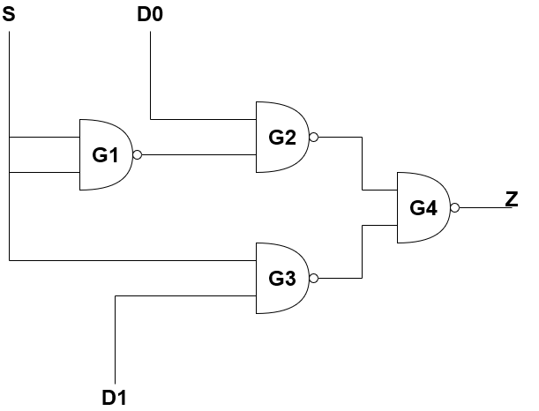מימוש:

**2.2 - mux4**

ת.ז נבחרת: 212363295

טבלת השהיות:

|  |  |  |
| --- | --- | --- |
|  | Tpdlh | Tpdhl |
| NAND2 | 6 | 6 |
| OR2 | 3 | 3 |
| XNOR2 | 3 | 3 |

|  |  |  |  |  |  |  |  |
| --- | --- | --- | --- | --- | --- | --- | --- |
| Path | D0 | D1 | D2 | D3 | S1 | S0 | Tpd |
| S1Sel3 | 0 | 0 | 1 | 0 | 0to1 | 0 | 12 |
| S1Sel3 | 0 | 0 | 1 | 0 | 1to0 | 0 | 12 |
| S0Sel1Sel3 | 0 | 1 | 0 | 0 | 0 | 0to1 | 12 |
| S0Sel1Sel3 | 0 | 1 | 0 | 0 | 0 | 1to0 | 12 |
| D0Sel1Sel3 | 0to1 | 0 | 0 | 0 | 0 | 0 | 12 |
| D0Sel1Sel3 | 1to0 | 0 | 0 | 0 | 0 | 0 | 12 |
| D1Sel1Sel3 | 0 | 0to1 | 0 | 0 | 0 | 1 | 12 |
| D1Sel1Sel3 | 0 | 1to0 | 0 | 0 | 0 | 1 | 12 |
| D2Sel2Sel3 | 0 | 0 | 0to1 | 0 | 1 | 0 | 12 |
| D2Sel2Sel3 | 0 | 0 | 1to0 | 0 | 1 | 0 | 12 |
| D3Sel2Sel3 | 0 | 0 | 0 | 0to1 | 1 | 1 | 12 |
| D3Sel2Sel3 | 0 | 0 | 0 | 1to0 | 1 | 1 | 12 |

מימוש:

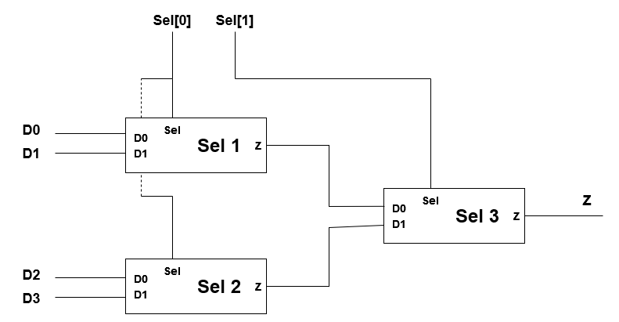

**2.3 – FAS**

טבלת השהיות:

|  |  |  |  |  |  |  |
| --- | --- | --- | --- | --- | --- | --- |
| Path | a | b | Cin | a_ns | Out | Tpd |
| aG1G5G7 | 0to1 | 1 | 0 | 0 | Cout | 15 |
| aG6 | 0to1 | 1 | 0 | 0 | S | 3 |
| bG2G5G7 | 0 | 0to1 | 0 | 0 | Cout | 15 |
| bG4G6 | 0 | 0to1 | 0 | 0 | S | 6 |
| a_nsG1G5G7 | 0 | 1 | 0 | 0to1 | Cout | 15 |
| a_ns----- | --- | --- | --- | --- | S | --- |
| CinG2G5G7 | 0 | 0 | 0to1 | 0 | Cout | 15 |
| CinG4G6 | 0 | 0 | 0to1 | 0 | S | 6 |

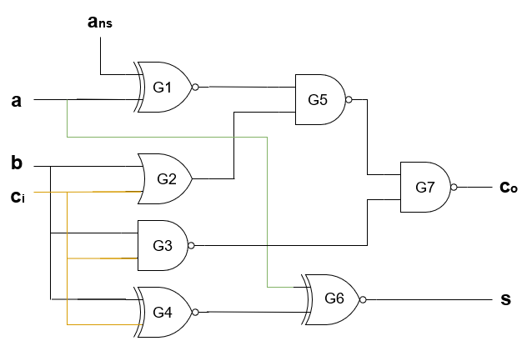

מימוש:

**2.4- alu1bit**

טבלת השהיות:

|  |  |  |  |  |  |  |  |
| --- | --- | --- | --- | --- | --- | --- | --- |
| Path | A | B | Cin | Op[1] | Op[0] | Out | Tpd |
| Op[1]Sel | 1 | 0 | 0 | 0to1 | 0 | S | 18 |
| Op[1]--- | --- | --- | --- | --- | --- | Cout | --- |
| aFAS | 0to1 | 1 | 0 | 1 | 0 | Cout | 15 |
| aG2G4G6Sel | 0to1 | 0 | 1 | 0 | 0 | S | 24 |
| bFAS | 1 | 0to1 | 0 | 1 | 0 | Cout | 15 |
| bG2G4G6Sel | 0 | 0to1 | 1 | 0 | 0 | S | 24 |
| CinFAS | 1 | 0 | 0to1 | 1 | 0 | Cout | 15 |
| CinFASSel | 0 | 0 | 0to1 | 1 | 0 | S | 18 |
| Op[0]G1FAS | 0 | 1 | 0 | 1 | 0to1 | Cout | 21 |
| Op[0]G1G4G6Sel | 1 | 0 | 1 | 0 | 0to1 | S | 27 |

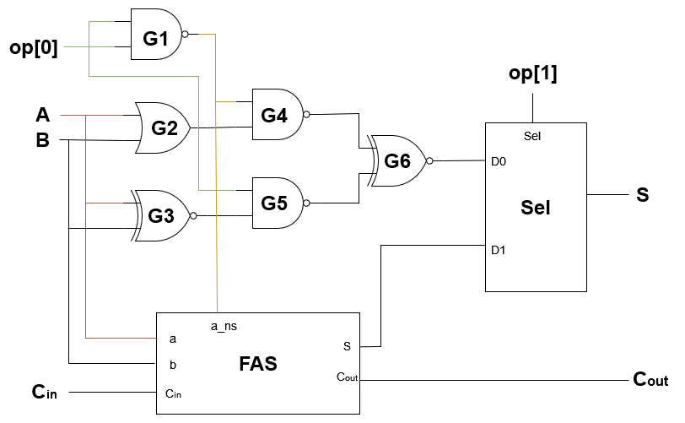מימוש:

**2.5 – alu64bit**

|  |  |  |  |  |  |  |  |
| --- | --- | --- | --- | --- | --- | --- | --- |
| Path | A[63:0] | B[63:0] | Cin | Op[1] | Op[0] | Out | Tpd |
| Op[0]ALU0….ALU63 | [0….0] | [0….01] | 0 | 1 | Oto1 | S[63] | 969 |

Tpd = Tpd_op[0]_Cout + Tpd_Cin_Cout*62 + Max(Tpd_Cin_S , Tpd_Cin_Cout)

**רטוב**

צילום מסך של הסימולציה הראשונה
**3.3**

**3.5**

**3.8**

