**Chatting Application**

**A PROJECT REPORT**

**for**

**Mini Project-I (K24MCA18P)**

**Session (2024-25)**

**Submitted by**

**Monty Sharma**

**(202410116100124)**

**Harsh Gupta**

**(202410116100082)**

**Gaurav Chauhan**

**(202410116100073)**

**Submitted in partial fulfillment of the**

**Requirements for the Degree of**

**MASTER OF COMPUTER APPLICATION**

**Under the Supervision of**

### Mr. Arpit Dogra

### Assistant Professor



**Submitted to**

**Department Of Computer Applications**

**KIET Group of Institutions, Ghaziabad**

**Uttar Pradesh-201206**

**(december- 2024)**

**CERTIFICATE**

Certified that **Monty Sharma(202410116100124), Harsh Gupta(202410116100082)** ,

**Gaurav Chauhan(202410116100073)**  have carried out the project work having “**Chatting Application**” (**MiniProject-I, K24MCA18P**) for **Master of Computer Application**from Dr. A.P.J. Abdul Kalam Technical University (AKTU**)** (formerly UPTU),Lucknow under my supervision. The project report embodies original work, and studies are carried out by the student himself/herself and the contents of the project report do not form the basis for the award of any other degree to the candidate or to anybody else from this or any other University/Institution.

**Mr.Arpit Dogra Dr. Arun Kr. Tripathi**

**Assistant Professor Dean**

**Department of Computer Applications Department of Computer Applications**

**KIET Group of Institutions, Ghaziabad KIET Group of Institutions, Ghaziabad**

**Chatting Application**

**Monty Sharma, Harsh Gupta, Gaurav Chauhan**

**ABSTRACT**

In the modern digital era, real-time communication has become an essential aspect of personal and professional interactions. This project focuses on the development of a user-friendly chatting application that offers seamless communication through text, multimedia sharing, and group chats. The application leverages advanced technologies to ensure robust performance, data security, and an intuitive user interface.  
  
The proposed chatting application is designed to cater to diverse user needs, incorporating features such as end-to-end encryption for secure messaging, cloud-based data storage for accessibility, and cross-platform compatibility for ease of use. The implementation emphasizes scalability to accommodate a growing user base and evolving technological trends. By integrating innovative functionalities such as customizable user profiles, status updates, and real-time notifications, the application aims to enhance the overall user experience.  
  
This project also addresses key challenges in modern communication platforms, including data privacy concerns, latency issues, and user authentication. Through meticulous planning, design, and testing, the application aspires to deliver a reliable and efficient communication solution that bridges the gap between users across various devices and geographies.

Keywords: Chatting Application, Real-Time Communication, End-to-End Encryption, Cross-Platform Compatibility, Data Privacy.

**ACKNOWLEDGEMENTS**

Success in life is never attained single-handedly. My deepest gratitude goes to my project supervisor, **Mr.Arpit Dogra** for her guidance, help, and encouragement throughout my project work. Their enlightening ideas, comments, and suggestions.

Words are not enough to express my gratitude to Dr. Arun Kumar Tripathi,Professor and Dean, Department of Computer Applications, for his insightful comments and administrative help on various occasions.

Fortunately, I have many understanding friends, who have helped me a lot on many critical conditions.

Finally, my sincere thanks go to my family members and all those who have directly and indirectly provided me with moral support and other kind of help. Without their support, completion of this work would not have been possible in time. They keep my life filled with enjoyment and happiness.

**Monty Sharma**

**Harsh Gupta**

**Gaurav Chauhan**

**TABLE OF CONTENTS**

* **Certificate** .................................................................................. ii
* **Abstract** ................................................................................... iii
* **Acknowledgements** ............................................................... iv
* **Table of Contents** .................................................................. v

### ****1. Introduction**** ............................................................. 1-9

1.1 Overview ..................................................................... 2  
   1.1.1 Significance ............................................................ 4  
      1.1.1.1 Real-Time Messaging .......................................... 7  
1.1.2 Objectives ................................................................. 8  
1.2 Features ..................................................................... 9  
1.3 Role of Spring Boot in Development ................................... 10

### ****2. Feasibility Study / Literature Review**** ................. 10-15

2.1 Technical Feasibility ...................................................... 11  
2.2 Operational Feasibility .................................................. 12  
2.3 Financial Feasibility ....................................................... 13  
2.4 Literature Review ......................................................... 14  
   2.4.1 Evolution of Messaging Applications ......................... 15

### ****3. Project / Research Objective**** ................................ xvi

### ****4. Hardware and Software Requirements**** ..................... xix

### ****5. Project Flow / Research Methodology**** ..................... xxi

### ****6. References / Bibliography**** ....................................... xxvii

### Introduction

1.1 Overview

A **chatting application** is a software tool that enables users to communicate in real time, fostering instant and effective interaction. In today’s digital age, such applications are integral to personal, professional, and organizational communication. They serve as a platform for exchanging messages, sharing files, and participating in group conversations, making communication seamless and efficient.

Communication plays a vital role in connecting individuals, organizations, and communities in the modern digital era. With the increasing reliance on digital tools, real-time messaging applications have become an essential part of personal and professional interactions. A **chatting application** bridges the gap by providing a platform for instant communication, enabling users to exchange messages, share files, and engage in group discussions effortlessly.

Communication is the cornerstone of human interaction, and in today’s fast-paced digital world, efficient and reliable tools for communication have become indispensable. Whether for personal, professional, or organizational purposes, people rely on applications that enable real-time interaction, seamless exchange of information, and effective collaboration. Chatting applications, as a subset of these tools, play a pivotal role in bridging geographical and temporal barriers, offering users a platform to stay connected and collaborate effortlessly..

This project aims to develop a robust and scalable **chatting application** using the **Spring Boot** framework, a powerful tool in Java-based application development. The application combines the capabilities of Spring Boot with real-time communication technologies to deliver a seamless user experience.

#### Significance of Chatting Applications

In modern times, chatting applications have transcended traditional boundaries and evolved into comprehensive communication platforms. These applications are no longer limited to text-based messaging but now support multimedia sharing, group discussions, voice calls, and even video conferencing. Such functionalities have made chatting applications essential in various domains:

1. **Personal Communication**: Individuals use chatting apps to connect with friends and family, share updates, and maintain relationships despite physical distances.
2. **Professional Collaboration**: Organizations depend on messaging tools for team coordination, project management, and efficient task execution. Features like group chats and file sharing streamline workflows.
3. **Customer Engagement**: Businesses utilize these platforms to interact with customers, offer support, and gather feedback in real time.

The widespread adoption of these tools highlights the importance of developing a reliable, secure, and feature-rich chatting application.

#### Objectives of the Project

The primary aim of this project is to design and implement a user-friendly chatting application that meets the modern communication needs of users while ensuring scalability, security, and performance. The key objectives include:

1. **Real-Time Messaging**: To provide instant and seamless communication between users using WebSocket technology or equivalent real-time frameworks.
2. **User Authentication and Management**: To implement secure mechanisms for user registration, login, and role-based access control using **Spring Security**.
3. **Data Persistence**: To establish a robust database for storing user information, chat history, and shared files while ensuring data integrity and accessibility.
4. **Scalability and Performance**: To design the application architecture in a way that supports scalability for handling increasing user loads without degradation in performance.
5. **Security**: To ensure end-to-end encryption for data transmission and implement best practices for safeguarding user data against unauthorized access.
6. **Facilitating Real-Time Communication**  
   Enable instant text, voice, or video communication between individuals or groups.
7. **User-Friendly Interface**  
   Offer an intuitive and straightforward design for ease of use by all demographics.
8. **Accessibility**  
   Provide support across multiple platforms (e.g., mobile, web, desktop) to ensure users can communicate anytime and anywhere.
9. **Privacy and Security**  
   Safeguard user data and conversations using encryption and secure authentication methods.
10. **Rich Messaging Features**  
    Include features like multimedia sharing (images, videos, files), emojis, stickers, and GIFs to make conversations more expressive.
11. **Scalability**  
    Support large user bases and ensure smooth performance even during peak usage.
12. **Customization**  
    Allow users to personalize their experience with themes, notifications, and profile settings.
13. **Low Latency**  
    Ensure quick message delivery with minimal delays for a real-time experience.
14. **Cost-Effectiveness**  
    Provide free or affordable communication options to users, often with additional premium features.

#### Features of the Chatting Application

The proposed chatting application is designed to offer a rich set of features aimed at enhancing user experience and functionality:

### ****1. User Authentication and Profile Management****

* Secure login using email, phone number, or social media accounts.
* Profile customization (profile picture, status, bio, etc.).
* Two-factor authentication for enhanced security.

### ****2. Real-Time Messaging****

* Instant text messaging with delivery and read receipts.
* Typing indicators to show when someone is composing a message.

### ****3. Multimedia Sharing****

* Ability to send and receive images, videos, audio files, and documents.
* In-app media preview.

### ****4. Group Chats****

* Create and manage group conversations.
* Add/remove members, assign group admins, and customize group settings.
* Broadcast messages to multiple users.

### ****5. Chat Customization****

* Personalize chats with themes, wallpapers, and font styles.
* Muting notifications for specific chats or groups.

### ****6. Emojis, Stickers, and GIFs****

* Rich libraries of emojis, animated stickers, and GIFs to enhance expressiveness.
* Custom sticker packs.

### ****7. Notifications****

* Real-time notifications for new messages, calls, and group activities.
* Smart notifications to prioritize important chats.

#### Role of Spring Boot in Development

Spring Boot is a widely acclaimed framework for building enterprise-level applications due to its simplicity, efficiency, and scalability. The choice of Spring Boot for this project stems from its ability to:

1. **Simplify Development**: Spring Boot’s auto-configuration and embedded servers reduce boilerplate code, enabling faster development cycles.
2. **Integrate Seamlessly**: The framework supports integration with tools like Spring Data for database operations, Spring Security for authentication, and Spring WebSocket for real-time messaging.
3. **Support Microservices Architecture**: Spring Boot’s modularity allows for the application to be broken into smaller, independent microservices, ensuring better maintainability and scalability.
4. **Enhance Performance**: With its built-in support for asynchronous programming and efficient resource management, Spring Boot ensures optimal application performance.

The development of a chatting application using Spring Boot is a significant endeavor in today’s technology-driven world. By combining cutting-edge technologies with user-centric design principles, this project aims to deliver a platform that meets the dynamic communication needs of individuals and organizations. The following sections of this report will delve into the design, implementation, testing, and deployment processes, showcasing how this application can become a reliable and indispensable communication tool for its users.

### ****Feasibility Study and Literature Review of a Chatting Application****

A feasibility study and literature review for a chatting application involve assessing the technical, operational, financial, and legal aspects of developing and deploying such an app. It also involves reviewing existing literature, technologies, and trends to evaluate the potential for success and innovation in the market.

### ****1. Feasibility Study****

The feasibility study focuses on evaluating the practicality of developing a chatting application. It considers several key aspects:

#### ****A. Technical Feasibility****

**1. Platform Development**

* **Native vs Cross-Platform**: Deciding whether to build native applications for Android/iOS or use cross-platform frameworks like React Native, Flutter, or Xamarin.
* **Backend Infrastructure**: A scalable backend is crucial for handling real-time data. Technologies like Node.js, Python with Django/Flask, or Java with Spring Boot can be considered. Real-time messaging systems require WebSocket or HTTP/2 protocols for low-latency communication.
* **Databases**: Choosing between SQL (e.g., PostgreSQL, MySQL) or NoSQL (e.g., MongoDB, Firebase) for managing user data, messages, and media.
* **Push Notifications**: Using services like Firebase Cloud Messaging (FCM) or Apple's Push Notification Service (APNS) for real-time updates.

**2. Real-Time Communication**

* **Message Delivery**: Use of WebSockets, MQTT, or HTTP/2 to provide real-time messaging features like message delivery and typing indicators.
* **Voice and Video Calls**: For VoIP and video calls, technologies like WebRTC or third-party APIs (e.g., Twilio, Agora, Daily.co) are commonly used.
* **Scalability**: Ensure the system can handle a large number of concurrent users, potentially using microservices or serverless architectures (e.g., AWS Lambda, Google Cloud Functions).

**3. Security**

* **End-to-End Encryption**: Encrypt messages using protocols like AES and RSA for secure communication. Open standards like the Signal Protocol could be used for encryption.
* **Data Protection**: Secure storage of user data (e.g., messages, media) using encryption at rest and secure key management.
* **Authentication**: Implementing multi-factor authentication (MFA) using OAuth2.0, JWT, or Firebase Authentication.

**4. Performance**

* **Optimizing Latency**: Minimizing delays in message transmission by utilizing technologies like WebSocket, caching, and content delivery networks (CDNs).
* **Data Compression**: Implementing algorithms for compressing media files to optimize bandwidth and storage usage.
* **Offline Mode**: Allowing users to send and receive messages offline, with synchronization once the device is connected to the internet.

#### ****B. Operational Feasibility****

**1. Market Demand**

* Analyzing the current demand for chatting applications. There is significant market interest, with major players such as WhatsApp, Facebook Messenger, Telegram, and Signal dominating the market. However, niche markets (e.g., privacy-focused, enterprise-specific) or new features can present opportunities.

**2. Competition Analysis**

* **Direct Competitors**: WhatsApp, Facebook Messenger, Telegram, Discord, and Slack.
* **Indirect Competitors**: Social media platforms like Instagram, Facebook, and Twitter, which also offer messaging features.
* **Innovation Opportunities**: There is room for innovation in security, privacy, and specialized features for specific user bases, such as businesses, communities, or niche social networks.

**3. User Base**

* **Target Audience**: The application could be targeted at different user bases, such as individual consumers, enterprises, or specific age groups. Understanding user preferences and needs is critical.
* **Growth Strategy**: Implementing viral marketing features, referrals, or integrations with other platforms to attract and retain users.

**4. Legal Feasibility**

* **Data Privacy and GDPR Compliance**: Ensure compliance with the General Data Protection Regulation (GDPR) and other regional data protection laws.
* **Terms of Service and Privacy Policies**: Clear and concise user agreements to govern the use of the app.
* **Content Moderation**: Handling abusive, illegal, or harmful content through automated systems or human moderators.

#### ****C. Financial Feasibility****

**1. Budget and Costs**

* Estimation of development, maintenance, and operational costs.
* Consideration of ongoing costs such as cloud hosting, third-party API subscriptions (e.g., video call services), and marketing.

**2. Revenue Model**

* **Freemium Model**: Offering basic messaging services for free while charging for premium features (e.g., additional storage, custom themes, video calling).
* **In-App Purchases**: Selling virtual goods like emojis, stickers, or premium themes.
* **Advertisements**: Displaying ads or partnering with businesses for sponsored messages.
* **Subscription**: Offering users access to advanced features or ad-free experiences through a subscription model.

### ****2. Literature Review****

The literature review focuses on evaluating existing research, technologies, and trends relevant to building a chatting application.

#### ****A. Evolution of Messaging Applications****

Messaging applications have evolved from basic SMS to feature-rich platforms supporting multimedia, real-time voice/video calls, and advanced features like bot integration. Researchers and developers have contributed to improving the scalability, security, and user engagement of these apps.

* **Early Messaging Systems**: Early applications such as ICQ and AOL Instant Messenger (AIM) set the stage for text-based communication over the internet.
* **Real-Time Messaging**: WebSocket and other real-time technologies (e.g., MQTT) emerged, enabling more efficient message delivery with lower latency.
* **Cross-Platform Apps**: With the rise of smartphones, cross-platform messaging became crucial, leading to the adoption of technologies like React Native, Flutter, and hybrid mobile development.
* **AI and Bots**: Chatbots, AI assistants, and automated systems have become increasingly common in messaging apps for customer service, personal assistants, and content curation.

#### ****B. Key Technologies for Chatting Applications****

1. **WebSocket**: WebSocket is a protocol that provides full-duplex communication channels over a single TCP connection, allowing real-time data exchange with minimal overhead.
2. **WebRTC**: WebRTC (Web Real-Time Communication) allows peer-to-peer voice, video, and data sharing between browsers without requiring plugins, commonly used for video calling.
3. **End-to-End Encryption**: Encryption techniques like the Signal Protocol, which ensures that only the sender and recipient can read the messages, have become standard for privacy-focused messaging apps.
4. **Push Notifications**: Push notifications are used to alert users of new messages even when the app is not actively open. Firebase Cloud Messaging (FCM) and Apple Push Notification Service (APNS) are commonly used.
5. **Cloud Computing**: Cloud services such as AWS, Google Cloud, and Azure are used for hosting backend servers, providing storage solutions, and scaling apps based on demand.
6. **Artificial Intelligence**: AI-based features like sentiment analysis, chatbots, or smart replies are becoming increasingly common in messaging apps.
7. **Blockchain**: There is growing interest in using blockchain for secure messaging, decentralized communication, and identity management, although this is still an emerging field.

#### ****C. Challenges and Trends****

* **Privacy and Security**: As messaging applications handle sensitive personal data, user privacy remains a major concern. Many users prefer end-to-end encryption, which has become a standard in privacy-conscious applications.
* **User Retention**: The success of a chatting application depends not only on the number of downloads but on user retention. Features like ease of use, cross-platform support, and ongoing updates play a crucial role.
* **Business Models**: While the freemium model is common, app developers are exploring new ways to monetize their platforms, such as through microtransactions, paid stickers, or enterprise-level solutions.

### ****Project / Research Objectives for a Chatting Application****

The objective of a chatting application project is to develop a robust, user-friendly, and feature-rich platform that addresses communication needs across personal, social, and professional domains. Below are detailed objectives that align with both the development and research perspectives:

### ****1. Development Objectives****

#### ****A. Core Functionality Objectives****

1. **Real-Time Communication**:  
   Enable seamless real-time text, voice, and video communication with low latency.
2. **File and Media Sharing**:  
   Allow users to share various file formats such as images, videos, audio, and documents securely.
3. **Group Interaction**:  
   Facilitate group chats, video conferencing, and collaborative discussions with administrative controls.

#### ****B. User Experience Objectives****

1. **Ease of Use**:  
   Design an intuitive user interface (UI) for effortless navigation across platforms (mobile, desktop, and web).
2. **Personalization**:  
   Offer customization options, such as themes, fonts, and notification preferences, to enhance user satisfaction.
3. **Accessibility**:  
   Ensure the application is accessible to people with disabilities through features like screen readers, text-to-speech, and high-contrast modes.

#### ****C. Security and Privacy Objectives****

1. **Data Protection**:  
   Implement end-to-end encryption for all communications and secure storage of user data.
2. **Privacy Controls**:  
   Enable users to control visibility settings for their profile, last seen, and online status.
3. **Compliance**:  
   Ensure adherence to privacy regulations such as GDPR, HIPAA, or local data protection laws.

#### ****D. Scalability and Performance Objectives****

1. **Scalability**:  
   Develop a backend architecture capable of handling millions of concurrent users with minimal performance degradation.
2. **Cross-Platform Support**:  
   Ensure smooth synchronization of conversations across devices and platforms.
3. **Offline Mode**:  
   Allow users to access and queue messages offline, syncing automatically when reconnected.

#### ****E. Innovation Objectives****

1. **AI Integration**:  
   Incorporate AI for smart replies, sentiment analysis, spam filtering, and personalized recommendations.
2. **Blockchain for Security**:  
   Explore blockchain-based solutions for decentralized communication and identity verification.
3. **Voice and Video Enhancements**:  
   Add advanced features like real-time language translation, virtual backgrounds, and screen sharing.

### ****2. Research Objectives****

#### ****A. Market Research Objectives****

1. **User Needs Analysis**:  
   Understand user expectations, preferences, and pain points related to existing chatting applications.
2. **Competitor Benchmarking**:  
   Study existing applications (e.g., WhatsApp, Telegram, Slack) to identify gaps and areas for improvement.
3. **Target Audience Segmentation**:  
   Identify specific user groups (e.g., individuals, businesses, communities) and their unique communication requirements.

#### ****B. Technical Research Objectives****

1. **Technology Stack Evaluation**:  
   Research the best programming languages, frameworks, and databases for developing a scalable and efficient chatting application.
2. **Real-Time Protocols**:  
   Explore protocols like WebSocket, MQTT, and WebRTC for optimal real-time communication performance.
3. **Encryption Standards**:  
   Analyze encryption protocols (e.g., Signal Protocol, TLS) to ensure secure data transmission and storage.

#### ****C. Innovation Research Objectives****

1. **Emerging Trends**:  
   Investigate current and future trends such as AI chatbots, decentralized messaging, and immersive AR/VR communication.
2. **User Engagement Strategies**:  
   Study the effectiveness of features like stories, polls, and gaming integration in increasing user engagement.
3. **Localization**:  
   Research language support and cultural customization for global audiences.

#### ****D. Social Impact Objectives****

1. **Digital Inclusion**:  
   Ensure the application is accessible to users in remote or underdeveloped regions with low bandwidth capabilities.
2. **Privacy Awareness**:  
   Promote responsible data usage and educate users about privacy settings and best practices.
3. **Community Building**:  
   Foster online communities by providing tools for collaboration, moderation, and shared experiences.
4. **Sustainability**:  
   Develop an energy-efficient application with minimal environmental impact, especially in terms of server energy consumption.

### ****Hardware and Software Requirements for a Chatting Application****

The requirements for a chatting application depend on its scale, features, and target audience. Below is a breakdown of the hardware and software requirements for **development**, **deployment**, and **user devices**.

### ****1. Development Environment****

#### ****A. Hardware Requirements****

For developers working on the application, the hardware specifications should ensure smooth coding, testing, and debugging processes:

* **Processor**: Intel Core i5 or higher / AMD Ryzen 5 or higher
* **RAM**: 8 GB (minimum); 16 GB or more (recommended for heavy workloads)
* **Storage**: SSD with at least 256 GB (minimum); 512 GB or more for larger projects
* **Graphics**: Integrated graphics for basic UI development; Dedicated GPU for multimedia or AR/VR features

#### ****B. Software Requirements****

1. **Operating System**:
   * Windows 10/11, macOS, or Linux (e.g., Ubuntu)
2. **IDE/Code Editors**:
   * IntelliJ IDEA, Visual Studio Code, Android Studio, or Xcode (for native apps)
3. **Programming Languages and Frameworks**:
   * **Frontend**: React.js, Angular
   * **Backend**: Spring Boot (Java)
4. **Database Management Systems**:
   * SQL: MySQL, PostgreSQL
5. **Development Tools**:
   * **Version Control**: Git, GitHub
   * **Containerization**: Docker for isolated testing environments
   * **Build Tools**: Maven, Gradle, Webpack
6. **Testing Tools**:
   * Selenium, Postman, JUnit, or Cypress for unit, integration, and API testing
7. **Real-Time Communication Libraries**:
   * Socket.IO, WebRTC, Twilio APIs, or Firebase for implementing real-time features
8. **Cloud and Hosting Services**:
   * AWS, Google Cloud, Azure for testing and staging environments

### ****2. Deployment Environment****

#### ****A. Hardware Requirements****

1. **Server Infrastructure**:
   * **Processor**: Multi-core server processors (e.g., Intel Xeon, AMD EPYC)
   * **RAM**: 16 GB (minimum); 32 GB or higher for handling large concurrent users
   * **Storage**: SSDs with a minimum of 1 TB (expandable for high-volume storage of media and backups)
   * **Network**: Dedicated high-speed bandwidth for low latency and high availability
   * **Scalability**: Load balancers for distributing traffic efficiently
2. **Data Center Requirements**:
   * Redundant power supplies
   * Cooling systems for optimal server performance
   * Backup systems for disaster recovery

#### ****B. Software Requirements****

1. **Operating System**:
   * Linux (e.g., Ubuntu, CentOS) for servers due to stability and performance
   * Windows Server for specific use cases
2. **Web Servers**:
   * Apache, Nginx for handling HTTP requests
   * Reverse proxy setup for performance optimization
3. **Database**:
   * MySQL/PostgreSQL for structured data
   * MongoDB for real-time chat and unstructured data
4. **Real-Time Messaging Infrastructure**:
   * WebSocket or MQTT protocols for real-time communication
   * Redis for caching and message queue management
5. **Cloud Services**:
   * **Compute**: AWS EC2, Google Compute Engine
   * **Storage**: AWS S3, Google Cloud Storage for storing media files
   * **Databases**: AWS RDS, Google Firebase for real-time data syncing
   * **CDN**: Cloudflare, AWS CloudFront for delivering content efficiently
6. **Containerization and Orchestration**:
   * Docker for creating portable applications
   * Kubernetes for managing and scaling containers
7. **Monitoring and Analytics Tools**:
   * Prometheus, Grafana for real-time system monitoring
   * Google Analytics or Mixpanel for tracking user behavior
8. **Security**:
   * Firewalls and DDoS protection tools
   * SSL certificates (via Let's Encrypt or other providers) for HTTPS

### ****3. End-User Requirements****

#### ****A. Hardware Requirements****

1. **Mobile Devices**:
   * **Processor**: Quad-core or better
   * **RAM**: 2 GB (minimum); 4 GB or more for optimal performance
   * **Storage**: 100 MB for app installation + space for media storage
   * **Camera and Microphone**: Required for video and voice call features
2. **Desktop/Laptop**:
   * **Processor**: Dual-core or higher
   * **RAM**: 4 GB (minimum)
   * **Storage**: Minimal app space required for web/desktop versions

#### ****B. Software Requirements****

1. **Operating System**:
   * Mobile: Android (8.0 or higher), iOS (12.0 or higher)
   * Desktop: Windows 10+, macOS 10.14+, or Linux
2. **Browser Compatibility**:
   * Chrome, Firefox, Edge, or Safari (latest versions) for accessing web applications
3. **Application Dependencies**:
   * Updated versions of system libraries (e.g., WebRTC support for video calls)
   * Push notification services enabled

Project Flow/ Methodology

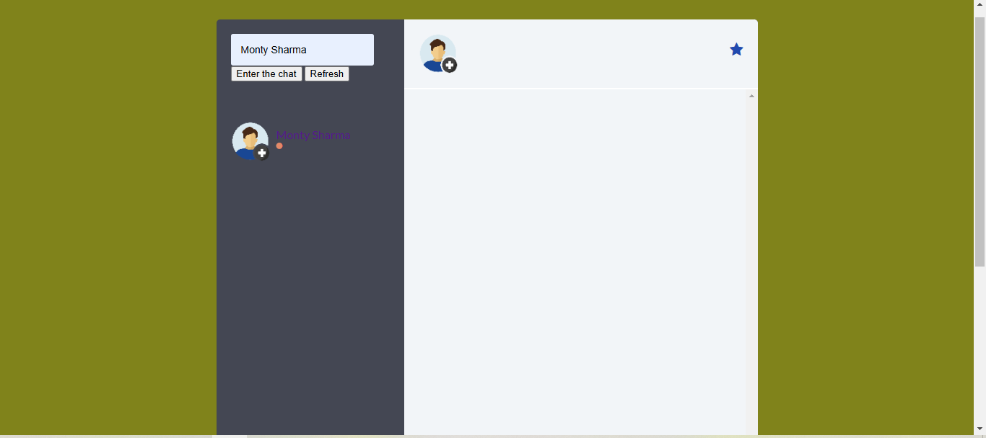



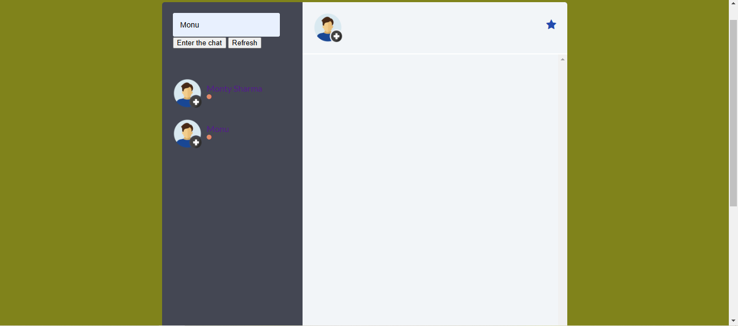

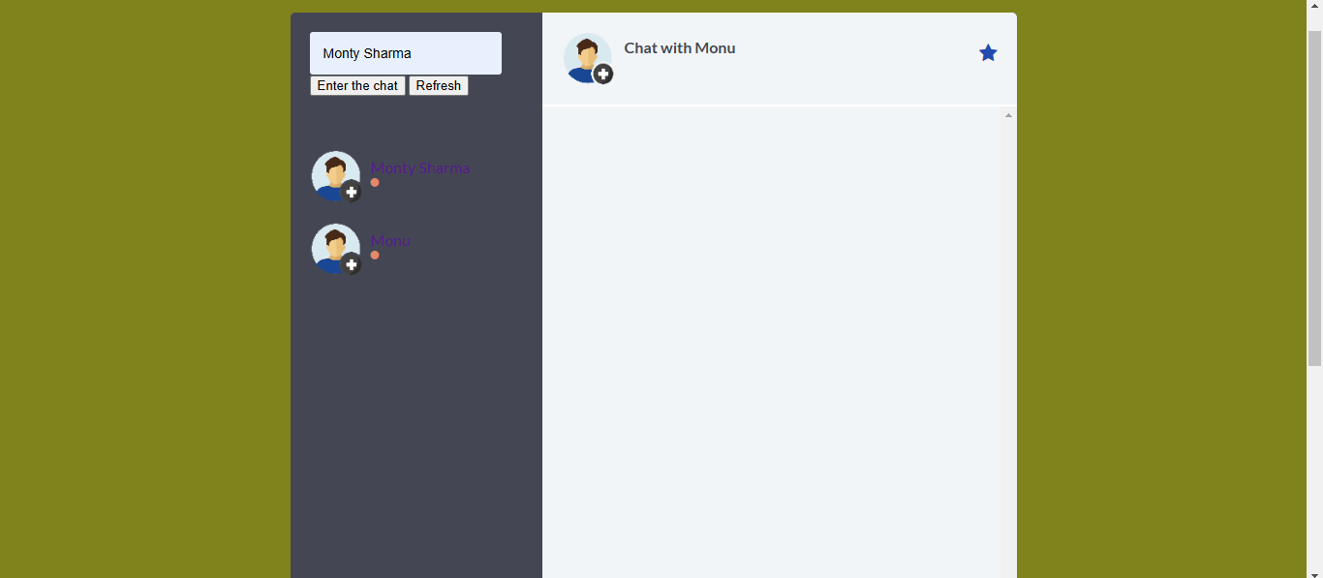

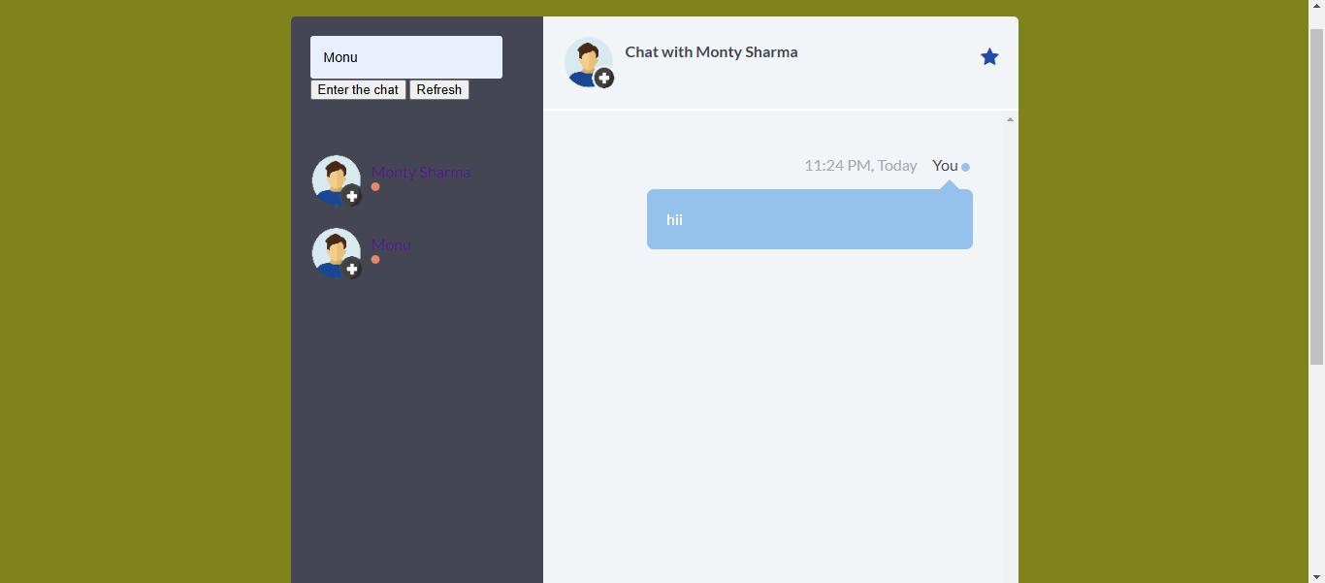

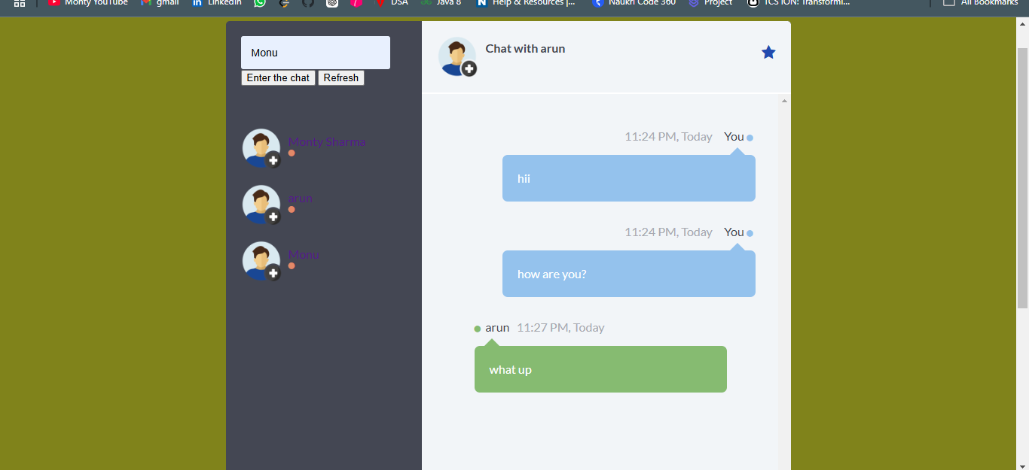

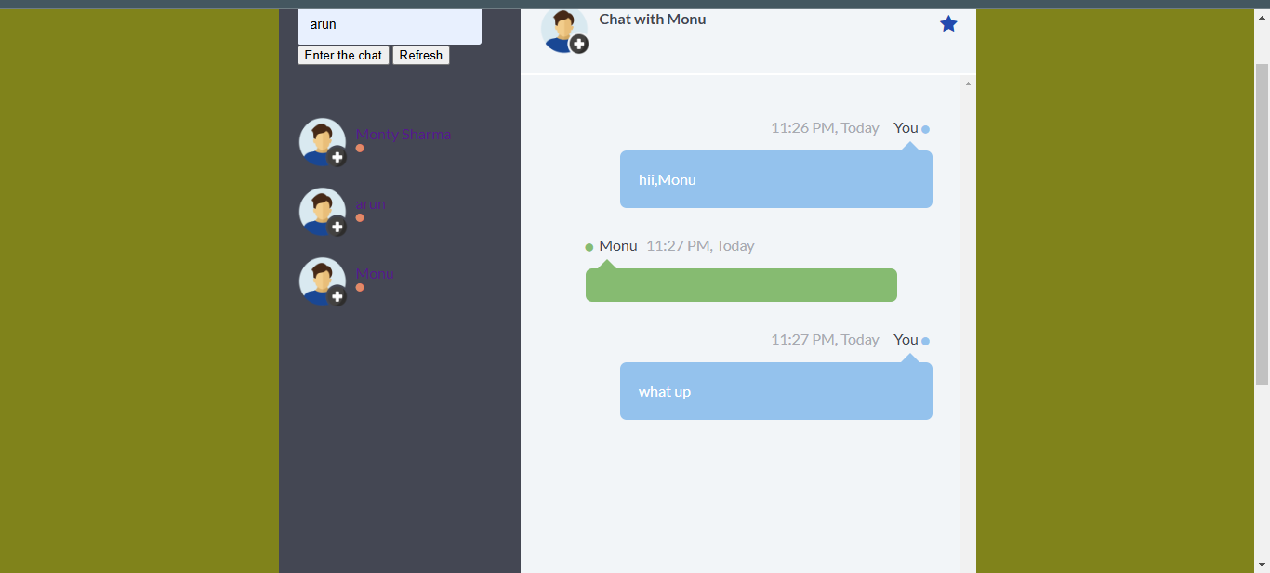





References/ Bibliography

#### ****Web Articles and Tutorials****

1. **Mozilla Developer Network (MDN)**  
   "WebSockets and Server-Sent Events."  
   <https://developer.mozilla.org>
   * A reliable source for understanding WebSocket implementation for real-time communication.

**Socket.IO Documentation**  
 https://socket.io/docs

* Official documentation on building real-time applications using Socket.IO.

Framework and Technology Documentation

**JavaScript.info**  
 <https://javascript.info/>

* Detailed guides on building responsive and interactive chat application UIs.

• **Spring Boot**  
 <https://spring.io/projects/spring-boot>

* For developing secure and scalable backend systems for chatting applications.