1. Hit http://apps.twitter.com and logged in to it
2. Created app as 'myFirstTwtngApp' as shown in below screen shot

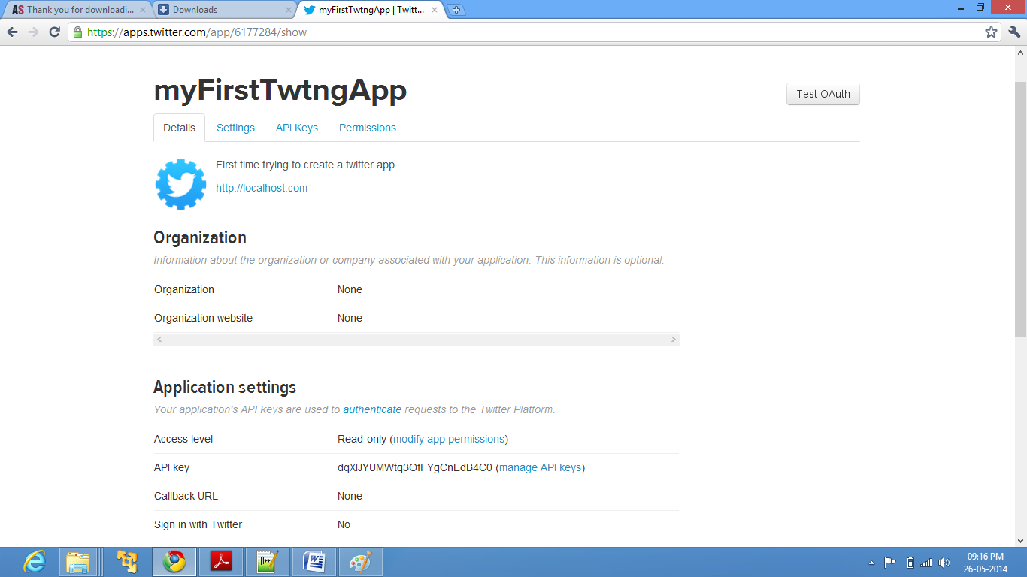

1. Clicked on Test OAuth to get the consumer key and access token as shown in below snapshot.

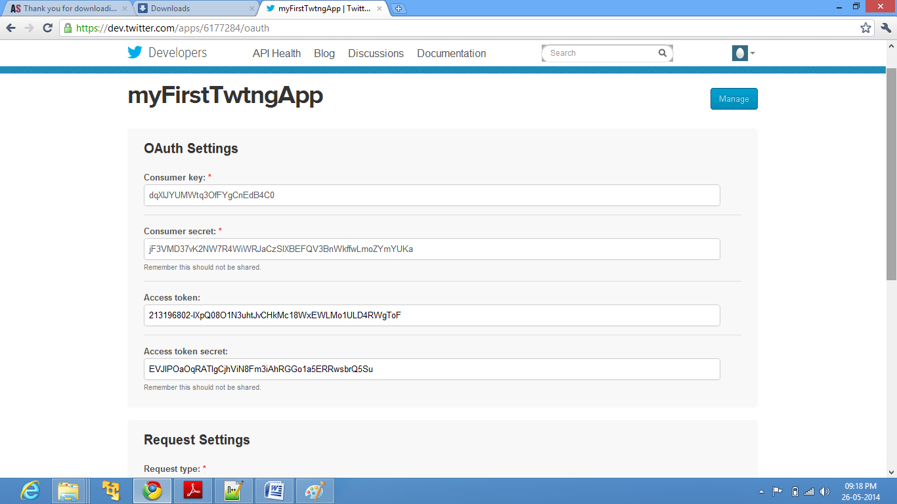

I kept the twitter source in **$FLUME_HOME/lib** directory