An Internship Report
Of
AI-Based Application Development

Submitted
To
School of Computer Science and Engineering
IILM University, Greater Noida, U.P

In partial fulfilment of the requirement of degree of
B.Tech (CSE)



By
Roll Number of Student: 25SCS1003004707
Name of Student: MONTY YADAV
Semester: 3rd Semester
Section: 2CSE15
Batch : 2025-29

CANDIDATE'S DECLARATION
I, MONTY YADAV, do hereby declare that the internship report titled “AI-Based Application Development” has been completed by me to fulfil the requirement for the award of the degree of Bachelor of Technology in Computer Science and Engineering. All the references have been quoted and I have not taken as such any material from any other source. I affirm that this report is my own and has not been submitted to any other institute for any degree/diploma requirement, and further I shall be solely responsible for any kind of copyright violation in this regard.
Signature:-
Student Name: MONTY YADAV
Roll No.: 25SCS1003004707

ACKNOWLEDGEMENT
I am using this opportunity to express my gratitude to everyone who supported me throughout the Internship Program. I am thankful for their aspiring guidance, invaluably constructive criticism and friendly advice during this work. I am sincerely grateful to them for sharing their truthful and illuminating views on a number of issues related to this work.
I would like to thank CodeAlpha for providing me the opportunity and a structured virtual internship platform to learn and gain hands-on exposure in the domain of Artificial Intelligence, from 20th July 2026 to 20th August 2026. I am also thankful to my institute, IILM University, Greater Noida, and the faculty of the School of Computer Science and Engineering for their continuous support and encouragement.
I express my gratitude to my parents for their blessings.
Signature:
Student Name: MONTY YADAV
Roll No.: 25SCS1003004707

TABLE OF CONTENTS
1. Candidate's Declaration
2. Acknowledgement
3. Internship Completion Certificate & Letter of Recommendation
4. Project Description
4.1 Introduction
4.2 Organization Profile
4.3 Problem Statement
4.4 Project Objectives
4.5 Scope of the Project
4.6 Technologies and Tools Used
4.7 System Architecture
4.8 Methodology
4.9 Project 1: Multilingual Translation Tool
4.10 Project 2: CampusConnect – FAQ Chatbot
4.11 Expected Outcomes
4.12 Certificate of Completion and Communication Proof
5. Bibliography / References

3. INTERNSHIP COMPLETION CERTIFICATE & LETTER OF RECOMMENDATION

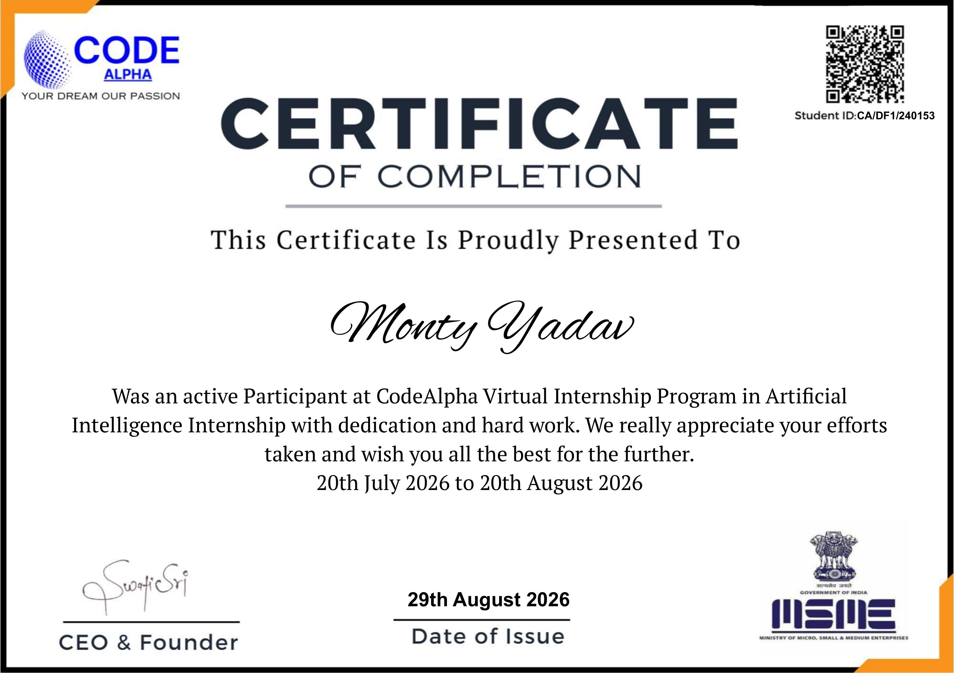

Letter of Recommendation
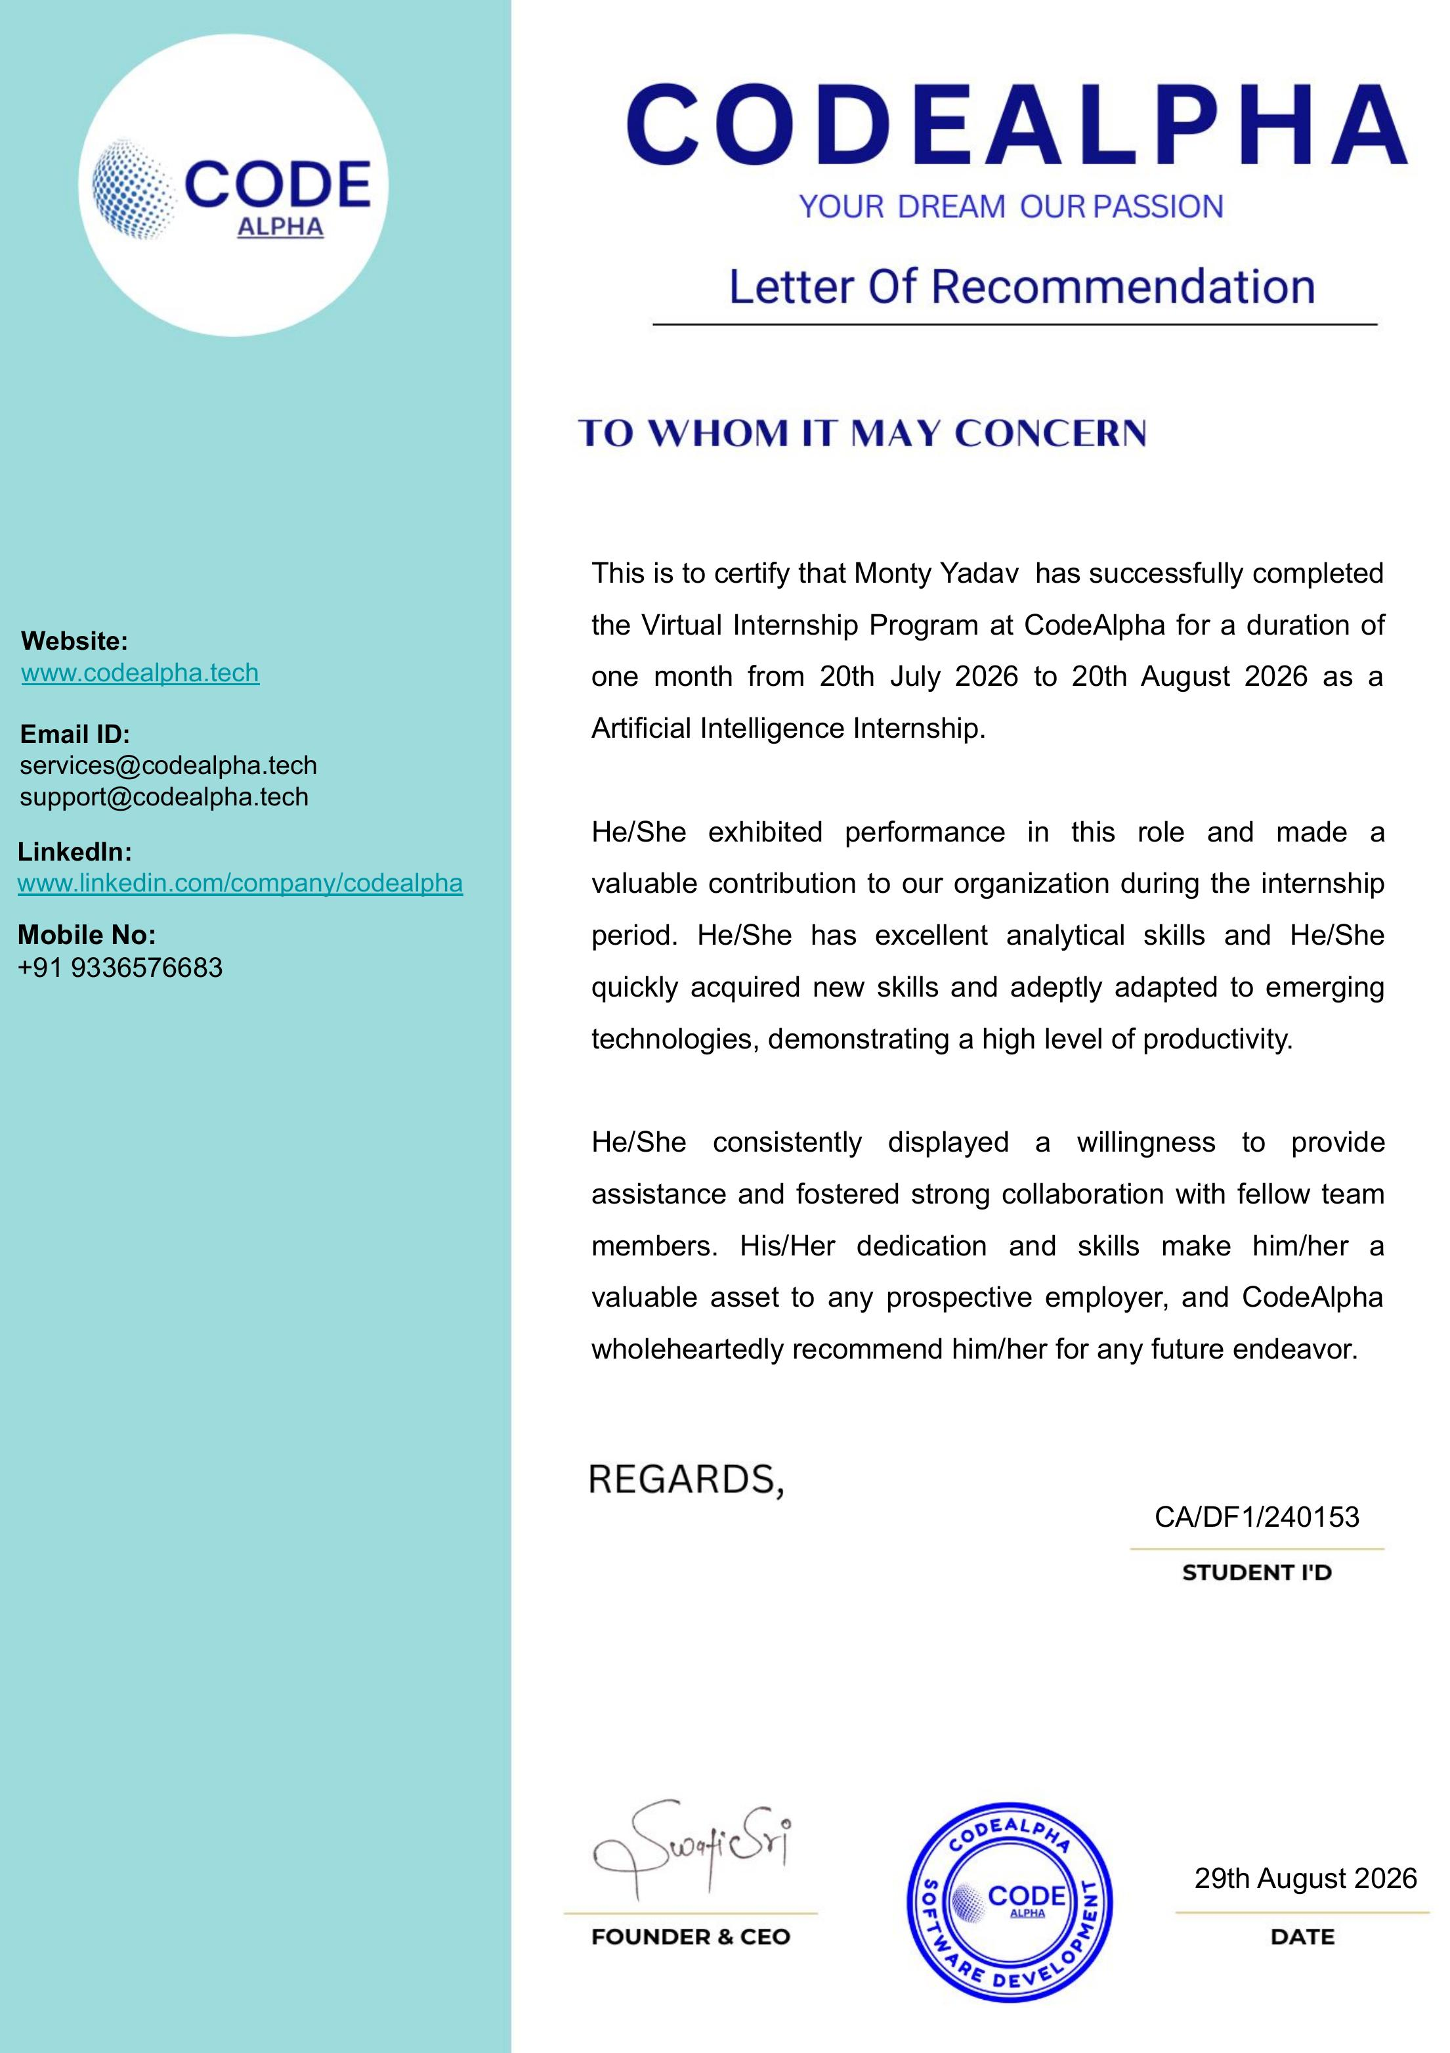

4. PROJECT DESCRIPTION

4.1 Introduction
This report presents a detailed account of the one-month Virtual Internship undertaken at CodeAlpha in the domain of Artificial Intelligence, carried out from 20th July 2026 to 20th August 2026, as part of the requirement of the Bachelor of Technology (Computer Science and Engineering) programme, 3rd Semester, Section 2CSE15, at IILM University, Greater Noida. During the internship, the intern worked on “AI-Based Application Development”, building practical Python and Streamlit applications, and gained hands-on exposure to natural language processing utilities, rule-based conversational logic, and user-interface design for web applications.
On successful completion of all internship requirements, an Internship Completion Certificate and a Letter of Recommendation were issued by CodeAlpha, and both projects developed during the internship were organized and submitted on GitHub.

4.2 Organization Profile
CodeAlpha is the organization where the internship was completed. As per the official Letter of Recommendation, CodeAlpha operates under the tagline “Your Dream, Our Passion” and provides virtual internship programs to engineering students in domains such as Artificial Intelligence, Web Development, and Software Development. CodeAlpha can be reached at www.codealpha.tech, and through the email addresses services@codealpha.tech and support@codealpha.tech.
During the internship, the organization provided a structured virtual environment for the intern to design, build, and document independent Python-based applications, culminating in the award of a Certificate of Completion and a Letter of Recommendation on 29th August 2026.

4.3 Problem Statement
Language barriers and repetitive information requests are common challenges faced by students and institutions alike. The internship addressed two practical problems: first, how to allow a user to translate text quickly between multiple languages without relying on a paid or complex service; and second, how a college or campus can automatically answer frequently asked questions from students regarding admissions, academics, fees, campus facilities, student services, and placements, without requiring a human to be available at all times.
Both problems were addressed by building lightweight, easy-to-use Streamlit web applications in Python that could be run locally or deployed with minimal setup.

4.4 Project Objectives
- To build a simple and reliable multilingual text-translation tool using Python.
- To provide an easy-to-use web interface for entering text and selecting source and target languages.
- To design a rule-based FAQ chatbot capable of answering common campus-related queries.
- To implement similar-question matching so that the chatbot can respond even when a question is not asked in the exact wording of the stored FAQ.
- To maintain chat history and provide a clear-chat option for a better user experience.
- To handle unknown or unmatched questions gracefully.
- To gain practical exposure to Python, Streamlit, and relevant NLP-support libraries.
- To organize, document, and publish both projects on GitHub.

4.5 Scope of the Project
The scope of this internship covered the design, development, and testing of two independent Streamlit-based applications: a Multilingual Translation Tool and the CampusConnect FAQ Chatbot. The work included interface design, core application logic, testing of translation and question-matching accuracy, and preparation of supporting documentation (README files and dependency lists) for both projects. The scope did not extend to server deployment, user authentication, or integration with a live college database; both applications were built and tested as self-contained, locally runnable tools.

4.6 Technologies and Tools Used
Tool / Technology | Use in the Internship Context
Python | Core programming language used to build both applications.
Streamlit | Framework used to build interactive web-based user interfaces for both projects.
deep-translator (Google Translator) | Library used to perform multilingual text translation in the Translation Tool.
difflib (get_close_matches) | Python standard library module used to implement similar-question matching in the FAQ chatbot.
GitHub | Used to organize, version, and submit both completed projects.

4.7 System Architecture
Translation Tool: The user enters text into a text area and selects a source and a target language from dropdown menus. On clicking Translate, the input is passed to the deep-translator library, which returns the translated text; the result is then displayed on screen and made available in a copyable text box. A Clear option resets the interface.
CampusConnect FAQ Chatbot: FAQs are organized category-wise (Admissions, Academics, Fees, Campus, Student Services, and Placements) into a combined question-answer dictionary. When a user submits a question, the system first checks for an exact match; if none is found, it uses difflib's close-match algorithm to find the most similar stored question; if that also fails, a keyword-based fallback search is used. If no answer can be found, a default help message is returned. All conversation turns are stored in session state to maintain chat history, and a sidebar provides category browsing and a clear-chat control.

4.8 Methodology
Step | Activity | Purpose
1 | Requirement understanding | Identify the two use-cases: text translation and campus FAQ handling.
2 | Interface design | Design simple, clean Streamlit layouts for both applications.
3 | Core logic development | Implement translation calls and FAQ matching logic (exact, similar, keyword).
4 | Testing | Test translation accuracy across languages and FAQ responses across categories.
5 | Documentation | Prepare README files and requirements files for both projects.
6 | Version control & submission | Organize and push both projects to GitHub.

4.9 Project 1: Multilingual Translation Tool
The Multilingual Translation Tool is a Streamlit web application that allows a user to translate text between ten languages, including English, Hindi, French, Spanish, German, Italian, Japanese, Chinese, Arabic, and Bengali. The user types or pastes text into an input box, chooses the source and target languages from two dropdown menus, and clicks the Translate button. The application uses the deep-translator library's GoogleTranslator interface to perform the translation and displays the result along with a copyable text field. The tool also handles edge cases, such as when the source and target languages are the same, or when the text field is left empty, and shows an appropriate message to the user in each case. A Clear button is provided to reset the interface for a new translation.

4.10 Project 2: CampusConnect – FAQ Chatbot
CampusConnect is a web-based FAQ chatbot built to provide quick answers to common college-related questions. The application organizes frequently asked questions into six categories – Admissions, Academics, Fees, Campus, Student Services, and Placements – and presents them through a styled sidebar and a chat-style interface. Users can either click a suggested question or type their own query into a chat input box. The chatbot first looks for an exact match to the question; if none exists, it applies similar-question matching (using Python's difflib library) to catch questions phrased differently but with a similar meaning; and as a final fallback, it performs keyword matching on longer, more distinctive words within the question. If no relevant answer can be found, the chatbot informs the user and suggests the categories they can ask about. The application also maintains a running chat history, displays basic usage statistics (number of categories, number of FAQs, and number of questions asked) in the sidebar, and provides a Clear Chat option to reset the conversation.

4.11 Expected Outcomes
- A practical understanding of building and deploying simple AI-support applications using Python and Streamlit.
- Hands-on experience with a translation library and multilingual text handling.
- Practical exposure to rule-based question-answering techniques, including similar-question and keyword matching.
- Improved skills in designing clean and functional web-based user interfaces.
- Better understanding of documentation practices, including writing README and requirements files.
- Experience in organizing and submitting completed projects on GitHub.

The Internship Completion Certificate and Letter of Recommendation issued by CodeAlpha confirm that the intern successfully completed the Artificial Intelligence Virtual Internship Program, demonstrating dedication, hard work, and excellent analytical skills, along with the ability to quickly acquire new skills and collaborate effectively with the team.

4.12 Certificate of Completion and Communication Proof
The following screenshots, taken from the official email received from CodeAlpha, confirm the successful completion of the internship and the issuance of the Internship Completion Certificate and Letter of Recommendation to Monty Yadav for the Artificial Intelligence Internship conducted from 20th July 2026 to 20th August 2026.
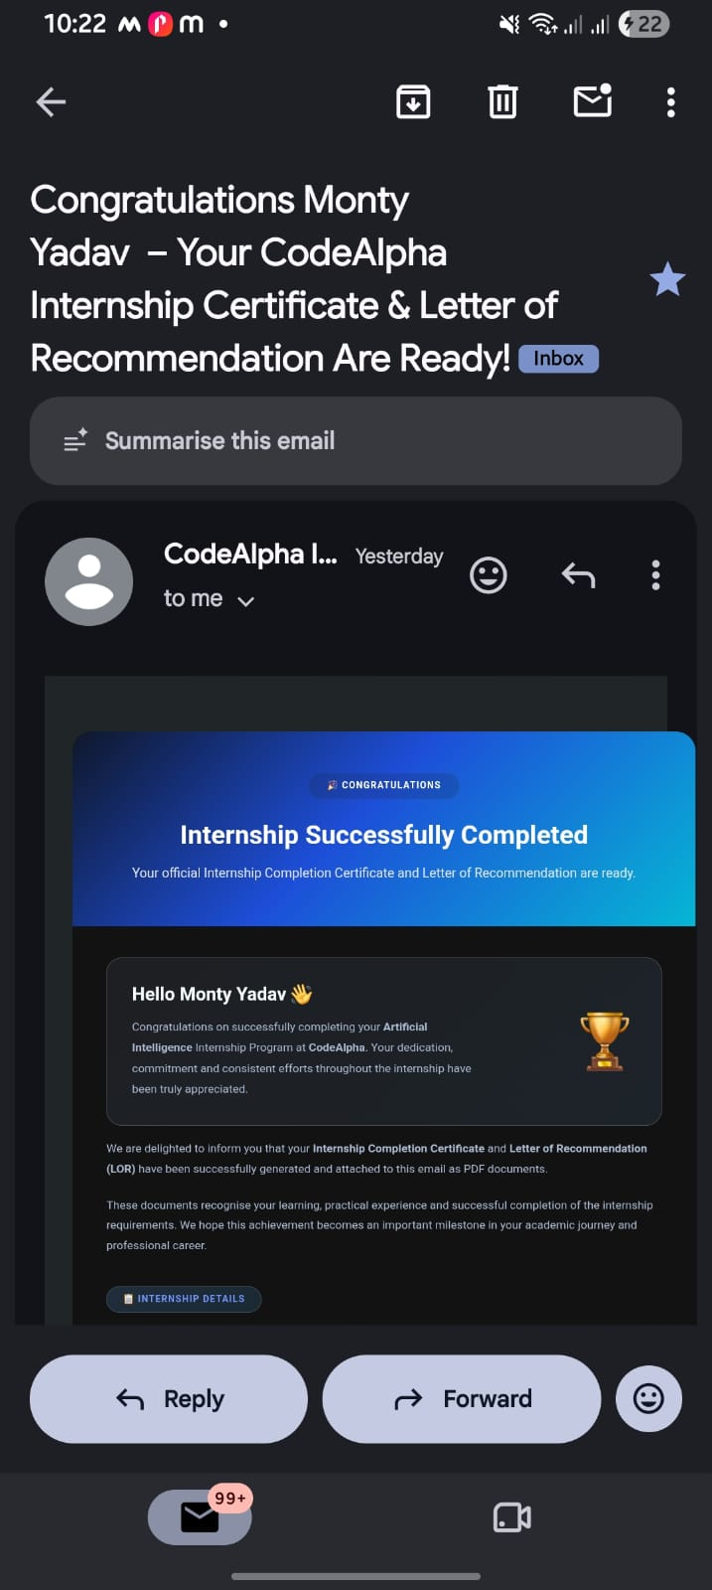

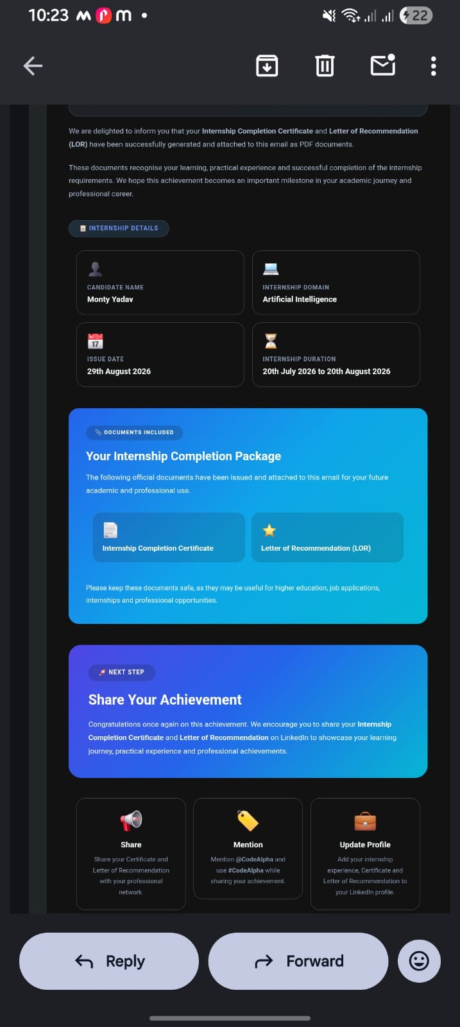

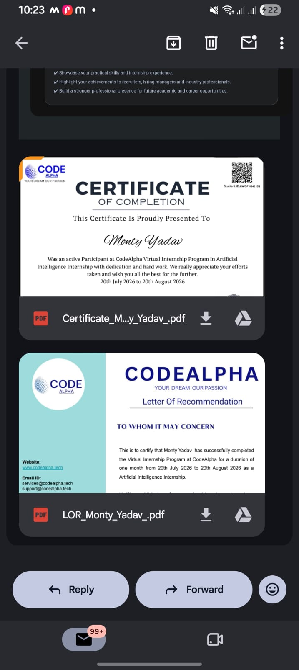

5. BIBLIOGRAPHY / REFERENCES
1. CodeAlpha – Internship Completion Certificate issued to Monty Yadav, Student ID: CA/DF1/240153, Issued on 29th August 2026.
2. CodeAlpha – Letter of Recommendation issued to Monty Yadav, Student ID: CA/DF1/240153, dated 29th August 2026.
3. deep-translator Library Documentation, https://pypi.org/project/deep-translator/
4. Streamlit Documentation, https://docs.streamlit.io/
5. Python difflib Documentation, https://docs.python.org/3/library/difflib.html
6. Project source code and README files for the Multilingual Translation Tool and CampusConnect FAQ Chatbot, prepared and submitted by the intern on GitHub.

