
PERSONALITY PREDICTION THROUGH CV

END TERM REPORT

by

Abhishek Rastogi, Bilal Alakhail, Naveen kumar Yadav & Ayush Soni

Section: K18JF
Roll Number(s): 36,54,57,31

Department of Intelligent Systems

School of Computer Science Engineering

Lovely Professional University, Jalandhar

April, 2020

GitHub:

TABLE OF CONTENTS

TITLE PAGE NO.

- Declaration ………………………………………………………………………………………………………….. 1

- Objectives ……………………………………………………………………………………………………………. 3

- Background of Personality Perception …………………………………………………………………. 4

- Dependencies of System ……………………………………………………………………………………… 5

- Description of Project …………………………………………………………………………………………. 6

- Code …………………………………………………………………………………………………………… 7-8

- Swot Analysis …………………………………………………………………………………………………………… 9

- Bonafide Certificate ……………………………………………………………………………………………. 10

2 | P a g e
OBJECTIVES

This system can be used in many business parts/areas that may require expert candidates. This system will reduce the workload of the (workers in general/hiring, training, and firing department). This system will help the (related to workers in general) to select the right candidate for the desired job profile, which in turn provide the expert (all the workers in a company or country) for the organization. Admin can easily shortlist a candidate based on their personality scores and select the appropriate candidate for a particular job profile.

Using Natural Language Processing (NLP) can be defined as a process that enables a machine to become more like a human, because of this deeply cutting the distance between machines and humans. This system will focus not only on qualification and inexperience but also focuses on other important aspects, which are needed/demanded for a particular job position. Admin can store the data in excel sheet for further comparison and sorting of data.

3 | P a g e
BACKGROUND OF PERSONALITY PERCEPTION

The Big Five Personality Traits model is based on findings from several independent researchers, and it dates back to the late 1950s. But the model as we know it now began to take shape in the 1990s.

Lewis Goldberg, a researcher at the Oregon Research Institute, is credited with naming the model "The Big Five." It is now considered to be an accurate and respected personality scale, which is routinely used by businesses and in psychological research.

The Big Five Personality Traits Model measures five key dimensions of people's personalities:

Openness: sometimes called "Intellect" or "Imagination," this measures your level of creativity, and your desire for knowledge and new experiences.

Conscientiousness: this looks at the level of care that you take in your life and work. If you score highly in conscientiousness, you'll likely be organized and thorough, and know how to make plans and follow them through. If you score low, you'll likely be lax and disorganized.

Extraversion/Introversion: this dimension measures your level of sociability. Are you outgoing or quiet, for instance? Do you draw energy from a crowd, or do you find it difficult to work and communicate with other people?

Agreeableness: this dimension measures how well you get on with other people. Are you considerate, helpful and willing to compromise? Or do you tend to put your needs before others'?

Natural Reactions: sometimes called "Emotional Stability" or "Neuroticism," this measure emotional reactions. Do you react negatively or calmly to bad news? Do you worry obsessively about small details, or are you relaxed in stressful situations?

4 | P a g e
DEPENDENCIES OF SYSTEM

Python Modules/Libraries:

- OS: For accessing the files and data from internal storage.

- Pandas: For accessing and manipulating datasheets.

- Numpy: For working on arrays and other data manipulation.

- Tkinter: For building the GUI.

- Functools: Tools for Manipulating Functions. Purpose: Functions that operate on other functions.

- Pyresparser: Module for extracting information from resume.

- Sklearn: It features various classification, regression and clustering algorithms. We used sklearn to make the model learn on various characteristic values using logical regression.

5 | P a g e
DESCRIPTION

The system built in this project predicts personality of peoples by using their gender, age, score of openness, conscientiousness, extraversion, agreeableness, neuroticism and experience. It parses all the data from CV/resume and on the result page, it shows all the information from the entered data and uploaded resume. This system uses logistic regression for training the model and pyresparser module for parsing the information from resume which is built using nltk and spaCy module in python.

Code

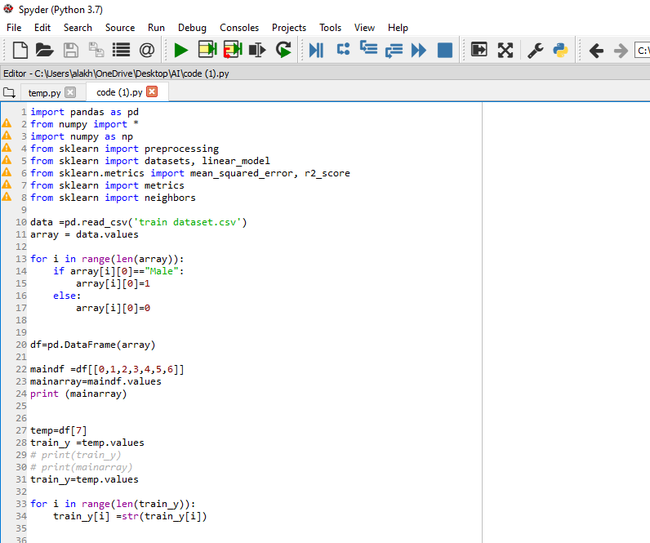

6 | P a g e

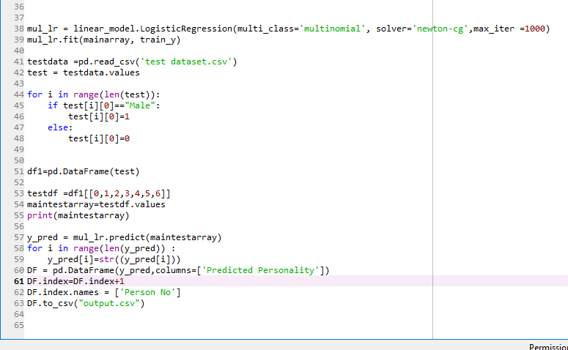

7 | P a g e

Division of Work

Abishek & Bilal - train_model class and prediction_result method.

Abishek & Bilal have used sklearn module for training the model that can predict the personality such as serious, lively, responsible, extraverted, dependable etc. The model learns from age, gender, openness, extraverted and other personality characteristics. The model uses logistic regression approach. Model trained from dataset of more than 700 people and predict the personality when a list of required values is passed to test function of class train_model. In prediction_result method, number of input values are taken from predict_person and it manipulate the data and calls the test function for predicting result and parse all the information from resume using pyresparser. After this, all raw values are printed on console and information and results printed to a Tkinter GUI window.

Naveen & Ayusg - main method, check_type method and contribution in report making

In main method, first I create a instance of class train_model and calls the method of class for training the model. Then a GUI windows created using Tk method from tkinter module which contains a button which take us to data entering method.

In check type method, various operations are designed for string manipulation. It Capitalize the string using title function of strings, convert tuple and list to string and returns the manipulated data. It also converts the numbers and other data types to string and returns.

8 | P a g e

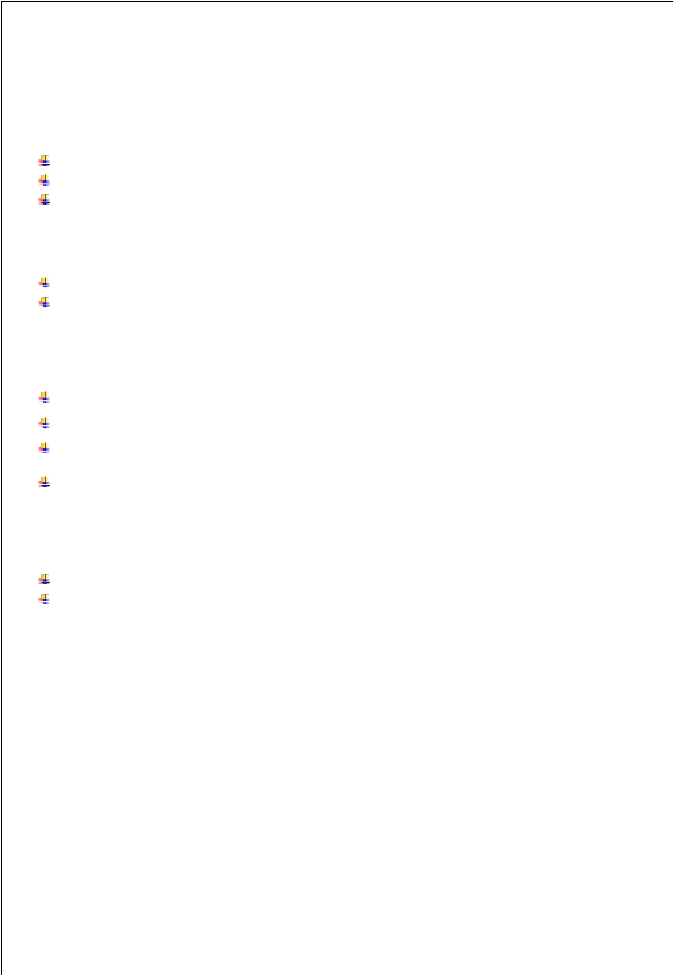
SWOT ANALYSIS

Strengths:

Interactive and easy to use.

Extract all the important features of resume in seconds

Easily predict the personality of applicant

Weakness:

It does not store the predicted personality data.

Bulk of CV cannot be parsed in one go.

Opportunities:

It can be extended for commercial uses

It can be made more interactives where we can easily handle bulk data and represent it.

It can improve the training model for various addition features that help us to predict more accurate result.

Instead of direct asking the five characteristic values we can add questionaries’ which ask some multiple-choice questions and auto calculate the various values.

Threats:

There is no security added in the app yet that gives different rights to different users.

There are a lot of companies in the world and their hiring system is different from sector to sector, so it needs to do changes with company to company requirement which can be complicated and expensive to maintains different views of application.

9 | P a g e
BONAFIDE CERTIFICATE

Certified that this project report PERSONALITY PREDICTION THROUGH CV is the bonafide work of Bilal Alakhail, Abhishek Rastogi, Naveen Kumar Yadav and Ayush Soni who carried out the project work under my supervision.

Signature: ……………………………

Name: Dipen Saini

Designation: Assistant Professor

UID: 23681

Department of Intelligent Systems

10 | P a g e

