ACTIVITY 2: SIMPLE HOUSE PRICE PREDICTION
Unit II – Supervised Learning: Regression | Marks: 5

1. Objective
To build a Linear Regression model that predicts house prices from property area and evaluate it using regression metrics.

2. Dataset Details
Dataset: Housing Prices Dataset (Housing.csv)
Source: https://www.kaggle.com/datasets/yasserh/housing-prices-dataset
Description: 545 residential property records and 13 columns. Features include area, bedrooms, bathrooms, stories, access/amenity indicators, parking and furnishing status. The target column is price.
Dataset inspection: 545 rows, 13 columns; 6 numeric and 7 categorical/object columns. Missing values: 0 in every column. Duplicate rows: 0. No missing-value or duplicate-row treatment was required.

3. Feature and Target Selection
Input feature (X): area. Target (y): price. Area is relevant because the size of a property may be associated with its selling price. The record index is not used as a predictive feature.

4. Relationship Visualization
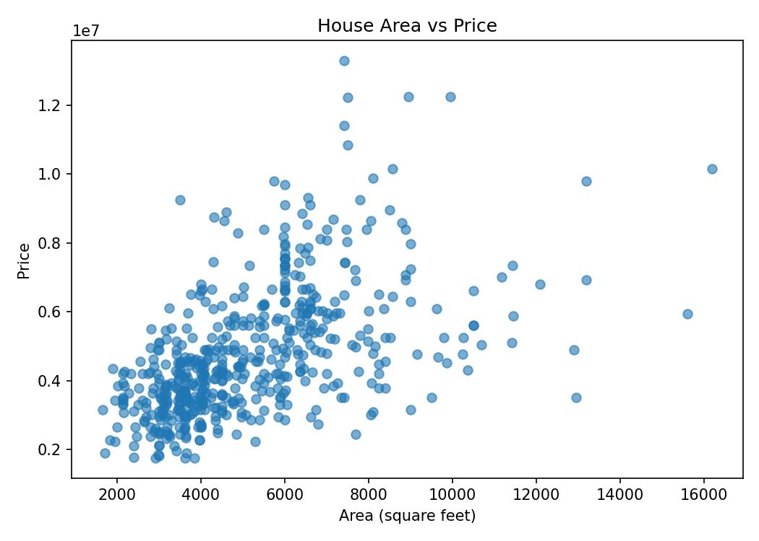
The scatter plot indicates a generally positive association: larger areas tend to be associated with higher prices, although the points are spread out. This association does not prove causation.

5. Train-Test Split
An 80:20 split was used with random_state=42. Training observations: 436. Testing observations: 109. The model was fitted only on training data; test data was reserved for evaluation.

6. Linear Regression Model
Coefficient (slope): 425.7298
Intercept: 2,512,254.2640
Equation: Predicted price = 2,512,254.26 + (425.73 × area)
The slope estimates an increase of approximately 425.73 price units for each additional square-foot unit of area. The intercept is the model's predicted price when area is zero; this is a mathematical baseline and is outside the practical data range.

7. Actual vs Predicted Values
Test record | Actual price | Predicted price
1 | 4,060,000 | 5,024,060
2 | 6,650,000 | 5,279,498
3 | 3,710,000 | 4,232,203
4 | 6,440,000 | 4,640,903
5 | 2,800,000 | 4,198,144
6 | 4,900,000 | 5,373,159
7 | 5,250,000 | 6,139,473
8 | 4,543,000 | 4,636,646
9 | 2,450,000 | 3,891,619
10 | 3,353,000 | 3,661,725
The actual and predicted values differ for many records. These differences are the prediction errors on the unseen test set.

8. Evaluation Metrics
- MAE = 1,474,748.13
- MSE = 3,675,286,604,768.19
- RMSE = 1,917,103.70
- R² = 0.2729
MAE is the average absolute prediction error. MSE averages squared errors and penalizes larger errors more strongly. RMSE is in the same units as price. R² compares the model with a mean-price baseline; this test R² indicates that area alone explains a limited portion of price variation.

9. Actual vs Predicted Plot
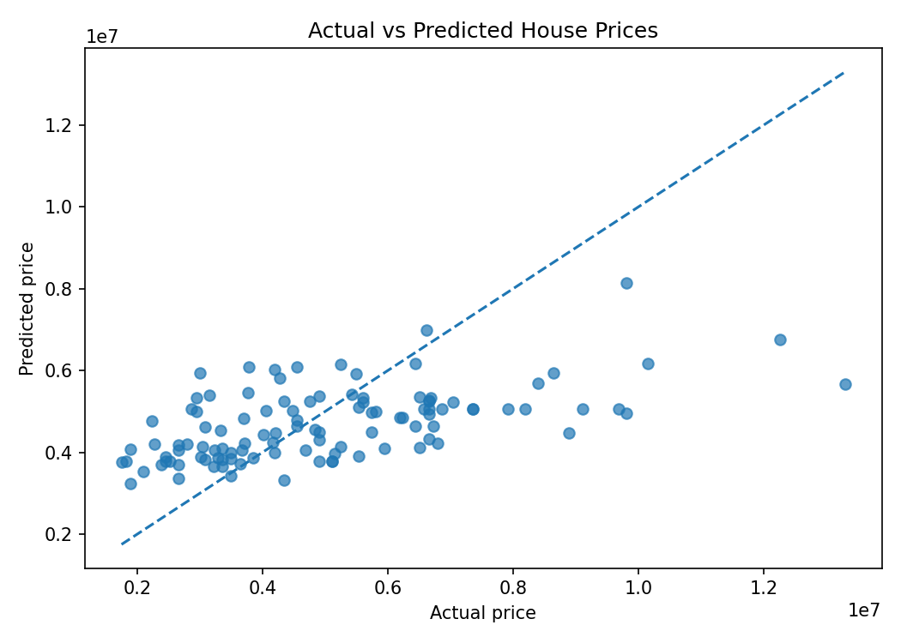
The dashed diagonal represents perfect predictions. The spread of points around this line indicates noticeable prediction errors, consistent with the modest test R².

10. New Prediction
For a new house with an area of 5,000 square feet, the predicted price is 4,640,903.47 in the dataset's price units.

11. Conclusion
A single-feature Linear Regression model was built using area to predict price. The model was trained on 436 records and evaluated on 109 unseen records. Its test R² of 0.2729 shows that area alone is not sufficient to explain house prices accurately. Actual prices can also depend on bedrooms, bathrooms, stories, location, parking, amenities and furnishing status. This model is suitable for demonstrating regression, but it has limitations for real-world price estimation.
Faculty reference and Machine Learning learning resources: https://github.com/Princy2129
This project was completed as part of the Machine Learning CIE 2 activity.

