COMPUTER NETWORK LAB FILE

Course | : B.Tech(Computer Engineering)
Semester | : V
Lab Code | : CEN - 593

Submitted by: |  | Submitted to:
Monu Kumar |  | DR. MD AMJAD  MR. MUMTAZ AHMAD
17BCS012 |  | MR. HANNAN

DEPARTMENT OF COMPUTER ENGINEERING
FACULTY OF ENGINEERING & TECHNOLOGY
JAMIA MILLIA ISLAMIA
2019

S.No. | PROGRAMS | P.No. | DATE | SIGNATURE
1. | WAP TO PERFORM ENCRYPTION AND DECRYPTION USING CAESER CIPHER | 3 | 22/07/19
2. | WAP TO PERFORM ENCRYPTION AND DECRYPTION USING TRANSPOSITION CIPHER | 5 | 29/07/19
3. | WAP TO PERFORM ENCRYPTION AND DECRYPTION USING VIGENERCIPHER | 8 | 05/08/19
4. | WAP TO PERFORM ENCRYPTION AND DECRYPTION USING HILL CIPHER | 12 | 19/08/19
5. | WAP TO PERFORM ENCRYPTION AND DECRYPTION USING RAIL FENCE CIPHER | 15 | 26/08/19
6. | WAP TO PERFORM MESSAGE TRANSFER BETWEEN CLIENT AND SERVER | 18 | 02/09/19
7. | WAP TO PERFORM ENCRYPTION AND DECRYPTION USING PLAY FAIR CIPHER BETWEEN CLIENT AND SERVER | 24 | 23/09/19
8. | WAP TO PERFORM MULTICASTING AND BROADCASTING | 27 | 30/09/19
9. | WAP TO PERFORM TEXT FILE TRANSFER BETWEEN CLIENT AND SERVER | 33 | 14/10/19
10. | WAP TO PERFORM MESSAGE TRANSFER BETWEEN COMPUTERS | 35 | 21/10/19
11. | WAP TO PERFORM MESSAGE TRANSFER BETWEEN CLIENT AND MULTIPLE SERVERS | 37 | 13/11/19
12 | WAP TO PERFORM ENCRYPTION AND DECRYPTION USING DIFFIE HELLMAN | 39
1.WAP TO PERFORM ENCRYPTION AND DECRYPTION USING CAESER CIPHER
#include <iostream>
#include <cstring>
using namespace std;

int main(){

string a;
cout<<"Monu Kumar\nRollNumber 17BCS012\n";
cout<<"Enter the Cipher text : "<<endl;
getline(cin,a);

cout<<endl;
cout<<"All combinations of Decrypted message are : "<<endl<<endl;
int k=1,n=1;

for(int j=0;j<25;j++){

string res = "";
for(int i=0;i<a.length();i++){

if((int(a[i]) >=65 )&& (int(a[i]) <= 90)) {

int x = (a[i]-n-65)%26;
x = (x+26)%26;
res += char(x + 65);

}
else if((int(a[i]) >=97 ) && (int(a[i]) <= 122)) {

int x = (a[i]-n-97)%26;
x = (x+26)%26;
res += char(x + 97);
}

}
cout<<"for Key Value "<<k<<",\t";
cout<<"the Decrypted message is : ";
cout<<res<<endl;
k++;
n++;
}
return 0;
}
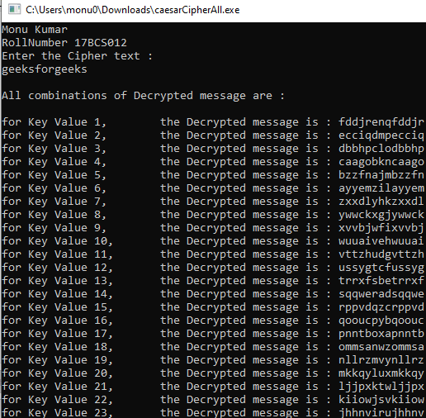

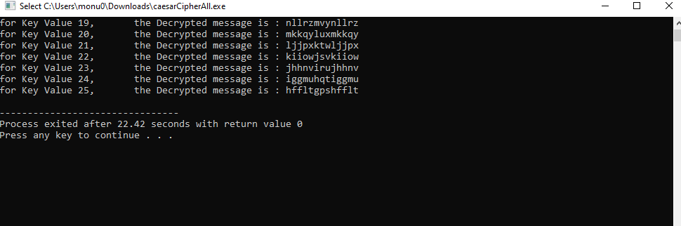
2.WAP TO PERFORM ENCRYPTION AND DECRYPTION USING TRANSPOSITION CIPHER

#include <iostream>
#include <cstring>
#include <algorithm>
using namespace std;

int main() {

string str;
cout<<"Monu Kumar\nRollNumber 17BCS012\n";
cout<<"Enter the message text : "<<endl;
getline(cin,str);

string key;
cout<<endl<<"Enter the key in capital letters :"<<endl;
getline(cin,key);
int l=key.length();

int i=0,k=1;
char arr[100][100];

for(int j=0;j<l;j++){
arr[0][j]=key[j];
}
while(str[i]!='\0'){

for(int j=0;j<l;j++){
arr[k][j]=str[i];
i++;
}
k++;
}

int brr[100];
for(int i=0;i<l;i++){
brr[i]=int(key[i]-65);
}
sort(brr,brr+l);
cout<<endl<<"Encrypted Cipher : "<<endl;

for(int m=0;m<l;m++){

for(int i=1;i<k;i++){
for(int j=0;j<l;j++){

if(brr[m]==(int(arr[0][j])-65)){
cout<<arr[i][j];

}
}
}

}
cout<<endl<<endl;

cout<<"Enter the Cipher text : "<<endl;
getline(cin,str);

int q=str.length();

for(int i=0;i<l;i++){
brr[i]=int(key[i]-65);
}
sort(brr,brr+l);
i=0,k=0;

for(int j=0;j<l;j++){
arr[0][j]=char(brr[j]+65);
}
while(str[i]!='\0'){

for(int j=1;j<=q/l;j++){
arr[j][k]=str[i];
i++;
}
k++;

}

cout<<endl<<"Decrypted Message : "<<endl;

int m=1;
i=0;
for(int s=0;s<q/l;s++){
for(int h=0;h<l;h++){
for(int j=0;j<l;j++){

if((arr[0][j])==key[i]){
cout<<arr[m][j];
i++;
break;
}
}
}
m++;
i=0;
}
cout<<endl;
return 0;
}

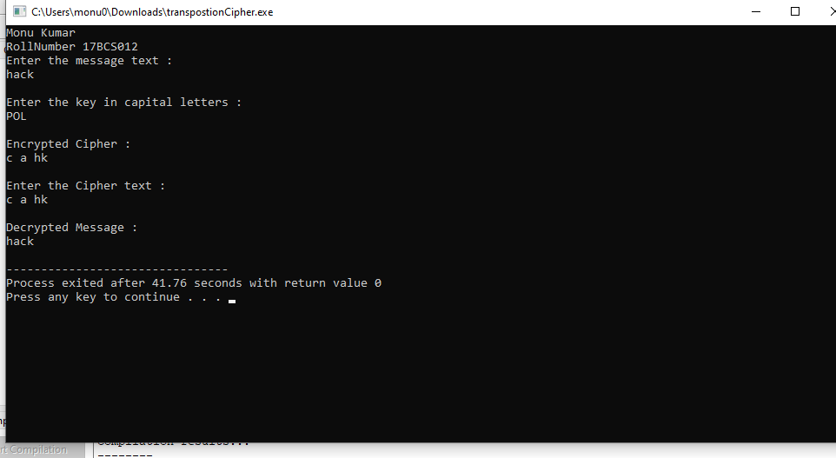

3.WAP TO PERFORM ENCRYPTION AND DECRYPTION USING VIGENERE CIPHER

#include <iostream>
#include <cstring>
using namespace std;
string generateKey(string str, string key)
{
int x = str.size();

for (int i = 0; ; i++)
{
if (x == i)
i = 0;
if (key.size() == str.size())
break;
key.push_back(key[i]);
}
return key;
}

// This function returns the encrypted text
// generated with the help of the key
string cipherText(string str, string key)
{
string cipher_text;

for (int i = 0; i < str.size(); i++)
{
// converting in range 0-25
int x = (str[i] + key[i]) %26;

// convert into alphabets(ASCII)
x += 'A';

cipher_text.push_back(x);
}
return cipher_text;
}

// This function decrypts the encrypted text
// and returns the original text
string originalText(string cipher_text, string key)
{
string orig_text;

for (int i = 0 ; i < cipher_text.size(); i++)
{
// converting in range 0-25
int x = (cipher_text[i] - key[i] + 26) %26;

// convert into alphabets(ASCII)
x += 'A';
orig_text.push_back(x);
}
return orig_text;
}

// Driver program to test the above function
int main()
{
string str = "GEEKSFORGEEKS";
string keyword = "AYUSH";

string key = generateKey(str, keyword);
string cipher_text = cipherText(str, key);
cout<<"Monu Kumar\nRollNumber 17BCS012\n";

cout << "Ciphertext : "
<< cipher_text << "\n";

cout << "Original/Decrypted Text : "
<< originalText(cipher_text, key);
return 0;
} 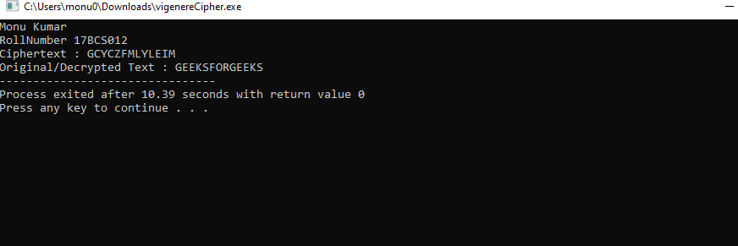

4.WAP TO PERFORM ENCRYPTION AND DECRYPTION USING HILL CIPHER

#include <iostream>
#include <cstring>
using namespace std;

int main(){

int n;
cout<<"Monu Kumar\nRollNumber 17BCS012\n";
cout<<"Enter size of message text : "<<endl;
cin>>n;
cin.ignore();

string pt;
cout<<"Enter the message text : "<<endl;
getline(cin,pt);

string key;
cout<<"Enter the key : "<<endl;
getline(cin,key);

int mat[n][n];
int k=0;
for(int i=0;i<n;i++){
for(int j=0;j<n;j++){
mat[i][j] = key[k++] - 'a';
}
}

cout<<endl<<"Encrypted Cipher : "<<endl;
int a[n];
int ans;
for(int l=0;pt[l]!='\0';){
for(int m=0;m<n;m++){
a[m]=pt[l++] - 'a';

}

for(int i=0;i<n;i++){
ans = 0;
for(int j=0;j<n;j++){

ans += (mat[i][j] * a[j]);

}

ans = ans % 26;
cout<<char(ans+'a');

}

}
return 0;
}
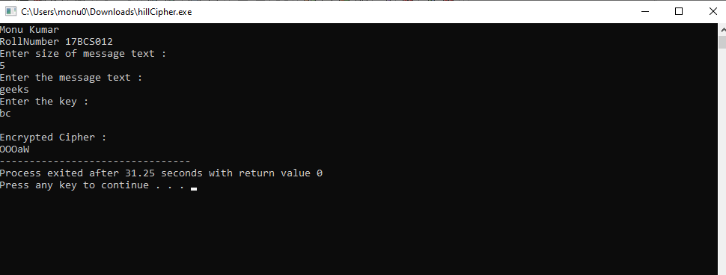

5.WAP TO PERFORM ENCRYPTION AND DECRYPTION USING RAIL FENCE CIPHER

#include <bits/stdc++.h>
using namespace std;

// function to encrypt a message
string encryptRailFence(string text, int key)
{
// create the matrix to cipher plain text
// key = rows , length(text) = columns
char rail[key][(text.length())];

// filling the rail matrix to distinguish filled
// spaces from blank ones
for (int i=0; i < key; i++)
for (int j = 0; j < text.length(); j++)
rail[i][j] = '\n';

// to find the direction
bool dir_down = false;
int row = 0, col = 0;

for (int i=0; i < text.length(); i++)
{
// check the direction of flow
// reverse the direction if we've just
// filled the top or bottom rail
if (row == 0 || row == key-1)
dir_down = !dir_down;

// fill the corresponding alphabet
rail[row][col++] = text[i];

// find the next row using direction flag
dir_down?row++ : row--;
}

//now we can construct the cipher using the rail matrix
string result;
for (int i=0; i < key; i++)
for (int j=0; j < text.length(); j++)
if (rail[i][j]!='\n')
result.push_back(rail[i][j]);

return result;
}

// This function receives cipher-text and key
// and returns the original text after decryption
string decryptRailFence(string cipher, int key)
{
// create the matrix to cipher plain text
// key = rows , length(text) = columns
char rail[key][cipher.length()];

// filling the rail matrix to distinguish filled
// spaces from blank ones
for (int i=0; i < key; i++)
for (int j=0; j < cipher.length(); j++)
rail[i][j] = '\n';

// to find the direction
bool dir_down;

int row = 0, col = 0;

// mark the places with '*'
for (int i=0; i < cipher.length(); i++)
{
// check the direction of flow
if (row == 0)
dir_down = true;
if (row == key-1)
dir_down = false;

// place the marker
rail[row][col++] = '*';

// find the next row using direction flag
dir_down?row++ : row--;
}

// now we can construct the fill the rail matrix
int index = 0;
for (int i=0; i<key; i++)
for (int j=0; j<cipher.length(); j++)
if (rail[i][j] == '*' && index<cipher.length())
rail[i][j] = cipher[index++];

// now read the matrix in zig-zag manner to construct
// the resultant text
string result;

row = 0, col = 0;
for (int i=0; i< cipher.length(); i++)
{
// check the direction of flow
if (row == 0)
dir_down = true;
if (row == key-1)
dir_down = false;

// place the marker
if (rail[row][col] != '*')
result.push_back(rail[row][col++]);

// find the next row using direction flag
dir_down?row++: row--;
}
return result;
}

//driver program to check the above functions
int main()
{
cout<<"Monu Kumar\nRollNumber 17BCS012\n";
cout << encryptRailFence("attack at once", 2) << endl;
cout << encryptRailFence("GeeksforGeeks ", 3) << endl;
cout << encryptRailFence("defend the east wall", 3) << endl;

//Now decryption of the same cipher-text
cout << decryptRailFence("GsGsekfrek eoe",3) << endl;
cout << decryptRailFence("atc toctaka ne",2) << endl;
cout << decryptRailFence("dnhaweedtees alf tl",3) << endl;

return 0;
}
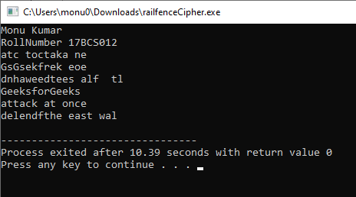

6.WAP TO PERFORM MESSAGE TRANSFER BETWEEN CLIENT AND SERVER

// Server side C/C++ program to demonstrate Socket programming
#include <unistd.h>
#include <stdio.h>
#include <sys/socket.h>
#include <stdlib.h>
#include <netinet/in.h>
#include <string.h>
#define PORT 8080
int main(int argc, char const *argv[])
{
int server_fd, new_socket, valread;
struct sockaddr_in address;
int opt = 1;
int addrlen = sizeof(address);
char buffer[1024] = {0};
char hello[20];

// Creating socket file descriptor
if ((server_fd = socket(AF_INET, SOCK_STREAM, 0)) == 0)
{
perror("socket failed");
exit(EXIT_FAILURE);
}

address.sin_family = AF_INET;
address.sin_addr.s_addr = INADDR_ANY;
address.sin_port = htons( PORT );

// Forcefully attaching socket to the port 8080
if (bind(server_fd, (struct sockaddr *)&address,
sizeof(address))<0)
{
perror("bind failed");
exit(EXIT_FAILURE);
}
if (listen(server_fd, 3) < 0)
{
perror("listen");
exit(EXIT_FAILURE);
}
if ((new_socket = accept(server_fd, (struct sockaddr *)&address,
(socklen_t*)&addrlen))<0)
{
perror("accept");
exit(EXIT_FAILURE);
}

while(hello[0] != 'q'){

printf("Server : ");
scanf("%s",hello);
valread = read( new_socket , buffer, 1024);
printf("Client : %s\n",buffer );
send(new_socket , hello , strlen(hello) , 0 );
}

return 0;
}

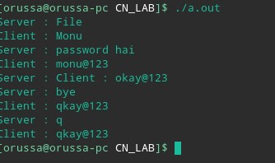

// Client side C/C++ program to demonstrate Socket programming
#include <stdio.h>
#include <sys/socket.h>
#include <arpa/inet.h>
#include <unistd.h>
#include <string.h>
#define PORT 8080

int main(int argc, char const *argv[])
{
int sock = 0, valread;
struct sockaddr_in serv_addr;
char hello[20];

char buffer[1024] = {0};
if ((sock = socket(AF_INET, SOCK_STREAM, 0)) < 0)
{
printf("\n Socket creation error \n");
return -1;
}

serv_addr.sin_family = AF_INET;
serv_addr.sin_port = htons(PORT);

// Convert IPv4 and IPv6 addresses from text to binary form
if(inet_pton(AF_INET, "127.0.0.1", &serv_addr.sin_addr)<=0)
{
printf("\nInvalid address/ Address not supported \n");
return -1;
}

if (connect(sock, (struct sockaddr *)&serv_addr, sizeof(serv_addr)) < 0)
{
printf("\nConnection Failed \n");
return -1;
}

while(hello[0] != 'q'){

printf("Client : ");
scanf("%s",hello);
send(sock , hello , strlen(hello) , 0 );
valread = read( sock , buffer, 1024);
printf("Server : %s\n",buffer );
}

return 0;
}

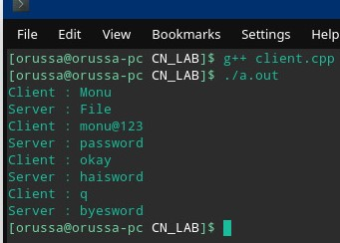

7.WAP TO PERFORM ENCRYPTION AND DECRYPTION USING PLAY FAIR CIPHER BETWEEN CLIENT AND SERVER

// Server side C/C++ program to demonstrate Socket programming
#include <unistd.h>
#include <stdio.h>
#include <sys/socket.h>
#include <stdlib.h>
#include <netinet/in.h>
#include <string.h>
#define PORT 8086
int main(int argc, char const *argv[])
{
int server_fd, new_socket, valread;
struct sockaddr_in address;
int opt = 1;
int addrlen = sizeof(address);
char buffer[1024] = {0};
char hello[20];

// Creating socket file descriptor
if ((server_fd = socket(AF_INET, SOCK_STREAM, 0)) == 0)
{
perror("socket failed");
exit(EXIT_FAILURE);
}

address.sin_family = AF_INET;
address.sin_addr.s_addr = INADDR_ANY;
address.sin_port = htons( PORT );

// Forcefully attaching socket to the port 8080
if (bind(server_fd, (struct sockaddr *)&address,
sizeof(address))<0)
{
perror("bind failed");
exit(EXIT_FAILURE);
}
if (listen(server_fd, 3) < 0)
{
perror("listen");
exit(EXIT_FAILURE);
}
if ((new_socket = accept(server_fd, (struct sockaddr *)&address,
(socklen_t*)&addrlen))<0)
{
perror("accept");
exit(EXIT_FAILURE);
}

printf("Server :\n");
printf("Enter the plain text :\n");
scanf("%s",hello);
send(new_socket , hello , strlen(hello) , 0 );

valread = read( new_socket , buffer, 1024);
printf("Client : %s\n",buffer );

printf("Server :\n");
printf("Enter the Cipher text :\n");
scanf("%s",hello);
send(new_socket , hello , strlen(hello) , 0 );

valread = read( new_socket , buffer, 1024);
printf("Client : %s\n",buffer );

return 0;

}
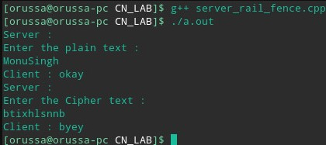

// Client side C/C++ program to demonstrate Socket programming
#include <stdio.h>
#include <sys/socket.h>
#include <arpa/inet.h>
#include <unistd.h>
#include <string.h>
#define n 5
#define PORT 8086

int main(int argc, char const *argv[])
{
int sock = 0, valread;
struct sockaddr_in serv_addr;
char hello[20];

char buffer[1024] = {0};
if ((sock = socket(AF_INET, SOCK_STREAM, 0)) < 0)
{
printf("\n Socket creation error \n");
return -1;
}

serv_addr.sin_family = AF_INET;
serv_addr.sin_port = htons(PORT);

// Convert IPv4 and IPv6 addresses from text to binary form
if(inet_pton(AF_INET, "127.0.0.1", &serv_addr.sin_addr)<=0)
{
printf("\nInvalid address/ Address not supported \n");
return -1;
}

if (connect(sock, (struct sockaddr *)&serv_addr, sizeof(serv_addr)) < 0)
{
printf("\nConnection Failed \n");
return -1;
}

char key[20];
printf("Client :\n");
printf("Enter the key :\n");
scanf("%s",key);

int l=strlen(key);
char mat[n][n];
int freq[26] = {0};
int k=0;
freq['j'-'a'] = 1;

for(int i=0;i<n;i++){
for(int j=0;j<n;j++){

if(k < l){
mat[i][j] = key[k];
freq[key[k]-'a'] = 1;
k++;
}else{
for(int m=0;m<26;m++){
if(freq[m] == 0){
mat[i][j] = (char)(m+'a');
freq[m] = 1;
break;
}
}
}

}
}

char pt[20];

valread = read( sock , buffer, 1024);
printf("Server : %s\n",buffer );

int i=0;
while(buffer[i] != '\0'){
pt[i] = buffer[i];
i++;
}
pt[i] = '\0';
printf("Encrypted Cipher\n");
k = strlen(pt);
int x=0,y=0,a=0,b=0;
for(int p=0;p<k;p+=2){

for(int i=0;i<n;i++){
for(int j=0;j<n;j++){

if(mat[i][j] == pt[p]){
x = i;
y = j;
}
if(mat[i][j] == pt[p+1]){
a = i;
b = j;
}
}

}
if(y == b && x != a){
if(x == n-1){
x = -1;
}
if(a == n-1){
a = -1;
}
printf("%c%c",mat[x+1][y],mat[a+1][b]);
}
else if(y != b && x == a){
if(y == n-1){
y = -1;
}
if(b == n-1){
b = -1;
}
printf("%c%c",mat[x][y+1],mat[a][b+1]);
}
else{
printf("%c%c",mat[x][b],mat[a][y]);
}
}

printf("\n");

printf("Client : ");
scanf("%s",hello);
send(sock , hello , strlen(hello) , 0 );

char ct[20];
valread = read( sock , buffer, 1024);
printf("Server : %s\n",buffer );

i=0;
while(buffer[i] != '\0'){
ct[i] = buffer[i];
i++;
}
ct[i] = '\0';

printf("Decrypted Message :\n");

x=0,y=0,a=0,b=0;
for(int p=0;p<k;p+=2){

for(int i=0;i<n;i++){
for(int j=0;j<n;j++){

if(mat[i][j] == ct[p]){
x = i;
y = j;
}
if(mat[i][j] == ct[p+1]){
a = i;
b = j;
}
}

}
if(y == b && x != a){
if(x == 0){
x = n;
}
if(a == 0){
a = n;
}
printf("%c%c",mat[x-1][y],mat[a-1][b]);
}
else if(y != b && x == a){
if(y == 0){
y = n;
}
if(b == 0){
b = n;
}
printf("%c%c",mat[x][y-1],mat[a][b-1]);
}
else{
printf("%c%c",mat[x][b],mat[a][y]);
}
}
printf("\n");
printf("Client : ");
scanf("%s",hello);
send(sock , hello , strlen(hello) , 0 );
return 0;
}

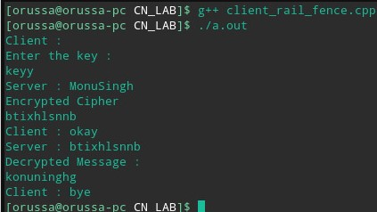

8.WAP TO PERFORM ENCRYPTION AND DECRYPTION USING PLAY FAIR CIPHER BETWEEN CLIENT AND SERVER

#include <stdio.h> /* for printf() and fprintf() */
#include <sys/socket.h> /* for socket() and bind() */
#include <arpa/inet.h> /* for sockaddr_in */
#include <stdlib.h> /* for atoi() and exit() */
#include <string.h> /* for memset() */
#include <unistd.h> /* for close() */

void DieWithError(char *errorMessage)
{
printf("Error- %s",errorMessage);
exit(1);
}

int main(int argc, char *argv[])
{
int sock; /* Socket */
struct sockaddr_in broadcastAddr; /* Broadcast address */
char *broadcastIP; /* IP broadcast address */
unsigned short broadcastPort; /* Server port */
char *sendString; /* String to broadcast */
int broadcastPermission; /* Socket opt to set permission to broadcast */
unsigned int sendStringLen; /* Length of string to broadcast */

if (argc < 4) /* Test for correct number of parameters */
{
fprintf(stderr,"Usage: %s <IP Address> <Port> <Send String>\n", argv[0]);
exit(1);
}

broadcastIP = argv[1]; /* First arg: broadcast IP address */
broadcastPort = atoi(argv[2]); /* Second arg: broadcast port */
sendString = argv[3]; /* Third arg: string to broadcast */

/* Create socket for sending/receiving datagrams */
if ((sock = socket(PF_INET, SOCK_DGRAM, IPPROTO_UDP)) < 0)
DieWithError("socket() failed");

/* Set socket to allow broadcast */
broadcastPermission = 1;
if (setsockopt(sock, SOL_SOCKET, SO_BROADCAST, (void *) &broadcastPermission,
sizeof(broadcastPermission)) < 0)
DieWithError("setsockopt() failed");

/* Construct local address structure */
memset(&broadcastAddr, 0, sizeof(broadcastAddr)); /* Zero out structure */
broadcastAddr.sin_family = AF_INET; /* Internet address family */
broadcastAddr.sin_addr.s_addr = inet_addr(broadcastIP);/* Broadcast IP address */
broadcastAddr.sin_port = htons(broadcastPort); /* Broadcast port */

sendStringLen = strlen(sendString); /* Find length of sendString */
for (;;) /* Run forever */
{
/* Broadcast sendString in datagram to clients every 3 seconds*/
if (sendto(sock, sendString, sendStringLen, 0, (struct sockaddr *)
&broadcastAddr, sizeof(broadcastAddr)) != sendStringLen)
DieWithError("sendto() sent a different number of bytes than expected");

sleep(3); /* Avoids flooding the network */
}
/* NOT REACHED */
}

#include <stdio.h> /* for printf() and fprintf() */
#include <sys/socket.h> /* for socket(), connect(), sendto(), and recvfrom() */
#include <arpa/inet.h> /* for sockaddr_in and inet_addr() */
#include <stdlib.h> /* for atoi() and exit() */
#include <string.h> /* for memset() */
#include <unistd.h> /* for close() */

#define MAXRECVSTRING 255 /* Longest string to receive */

void DieWithError(char *errorMessage)
{

printf("Error- %s",errorMessage);
exit(1);
}

int main(int argc, char *argv[])
{
int sock; /* Socket */
struct sockaddr_in broadcastAddr; /* Broadcast Address */
unsigned short broadcastPort; /* Port */
char recvString[MAXRECVSTRING+1]; /* Buffer for received string */
int recvStringLen; /* Length of received string */

if (argc != 2) /* Test for correct number of arguments */
{
fprintf(stderr,"Usage: %s <Broadcast Port>\n", argv[0]);
exit(1);
}

broadcastPort = atoi(argv[1]); /* First arg: broadcast port */

/* Create a best-effort datagram socket using UDP */
if ((sock = socket(PF_INET, SOCK_DGRAM, IPPROTO_UDP)) < 0)
DieWithError("socket() failed");

/* Construct bind structure */
memset(&broadcastAddr, 0, sizeof(broadcastAddr)); /* Zero out structure */
broadcastAddr.sin_family = AF_INET; /* Internet address family */
broadcastAddr.sin_addr.s_addr = htonl(INADDR_ANY); /* Any incoming interface */
broadcastAddr.sin_port = htons(broadcastPort); /* Broadcast port */

/* Bind to the broadcast port */
if (bind(sock, (struct sockaddr *) &broadcastAddr, sizeof(broadcastAddr)) < 0)
DieWithError("bind() failed");

/* Receive a single datagram from the server */
if ((recvStringLen = recvfrom(sock, recvString, MAXRECVSTRING, 0, NULL, 0)) < 0)
DieWithError("recvfrom() failed");

recvString[recvStringLen] = '\0';
printf("Received: %s\n", recvString); /* Print the received string */

close(sock); exit(0);

9.WAP TO PERFORM TEXT FILE TRANSFER BETWEEN CLIENT AND SERVER

// server code for UDP socket programming
#include <arpa/inet.h>
#include <netinet/in.h>
#include <stdio.h>
#include <stdlib.h>
#include <string.h>
#include <sys/socket.h>
#include <sys/types.h>
#include <unistd.h>

#define IP_PROTOCOL 0
#define PORT_NO 15050
#define NET_BUF_SIZE 32
#define cipherKey 'S'
#define sendrecvflag 0
#define nofile "File Not Found!"

// function to clear buffer
void clearBuf(char* b)
{
int i;
for (i = 0; i < NET_BUF_SIZE; i++)
b[i] = '\0';
}

// function to encrypt
char Cipher(char ch)
{
return ch ^ cipherKey;
}

// function sending file
int sendFile(FILE* fp, char* buf, int s)
{
int i, len;
if (fp == NULL) {
strcpy(buf, nofile);
len = strlen(nofile);
buf[len] = EOF;
for (i = 0; i <= len; i++)
buf[i] = Cipher(buf[i]);
return 1;
}

char ch, ch2;
for (i = 0; i < s; i++) {
ch = fgetc(fp);
ch2 = Cipher(ch);
buf[i] = ch2;
if (ch == EOF)
return 1;
}
return 0;
}

// driver code
int main()
{
int sockfd, nBytes;
struct sockaddr_in addr_con;
int addrlen = sizeof(addr_con);
addr_con.sin_family = AF_INET;
addr_con.sin_port = htons(PORT_NO);
addr_con.sin_addr.s_addr = INADDR_ANY;
char net_buf[NET_BUF_SIZE];
FILE* fp;

// socket()
sockfd = socket(AF_INET, SOCK_DGRAM, IP_PROTOCOL);

if (sockfd < 0)
printf("\nfile descriptor not received!!\n");
else
printf("\nfile descriptor %d received\n", sockfd);

// bind()
if (bind(sockfd, (struct sockaddr*)&addr_con, sizeof(addr_con)) == 0)
printf("\nSuccessfully binded!\n");
else
printf("\nBinding Failed!\n");

while (1) {
printf("\nWaiting for file name...\n");

// receive file name
clearBuf(net_buf);

nBytes = recvfrom(sockfd, net_buf,
NET_BUF_SIZE, sendrecvflag,
(struct sockaddr*)&addr_con, &addrlen);

fp = fopen(net_buf, "r");
printf("\nFile Name Received: %s\n", net_buf);
if (fp == NULL)
printf("\nFile open failed!\n");
else
printf("\nFile Successfully opened!\n");

while (1) {

// process
if (sendFile(fp, net_buf, NET_BUF_SIZE)) {
sendto(sockfd, net_buf, NET_BUF_SIZE,
sendrecvflag,
(struct sockaddr*)&addr_con, addrlen);
break;
}

// send
sendto(sockfd, net_buf, NET_BUF_SIZE,
sendrecvflag,
(struct sockaddr*)&addr_con, addrlen);
clearBuf(net_buf);
}
if (fp != NULL)
fclose(fp);
}
return 0;
}

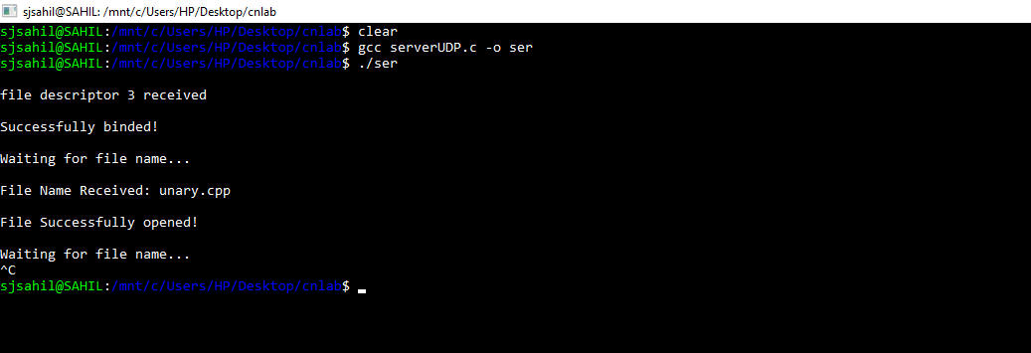

// client code for UDP socket programming
#include <arpa/inet.h>
#include <netinet/in.h>
#include <stdio.h>
#include <stdlib.h>
#include <string.h>
#include <sys/socket.h>
#include <sys/types.h>
#include <unistd.h>

#define IP_PROTOCOL 0
#define IP_ADDRESS "127.0.0.1" // localhost
#define PORT_NO 15050
#define NET_BUF_SIZE 32
#define cipherKey 'S'
#define sendrecvflag 0

// function to clear buffer
void clearBuf(char* b)
{
int i;
for (i = 0; i < NET_BUF_SIZE; i++)
b[i] = '\0';
}

// function for decryption
char Cipher(char ch)
{
return ch ^ cipherKey;
}

// function to receive file
int recvFile(char* buf, int s)
{
int i;
char ch;
for (i = 0; i < s; i++) {
ch = buf[i];
ch = Cipher(ch);
if (ch == EOF)
return 1;
else
printf("%c", ch);
}
return 0;
}

// driver code
int main()
{
int sockfd, nBytes;
struct sockaddr_in addr_con;
int addrlen = sizeof(addr_con);
addr_con.sin_family = AF_INET;
addr_con.sin_port = htons(PORT_NO);
addr_con.sin_addr.s_addr = inet_addr(IP_ADDRESS);
char net_buf[NET_BUF_SIZE];
FILE* fp;

// socket()
sockfd = socket(AF_INET, SOCK_DGRAM,
IP_PROTOCOL);

if (sockfd < 0)
printf("\nfile descriptor not received!!\n");
else
printf("\nfile descriptor %d received\n", sockfd);

while (1) {
printf("\nPlease enter file name to receive:\n");
scanf("%s", net_buf);
sendto(sockfd, net_buf, NET_BUF_SIZE,
sendrecvflag, (struct sockaddr*)&addr_con,
addrlen);

printf("\n---------Data Received---------\n");

while (1) {
// receive
clearBuf(net_buf);
nBytes = recvfrom(sockfd, net_buf, NET_BUF_SIZE,
sendrecvflag, (struct sockaddr*)&addr_con,
&addrlen);

// process
if (recvFile(net_buf, NET_BUF_SIZE)) {
break;
}
}
printf("\n-------------------------------\n");
}
return 0;
}

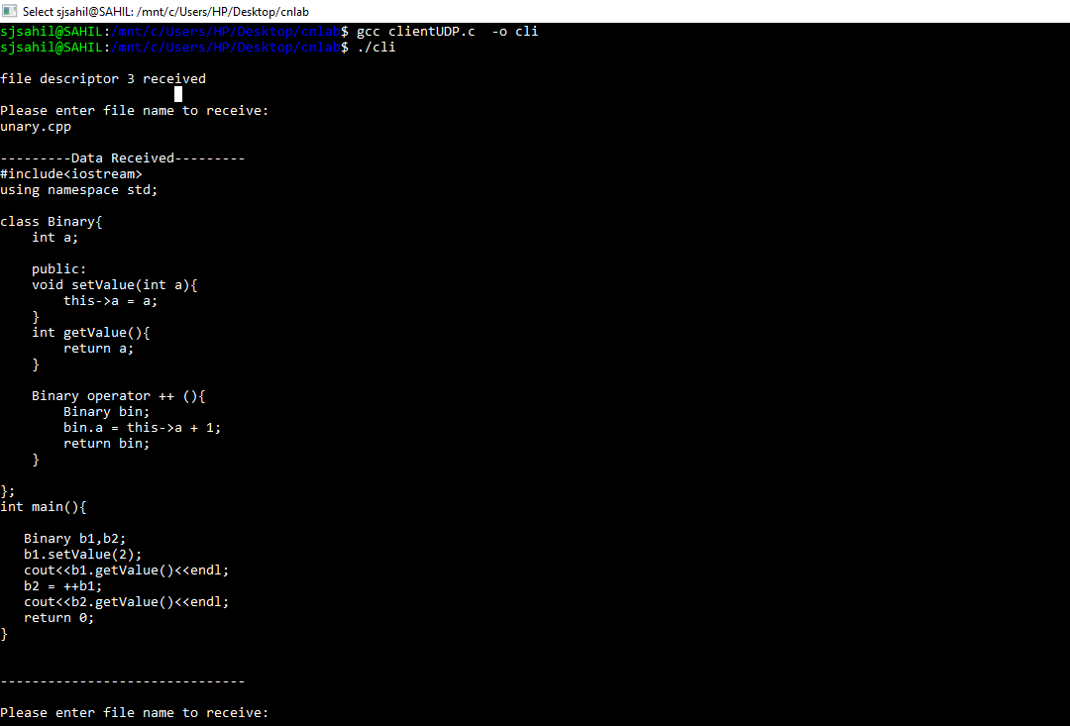

10.WAP TO PERFORM MESSAGE TRANSFER BETWEEN COMPUTERS

import java.io.*;
import java.net.*;
public class GossipClient
{
public static void main(String[] args) throws Exception
{
Socket sock = new Socket("127.0.0.1", 3000);
// reading from keyboard (keyRead object)
BufferedReader keyRead = new BufferedReader(new InputStreamReader(System.in));
// sending to client (pwrite object)
OutputStream ostream = sock.getOutputStream();
PrintWriter pwrite = new PrintWriter(ostream, true);

// receiving from server ( receiveRead object)
InputStream istream = sock.getInputStream();
BufferedReader receiveRead = new BufferedReader(new InputStreamReader(istream));

System.out.println("Start the chitchat, type and press Enter key");

String receiveMessage, sendMessage;
while(true)
{
sendMessage = keyRead.readLine(); // keyboard reading
pwrite.println(sendMessage); // sending to server
pwrite.flush(); // flush the data
if((receiveMessage = receiveRead.readLine()) != null) //receive from server
{
System.out.println(receiveMessage); // displaying at DOS prompt
}
}
}
}

import java.io.*;
import java.net.*;
public class GossipServer
{
public static void main(String[] args) throws Exception
{
ServerSocket sersock = new ServerSocket(3000);
System.out.println("Server ready for chatting");
Socket sock = sersock.accept( );
// reading from keyboard (keyRead object)
BufferedReader keyRead = new BufferedReader(new InputStreamReader(System.in));
// sending to client (pwrite object)
OutputStream ostream = sock.getOutputStream();
PrintWriter pwrite = new PrintWriter(ostream, true);

// receiving from server ( receiveRead object)
InputStream istream = sock.getInputStream();
BufferedReader receiveRead = new BufferedReader(new InputStreamReader(istream));

String receiveMessage, sendMessage;
while(true)
{
if((receiveMessage = receiveRead.readLine()) != null)
{
System.out.println(receiveMessage);
}
sendMessage = keyRead.readLine();
pwrite.println(sendMessage);
pwrite.flush();
}
}
}

11.WAP TO PERFORM MESSAGE TRANSFER BETWEEN CLIENT AND MULTIPLE SERVERS

# Python program to implement server side of chat room.
import socket
import select
import sys
from thread import *

"""The first argument AF_INET is the address domain of the
socket. This is used when we have an Internet Domain with
any two hosts The second argument is the type of socket.
SOCK_STREAM means that data or characters are read in
a continuous flow."""
server = socket.socket(socket.AF_INET, socket.SOCK_STREAM)
server.setsockopt(socket.SOL_SOCKET, socket.SO_REUSEADDR, 1)

# checks whether sufficient arguments have been provided
if len(sys.argv) != 3:
print "Correct usage: script, IP address, port number"
exit()

# takes the first argument from command prompt as IP address
IP_address = str(sys.argv[1])

# takes second argument from command prompt as port number
Port = int(sys.argv[2])

"""
binds the server to an entered IP address and at the
specified port number.
The client must be aware of these parameters
"""
server.bind((IP_address, Port))

"""
listens for 100 active connections. This number can be
increased as per convenience.
"""
server.listen(100)

list_of_clients = []

def clientthread(conn, addr):

# sends a message to the client whose user object is conn
conn.send("Welcome to this chatroom!")

while True:
try:
message = conn.recv(2048)
if message:

"""prints the message and address of the
user who just sent the message on the server
terminal"""
print "<" + addr[0] + "> " + message
reciever = message.split(' ',1)
# Calls broadcast function to send message to all
message_to_send = "<" + addr[0] + "> " + reciever[1]
broadcast(message_to_send, conn,reciever[0])

else:
"""message may have no content if the connection
is broken, in this case we remove the connection"""
remove(conn)

except:
continue

"""Using the below function, we broadcast the message to all
clients who's object is not the same as the one sending
the message """
def broadcast(message, connection,reciever):
client = list_of_clients[int(reciever)-1]
client.send(message)

"""The following function simply removes the object
from the list that was created at the beginning of
the program"""
def remove(connection):
if connection in list_of_clients:
list_of_clients.remove(connection)

while True:

"""Accepts a connection request and stores two parameters,
conn which is a socket object for that user, and addr
which contains the IP address of the client that just
connected"""
conn, addr = server.accept()

"""Maintains a list of clients for ease of broadcasting
a message to all available people in the chatroom"""
list_of_clients.append(conn)

# prints the address of the user that just connected
print addr[0] + " connected"

# creates and individual thread for every user
# that connects
start_new_thread(clientthread,(conn,addr))

conn.close()
server.close()

# Python program to implement client side of chat room.
import socket
import select
import sys

server = socket.socket(socket.AF_INET, socket.SOCK_STREAM)
if len(sys.argv) != 3:
print "Correct usage: script, IP address, port number"
exit()
IP_address = str(sys.argv[1])
Port = int(sys.argv[2])
server.connect((IP_address, Port))

while True:

# maintains a list of possible input streams
sockets_list = [sys.stdin, server]

""" There are two possible input situations. Either the
user wants to give manual input to send to other people,
or the server is sending a message to be printed on the
screen. Select returns from sockets_list, the stream that
is reader for input. So for example, if the server wants
to send a message, then the if condition will hold true
below.If the user wants to send a message, the else
condition will evaluate as true"""
read_sockets,write_socket, error_socket = select.select(sockets_list,[],[])

for socks in read_sockets:
if socks == server:
message = socks.recv(2048)
print message
else:
message = sys.stdin.readline()
server.send(message)
sys.stdout.write("<You>")
sys.stdout.write(message)
sys.stdout.flush()
server.close()

12.WAP TO PERFORM ENCRYPTION AND DECRYPTION USING DIFFIE HELLMAN
package Networklab;

import java.util.*;

public class Diffiehellman {
public static void main(String args[]) {
Scanner sc = new Scanner(System.in);
System.out.printf("Monu Kumar\n17BCS012\n");
System.out.println("Enter modulo(p)");
int p = sc.nextInt();
System.out.println("Enter primitive root of " + p);
int g = sc.nextInt();
System.out.println("Choose 1st secret no(Alice)");
int a = sc.nextInt();
System.out.println("Choose 2nd secret no(BOB)");
int b = sc.nextInt();

int A = (int) Math.pow(g, a) % p;
int B = (int) Math.pow(g, b) % p;

int S_A = (int) Math.pow(B, a) % p;
int S_B = (int) Math.pow(A, b) % p;

if (S_A == S_B) {
System.out.println("ALice and Bob can communicate with each other!!!");
System.out.println("They share a secret no = " + S_A);
}

else {
System.out.println("ALice and Bob cannot communicate with each other!!!");
}
}
}
