Claude on Azure — Project Summary

Date: 2026-09-10
Version: 1.0
Audience: Engineering Team, Architects, Stakeholders

Table of Contents

1. Executive Summary
Claude on Azure is a working guide and reference implementation for running Anthropic's Claude models inside the Microsoft ecosystem. It documents and deploys an Entra ID-authenticated Azure API Management (APIM) gateway that fronts a Claude deployment on Microsoft Foundry, a per-developer dollar-budget enforcement platform (Event Hub, Redis, Cosmos DB, two Azure Function Apps), and an admin usage/cost reporting stack (Azure Monitor workbook and an optional Grafana dashboard). The project is delivered as a Jekyll documentation site (index.md) plus deployable Bicep templates (infra/) and the Python/shell code that runs against the deployed platform (snippets/). It targets platform engineers rolling out Claude Code, Claude Desktop/Cowork, and the Microsoft 365 connector to large developer populations under centralized identity, quota, and cost controls.

2. Architecture Overview
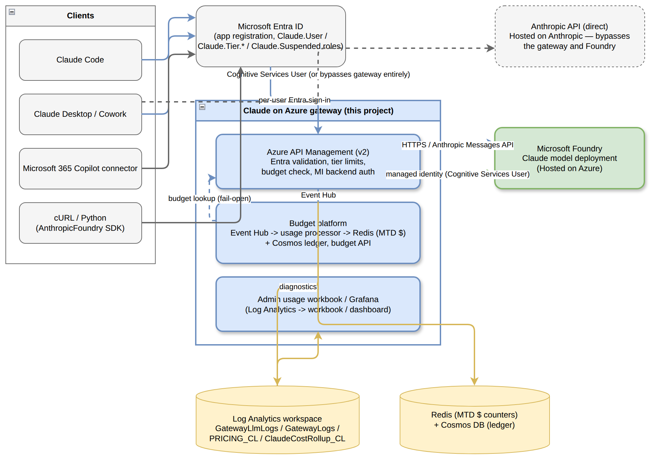
High-Level Architecture
At the system boundary, four kinds of clients call into the platform: Claude Code, Claude Desktop (including Cowork), the Microsoft 365 Copilot connector, and direct cURL/Python callers using the AnthropicFoundry SDK. All of them authenticate against Microsoft Entra ID using an app registration whose app roles (Claude.User, Claude.Tier.Pro / Claude.Tier.Basic / Claude.Tier.Lite, Claude.Suspended) drive authorization and tiering.
The project's own component — the Claude on Azure gateway — is the shaded (blue) system in the diagram. It is not a single service but three cooperating layers, all deployed by the Bicep templates in infra/:
- Azure API Management (v2 SKU) validates the Entra token, derives caller identity and tier, checks admin-suspension, calls the budget API, enforces per-tier token-per-minute limits, and forwards the request to Foundry using its own system-assigned managed identity (Cognitive Services User role) — the client never holds a Foundry credential directly.
- The budget platform (Event Hub, a usage-processor Function App, Redis, and Cosmos DB) turns gateway diagnostics into a near-real-time month-to-date dollar figure per developer, which the gateway policy reads back on every request.
- The admin usage workbook and Grafana dashboard read the same Log Analytics workspace the gateway writes diagnostics to, for humans rather than for the request path.
Downstream, Microsoft Foundry hosts the actual Claude model deployment ("Hosted on Azure"). A dashed line to a separate Anthropic API (direct) box marks the alternative, gateway-bypassing path some Claude Desktop configurations can still take — a decision point the guide calls out explicitly (index.md, Part 5, "Two doors marked Anthropic that you should walk past").

3. Processing Pipeline
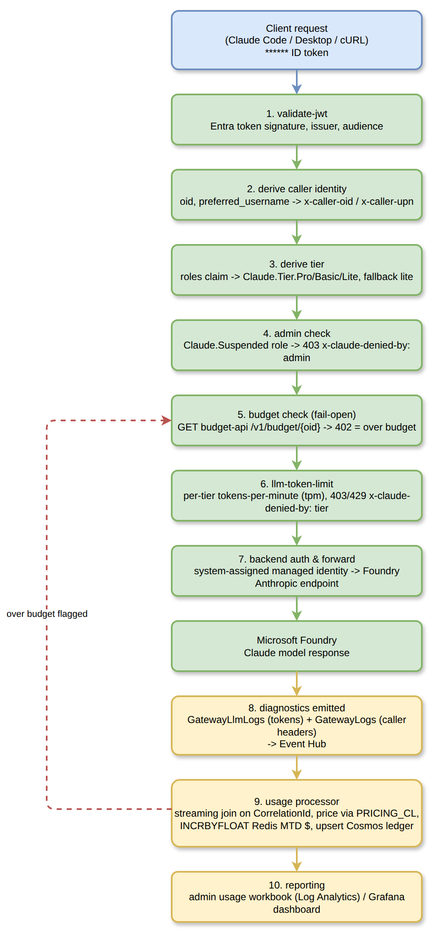
Processing Pipeline
A single Claude request through the gateway passes through the following stages, all implemented as one APIM inbound policy (infra/03-apim-claude-policy.xml):
- `validate-jwt` — verifies the Entra ID token's signature, issuer, and audience. The audience is the *bare application ID* for tokens requesting API version 2, not the api://<guid> identifier URI — a mismatch here 401s every request with no explanatory error.
- Derive caller identity — reads oid and preferred_username (not upn, which does not exist on a v2 token) and stamps them as x-caller-oid / x-caller-upn headers so downstream logs are not anonymous.
- Derive tier — reads the roles claim; a token carrying both Claude.User and a Claude.Tier.* role selects that tier, and a token with only Claude.User falls back to lite.
- Admin check — Claude.Suspended short-circuits the request with 403 and x-claude-denied-by: admin.
- Budget check (fail-open) — calls the budget API's GET /v1/budget/{oid}; a 402 response means over budget (403, x-claude-denied-by: budget), and anything else (including no answer) is treated as within budget by design.
- `llm-token-limit` — enforces the tier's tokens-per-minute and token-quota named values; a breach returns 429/403 with x-claude-denied-by: tier.
- Backend auth & forward — the gateway's own managed identity authenticates to Foundry; the request is forwarded to https://<foundry-account>.services.ai.azure.com/anthropic.
- Diagnostics emitted — Foundry's response produces two separate diagnostic records (GatewayLlmLogs with token counts, GatewayLogs with the caller headers), correlated only by CorrelationId, delivered to an Event Hub.
- Usage processor (snippets/17-usage-processor/function_app.py) performs a streaming join of the two record halves through Redis, prices the request from PRICING_CL, INCRBYFLOATs the developer's month-to-date dollar counter in Redis, and upserts a ledger row in Cosmos DB. If the counter now exceeds the tier's costQuota, the developer is flagged over budget — which step 5 will read back on their *next* request.
- Reporting — the admin usage workbook and Grafana dashboard read the Log Analytics workspace independently of the request path, for humans rather than enforcement.
The dashed feedback edge in the diagram (processor → budget check) is the platform's core enforcement loop: a request is never blocked mid-flight by its own cost, only by the *previous* request's accumulated spend.

4. Core Components
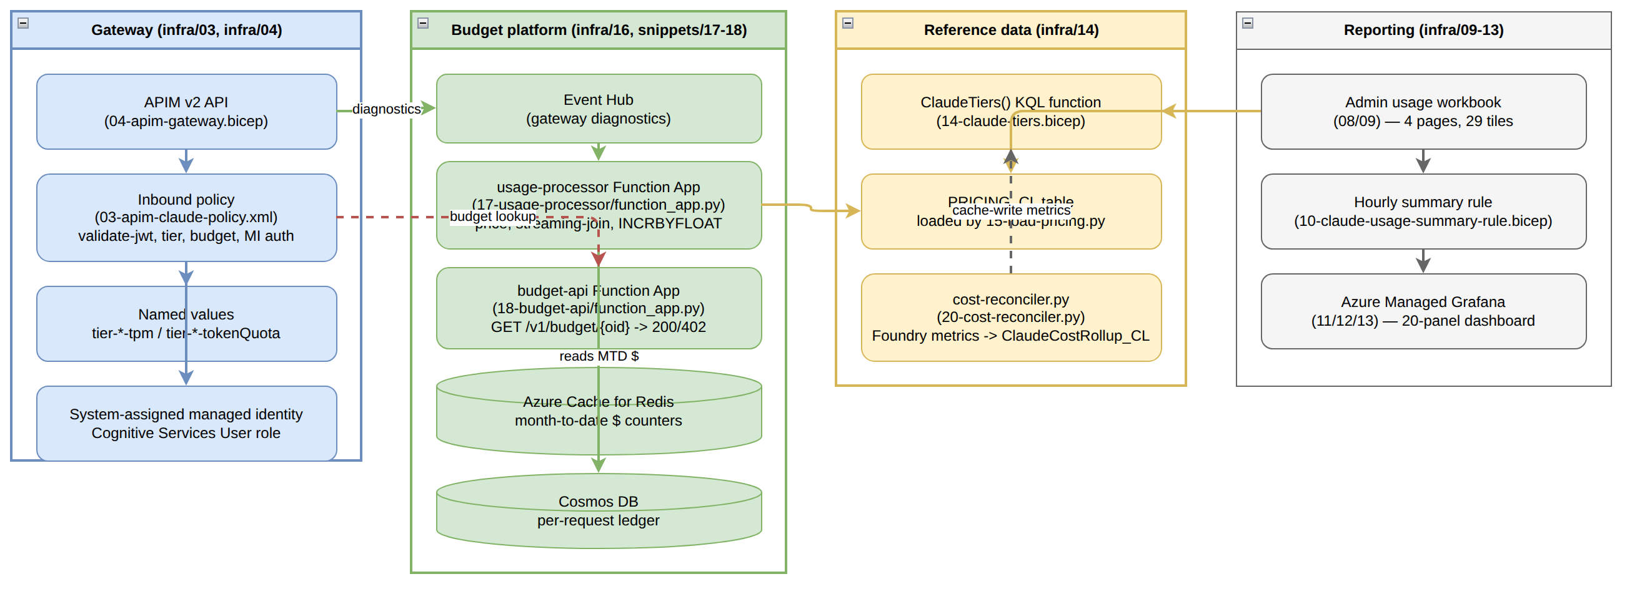
Component Relationships
Group | File(s) | Responsibility
Gateway | infra/03-apim-claude-policy.xml, infra/04-apim-gateway.bicep | Entra validation, tier derivation, admin/budget checks, per-tier rate limiting, managed-identity backend auth, diagnostics
Budget platform | infra/16-budget-platform.bicep, snippets/17-usage-processor/function_app.py, snippets/18-budget-api/function_app.py | Turns diagnostic events into a per-developer month-to-date dollar figure; exposes a single boolean the gateway policy consumes
Reference data | infra/14-claude-tiers.bicep, snippets/15-load-pricing.py, snippets/20-cost-reconciler.py | Single source of truth for tier limits (ClaudeTiers() KQL function) and model prices (PRICING_CL); reconciles cache-write metrics Azure Monitor exposes nowhere else
Reporting | infra/08/09-claude-usage-workbook.json/.bicep, infra/10-claude-usage-summary-rule.bicep, infra/11–13-*grafana* | Admin-facing dashboards over the same Log Analytics data, independent of the request path

Interfaces and contracts
- `tiersConfig` is declared identically in three templates — 04-apim-gateway.bicep, 14-claude-tiers.bicep, and 16-budget-platform.bicep — each entry carrying name, tpm (tokens per minute, enforced by APIM), tokenQuota (enforced by APIM), and costQuota (a dollar figure enforced only by the usage processor, not by APIM). A mismatch across the three is silent: the policy and the processor would throttle against different numbers.
- Budget API contract (snippets/18-budget-api/function_app.py): GET /v1/budget/{oid} returns 200 (within budget) or 402 (over budget) with no response body — the policy reads only the status code, by design, so a garbled response cannot be misread as "over budget."
- `ClaudeTiers()` (a saved KQL function deployed by 14-claude-tiers.bicep) is the one place the workbook, the Grafana dashboard, and the summary rule read tier limits from, rather than each carrying its own copy.

5. API Contracts / Message Schemas
Header / Field | Set by | Meaning
x-caller-oid | gateway policy, step 2 | Entra object ID of the calling developer
x-caller-upn | gateway policy, step 2 | preferred_username from the token
x-caller-tier | gateway policy, step 3 | Resolved tier: pro / basic / lite
x-claude-denied-by | gateway policy, steps 4–6 | admin, budget, or absent (rate/quota denial via llm-token-limit)
x-tokens-remaining | llm-token-limit policy | Remaining tokens in the current tier bucket

Ledger field (Cosmos, per request) | Source
CorrelationId (document id, upsert key) | Shared by GatewayLlmLogs and GatewayLogs
tier, model, token counts, priced cost | Usage processor, joined from both log halves and PRICING_CL
cache-write token counts | Explicitly marked unknown, never zero — see §8

6. Infrastructure & Deployment
Everything under infra/ is deployed with az deployment group create from the repository root. The gateway and the budget platform reference each other, so 04-apim-gateway.bicep is deployed twice — once with the budget API pointed at an unreachable placeholder (so the fail-open budget check passes every request while the platform doesn't exist yet), and again after the budget platform's outputs are available.
Order | Template | Deploys
1 | infra/04-apim-gateway.bicep | APIM v2 + system identity + Anthropic API + tier named values + role assignment
2 | infra/14-claude-tiers.bicep + snippets/15-load-pricing.py | ClaudeTiers() function, PRICING_CL table
3 | infra/16-budget-platform.bicep + snippets/17-usage-processor/, snippets/18-budget-api/ | Event Hub, Redis, Cosmos, both Function Apps
4 | infra/04-apim-gateway.bicep (again) | Re-deployed with the budget platform's real outputs
5 (optional) | infra/09-workbook.bicep, infra/10-claude-usage-summary-rule.bicep | Admin usage workbook, hourly rollup
6 (optional, billable) | infra/11-grafana.bicep, infra/13-import-grafana-dashboard.sh | Azure Managed Grafana + 20-panel dashboard
7 (optional) | infra/21-reconciler-metrics-rbac.bicep (module) | Monitoring Reader for snippets/20-cost-reconciler.py

Prerequisites: a Foundry resource with a Claude deployment, a Log Analytics workspace, an Entra app registration with a Claude.User app role, the correct aud value (decode a real token — do not guess), and an APIM v2 SKU (BasicV2/StandardV2/PremiumV2); the llm-* policies do not work on v1 SKUs and az apim create --sku-name cannot create v2 at all, which is why this is Bicep rather than CLI.
Deployment status (see infra/README.md for the authoritative, per-template record): 16-budget-platform.bicep and 14-claude-tiers.bicep are deployed and verified end to end (2026-09-04); 09-workbook.bicep is deployed and verified (2026-09-02, 22/22 queries against real data); 04-apim-gateway.bicep's policy is verified but its own resource composition has never been deployed from scratch; 10, 11, 11a, 21 compile but are not deployed from scratch.
Building without deploying: for f in infra/*.bicep; do az bicep build --file "$f" --stdout > /dev/null; done — expect one suppressed BCP037 in 04-apim-gateway.bicep.

7. Extension Patterns
Add a new developer tier. Add an entry to the tiersConfig array in *all three* templates (infra/04-apim-gateway.bicep, infra/14-claude-tiers.bicep, infra/16-budget-platform.bicep) with matching name, tpm, tokenQuota, and costQuota. TIERED-QUOTAS.md explains sizing tokenQuota as costQuota divided by the cheapest model's rate, so the token quota does not bind before the dollar cap.
Update model prices. Edit the PRICES table in snippets/15-load-pricing.py and re-run it against your DCR ingestion endpoint. Prices are stored per 1,000 tokens in PRICING_CL; every consumer (workbook, Grafana, processor) divides by 1,000, so a per-1M-token price pasted in directly will silently overcharge or undercharge by 1,000x.
Add a new reporting tile. Extend infra/08-claude-usage-workbook.json (embedded by infra/09-workbook.bicep) or infra/12-claude-usage-grafana-dashboard.json, and query ClaudeTiers() and PRICING_CL rather than hardcoding tier or price values in the query.
Close the cache-write cost gap. CACHE-TOKEN-ANALYSIS.md documents that cache writes (1.25x input for 5-minute TTL, 2x for 1-hour TTL) are unreported by any APIM diagnostic surface and were 62% of measured Opus 5 spend; snippets/20-cost-reconciler.py reads them from Foundry's own Azure Monitor metrics (cacheReadInputTokens, ephemeral5mInputTokens, ephemeral1hInputTokens) instead, and needs infra/21-reconciler-metrics-rbac.bicep (Monitoring Reader on the Foundry account) to run.

8. Rules & Anti-Patterns
- Do decode a real token before setting gatewayAudience — for an app with requestedAccessTokenVersion: 2 the aud claim is the bare application ID, never api://<guid>, and every request 401s silently if this is wrong.
- Do keep tiersConfig identical across all three templates that declare it; a mismatch throttles on one set of numbers while the processor budgets against another, with no error anywhere.
- Do treat the budget check as fail-open by design — an unreachable budget API must not stop 100,000 developers from working; the per-tier token quota is the synchronous backstop.
- Don't assume the workbook or Grafana numbers are complete dollar ceilings. Cache reads are metered; cache writes are not, and the measured sample captured only about 38% of actual cost in the processor.
- Don't gate authorization on the groups claim — it is capped at 200 object IDs and Entra omits it above that threshold, which is why tier and suspension are app roles.
- Don't apply the 5-minute cache-write rate to 1-hour writes when reconciling cost; that specific substitution caused a measured $3.28 shortfall in the seven-day sample (tests/test_cache_accounting.py).
- Don't try to update 10-claude-usage-summary-rule.bicep's destination table retention with az monitor log-analytics workspace table update — it sends the whole schema and fails the summary rule's own validation; use az rest --method patch.

9. Dependencies
Category | Technology / Package | Where used
Documentation site | Jekyll (minima theme), kramdown/GFM | _config.yml, index.md
Infra-as-code | Bicep (Azure CLI az bicep) | infra/*.bicep
API gateway | Azure API Management v2 (llm-* policies) | infra/04-apim-gateway.bicep, infra/03-apim-claude-policy.xml
Compute | Azure Functions (Python, Linux plan) | snippets/17-usage-processor/, snippets/18-budget-api/
Data stores | Azure Cache for Redis, Azure Cosmos DB, Log Analytics workspace | infra/16-budget-platform.bicep
Reporting | Azure Monitor Workbooks, Azure Managed Grafana | infra/08/09, infra/11–13
Python libraries | azure-functions, azure-cosmos, azure-identity, redis, azure-monitor-ingestion, requests | snippets/17-usage-processor/requirements.txt, snippets/18-budget-api/requirements.txt
Testing | unittest (standard library) | tests/test_cache_accounting.py
Site build | bundle / Gemfile (Ruby, Jekyll) | Gemfile

10. Code Structure
index.md the guide (1,068 lines) — Parts 1-7 plus governance/decision tables
README.md repo overview, deploy pointer, licensing
TIERED-QUOTAS.md design doc: three tiers, per-developer $ budgets at ~100K developers
CACHE-TOKEN-ANALYSIS.md measured cache-accounting gaps and remediation review
AIGATEWAY-ISSUE-DRAFT.md draft issue text
images/ guide screenshots + architecture.drawio, tiered-quotas-architecture.drawio
infra/ deployable Bicep + the APIM policy XML + workbook/dashboard JSON
03-apim-claude-policy.xml inbound policy: auth, tier, budget, MI backend auth
04-apim-gateway.bicep APIM v2 + identity + API + named values + role assignment
08-claude-usage-workbook.json admin workbook definition (embedded by 09)
09-workbook.bicep deploys the workbook
10-claude-usage-summary-rule.bicep hourly rollup past 30-day raw retention
11-grafana.bicep / 11a-*rbac.bicep Azure Managed Grafana + cross-RG RBAC
12-claude-usage-grafana-dashboard.json 20-panel dashboard definition
13-import-grafana-dashboard.sh imports the dashboard (no ARM path for AMG dashboards)
14-claude-tiers.bicep ClaudeTiers() KQL function + PRICING_CL + DCR
16-budget-platform.bicep Event Hub, Redis, Cosmos, two Function Apps
21-reconciler-metrics-rbac.bicep Monitoring Reader module for the cost reconciler
README.md prerequisites, deploy order, per-template verification status
snippets/ code that runs against the deployed platform
01-curl-entra.sh, 02-python-entra.py keyless Entra auth examples (cURL, AnthropicFoundry SDK)
05-gateway-smoke-test.sh positive/negative/streaming gateway smoke tests
06-claude-code-managed-settings.json admin-pushed Claude Code settings
07-claude-gateway-token.sh apiKeyHelper minting a per-user Entra token
15-load-pricing.py maintained Claude prices -> PRICING_CL (+ Redis)
17-usage-processor/function_app.py Event Hub trigger: price, count, flag over-budget
18-budget-api/function_app.py the boolean the gateway policy asks
19-tier-smoke-test.sh per-tier limits, rejection reasons, fail-open
20-cost-reconciler.py Foundry cache-write metrics -> ClaudeCostRollup_CL
tests/
test_cache_accounting.py regression tests for pricing and processor arithmetic
docs/ generated documentation (this file, diagrams, Word export)

