Project 1: DC-DC converter (synchronous buck regulator with controller LT3741)

**DC-DC converters**

In this project, a DC to DC converter is implemented. DC-DC converters are needed since all electronic devices require constant voltage supply and DC-DC converters are the circuits converting the unregulated DC input to a controlled DC output at a desired voltage level. They can be separated into two groups: linear and switcher type. Since a switching type regulator is made in this project, the details of linear type regulators will be skipped.

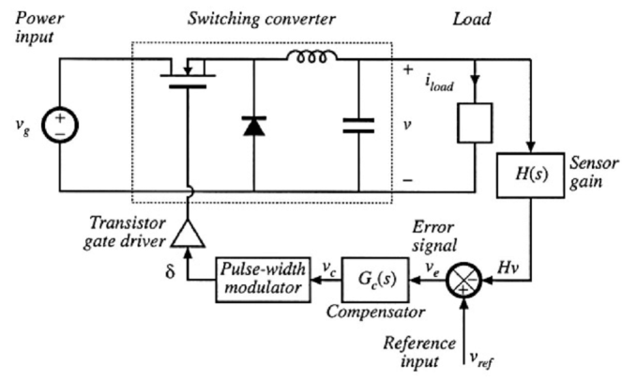

O iki transistor synchronous yapıyor daha iyi diyottan