**Unveiling Progress: Thematic Analysis of VNRs for SDGs and the Triple Paradox**

In the relentless march towards sustainable development, deciphering the subtle intricacies of progress is paramount. Voluntary National Reviews (VNRs), those meticulous policy documents, offer a window into how nations advance towards the Sustainable Development Goals (SDGs). Yet, the sprawling and often convoluted data within these reviews demands a more systematic approach to extract actionable insights. Enter thematic analysis, powered by advanced AI techniques, promising to transform this data into a clear roadmap for policymakers.

**Thematic Analysis: A Clearer View of Sustainable Development**

Thematic analysis, a robust qualitative research method, excels at identifying, analyzing, and reporting patterns within data. Applied to VNRs, it illuminates a country’s strides, hurdles, and prospects in achieving the SDGs. This method goes beyond mere data, diving deep into core issues and advancements, offering a structured approach to dissecting complex documents and revealing underlying themes and trends.

**The Triple Paradox: A Fresh Analytical Lens**

The triple paradox, highlighted in the OSAA 2023 New Partnership for Africa's Development (NEPAD) report, provides a unique perspective for analyzing VNRs. It encompasses three critical paradoxes:

1. **Financing Paradox:** The conundrum of financing sustainable development despite substantial economic growth.
2. **Energy Paradox:** The quest for sustainable energy solutions amidst abundant natural resources.
3. **Food Systems Paradox:** The battle to achieve food security despite vast agricultural potential.

Examining VNRs through these paradoxes unveils the multifaceted challenges and progress in these essential areas, providing a richer understanding of the complexities involved.

**Harnessing AI for Thematic Analysis**

Utilizing advanced AI techniques, our approach, grounded in the principles outlined in the academic paper "Using ChatGPT for Thematic Analysis," revolutionizes how VNRs are analyzed. This methodology leverages Few-Shot Learning, Chain-of-Thought Approaches, and Role-Playing Scenarios, ensuring a thorough and precise analysis.

**The Value of AI in Thematic Analysis**

AI’s integration into thematic analysis simplifies and enhances the examination of VNRs. This technological synergy produces PowerBI reports, distilling main sentences related to each SDG and classifying them as challenges or opportunities. The result? A more accessible and insightful analysis.

**Outcomes of the AI-Driven Analysis**

1. **PowerBI Reports:** These reports streamline analysis and readability, extracting key sentences related to each SDG and categorizing them into challenges or areas of opportunity. This clear classification aids policymakers in swiftly identifying critical issues and potential solutions.

<iframe title="VNRs_Visual_Final_6_concept note" width="1140" height="541.25" src="https://app.powerbi.com/reportEmbed?reportId=49d6c779-c019-4630-9c30-7e29abcac00b&autoAuth=true&ctid=0f9e35db-544f-4f60-bdcc-5ea416e6dc70" frameborder="0" allowFullScreen="true"></iframe>

1. **Fact Sheets:** Concise fact sheets highlight the most pertinent SDGs for each country, pinpointing specific challenges or opportunities under each goal. These fact sheets serve as quick references for decision-makers, encapsulating essential information at a glance.

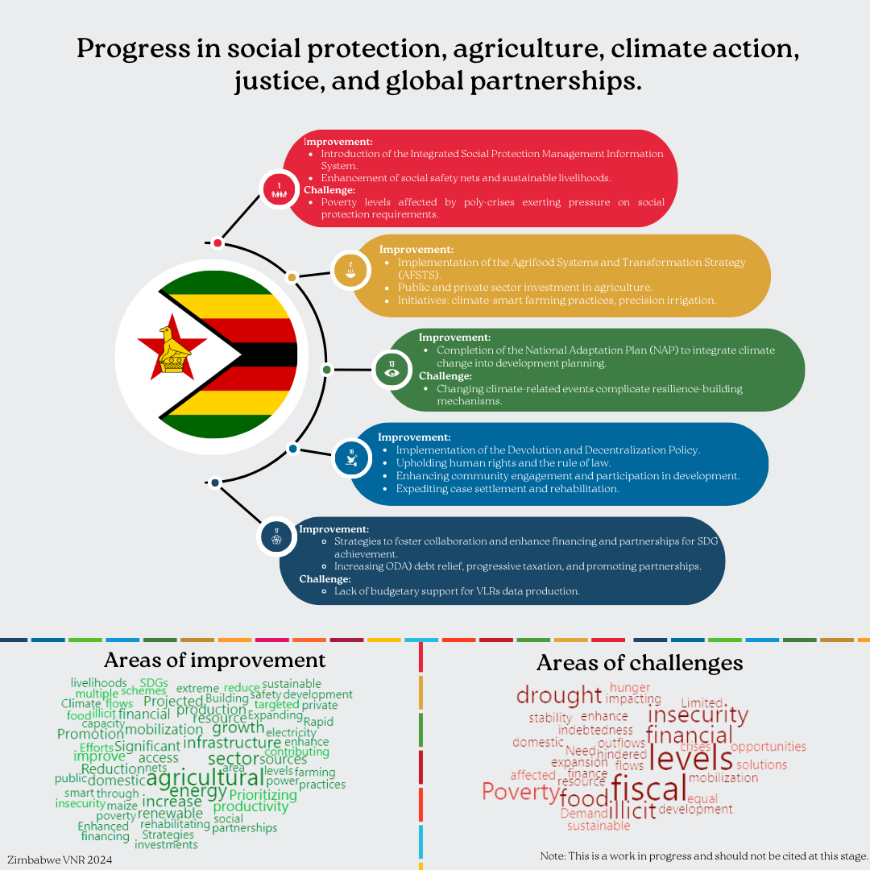

**Conclusion: The Road Ahead**

Thematic analysis of VNRs, augmented by AI, emerges as a potent tool for uncovering the underlying themes and trends in sustainable development. By focusing on the SDGs and the triple paradox, this approach yields invaluable insights, guiding policymakers in crafting informed and effective strategies. As the world continues its quest for sustainability, such detailed and structured analyses will be indispensable in understanding progress, challenges, and opportunities.

This innovative methodology not only advances policy research but also offers practical implications, providing a roadmap for countries to align their policies with sustainable development goals. Ultimately, it fosters a more sustainable and equitable world, where informed decision-making drives meaningful progress.