**How to run the Students Record System Django Python**

**1.** Download the zip file

**2.** Extract the file, copy studentrs  folder, and paste it on the desktop

**3.** Open MySQL Create a database srspythondb then import the SQL File available in the SQL File Folder (For MySQL we used [XAMPP](https://phpgurukul.com/how-to-install-xampp/)server)

**4.** Open PyCharm and click on the terminal

**5.** Navigate the project folder using the cd command

cd project_path

**For ex:**cd C:\Users\ANUJ\OneDrive\Desktop\studentrs

**6.** Now Navigate to the Apartment Visitor System folder

cd studentrecordsys

**7.** Run the Project using the following command

python manage.py runserver

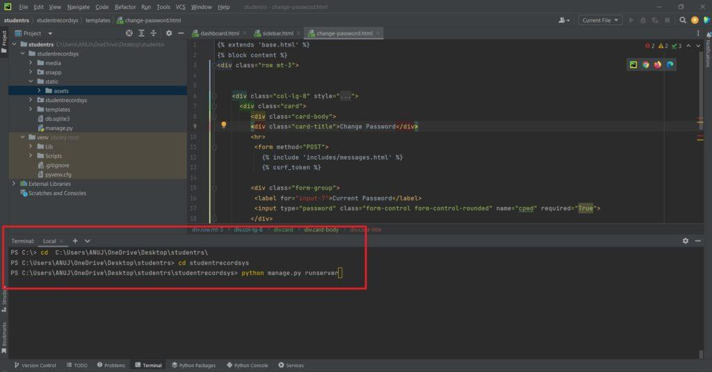

Now click the URL http://127.0.0.1:8000 and the Project will run

@ Stephen Thompson