**Assignment 1**

**Write the SQL commands to create the course table given below**

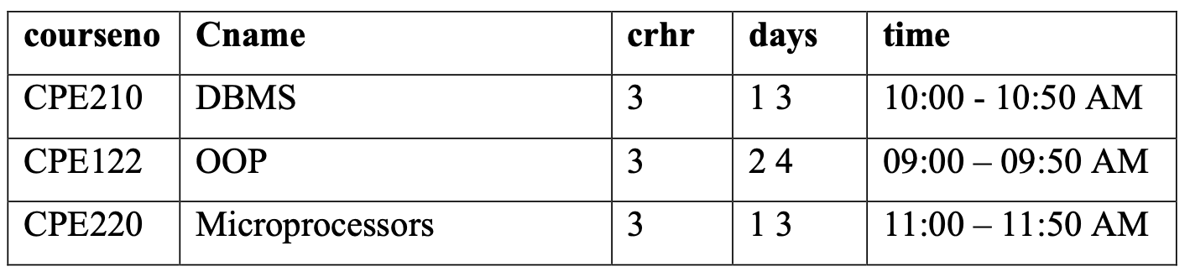

1. **Create course table:**

CREATE TABLE course (

courseno VARCHAR(10) PRIMARY KEY,

Cname VARCHAR(50),

crhr number(3),

days number(3),

time VARCHAR(50)

);

1. **Insert data to the table:**

INSERT INTO course VALUES('CPE210', 'DBMS', 3, 13, '10:00 - 10:50 AM');

INSERT INTO course VALUES('CPE122', 'OOP', 3, 24, '09:00 - 09:50 AM');

INSERT INTO course VALUES('CPE220', 'Microprocessors', 3, 13, '11:00 - 11:50 AM');

Implementation