What Makes Players the Best
When I first started playing Toki, I can admit I was horrible, it was only after watching good players for a month or so, that I began to understand the patterns, and techniques that separate the best from the average. All the time now people are getting better at toki toki and the standards are constantly rising. For proof of this point think about what happened when any of us stop playing for a week or so, suddenly just because we are abit out of form, a lot of people start beating us. Because of how competitive toki is becoming, I though I would write down some of my ideas about what makes a good toki toki player, and how we can all improve and get better.

People always say, that there is no one best toki toki player, I think this comment is true, however all of us can improve, and by sharing ideas on this page I hope that every XXXX player can gain something from other peoples knowledge. We are a team now, and I believe it is important we share our own insights to try to help others.

Speed
The biggest thing that determines good players from average players is their speed. Quite often if you can get 4-5 pieces ahead of the other person, and you maintain control, then you have won the game. The reason being is that you get to the arrows and globes before your opponent, and can often finish him off before he gets the right pieces. However even if you are the fastest player, you will still lose if you don’t play smart.

People who continually use direct attacks, by setting small groups of one color time after time, just make it easy for others to use timers against them. Even if they are ahead of their opponent they will always be in trouble if their opponent can use timers, and chain properly. It is VERY important to always try to set up a “toki toki boom”, because this means you will send more then one color to your opponent which makes it harder for him to use these pieces against you.

The other important thing to remember is accuracy. Some of the fastest toki players will occassionaly make mistakes and will be hampered by their own speed, sometimes these players are careless and will leave large towers in their 3rd left column where block come down. If you can attack them quickly you can sometimes kill these people off fast because they are trapped by their own carelessness. Citizen is a good example of a player who is not very accurate, as he will often do stupid things when he tries to speed up, this is one of the reasons why he isn’t a good toki player.

Despite these problems speed is a critical factor in games. People who play with a lot of speed, and can successfully pull of greed strategies, or chain strategies will always be tough to beat. In my mind these players are the best in Toki Toki.

A good example of the importance of playing with speed, is seen when using a one color greed strategy. For this strategy you mass one color on the right of your screen and try to set off all of your other colors to slow down your opponent. In practical examples, if two players use this strategy the fastest player will almost always win. This is because the faster player is setting off his other colors faster, and is using this to slow down his opponent, which also makes it much harder for him to continue to mass a color. This gives the faster player “board control” as he is dictating how the game will be played. By being faster he can easily keep control over a game, making “one color greed” a very safe strategy to use for experienced players. CamronKozzie is proof of how successful this strategy can be, because this greed strategy combined with his speed is one of main reasons why Cam was so successful on the RM ladder.

Speed is also a key component to all walling strategies, for you to win your wall must be in place and set off before your opponent is ready. This is the key advantage and weakness of a wall, in that if you wall properly you can often catch other players unaware. However if you set up your wall to slowly you will be trapped and often lose because you run of space and find it impossible to set off your wall.

Chaining
I think most people underestimate the importance of chaining. Absolutely every single strategy used in toki toki will be more successful if a player uses chaining to execute or support his strategy. This might not make much sense now but let me explain.

Chaining isn’t just important when building big toki toki boom chains, similar to those used by good players such as Wo and Solar. If someone is to use a greed strat, is it always helpful if they can send small chains to their opponent slowing them down, and giving the player more time to mass their color. The reason why chains are so affective in this situation is because when you create a three part chain, you send multiple colors to your opponent, this makes it much harder for them to use timers to get rid of their pieces. As such chains are much more effective in this case, this sending off one color at a time, because this will only drop individual color blocks onto your opponent, making it easy for them to use timers and send these blocks back to you. This is an example of the weakness of direct attack.

PhilM uses an interesting strategy, which I call quickfire. This strategy is based on combining speed with short chains. By continually setting off these short chains, Phil slows down his opponent and tries to wreck the towers, wedges or chains they have built. By continually playing “timer blocks” on top of their own blocks Phil makes it much harder for them to get down to their set ups and forces them to often send much smaller parcels back against Phil. Because phil is very good with timers, his strategy is extremely effective, and in form he is one of the toughest opponents. This shows just how versatile chains are, as even someone who only masses small groups of blocks need to use chains to make his strategy successful.

Chains and the ability to cause small toki toki booms, will also make greed strategies much more successful. Ultimately chains will make it much harder for opponents to send blocks back to you, which makes it easier for you to mass one color, and keep control over the game. Nothing in toki toki is certain however, as arrows, luck, timers and genuine skill will always make ever the safest strategies risky. However I believe it is important to throw in chains wherever possible. Whenever I use a greed strategy I always try to throw in small chains, and I’ve noticed that I have been much more successful when I use chains. My own walling strategy is also designed to allow me to chain off the wall, by aligning my globes and blocks in a particular way. This is why I am always confident I will win against conventional wallers and people who only put their pieces down in a random pattern.

Below are some examples of different ways of setting up chains. Aswell as some of the problems and mistakes that can be made when creating chains.

The first example is a very simple layers chain, that involve colored block layered horiziontally, the basic idea is that as one color is removed, the globes above fall down setting off other colors. This particular chain can be set off in two different ways, the first way is by removing the yellow block on the second bottom of the second right column, this will then cause the green globe to fall, setting of the greens, then the blues, then the reds and the yellows. This is a simple chain that can be set easily and quicky at the start of any game. Also by playing the blue globe on top of the timer blue blocks the chain can be set off, removing the blues, then the red, then the yellos and finally the greens.

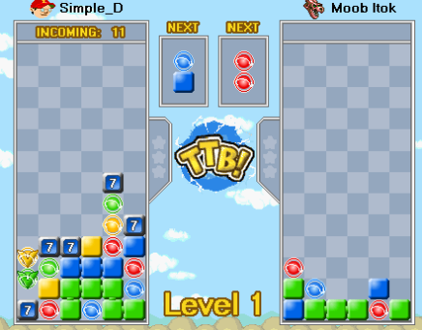

Below is another example of a chain. The second example is a much smaller chain that would more likely be used in a strategy such as Phil’s quickfire strat. This is because the chain is very small and easy to set up, however the payload of this chain is also small only equally 12 blocks. By continually building small chains like this, phil will often try to suppress his opponent and gain control of a match. It is also important to note that the yellow block needs to be placed horiziontally, otherwise the yellow block and globe will set off, making the chain smaller.

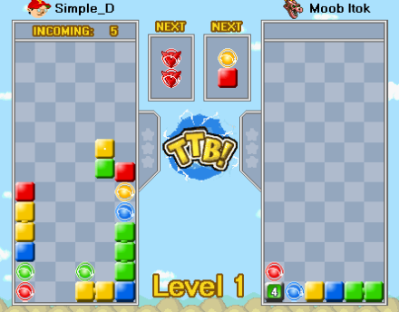

The final chaining example I will show, is of the chain wall strategy I use, I don’t want to discuss in detail how I plan and build for this strat I would like to show quickly the end result.

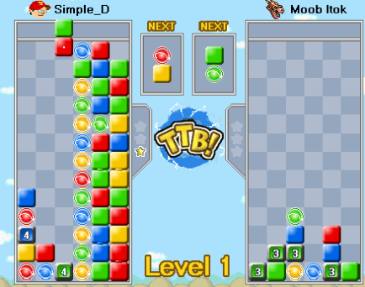

By flipping the green onto the bottom, I begin to set off this chain, which sets off the bottom yellows, blues, greens and reds, on the top this also sets of another two green globes and a yellow globe. The end result is a chain of 32. By removing large numbers of blocks next to the globes it is possible to get chains of up to 40-50 using this strategy.

When playing opponent who use chains, it is important to remember that especially with large chains it takes time for them to be set up, as in all encounter speed is important, if you can stay ahead of them it is possible to finish them off before they can use their chain against you. As the ability to continually send small groups of blocks against someone who is building a big chain will help to mess up your opponents plan. Also when someone is trying to chain using timer blocks, REMEMBER they must survive for 7 turns, if you can send enough to kill them before the timer blocks have transformed you will often win. Some chainers go overboard, and this will leave them vulnerable to quick attacks.

When I play opponents who use small chains, I will often go for a one color greed strategy, by building upwards quickly I can negate the effects of their small chain, and because I am also sending blocks and massing a color I will often have a big advantage against them later on in the game.

