Moobin – Overview
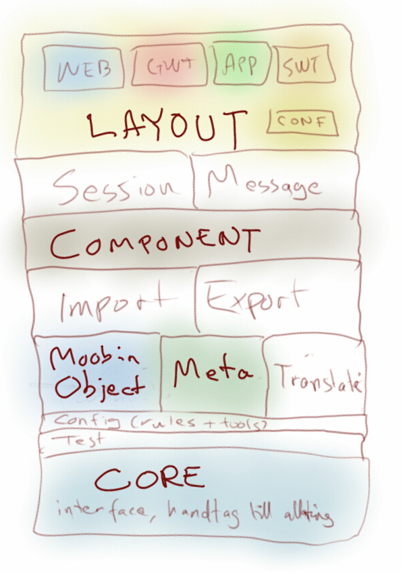

Development Projects
- Moobin Doc – “owner” of this document, documents and rules for documentation
- Moobin Core – interfaces for all aspects of the Moobin Framework
- Moobin Test – abstract implementations for testing the system
- Moobin Config – tools and rules for configuration (xml and annotations)
- Moobin Object - Rules for objects in cache and messages
- Moobin Meta – tools for creating and handling of meta data, “Moobin Object” rules
- Moobin Translate – tools and rules for translation and formatting
- Moobin Cache – implementation of cache interfaces, caching mechanisms
- Moobin Import – how to import data (xml, csv, rss, broadcast, java objects, reflection...)
- Moobin Export – how to retrieve data (xml, json, csv...)
- Moobin Component – rules and implementation of components and subcomponents
- Moobin Session – implementation of session handling, abstract logon (component)
- Moobin Message – rules for communication with client
- Moobin Layout – rules for defining interaction with the application (views, menus...)
- Moobin Example – project implementing all aspects of the framework

Moobin Doc

Moobin Core

Moobin Test

Moobin Config

Rules for Moobin Objects
All fields has to be of predefined java types.
A field can be specified with annotations or xml. An xml specification always takes precedence (of course, since the annotation is “final”).
With annotations it is possible to specify that a field is or is not
- system
- mandatory
- unique
- id
- ignored
- ...
When extending a component, these object descriptions can be modified using xml.
There are also business type annotations. A field can only have one business type annotation and if missing, a field is assigned a business type depending on the data type.
- Price (currencyRef, tickRef...)
- Time (min, max...)
- Date (min, max...)
- TimeStamp (min, max...)
- DisplayName (minlength, maxlength...)
- Reference (to...)
- Number (min, max...)
- Decimal(min, max, decimals...)
- Text (minlength, maxlength, regexp...)
- …
Objects describing the system (cache/metadata/views...) are themselves Moobin Objects and thus can be retrieved from the cache. And displayed as any other data.

Moobin Meta
Moobin Meta

Moobin Cache
In the cache only Moobin Objects are allowed. A Moobin Object is any java object in compliance with the Moobin Object rules.
What is visible in the cache depends on who is watching.

Moobin Component
Each component has a unique component id.
A component can extend or inherit other components. When extending a component the extended component keeps the component id. By extending it is possible to add or remove entity types. It is also possible to add, remove or modify entity fields.
An inherited component keeps its id, and becomes a subcomponent.

Moobin Session

Moobin Message

Moobin Layout

Moobin Example

