**虚拟机Centos如何和主机共享目录**

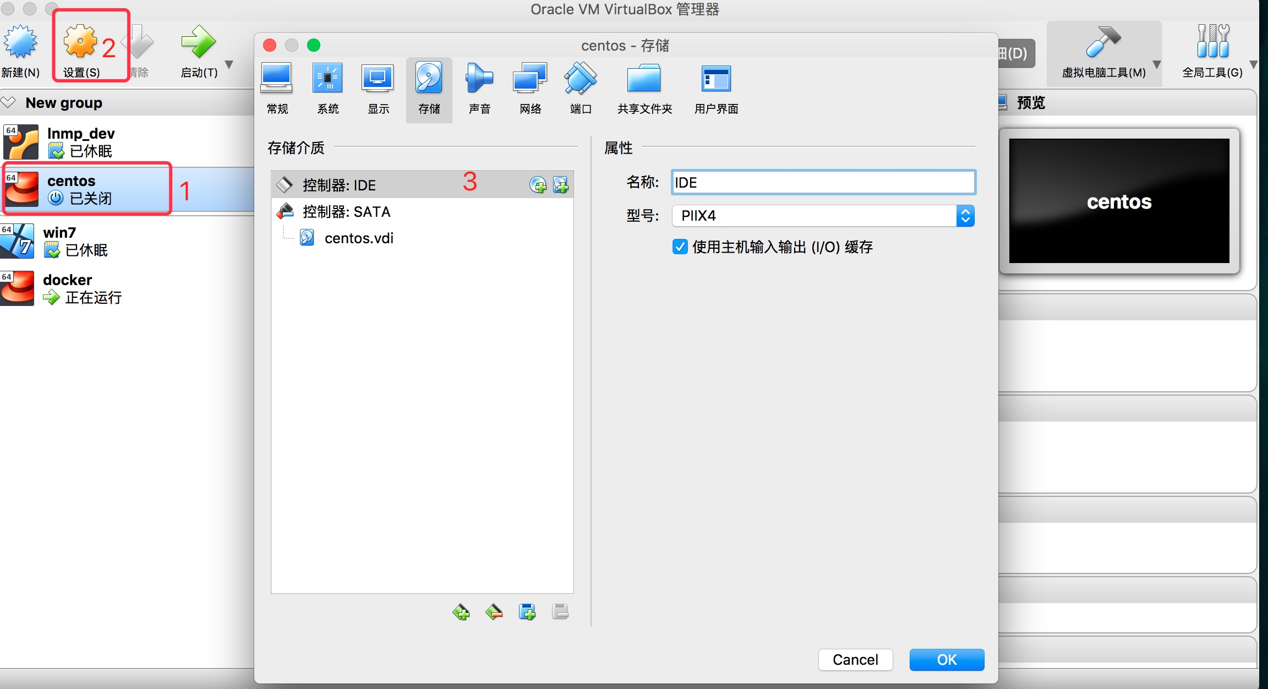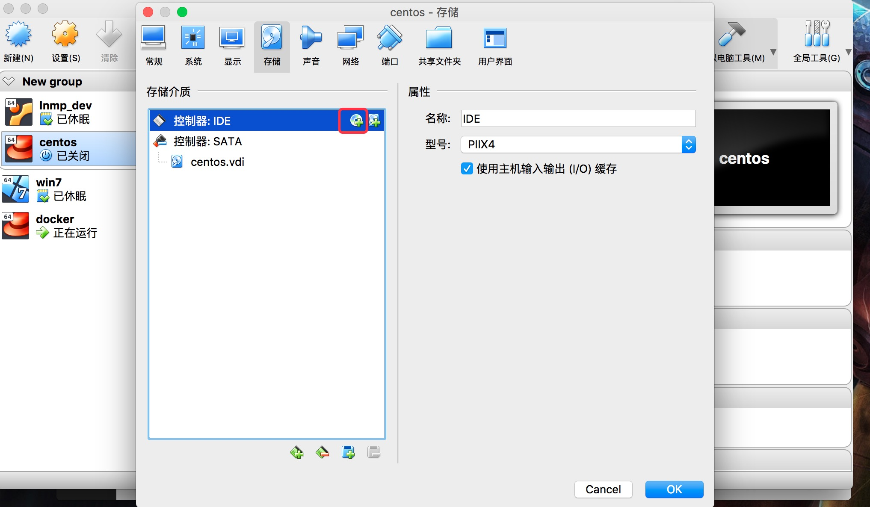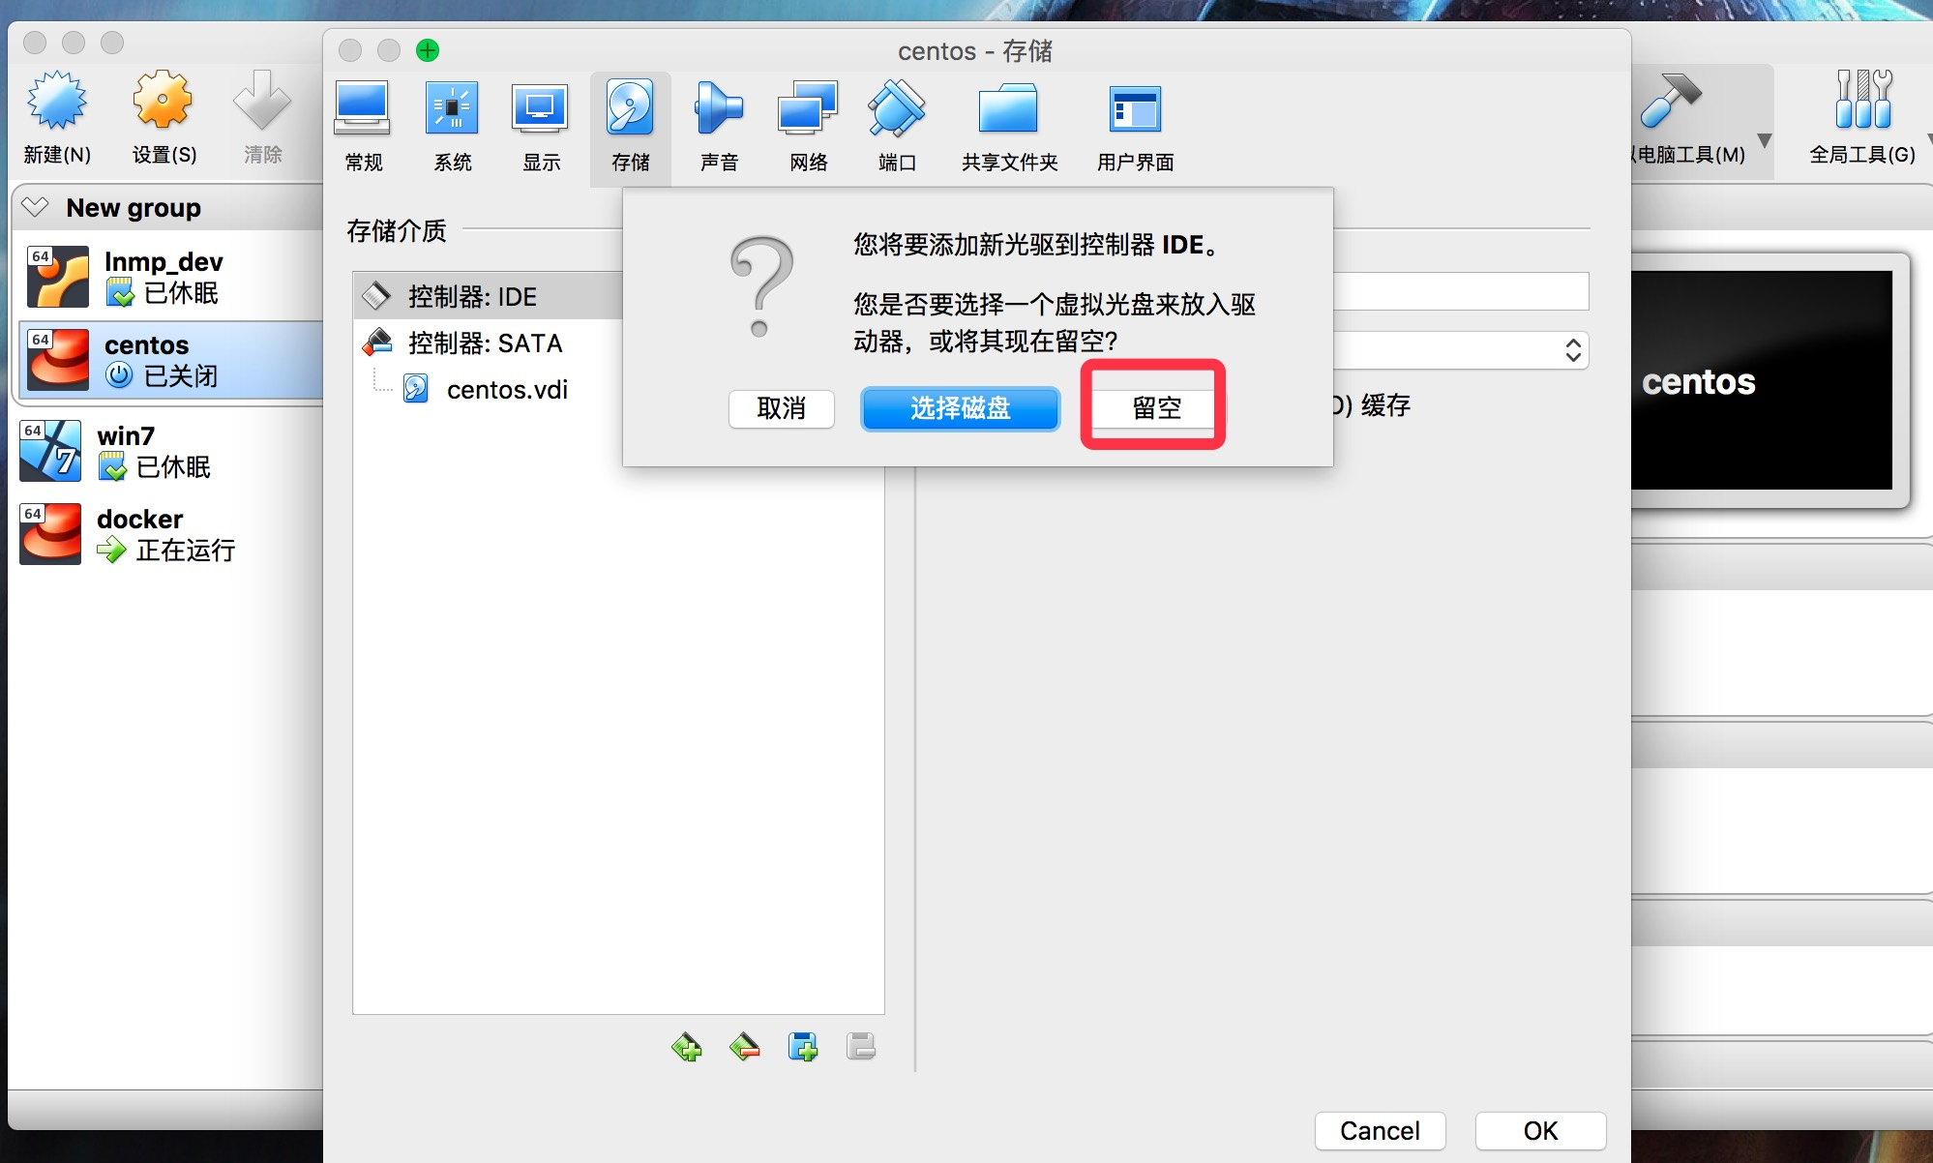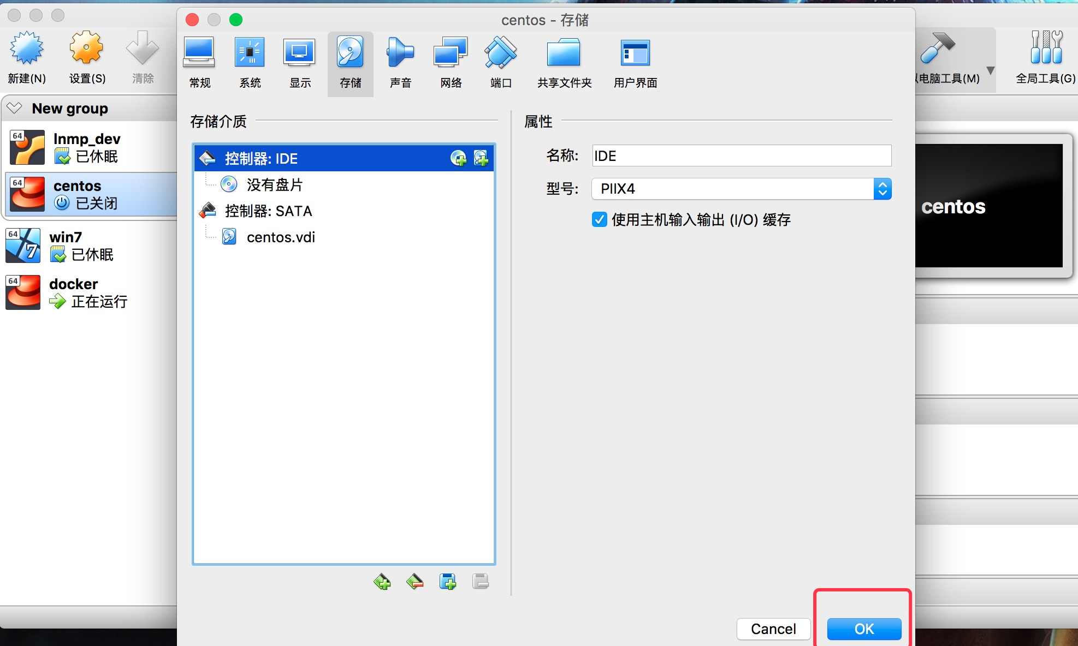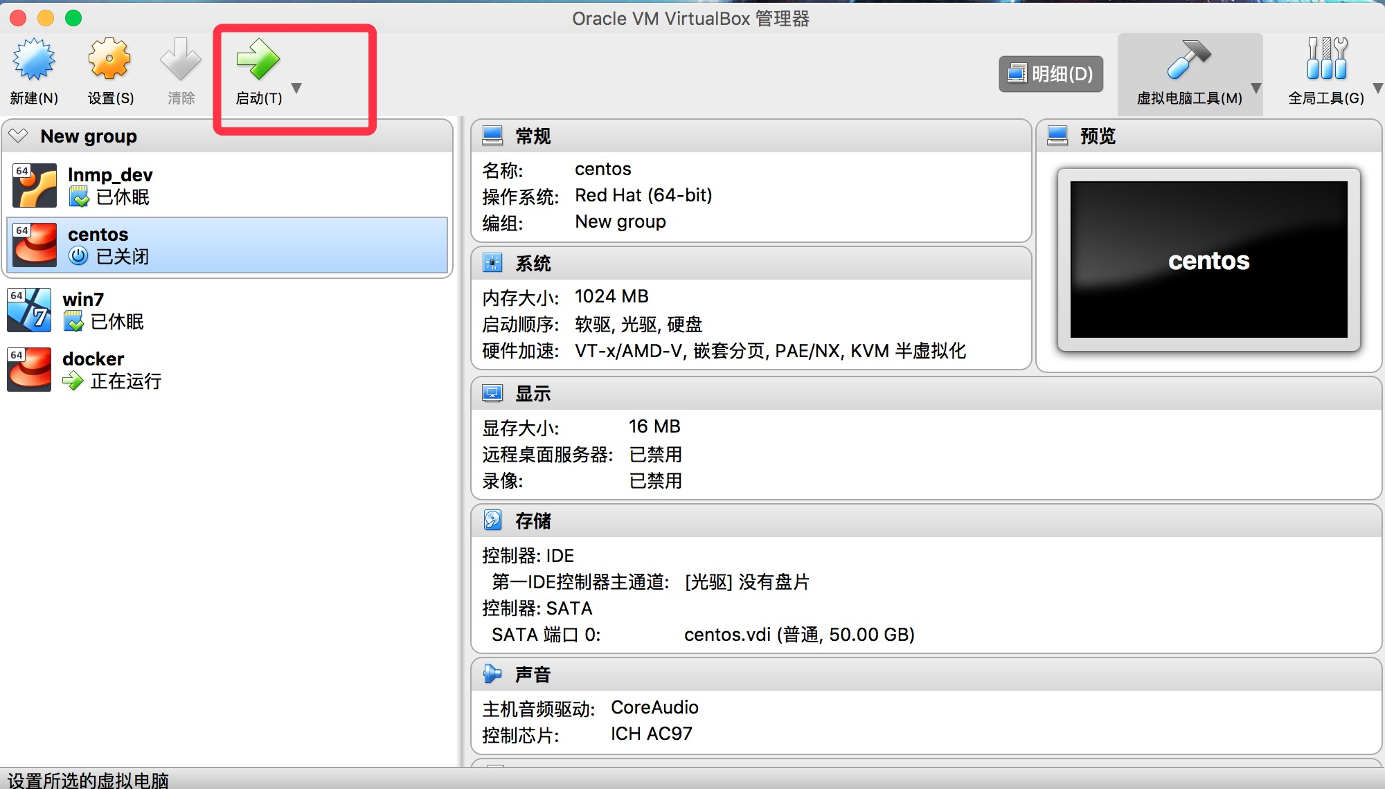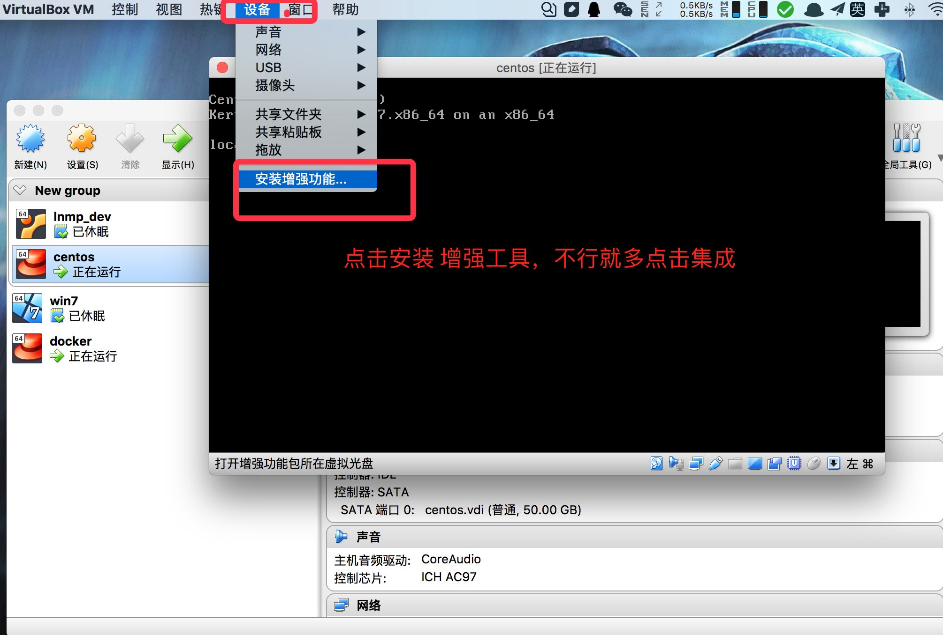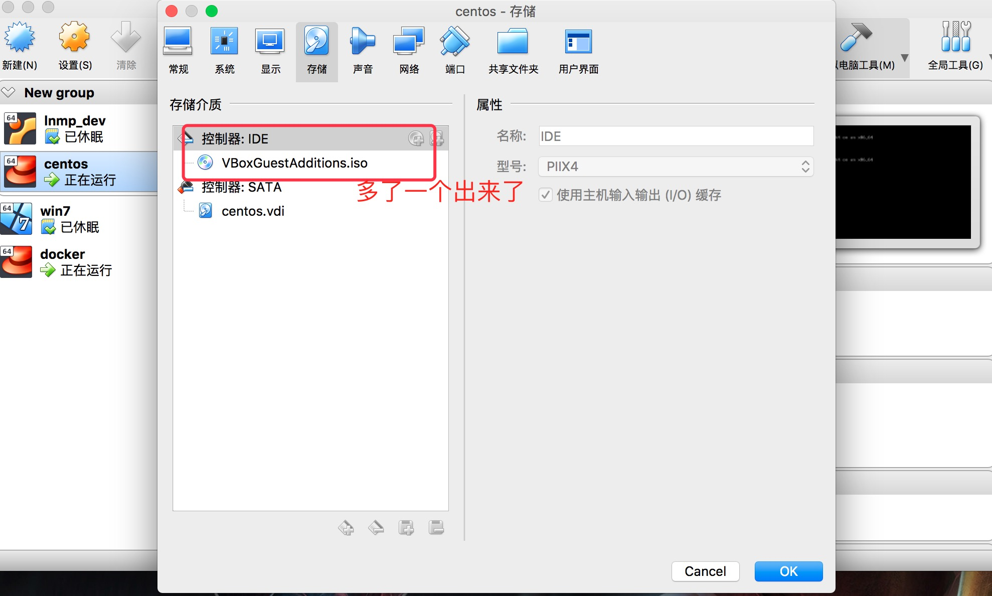

**1.mkdir /mnt/cdrom**

**2.mount /dev/cdrom /mnt/cdrom**

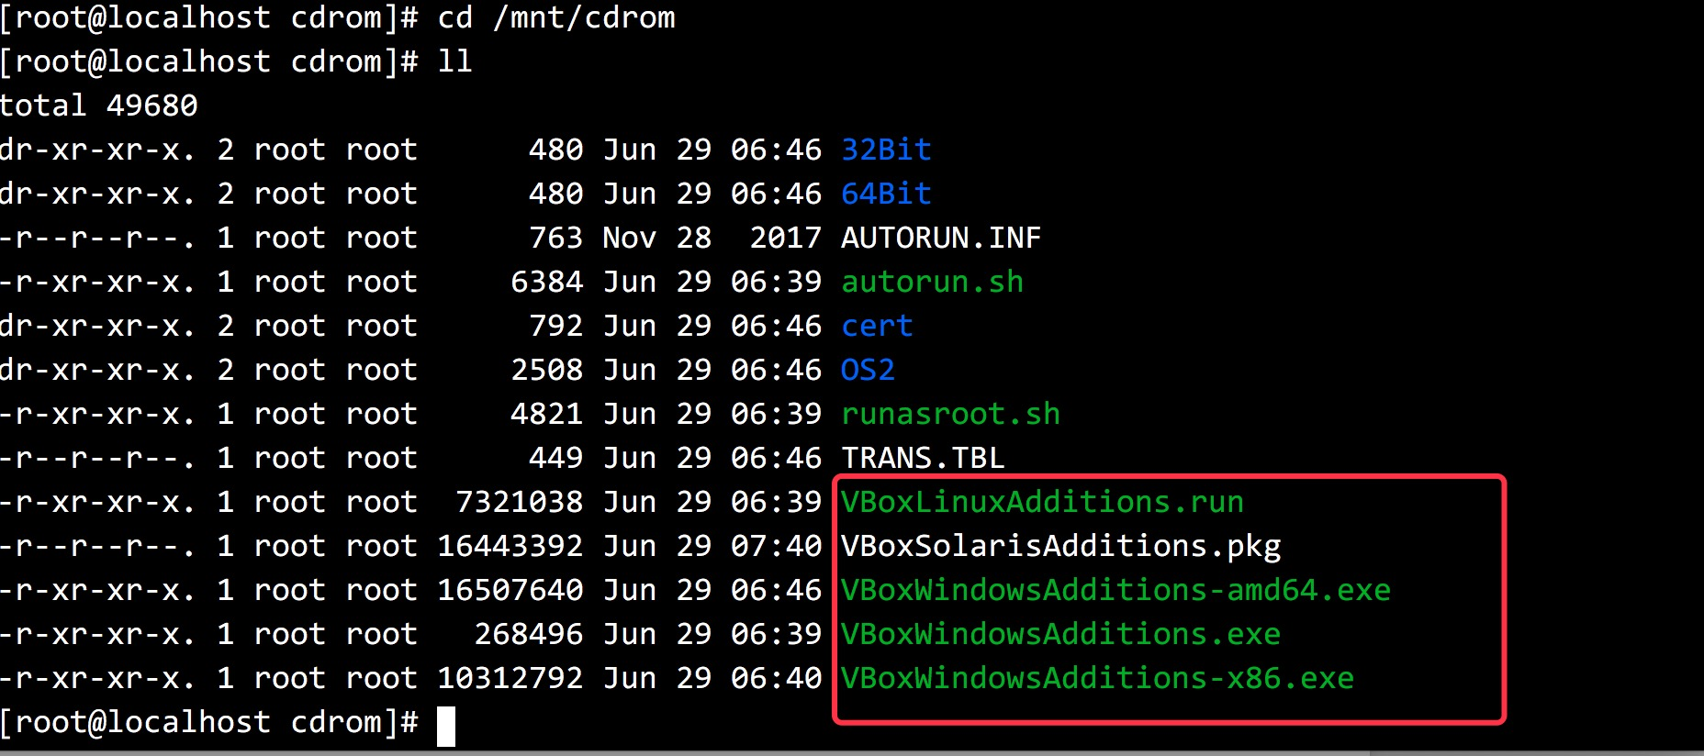

**3.cp -R /mnt/cdrom /usr/local/src/VBoxAdditions**

**4.yum install -y gcc gcc-devel gcc-c++ gcc-c++-devel make kernel kernel-devel bzip2**

**5./usr/local/src/VBoxAdditions/VBoxLinuxAdditions.run install**

**6.启用共享文件夹：**

**mkdir /home/www**

**mount -t vboxsf mooc /home/www**

**问题汇集**

如图错误

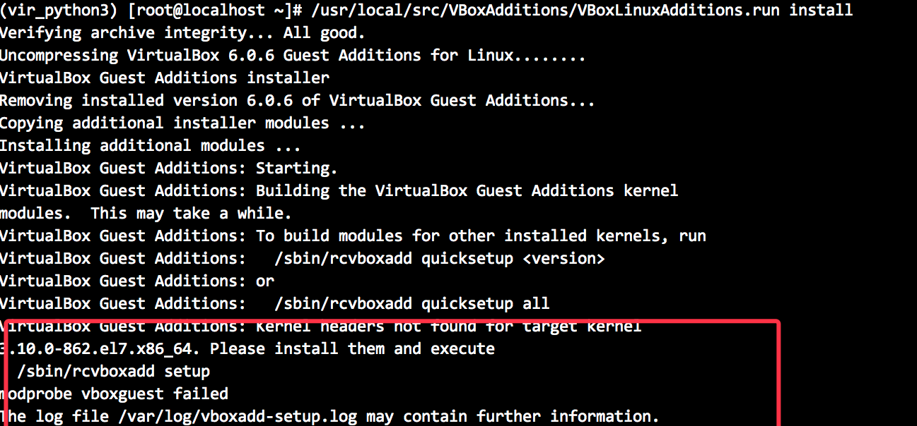

重启虚拟机看看是否就可以了

**参考文章**

[**https://blog.csdn.net/MingL_Wang/article/details/45156019**](https://blog.csdn.net/MingL_Wang/article/details/45156019)

