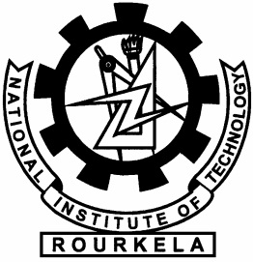**Fourier Transform Demo – ABOUT**

**Fourier Transform Demo is a program for demonstrating the frequency domain representation on any time domain signal, and vice versa. The sole purpose of developing such a program was to increase the understanding of frequency domain representations of time-domain signals among students. Since, understanding of Fourier transform is fundamental to some fields of Engineering, an effort for enhancement of such understanding of such knowledge through this program. See “copyright.txt” for Copyright message.**

**Developed By:**

**Subhajit Sahu**