Etham Eatery POS — Station Setup
Waiter tablets, kitchen screens and the till, each seeing only its own work
September 2026
Table of Contents

What this achieves
One POS, three different screens. Each device signs in once and shows only what that job needs:
Station | Sees | Cannot see or do
Waiter tablet | tables and seats, seat a guest, take orders, send to kitchen | Kitchen/Bar boards, the money button, opening or closing the day, releasing a table
Kitchen / Bar screen | its own board of incoming tickets | tables, seating, money, the day
Cashier till | everything — tables, boards, and the money | editing the menu
Admin (you) | everything | —
This is enforced by the server, not by hiding buttons. A waiter who reaches the payment call anyway is refused, and the attempt is recorded against their session. Hiding the controls simply keeps the screen honest and uncluttered.

The two identity layers
Devices log in. People don’t.
- Each device signs into the site once with its station account and stays signed in — a waiter tablet as waiter@, the kitchen screen as kitchen@, the till as cashier@.
- Waiters identify by PIN on the shared tablet: floor → Waiter → name → 4-digit PIN, once per shift. That PIN is what stamps their name on parties, orders and the sales report.
Kitchen and cashier need no PIN — the station login is the identity.

1. Set up a waiter tablet (or desktop)
- Open frappe.ikobriq.com/login on the device.
- Sign in as waiter@etham.co.ke. Tick Remember me so it stays signed in.
- Go to frappe.ikobriq.com/app/restaurant-manage.
- Bookmark that page, or “Add to Home screen” on a tablet so it opens like an app.
- Confirm the screen shows: tables only, and just three buttons — Seat guest · Waiter · Door. No Kitchen or Bar tiles, no day buttons.
Every waiter then taps Waiter → their name → PIN at the start of their shift.

2. Set up a kitchen or bar screen
- Sign the screen in as kitchen@etham.co.ke.
- Go to /app/restaurant-manage and bookmark it.
- The floor shows only Kitchen and Bar — no tables, no toolbar buttons.
- Tap Kitchen (or Bar) to open that board full-screen. Leave it there.
Tickets appear as waiters fire orders. Tapping an item walks it Sent → Preparing → Ready → Served. Use one screen per station: the kitchen screen on Kitchen, the bar screen on Bar.

3. Set up the cashier till
- Sign in as cashier@etham.co.ke.
- Go to /app/restaurant-manage and bookmark it.
- The till sees everything: all tables and the Kitchen/Bar boards, plus the day button (Open day / Close day) and Release a table under the ⋯ menu.
The cashier’s daily rhythm: Open day with the counted float before service → settle checks through the day → Close day at the end.

4. Add another device or change a password
Another tablet of the same kind: just sign in with the same station account. Any number of devices can share one station login.
A new kind of station: search User → Add, then under Roles copy the roles from the station account that matches the job. The roles that matter:
Role | Grants
Restaurant User + Restaurant Manager | see and work the floor
Waiter Station | hide the Kitchen/Bar boards
Kitchen Station | hide the tables and the front-of-house buttons
Accounts User | take payments
Sales Manager | open and close the day, release tables
Give a waiter tablet the first two plus Waiter Station. Give a kitchen screen the first two plus Kitchen Station. Give a till everything except the station roles.
Passwords: avatar (bottom-left) → My Settings → Reset Password. Change all three station passwords on first use.

5. Confirming it worked
On each device, check the toolbar — it is the quickest tell:
Station | Toolbar should read
Waiter | Seat guest · Waiter · Door
Kitchen | (no buttons — just the two boards)
Cashier | Seat guest · Waiter · Door · Open day/Close day · ⋯
And on a waiter tablet, open a table with a party on it: the pad shows the menu and the check, but no Complete button — payment is the till’s job.

6. Proof from the live system
These are real screenshots of frappe.ikobriq.com, one per station, taken with a party of two seated on Table 2.
Waiter tablet — five tables, SH·2 badge and 2/10 seats on Table 2, and only three buttons. No Kitchen, no Bar, no money.
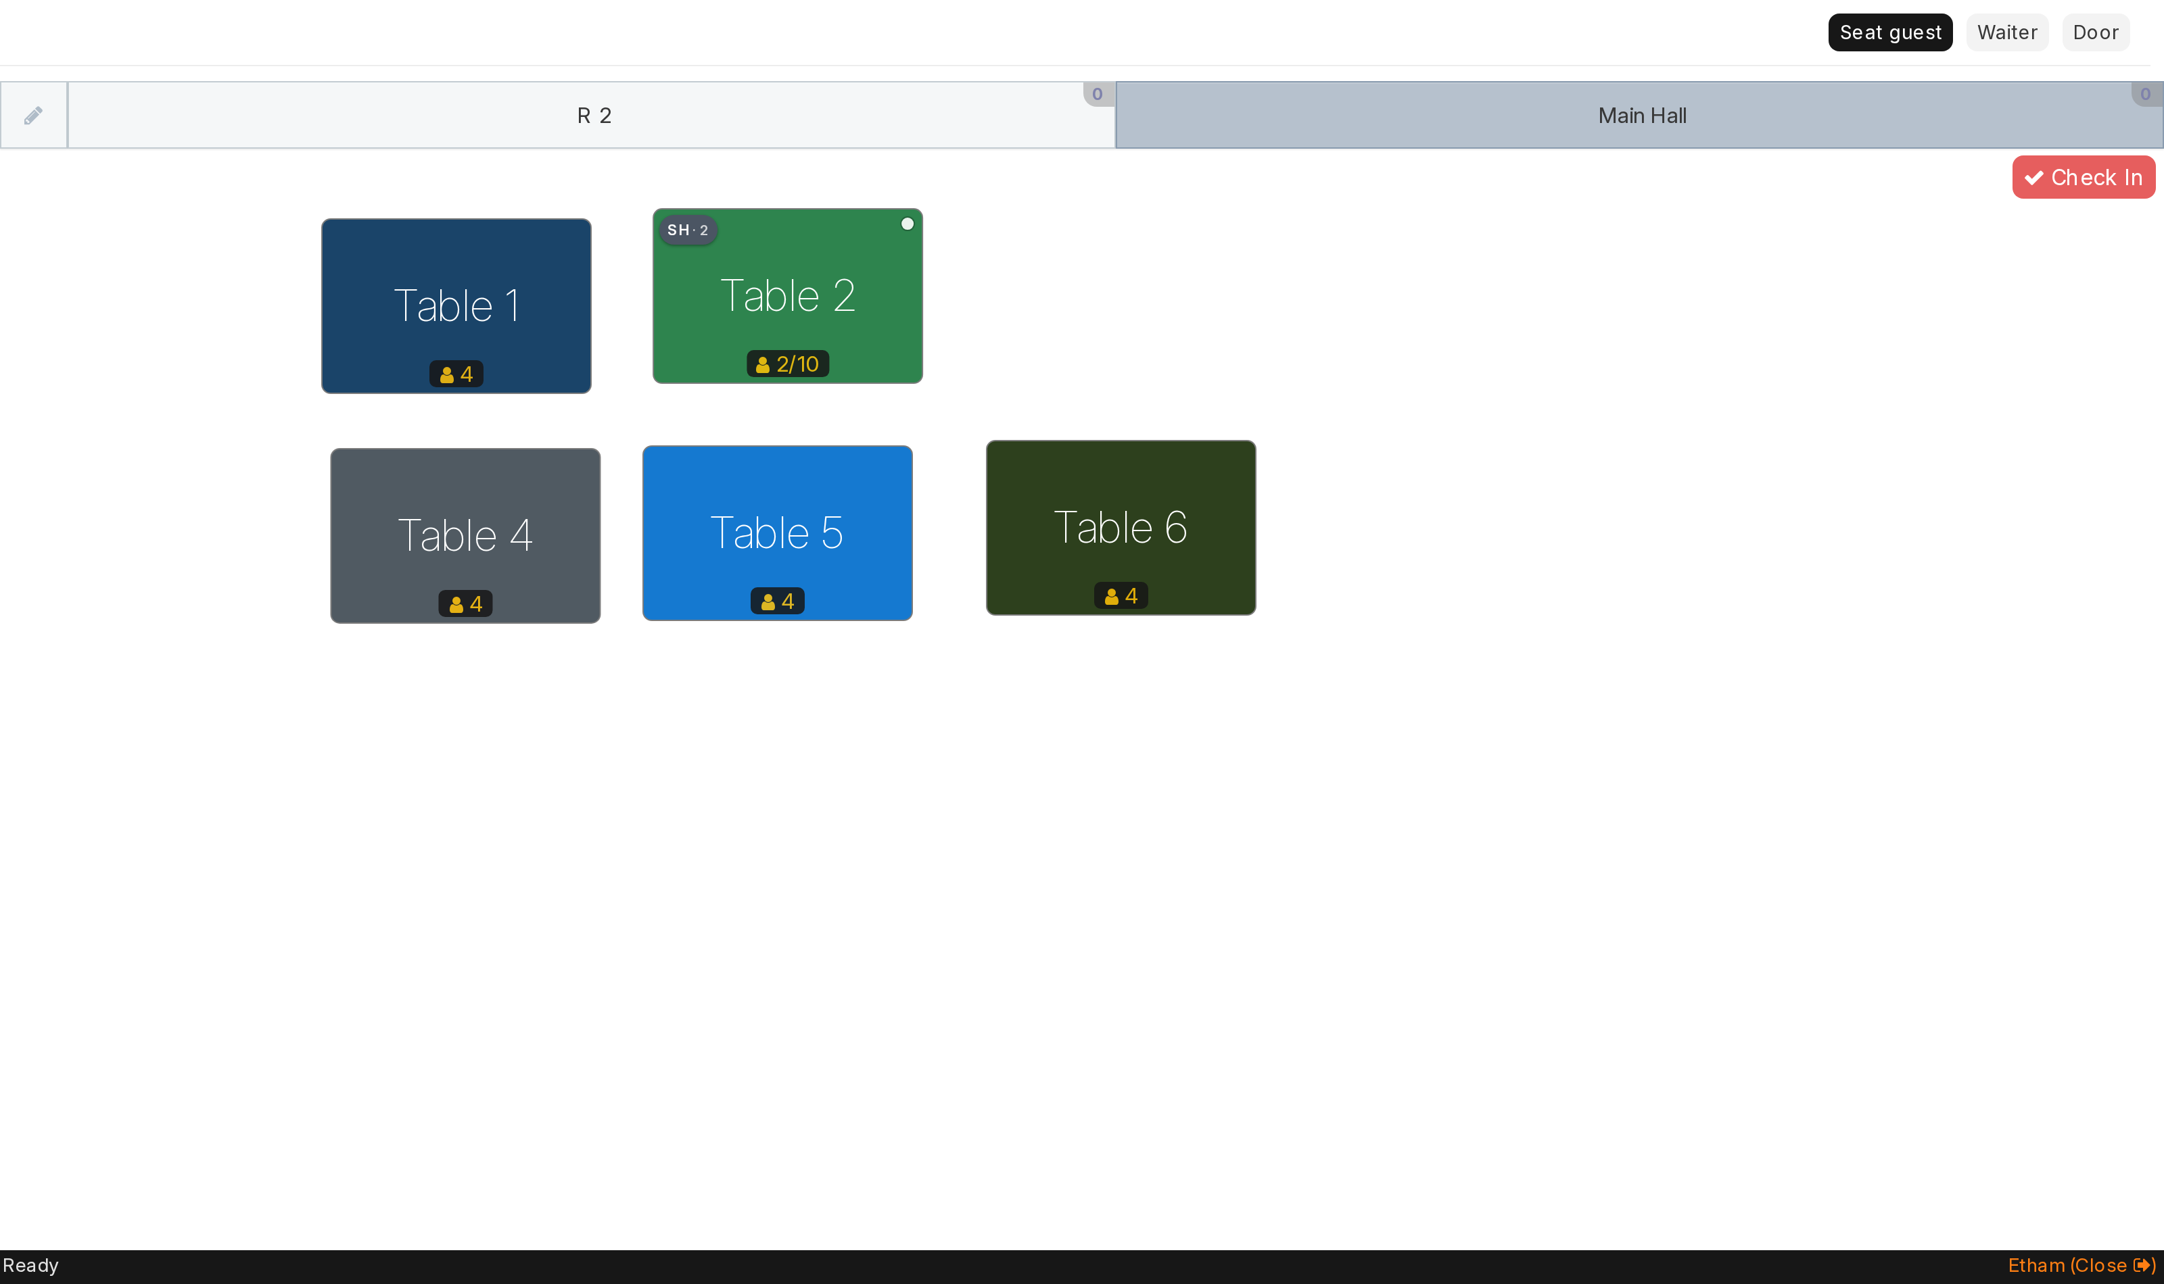
Waiter station
Kitchen screen — Kitchen and Bar only. No tables, no buttons at all.
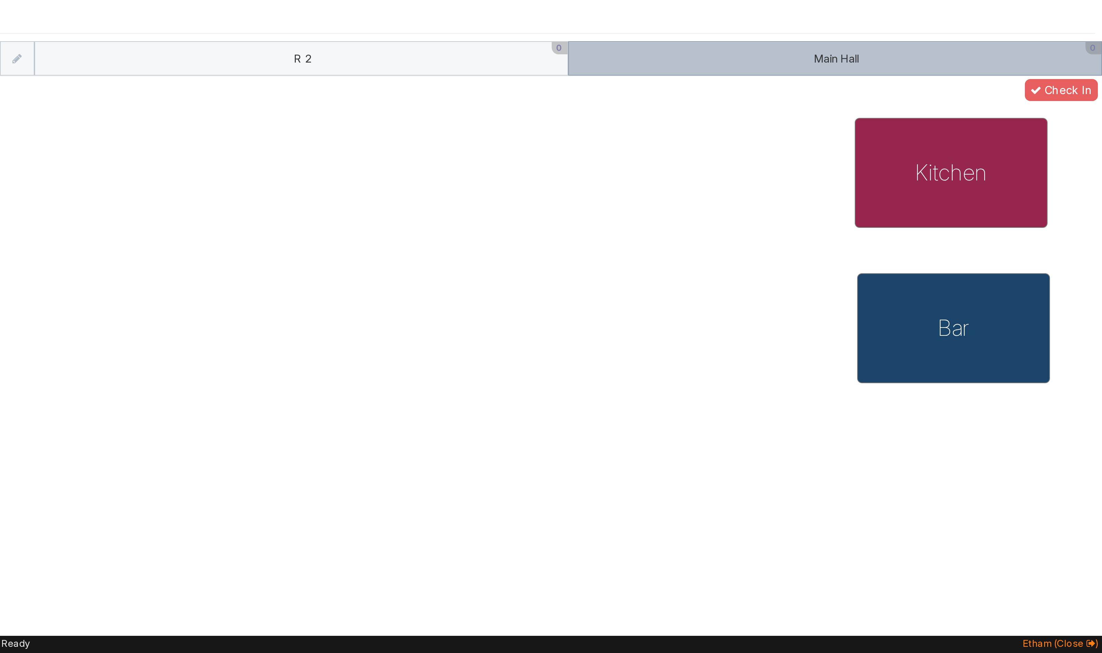
Kitchen station
Cashier till — the same five tables plus Kitchen and Bar, the table to be billed showing 2/10, and Close day on the toolbar with Release a table under ⋯.
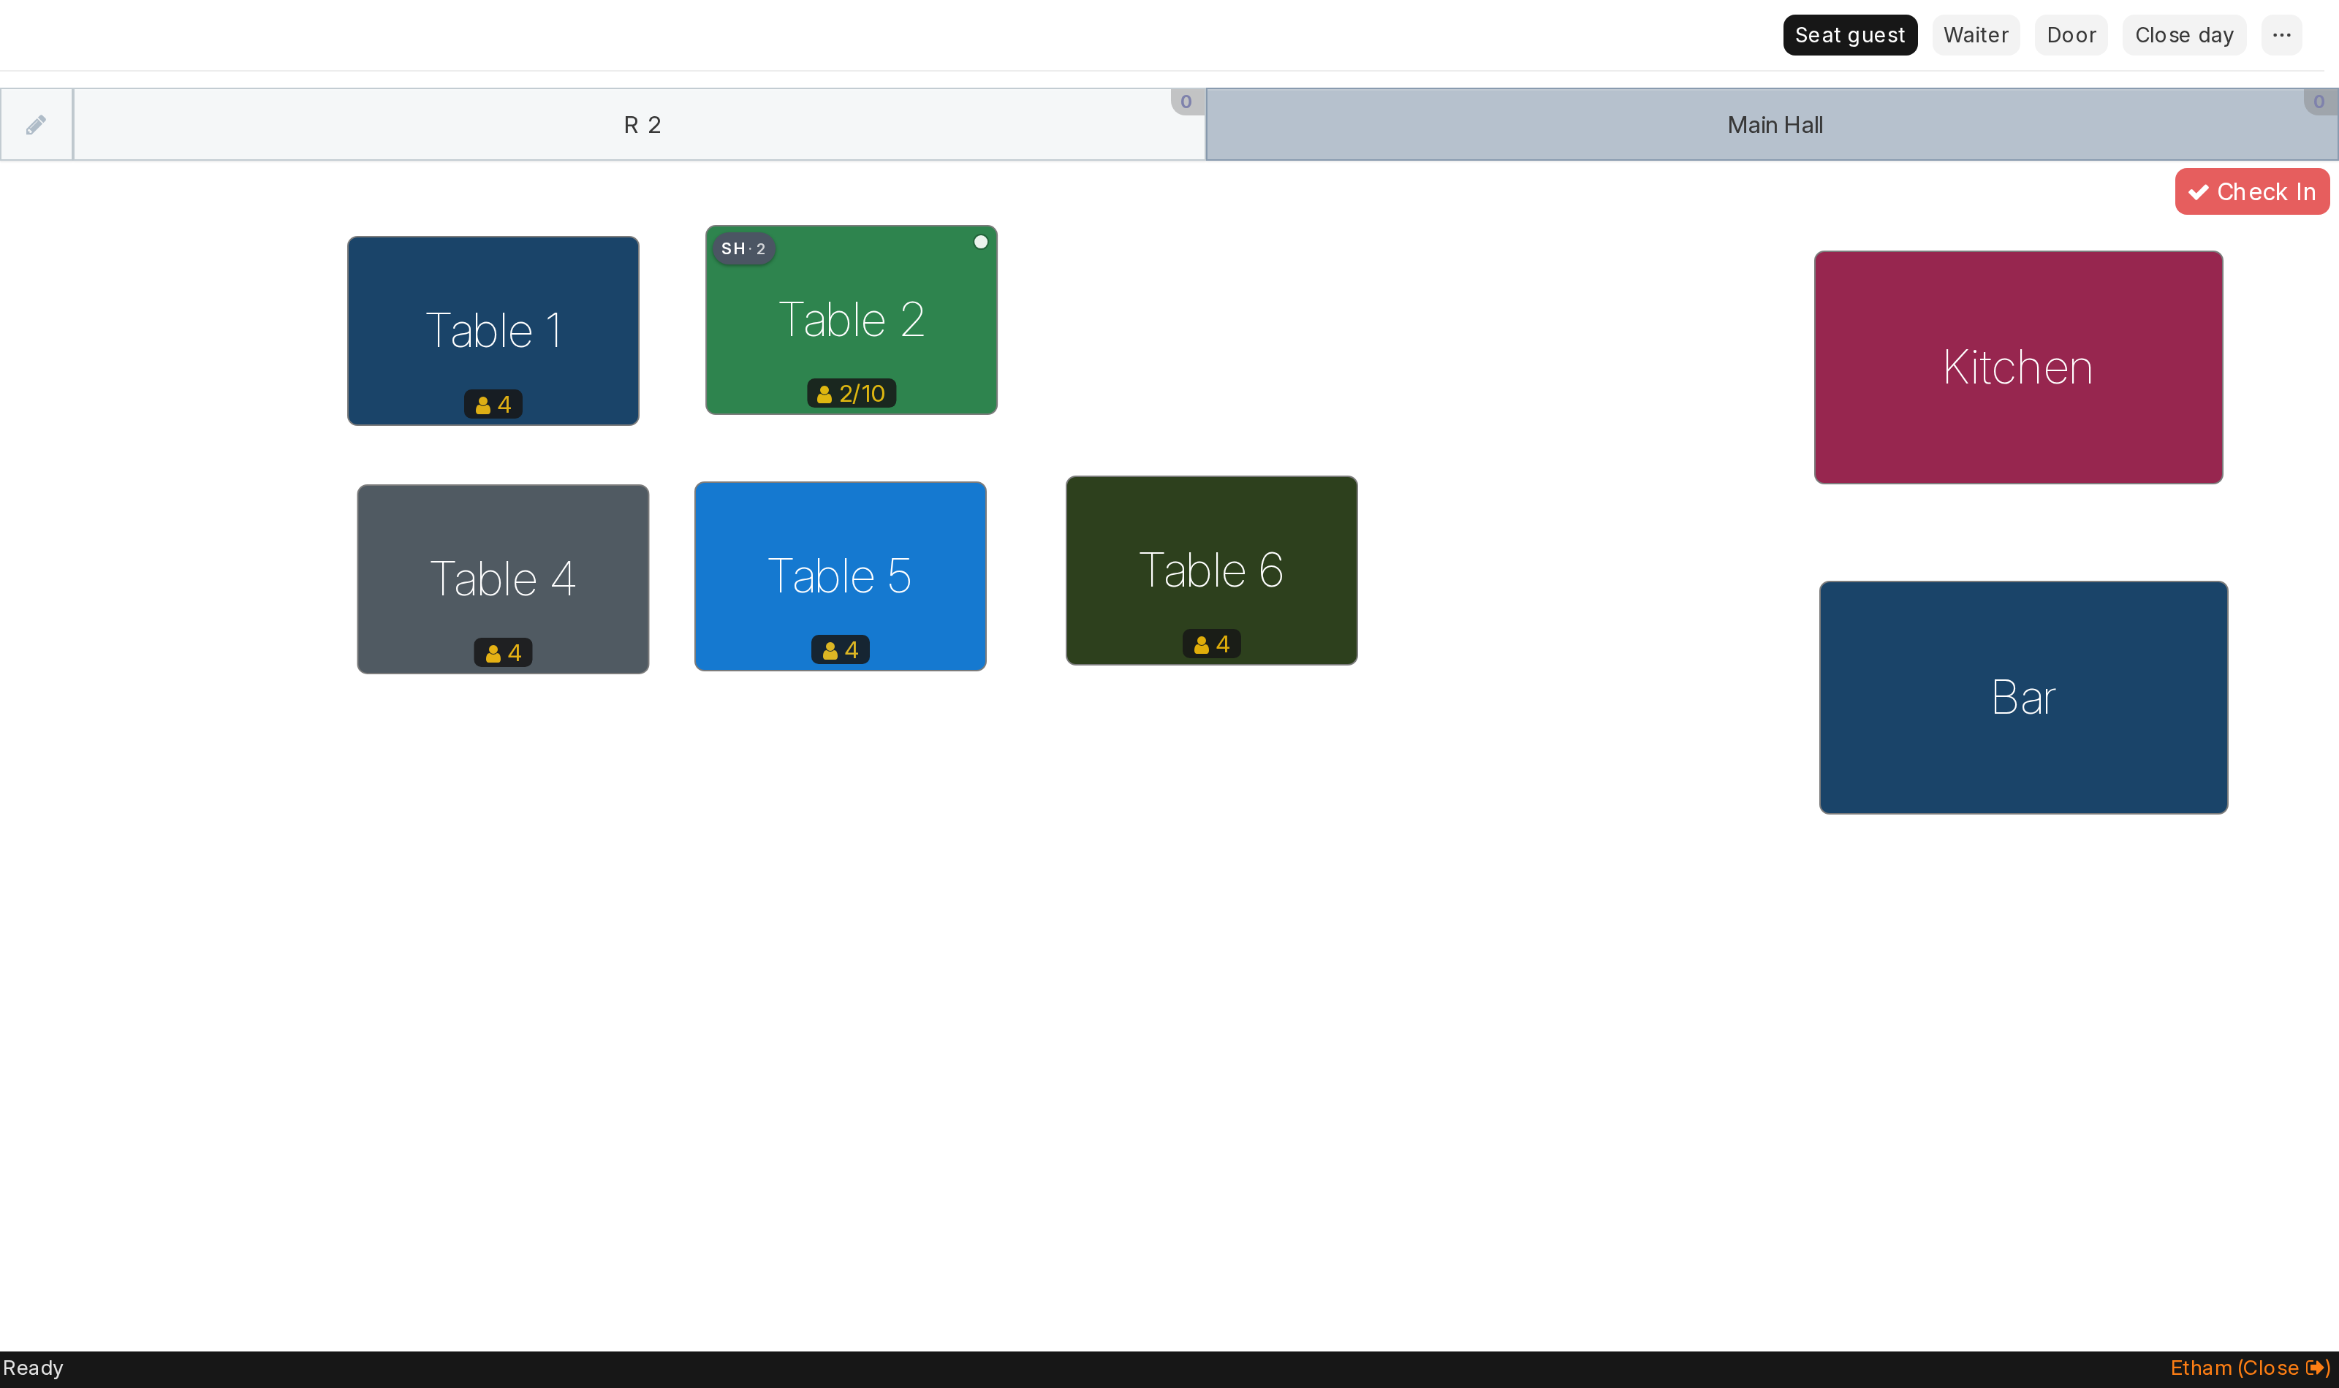
Cashier station

7. If a screen looks wrong
Symptom | Fix
Waiter tablet shows Kitchen/Bar tiles | The account is missing the Waiter Station role — add it (section 4).
Kitchen screen shows tables | Missing the Kitchen Station role.
Cashier has no day button | Missing Sales Manager.
“Wrong PIN” | The stored PIN differs from what was typed. Open Restaurant Waiter, tap the eye icon on the PIN field to see it before saving.
Buttons hidden under a ⋯ menu | Normal on a narrow window — widen it, or use the menu.
Blank floor after an update | Reload the page once; the browser is holding an old copy.

