Folder structure –
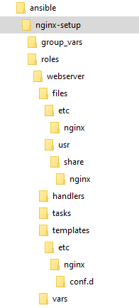
this setups nginx server on Linux red hat 8 and allows to add & configure static web applications, new web applications can be easily added with minimal effort, i.e., just adding few configurations at group_vars/webservers.yml would deploy a new web application on the nginx server.
Justification: I selected this approach to minimize manual interventions and make the process automated as much as possible to add any newer web application in the feature.

Run ansible-playbook -i inventory.ini site.yml from the root directory nginx-setup/. it will execute the tasks, using a Standard Ansible role setup and directory layout.

