Human malignancies show increased occupancy of a shared region of normal-cell regulatory space
Theodor Spiro
Vaika Inc., East Aurora, NY, USA
Correspondence: tspiro@vaika.org · ORCID 0009-0004-5382-9346
Short title (running head): Malignancy raises occupancy of a normal cell state
Significance Statement. Using 44 regulatory modules scored in single-cell RNA data, we built a map of normal human cell states from normal cells alone — no cancer enters its construction — and projected individual cancer cells onto it. Within patients, malignant epithelium occupies one particular region of that map far more often than the same patient’s own matched normal epithelium: in colorectal cancer a median 19% against 5%, higher in 43 of 46 patients, and the difference survives removing overall transcriptional output. The same region is occupied by cancers of twenty-five lineages. Which normal cell lies nearest it is less certain: under our catalog it is the placental cytotrophoblast, whose physiology natively accommodates invasion and proliferation, but independently reconstructed catalogs reproduce the region while naming a different cell inside it. Malignancy therefore raises occupancy of a pre-existing normal physiological state rather than creating a cancer-specific one. Whether that state is specifically trophoblast-like, and whether cancers thereby reactivate an embryonic program, remain open questions we treat as such.

Abstract
We compared cellular regulatory states using 44 transcriptional modules representing major signaling and stress-response pathways. Their activities across 154 normal human cell types, from single-cell RNA-sequencing data alone, were decomposed by principal component analysis into a nine-dimensional reference space constructed without reference to any cancer. In matched samples, malignant epithelium occupied one region of this space far more often than the patient’s own normal epithelium: in colorectal cancer a median 19% against 5%, higher in 43 of 46 patients (paired P = 9 × 10⁻¹³), +10.5 points with transcriptional magnitude removed (44 of 46), holding against the crypt-base progenitors these tumors arise from, and reproduced in every tissue tested except prostate; pooled across four paired datasets a mixed-effects model credits the dataset clustering and estimates +13.0 percentage points (P = 1.9 × 10⁻¹²). Malignant cells from 25 cancer datasets spanning diverse lineages occupy the same region, at a mean pairwise distance of 0.16 against 0.99 among their normal tissues of origin — but most of that contraction is shared transcriptional output and matched averaging rather than lineage-independent convergence, and the magnitude-removed residue is smaller and sensitive to specification. Ranking normal cell types by cross-cancer recurrence and depth put the placental cytotrophoblast nearest the region, while independent reconstructions of the catalog from the same criteria reproduce the region and name a different cell in it, so the region is robust and the identity of the nearest cell is conditional on this catalog. Malignancy thus raises occupancy of a pre-existing normal physiological state that accommodates key malignant phenotypes, rather than producing a wholly cancer-specific identity.

Introduction
A mammalian organism comprises cells occupying numerous epigenetically determined differentiation states, each characterized by a distinct transcriptional phenotype. Cancers arising in different tissues retain many epigenetic and phenotypic features of their cells and tissues of origin. At the same time, malignancy imposes a set of broadly shared functional requirements, including sustained proliferation, invasion and motility, resistance to hypoxic and proteotoxic stresses, immune evasion, and metabolic reprogramming (Hanahan & Weinberg, 2000, 2011; Hanahan, 2022). None of these properties is intrinsically cancer-specific: each is physiologically deployed by particular normal cell types under particular conditions. This raises a fundamental question: to what extent is the state of a malignant cell determined by its tissue-specific ancestry, and to what extent does malignant transformation drive cells of different origins toward a common epigenetic and functional state?
Single-cell transcriptomics provides a direct readout of the transcriptional manifestations of cellular epigenetic states and, in principle, makes this question experimentally accessible. Direct comparison of whole transcriptomes, however, is poorly suited to identifying convergence at the level of regulatory state. Transcriptomes are dominated by lineage-specific gene expression, technical variation, and differences in transcriptional complexity, whereas functionally related states may arise through coordinated changes in multiple regulatory pathways without requiring global transcriptomic similarity. A biologically interpretable comparison therefore requires reducing transcriptomes from thousands of individual genes to a common set of functional regulatory programs whose activities can be compared across otherwise unrelated cell types.
To accomplish this, we developed a program-based coordinate system of cellular state. Rather than allowing cancer datasets themselves to define the dimensions of comparison, we first constructed a cancer-independent reference from normal human cells. We selected 44 transcriptional modules representing major cellular signaling and stress-response mechanisms, each defined mechanistically around a regulatory circuit comprising a signal-sensing component, transcription-factor output and targets, cyclical negative feedback, and receptor-field specificity. Module activities were inferred from single-cell RNA-sequencing data for 154 normal human cell types and used to construct a low-dimensional eigenspace representing the major axes along which normal cellular regulatory states vary. Once established, this reference coordinate system remains fixed: individual cells from independent datasets can be projected into it without retraining, permitting their regulatory states to be compared with one another and with the spectrum of normal human cell states.
This strategy differs conceptually from conventional transcriptome clustering or dimensional reduction performed jointly on normal and malignant cells. Cancer contributes neither to selection of the regulatory dimensions nor to construction of the reference geometry. Consequently, any recurrent localization of independently generated cancers within that geometry constitutes an out-of-sample observation rather than a structure imposed by cancer-derived variation. It also makes the analysis directly falsifiable: preservation of tissue identity should leave cancers dispersed near their respective normal origins, whereas acquisition of a common regulatory state should cause independently arising malignancies to converge within the fixed normal-cell space. Prior work has projected tumors onto normal references organ by organ (Young et al., 2018; Kildisiute et al., 2021) and has catalogued recurrent malignant programs derived from cancer data themselves (Kinker et al., 2020; Barkley et al., 2022; Gavish et al., 2023); an influential alternative view holds that malignant states remain lineage-local, near each tumor’s own cell of origin (Patel & Yanai, 2024). We differ in resolving single malignant cells of twenty-five lineages onto a mechanistically interpretable, cancer-blind frame, and in naming a specific, differentiated, physiological normal cell rather than a pluripotent abstraction (Chen & He, 2016).
Applying this approach to single-cell transcriptomes from 25 cancers of diverse origins, and to paired tumour and normal epithelium from the same patients, separates three claims that are easily conflated and that we keep apart throughout: that malignant cells occupy one shared region of normal regulatory state more often than their matched normal counterparts, which the data support directly; that the normal cell lying nearest that region is the placental cytotrophoblast, which holds under our module catalog but not under independently reconstructed ones; and that cancers thereby reactivate an embryonic or trophoblast-like program, which remains a hypothesis and is treated as one. The convergent state is therefore not a cancer-created transcriptional state but a pre-existing physiological state represented among normal human cells, and the regulatory features that distinguish it within the normal-cell reference are reproduced during cancer convergence. These observations provide a quantitative framework in which the long-standing concept that malignancy involves reacquisition and modification of embryonic cellular programs (Abelev, 1971; Sharma & Ginhoux, 2022) becomes testable; we return to it in the Discussion as an interpretation, not as a result.

Results
Three claims of different strength run through what follows, and we keep them apart throughout. The first — that malignant cells occupy one shared region of normal regulatory state far more often than their own matched normal counterparts — is settled in §§2 and 5 by direct measurement, and is the claim this paper defends. The second — that the normal cell nearest that region is the placental cytotrophoblast — is established in §3 under this module catalog, and independently reconstructed catalogs reproduce the region while naming a different cell inside it. The third — that cancers thereby reactivate an embryonic or trophoblast-like program — is not a result but an interpretation, and it appears only in the Discussion.

A cancer-independent program space recovers normal cell-state biology
We define a cell’s state by 44 regulatory modules. A module is a self-contained regulatory unit specified by four operational criteria: a signal-sensing component; a transcription-factor output with documented target genes; a cyclical negative-feedback element; and receptor-field specificity. Approximately 75 candidate signaling and metabolic axes were screened against these criteria (KEGG, Reactome and the primary literature). A candidate was retained when it represented a biologically distinct regulatory input or response; when the direction of its response could be read from a defined transcriptional output rather than from the expression of a single pathway component; and when its sensor, downstream transcriptional regulator and target-gene response were characterized well enough to fix that direction. Candidates lacking a defined transcriptional output, substantially duplicating a module already retained, or acting primarily post-transcriptionally were dropped. This yielded 44 modules (Tables S9, S9b), fixed before any cancer data were examined and chosen for interpretability and transcriptional observability — not for the ability to discriminate cancers or particular normal cell types. The panel spans growth-factor and developmental signaling, inflammatory and innate-immune signaling, cell-cycle control, nutrient and energy sensing, lipid and sterol metabolism, hypoxic and oxidative stress, proteotoxic stress and the unfolded-protein responses, DNA-integrity responses, nuclear-receptor endocrine signaling, and autophagic and other homeostatic programs.
Three properties of the panel itself can be checked on normal cells alone. First, the selection produces genuine units: across the 154 normal cell types the genes of a module co-vary far more than size-matched random gene sets (median within-module coherence +0.154 versus +0.014; P = 3 × 10⁻¹⁵) and more than the modules of any established pathway collection scored identically — KEGG +0.062, Reactome +0.058, Hallmark +0.070, PROGENy +0.051 — despite carrying twenty- to thirty-fold fewer genes each (SI). Second, the transcriptional-output requirement is what makes a module readable: the induced arm of a module — its feedback element and transcription-factor targets — varies across normal cell types substantially more than its structural arm of sensors and cascade components (median SD 0.287 versus 0.222; P = 3 × 10⁻⁵), which is why pathways read out through induced targets rather than through the abundance of their receptors or kinases. Third, the catalog’s size is adequate rather than arbitrary: random subsets of the 44 recover the normal-cell geometry progressively and reach 95% of the full panel’s biological-family recovery, and 95% of its cell-to-cell geometry, only at 35 modules, with both still improving at 44 (SI).
We state the limits of the selection as plainly as its basis. The negative-feedback criterion was the organizing idea of the panel — motivated by the recurrent observation that induced negative regulators behave as brakes whose loss releases the pathway (Amit et al., 2007; Lito et al., 2013; Chandarlapaty, 2012) — rather than an independently validated selector. A canonical feedback element can be named for 38 of the 44 modules and not for six; each is listed, with its gene and its status, in Table S9b, and two attempts to validate the criterion independently are reported in Note S-N. Nor is an individual module a classifier of cell identity: one five-gene module separates biological families no better than five random expressed genes (η² 0.33 versus 0.33). What the panel supplies is a set of coherent, individually interpretable axes; the biology emerges from the space they span, not from any module alone. Scoring, the 154 × 44 matrix and its decomposition into the nine-dimensional reference space are specified in Methods (Fig. 1A). The frame differs from label-transfer annotation (Aran et al., 2019) and from open-loop pathway or regulon scoring (Schubert et al., 2018; Aibar et al., 2017; Lotfollahi et al., 2023) in being a fixed, linear, biology-defined frame built once from normal cells and never refit.
Before any disease data are introduced, the map is biologically meaningful, in three independent ways (Fig. 1B). Its axes are individually interpretable: the first component (29% of variance) runs from inflammatory cells to terminal germline cells, the second (14%) from quiescent to proliferative cells, the third from signaling-dominated immune cells to metabolic epithelia — and an external quality signature scored without reference to the modules orders each axis monotonically (immune signalling on PC1, Spearman ρ = −0.89; translational output on PC2, +0.75). An independent biological-family label explains a large fraction of where cells fall on every axis (η² = 0.31–0.70, each against its own label-permutation null and each above all 2,000 draws of it — P < 5 × 10⁻⁴, the floor 2,000 draws can reach; Figs. S1-II and S3). The modules are also not restating one another: of the 946 module pairs only six exceed |r| > 0.7 across the normal cell types, and two of those share a gene by construction (Fig. S2). Its global layout is biological: families form coherent territories, and a cell’s nearest neighbour in the full space shares its biological family 62% of the time (95% CI 55–70%) versus 14% under a family-size-preserving label permutation (P = 1 × 10⁻⁴, the floor of 10,000 draws). This last statistic shows that the space is organized, but it does not distinguish this panel from others: size- and expression-matched random gene panels put through the identical pipeline reach ~61%, and a generic highly-variable-gene decomposition reaches 68–71% (SI). The evidence that the panel is the right frame is its interpretability and coherence, not this concordance figure. Constructed from normal cells and not one cancer cell, the map already recovers structure it was never told — the fact on which everything below rests.
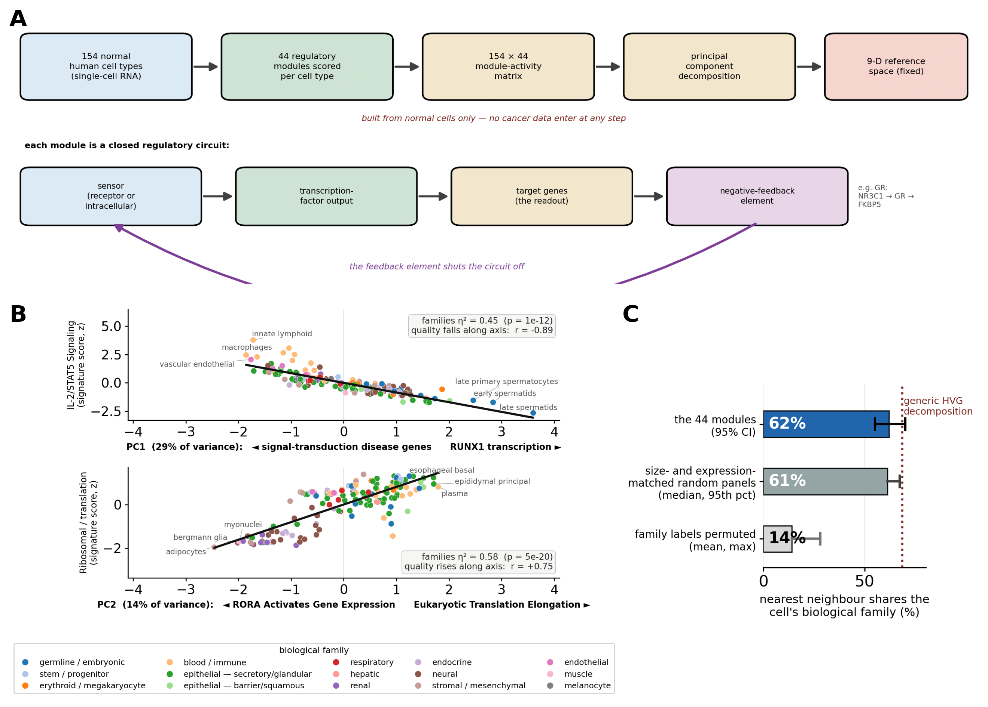
Fig. 1. A cancer-independent coordinate system of cellular state, and what it recovers before any disease data are introduced. (A) The analytical workflow: 44 regulatory modules are scored across the 154 normal human cell types of the Human Protein Atlas, and the resulting 154 x 44 activity matrix is decomposed into a nine-dimensional reference space that is then held fixed. Below, the anatomy of one module: a sensor, a transcription-factor output, its target genes, and the negative-feedback element induced by the module’s own activity. No cancer data enter any step. (B) The three leading axes are individually interpretable. Each of the 154 normal cell types is placed on one principal axis (x) against an external quality signature scored from gene-level HPA data without using the modules (y); the axis is monotonically ordered by that independent signature (Spearman r = -0.89, +0.75, +0.50 for PC1-PC3), and biological families, an annotation not used to build the space, separate along each axis (eta^2 = 0.45, 0.58, 0.70). (C) Global layout: a cell’s nearest neighbour in the full nine-dimensional space shares its biological family 62% of the time (95% CI 55-70%), against 14% when family labels are permuted. The comparison that matters for the panel, however, is the one in grey: size- and expression-matched random gene panels put through the identical pipeline reach 61%, and a generic highly-variable-gene decomposition reaches 68%. The space is organized, but this statistic does not by itself distinguish these modules from other panels of comparable size; the evidence for the panel is its coherence and interpretability (Note S-N).

Diverse cancers converge onto one region of normal-cell state space
We then project into this frame the malignant single cells of twenty-five quality-controlled cancers (Fig. 2). They span essentially every lineage — epithelial, hematopoietic, glial, neural-crest, two independent mesenchymal sarcomas, two independent germ-cell tumors, and neuroendocrine — and their normal cells of origin are, accordingly, near-orthogonal in the eigenspace (mean pairwise cosine distance 0.99; cosine distance runs from 0 to 2, so 0.99 is the value expected for orthogonal states, and three of the 300 origin pairs share an assigned origin by construction and contribute exactly 0). Their malignant compartments are not: they cluster to a mean pairwise distance of ~0.16, against ~0.99 among their near-orthogonal origins. This raw contraction is largely a matched-averaging and shared-magnitude effect, and we are explicit about it: twenty-five equal-sized aggregates of unrelated normal cells, formed by the same averaging, cluster nearly as tightly (a matched-averaging null of coherent normal micro-populations reaches ~0.13), and the malignant clustering does not tighten as more cells are averaged — it is flat from 25 to 4,000 cells per cancer (SI), so it is a stable biological quantity, not the shrinkage of large means. What is not an averaging artifact is the module shape: with the overall-magnitude component removed, the malignant states cluster more tightly than the same matched-averaging null — a real, if modest, convergence in regulatory pattern beyond shared output (Fig. 2). Its size depends on how magnitude-removed scores are rescaled; we report all three specifications we ran rather than the most favourable, and two of the three — including the simplest, unrescaled one — put the malignant centroids tighter than the null (Note S-K). This is the size of the effect: unrelated cancers do occupy a common region, but the headline is a shared high-output state, with a smaller specific-shape residue on top. The convergence does not depend on which normal cell we call each cancer’s origin — the origin labels are coarse and used only to annotate lineage (Table S8) — and the four added-lineage cohorts whose malignant cells are marker-labeled rather than author-annotated (both sarcomas, both germ-cell tumors) — where marker selection (POU5F1/SALL4 in the germ-cell tumors) risks picking the very stem/high-output cells that then converge — can be dropped with the result essentially unchanged (SI), and is present in 24 of 25 cancers.
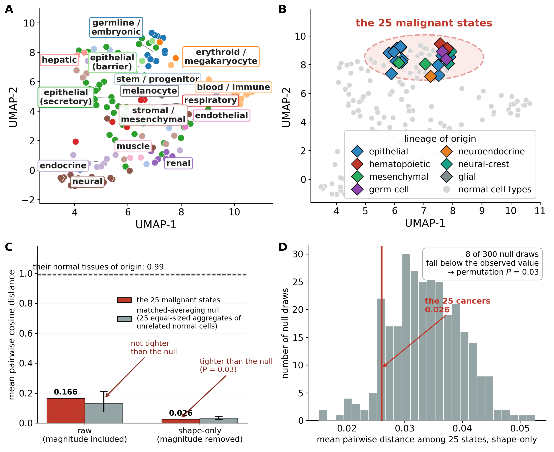
Fig. 2. Malignant cells of twenty-five lineages converge onto one region of the normal-cell space. (A) The 154 normal cell types in the fixed nine-dimensional reference space (UMAP), coloured by biological family. (B) The same map with the 25 malignant states projected into it (diamonds, coloured by lineage of origin; normal cell types in grey). Their normal tissues of origin are spread across the whole map, while the malignant states fall into the one outlined region; the median pairwise separation on the map is 4.1 among normal cell types against 1.5 among the malignant states — illustrative only, since UMAP inter-point distances are not metrically meaningful; the quantitative claim is the nine-dimensional comparison in (C). (C) The same contraction measured in the full nine dimensions, against the null that matters: 25 equal-sized aggregates of unrelated normal cells formed by the same averaging. With magnitude included the malignant states are NOT tighter than that null (0.166 against 0.129), so most of the raw contraction is shared transcriptional output and the averaging itself. With the overall-magnitude component removed, the residual convergence in module pattern is real (0.026 against 0.034). Their normal tissues of origin sit at 0.99, the value expected for orthogonal states. (D) The shape-only comparison as a distribution: the observed malignant value falls below 292 of 300 matched-averaging draws, a permutation P = (8+1)/(300+1) = 0.03. Specification sensitivity of this test is reported in Note S-G and Fig. S10.
This resolves the fork toward convergence rather than lineage-locality, and it does so by a static geometric test — a convergent endpoint across origins, not a measured trajectory. We say convergence, not convergent evolution: the data are snapshots and assert no gradual path between origin and endpoint (the transition may well be abrupt; Discussion). A per-cancer breakdown of which lineages converge most is in the per-cell-type convergence heatmap (Fig. S4-III) and the full recurrence ranking (Fig. S6-II).

Where the convergence lands: a reproducible neighbourhood, and the cell nearest it under this catalog
Where the cancers land, and whether their target survives scrutiny, are separate questions (Fig. 3). To name the target without circularity we rank all 154 normal cell types not by proximity to any pre-chosen point but by cross-cancer recurrence — the number of cancers in which a cell is among the five most frequent nearest neighbours — and, orthogonally, by depth (the median per-cancer fraction of cells reaching it; the mean is reported alongside it in Table S2, and on the mean it is the cytotrophoblast that the third-ranked candidate is not separated from — 13.5%, 11.0% and 10.4% for the megakaryocyte, the cytotrophoblast and the gastric progenitor). Both rankings are led, by a clear margin, by two cells: the cytotrophoblast (a top target in 18 of 25 cancers) and the megakaryocyte (18 of 25), with no clean third. The two are separated by a transcriptome-complexity control (Fig. 3D): as detected-gene count rises, cytotrophoblast assignment rises while megakaryocyte assignment falls, tracking the nucleus-less erythrocyte we quarantine as a low-complexity artifact. Under this catalog, therefore, the cytotrophoblast is the cell nearest the region — the highest-depth, complexity-robust target, and the one normal cell that natively invades tissue, proliferates and evades immunity — and the megakaryocyte is carried no further than a secondary target. We state this as a property of the ranking under our catalog, not as an identification of the state: three independently reconstructed catalogs reproduce the region and name a different cell inside it (below); within our own catalog the same fragility is visible gene by gene, four single genes — EIF4EBP1, FKBP5, SLC2A1 and CD36 — each displacing the cytotrophoblast from the top two when removed alone (Note S-O-iv); re-scoring the same modules by regulatory output rather than component abundance keeps the convergence and moves the target to another cell (Note S-T); and nothing in §§5–7 depends on the name. It is not set aside for being blood-specific — it draws a comparable share of convergence in several solid cancers (germ-cell 29%, renal 19%, breast 14%) as in the hematopoietic ones — but because it fails the complexity control, falling with detected-gene count exactly as the quarantined erythrocyte does (Fig. 3D, Fig. S5-II). Those three properties describe the normal cell, and only the first two appear to be inherited: malignant cells in the state carry the invasion program (MMP2, MMP9, ITGA5) but show no detectable relation between depth in the state and immune infiltration — which is what the coordinate itself predicts, since Type I interferon is the one target-defining module cancer does not reproduce (below; SI). Convergence onto the anchor alone captures 11.1% of malignant cells, 16.9-fold over the 0.66% expected for a single cell type. We lead with this rather than with the two-cell core, whose 23.9% (18.2-fold over 1.3%) is about half contributed by the megakaryocyte that the complexity control in Fig. 3D rejects. The enrichment persists as the region is widened (15.9-fold for the four most recurrent cell types, 8.4-fold for the fourteen; Fig. 3F, Table 1), and survives applying the complexity control to every member rather than only to the two leading ones: six of the fourteen fall with transcriptome complexity as the quarantined erythrocyte does, but dropping them leaves the enrichment essentially unchanged, because the chance baseline falls with the membership (Note S-Q); the convergent cells form a genuine neighbourhood (mutual cosine 0.77 versus −0.01 for random pairs).
boundary | k | occupancy (%) | chance (%) | fold | members
core (top-2) | 2 | 23.9 | 1.32 | 18.2 | cytotrophoblasts; megakaryocytes
neighbourhood (top-4) | 4 | 41.9 | 2.63 | 15.9 | cytotrophoblasts; megakaryocytes; gastric progenitor cells; late spermatids
broader region (top-14) | 14 | 76.9 | 9.21 | 8.4 | cytotrophoblasts; megakaryocytes; gastric progenitor cells; late spermatids; gastric chief cells; esophageal apical cells; hofbauer cells; pancreatic acinar cells; migrating cytotrophoblasts; differentiating spermatogonia; epididymal clear cells; early primary spermatocytes; paneth cells; undifferentiated spermatogonia
The naming survives the obvious alternatives. It is not the geometric centre of the normal manifold, which any contracting process would reach: the true medoid — an alveolar type-1 pneumocyte — receives zero convergence (outside the top 70 of 154; many cells tie at the 0.04% floor, so the exact rank is tie-rule dependent), and the malignant attractor points away from the centre and onto the core. It is not the germline, which matches the core on the single most heavily weighted axis but diverges across the remaining eight, stable across 2,000 bootstraps (SI). And it is not a technical artifact: the one cell outranking the core on raw proximity, the erythrocyte, is a nucleus-less low-complexity artifact quarantined in quality control by the same control that clears the cytotrophoblast. One structural caveat belongs here rather than in a note. The trophoblast states in the reference come from a different dataset and platform (Vento-Tormo et al., 2018) than the remaining 154-type gallery, so a platform contribution to their position cannot be excluded; because those states also carry most of the within-patient signal in §5, this is a limitation of the paper and not only of §3, and we flag it as such (Note S-K, Discussion). Nor does the result depend on the exact module partition: dropping any five modules and rebuilding the whole pipeline leaves the convergence and the ranking essentially unchanged, and dropping each of the 25 cohorts in turn leaves the cytotrophoblast ranked first in eight panels and second in the remaining seventeen. Adding five decoy modules of random genes was pre-registered as the harsher test, and measured against the right comparator it is not harsher: in the reduced harness where a decoy module can be scored at all, the cytotrophoblast holds the top three in 42% of decoy draws against 48% when five real modules are dropped under the same metric and the same harness (Fisher P = 0.39), and the core fraction and its enrichment are marginally higher with the decoys present. The two percentages that look discrepant are two rankings and not two perturbations: by cosine to the malignant attractor, where the cytotrophoblast is first unperturbed, it stays in the top three in 84% of five-module drops; by cross-cancer recurrence, where it is third unperturbed, in 44% — which is what moving a third-ranked cell by a fifth of the catalog does. No decoy arm exists in the full 25-cohort pipeline, because a decoy module has to be scored gene by gene and only the reduced harness does that (Note S-O(iv)). What the partition control does not remove is the curated gene list itself: reshuffling the same 203 scored genes into random modules still yields 14% convergence against 6% for random genome-wide panels and 21% for the real modules. Above the random-genome floor that is about half the effect carried by the gene set rather than by how those genes are grouped, and the real-versus-reshuffled difference is not itself significant (z = +1.3); the gene set was assembled with cancer biology in view, and we treat that prior as unresolved rather than bounded. The gene-level reproduction and the module-drop control bound that residual prior; they do not erase it. How far does the naming depend on this particular catalog? We tested that directly, by asking three independent curations to build a module catalog from the same four criteria and the same size target, with our catalog, this paper and the words “trophoblast” and “megakaryocyte” withheld. The answer separates two claims that are easy to conflate. The convergence region reproduces: five normal cell types — gastric progenitor, gastric chief, pancreatic acinar, oesophageal apical and the megakaryocyte — are among the ten nearest targets under all four catalogs, and every catalog lands on the same neighbourhood of high-output secretory and progenitor states. The anchor within that region does not: each independent curation shares about half our genes, and all three place the cytotrophoblast 26th to 35th of 152 by proximity (cosine 0.51–0.64 against 0.96 for their own winner) and name the gastric progenitor instead. The four criteria therefore constrain the region but do not by themselves select the cell inside it; the cytotrophoblast is the anchor under this catalog, supported by the depth and complexity controls above and by the orthogonal signature below, and we state it at that strength (Note S-O).
This is a lineage-independent convergence onto a specific normal cell — distinct from the lineage-restricted convergence onto an organ-matched fetal cell reported within a single cancer type (Kildisiute et al., 2021), and from cancer-derived recurrent-program catalogues (Barkley et al., 2022) in naming one convergent normal target.
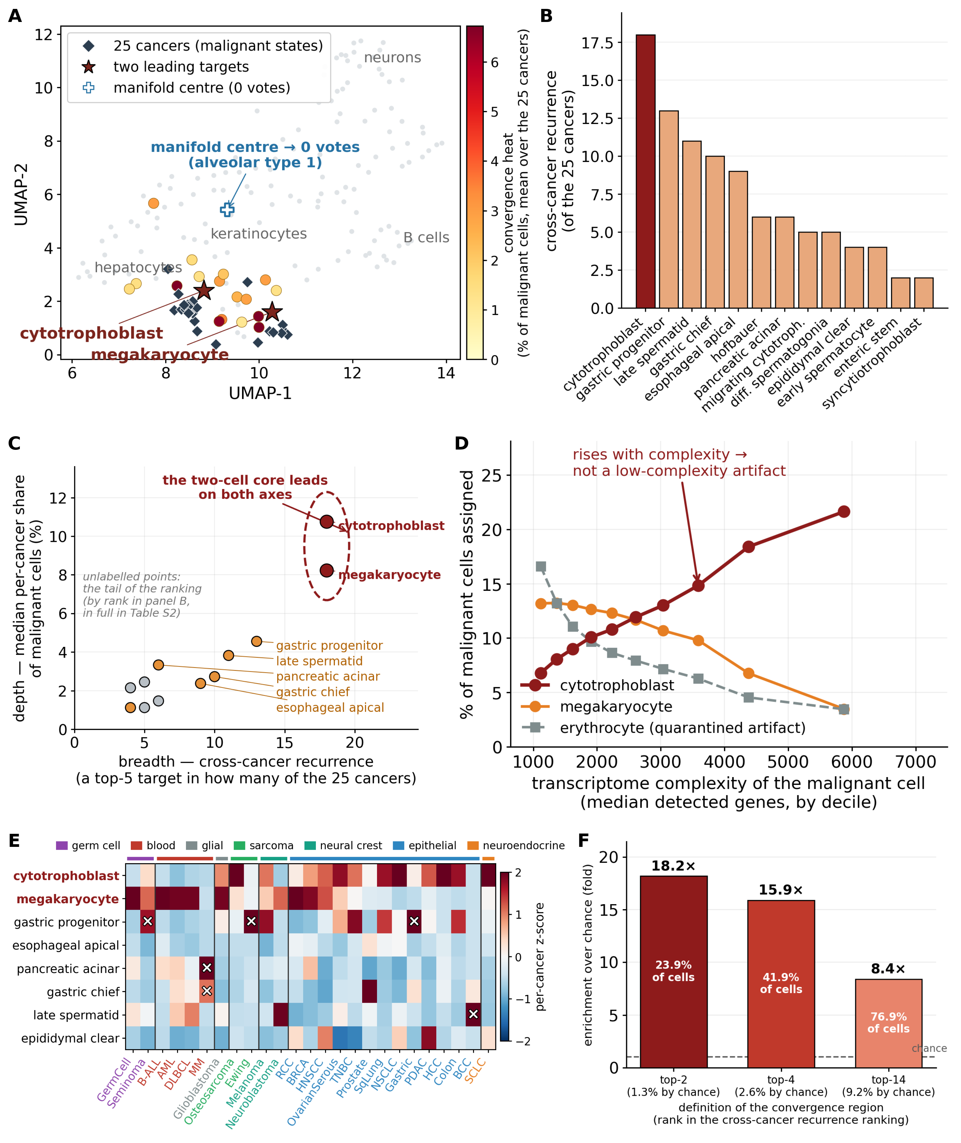
Fig. 3. Where the convergence lands: a reproducible neighbourhood of normal states, and the cell nearest it under this catalog. (A) The 25 malignant states (diamonds) on the normal-cell map, cell types coloured by the convergence they receive; the manifold’s own centre (an alveolar type-1 pneumocyte, cross) receives none. (B) Cross-cancer recurrence — the number of the 25 cancers in which a cell type is a top-5 nearest neighbour; the erythrocyte and the megakaryocyte are omitted because the control in (D) rejects both; the megakaryocyte is still named as the second member of the two-cell core wherever that denominator is used, and carried no further (full ranking including both, Fig. S6-II). (C) Breadth against depth: only the two core cells lead on both axes, and of those only the cytotrophoblast survives (D). (D) The control that separates them: over deciles of transcriptome complexity, cytotrophoblast assignment rises (6.8% to 21.6%) while megakaryocyte assignment falls (13.2% to 3.5%), tracking the quarantined erythrocyte (16.6% to 3.5%); Note S-Q runs the same control for every region member. (E) Convergence per cancer and per target (column-standardized), cancers grouped by lineage of origin; a white cross is a single-cancer resonance (>25% of that cancer’s malignant cells). (F) The enrichment survives widening the region (18.2-fold, 15.9-fold, 8.4-fold); occupancy inside each bar.

A reduced negative-feedback transcriptional signature defines the convergent state
A final test closes the circle on non-circularity (Fig. 4). Setting cancer aside and asking which of the 44 modules single the core out among all 154 normal cells, the answer is defined with no cancer data: the target cells are the pair that carry a markedly reduced transcriptional signature of a dozen negative-feedback and checkpoint modules — Circadian, Type I IFN, JAK-STAT, PI3K/PTEN, Notch, Wnt, SREBP and others — sitting ~1–1.8 standard deviations below the rest of the panel on each; Fig. S8 shows the core against the full normal-cell distribution for every module, so the reader can see which of the 44 the claim rests on. Two cautions apply to every statement of this kind in this paper. First, a module score is a transcriptional signature, not a biochemical measurement of pathway activity: reduced expression of a negative-feedback gene is consistent with release of that feedback, but equally with the pathway being less active overall, so we speak throughout of a reduced or enhanced negative-feedback signature and not of released inhibition. Second, the readout is only as good as the genes actually scored — 104 of the 216 scored gene slots (Table S9 lists 219 slots over 206 unique genes; the three remaining slots are the deprecated aliases ARNTL, MB21D1 and TMEM173, which matched nothing in the reference and so were scored by no cell, Note S-Q(ii)) are induced genes (feedback elements or transcription-factor targets), while six modules (AMPK, Hippo, Insulin/FOXO, Calcium, cAMP/CREB, NPAS4) score none at all and are read through their components alone (Table S9b, Note S-N). Scoring the same modules by regulatory output instead of component abundance was pre-registered as a test of the right measurement level, and it separates the two halves of the result. The convergence is larger at the output level — 33% of malignant cells in the three-cell core against 25% under readiness scoring in the same harness — and the magnitude-removed within-patient deepening three to four times larger (+19.5 points against +4.9); but the cytotrophoblast is not the cell converged upon. It falls to rank 17 of 152 with 0 of 25 cancers under the pre-registered estimator, and the output-level target is the megakaryocyte in 25 of 25. The pre-registration committed the test to fail on exactly that, and we report it as a failure: what this catalog reads when it names the cytotrophoblast is a cell’s equipment for the state rather than its pathway output (Note S-T). This pre-existing, cancer-blind signature is exactly what cancer reproduces: decomposing each cancer’s proximity to the core into per-module contributions and plotting them against the target-defining suppression gives a strong positive relationship (module-level Spearman ρ = +0.88), and the same holds, bypassing the modules entirely, gene by gene at moderate strength and by rank only (Spearman ρ = +0.56, Pearson r = +0.10, over the 17 of the 25 cohorts whose objects can be scored at gene level; Fig. S7-III). Both are reported as effect sizes: a P-value here would reflect the number of features, not the strength of the match. The map fingerprinted the target before any cancer was seen, and cancer reproduces that fingerprint — strongly at the level of modules, moderately but consistently gene by gene. (The correlation is stable — bootstrapping the modules gives ρ = 0.87, 95% CI [0.78, 0.93], positive in 100% of 2,000 resamples — and Type I IFN is the single most-below-trend module — the one target-defining brake cancer does not reproduce. Below-trend here is a statement about the residual: Type I IFN ranks 14th of 44 on raw contribution, but 1st of 44 on how far that contribution falls short of what its suppression predicts. Details of the module signature and how the malignant occupant differs from the normal occupant of the same state are in SI.)
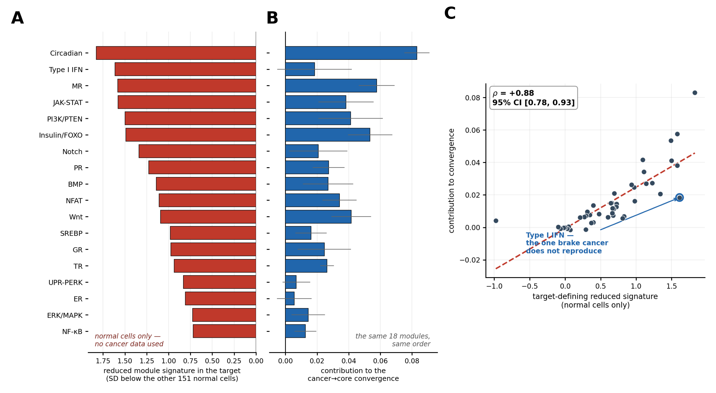
Fig. 4. The regulatory signature that defines the target is the one cancer reproduces. (A) What pre-defines the target, using normal cells only: how far the convergence target sits below the other 151 normal cell types on each module, for the eighteen modules it suppresses most (the full 44 are in Table S7). No cancer data enter this panel. (B) What cancer contributes: the mean per-module contribution to the cancer-to-core convergence across the 25 cancers (+/- SD), for the same eighteen modules in the same order, so each pair can be read across. (C) The two against each other across all 44 modules: Spearman rho = +0.88 (bootstrap 95% CI 0.78-0.93, positive in 100% of 2,000 resamples). The programs that make the normal target unusual are the programs cancers reproduce as they converge on it. Type I interferon is the single most below-trend by OLS residual (third by rank residual) module - the one target-defining brake cancer does not reproduce - which is a statement about the residual: it ranks 14th of 44 on raw contribution but 1st of 44 on how far that contribution falls short of what its suppression predicts.

The convergent state exists in normal physiology but malignancy increases its occupancy
The natural reading — that this is a cancer signature — is wrong, and the correction is the pivot of the paper (Fig. 5A). Running the identical pipeline on healthy tissue, normal lung epithelium occupies the convergent state — defined throughout as a cell whose nearest normal neighbour is one of three reference types, the cytotrophoblast, the migrating cytotrophoblast and the megakaryocyte (Methods; Note S-K) — at 16.1% — as fully as many of the cancers — while healthy kidney (0.5%) and neural tissue (7.6%) sit far from it. Proximity to the convergent state is therefore a tissue-baseline property of normal physiology, not a destination unique to cancer: the professional secretory and high-output epithelia constitutively occupy it, transport and post-mitotic tissues do not. The unit of the result is therefore a physiological cell state. The question is no longer where cancer goes, but what it does once there.
Holding tissue baseline fixed answers it (Fig. 5B). Because a cancer arises from a particular epithelial subtype rather than from a tissue, the comparison must be to the right normal cell. Whole-transcriptome similarity identifies it: scored on 2,000 highly-variable genes rather than on the modules, the malignant epithelium of 57 of 62 patients is closest to the proliferating crypt-base stem/transit-amplifying population, and each malignant subtype is closest to its own normal counterpart. Comparing like with like does not remove the effect: against normal crypt-base progenitors specifically, malignant epithelium is still higher in 35 of 39 patients (+13.6 points), and the same subtype against itself gives +14.8 points. Comparing instead against the differentiated surface epithelium, which occupies the state far less often, would have overstated the effect, so the crypt-base comparison is the primary one (Note S-O). In a colorectal cohort with paired tumor and adjacent-normal tissue (Pelka et al., 2021), malignant epithelium occupies the core at a median 18.9% versus 4.7% for the same patient’s normal colon epithelium — an increase of about sixteen percentage points on the per-patient mean, higher in 43 of 46 patients (a fourfold ratio of the medians, but we report points because the fold-change is inflated by the small normal denominator) (paired P = 9 × 10⁻¹³). Applied to every further tissue with paired single-cell data, malignant epithelium occupies the state more often than the same patient’s matched-normal. Where the baseline is low the increase is large: an independent colorectal dataset replicates it (23/25 donors), and kidney and liver concur (each individually underpowered but same-signed). Pooled across these four datasets, malignant epithelium is deeper in 77 of 86 patients; because pooling patients across datasets could manufacture a Simpson’s-paradox artifact, a mixed-effects model that credits the dataset clustering — a dataset random intercept — estimates a +13.0-percentage-point increase in occupancy (SE 1.87; z = 6.95; one-sided P = 1.9 × 10⁻¹²), with all four datasets increasing in the mean. The effect is not a tumor-versus-normal complexity artifact: resampling malignant cells to each patient’s own matched-normal complexity distribution retains about 80% of it (SI). A second organ replicates it: twenty-three paired gastric patients (GSE150290), analyzed only after the account was fixed (18/22, 8.8% → 14.2%, P = 0.001; Fig. S11-I). None of the paired cohorts is cleanly outside the panel: the panel’s gastric cohort is these same twenty-three tumour samples, the panel’s colorectal cohort is Pelka, and five of the ten paired lung patients are among the nine GSE131907 donors carried by the panel’s smallest cohort (Note S-U, scripts/verify/paired_overlap.py). What the paired design buys is not independence of the patients but the cancellation of lineage and batch — both arms are the same patient, the same tissue, the same protocol — and the question it answers is whether malignancy raises occupancy of the state, not whether the state was named out of sample.
The increase is not gated by tissue baseline. An apparent absence in high-baseline lung was a cell-selection artifact: the lung “tumor” arm of the pan-tissue reference was ~90% normal-adjacent alveolar epithelium and only ~9% annotated-malignant cells, diluting it to the normal baseline. With cleanly identified malignant cells, high-baseline lung behaves like the rest (GSE131907: 10 of 10 patients, 23% → 39%, P = 0.002 — the smallest value a two-sided paired Wilcoxon can return at n = 10; Fig. S11-II). Increased occupancy is therefore a broadly shared feature of malignancy rather than a universal requirement, not a low/high dichotomy: it holds in every tissue tested but one, high-baseline lung included, and the exceptions are real. Prostate is an open negative in which two paired cohorts disagree about the normal baseline itself and neither shows an increase (SI); the gastric cohort is the weakest of the three once magnitude is removed (+3.4 points, significant by Wilcoxon but only borderline by a sign test); and the pre-invasive prediction fails outright in Barrett’s oesophagus (below). We report these as limits on generality, not as noise. On the additive scale the amount is roughly constant across tissues (~+10 points; r = +0.4 with baseline, P = 0.5); the impression of “more room where the baseline is lower” is a fold-change artifact of a small denominator (SI).
Most important, the increase in occupancy is not merely the shared high output that carries the (modest) convergence. Because it is measured in the same core-fraction currency, it is exposed to the same magnitude confound, so we remove it: recomputing the core with the overall-magnitude component of each cell subtracted, patient-matched malignant epithelium still sits deeper in the shape-only core than matched-normal — colorectal +10.5 points (44/46; paired Wilcoxon P = 10⁻¹³, sign-test P < 10⁻¹⁰; the colorectal comparator recomputes the same quantity by its own route and gives +10.4 and 43/46, the single disagreeing patient being one whose two arms differ by 0.3 points, Note S-K), corrected lung +12.1 (9/10; P = 0.004, sign-test P = 0.011), and gastric +3.4 (15/22; P = 0.04 by Wilcoxon but only borderline by a sign test, P = 0.07) — retaining 63–77% of the raw effect (SI). The colorectal and lung shape-only results are robust under either test; the gastric cohort — the smallest — is the weakest of the three once magnitude is removed, and we mark it as suggestive rather than significant. What is specifically malignant is thus a genuine shift in regulatory pattern toward the target, not transcriptional brightness alone — and this within-patient increase in occupancy, not the cross-lineage convergence, is the strongest claim in this paper. It is also the most portable: established pathway collections put through the identical pipeline — KEGG, Reactome, Hallmark, PROGENy — reproduce the within-patient increase at the same size or larger, and under every one of them the largest within-patient shift in colorectal epithelium is toward a trophoblast state. The increase in occupancy is therefore a property of curated regulatory biology projected onto a normal-cell gallery, not of this catalog in particular; what this catalog adds is the cross-lineage generality of the target across all 25 cancers, which no off-the-shelf collection reproduces (Note S-O).
Correcting the lung reading cost a negative control, and we replace it with a stricter one: a non-malignant disease of the same organ. Idiopathic pulmonary fibrosis is the hardest benign comparator available — chronically injured, ECM-remodelling epithelium containing the aberrant-basaloid and transitional-AT2 populations repeatedly described as cancer-like. If invasive remodelling alone sufficed, fibrotic lung should enter the state. It does not, or barely: across twenty-two donors, fibrotic lung sits at 19.9% versus 16.1% for control lung (raw) and 8.9% versus 7.6% (shape-only) — rises of 3.8 and 1.3 points, neither significant (one-sided unpaired Mann–Whitney over the donors, P = 0.12 and 0.21; two-sided, 0.25 and 0.41) — whereas malignant epithelium in the same organ moves 23.4% → 39.0% raw in ten of ten patients and 18.2% → 30.3% shape-only in nine of ten (P = 0.002 and 0.004; Fig. S12), four- to ninefold more. The two sides are within-dataset effects from different cohorts, platforms and pipelines — the two normal-lung baselines themselves differ by 7 points (16.1% against 23.4%) — so this is a comparison of two within-dataset deltas, not a single contrast. Within fibrotic lung the ordering is biologically sensible (transitional-AT2 highest, ciliated lowest; SI), so the state tracks invasive high-output phenotypes generally — but only malignancy carries a tissue into it. The event also appears early and essentially all-or-none, independent of grade and stage (SI).
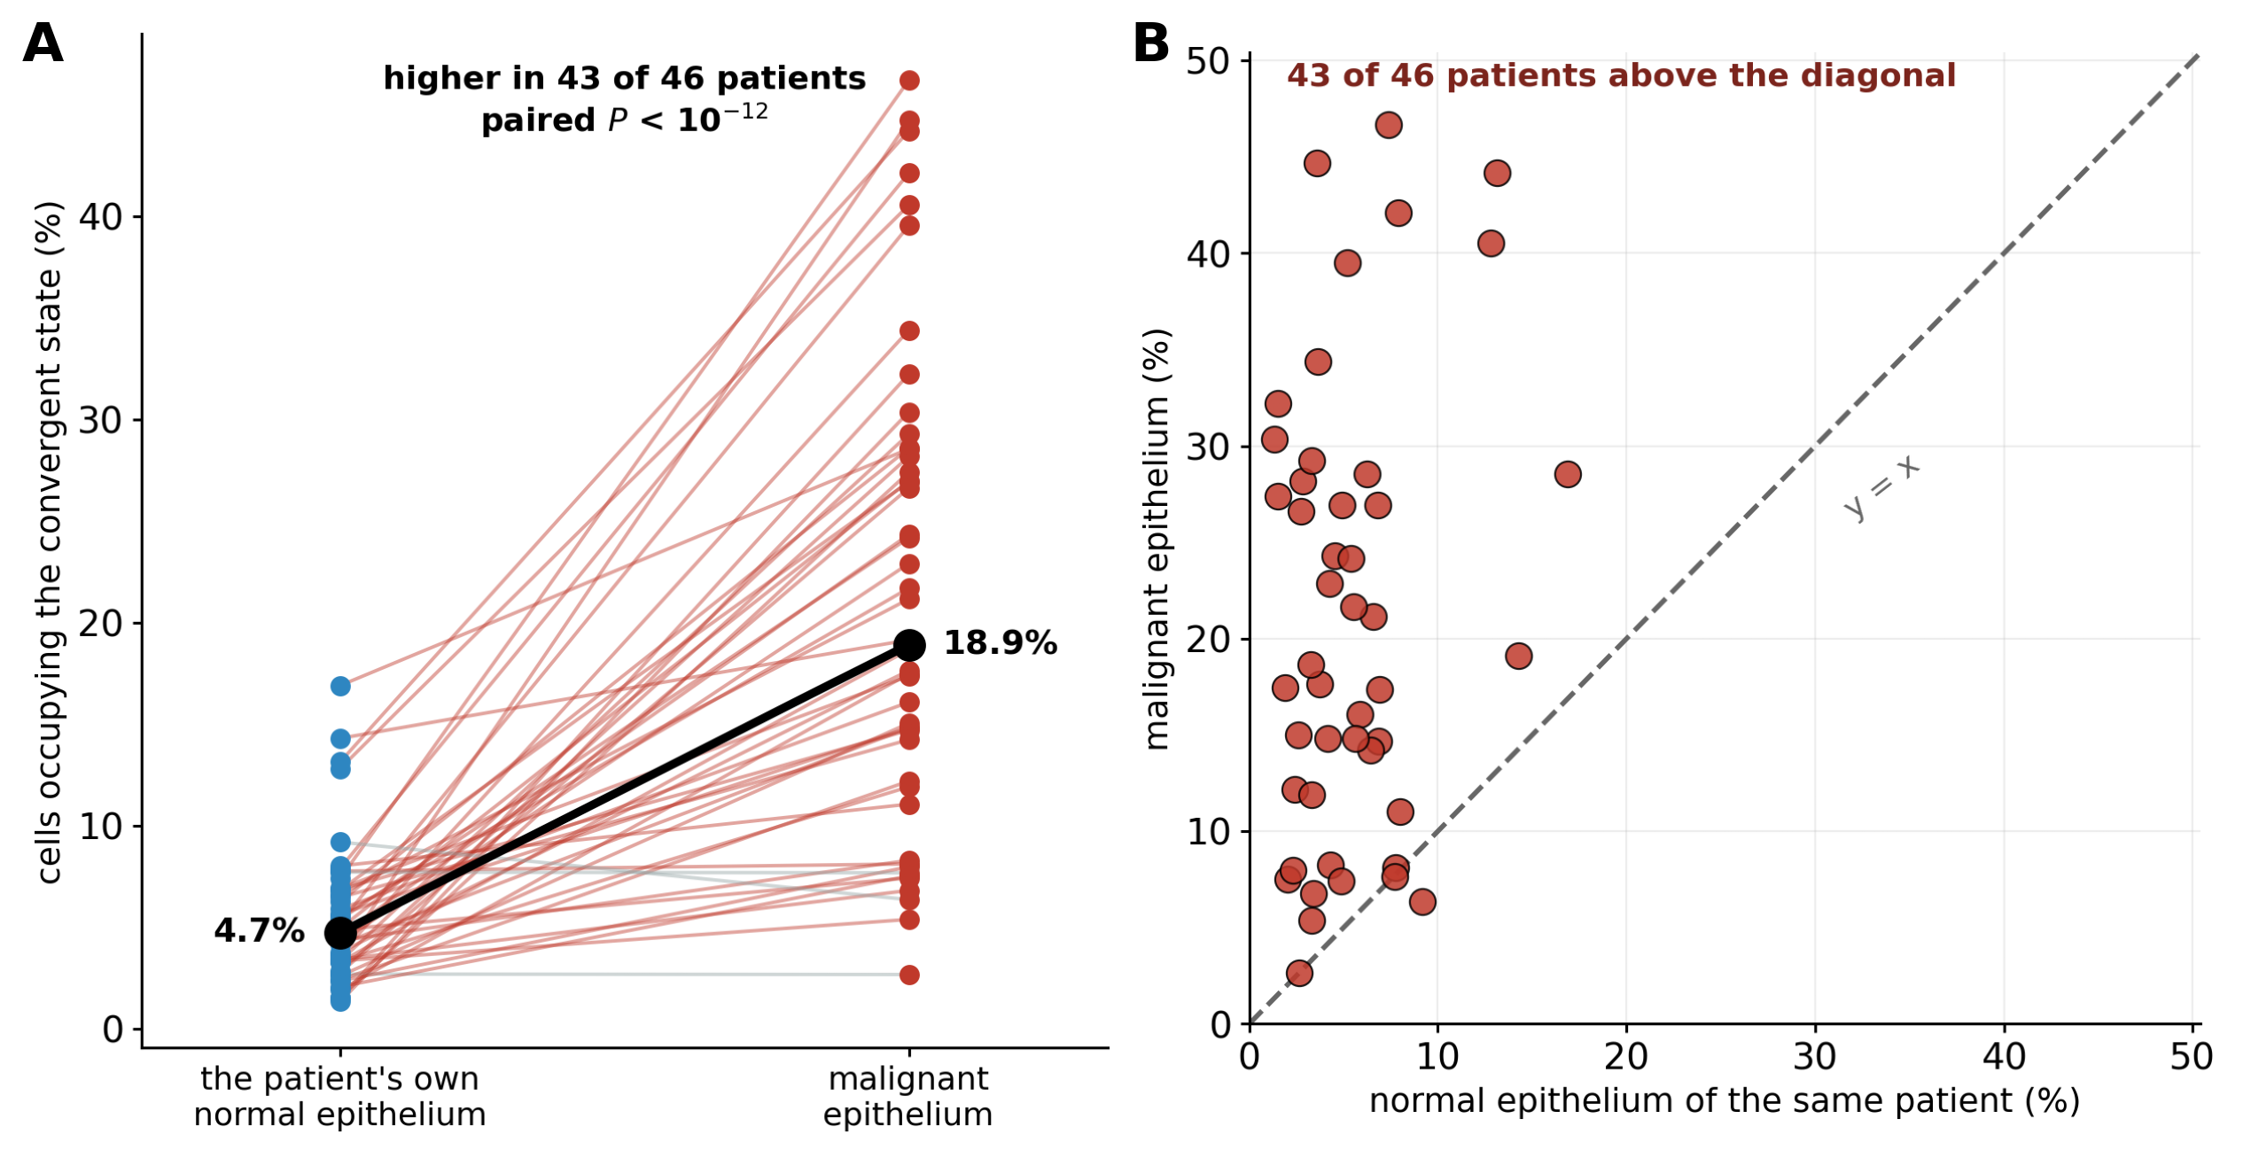
Fig. 5. Malignancy increases occupancy of a pre-existing physiological state. (A) Within-patient, cell-type-matched paired test in colorectal cancer (Pelka et al. 2021): each line is one patient, joining the fraction of that patient’s own normal epithelium occupying the convergent state to the fraction of their malignant epithelium that does. Medians 4.7% and 18.9%; higher in 43 of 46 patients, paired Wilcoxon P = 9 × 10^-13. (B) The same data per patient against the diagonal: 43 of 46 points lie above y = x. Because both arms come from the same patient, the same tissue and the same protocol, lineage and batch cancel. The effect survives matching on transcriptome complexity, survives removal of the magnitude component, replicates in a second, gastric cohort, and holds against the crypt-base progenitors from which these tumours arise (SI). Baseline occupancy of normal epithelium tissue by tissue is in the SI.

Transformation of human cells from a known precursor moves them into the state
Every comparison so far matches a malignant cell to a normal cell we believe to be its counterpart. Transformation of human cells in culture removes the belief: the precursor is in the same dish, profiled before the oncogenic hits are delivered. We tested five isogenic series of this kind, each against a pre-registration frozen before the data were read (perceptome_validation/PREREG_T9_invitro.md). These are the only analyses in this paper that are not single-cell — an isogenic within-donor design exists in bulk RNA-seq and on microarray and nowhere else — so the coordinate is scored here on whole-population profiles, every statistic is a within-series paired difference, and arrays and sequencing are never pooled.
The displacement is large, and it arrives in two stages (Fig. 6A–C). In the one series carrying a paired within-donor time course — ten donors of primary human prostate basal cells transduced with five defined oncogenic factors and followed through to tumour formation (PARCB; Chen et al., 2023) — the cells travel +0.509 in cosine to the malignant attractor from their own untreated basal state to the endpoint tumour, and 71% of that distance (+0.360) is already covered at week 0, in cells that carry all five factors and are not yet tumours (10 of 10 donors in both; sign-test P = 0.001), with the stage ordering monotone in every donor (mean Spearman ρ = +0.80). Scored by regulatory output instead of component abundance (DoRothEA/PROGENy footprints under VIPER), the same transduced-not-yet-tumour arm contributes nothing (−0.031; 1 of 10 donors) while the endpoint tumour still sits closer to the attractor than its own precursor (+0.052, 9 of 10, P = 0.011; magnitude-removed +0.028, 8 of 10, P = 0.055; under the ULM estimator +0.401 and +0.214, 10 of 10 for both). The discrete readout used throughout the main text — nearest-normal assignment — follows the output timing: no donor lies inside the convergent region at baseline, one after transduction, all ten at the endpoint tumour. The regulatory state therefore begins to move with the genetic lesion itself, before a malignant phenotype exists, and the part of the move visible at the level of pathway output accrues with the tumour. Both scorings are reported: they date the same displacement differently, and that difference is itself the result.
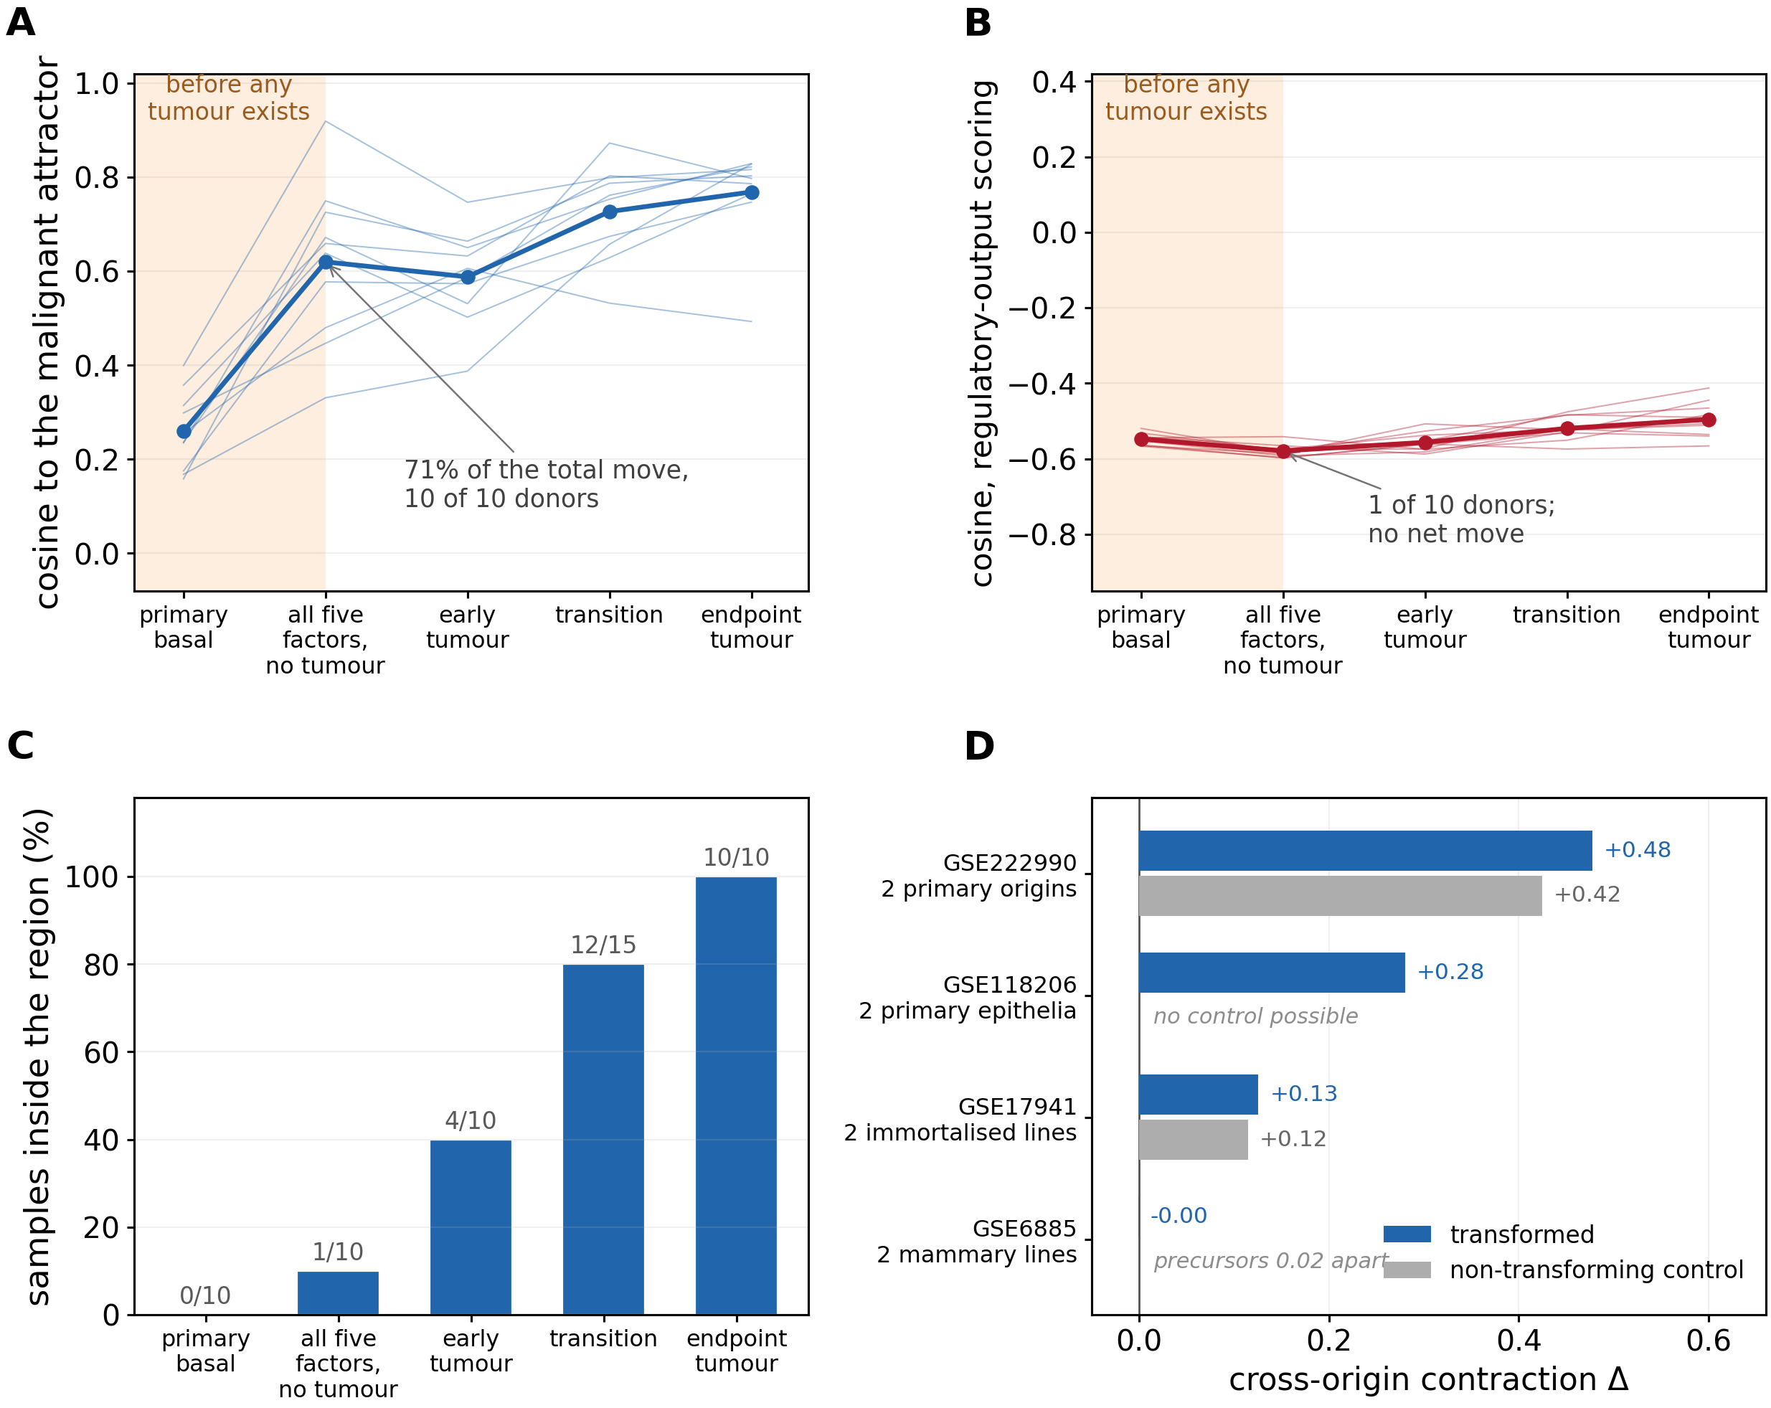
Fig. 6. Transformation of human cells from a known precursor: a two-stage displacement, and what the cross-origin convergence does once a non-transforming control exists. (A) Ten donors of primary human prostate basal cells carrying five defined oncogenic factors (PARCB; Chen et al. 2023, GSE240057), paired within donor. Thin lines are donors, bold is the mean; the shaded band marks the arm that carries all five factors but has not yet formed a tumour. Under component-abundance scoring the cells are already 71% of the way from their own untreated basal cells to the endpoint tumour before any tumour exists (+0.360 of +0.509 in cosine to the malignant attractor, 10 of 10 donors in both; sign-test P = 0.001), and the stage ordering is monotone in all ten (mean Spearman rho = +0.80). (B) The same donors scored by regulatory output instead of component abundance (DoRothEA/PROGENy footprints, VIPER). Here the transduced-not-yet-tumour arm contributes nothing (-0.031; 1 of 10 donors positive) while the endpoint tumour remains closer to the attractor than its own precursor (+0.052, 9 of 10, P = 0.011; magnitude-removed +0.028, 8 of 10, P = 0.055; under the ULM estimator +0.401 and +0.214, 10 of 10 for both). The two scorings date the move differently: the abundance-level displacement arrives with the genetic lesion, the output-level displacement accrues with the tumour. (C) The discrete readout agrees with the latter - nearest-normal assignment places no donor inside the convergence region at baseline, one after transduction, and all ten at the endpoint. (D) Cross-origin contraction in the four series that transform two distinct origins, each beside its non-transforming control twin: in GSE222990 (primary acinar and ductal pancreas, same four drivers) substituting an acinar arm that received no drivers at all for the transformed one reproduces +0.42 of the +0.48 contraction; in GSE17941 the twin converges as much in raw scores and more after magnitude removal (+0.15 against +0.09); GSE118206 is the only clean positive and the only design in which no such control can be built; GSE6885 is uninformative because its two precursors start 0.02 apart. Pre-registration perceptome_validation/PREREG_T9_invitro.md (frozen before each run), results T9_RESULTS.md, scripts/T9_invitro_transformation.py, T9c_trajectory.py, T9d_activity.py, T9e_pancreas.py, figure scripts/build_figS29_invitro.py.
This is also the one tissue in which the within-patient test is negative, and the two findings are compatible rather than contradictory. The PARCB endpoint is a neuroendocrine programme, not the adenocarcinoma of the paired prostate cohorts of §5; engineered transformation of prostate basal cells enters the state, while prostate adenocarcinoma in patients — in two cohorts that disagree about the normal baseline itself — does not.
The paired design also puts a control under the cross-lineage contraction of §2, and there the result is negative (Fig. 6D). Four of the five series transform two distinct origins, and three of those carry an arm manipulated without being transformed. In primary human pancreatic acinar and ductal cells given the same four drivers (GSE222990), the step from fresh tissue into organoid culture is 0.285 in cosine distance and the drivers add 0.063 on top of it; substituting the arm that received no drivers at all for the transformed one reproduces +0.42 of the +0.48 cross-origin contraction. In GSE17941 the pre-registered specificity twin — two manipulations that do not transform — converges as much as the transformed arms in raw scores (+0.115 against +0.126) and more after magnitude removal (+0.151 against +0.091). The one clean contraction, GSE118206 — prostate basal and bronchial epithelium given the same five factors, 0.285 → 0.004, permutation P = 0.012; magnitude-removed 0.190 → 0.010, P = 0.004, beating 199 of 200 expression-matched random gene panels in raw scores — is also the only one of the four in which no non-transforming control can be built, and its endpoint is a single fixed five-factor neuroendocrine programme. The fifth series cannot test it at all: in GSE6885 the two precursors start 0.024 apart and have no room to converge.
The five series therefore license the within-donor statement and not the cross-origin one. Transformation from a known precursor raises occupancy of the state measured against that precursor; the cross-origin contraction seen in snapshots of unrelated cancers is, in culture, largely attributable to culture itself and to oncogene expression. Three of the five series start from immortalised lines, the pancreatic precursor already lies inside the region so that its attractor-directed statistic is at a ceiling and its key arm has n = 3, and every endpoint is one engineered programme rather than a spontaneous cancer (Note S-R).

Malignant cells superimpose stress and growth programs on the shared physiological state
Increased occupancy is only half of what malignancy does. The sharper question is what distinguishes a malignant cell already in the convergent state from a normal cell of the same patient that is also in it — same state, same tissue, same patient, so lineage and batch cancel (Fig. 7). Comparing the two occupant populations module by module within each of thirty colorectal patients (≥10 core-assigned cells per arm), and balancing detection depth so the comparison is not a library-size effect (Fig. 7), sixteen modules separate the occupants reproducibly. The malignant occupant carries higher transcriptional signatures of the retained integrity and stress responses — HIF, NRF2, HSF1, UPR-PERK and autophagy — together with anabolic and proliferative ones (mTOR, SREBP, cell cycle, Wnt), and lower signatures of PPARα, MR and PI3K/PTEN. For the kinase-centred modules in that list the caution of §4 applies with particular force: mTOR and PI3K/PTEN are scored almost entirely from component transcripts, so “higher mTOR” here means higher mTOR-component message and not demonstrated mTORC1 activity. The p53 module also rises, but through its downstream damage targets (p21, BAX, PUMA, NOXA) rather than TP53 itself, whose transcript is unchanged — a replication-stress footprint rather than retained p53 function.
Critically, this difference lies largely off the axis that defines the target. Plotted against the reduced-feedback signature that distinguishes the target among normal cells, the malignant-versus-normal occupant differences correlate only weakly (ρ = +0.36): malignancy does not push cells further along the same axis that made the state special, it adds a different, stress-and-growth program on top of it (the module-by-module within-patient view is Fig. S15). The two statements should therefore be kept apart throughout: at the level of the population, malignancy increases occupancy of a pre-existing physiological state; among the cells already occupying it, malignancy modifies the state qualitatively rather than intensifying its defining features. This analysis is colorectal only and awaits replication wherever paired malignant and normal cells both occupy the state in sufficient numbers.
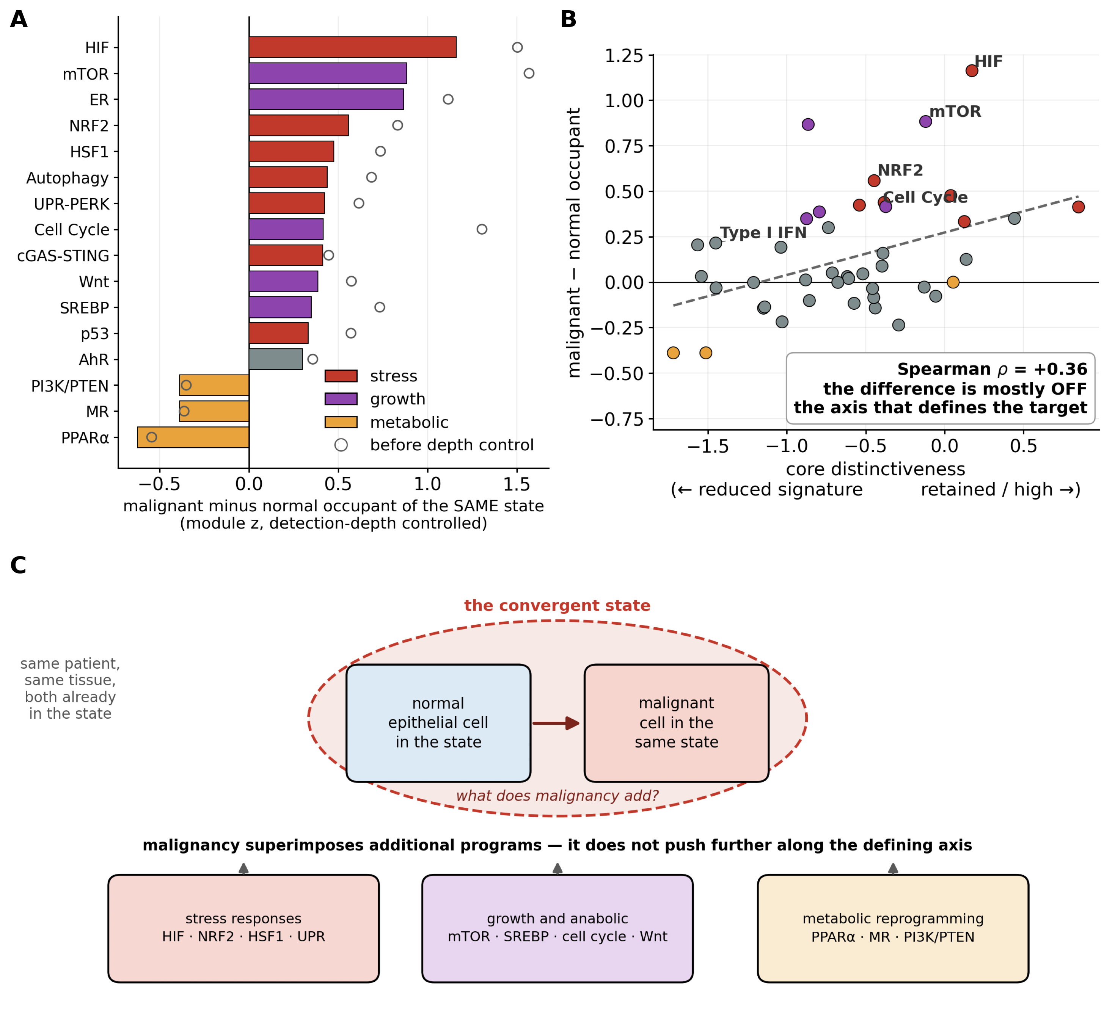
Fig. 7. Having converged, malignant cells modify the state rather than moving further along it. Malignant and matched-normal epithelial cells that BOTH occupy the convergent state are compared module by module within each of 30 colorectal patients (>=10 core-assigned cells per arm; paired Wilcoxon, detection depth balanced to median 2,640 versus 2,496 detected genes from a raw 4,351 versus 2,395). (A) The sixteen modules that survive the depth control, coloured by functional class; open circles give the uncontrolled value, so the shrinkage imposed by the control is visible. The malignant occupant carries higher transcriptional signatures of the stress responses (HIF, NRF2, HSF1, UPR-PERK, autophagy) and of anabolic programs (mTOR, SREBP, cell cycle, Wnt) and shifts metabolically (PPARalpha, MR, PI3K/PTEN down). Every one of these is a transcriptional signature and not a measured pathway activity; mTOR and PI3K/PTEN in particular are scored almost entirely from component transcripts, so “higher mTOR” means higher mTOR-component message. The p53 module rises through its downstream damage targets rather than TP53 itself, whose transcript is unchanged - a replication-stress footprint, not retained p53 function. (B) The same differences against the axis that defines the target: the correlation is weak (Spearman rho = +0.36 across all 44 modules), so the difference lies largely OFF the defining axis. (C) The reading: at the level of the population malignancy increases occupancy of a pre-existing state (Fig. 5), and among the cells already occupying it malignancy superimposes stress, growth and metabolic programs rather than intensifying the features that make the state special. Colorectal only; this awaits replication wherever paired malignant and normal cells both occupy the state in numbers.
Occupancy also does not simply rise with dissemination: within six breast patients the matched lymph-node metastasis sits lower in the state than the patient’s own primary (means of 21.8% → 13.4%, six of six, paired P = 0.031 — the floor at n = 6; Fig. S13-III), so the state appears to accompany invasion rather than to mark the metastatic endpoint — on small numbers, and on nodal rather than distant metastases.

Discussion
Read against Abelev’s fifty-year-old embryonic-state theory of cancer (Abelev, 1971), the result gives the theory a concrete coordinate: cancer does not manufacture a program, it re-enters a bounded, pre-existing normal one — the physiology of the invasive, immune-evading, high-output early placenta — and removes the bound. The convergence target is not unique to cancer, so the claim is a physiological state whose occupancy malignancy increases, not a cancer-specific destination; stated this way, the embryonic-state reading is strengthened rather than weakened, because the destination demonstrably pre-exists in normal biology, and the coordinate system that reveals it was built from normal cells alone.
This positions the work among, and apart from, several literatures. The closest design, a bulk projection of tumors onto a normal-cell space reporting one destination (Chen & He, 2016), landed on an abstract embryonic-stem state; resolving single malignant cells across twenty-five lineages lands instead on a specific, differentiated cell. Pan-cancer stemness indices (Malta et al., 2018) and developmental-potency scores (Gulati et al., 2020) measure a scalar toward a generic pluripotent reference; the convergent region is genuinely high-potency by those measures, but here it resolves to a named normal cell rather than a “more stem-like” number. The result also engages the contrasting lineage-local view (Patel & Yanai, 2024): the cross-lineage clustering reported here is the direct test, reconciled by noting that convergence is a claim about the destination, not the direction of travel — origins as different as blood and skin reach the same region without following the same path. The trophoblast–cancer resemblance, long argued qualitatively (Ferretti et al., 2007; Costanzo et al., 2018), becomes here a measured, positional, cross-lineage anchor.
We are explicit about what the data do and do not support. A convergent endpoint in static snapshots is not a proven dynamical attractor: the coordinate system locates where cancers come to rest, but attraction is a claim about motion (Kauffman, 1971; Huang et al., 2009). One time-resolved dataset lets us take a first step. Following human lung-adenocarcinoma cells through eleven days of targeted therapy (Aissa et al., 2021), the population moves in the coordinate: occupancy rises sharply by day 2, drops at day 4 as the drug-tolerant persister trough forms, and recovers through days 9–11 as the survivors resume growth. We report the shape of that course and not its levels, because the levels are a function of the quality-control threshold — day 2 reads anywhere from 18% to 62% as the detected-gene floor moves from 0 to 1,000 — and because core assignment in this shallow Drop-seq data tracks transcriptome complexity within every timepoint (Spearman +0.77 to +1.00). Restricting all timepoints to a common detected-gene window leaves the rise and the trough intact, so the movement is not a complexity artifact (Fig. S14); whether the population ends above where it began is window-dependent and we make no such claim. A cell line without a microenvironment, with survivorship thinning the later timepoints and no lineage tracing, also cannot separate movement of cells from selection among them. Notably, the state is not moved by single-gene perturbation at all: across nearly ten thousand CRISPR knockdowns, knocking a target-defining brake down shifts its own module by up to two standard deviations yet leaves the nine-dimensional position essentially unchanged and in no consistent direction (SI). The state behaves as a many-module consensus — buffered against single genes, displaced by coordinated pressure. Four candidate organizing principles for the state — driver-gene enrichment, module evolutionary age, an exteroception–interoception axis, and immune privilege — were each tested and falsified (SI). One further observation, which we report as suggestive rather than established, sharpens what the state is for. Comparing each patient’s primary tumour with their own lymph-node metastasis, the metastasis sits lower in the state, not higher — in breast, means of 21.8% → 13.4% across six patients (lower in six of six; paired P = 0.031, which is the floor a two-sided Wilcoxon can reach at n = 6; shape-only 14.3% → 9.6%), with the single evaluable liver pair in the same direction. Of the two portal-vein tumour thrombi available — tumour actively occupying a vessel — one sits well above its primary and the other does not move, so we read them as a single suggestive case. Read together, the state accompanies invasion and primary growth and is relinquished on colonization, which is what the trophoblast analogy would predict: the cytotrophoblast lineage invades the decidua, it does not seed distant organs. The comparison rests on nodal rather than distant metastases and on small numbers, and needs a dedicated cohort.
The account makes falsifiable predictions: pre-invasive lesions should already occupy the convergent region before invasion is histologically present, and we have now tested this in three organs with a mixed result we report in full (Fig. S13-I, Fig. S13-II). In colorectum it holds: across three patients with matched normal, adenoma and carcinoma epithelium, the adenoma already sat above matched normal in all three, at roughly two-thirds of the carcinoma level. In breast it holds directionally: ductal carcinoma in situ sits between normal breast and invasive carcinoma (7.7% → 11.3% → 21.8%), reaching about half the invasive level, though with a single normal sample the comparison is weak. In esophagus it fails: Barrett’s metaplasia sits below the same patient’s own normal squamous epithelium in four of four patients (2.1% versus 7.7%) and below gastric epithelium in three of three. Two readings are open and we do not choose between them: either the prediction is confined to neoplastic precursors — the adenoma and the in-situ carcinoma are clonal neoplasms, Barrett’s metaplasia is a lineage switch and a risk factor rather than a neoplasm — or the prediction is simply wrong in esophagus. The datasets available to us are mostly non-dysplastic Barrett’s, so the properly pre-invasive esophageal lesion, dysplasia, remains untested. A second prediction: cancers adjacent to the core should not reproduce the one trophoblast brake — Type I IFN silencing — that defines the target but that cancer does not follow. (An earlier structural argument — that the two core cells share polyploidy by endoreduplication — we drop as imprecise: the megakaryocyte does endoreduplicate, but the villous cytotrophoblast named here as the anchor is the trophoblast lineage’s mononuclear diploid progenitor; polyploidy is a property of its syncytial and extravillous derivatives, not of the anchor cell itself.) The within-patient occupancy test is released as a dataset-agnostic pipeline that, given any paired tumor/normal cohort, predicts increased occupancy — with no condition on the tissue’s baseline — the direct replication the generality of the claim invites.
Four controls bound the claim and change how the result should be read (Notes S-A, S-B, S-C and S-H). The convergence is substantially a signal of overall regulatory level: removing the magnitude component and keeping only the relative module shape reduces the core convergence from ~27% to ~7–11% (still four- to fivefold over chance), so the reading is convergence onto a high-output state carried largely by module magnitude, with a smaller but real module-shape residual. Magnitude does not, however, explain which normal cell is named, and three orthogonal tests say the address is specific rather than merely bright: removing magnitude sharpens the target onto the trophoblast instead of diffusing it across high-output cells; the professional high-output secretory cells a pure-magnitude account predicts — hepatocytes and plasma cells — each receive ~0.1% of the cross-cancer convergence against 11–13% for the core; and core assignment is essentially uncorrelated with library size and detected-gene count. The magnitude of the effect is calibration-dependent, resolved only under the single-cell-matched calibration the single-cell tumour data require — a choice justified without cancer, because the pseudobulk alternative collapses even independent normal single cells onto low-complexity targets (Note S-H). And “no cancer data” is precise about the coordinate system and not the feature set: the 44 modules were curated from regulatory biology, some of it studied in cancer, a residual prior that the module-drop robustness (Fig. S7-II) and the module-independent gene-level reproduction (Fig. S7-III) bound but do not erase.
Three limitations attach specifically to the identity, which we hold more provisionally than the convergence itself. The 154-cell-type gallery is a limited sample of normal states, sparse in progenitor and fetal cells, so the cytotrophoblast is most defensibly read as the nearest available normal proxy for an invasive, high-output state; a richer developmental atlas could refine the target. The trophoblast reference comes from another dataset and platform (§3), a difference the shape-only result bounds but does not erase. And the name is specific to the level at which the modules are measured: scored by regulatory output rather than by component abundance, the convergence survives and grows while the cytotrophoblast leaves the top ten entirely, so the identity claim is about a cell’s equipment for the state rather than about its pathway output (Note S-T). Against the first two, one external check argues the address is not a gallery artifact: applied to mouse fibroblast-to-iPSC reprogramming (Schiebinger et al., 2019) — another species, another laboratory, no cancer anywhere in the analysis — the fraction of cells the coordinate assigns to the cytotrophoblast collapses to 1.8% early in reprogramming and then rises about ninefold, to between 11% and 20% from day fourteen onward (median 16.7%; ρ = +0.76 with reprogramming day, P = 3 × 10⁻⁸; Fig. S9), which is the window in which this system is known to throw off extraembryonic and trophoblast-like fates — although that dataset carries no cell-type labels, so we cannot confirm these are the same cells the original study called trophoblast-like. To map the remaining analytic freedom rather than assert a point in it, a 36-way specification curve crossing calibration, magnitude handling, core definition and erythroid treatment puts the convergence above chance in every one of the eighteen specifications run under the single-cell calibration; the only specifications that fall to chance are confined to the pseudobulk calibration we independently show to degenerate (Fig. S10).

Methods (summary; full procedures in SI)
Modules and eigenspace. 44 modules curated with the four operational criteria in view — the criteria record how the panel was built and are not a verified property of the genes as scored (Table S9b, Note S-N); module signature scored as mean log-normalized expression of component genes across 154 Human Protein Atlas single-cell types (Uhlén et al., 2015; trophoblast reference states from Vento-Tormo et al., 2018), z-scored and decomposed by correlation PCA, nine components retained by the Kaiser criterion. Cancer projection. Per cancer, malignant single cells are quality-filtered, scored on the 44 modules, projected through the fixed loadings, and assigned to their top-1 nearest normal cell-type centroid by cosine. Non-circular target identification. Cross-cancer recurrence (top-5 membership over the 25 cancers) and per-cancer depth, computed after quarantining the erythrocyte-family low-complexity artifact. Cross-origin contraction. Mean pairwise cosine distance among the 25 malignant centroids against a matched-averaging null — 200–300 aggregates of unrelated normal cells formed by the same averaging and of the same sizes — reported raw and with the overall-magnitude component removed. The earlier comparison against random 25-cell-type draws (a Stayton-type test; Stayton, 2015) is superseded: it mis-specified the null by ignoring the averaging itself, and the fold-contraction it produced is withdrawn (Note S-G). Within-patient occupancy (the study’s falsifiable general assay). For each cohort with paired tumor and adjacent-normal epithelium of the same patients (Pelka et al., 2021; Lu et al., 2022; CELLxGENE Census), occupancy of the convergent state — a cell whose top-1 nearest normal neighbour among the 152 candidates is the cytotrophoblast, the migrating cytotrophoblast or the megakaryocyte, chance 3/152 = 2.0% — is computed per patient for the malignant and matched-normal arms (≥ 20 cells each) and compared by paired Wilcoxon and a sign test; the unit of replication is the patient, not the cell. Cell-count denominators. Four different totals appear in this paper and each means something different: the full quality-controlled pool across the 25 cohorts is 448,399 cells (Table S1); the subset carried into the projection after the ≥1,000-detected-gene filter but before the 4,000-cells-per-cohort cap is 312,220 cells — drawn from the 17 of the 25 cohorts whose objects retain per-cell detected-gene counts, which is the pool the complexity analyses use for that reason (Fig. S5-II, Note S-Q); applying the cap leaves the 83,819 cells on which every convergence statistic is computed; and Table S6 tabulates 574,451 assignments because it includes the normal-atlas projections as well as the cancers. Reproducibility. The pipeline is released with the 44 module gene lists (Table S7), the exact CELLxGENE Census snapshot used throughout (version 2025-11-08), all GEO accessions (Data Availability), and a runnable end-to-end script that regenerates the main and SI figures from public inputs (Code availability). Full parameters, quality control, controls, and the single-cell-only rationale are in SI.

References
Amit I et al. (2007) Nat Genet 39:503–512. · Chandarlapaty S (2012) Cancer Discov 2:311–319. · Lito P, Rosen N, Solit DB (2013) Nat Med 19:1401–1409. · Aynaud MM et al. (2020) Cell Rep 30:1767–1779. · Gier RA et al. (2023) bioRxiv 2023.01.26.525564. · Liu Y et al. (2021) Front Oncol 11:709210. · Lu X et al. (2023) Nat Commun 14:8462. · Mo L et al. (2022) Front Oncol 12:871489. · Tokura M et al. (2022) Cancer Res 82:3236–3248. · Aissa AF et al. (2021) Nat Commun 12:1628. · Chen CC et al. (2023) Cancer Cell 41:2066–2082. · Grubman A et al. (2019) Nat Neurosci 22:2087–2097. · Habermann AC et al. (2020) Sci Adv 6:eaba1972. · Hirsch HA et al. (2010) Cancer Cell 17:348–361. · Ince TA et al. (2007) Cancer Cell 12:160–170. · Kim J et al. (2022) npj Precis Oncol 6:9. · Kim N et al. (2020) Nat Commun 11:2285. · Ledergor G et al. (2018) Nat Med 24:1867–1876. · Lu Y et al. (2022) Nat Commun 13:4594. · Moncada R et al. (2020) Nat Biotechnol 38:333–342. · Park JW et al. (2018) Science 362:91–95. · Replogle JM et al. (2022) Cell 185:2559–2575. · Schiebinger G et al. (2019) Cell 176:928–943 (Erratum: Cell 176:1517). · Song H et al. (2022) Nat Commun 13:141. · Stayton CT (2015) Evolution 69:2140–2153. · van Galen P et al. (2019) Cell 176:1265–1281. · Wu SZ et al. (2021) Nat Genet 53:1334–1347. · Xu Y et al. (2024) Nat Commun 15:818. · Yost KE et al. (2019) Nat Med 25:1251–1259. · Zheng X et al. (2022) Signal Transduct Target Ther 7:60. · Abelev GI (1971) Adv Cancer Res 14:295–358. · Aibar S et al. (2017) Nat Methods 14:1083–1086. · Aran D et al. (2019) Nat Immunol 20:163–172. · Barkley D et al. (2022) Nat Genet 54:1192–1201. · Chen H, He X (2016) Mol Biol Evol 33:4–12. · Costanzo V et al. (2018) Open Biol 8:180081. · Ferretti C et al. (2007) Hum Reprod Update 13:121–141. · Gavish A et al. (2023) Nature 618:598–606. · Gulati GS et al. (2020) Science 367:405–411. · Hanahan D (2022) Cancer Discov 12:31–46. · Hanahan D, Weinberg RA (2000) Cell 100:57–70. · Hanahan D, Weinberg RA (2011) Cell 144:646–674. · Huang S, Ernberg I, Kauffman S (2009) Semin Cell Dev Biol 20:869–876. · Kauffman S (1971) J Theor Biol 31:429–451. · Kildisiute G et al. (2021) Sci Adv 7:eabd3311. · Kinker GS et al. (2020) Nat Genet 52:1208–1218. · Lotfollahi M et al. (2023) Nat Cell Biol 25:337–350. · Malta TM et al. (2018) Cell 173:338–354. · Patel AS, Yanai I (2024) Cell 187:2907–2918. · Pelka K et al. (2021) Cell 184:4734–4752. · Schubert M et al. (2018) Nat Commun 9:20. · Sharma A, Ginhoux F (2022) Nat Rev Cancer 22:593–602. · Uhlén M et al. (2015) Science 347:1260419. · Vento-Tormo R et al. (2018) Nature 563:347–353. · Young MD et al. (2018) Science 361:594–599.

Acknowledgments
We thank Andrei V. Gudkov, who advised this work throughout as a scientific consultant, for extensive discussion — the demand for an objective, visible demonstration of the convergence, the caution against cross-cancer aggressiveness comparisons, the emphasis on single-cell-only data, the module-robustness and honesty controls, grounding the finding in the embryonic-state theory of cancer, and critical reading of successive drafts. The interpretations presented here, and any remaining errors, are the author’s own.

Data availability
All data analysed here are previously published and publicly available. The normal-cell reference is the Human Protein Atlas single-cell resource (Uhlén et al., 2015) with trophoblast states from Vento-Tormo et al. (2018). Cancer, disease and perturbation cohorts were obtained from the Gene Expression Omnibus and from the CZ CELLxGENE Census (snapshot 2025-11-08, used for every Census-derived analysis in this paper). GEO accessions used in the analyses reported here: GSE131907 (lung, Kim et al. 2020 — the corrected lung cohort), GSE135893 (idiopathic pulmonary fibrosis, Habermann et al. 2020), GSE150290 (gastric, Kim et al. 2022 — the paired gastric cohort, whose tumour samples are also the panel’s gastric cohort, Note S-U), GSE161277 (colorectal adenoma, Zheng et al. 2022 — pre-invasive test), GSE176031 (prostate, Song et al. 2022 — the second prostate cohort), GSE195861 (breast DCIS/IDC, Tokura et al. 2022), GSE291080 (Barrett’s oesophagus, Gier et al. 2023, preprint), GSE134839 (erlotinib time course, Aissa et al. 2021), GSE162454 (osteosarcoma, Liu et al. 2021), GSE130024 (Ewing sarcoma, Aynaud et al. 2020), GSE228501 (embryonal germ-cell tumour, Lu X et al. 2023) and GSE197778 (seminoma, Mo et al. 2022), GSE149614 (hepatocellular carcinoma, Lu Y et al. 2022) and GSE111672 (pancreatic ductal adenocarcinoma, Moncada et al. 2020); the remaining cohorts of the 25-cancer panel, with their sources, are listed in Table S1. The genome-wide Perturb-seq data are from Replogle et al. (2022) via the scPerturb release, and the reprogramming time course from Schiebinger et al. (2019). The five isogenic transformation series of Fig. 6 and Note S-R are GSE240057 (prostate PARCB time course, Chen et al. 2023), GSE118206 (prostate and bronchial epithelium, same five factors, Park et al. 2018), GSE222990 (pancreatic acinar and ductal, Xu et al. 2024), GSE17941 (the pre-registered specificity twin, Hirsch et al. 2010) and GSE6885 (breast epithelial cell types, Ince et al. 2007); these are the only analyses in this paper not run on single-cell data — three are bulk RNA-seq and two are microarray, which is what an isogenic within-donor design is available in, and every statistic drawn from them is a within-series paired difference, never pooled across platforms (Note S-R). Per-cohort provenance, cell counts and malignant-cell selection are given in Table S1 and Table S-P.

Code availability
All analysis code and the derived tables it reads are released at https://github.com/mool32/normal-cell-regulatory-space under the MIT licence. The repository contains the module definitions and gene lists (Table S4, Table S9, Table S9b), the fixed nine-dimensional eigenspace (reference_v03), the released within-patient occupancy pipeline, every numbered analysis script cited in the figure and note captions (E0–E43, the figure builders, and the pre-registered test scripts T1–T9 of the validation harness together with their frozen prompts and registry), and scripts/make_figures.py, which regenerates every figure in this paper and both document formats in one command. That run takes about three minutes and reads only the derived tables committed with the code; four stages — one supplementary panel (Fig. S4-I) and three checks — additionally open single-cell matrices too large to redistribute, and name the accession they need and skip rather than fail, their conclusions shipping as finished tables (census_cohorts.csv, cohort_provenance.csv). The same command ends by re-running the verification harnesses: scripts/verify/check_numbers.py, which recomputes every load-bearing number in the text from one named artifact each and refuses to build on a disagreement, check_citations.py, which resolves every citation and cross-reference, and cohort_provenance.py, which resolves each of the 25 cohorts to its accession.

Ethics
This study is a re-analysis of previously published, de-identified, publicly available human single-cell data. No new human or animal subjects were involved and no new samples were collected; ethical approval and informed consent were obtained by the original studies as described in their respective publications.

Use of generative AI
Large language models were used in two distinct ways, and the distinction matters.
As an instrument, pre-registered. Two of the pre-registered validation tests use model agents as blinded subjects rather than as assistants. In T5 (Note S-O(i)) three independent agents each built a module catalog from the four operational criteria and the size target alone, working from a prompt frozen on 2026-09-19 and instructed to use no local file, not to look for an existing catalog and not to infer what was being tested; their catalogs are what reproduce the convergence region while naming a different cell inside it, and they are the reason the cytotrophoblast is reported here as conditional on this catalog rather than as established. In T6 three further agents, each shown one anonymised sheet of axis loadings and nothing else, scored how nameable each axis was. The frozen prompts, the rubric and the resulting catalogs are released with the code (perceptome_validation/registry/). Because these agents come from one model family and share its priors, their agreement with one another is weak evidence and only their disagreement with the incumbent catalog is informative — a limit stated where the result is used.
As an assistant. The analysis and figure code, and drafts of this manuscript, were written with AI coding assistance under the author’s direction. Nothing was accepted on a model’s word: every load-bearing quantity in the text is recomputed from one named artifact on every build by scripts/verify/check_numbers.py, and every citation and cross-reference by check_citations.py.
No AI system is an author. The author alone is responsible for all content, including content produced with these tools.

Funding
This work was supported by Emergent Ventures grant #15834 (Mercatus Center, George Mason University). The funder had no role in the design, analysis, interpretation or reporting of the study.

Competing interests
The author declares no competing financial interests. The author is affiliated with Vaika Inc., a non-profit research organisation, which had no role in the design, analysis or reporting of this study.

Author contributions
T.S. designed the study, built the coordinate system, performed all analyses, and wrote the manuscript.

