Ex. No:6:- Use Sleuth Kit to analyze digital evidence
Date:-

Aim:-
To use The Sleuth Kit command-line tools to analyze a disk image and extract digital evidence.

Description:-
The Sleuth Kit (TSK) is a collection of command-line tools that allow you to analyze disk images and recover digital evidence. Here's a step-by-step guide to using Sleuth Kit on a Windows machine to analyze digital evidence:
Step 1: Install Sleuth Kit
- Download Sleuth Kit:
  - https://drive.google.com/drive/u/1/folders/1ilSFY7Tqn2L7AjQGhq8yJ8kixc_xTU-v o and download the latest version for Windows.
- Install Sleuth Kit:
  - Run the installer and follow the instructions to install Sleuth Kit on your Windows machine.
Step 2: Acquire the Disk Image
Before analysis, you need a disk image of the evidence. This can be an image of a hard drive, memory card, or any other storage device.
1. Create Disk Image:
- Use a tool like FTK Imager or dd to create a bit-by-bit copy of the storage device.
Ensure the image is in a format supported by Sleuth Kit, such as .dd, .raw, .img, or .E01.
- Download the below files from the google drive
  - 4Dell Latitude CPi.E01
  - 4Dell Latitude CPi.E02
Step 3: Mount the Disk Image (Optional)
Mounting the disk image makes it easier to analyze the file system.
1. Mount the Image:
- You can use a tool like OSFMount to mount the image as a virtual drive on your Windows system.
- This step is optional but helps with navigating the file system easily.
Step 4: Analyze the File System
Use Sleuth Kit tools to analyze the file system and locate evidence.
- Navigate to the Sleuth Kit Directory:
  - Open the Command Prompt and navigate to the directory where Sleuth Kit is installed.
- Identify File System Type with fsstat:
  - Run the command: arduino fsstat [image file] > filesystem_info.txt
  - This command outputs information about the file system, which is crucial for understanding the structure of the disk.
- List Partitions with mmls:
  - Run the command:
arduino mmls [image file] > partitions.txt o This command lists the partitions within the image file.
- Analyze File System with fls:
  - Run the command: arduino
fls -r [image file] > file_list.txt o This command recursively lists files and directories in the file system, showing their metadata.
- Recover Deleted Files with icat:
  - To extract a specific file, use icat:
css icat [image file] [inode number] > [output file] o Replace [inode number] with the inode of the file
you want to recover, which you can find from the fls output.
Step 5: Analyze Metadata
Extract metadata from files to understand more about the file's history.
1. View Metadata with istat:
o Run the command: css
istat [image file] [inode number] > metadata_info.txt o This provides detailed information about a file, including timestamps, size, and allocation status.
Step 6: Timeline Analysis (Optional)
Creating a timeline of file activity can be crucial in an investigation.
1. Create Timeline with mactime:
_{o} Generate a body file using fls: css fls -m / -r [image file] > body.txt o Then create the timeline: css
mactime -b body.txt > timeline.txt o The timeline includes MAC (Modified, Accessed, Changed) times of files.
Step 7: Generate a Report
Document your findings by compiling all the data into a comprehensive report.
- Compile the Data: o Gather all the output files (e.g., filesystem_info.txt, partitions.txt, file_list.txt, metadata_info.txt, timeline.txt).
- Analyze and Document:
o Review the findings, highlight important evidence, and write a report summarizing the investigation's results.
Step 8: Finalize and Store Evidence
Ensure that all evidence and reports are securely stored.
- Archive Evidence:
  - Use a secure method to archive the disk image and analysis results, ensuring integrity and confidentiality.
- Store Securely:
  - Store the archived data in a secure location, following the chain of custody procedures. By following these steps, you can use Sleuth Kit on a Windows machine to effectively analyze digital evidence and extract crucial information for your investigation.
SCREENSHOTS :

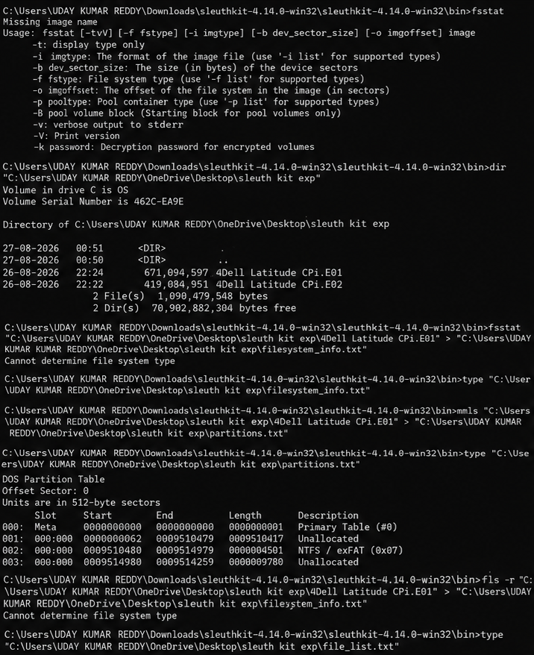

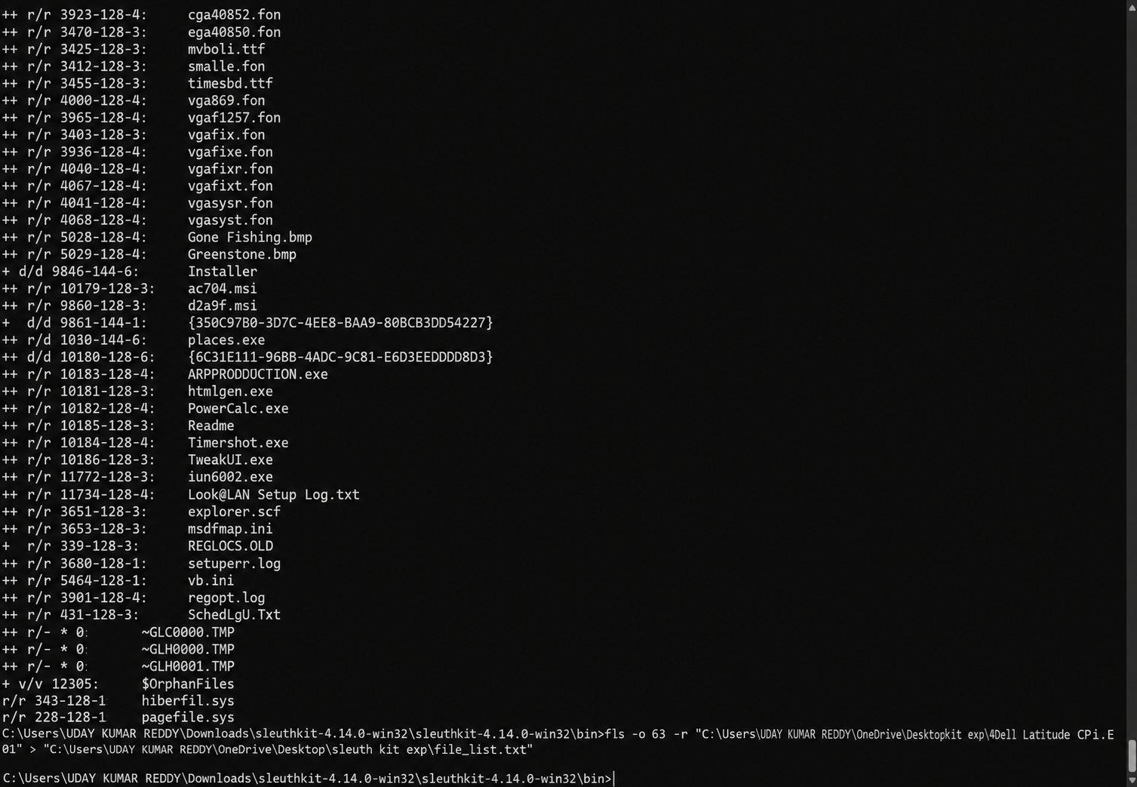
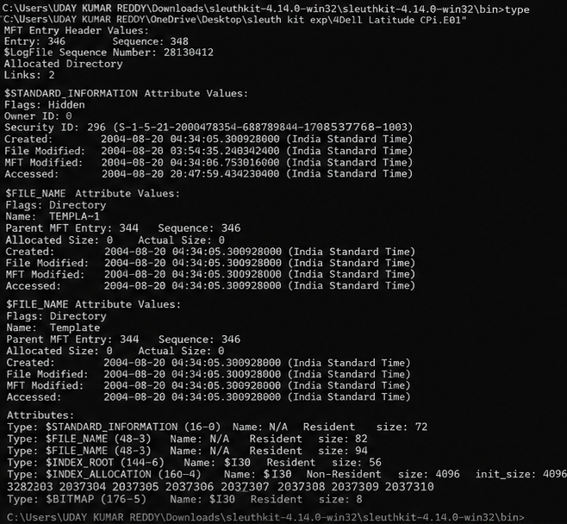

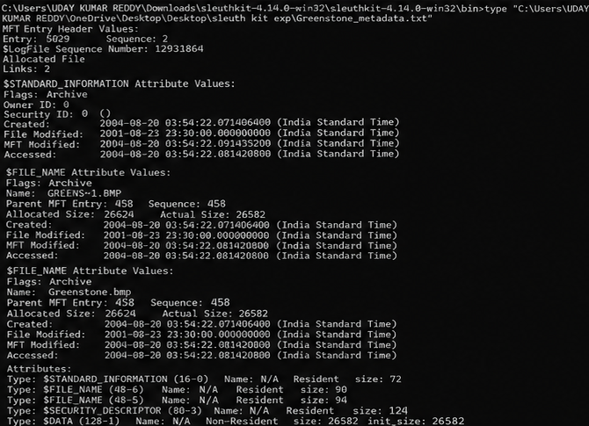

Rubrics:-
Criteria & Marks Assigned | Mark  Allotted | Mark  Awarded
1. GitHub Activity & Submission Regularity | 3
2. Application of Forensic Tools & Practical  Execution | 3
3. Documentation & Reporting | 2
4. Engagement, Problem-Solving & Team  Collaboration | 2
Total | 10

Result:-
The disk image was analyzed with mmls, fls, istat, icat, and mactime. The partitions and files were listed, a file's metadata and timestamps were extracted, and a timeline of file activity was generated.

