Scaling Certificate Issuance with
EJBCA + Autoscaling Nitro Enclaves + KMS
A PKCS#11-fronted, load-balanced signing fabric — FIPS 140-3 Level 1 software custody

Purpose | Scale workload-identity cert issuance to any volume without an HSM cluster
Signing custody | FIPS 140-3 Level 1 — Go Cryptographic Module #5247 (GOFIPS140=v1.0.0), in a Nitro Enclave
Trust anchoring | One workload sub-ICA, signed by the existing root, sealed once, shared fleet-wide
EJBCA integration | Config-loaded PKCS#11 module (no EJBCA rebuild) → mTLS → enclave fleet
Scaling | EC2 Auto Scaling Group behind an NLB; scales on sign-rate; no session affinity
Document date | 2026-07-09
Author | Kishore Mooli

1 Problem statement — why AWS CloudHSM does not fit high-scale workload identity
Workload identity at scale means issuing large volumes of short-TTL certificates, elastically, across regions, increasingly with post-quantum agility. Evaluated against that profile, an AWS CloudHSM cluster has six structural limitations. Each below is stated with the AWS-documented basis (see §11 references); where a common claim is an overstatement, it is corrected so the argument holds up to scrutiny.

1.1 Cost of an HA cluster is prohibitive at scale
CloudHSM is billed per HSM per hour, 24×7, for peak provisioned capacity — you pay whether the HSMs are saturated or idle. Per-HSM signing throughput is finite: measured ~1,600 ECDSA P-384 signatures/sec per hsm2m.medium node (P-256 ~2,500/node). At ~$1.45/HSM-hour (~$1,059/HSM-month, us-east-1), high availability needs at least two HSMs across two AZs — and because a CloudHSM cluster cannot span regions, seamless multi-region failover means a second full cluster. The table sizes each of two regions for the full P-384 load.
Signatures/sec (P-384) | HSMs / region (~1,600/HSM) | 2-region total | $ / month | $ / year
2,000 | 2 | 4 | $4,236 | ~$51k
3,000 | 2 | 4 | $4,236 | ~$51k
5,000 | 4 | 8 | $8,472 | ~$102k
8,000 | 5 | 10 | $10,590 | ~$127k
10,000 | 7 | 14 | $14,826 | ~$178k
Assumptions: measured throughput — ~1,600 ECDSA P-384 sig/sec per hsm2m.medium node (P-256 ~2,500/node); hsm2m.medium ~$1.45/HSM-hr (~$1,059/mo, us-east-1; ~10% higher in some regions); each region sized for the full load so failover is seamless, both billed 24×7 at peak regardless of utilization. The 2,000–3,000/sec rows are floored at 2 HSMs/region for AZ redundancy. N+1 (no throughput loss on a single HSM failure) adds one HSM per region. By contrast the EC2 signing fleet does ECDSA-P384 in software (thousands/sec per core) and scales with demand — a small on-demand fleet matches the HSM cluster at a fraction of the always-on cost, and KMS charges only the per-boot release.

1.2 No autoscaling — capacity must be provisioned for peak
AWS states plainly that CloudHSM clusters do not autoscale: to change capacity you add or remove HSMs yourself. There is no load-driven scaling policy, so you must provision for peak and carry that cost continuously. Adding/removing HSMs is an API call you must automate and sequence carefully, and each HSM has a hard ceiling of 2,048 open connections — a limit that, once hit under a load spike, causes application-level outages with no elastic relief valve.

1.3 Regional service — cross-region failover is manual
A CloudHSM cluster is a regional resource that cannot span regions, and AWS provides no native DR. Cross-region resilience is a manual clone: copy a cluster backup to the second region, create a cluster from it, then keep the two in sync by hand — creating users on both, syncing passwords, and syncing newly created keys. Failover is therefore an operator procedure, not a seamless regional cutover, so a regional impairment translates into a signing outage until the manual failover completes.

1.4 No production post-quantum
The algorithm set is bound to the HSM firmware — you cannot add new algorithms — and there is no production post-quantum signing (only experimental firmware PQC; ML-DSA is not GA/validated). For a PQC-ready workload PKI this is the real gap: the software enclave module can issue ML-DSA-65 and hybrid composite (ECDSA-P384 + ML-DSA-65) certificates today, which the HSM firmware cannot.

1.5 Signing is bound to firmware mechanisms — no hybrid/composite construction
Signing is limited to the firmware's mechanisms (CKM_ECDSA, CKM_RSA_PKCS/PSS). There is no room for custom signing logic or X.509 alt-signature / composite construction inside the HSM. A software signer can implement the draft-ietf-lamps-x509-alt composite and pure-PQ shapes the HSM cannot.

1.6 Metrics are infrastructure-level, with a hard connection cliff
The metrics are infrastructure signals — open connections, session/token key counts, HsmSessionCount, processor junction temperature — not signing throughput or latency. You cannot directly observe operations/sec or queue depth, which makes load-based capacity planning guesswork, and the 2,048-connection ceiling is an outage cliff you can hit before any obvious warning. Elastic, request-rate-driven autoscaling is impossible on signals like these.

1.7 Net
For high-scale workload identity — elastic demand, multi-region, PQC-ready, cost-sensitive — CloudHSM is cost-prohibitive at HA (§1.1), cannot autoscale (§1.2), needs manual cross-region DR (§1.3), is fixed to firmware algorithms with no production PQC (§1.4–1.5), and offers only infrastructure metrics with a hard connection cliff (§1.6). These make an HSM-backed workload-identity CA impractical and expensive at scale.

2 Proposed solution
Replace the HSM cluster with a PKCS#11-fronted, load-balanced fleet of AWS Nitro Enclaves that release one shared workload sub-ICA from AWS KMS under hardware attestation, and sign in-enclave. EJBCA reaches it through a config-loaded PKCS#11 module — no EJBCA rebuild — that forwards raw signatures over mTLS to the fleet.
- Elastic + cost-scaling. An EC2 Auto Scaling Group scales on sign-rate; you pay for the load you serve, not peak 24×7 HSM hours.
- Multi-region-friendly. The ICA is sealed once to inert ciphertext in SSM/Secrets Manager; any region's fleet releases the same key — no manual cluster cloning.
- PQC-capable. The software module issues ML-DSA-65 and hybrid composite certs the HSM firmware cannot.
- App-level metrics. Sign-rate, latency and NLB flow counts drive real autoscaling and capacity planning.
- No EJBCA changes. EJBCA loads a stock PKCS#11 module by config; the same signing fabric also serves cert-manager natively.
The one honest trade-off. Custody is FIPS 140-3 Level 1 (a validated software module run attested in a Nitro Enclave), not the Level 3 hardware custody CloudHSM provides. For workload-identity leaf/SVID issuance — high volume, short TTL, elastic, PQC-ready — L1-attested-in-enclave is the appropriate and far more scalable point on the curve. Reserve L3 (KMS/CloudHSM) for the offline/near-offline root.

2.1 Cost at the same loads — head-to-head
Same ECDSA P-384 loads, same two-region base. The signing tier is 2× c5.4xlarge per region (4 instances) with autoscaling. A 16-vCPU c5.4xlarge running software ECDSA-P384 is expected to sustain well above 5,000 signs/sec (now validated on AWS — see §10: a single 64-vCPU box sustained ~86,000 signs/sec, and a 4-vCPU-enclave fleet box ~11,000), so a 2-instance/region baseline covers the 10,000/sec peak with headroom — the fleet stays flat while CloudHSM must add HSMs linearly.
Sig/sec (P-384) | CloudHSM (HSMs → $/yr) | Our solution (c5.4xlarge → $/yr, on-demand)
2,000 | 4 → ~$51k | 4 → ~$24k
3,000 | 4 → ~$51k | 4 → ~$24k
5,000 | 8 → ~$102k | 4 → ~$24k
8,000 | 10 → ~$127k | 4 → ~$24k
10,000 | 14 → ~$178k | 4 → ~$24k
Our-solution assumptions: c5.4xlarge ~$0.68/hr on-demand (~$496/mo, us-east-1); 4 instances (2 per region) ≈ $1,986/mo ≈ $24k/yr. Nitro Enclaves add no charge (carved from the parent instance); NLB + per-boot KMS release + SSM add ~$1k/yr. The line is flat because 2× c5.4xlarge/region covers the peak; autoscaling adds instances only above that (and scales down off-peak). Net: ~2× cheaper at the lowest load and ~7× cheaper at 10,000/sec — and the fleet tracks demand rather than always-on peak HSM hours.

3 Architecture
EJBCA (stock, HA) builds each certificate and calls a config-loaded PKCS#11 module for the signature; the module forwards raw-sign over mTLS to an NLB in front of an autoscaling enclave-signer fleet. Every enclave released the same workload ICA from the sealed blob in SSM, so the NLB needs no session affinity.
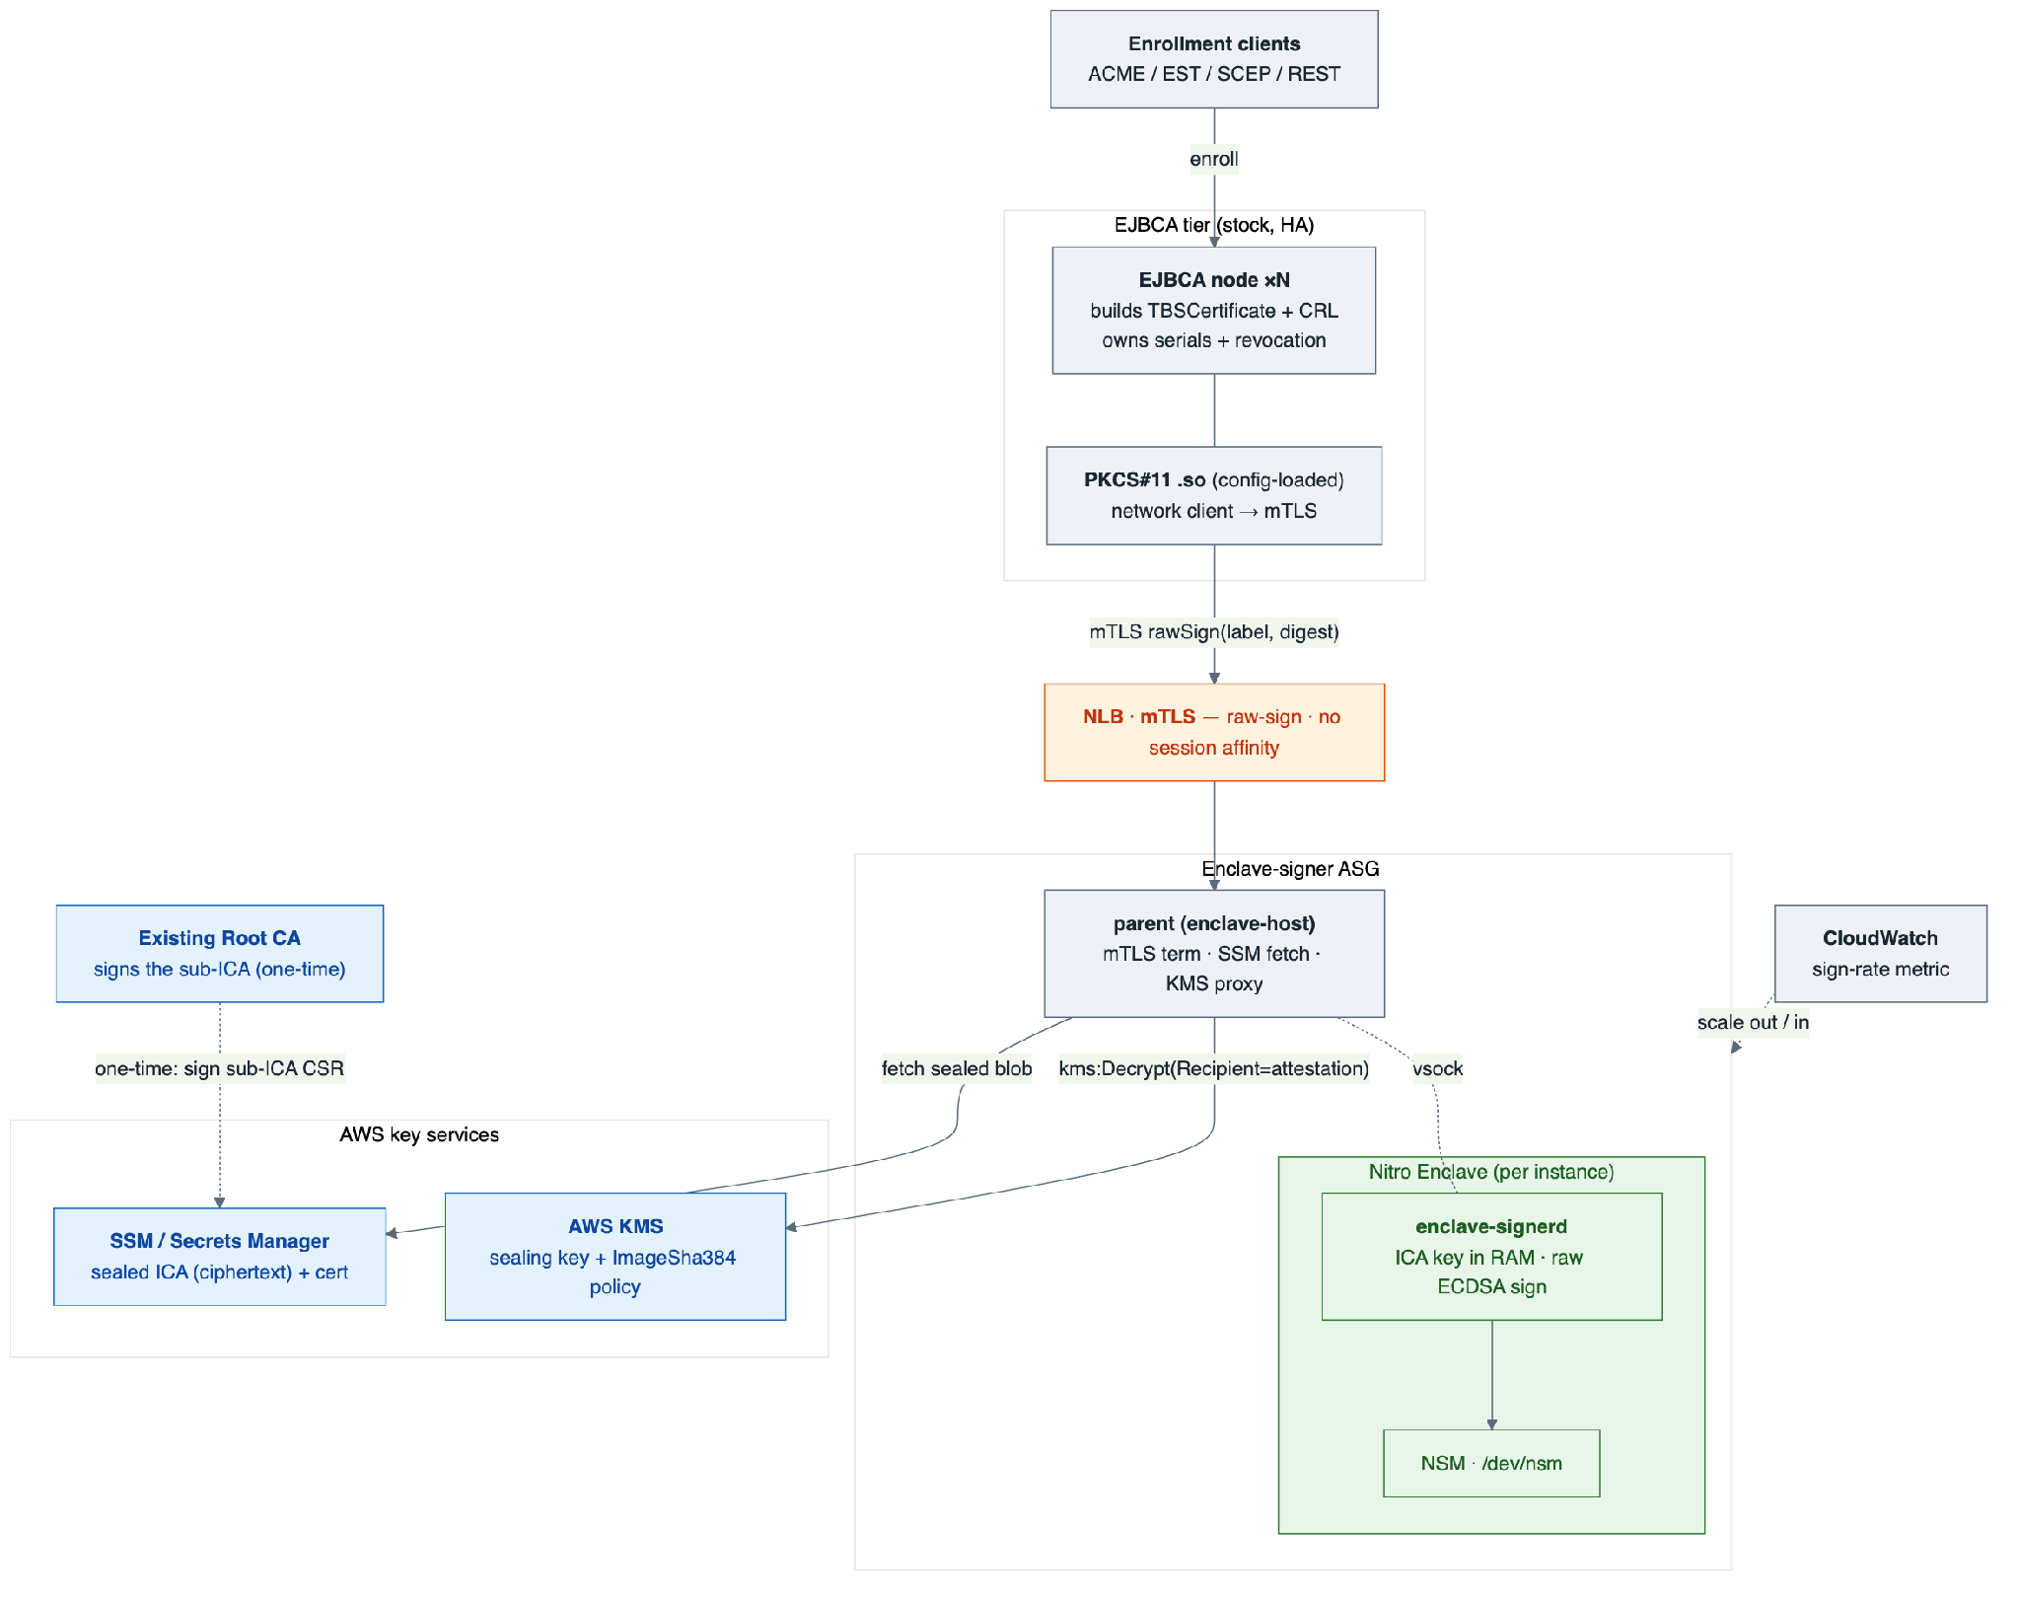
Figure 1 — EJBCA → config-loaded PKCS#11 module → mTLS NLB → autoscaling Nitro enclave-signer fleet, all releasing one shared ICA from SSM under the KMS attestation gate.

3.1 Components
Component | Role
EJBCA tier (stock, HA) | Builds TBSCertificate/CRL; owns serial space + revocation; loads the PKCS#11 module
PKCS#11 module (.so) | Config-loaded into EJBCA (no rebuild); a network client that forwards C_Sign over mTLS
NLB (mTLS) | Fronts the signer fleet; round-robins raw-sign; no affinity (replicated key)
Enclave-signer ASG | Autoscaling EC2 Nitro instances; scales on sign-rate; Spot-capable
parent (enclave-host) | mTLS termination · SSM fetch · KMS vsock proxy · vsock bridge (no key access)
Nitro Enclave (enclave-signerd) | Holds the released ICA in RAM; performs raw ECDSA/PQC signing; /dev/nsm attestation
SSM / Secrets Manager | Stores the sealed ICA (inert ciphertext) + intermediate cert
AWS KMS | Sealing key + attestation-gated release policy (kms:RecipientAttestation:ImageSha384)
Existing Root CA | Signs the workload sub-ICA once, anchoring it in the trust path

4 One-time ICA provisioning & KMS sealing
The workload sub-ICA is created and sealed exactly once — never per instance. Best practice is to generate and seal it inside a one-time bootstrap enclave so the private key is born and dies inside an enclave; only the ciphertext and cert leave.
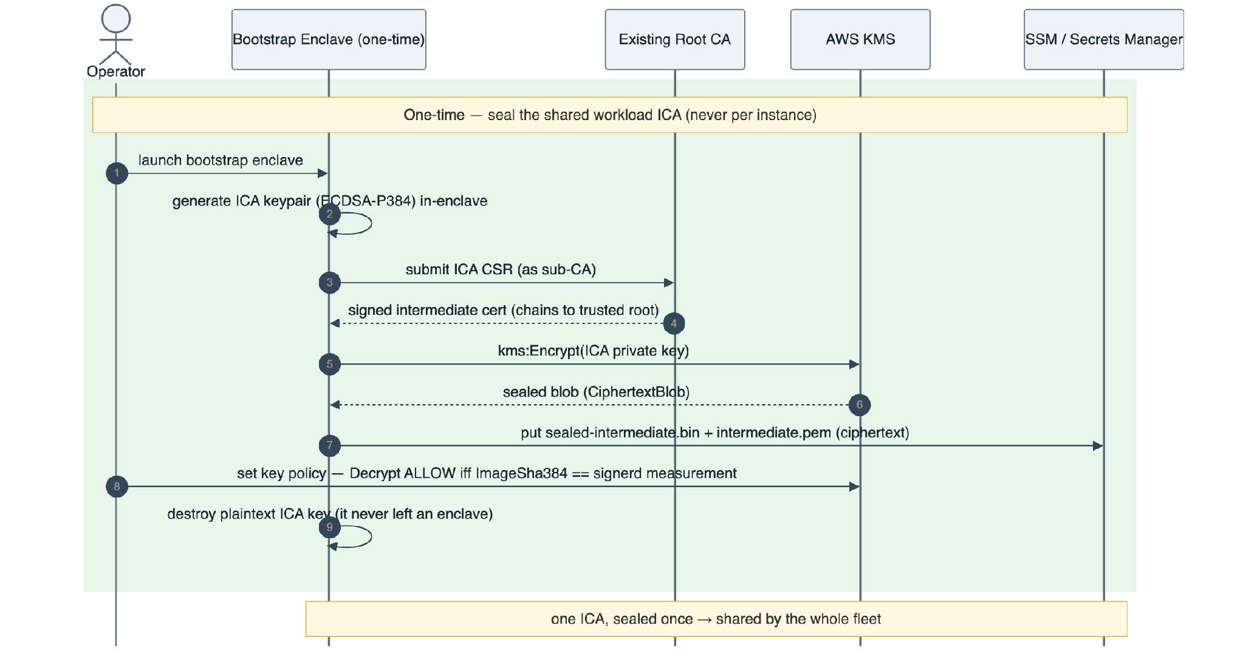
Figure 2 — One-time provisioning: generate ICA in-enclave, root signs the sub-ICA CSR, kms:Encrypt seals the key, ciphertext published to SSM, KMS policy bound to the enclave measurement.

4.1 Why one ICA, shared
Every enclave from the same image has the same measurement, so the same KMS policy releases the same key to all of them — one issuer identity across the whole fleet. Generating an ICA per instance would fork the issuer (N serial spaces, N revocation points) and defeat the model; sealing once and sharing the ciphertext is what makes autoscaling coherent.

5 Auto-scaling & attested key release
A new instance only serves traffic after it has attested and released the ICA — so the fleet grows and shrinks with load while every serving node provably holds the same key.
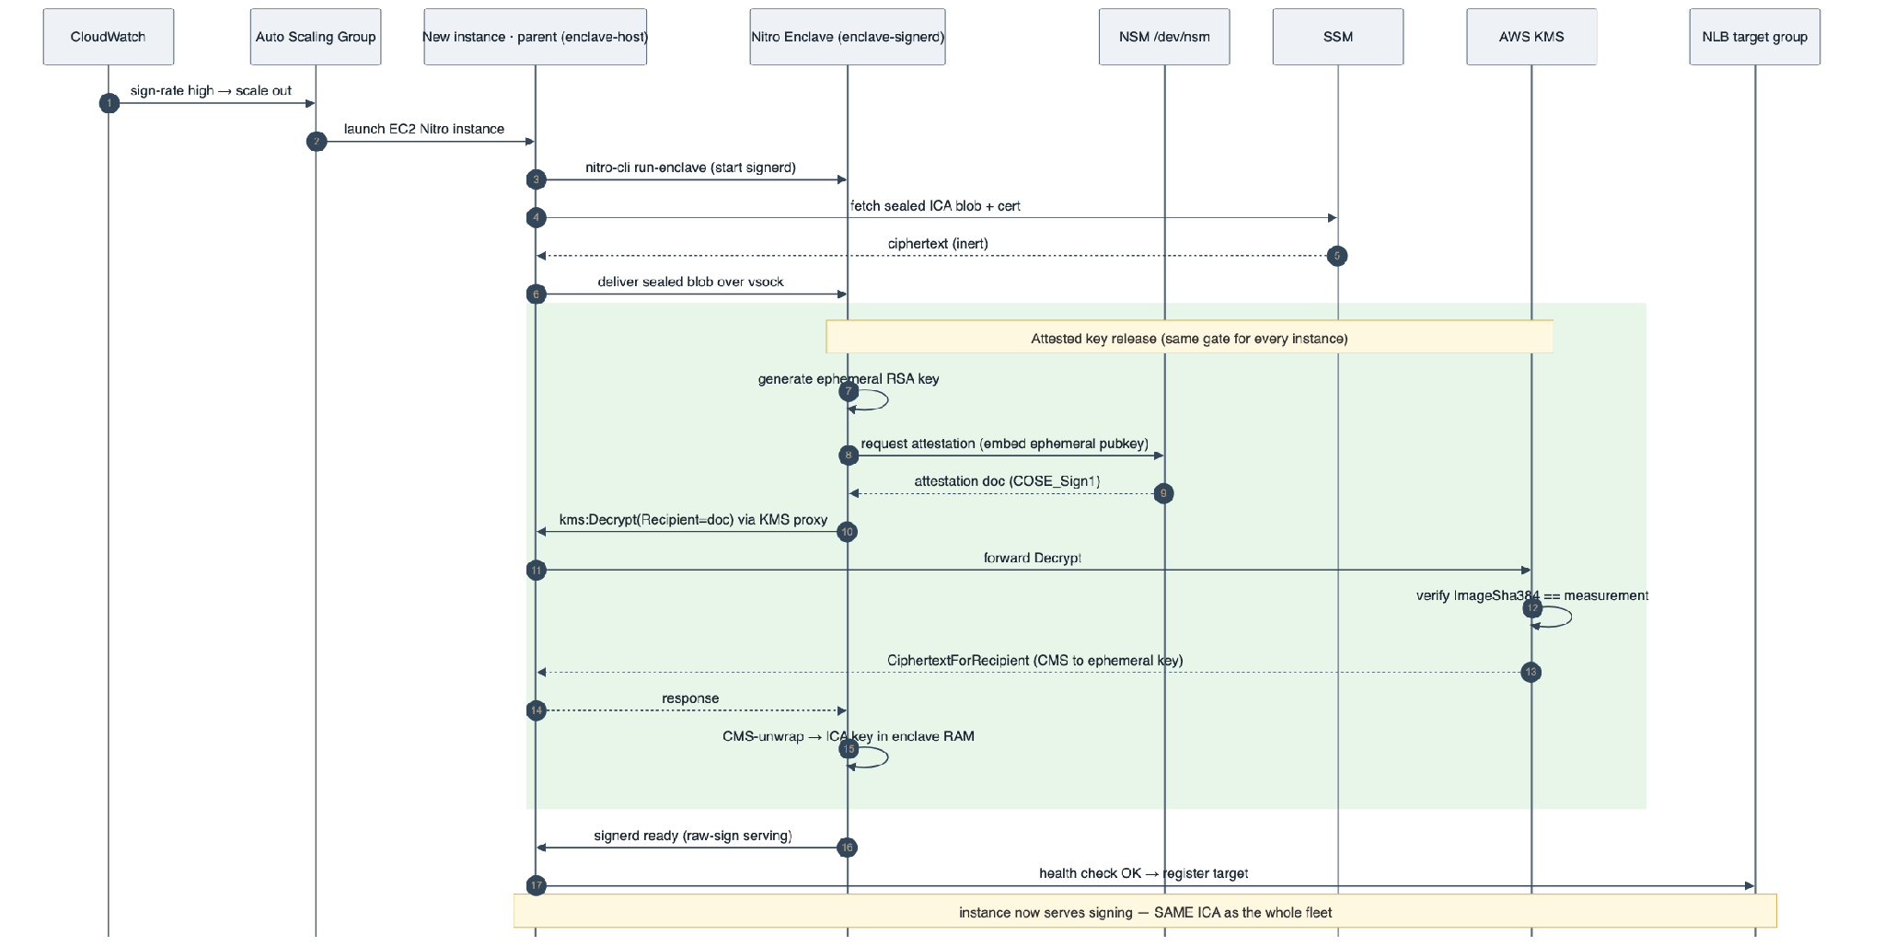
Figure 3 — Scale-out: ASG launches an instance; the enclave attests via NSM; KMS releases the ICA only if the measurement matches; the instance registers healthy and joins the NLB.

5.1 Scaling design
- Separate ASG. The enclave-signer fleet is its own Auto Scaling Group, independent of the EJBCA tier, so signing scales without scaling the JVM/DB tier.
- Scale signal. Target-tracking on raw-sign requests/sec per instance (or NLB active-flow count / CPU) — real application throughput, unlike CloudHSM's infra-only metrics.
- Attested warm-up. A new instance passes the NLB health check only after the attested release completes (a few seconds), so it never receives traffic without the key. Use a small warm pool / predictive scaling for spiky demand.
- No affinity. Replicated key ⇒ any node signs identically; the NLB round-robins and scale-in just drains connections.
- Multi-region. Stand up the same ASG + sealed blob in each region; no cluster cloning or manual key sync — the ciphertext is identical and only attested enclaves can open it.

6 Certificate signing process
EJBCA assembles the certificate and asks the token only for the private-key signature over the digest — so the enclave exposes a raw-sign primitive, not full cert assembly.
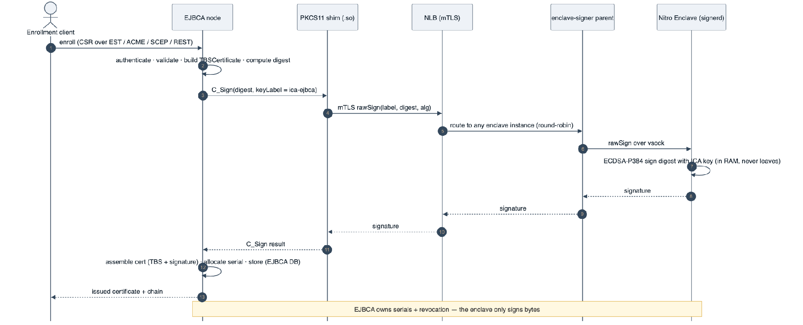
Figure 4 — Per-certificate signing: EJBCA C_Sign → PKCS#11 module → mTLS NLB → any enclave → raw ECDSA sign → back to EJBCA, which assembles and stores the cert.

6.1 What the enclave must expose
cert-manager uses full-assembly (CSR → finished cert); EJBCA needs raw-sign. Both live on the same daemon:
Consumer | Primitive
cert-manager | Full assembly — SignRequest → SignResult (exists today)
EJBCA via PKCS#11 | rawSign(keyLabel, digest, alg) → signature, plus getPublicKey / listByLabel (to add)
EJBCA references the ICA as an existing key by label (e.g. ica-ejbca) with C_GenerateKeyPair disabled — the ICA is provisioned once, never per node. EJBCA owns the serial space and revocation; the enclave only signs bytes.

7 KMS operations reference
Operation | When | Who | Control
kms:Encrypt (seal) | Once, at provisioning | Bootstrap enclave | Restricted seal role; plaintext key never leaves an enclave
kms:Decrypt + Recipient (release) | Every instance boot | The attested enclave only | Granted ONLY by kms:RecipientAttestation:ImageSha384 == measurement
Key policy | Set once, updated on image change | KMS admin | Attestation-conditioned Decrypt; instance role has NO kms:Decrypt
Pinned key ID | Every release | Enclave config | Fixed key id blocks swapped-blob-under-other-key attacks
The instance IAM role may read the SSM ciphertext but must not hold kms:Decrypt — otherwise it bypasses attestation and the host could read the key. Decrypt authority comes solely from the attestation-conditioned key-policy statement.

8 Security controls
- Attestation is the boundary. The sealed blob is inert ciphertext; only an enclave whose ImageSha384 matches the KMS policy can release the key. Distribute it freely (SSM, every host).
- No IAM decrypt. The instance role never has kms:Decrypt — the single most important control.
- mTLS-lock the raw-sign endpoint. It is a signing oracle: anyone who can call it can forge certs. Require mTLS client auth + private network + authz.
- Verify key⟷cert⟷root at release. Confirm the released key matches the pinned intermediate cert and chains to the expected root (defends against a swapped valid blob).
- Least-privilege storage. SSM write = provisioning role only; read = instance role only; versioned for rotation.
- Key never in plaintext outside an enclave. Generate+seal in a bootstrap enclave; the parent, SSM and anyone holding the blob only ever see ciphertext.

9 What to build

9.1 EJBCA side — config only, no rebuild
- Register the PKCS#11 module in conf/web.properties (library path + slot) and create a PKCS#11 crypto token in the Admin UI. Works on CE (SunPKCS11) and Enterprise (P11NG).
- The module is a network client (fork aws-kms-pkcs11): C_Sign forwards over mTLS to the NLB; implement the sign-only subset + find-by-label; disable key generation.

9.2 Enclave / fleet side
- Add rawSign(keyLabel, digest, alg) + getPublicKey + listByLabel to enclave-signerd (alongside the existing full-assembly path used by cert-manager).
- Add fetch-sealed-blob-at-boot in enclave-host (SSM/Secrets Manager → configured file) so ICA rotation needs no image rebuild.
- Add key⟷cert⟷root verification at release; swap the nitro runtime's LocalStack KMS client for the real default-chain client.
- Package the AMI/EIF, ASG, NLB, target-group health = attested-ready; target-tracking scale policy on sign-rate.

10 Validation — measured end-to-end on AWS
The proposal's throughput, autoscaling, recovery and post-quantum claims were validated on real AWS Nitro Enclaves (us-east-1, spot instances, real KMS attestation and SSM/Secrets Manager release of the sealed ICA). The full campaign cost ~$2–3 per run on spot. This section replaces the “validate by load test” projections in §2.1 and §5.1 with measured figures.
One framing point governs every number below. All ops/sec are the raw in-enclave signing ceiling — a digest arriving over mTLS → vsock → enclave and a signature returning — i.e. the HSM-equivalent throughput of the fabric. They are NOT EJBCA's certificate-issuance rate. End-to-end issuance is bounded by EJBCA (PKCS#10 parse, TBSCertificate assembly, database writes, CRL/publishing, REST), exactly as it is with any HSM. The measured result is that the signer carries far more headroom than EJBCA can consume, so the signing tier is never the bottleneck — EJBCA over this enclave performs like EJBCA over any HSM, with the custody, cost and elasticity gains on top.

10.1 Single-node signing ceiling — vertical headroom
One c8g.16xlarge (64 vCPU), sustained 15-second windows, self-signed demo ICA, zero errors. This is the ceiling one large box delivers before any horizontal scaling:
Cipher | Sustained signs/sec | Peak (tiered) | p99 (ms) | Errors
ECDSA P-384 (the sealed ICA path) | 86,069 | 88,714 | ~29 | 0
ML-DSA-65 (PQC, FIPS 204) | 55,683 | 57,757 | ~36 | 0
Hybrid ECDSA-P384 + ML-DSA-65 | 37,052 | 37,052 | ~62 | 0
This clears §2.1's “well above 5,000 signs/sec” projection by ~17× on a single box, and confirms §1.4–1.5: the software module issues ML-DSA-65 and hybrid-composite certificates — which the HSM firmware cannot — at production rates.

10.2 Elastic autoscaling fleet — horizontal scale
The §5 scaling design was run live: an ASG of c8g.2xlarge spot instances (4 vCPU carved to each enclave) behind an internal NLB, scaling on the custom enclave-CPU / backlog / p99 CloudWatch metrics of §1.6 — real application signals, not CloudHSM's infrastructure-only counters.
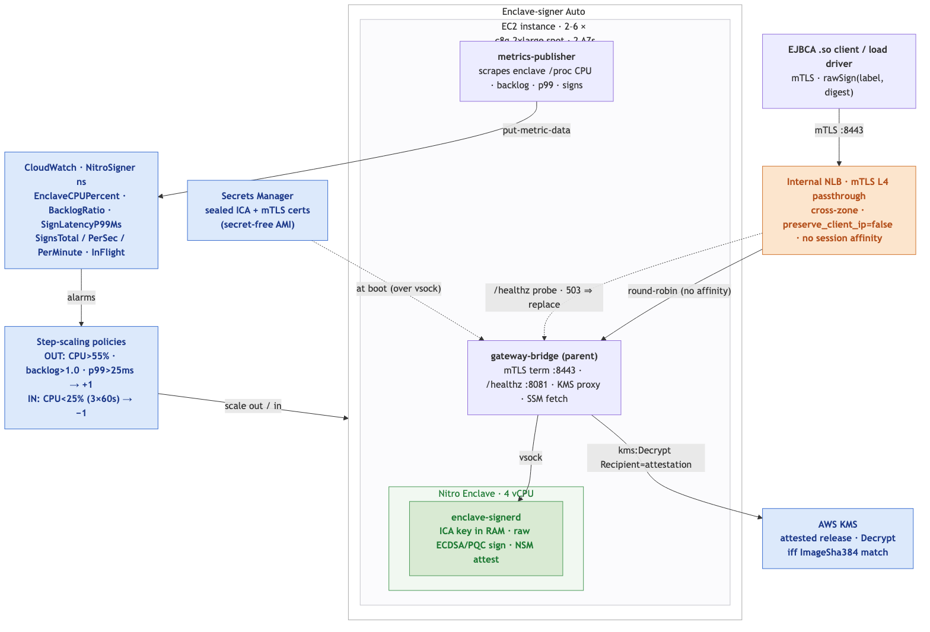
Figure 5 — Validated deployment topology: EJBCA .so → internal mTLS NLB → autoscaling c8g.2xlarge fleet (gateway-bridge → vsock → enclave-signerd), driven by custom CloudWatch metrics; sealed ICA + certs from Secrets Manager, attested KMS release.
• Per box: ~11,000 ECDSA-P384 signs/sec on 4 enclave vCPU.
• Scale-out ladder: 2 → 6 instances tracked load from ~16,700 → ~48,000 signs/sec — near-linear per-box scaling with no session affinity (every node signs identically from the same sealed ICA, §4.1).
• Scale-out latency: a new spot instance boots from the golden AMI, performs the attested KMS release (~1 min), and passes the NLB health check to accept traffic in ~3 min from the ASG decision. A 200s default-instance-warmup stops back-to-back over-provisioning while a box is still booting.
• Scale-in: drained to min=2 as load fell, releasing spot capacity — pay-for-load, not pay-for-peak.
This is the elastic behaviour §2.1/§5.1 projected, validated end-to-end — including the multi-region-shaped property (§1.3, §5.1) that every node opens the same sealed ciphertext under attestation with no key sync or cluster cloning.

10.3 Per-cipher saturation & graceful degradation
A gradual concurrency ramp per cipher mapped where each saturates and how it behaves past the knee (fleet-level figures):
Cipher | Approx. peak signs/sec | Saturates around | Behaviour past saturation
ECDSA P-256 | ~24,500 | conc ~1024 | graceful — latency rises, 0 errors
ECDSA P-384 (ICA) | ~20,500 | conc ~1024 | graceful
RSA-2048 | ~5,100 | conc ~128 | graceful
RSA-4096 | ~792 | conc ~16 | graceful (p99 → ~5s)
ML-DSA-65 | ~13,300 @ conc 512 | — | breaks at conc 2048 (see §10.5)
Classical and RSA degrade gracefully: throughput plateaus, latency climbs, errors stay at zero. Only PQC at extreme concurrency misbehaved — the subject of §10.5.

10.4 Chaos & self-healing — recovery
To exercise the §5 failure story, a healthy fleet node was killed under full load:
• Impact: 696 failed requests during the ~40-second NLB deregistration window (in-flight connections to the dead node).
• Recovery: the NLB rerouted to surviving nodes, the ASG launched a replacement (attested release → healthy), and fleet throughput self-healed back to ~48,000 signs/sec — no operator action, no key re-sync.
This is the seamless node loss that CloudHSM's manual cross-region DR (§1.3) cannot match: fleet capacity is fungible and replaced automatically.
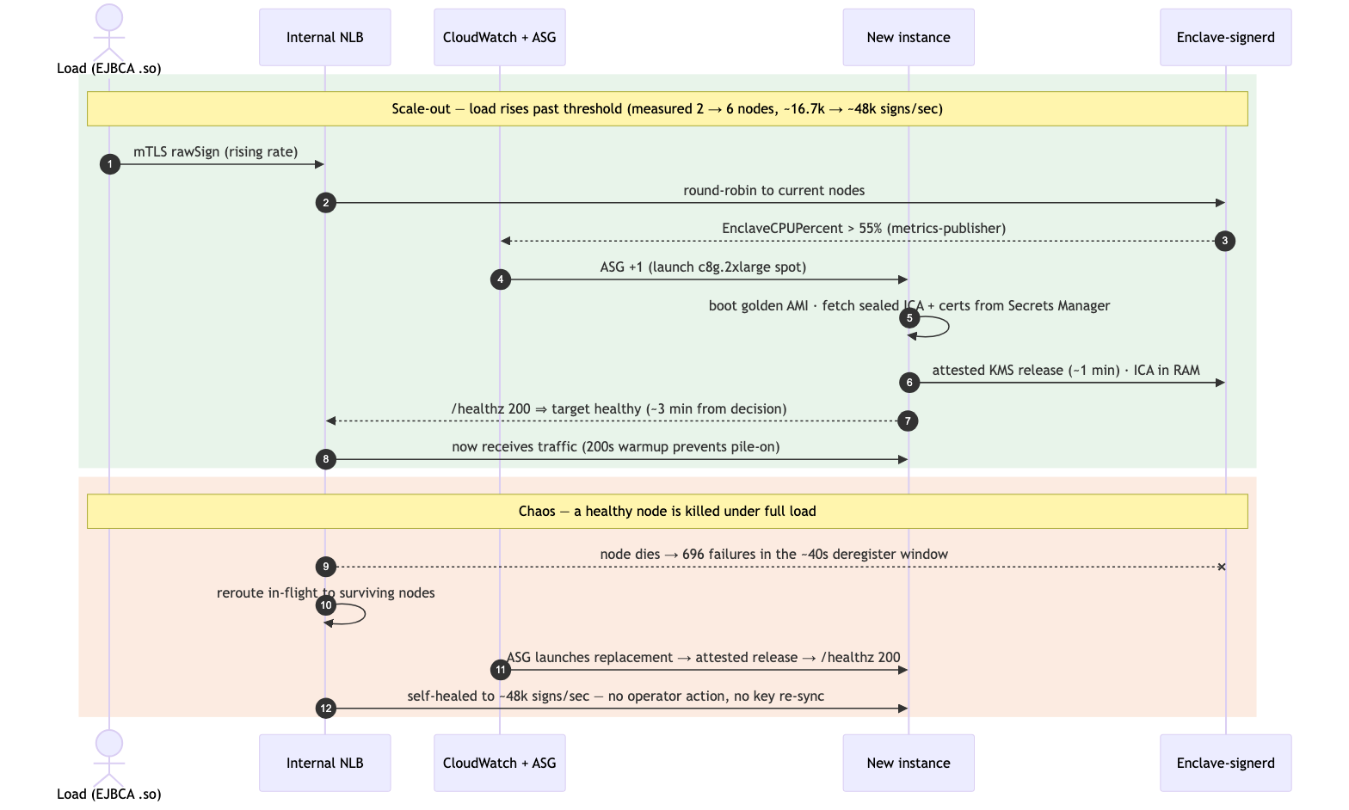
Figure 6 — Measured scale-out and chaos/recovery: metric breach → ASG +1 → attested release → healthy in ~3 min; a killed node self-heals to ~48,000 signs/sec (696 failures in the ~40s deregister window).

10.5 Finding & fix — enclave-aware health for PQC saturation
The one real defect the campaign surfaced, with the corrective control now in the design:
• Finding: ML-DSA-65 / hybrid at very high concurrency (conc 2048) exhausts enclave memory and wedges enclave-signerd — it does not self-recover, and a plain TCP health check stayed green while the box served errors. PQC signatures are ~3.3 KB each; 2048 concurrent in a memory-bounded enclave is the trigger.
• Fix (committed): an enclave-aware /healthz on the parent's gateway-bridge (plain HTTP so the NLB can probe it) that reaches the enclave over vsock with a 3s timeout. A hung enclave → 503 → the NLB marks the target unhealthy → the ASG replaces it. It is declarative: the app only exposes health; the infrastructure (NLB + ASG) detects and acts — no AWS API calls or SetInstanceHealth IAM on the box.
• Residual (root cause, tracked): bound PQC concurrency (a semaphore on ML-DSA signs) and/or raise enclave memory before trusting PQC at extreme concurrency; classical and RSA already degrade gracefully.

10.6 What this validated
Mapped back to the six structural limits of §1:
• Cost & elasticity (§1.1–1.2): the fleet scaled 2→6 with load and back to 2 — pay-for-load, not always-on peak HSM hours.
• Autoscaling on real metrics (§1.6): enclave-CPU / backlog / p99 drove scale-out — application throughput, not infra-only counters.
• Multi-region shape (§1.3): every node released the same sealed ICA under attestation — no manual clone, no key sync.
• Production PQC (§1.4–1.5): ML-DSA-65 and hybrid composite issued at tens-of-thousands of signs/sec.
• Resilience (§5): node loss self-healed automatically; no operator failover.
• Custody: signing stayed in-enclave throughout; the parent saw only digests-in / signatures-out, never key material.

10.7 Deployment parameters — as tested
The exact fleet configuration exercised in §10, taken from the deploy scripts (enclave/deploy/ha) — the hard operational settings behind the measured behaviour:
Parameter | Value (as tested)
Fleet / instance | c8g.2xlarge spot · 4 vCPU carved to the enclave · 40 GB gp3 · 2 AZs
ASG sizing | min 2 · max 6 · desired 2 · health-check-type ELB · grace 240s · default-instance-warmup 200s
Load balancer | internal NLB · TCP :8443 L4 mTLS passthrough · cross-zone on · preserve_client_ip=false · dereg delay 30s
Health check | HTTP /healthz :8081 — enclave-aware (parent probes the enclave over vsock, 3s timeout) · interval 10s · healthy 2 / unhealthy 2
Scale-out (any of) | EnclaveCPUPercent > 55% (1×60s) · BacklogRatio > 1.0 · SignLatencyP99Ms > 25ms → +1
Scale-in | EnclaveCPUPercent < 25% for 3×60s → −1
CloudWatch metrics (NitroSigner ns) | EnclaveCPUPercent · BacklogRatio · SignLatencyP99Ms · SignsTotal · SignsPerSec · SignsPerMinute · InFlight (per InstanceId + per ASG)
Boot provisioning | sealed ICA + mTLS certs fetched from Secrets Manager, delivered over vsock — secret-free golden AMI (nothing sensitive baked in the image)
Environment / cost | us-east-1 · spot instances · ~$2–3 per full validation run

11 References
- AWS CloudHSM — Pricing — https://aws.amazon.com/cloudhsm/pricing/
- AWS CloudHSM — Performance — https://docs.aws.amazon.com/cloudhsm/latest/userguide/performance.html
- AWS CloudHSM — Scaling HSMs (add/remove; no autoscaling) — https://docs.aws.amazon.com/cloudhsm/latest/userguide/add-remove-hsm.html
- AWS CloudHSM — Resilience / DR (regional; manual) — https://docs.aws.amazon.com/cloudhsm/latest/userguide/disaster-recovery-resiliency.html
- AWS Security Blog — How to clone a CloudHSM cluster across regions — https://aws.amazon.com/blogs/security/how-to-clone-an-aws-cloudhsm-cluster-across-regions/
- AWS CloudHSM — PKCS#11 supported mechanisms — https://docs.aws.amazon.com/cloudhsm/latest/userguide/pkcs11-mechanisms.html
- AWS CloudHSM — CloudWatch metrics — https://docs.aws.amazon.com/cloudhsm/latest/userguide/hsm-metrics-cw.html
- AWS CloudHSM — Cluster management best practices (2,048 connections) — https://docs.aws.amazon.com/cloudhsm/latest/userguide/bp-cluster-management.html
- AWS KMS — Pricing — https://aws.amazon.com/kms/pricing/
- Amazon EC2 — c5.4xlarge pricing/specs — https://instances.vantage.sh/aws/ec2/c5.4xlarge
- Amazon EC2 — Spot Instances pricing — https://aws.amazon.com/ec2/spot/pricing/
- AWS Nitro Enclaves — Concepts (vsock, KMS attestation) — https://docs.aws.amazon.com/enclaves/latest/user/nitro-enclave-concepts.html
- EJBCA — Generic PKCS#11 Provider — https://docs.keyfactor.com/ejbca/latest/generic-pkcs-11-provider
- aws-kms-pkcs11 — PKCS#11 provider (fork base) — https://github.com/JackOfMostTrades/aws-kms-pkcs11

