Tab 10: False Positive Optimization — Continuous Learning Pipeline
DLP programs live or die by false positive rates. A rule that blocks 40% legitimate traffic is worse than no rule — analysts stop trusting alerts, end users escalate, and the security team loses credibility. The seven-layer FP elimination stack (Tab 6.4) handles authoring-time prevention. This section covers what happens after deployment — how production FP signals feed back into rule improvement through two complementary workflows.

10.1 Workflow 1: User-Driven FP Feedback with Intelligent Recommendations
When an analyst marks an alert as a false positive, the system doesn't just log it — it analyzes the blocked content to recommend specific suppression tags that would prevent similar FPs in the future, with the analyst approving each recommendation before it takes effect.

How It Works
Step 1: Analyst marks an alert as false positive.
The analyst reviews a blocked transaction in the incident queue and marks it FP. The system captures the analyst verdict (true_positive / false_positive / false_negative / inconclusive), free-form notes, and time-to-review — all stored in the retroactive decision record for ML training eligibility.
Step 2: System analyzes the blocked content and generates suppression recommendations.
Three recommendation algorithms run in parallel against the content surrounding the matched value:
Algorithm | What It Does | Confidence | Example
Near-miss labels | Extracts 1-3 token phrases from the context window and compares against the entity type's existing suppression list using root-word matching and edit-distance similarity (<40% Levenshtein). Surfaces candidates that are *close to* but *not yet in* the suppression set. | Medium | Rule suppresses "order number" but context contains "order ref" — suggested as a near-miss variant
Proximity labels | Extracts the phrase immediately before the matched value (40-char window). High-confidence signal — if a field label like "tracking #" or "reference id" precedes the matched digits, that label is almost certainly the reason for the FP. | High | Content: Job Token: 576-84-1234 — "job token" extracted as proximity label
KB cross-entity history | Checks whether any label already approved by a human for a *different* entity type appears in the current context. A label validated for SSN suppression that also appears near a credit card match is strong evidence it's a benign domain phrase. | Highest | "customer id" was approved for SSN → now appears near a credit card match → suggested with "previously approved for SSN" note

Step 3: Analyst reviews and approves recommendations (human-in-the-loop).
Each suggestion is presented with:
- The candidate label and why it was recommended
- The context snippet showing where it appeared relative to the match
- The source signal (near-miss, proximity, midlane downgrade, Luhn failure, KB history)
- The similar existing label it was compared against (if any)
The analyst approves, modifies, or rejects each suggestion. No suppression is applied without explicit human approval.
Step 4: Approved label takes effect immediately and durably.
On approval, three stores update atomically:
- FastLane runtime overlay — the suppression label is pushed to the detection engine's in-process memory via hot-reload. Takes effect on the next scan — no restart, no redeployment.
- In-memory learned labels — future suggestion runs reflect the new label immediately, preventing duplicate recommendations.
- OPA policy store — the authoritative durable record. Hydrated on startup, auditable, tagged with who approved it and when.
The label is normalized to the entity family root (e.g., CREDIT_CARD_VISA → CREDIT_CARD) so a single approval covers all sub-type variants.

Signal Amplification from ML
The recommendation engine gains additional signal from the MidLane ML classifier. When the ML model classifies a FastLane BLOCK as a false positive (action=DOWNGRADE), the system:
- Elevates all suggestions for that finding to midlane_downgrade source (higher confidence)
- Activates proximity label extraction even for findings that wouldn't normally qualify
- Includes the ML model's reasoning in the suggestion note (e.g., "MidLane: content classified as benign business document")
Similarly, Luhn validation failures for credit card patterns are treated as high-confidence FP signals — a sequence that looks like a credit card number but fails the Luhn checksum is almost certainly not a real card number, and the surrounding context likely contains a suppression-worthy label.

10.2 Workflow 2: ML-Driven Suppression Discovery via Clustering
While Workflow 1 is reactive (analyst marks FP → system recommends), Workflow 2 is proactive — the system periodically analyzes accumulated FP data to identify systemic suppression opportunities that no individual analyst would notice.

The Problem It Solves
An analyst reviewing a single FP sees one context. But across thousands of FP events, patterns emerge:
- 200 SSN FPs all have "employee id" or "badge number" in the context — but neither label is in the suppression list
- Credit card FPs cluster around invoice templates from three specific vendors
- Driver's license FPs spike every Monday morning when HR runs a batch report
Individual analysts can't see these patterns. Clustering can.

How It Works
Stage 1: Feature extraction from FP corpus.
For every confirmed FP (analyst verdict or ML downgrade), the system extracts:
- Context tokens (1-3 word phrases from the surrounding text)
- Entity type and sub-type
- Channel (email, web, USB, cloud, print)
- Content structure (email header, table cell, code block, URL, file path)
- Temporal features (time of day, day of week, recurring patterns)
- Source metadata (sender domain, application, file type)
Stage 2: Clustering to identify suppression candidates.
The extracted features feed into unsupervised clustering:
Technique | Purpose | Output
TF-IDF + K-Means on context tokens | Group FPs with similar surrounding text | Clusters of FPs that share the same context phrase (e.g., "patient mrn", "case number") — each cluster centroid is a candidate suppression label
DBSCAN on temporal-channel features | Detect recurring FP bursts | Scheduled jobs or batch processes that trigger FPs at predictable intervals — candidates for time-based or source-based scope exclusions
Hierarchical clustering on entity+context | Find cross-entity suppression opportunities | Labels that cause FPs across multiple entity types (e.g., "reference" triggers FPs for SSN, credit card, and phone number) — candidates for global suppression rules

Stage 3: Leverage existing suppressors.
Before recommending new suppression tags, the system cross-references against:
- The existing pattern_fp_labels.json database (1,000+ entity-specific suppression rules with context windows and confidence deltas)
- Previously approved learned labels in OPA
- Cross-entity approval history (a label approved for one entity type is pre-validated for others)
This prevents duplicate recommendations and surfaces gaps — "you suppress 'order number' and 'order ref' for credit cards, but not 'order id' which appears in 47 FPs this month."
Stage 4: Recommendation generation with evidence.
Each cluster that exceeds a configurable threshold (e.g., 10+ FPs with the same context pattern) generates a recommendation:
RECOMMENDATION: Add "badge number" as suppression label for SSN
Evidence: 234 FPs in last 30 days with "badge number" in context
Cluster size: 234 events across 12 channels
Affected rules: SSN-US-BASIC, SSN-US-ENHANCED
Existing similar labels: "employee id" (already suppressed)
Estimated FP reduction: ~2.1% of total SSN FPs
Confidence: HIGH (consistent context, single phrase, cross-channel)
Stage 5: Human review and batch approval.
Recommendations are surfaced in the Composer UI as a periodic "FP Optimization Report" — not auto-applied. The security team reviews each recommendation with full evidence, approves or rejects in batch, and approved labels flow through the same three-store update path as Workflow 1.

Active Learning Integration
The clustering pipeline connects to the broader active learning loop:
- Uncertainty sampling — Findings where the ML classifier confidence falls between 0.4-0.7 are routed to the analyst review queue (maximizes information gain per human review)
- Disagreement sampling — When FastLane says BLOCK but MidLane says ALLOW, the disagreement is prioritized for analyst review (these are the most informative training examples)
- Diversity sampling — Embedding-based clustering ensures the analyst queue covers all content archetypes, not just the most frequent patterns
- Feedback cadence — Weekly batch retraining of the ML classifier incorporates all analyst verdicts from the past week; daily micro-updates adjust confidence thresholds

Drift Detection
The clustering pipeline also monitors for rule drift — an established rule whose FP rate is rising over time:
- Per-rule FP rate tracked as a time series
- Alert when FP rate exceeds 2x the 30-day moving average
- Root cause analysis: is it a new data source, a format change, a seasonal pattern, or a genuine rule degradation?
- Recommendation: add suppressions, adjust thresholds, or flag for manual rule review

10.3 The Three Maturity Levels
These two workflows operate at different maturity levels, deployed incrementally:
Level | Workflow | Human Involvement | FP Rate Impact
Level 1: Manual + Recommendations | Analyst marks FP → system recommends suppression labels → analyst approves | High — every label requires approval | Reduces FP investigation time from ~15 min to ~2 min per incident
Level 2: ML-Assisted Clustering | Clustering identifies systemic FP patterns → batch recommendations with evidence → security team reviews weekly | Medium — batch review, not per-incident | Catches patterns invisible to individual analysts; estimated 30-50% FP reduction over 6 months
Level 3: Autonomous with Guardrails | High-confidence recommendations (KB cross-entity, >100 FP cluster, <0.3 ML confidence) auto-apply with 24-hour rollback window | Low — review-by-exception, auto-applied labels flagged in audit log | Continuous improvement without analyst bottleneck; target <5% FP rate

Level 3 is the long-term vision. Level 1 is implemented and validated in prototype. Level 2 is designed and partially implemented (feature extraction and suggestion algorithms exist; clustering pipeline is specified but not yet in production).

10.4 Data Architecture
The feedback loop requires specific data capture at each stage:
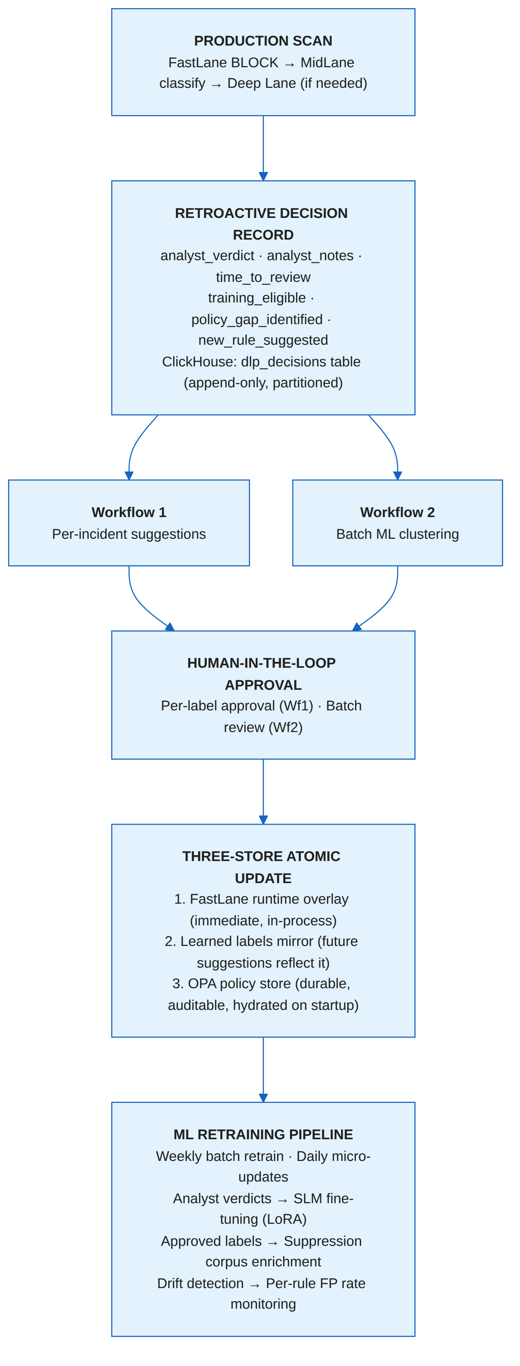

10.5 Why This Matters
No DLP vendor today implements a closed-loop FP feedback pipeline. Every vendor we evaluated (Trellix, Proofpoint, Symantec, Palo Alto, Netskope, Zscaler, Skyhigh, Forcepoint) treats FP handling as a manual, per-incident process: analyst sees FP → analyst edits rule → analyst redeploys. There is no systemic learning, no cross-entity knowledge transfer, no clustering-based discovery.
This is the gap. A DLP system that gets measurably better over time — not because an engineer manually tuned it, but because every analyst interaction and every ML classification feeds back into the suppression corpus — is fundamentally different from a system that stays as good as its last manual update.
The conservative target: FP rates below 10% initially (seven-layer prevention), declining to below 5% within 6 months of production deployment as the feedback loop matures. The mechanism is concrete: more analyst verdicts → richer suppression labels → fewer FPs → less analyst time per remaining FP → faster verdicts → more training data → better ML → cycle continues.

