PERFORMANCE STUDY
EJBCA Load Characteristics with a Lightweight Enclave HSM

Benchmarking EJBCA's true issuance ceiling without CloudHSM cost, latency, or connection limits
NitroEnclave · elastic enclave signer
Measured on AWS · us-east-1 · 0 errors
1 Thesis
Use the elastic enclave signer as a lightweight, high-throughput HSM to measure EJBCA's OWN load characteristics — without CloudHSM cost, latency, or connection limits distorting the result.
The signer is never the bottleneck
The enclave signer's raw ceiling (~8.6k signs/sec/box) sits far above EJBCA's issuance rate, so it never throttles the test. Whatever number you measure is EJBCA itself — not the HSM in front of it.

2 Why benchmark EJBCA this way
- Removes the HSM as a variable — The signer's raw ceiling (~8.6k/box) is far above EJBCA's issuance rate, so the HSM never throttles the test — you see EJBCA's real ceiling.
- No CloudHSM complexity/cost — No cluster to stand up, no per-HSM 24/7 bill, no connection cliff. Spin the enclave signer up on spot EC2, benchmark, tear down.
- Full cipher coverage incl. PQC — Benchmark RSA/ECDSA and ML-DSA/hybrid profiles that CloudHSM firmware cannot issue at all.
3 Method
We drove real PKCS#10 enrollments with cmd/enroll-loadtest against a single EJBCA CE node. The NitroEnclaveCA CryptoToken forwards every C_Sign over mTLS to the in-enclave ICA (ECDSA P-384), which signs the digest and returns the signature — EJBCA never sees the private key. Leaf certificates were ecdsa-p256; concurrency was swept across 16 / 32 / 64 clients at 2000 certs per run, with 0 errors on every run.
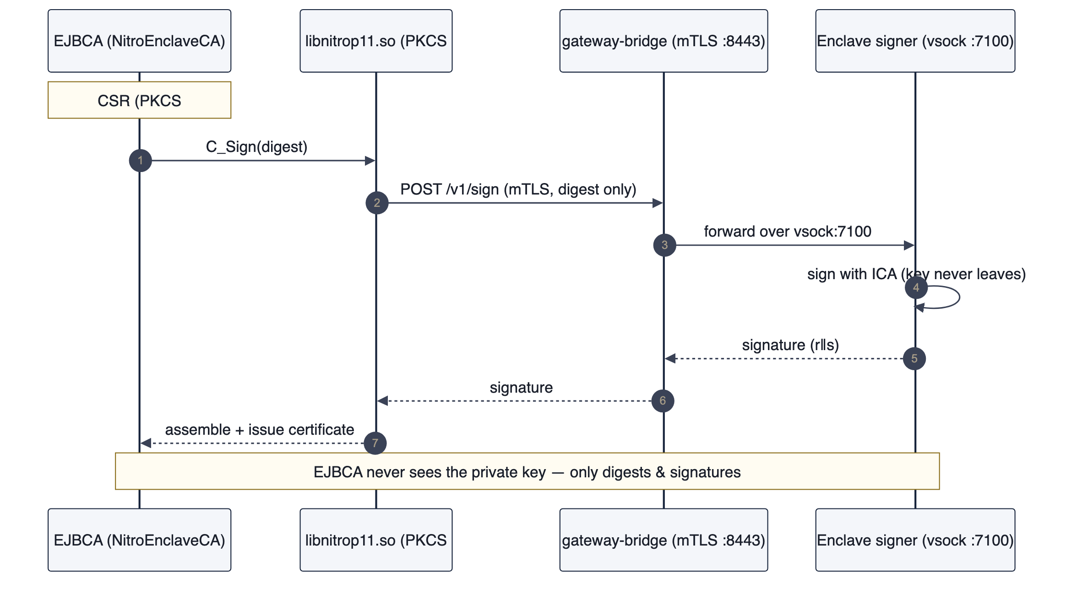
Each enrollment: EJBCA → PKCS#11 .so → gateway → in-enclave sign → issued cert.
4 Results
Concurrency | certs/sec | note
16 | 767 | warming
32 | 895 | peak
64 | 805 | saturated — p99 ~2× conc32
EJBCA peaked at ~895 certs/sec and then regressed past concurrency 32 (conc 64 fell to 805 with roughly double the p99 latency). The bottleneck is EJBCA's own parse / assemble / DB-write pipeline — not the signer behind it.
5 Interpretation — the signer is not the limit
The raw enclave sign ceiling is ~8,600 signs/sec on a single box (ecdsa-p384) — about 10× the EJBCA issuance rate. EJBCA saturates first, by a wide margin, so the measured ~895 certs/sec is a clean read on EJBCA's own capacity with the HSM removed as a variable.
Exactly the number you want
This is exactly the number you want when sizing EJBCA — its own ceiling, with the HSM removed as a variable.

6 Bonus — full cipher coverage incl. PQC
The same signer benchmarks RSA and ECDSA alongside ML-DSA / hybrid profiles that CloudHSM firmware cannot issue at all — so a single elastic signer covers both classical and post-quantum sizing on one test rig.
Cipher | signs/sec (enclave ceiling)
ECDSA P-384 | 7530
ML-DSA-65 (PQC) | 6261
ML-KEM-1024 | 8478
RSA-4096 | 497
7 Takeaways for an EJBCA deployment
- Plan for EJBCA's ceiling, not the HSM's — size each EJBCA node to ~800–900 certs/sec and scale horizontally — add nodes, not a bigger HSM.
- The enclave HSM adds capability, not drag — custody (FIPS 140-3 L1, key never leaves the enclave), native PQC, and spot-EC2 elasticity — without becoming the bottleneck.
- No CloudHSM needed — no cluster to stand up, no per-HSM 24/7 bill, no connection cliff — for the benchmark or for production.
- One rig, honest numbers — remove the HSM as a variable and you measure EJBCA truthfully; the same rig then sizes classical and post-quantum profiles side by side.

