 南昌大学实验报告
学生姓名： 丁俊 学 号： 8003119100 专业班级： 信息安全193班
实验类型：□ 验证 □ 综合 □ 设计 □ 创新 实验日期： 5.4 实验成绩：

一、实验项目名称
实验二: JavaScript
二、实验目的
1.掌握在网页中加入JavaScript的方法
2.掌握JavaScript中的变量定义和使用方法
3.掌握使用JavaScript动态函数处理页面的方法
4.掌握事件驱动及事件处理的操作模式
三、实验要求
1.．要求使用JavaScript动态函数实现一个动态菜单
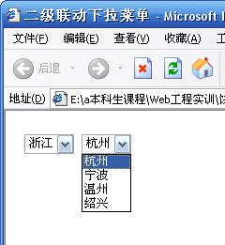

- 利用函数的方式实现九九乘法表，并以倒序的形式显示（9*9在第一行，1*1在最后一行）。

3. 分别利用if以及switch实现输入框中60分以下，60~70，70~80，80~90，90~100的判断

4. 分别利用while与do…while实现100以内偶数求和

5．输入信息的验证
实现一个注册页面，如下图所示，能根据用户所填写信息的错误给出相应的提示，如果正确，进入下一个页面。其中要求所有信息不为空，密码与密码确认相同，email中@和.不能有两个，且不能在首部和尾部。同时在状态栏显示动态日期和时间。
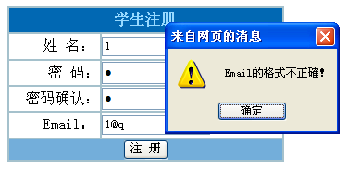
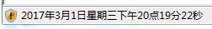

四、主要仪器设备及耗材
Windows10、vscode、gcc、2020.2
五、实验步骤
1、动态菜单
实验代码
- <!DOCTYPE html>
- <html lang="en">
- <head>
- <meta charset="UTF-8">
- <meta http-equiv="X-UA-Compatible" content="IE=edge">
- <meta name="viewport" content="width=device-width, initial-scale=1.0">
- <title>javascript动态菜单</title>

- <script type = "text/javascript">
- var aCity = new Array();
- aCity[0] = new Array();
- aCity[1] = new Array();
- aCity[2] = new Array();
- aCity[3] = new Array();
- aCity[4] = new Array();
- aCity[5] = new Array();
- aCity[6] = new Array();
- aCity[0][0] = "--请选择--";
- aCity[1][0] = "--请选择--";
- aCity[1][1] = "宁波";
- aCity[1][2] = "温州";
- aCity[1][3] = "绍兴";
- aCity[1][4] = "金华";
- aCity[1][5] = "杭州";
- aCity[1][6] = "义务";

- aCity[2][0] = "请选择";
- aCity[2][1] = "南昌";
- aCity[2][2] = "宜春";
- aCity[2][3] = "吉安";
- aCity[2][4] = "萍乡";
- aCity[2][5] = "九江";
- aCity[2][6] = "赣州";

- aCity[3][0] = "请选择";
- aCity[3][1] = "东莞";
- aCity[3][2] = "深圳";
- aCity[3][3] = "阳江";
- aCity[3][4] = "广州";
- aCity[3][5] = "珠海";
- aCity[3][6] = "惠州";

- aCity[4][0] = "请选择";
- aCity[4][1] = "长沙";
- aCity[4][2] = "湘潭";
- aCity[4][3] = "衡阳";
- aCity[4][4] = "岳阳";
- aCity[4][5] = "张家界";
- aCity[4][6] = "益阳";

- aCity[5][0] = "请选择";
- aCity[5][1]="新城区";
- aCity[5][2]="碑林区";
- aCity[5][3]="莲湖区";
- aCity[5][4]="雁塔区";
- aCity[5][5]="灞桥区";
- aCity[5][6]="长安区";

- aCity[6][0] = "请选择";

- function ChangeCity()
- {
- var i,ProvinceIndex;
- ProvinceIndex = document.frm.optProvince.selectedIndex;
- CityCount = 0;
- while(aCity[ProvinceIndex][CityCount] != null)
- {
- CityCount++;
- }
- document.frm.optCity.length = CityCount;
- for(i = 0; i <= CityCount-1;i++)
- document.frm.optCity[i] = new Option(aCity[ProvinceIndex][i]);
- document.frm.optCity.focus();
- }
- </script>
- </head>
- <body onfocus="ChangeCity()">
- <h3>选择省份和城市</h3>
- <form name = "frm">
- <p>省份: <select name = "optProvince" size = "1" onchange="ChangeCity()">
- <option>--请选择--</option>
- <option>浙江省</option>
- <option>江西省</option>
- <option>广东省</option>
- <option>湖南省</option>
- <option>陕西省</option>
- <option>山东省</option>
- </select>

- </p>
- <p>城市:
- <select name = "optCity" size = "1">
- <option>--请选择--</option>
- </select>
- </p>
- </form>
- </body>
- </html>
首先在js动态函数ChangeCity()中，定义了一个二维数组，每一维分别存储一个省份对应下的城镇。两个下拉列表的name表示名称，当第一个下拉列表选择了对应的省份，有一个onChange属性表示元素值改变时触发ChangeCity函数。
通过optProvince.selectedIndex获取省份所在二维数组中的序号，并将对应的第二维中的城镇赋值给第二个下拉列表中的内容，然后使用optCity.focus()获取焦点自动把光标移动到此组件上面。因此实现了第一个列表改变时第二个列表也随之更新内容，就可以一个省份对应相应的城市了。

2、九九乘法表
实验代码
- <!DOCTYPE html>
- <html lang="en">
- <head>
- <meta charset="UTF-8">
- <meta http-equiv="X-UA-Compatible" content="IE=edge">
- <meta name="viewport" content="width=<device-width>, initial-scale=1.0">
- <title>Document</title>
- </head>
- <body>
- <script>
- document.write("<table>");
- for(var x = 9; x >= 1;x--)
- {
- document.write("<tr>");
- for(var y = 1; y <= x; y++)
- {
- document.write("<td>" + y + "x"+x+"="+y*x+"</td>");
- }
- document.write("</tr>");
- }
- document.write("<table>");
- </script>
- </body>
- </html>

3、分数等级判断
if语句：
- <!DOCTYPE html>
- <html lang="en">
- <head>
- <meta charset="UTF-8">
- <meta http-equiv="X-UA-Compatible" content="IE=edge">
- <meta name="viewport" content="width=device-width, initial-scale=1.0">
- <title>Document</title>
- <script>
- function myFunction()
- {
- var x;
- var ve = document.getElementById("textid").value;
- x = parseInt(ve);
- if(x < 60)
- {
- alert("不及格");
- }

- else if( x < 70 && x >= 60)
- {
- alert("及格");
- }

- else if(x < 80 && x >= 70)
- {
- alert("良好");
- }

- else if(x < 90 && x >= 80)
- {
- alert("优秀");
- }

- else if(x <= 100 && x >= 90)
- {
- alert("非常好，超越了大部分人");
- }

- }

- </script>
- </body>
- </head>
- <body>
- 请输入你的分数:
- <input type = "text" value = "" id = "textid" class = "tetxClass" name = "textName">
- <button type = "button" onclick="myFunction()">submit</button>

- </html>
switch语句：
- <!DOCTYPE html>
- <html lang="en">
- <head>
- <meta charset="UTF-8">
- <meta http-equiv="X-UA-Compatible" content="IE=edge">
- <meta name="viewport" content="width=device-width, initial-scale=1.0">
- <title>Document</title>
- <script>
- function TwoFunction()
- {
- var score;
- var ve = document.getElementById("textid").value;
- score = parseInt(ve);
- score = parseInt(score/10);
- switch(score)
- {
- case 10:
- alert("非常好超越了大部分人");
- break;
- case 9:
- alert("非常好超越了大部分人");
- break;
- case 8:
- alert("优秀");
- break;
- case 7:
- alert("良好");
- break;
- case 6:
- alert("及格");
- break;
- default:
- alert("不及格");
- break;
- }
- }
- </script>
- </head>
- <body>
- 请输入你的分数:
- <input type = "text" value = "" id = "textid" class = "tetxClass" name = "textName">
- <button type = "button" onclick="TwoFunction()">submit</button>
- </body>
- </html>
4、1~100偶数求和
实验代码
While和do..while
- <!DOCTYPE html>
- <html lang="en">
- <head>
- <meta charset="UTF-8">
- <meta http-equiv="X-UA-Compatible" content="IE=edge">
- <meta name="viewport" content="width=device-width, initial-scale=1.0">
- <title>Document</title>
- </head>
- <body>
- <script>
- var i = 2, sum = 0;
- while(i <= 100)
- {
- sum += i;
- i += 2;
- }
- document.write("100以内的偶数和为"+sum);
- document.write("<br>");
- var j = 0; sum2 = 0;
- do{
- j = j + 2;
- sum2 += j;
- }while(j < 100);
- document.write("100以内的偶数和为"+sum2);
- </script>
- </body>
- </html>

5、该页包含两个处理响应文件
homework5.html
- <!DOCTYPE html>
- <html lang="en">
- <head>
- <meta charset="UTF-8">
- <meta http-equiv="X-UA-Compatible" content="IE=edge">
- <meta name="viewport" content="width=device-width, initial-scale=1.0">
- <title>学生注册</title>
- <script type = "text/javascript" src ="../JS/checke5.js"></script>
- <style>
- div{
- width:300px;
- height:30px;
- margin: 0 auto;
- }
- </style>

- </head>
- <body>
- <form action=""method = "">
- <table border = "26" align = "center" >
- <caption>用户注册</caption>
- <tr align = "center">
- <td colspan = "2">
- <span id = "tips">欢迎注册用户!</span>
- </td>
- </tr>
- <tr>
- <td algin = "center">
- 姓名:
- </td>
- <td>
- <input type = "text" name = "username" id = "username" class = "input_class" />
- </td>

- </tr>
- <tr>
- <td algin = "center">
- 密码:
- </td>
- <td>
- <input type = "password" name = "password" id = "password" class = "input_class" />

- </td>
- </tr>
- <tr>
- <td algin = "center">
- 密码确认:
- </td>
- <td>
- <input type = "passwprd" name = "repassword" id = "repassword" class = "input_class" />

- </td>
- </tr>
- <tr>
- <td aling = "center">
- Email:
- </td>
- <td>
- <input type = "text" name = "Email" id = "Email" class="input_class" />
- </td>
- </tr>
- <tr align = "center">
- <td colspan = "2">
- <button type ="button" onclick = "regist()">注册</button>
- </td>
- </tr>

- </table>
- </form>

- <div id = "localtime">当地时间</div>

- <script type = "text/javascript">
- function showLocale(objD)
- {
- var str,colorhead,colorfoot;
- var yy = objD.getYear();
- if(yy<1900) yy = yy+1900;
- var MM = objD.getMonth()+1;
- if(MM<10) MM = '0' + MM;
- var dd = objD.getDate();
- if(dd<10) dd = '0' + dd;
- var hh = objD.getHours();
- if(hh<10) hh = '0' + hh;
- var mm = objD.getMinutes();
- if(mm<10) mm = '0' + mm;
- var ss = objD.getSeconds();
- if(ss<10) ss = '0' + ss; //前缀0
- var ww = objD.getDay();
- // if ( ww==0 ) colorhead="<font color=\"#FF0000\">";
- // if ( ww > 0 && ww < 6 ) colorhead="<font color=\"#373737\">";
- // if ( ww==6 ) colorhead="<font color=\"#008000\">";
- if (ww==0) ww="星期日";
- if (ww==1) ww="星期一";
- if (ww==2) ww="星期二";
- if (ww==3) ww="星期三";
- if (ww==4) ww="星期四";
- if (ww==5) ww="星期五";
- if (ww==6) ww="星期六";
- var daytime;
- if(hh > 12) daytime = "下午";
- if(hh < 12) daytime = "上午";
- colorfoot="</font>"
- str = yy + "年" + MM + "月" + dd + "日" + ww + daytime + hh + ":" + mm + ":" + ss + " " + colorfoot;
- return str;
- }
- function tick()
- {
- var today;
- today = new Date();
- document.getElementById("localtime").innerHTML = showLocale(today);
- window.setTimeout("tick()", 1000); // 用于在指定的毫秒数后调用函数或表达式
- }
- tick();
- </script>

- </body>
- </html>
上面是html代码表示要输入的表格形式，下部分是显示的时间，通过getYear()函数获取完整的时间信息，再抽取其中的年月日时分秒用if语句进行判断星期几和上下午。
Check5.js
- function regist()
- {
- var uname = document.getElementById("username");
- var upass = document.getElementById("password");
- var urepass = document.getElementById("repassword");
- var email = document.getElementById("Email");

- var reason = "";
- reason += validateUsername(uname);
- reason += validateUseroword(upass);
- reason += validateSecondword(urepass);
- reason += validateEmail(email);
- reason += validateCheckword(upass,urepass);
- reason += checkEmail(email);
- if(reason != ""){
- alert("输入有误:\n"+reason);
- }else{
- alert("登录成功!");
- }
- }
- function validateUsername(fld){
- var error = "";
- if(fld.value == null || fld.value == ""){
- error = "用户名不能为空! \n";
- }
- return error;
- }
- function validateUseroword(fld){
- var error = "";
- if(fld.value == null || fld.value == ""){
- error = "密码不能为空! \n";
- }
- return error;
- }
- function validateSecondword(fld){
- var error = "";
- var tempError= validateUseroword(document.getElementById("password"));
- if(tempError == "" ){ // 输入了密码
- if((fld.value == null || fld.value == "")){
- error = "请再次输入密码 \n";
- }
- }
- return error;
- }
- function validateCheckword(fld1,fld2){
- var error = "";
- var temp = validateSecondword(document.getElementById("repassword"));
- if(temp == ""){
- if(fld1.value != fld2.value){
- error = "两次密码不一致! \n";
- }
- }
- return error;
- }
- function validateEmail(fld){
- var error = "";
- if(fld.value == "" || fld.value == ""){
- error = "邮箱不能为空! \n";
- }
- return error;
- }
- function checkEmail(fld){
- var reg = /^[A-Za-z0-9\u4e00-\u9fa5]+@[a-zA-Z0-9_-]+(\.[a-zA-Z0-9_-]+)+$/;
- var error = "";
- if(validateEmail(document.getElementById("Email")) == ""){
- if(!reg.test(fld.value)){
- error = "邮箱格式不正确! \n";
- }
- }
- return error;
- }

Check5.js是对注册输入的信息进行判断是否符合要求的文件，通过document.getElementByid获取对应输入框输入的内容格式从而向用户给出提示信息。
六、实验数据及处理结果
1、实验结果
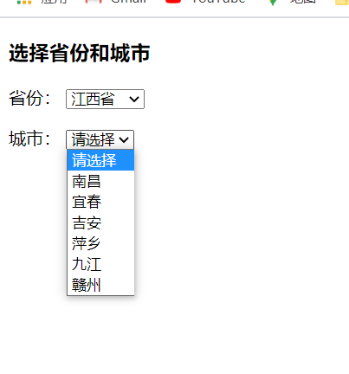

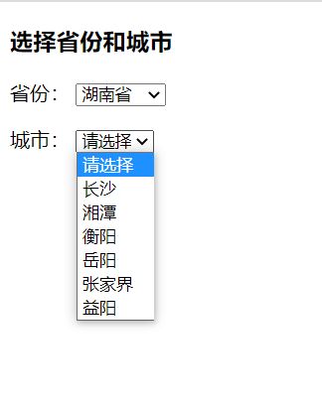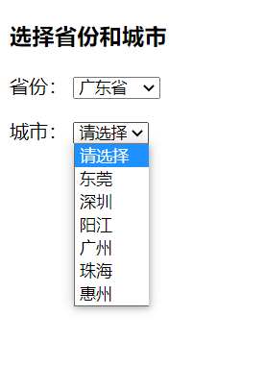

2、实验结果
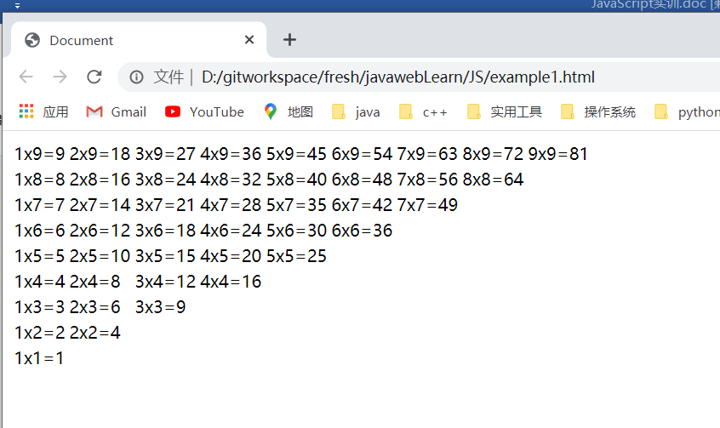

3、实验结果

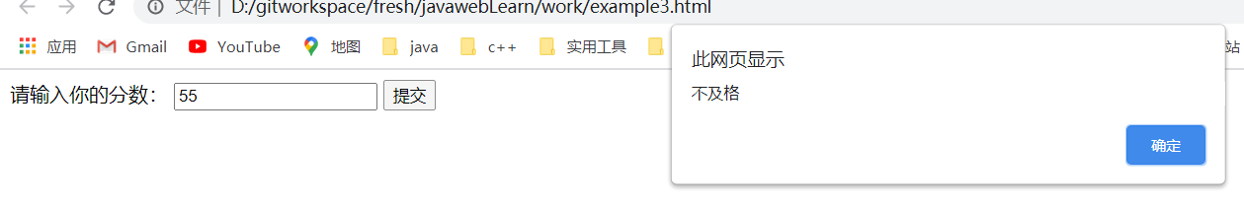
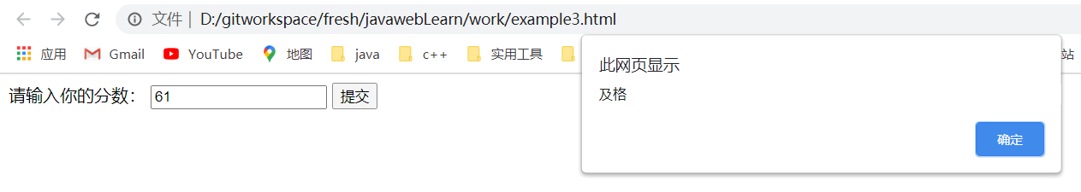
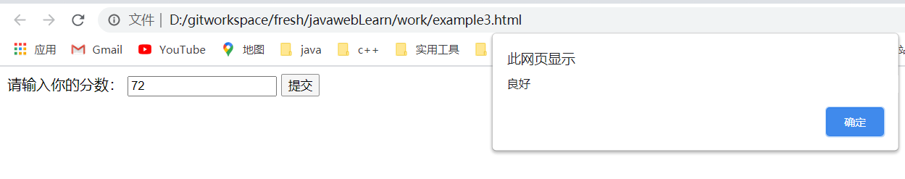

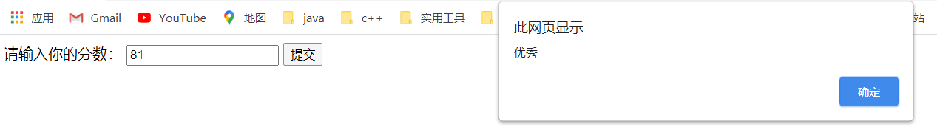
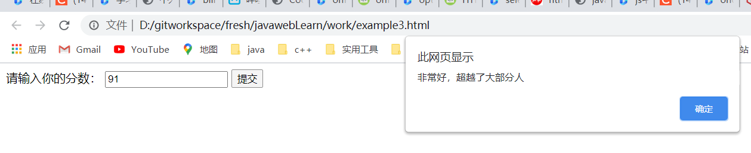
4、实验结果
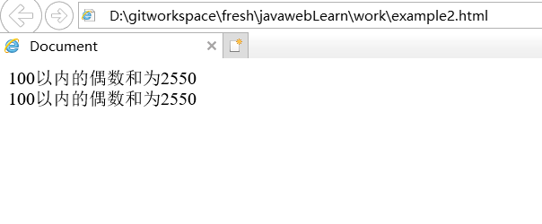

5、实验结果
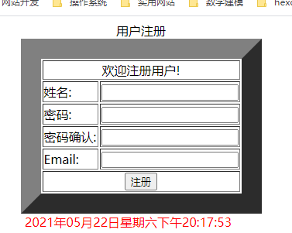

输入正确信息，登录成功
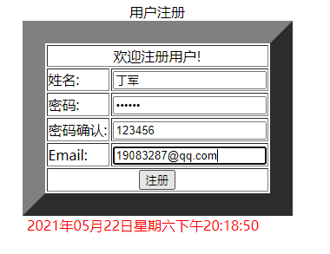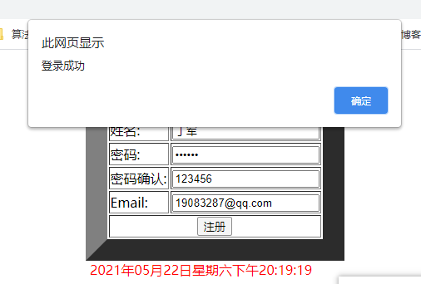
若输入不符合标准，会提示所以错误信息
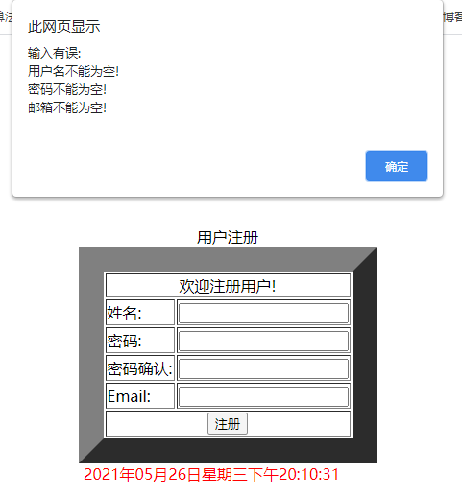
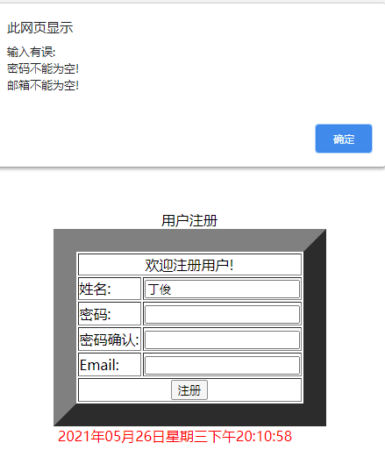

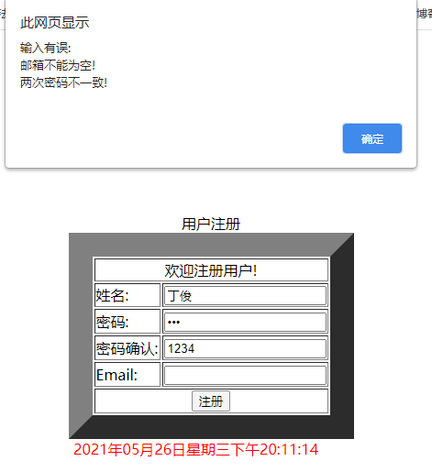
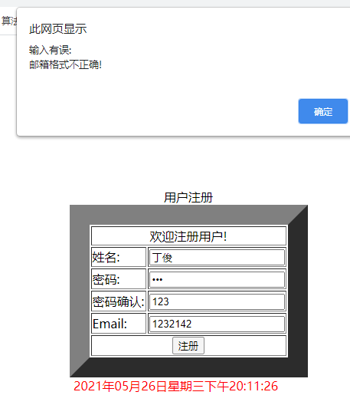
提示结果会根据用户当前输入的信息给出所以提示。

七、思考讨论题或体会或对改进实验的建议

