VISUAL RESULTS & FIGURES
Temporal Behavioral Analysis for Mental Health Risk Detection
A collection of the project’s diagrams and charts, with concise headings and descriptions.

Main Results Chart 1
A visual summary of the project’s main analysis results.
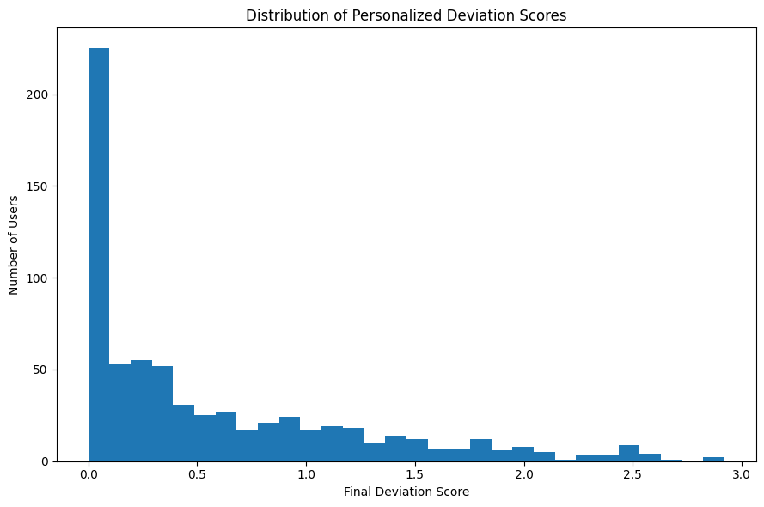

Main Results Chart 2
A visual summary of the project’s main analysis results.
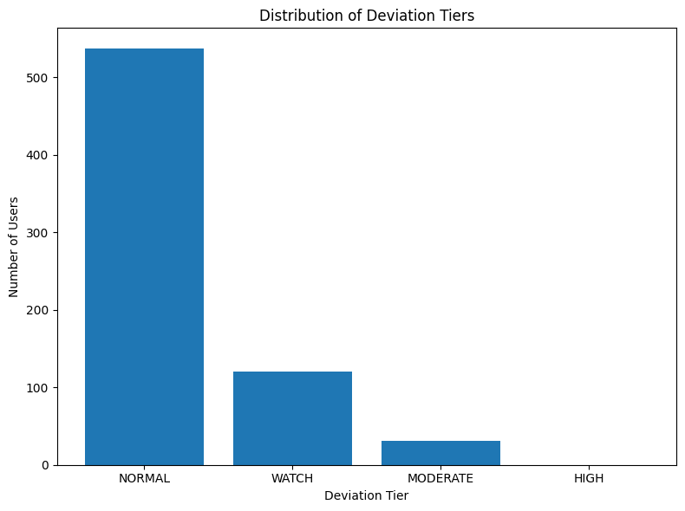

Presentation Figure 1
A presentation-ready view of a result produced by the analysis.
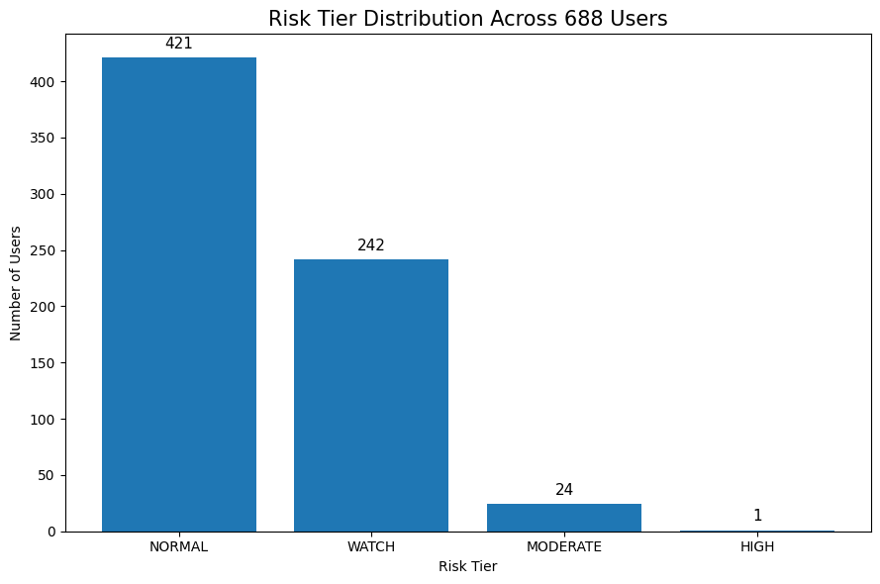

Presentation Figure 2
A presentation-ready view of a result produced by the analysis.
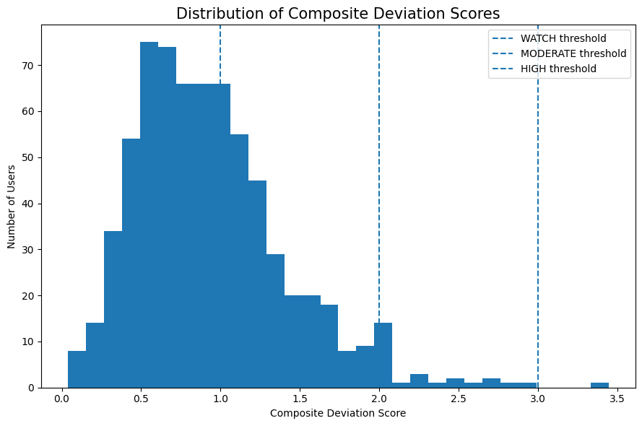

Presentation Figure 3
A presentation-ready view of a result produced by the analysis.
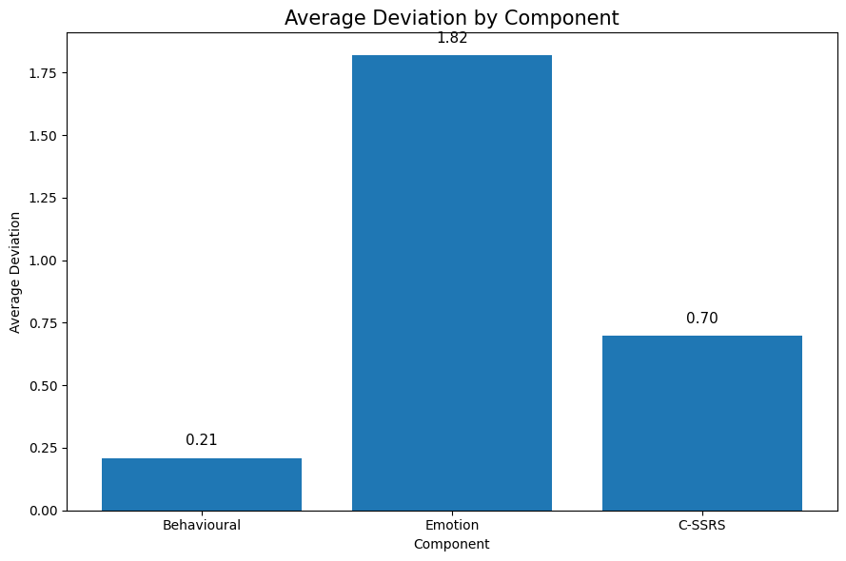

Presentation Figure 4
A presentation-ready view of a result produced by the analysis.
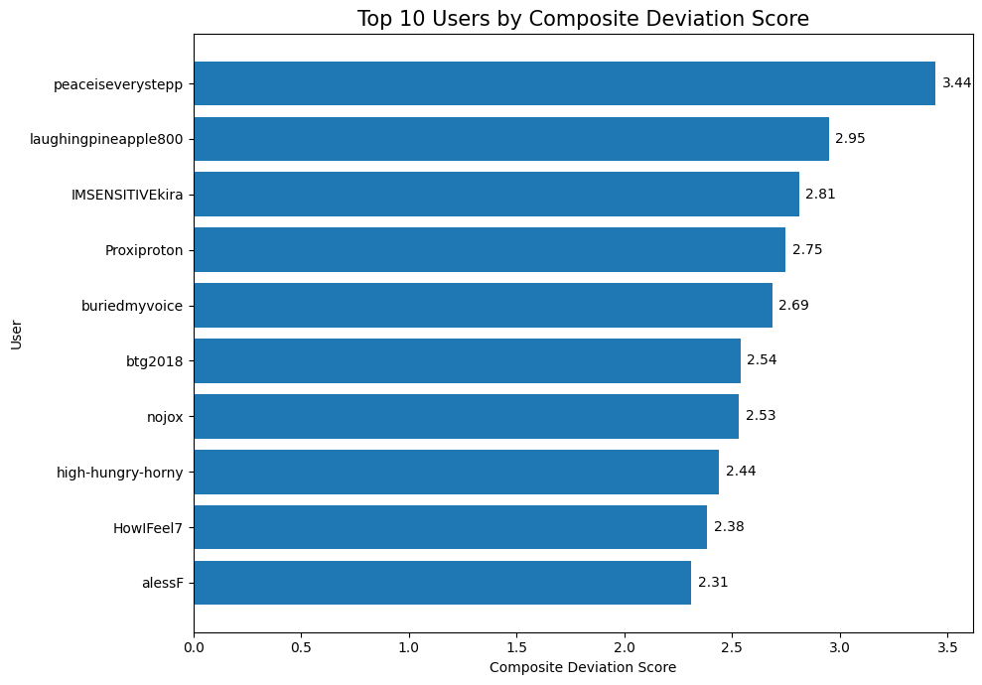

Presentation Figure 5
A presentation-ready view of a result produced by the analysis.
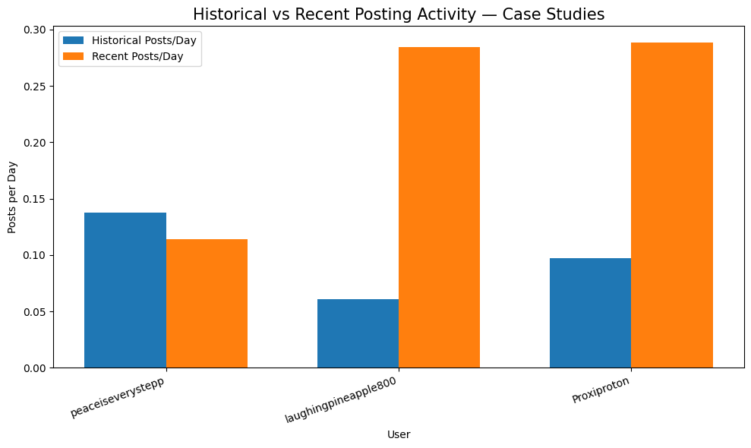

Project Workflow Overview
Overview of the main project components and the connections between data, model outputs, and analysis.
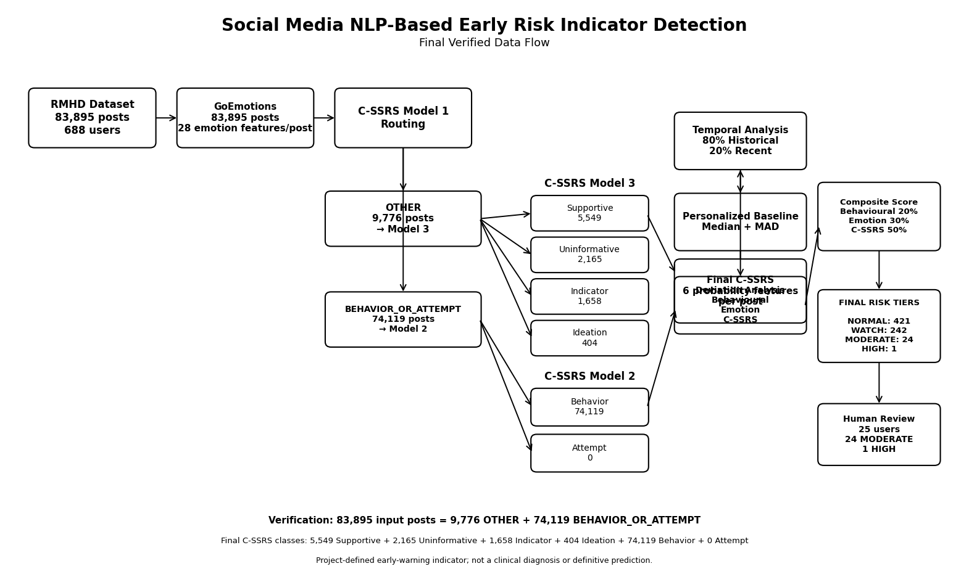

Project Pipeline Diagram
Overview of the main project components and the connections between data, model outputs, and analysis.
