Asian Journal of Electrical Sciences ISSN: 2249-6297 (P); 2583-7923 (E) Vol.13 No.2, 2024, pp.19-24

© Centre for Research and Innovation
www.crijournals.org
DOI: https://doi.org/10.70112/ajes-2024.13.2.4248

Design and Implementation of a Web-Based Laboratory Management System for Efficient Resource Tracking
Abiona Akeem Adekunle*, Badmus Lukman Abolore, Ganiyu Mutiu and Ajinaja Micheal Olalekan Department of Computer Science, Federal Polytechnic Ile-Oluji, Nigeria
E-mail: lukbadmus@fedpolel.edu.ng, mutganiyu@fedpolel.edu.ng micajinaja@fedpolel.edu.ng
*Corresponding Author: akeabiona@fedpolel.edu.ng
(Received 8 August 2024; Revised 28 August 2024, Accepted 30 September 2024; Available online 8 October 2024)
Abstract - Effective management of laboratory resources and equipment is crucial for academic institutions to support teaching and learning activities. At the Federal Polytechnic, Ile-Oluji, Ondo State, the Computer Science Department faced challenges with manual tracking of ICT gadgets and inefficient laboratory resource management, resulting in errors and delays. This study aims to design and implement a Web-Based Laboratory Management System (WBLMS) to automate the processes of reservation, tracking, and inventory management, thereby enhancing operational efficiency and reducing errors in laboratory resource management. The research employed a system development methodology that included requirement analysis, system design, implementation, and testing. A user-centric approach was adopted to ensure the system meets the specific needs of laboratory staff and students. Key system modules include an administrator login, a dashboard for gadget reservations, transaction and inventory management sections, data visualization features, and a history tracking module. The WBLMS was deployed in the ICT laboratory and underwent initial testing, which demonstrated significant improvements in resource management. The system facilitates real-time monitoring of borrowed equipment, providing details such as model, brand, and quantity. It streamlines operations, reduces manual effort, and minimizes errors, offering an intuitive and automated solution for laboratory management. The implementation of WBLMS enhances the overall efficiency of laboratory operations by providing a user-friendly platform for managing laboratory resources. It ensures accurate record-keeping, reduces human error, and simplifies resource tracking, making it a valuable tool for academic institutions aiming to optimize their laboratory management processes.  Keywords: Laboratory Management, Web-Based Laboratory Management System (WBLMS), Inventory Management, Resource Tracking | 19 | This study aims to design and implement a Web-Based Laboratory Management System (WBLMS) that automates the management of laboratory resources in the ICT laboratory of the Computer Science Department. The proposed system provides a more efficient, reliable, and user-friendly platform for laboratory staff and students. The scope of this study includes the development of a web-based application that streamlines laboratory operations by offering functionalities such as real-time tracking of borrowed ICT equipment, automated inventory management, resource reservation, and detailed monitoring of equipment usage.
 |  | The WBLMS is designed with multiple modules to facilitate user login, transaction management, borrower and item records, and data visualization through graphical reports. Additional features include room allocation and historical tracking of laboratory activities, ensuring comprehensive resource management. The significance of this study lies in its potential to transform laboratory resource management in academic institutions. By automating inventory and reservation processes, the WBLMS reduces manual effort and minimizes the risk of human error. This leads to increased efficiency, better resource utilization, and improved user satisfaction.
 |  | Furthermore, the system provides laboratory administrators with real-time data on equipment status, enabling informed decision-making and effective management of ICT resources. Similar studies have demonstrated that implementing web-based management systems in educational environments enhances operational efficiency and resource accountability [1], [2]. This research addresses the specific challenges faced by the Federal Polytechnic, Ile-Oluji, while contributing to the growing body of knowledge on the use of information technology in educational resource management. By offering a practical solution tailored to the institution’s needs, this study illustrates how ICT innovations can improve operational processes in academic settings.
I. INTRODUCTION
Laboratory management plays a crucial role in the smooth operation of academic institutions, particularly in technical and computer science departments, where the efficient handling of ICT resources is essential for practical learning and research. In many institutions, laboratory management is still handled manually, resulting in inefficiencies such as resource mismanagement, data entry errors, and difficulties in tracking borrowed equipment. This problem is prevalent at the Federal Polytechnic, Ile-Oluji, Ondo State, where the current system relies heavily on manual processes that are time-consuming, prone to errors, and lack real-time monitoring.
 |  | II. REVIEW OF LITERATURE
 |  | In the domain of web-based laboratory management systems (LMS), significant progress has been made in automating various aspects of laboratory functions, including resource tracking, equipment monitoring, and user management.
____________________________________________________________ This is an open access article under the CC BY-NC-ND license  (http://creativecommons.org/licenses/by-nc-nd/4.0/). |  | AJES Vol.13 No.2 July-December 2024

Abiona Akeem Adekunle, Badmus Lukman Abolore, Ganiyu Mutiu and Ajinaja Micheal Olalekan

Various studies have highlighted the effectiveness of LMS in enhancing the operational efficiency of laboratories, particularly in educational and research institutions.
One study [3] emphasized the role of performance testing in laboratory environments and introduced a model for web-based systems aimed at optimizing software deployment and resource management. This approach, similar to LMS, underscores the need for accurate real-time performance assessment, especially in technical laboratories, such as the proposed ICT laboratory at the Federal Polytechnic, Ile-Oluji. A related study [4] on web-based remote laboratory systems provided insights into how LMS can support remote laboratory work, particularly for embedded systems. This model demonstrated how students and researchers can conduct experiments remotely, a key advantage in resource-limited settings.
Furthermore, research byP. Rajesh et al., [5] discussed the design of distance laboratories for engineering education, focusing on web-based software and hardware integration. This study parallels the Federal Polytechnic project by highlighting the importance of online platforms for managing complex technical resources and offering detailed user interfaces for system administrators. Another relevant study [6]explored how virtual tours and building information models (BIMs) can be integrated into laboratory management systems using IoT technologies. Their system enhanced facility management by enabling real-time monitoring of laboratory assets, which is directly relevant to the proposed system for ICT gadgets and borrower tracking.
Lastly, Hua Jiang et al., [7] proposed a state-driven approach to resource management within distributed web applications, focusing on scalable deployment across laboratory systems. This model could inform the design of the WBLMS for the Computer Science Department’s ICT laboratory by offering methods for handling large datasets and managing multiple users simultaneously. Each of these works provides valuable perspectives on the design and implementation of web-based laboratory systems, emphasizing resource management, automation, and user interface design - core components of the proposed WBLMS for the Federal Polytechnic’s ICT laboratory.
III. METHODOLOGY
The methodology for the design and implementation of the Web-Based Laboratory Management System (WBLMS) for the Federal Polytechnic, Ile-Oluji, Ondo State, is divided into several key stages to ensure the software meets the institution’s specific needs and efficiently manages ICT laboratory resources.
A. System Requirements Gathering
1. Stakeholder Engagement: This phase involves interacting with key stakeholders, such as ICT lab administrators, lecturers, and students, to identify requirements for managing

laboratory resources. The primary data collected include the types of ICT gadgets (e.g., computers, projectors, printers) in the lab, the expected borrowing process, inventory tracking, and user management.
2.Requirements Documentation: All functional and non-functional requirements are documented. Functional requirements include user authentication (admin and borrower login), gadget reservation, gadget inventory management, and transaction records. Non-functional requirements include system performance, scalability, and security.
B. System Design
1.Database Design: The system requires a relational database for storing information about items, transactions, users, rooms, and borrower details. The database schema is structured with key tables such as:
a.Users: Stores login credentials, roles (admin, borrower), and personal details.
b.Inventory: Keeps details of available ICT gadgets (e.g., model, brand, quantity).
c. Transactions: Tracks gadgets borrowed and returned, along with timestamps.
d.Borrowers: Stores borrower information, including department, ID, and history.
e. Rooms: Stores information about rooms where gadgets are located.
C. User Interface Design
The system’s user interface is divided into different sections: Login, Dashboard, Transactions, Inventory Management, Borrowers, Rooms, User Management, and History. Each section provides specific functionality for administrators to manage laboratory operations effectively.
1. Admin Dashboard: Provides an overview of reservations, gadget availability, and system usage.
2. Transactions Module: Tracks the borrowing and returning of gadgets, including due dates.
D. System Development
1. Front-End Development: The front end is developed using web technologies such as HTML, CSS, and JavaScript for dynamic content and interactivity. The Bootstrap framework is used to ensure responsive design for both mobile and desktop use.
2. Back-End Development: The back end is developed using PHP and MySQL for the database. PHP is chosen for server-side scripting to handle user requests, manage sessions, and interact with the database. APIs are developed to facilitate communication between the front end and back end for operations such as fetching inventory data, updating transaction logs, and managing user sessions.

AJES Vol.13 No.2 July-December 2024 20

Design and Implementation of a Web-Based Laboratory Management System for Efficient Resource Tracking

3.Authentication and Authorization: JWT (JSON Web Token) or session-based authentication is implemented to manage user login and ensure that only authorized users (e.g., administrators) can perform sensitive operations, such as adding new items to the inventory or viewing transaction histories.
E. Testing and Validation
1. Unit Testing: Each module is tested individually to ensure functionality, including login, data retrieval, and gadget reservation processes.
2. Integration Testing: This phase ensures that all components (database, front end, and back end) work together seamlessly.
3. User Acceptance Testing (Uat): The system is deployed in a test environment, where stakeholders, such as lab administrators, validate whether the system meets their requirements.
F. Deployment and Maintenance
1.Deployment: The system is deployed on a Linux-based server and is accessible via a web browser over the institution’s local intranet or the internet, depending on the configuration. Apache is used as the web server, and MySQL as the database.
2. Maintenance: Regular maintenance is performed to ensure system performance and security. Updates are rolled out periodically based on user feedback or changing requirements.
G. Architecture of The System
1. User Interface: The front-end interface allows administrators to log in and manage the laboratory’s inventory, borrowers, and transactions. The design is user-friendly, providing quick access to key system features such as reservations, transaction logs, and inventory status.
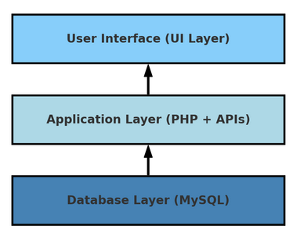
Fig. 1 Architecture of Web-Based Laboratory Management System
2.Application Layer: This layer contains the core business logic, processing user requests such as fetching inventory

21 AJES Vol.13 No.2 July-December 2024

Abiona Akeem Adekunle, Badmus Lukman Abolore, Ganiyu Mutiu and Ajinaja Micheal Olalekan

inventory. This streamlined layout allows lab administrators to easily track the availability and status of all ICT equipment.
B. Navigation Panel
The left sidebar of the Laboratory Management System (LMS) dashboard provides navigation options for accessing various features and functionalities:
1.Dashboard: The central hub that provides an overview of key metrics and information, such as recent transactions, inventory status, and system notifications.
It offers a quick snapshot of lab operations equipment usage.
2.Transaction: Tracks all lending and borrowing activities within the laboratory. Each transaction logs details such as the borrower, the item borrowed, the quantity, and the borrowing/return dates. This ensures accurate records of ICT gadget usage.
3.Item: Manages all items or gadgets available in the ICT laboratory. Administrators can add, modify, or remove items. Each item entry records information such as model, category, brand, and quantity.
4.Borrower: Manages details about individuals authorized to borrow equipment from the lab. It stores information such as the borrower’s name, department, and borrowing history.

5.Room: Tracks and manages different rooms or locations within the lab or institution. This module allows administrators to allocate and assign equipment to specific rooms, ensuring proper resource distribution and tracking.
6.Inventory: Provides a detailed overview of all lab equipment, including current quantities and statuses (e.g., new, in-use, or damaged). Administrators can use this tab to manage stock levels in real time.
7.Graph: Displays visual reports and analytics on lab usage, such as frequently borrowed items, inventory trends, and other key metrics. Graphical representations enable quick interpretation of data.
8.User: Manages system users and their roles (e.g., administrators, staff). Administrators can add or remove users and assign privileges, controlling access to different sections of the LMS.
9.History: Maintains a log of all past actions within the system, including previous transactions, item modifications, and changes to borrower information. This feature is essential for auditing and tracking the historical use of lab resources.
Each of these options ensures efficient management and smooth operations within the ICT laboratory, enabling proper tracking and utilization of resources.

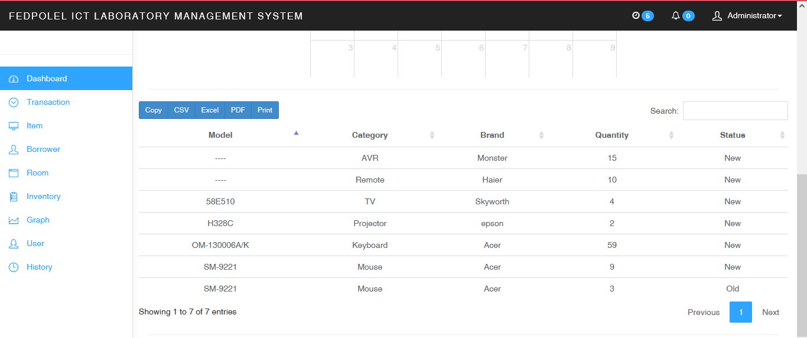
Fig. 3 Dashboard of the System

The Item section in the Laboratory Management System (LMS) is responsible for managing and displaying information related to all ICT laboratory equipment:
1.Image: Displays a visual representation or image of the item (e.g., mouse, projector, remote) for easy identification.
2.Model: Shows the specific model name or number of each item (e.g., SM-9221 for a mouse), helping to distinguish between different types or versions of similar devices.
3.Category: Specifies the category of each item, such as Mouse, AVR (Automatic Voltage Regulator), Projector,

Keyboard, or Remote. This aids in organizing and grouping similar types of equipment.
4.Brand: Indicates the brand or manufacturer of the item (e.g., Acer, Haier, Epson), providing additional information about the product’s make and origin.
5.Quantity: Displays the total number of units available for each item in the inventory, helping administrators keep track of stock levels.
6.Quantity Left: Shows the remaining number of units available after some have been borrowed or used. This information is crucial for identifying which items are in short supply.

AJES Vol.13 No.2 July-December 2024 22

Design and Implementation of a Web-Based Laboratory Management System for Efficient Resource Tracking

7.Status: Indicates the condition or status of the item, such as “NEW” or “OLD.” This helps track the usability or wear of the equipment.

8.Action: Provides a button labeled “More Info” that allows the administrator to view more detailed information about the item, including its borrowing history, maintenance records, or other relevant data.

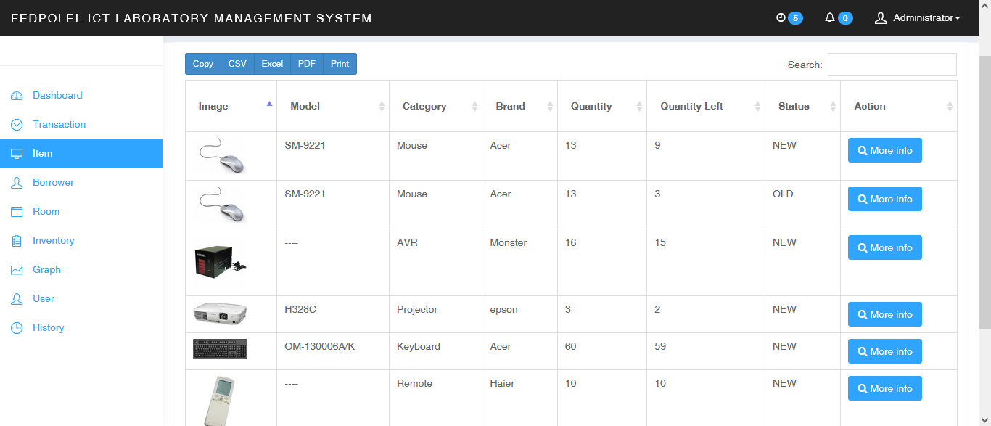
Fig. 4 Item section of the system

At the top, there are options to export the list of items in various formats, such as CSV, Excel, PDF, or to print the inventory directly. A search bar is also available to quickly find specific items by model, category, or brand. This section ensures that administrators can efficiently manage the ICT equipment inventory, monitor availability, and track the condition and usage of each item.
C. Relational database design
Figure 5 below shows relational database design with several interconnected tables, used for managing the system:
1.Borrow (lms19.borrow): Tracks borrowing transactions. date_borrow (timestamp), borrowed (item identifier), member_id (link to member), stock_id, quantity, status, and date_return (expected return date). 2.Room Equipment (lms19.room_equipment): Represents equipment assigned to rooms. Attributes include: equipment_id, room_id (link to rooms), and quantity. 3.History Logs (lms19.history_logs): Logs actions performed in the system for auditing purposes.
Attributes: description, table_name, status_name, user_type, user_id, date_created.
4.Equipment Inventory (lms19.equipment_inventory): Holds information about equipment available for use. Attributes: equipment_id, remarks, status.
5.Member (lms19.member): Represents users of the system, such as members or employees. Attributes: User details such as id, name, school, contact, gender, department, password, and status.

23 AJES Vol.13 No.2 July-December 2024

Abiona Akeem Adekunle, Badmus Lukman Abolore, Ganiyu Mutiu and Ajinaja Micheal Olalekan

Overall, this Entity-Relationship Diagram (ERD) is designed to manage an equipment borrowing and reservation system

with detailed tracking of inventory, transfers, and user interactions.

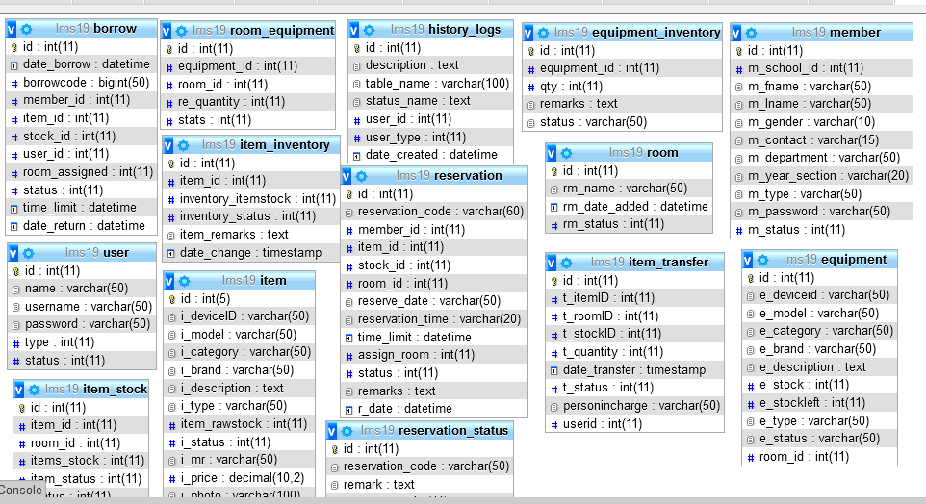
Fig. 5 Database Design of the system

V. CONCLUSION
In conclusion, the Web-Based Laboratory Management System (WBLMS) designed for the ICT Laboratory at the Federal Polytechnic, Ile-Oluji, offers a streamlined and efficient solution for managing laboratory resources. By integrating essential features such as inventory management, transaction tracking, borrower records, and real-time status updates, the system significantly reduces the administrative workload while enhancing the accuracy of laboratory operations. The user-friendly interface ensures that administrators can easily monitor equipment usage, track borrowings, and maintain updated records, thereby improving overall accountability and resource management. Moreover, the system’s ability to generate detailed reports and visual representations of data facilitates better decision-making, enabling timely interventions when resources are running low or require maintenance. By deploying the WBLMS, the ICT Laboratory can optimize the availability and management of its equipment, fostering a more organized and efficient environment for both staff and students. The case study of the Federal Polytechnic, Ile-Oluji, demonstrates the system’s practicality and scalability, making it adaptable to other institutions with similar needs. Future enhancements could involve integrating more advanced features, such as predictive maintenance alerts or incorporating artificial intelligence to further streamline operations and enhance the user experience. Overall, the WBLMS is a valuable tool for ensuring effective

management environments. | of | laboratory | resources | in | academic
REFERENCES
[1]  [2]  [3]  [4]  [5]  [6]  [7] | G. Ru and L. X. Long, “Development and application of multimedia network resources platform: Multimedia application in networks,” 2012 2nd International Conference on Consumer Electronics, Communications and Networks (CECNet), Yichang, China, 2012, pp. 272-275, doi: 10.1109/CECNet.2012.6201741.  C. P. Weinthal, M. M. Larrondo-Petrie, and L. F. Zapata-Rivera,“Academic integrity assurance methods and tools for laboratory settings,” 2019 IEEE Frontiers in Education Conference (FIE), Covington, KY, USA, 2019, pp. 1-6, doi: 10.1109/FIE43999.2019. 9028482.  S. Ravichandran and M. Umamaheswari, “Innovative method of software testing environment in cloud computing technology,” Asian Journal of Computer Science and Technology, vol. 3, no. 2, pp. 34-39, Oct. 2014.  O. D. Adekola, “An online road transport booking system,” Asian Journal of Computer Science and Technology, vol. 10, no. 2, pp. 1-5, Jul. 2021.  P. Rajesh, A. Valarmathi, K. Sathishkumar, and S. Yoga Vignesh,“Secured e-counselling framework using composite web services,”Asian Journal of Computer Science and Technology, vol. 1, no. 1, pp. 118-120, May 2012.  V. Bhagyasree, K. Rohitha, K. Kusuma, and S. Kokila, “Big data integration with IoT to achieve the challenges,” Asian Journal of Computer Science and Technology, vol. 8, no. S3, pp. 45-49, Apr. 2019.  H. Jiang and X. Zhao, “Study on the lab teaching system construction of information management and information system profession,” 2010 International Conference on E-Health Networking Digital Ecosystems and Technologies (EDT), Shenzhen, 2010, pp. 364-366, doi: 10.1109/EDT.2010.5496344.

AJES Vol.13 No.2 July-December 2024 24

