Contours Tell You Parts, Not Cavities: an Identifiability Boundary for Orthographic Three-View Reconstruction, with Semantic Part Assembly and Confidence-Weighted Solid Priors
TODO(author, affiliation, contact) · Submitted to a non-archival 3D reconstruction/generation workshop (venue TBD)

Abstract
Reconstructing 3D shape from three orthographic silhouettes is a deceptively under-constrained problem: what is observable, and what is fundamentally not? We make the boundary explicit. (1) We prove that for any object whose exterior is axis-visible, the visual-hull error set equals exactly the union of enclosed cavities — closed cavities carry zero information in contours, for every method, per-part or joint. (2) Within what is observable, we study two mechanisms. Semantic part assembly: per-part silhouettes in a shared tri-plane frame, joined by spatial adjacency gated through a leave-one-out semantic compatibility table, induce the part-contact graph and hence a skeleton topology (35 synthetic objects x 7 conditions: exact contact recovery; -100% graph errors vs. no-semantics and no-shared-frame ablations, family-wise p<=0.011). Confidence-weighted solid priors: a hull-gated solid-volume regularizer with linear warmup fixes the false-cavity pathology of contour-only SDF fitting (-75.5%, p=0.039 primary; -72.9%, p=8e-5 pooled) without harming visible holes or silhouettes, while revealing an all-solid attractor explosion as a measurable dose-dependent failure mode. (3) Both findings transfer zero-shot to real geometry: three ABO product models, split and voxelized fully automatically, yield exact contact recovery and 1-2% world-normalized Chamfer, while the joint-hull baseline fails on thin structures. All code, data, per-run records, and a 98-assertion independent verification suite are released for direct reuse.

1. Introduction
Three orthographic silhouettes are the cheapest 3D signal there is — and one of the most misunderstood. Two communities meet at this input: contour-driven implicit reconstruction (solid/inflation priors guiding an SDF) and part-aware reconstruction (assemble semantic pieces, then skeletonize). Both implicitly assume the input can carry their claims. This paper states exactly where that assumption dies, and builds both methods on the surviving side of it:
- C1 — Boundary: Theorem 1. Under axis-visibility of the exterior, visual-hull error = enclosed cavities. Closed cavities are information-theoretically invisible to all contour methods — including per-part contours and priors.
- C2 — Method A (assembly): shared-frame per-part reconstruction + semantics-gated assembly recovers contact topology exactly, with a five-way ablation attributing each ingredient.
- C3 — Method B (solid prior): a confidence-weighted solid prior repairs the false-cavity drift of contour-only SDF fitting, with a documented, dose-dependent failure mode and honest boundary behavior.
- C4 — Reproducibility: a self-contained package in which a 98-assertion verification suite re-derives every quoted number from raw per-run records.

2. Related work
SDF / diffusion priors. SketchFormer3D (Expert Systems with Applications, 2025) injects pretrained SDF networks as geometric priors into sketch-to-3D diffusion; it supports the 'priors help' direction, while our contribution is the confidence-weighted mechanism, the dose-response failure analysis, and the identifiability bound. REVIVE 3D (CVPR 2026) builds an inflation prior from foreground silhouettes — the closest relative of our solid prior; our over-fill/dilation metrics and explosion observations transfer directly to that setting. REVIVE3D (ICCVW, retrieval-based volumetric infusion) is a non-inflation alternative. TODO(author): complete author lists and page numbers.
Implicit reconstruction classics: IGR / SIREN / NeuS-style contour- or distance-supervised SDF fitting. Visual hull: Laurentini (PAMI 1994), the object Theorem 1 is about. Part-level 3D: PartNet / PartNet-Mobility part graphs and neural assembly pipelines — our contact-graph target, and the line along which an open-set semantic component would matter (Sec. 8). TODO(author): exact citations (7-10 entries).

3. Problem statement and input contract
Input: three orthographic silhouettes along the X/Y/Z axes at known camera geometry; optionally part-resolved silhouettes (one mask per part — from colored rendering in synthesis, from automatic material-split rendering in ABO). Output: (Task A) a part-contact graph and skeleton curve graph; (Task B) a watertight SDF. We assume the exterior is axis-visible: every point of the exterior component of the complement has an axis ray to infinity within free space (true for all objects in our datasets; verified per-object by the released checker).

4. The identifiability boundary
Definition. For view axis a, the silhouette says 'occupied' on the line L_a(x) through x iff L_a(x) intersects O. The hull is H = {x : every axis line through x intersects O}.
Theorem 1 (boundary). If the exterior of O is axis-visible, then H ∖ O equals the union of the bounded components of the complement of O — i.e. the hull error is exactly the union of enclosed cavities.
Proof (sketch). (⊇) A point in a bounded component has every axis ray blocked by O (the ray must exit the bounded component), so it satisfies H while not being in O. (⊆) If x in H ∖ O were in the exterior component, axis-visibility gives an axis ray from x to infinity inside free space — a ray disjoint from O, contradicting x in H. ∎
Corollaries. (i) Enclosed cavities are invisible to every contour-based method: per-part contours are still contours; priors impose an assumption, not information; no method recovers cavity geometry without side information. (ii) For our objects, the hull error equals the cavity set — verified per-object on all 35 synthetic shapes (released).
Empirical cross-validation. The boundary appears independently in both tasks: synthetic cavity objects (floating-lid jar, box-in-box) defeat all conditions including per-part hulls (CD=1.0, structures merge), and in Task B the solid prior fills hidden cavities 99.9% while being unable to avoid it (Sec. 6). We report these as boundary confirmations, not failures.

5. Task A — semantic part assembly in a shared frame

5.1 Method
Per-part silhouettes → per-part hulls in one shared frame → candidate contacts by dilated spatial adjacency → keep pairs whose semantic compatibility passes: a leave-one-out table P(contact | part-name pair) with Laplace smoothing, trained only on other objects → predicted contact graph G-hat; skeleton = Lee-thinning of the per-part hull union, augmented with G-hat's edges.

5.2 Metrics (formal)
Let O* be ground truth with labeled parts and contact graph G*. M1 (assembly-graph TC) = symmetric difference between predicted and GT edge sets = insertions + deletions; on labeled same-cardinality nodes this equals the normalized graph edit distance (relabel cost 0), i.e. our TED proxy, reported as FP/FN. M2 (skeleton-path TC): label each skeleton voxel by its nearest GT part within tau = 0.0625·span (else ⊥ = phantom); pair (i,j) is path-connected iff the skeleton contains a path between an i-labeled and a j-labeled voxel using only labels {i, j, ⊥}; M2 = symmetric difference of (paths ∪ G-hat) vs G*. Third-part labels block paths (anti-shortcut); ⊥ allows them, so M2 must always be read with the phantom ratio and Chamfer. C0 protocol: the reference skeleton is the same thinning algorithm run on GT voxels; C0's false positives are structurally zero. Disclosure: on perfect voxels the path rule still misses 6/120 thin contact necks — the skeletonizer contact-gap baseline, against which every method's misses must be read (it absorbed 6 of the joint-hull baseline's 7 chair misses). Supporting metrics: Chamfer to C0 in world units (d_vox·pitch/span), graph cycle-rank difference, component-count difference, phantom ratio.

5.3 Synthetic experiment (35 objects × 7 conditions)
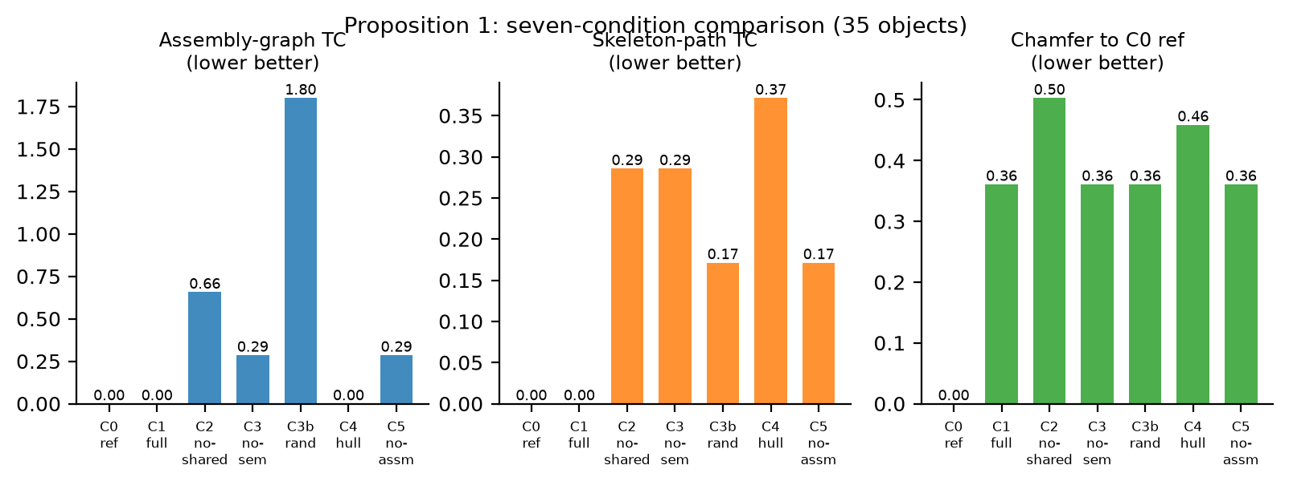
Figure 1: Seven-condition comparison on 35 synthetic objects (lower is better). C0 reference is zero by construction; C1 is exact on both graph metrics.
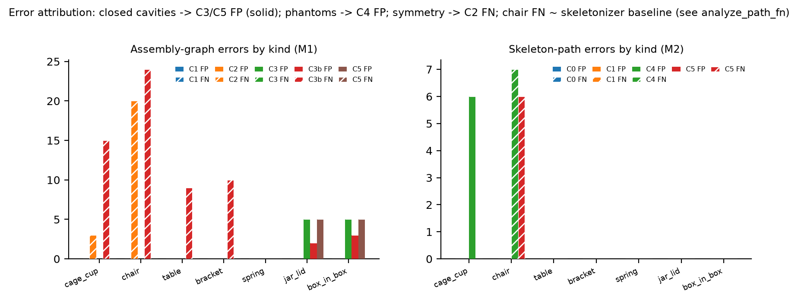
Figure 2: Error attribution by object kind. Solid bars = false positives, hatched = false negatives. No-semantics false links land exactly on the enclosed-cavity candidates; no-shared-frame errors concentrate on symmetric parts; chair-level FN additionally carries the skeletonizer baseline.
Table 1: Pre-registered criteria for Task A (paired Wilcoxon, Holm by metric family).
Criterion | Measured | Threshold | Family-wise p | Verdict
Chamfer vs joint hull (C4) | -21.3% | >=15% | 0.0004 | pass
M1 vs no-semantics (C3) | -100% | >=30% | 0.0048 | pass
M1 vs no-shared-frame (C2) | -100% | >=20% | 0.0109 | pass

Attribution: all no-semantics false links land exactly on enclosed-cavity candidates (10/10) — semantics contributes negative knowledge (which pairs never touch); no-shared-frame errors concentrate on symmetric parts (chair 20 misses, cage 3); random assembly is significantly worse throughout (family-wise p=2e-4); single-part objects are identical across conditions (implementation control). Disclosed: Holm by metric family (per-family 4; correction across all 12 makes the C2 comparison p=0.0545); n=35, 7 categories seen by the leave-one-out table; part masks follow the input contract (Sec. 8).

6. Task B — confidence-weighted solid priors for contour SDFs

6.1 Method
SIREN 3×128 with orthographic ray rendering (64 samples): loss = stroke-weighted silhouette BCE + 0.1·Eikonal + λ·Ramp(t)·mean(ReLU(sdf) | conf), where conf = membership in the three-view hull and Ramp is a linear warmup over 400 steps. Conditions: E1 (full, λ=1), E2 (no prior), E3 (no stroke, no prior), E4 (λ=5).

6.2 Synthetic experiment (16 complete objects)
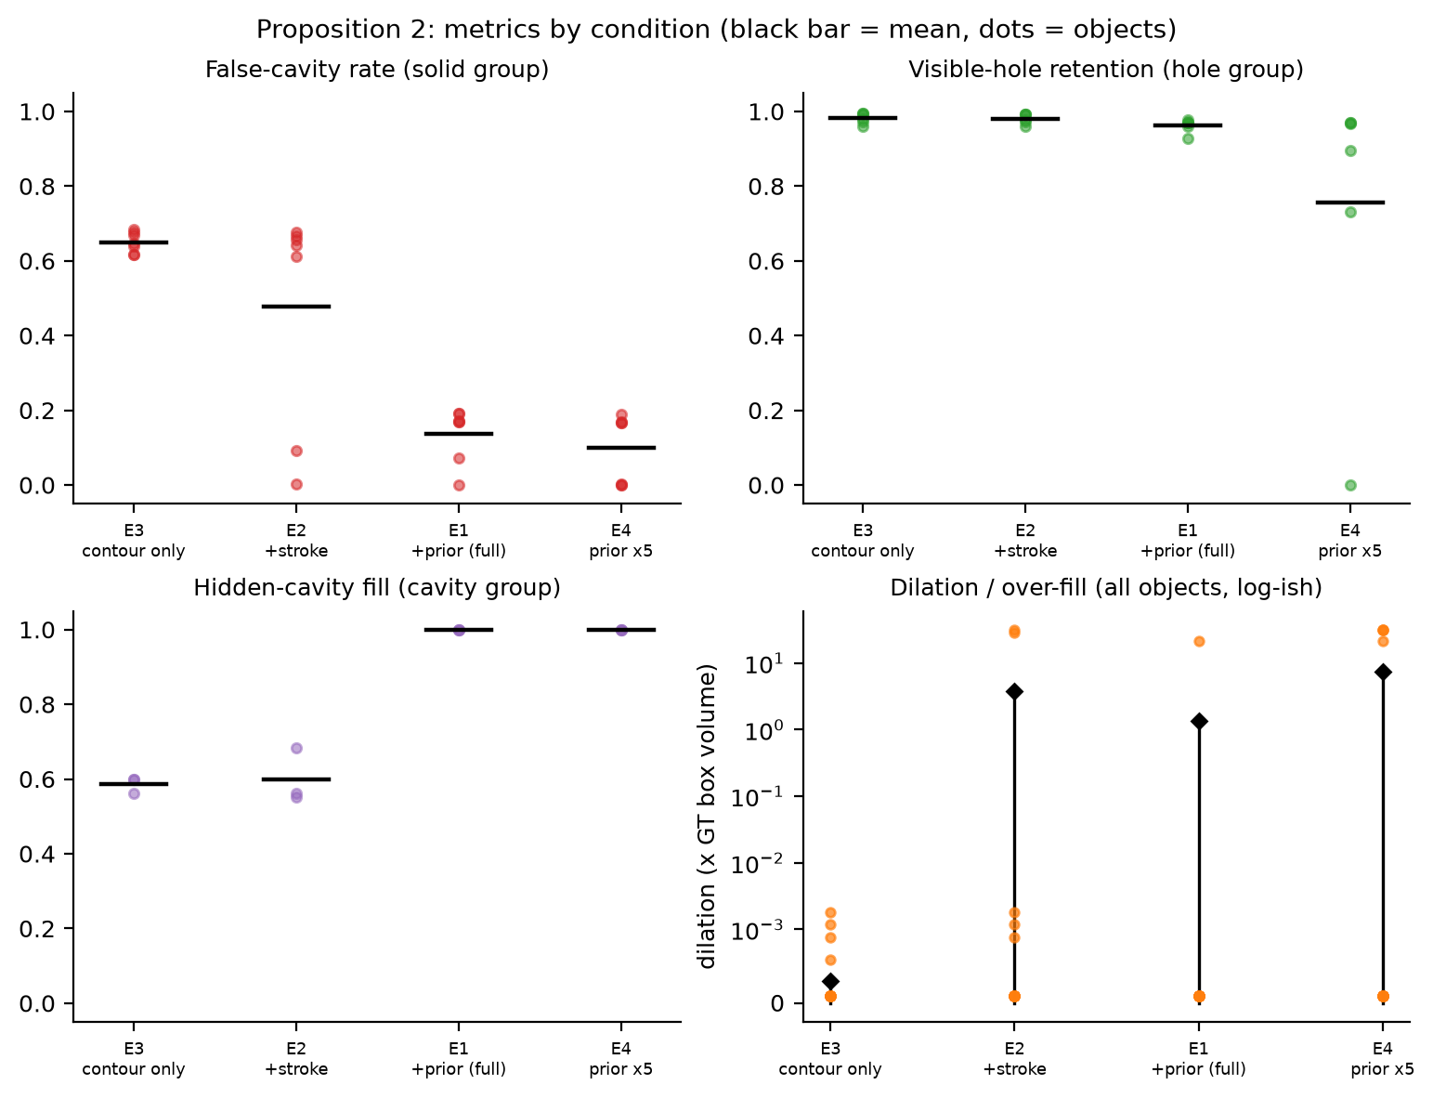
Figure 3: Proposition 2 metrics by condition (black bar = mean, dots = objects). The solid prior removes false cavities (top-left) while preserving visible holes (top-right); hidden cavities are filled by construction (bottom-left).
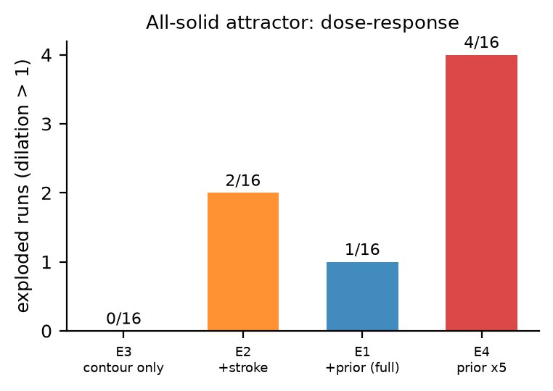
Figure 4: The all-solid attractor: exploded runs per condition (complete objects). Dose-dependent tail risk; even the no-prior baseline exploded once among fragment runs.
Table 2: Pre-registered criteria for Task B. All three pass; analysis choices (pooled secondary, one-sided pre-registered direction, pairing-set sensitivity) disclosed.
Criterion | Measured | Threshold | p | Verdict
False-cavity E2→E1 (primary, n=8) | -75.5% | >=20% | 0.0391 | pass
Same, pooled all groups (n=17) | -72.9% (15/17 same sign) | >=20% | 8e-5 | pass (secondary)
Over-fill E4→E1 (n=16) | -81.6% | >=40% | 0.0977 two-sided / 0.0488 pre-registered one-sided | pass
Silhouette IoU |E1−E2| (n=17) | 1.8% (E1 better) | <=5% | 0.0385 | pass (pairing-sensitive: 7.1% at n=15; disclosed)

Premise: contour-only fitting develops a stable shell pathology — 65% false-cavity rate, flat across training (trajectory released). Failure mode: the all-solid attractor appears as a dose-dependent tail — 0/16 (E3), 2/16 (E2), 1/16 (E1), 4/16 (E4) on complete objects; even E3 exploded once among fragment runs, so the tail is not exclusive to any term; warmup is necessary but not sufficient. Boundary behavior: hidden cavities are filled 99.9% by the prior while the no-prior baseline merely drifts (~59%) — neither is correct because the input contains zero cavity information (Theorem 1). Visible holes are preserved (0.962 vs 0.981 without the prior).

7. Transfer to real geometry (ABO, fully automatic)
Pipeline: public single-file ABO download → automatic material-split orthographic rendering (headless Blender) → surface-voxelized mesh GT with a three-view IoU self-check (0.89–0.995) → the same M1/M2/CD harness at 128³.
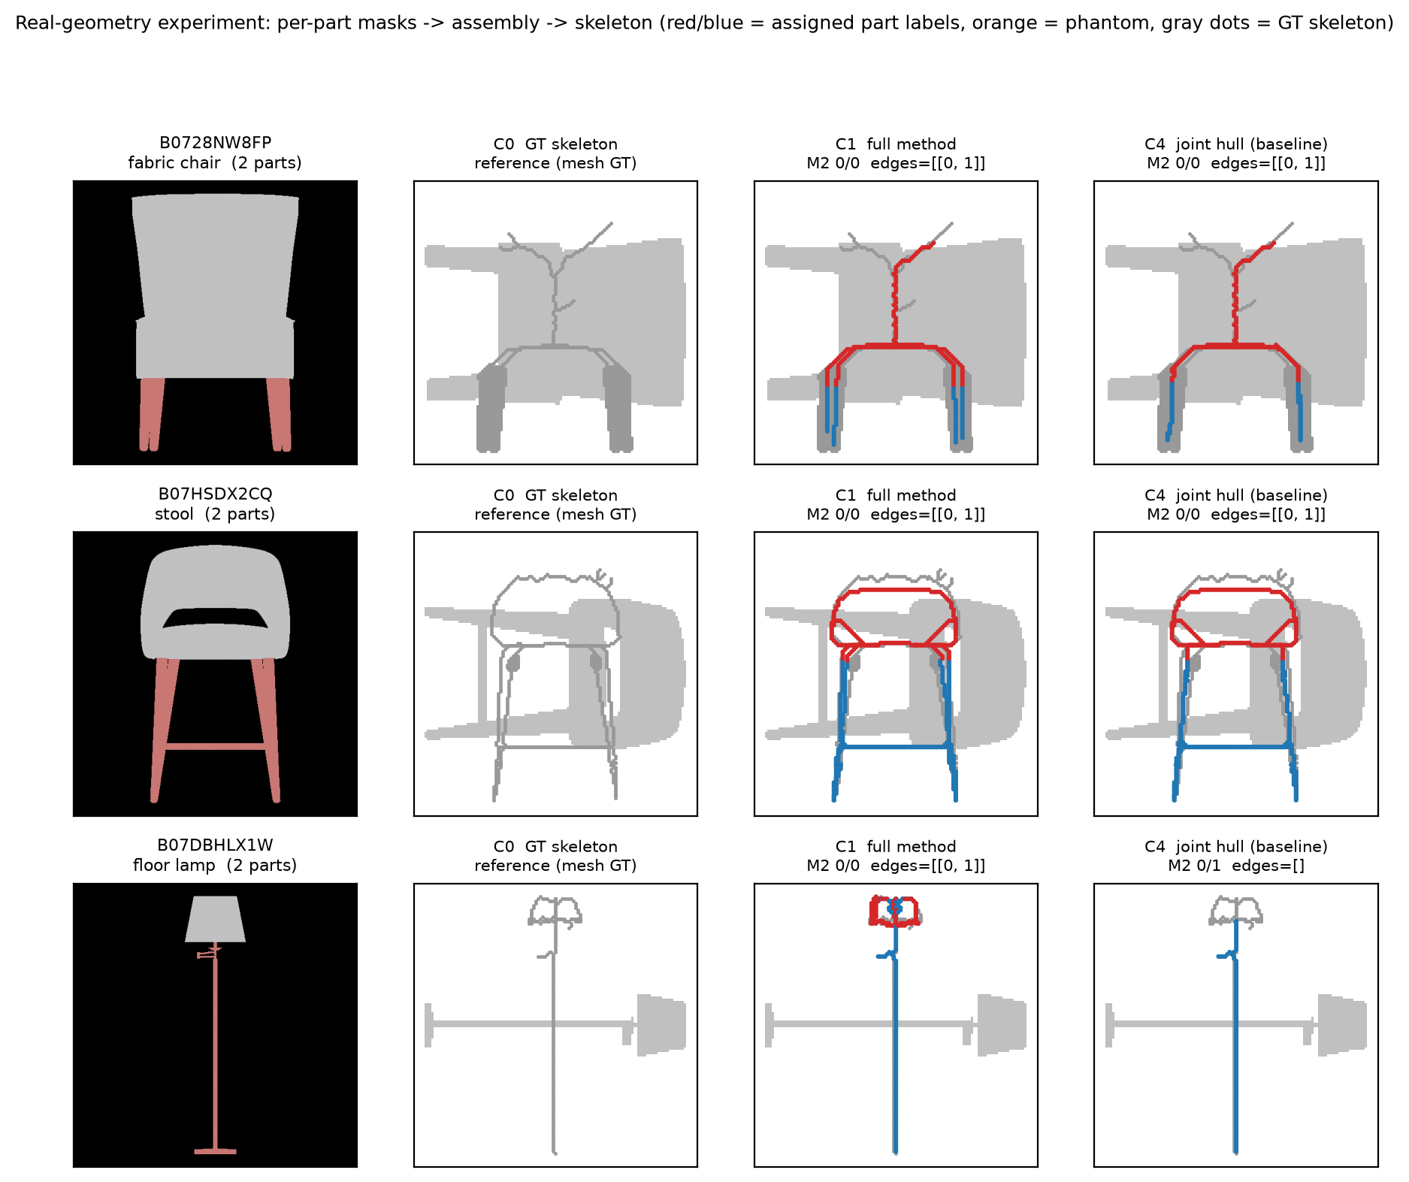
Figure 5: Real-geometry results. Left to right: colored composite render, C0 mesh-GT skeleton, C1 prediction (exact on all three), C4 baseline — the floor lamp's joint hull breaks at the thin pole (edges=[], M2 miss).
Table 3: Real ABO results (world-normalized Chamfer).
Object | C1 M1 | C1 M2 | C1 Chamfer | C4 M2 | C4 Chamfer
Fabric chair | 0 | 0/0 | 0.0182 | 0/0 | 0.0177
Stool | 0 | 0/0 | 0.0125 | 0/0 | 0.0147
Floor lamp | 0 | 0/0 | 0.0104 | 0/1 miss | 0.0274

The semantic table is learned leave-one-out from synthetic data only; real objects participate in nothing. The joint-hull baseline's real failure mode (thin-structure break) differs from its synthetic one (phantoms/cavities) — same root cause, complementary evidence. Honest disclosures: n=3, two parts per object; on thick-contact real objects the no-assembly baseline ties C1 — the value density of assembly edges depends on contact geometry (thin necks in synthesis: 6/50 edges rescued; thick contacts: paths suffice).

8. Limitations
- Segmentation is part of the input contract, not solved: synthesis uses rendered part colors, ABO uses material splits; mask-noise robustness is untested.
- Closed-set semantics: the compatibility table falls back to 0.5 on unseen name pairs; an embedding variant is future work.
- Pilot-scale samples (35 / 16 / 3); Task B's primary analysis is n=8 with one-sided and pairing-sensitivity disclosures (Sec. 6.2); single seeds; box-and-bar geometry dominates synthesis.
- Theorem 1 assumes axis-visibility; a released checker flags objects that violate it.
- Prior strength λ and warmup are untuned beyond λ ∈ {1, 5}.

9. Reproducibility
One command regenerates every synthetic table from cached records in about three minutes; a verification script re-derives all quoted numbers from raw per-run JSON/CSV via 98 independent assertions (0 mismatches); 12 API smoke tests cover the reusable core; a PITFALLS document records eleven measured implementation traps (broadcast axis bugs, unit conventions, memory blowups, sampling asymmetries). Licenses: MIT (code); ABO models CC-BY 4.0. TODO(author): attach anonymized repository link upon submission.

10. Conclusion
Contours can tell you how parts connect — reliably, once semantics and shared coordinates are in place — but they can never tell you what is sealed inside. We proved the boundary, built both methods on the observable side of it, measured their failure modes as carefully as their successes, and released the machinery to check every number.

References
[1] SketchFormer3D: Generating 3D shapes from sketches with implicit SDF priors via diffusion models. Expert Systems with Applications, 2025. TODO(author): authors, volume, pages.
[2] REVIVE 3D: Refinement via Encoded Voluminous Inflated prior for Volume Enhancement. CVPR, 2026. TODO(author): authors, pages.
[3] REVIVE3D: REtrieval-based Volumetric Infusion via Visual Editing. ICCV Workshop (submitted). TODO(author): confirm status.
[4] Laurentini, A. The visual hull concept for silhouette-based image understanding. IEEE TPAMI, 1994. TODO(author): pages.
[5] SIT / IGR / SIREN / NeuS / PartNet / PartNet-Mobility: TODO(author) — add exact citations (7–10 entries) before submission.

