Database Project HW1

2016312107 문경진

**1. Run the given hw1_1_script (MATLAB script). The first column of the X matrix indicates 'Relative Compactness', and the second column indicates 'Surface Area', and the vector y indicates 'Heating Load'. Set the first 400 rows of the X matrix as the training data whereas the rest is reserved for the test data.**

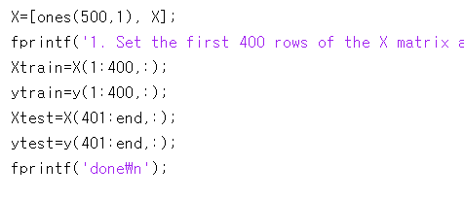

After load data1.mat, I set train and test data like this, which splits data. Before split train and test data, I add constant ‘1’ column to add constant term in regression equation. So the equation will be like this.

$$y_{pred}=Xw=x_{1}w_{1}+x_{2}w_{2}+w_{0}$$

**2. Implement the Least Squares Regression, and report the w by rounding the numbers to 4 decimal places.**

The purpose of least squares regression is to minimize objective function, and its form is…

$$\frac{1}{2}{\left\|y-Xw\right\|}_{2}^{2}$$

And to minimize those error, $Xw$ and $(y-{Xw}^{*})$ should be perpendicular, $Xw^{*}$ indicates the orthographic projection of $y$ on range(X). So,

$$w^{*}={\left(X^{T}X\right)}^{-1}X^{T}y$$

We should use training data(Xtrain and ytrain) for X and y value.

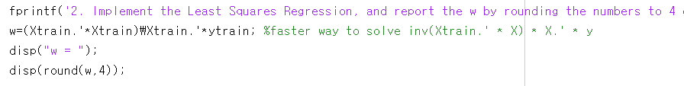

X.’ is same as transpose(X). And, there are several ways to represent $A^{-1}B$ in MATLAB, such as A\B, inv(A)*B, etc. In this case, A\B is faster than inv(A)*B. But their answer is almost same. So in this time, I used the former one. To print w by rounding the numbers to 4 decimal places, round() is used, by using 4 for second parameter. And the answer is… [ 347.0713 ; -178.8041 ; -0.283]. last term only printed 3 decimal places, as the last digit is zero. So, the regression equation f is like this.

$$f\left(x\right)=-178.8041x_{0}-0.283x_{1}+347.0713$$

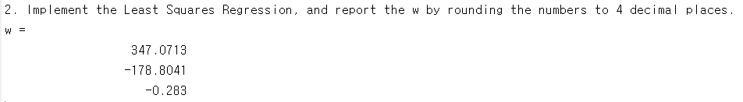

**3. Compute the RMSE on the test dataset. Round the value to 8 decimal places.**

RMSE is root-mean-square-error. So to calculate RMSE, we should ‘square’, ‘mean’, and ‘sqrt’ the value. Note that predicted value should be $(test_x) w^{*}$, to compute RMSE on the test dataset.

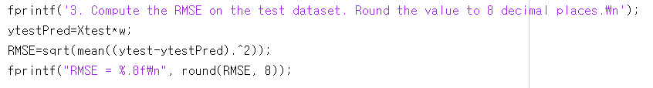

First, calculate each difference between label and predicted value and square it. Then mean function calculates the mean value. Finally calculate square root. That is RMSE, and its value is..



**4. For each feature, represent the ground-truth y values and the predicted y values for the entire dataset. That is, you should have two figures: (1) Heating Load vs. Relative Compactness, and (2) Heating Load vs. Surface Area. Refer to the following example.**

To plot result concurrently, I used subplot. figure function specifies the location and size of figure window.

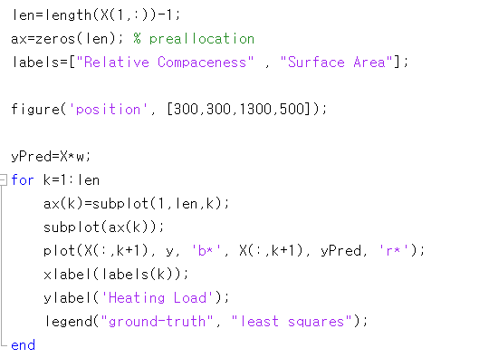

Variable len means the length of one row in X. So its value is 3.

yPred is predicted value for entire dataset.

As first column is constant ‘1’, the index of plotting value should be added 1. And then put x/y label in the graph. The graphs will show at the same time. Here are the graphs. Graphs are also attached(hw1.png) in the same folder as this file.

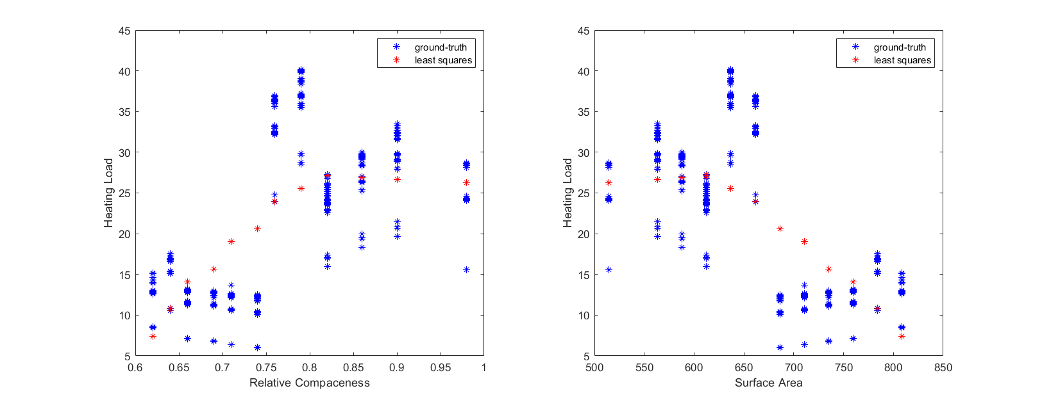

**5. Run the given hw1_2_script (MATLAB script). The first column of the X matrix indicates 'Relative Compactness', and the second column indicates 'Surface Area', the third column indicates 'Wall Area', and the fourth column indicates 'Roof Area'. Set the first 400 rows of the X matrix as the training data whereas the rest is reserved for the test data.**

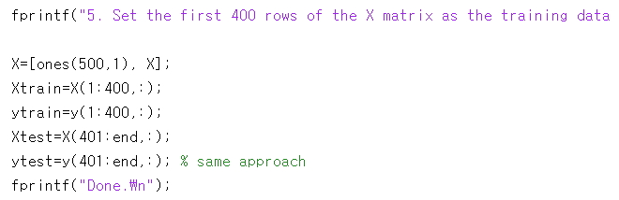

Same approach as question 1. The only difference is file name.

**6. Compute the RMSE of the Least Squares and the Ridge Regression (λ = 0.01). Round the numbers to 4 decimal places.**

The objective function of Least Squares Regression is

$$\frac{1}{2}{\left\|y-Xw\right\|}_{2}^{2}$$

and the solution is

$$w^{*}={\left(X^{T}X\right)}^{-1}X^{T}y$$

As the purpose of the Ridge Regression is to minimize this objective function :

$$\frac{1}{2}{\left\|Xw-y\right\|}_{2}^{2}+λ{\left\|w\right\|}_{2}^{2}, λ≥0$$

and the solution is

$$w^{*}={\left(X^{T}X+λI\right)}^{-1}X^{T}y$$

It’s similar to the solution of Least Squares, , but the difference is, identity matrix is added. RMSE equation is exactly same as q2.

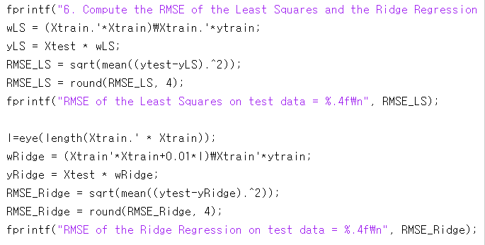

So, the RMSE value of each regressions are 4.3980 and 4.5314.

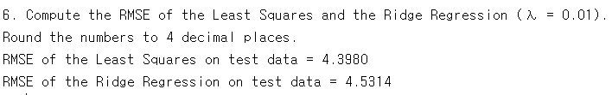

**7. For each feature, represent the ground-truth y values, the predicted y through the Least Squares and the predicted y through the Ridge Regression for the entire dataset. Note that you should have four figures. The following figure shows an example of the four figures.**

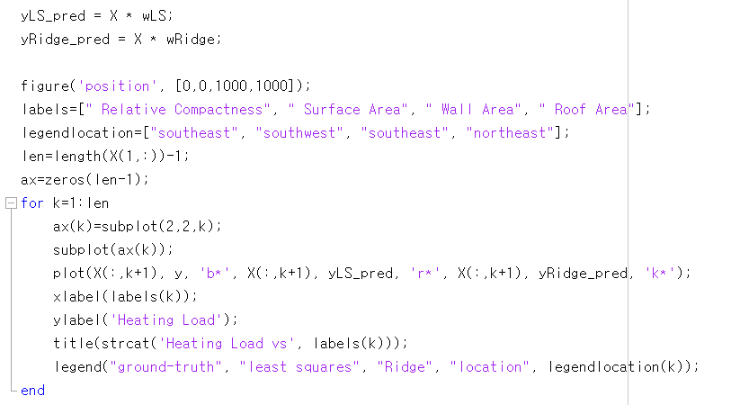

wLS is calculated weight using least square regression, and wRidge is the weight derived by Ridge regression. yLS_pred and yRidge_pred are predictions for each regressions.

To represent title and label, I declared ‘labels’ and to set the location of legend I declared ‘legendlocation’.

After calculation, plot it. I also used subplot. Graphs are also attached(hw2.png).

