ABC-SC-9999 (CES Doc Number)

Commented Polarion Ingestion Rules Example Doc (CESTitle)

Intended for internal Chevron use only; not for distribution to non-Chevron personnel or organizations.

This document is the confidential property of Chevron U.S.A. Inc. and its affiliates. When made available to any contractor providing services to Chevron U.S.A. Inc. or its affiliates, the contractor’s use of this document shall be governed by the confidentiality provisions of the applicable contract or bid package. Without limiting the foregoing, neither the whole nor any part of this document may be disclosed by the contractor to any third party, other than an affiliate of the contractor that requires this information for purposes of the contract with the Chevron entity, without the prior written consent of the Chevron entity that has disclosed this document to the contractor. When requested by Chevron U.S.A. Inc. or its disclosing affiliate, the contractor must return all copies of this document to the Chevron entity requesting such return and delete any electronic copies from the contractor’s systems.  
  
Any and all modifications (changes, amendments, etc.) to this document must follow approved  
Chevron Engineering Standards governance processes.

|  |  |  |  |  |
| --- | --- | --- | --- | --- |
| Rev. | Date | Description | Author | Technology Leader |
| — | MM/YY | Initial release. Always keep original release line item. Original version is not given a letter. | Initials & last name | Initials & last name |
| A | MM/YY | General revision: keep as many revisions as can be listed on cover page. |  |  |
| A.1 | MM/YY | Tech Mod: Short description (detailed description on Summary of Changes table) |  |  |
| — | MM/YY (E) | Errata: short description. |  |  |
| B | MM/YY | General revision. |  |  |
|  |  |  |  |  |

Summary of Changes

The Author denotes the following technical changes to this revision as detailed below:

|  |  |
| --- | --- |
|  | Author notations regarding this revision |
|  | Author to provide what summary of changes are necessary to be reflected here.  Author determines where change bars need to be placed. |
|  | At a minimum, there needs to be a statement about what technical content changed. |
|  | A “Changes not tracked” statement is not acceptable. |
|  |  |
|  |  |
|  |  |
|  |  |
|  |  |
|  | Safety Critical Changes (if applicable) are noted below |
|  | Enter “n/a” here if there are no safety critical changes. |
|  |  |
|  |  |
|  |  |

Contents

1.0 Scope 3

1.1 Conflict Resolution (required section) 3

1.2 Units of Measurement (required section) 3

2.0 References 3

2.1 Owner Documents 3

2.2 Industry Codes and Standards 3

3.0 Terminology 3

3.1 Acronyms (optional) 3

3.2 Definitions (optional) 3

4.0 General Requirements (or Author titled heading) (main content begins) 3

4.1 Format styles for numbered lists: 3

4.2 Format styles for Commentary: 3

4.3 Format styles for table text: 3

5.0 Inspection and Testing Requirements (optional) 3

6.0 Documentation Requirements (optional) 3

7.0 Inspection and Testing Requirements (optional) 3

8.0 Heading Levels 3

9.0 Inserting Tables 3

10.0 Inserting Captions 3

10.1 Table and Figure Captions 3

10.2 Equation Captions 3

11.0 Inserting Graphics 3

12.0 Working with Equations 3

12.1 Inserting Equations and Mathematical Elements 3

12.2 Inserting Equations 3

12.3 Inserting mathematical elements (fraction, square root, bracket, etc.) 3

13.0 Adding Different Page Sizes/Orientations 3

Appendix A Appendix Title Here 3

Appendix B Appendix Title Here 3

# Scope

This template is used for formatting CES Specification documents. It does not apply to CES Guidelines documents. CES Guideline documents use a different template.

This template was developed as a tool for formatting. Every effort was made to capture and create formatting styles for most documentation situations, however; occasional manual formatting of some elements may be necessary. In instances where field codes are used to automate populating data, applying a style will not insert a field code.

## Conflict Resolution

The Conflict Resolution section is required. Sample boilerplate text is below. The Author may adjust the conflict resolution requirements as necessary. Basic Conflict resolution might typically include one or more of the following statements:

1. Supplier shall submit any conflicts among the inquiry documents in writing to Owner for resolution.
2. In the event of conflicts between this standard and any other code/standard or specification the most stringent requirements shall apply.
3. Additional and/or modified conflict resolution requirements can be added.

Other examples of conflict resolution text are below:

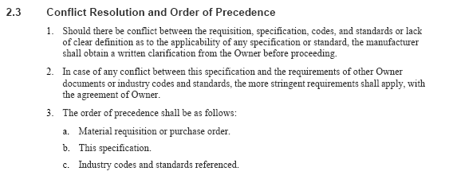

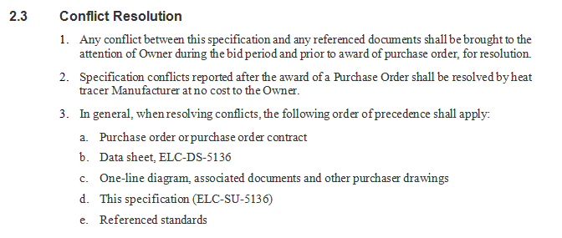

## Units of Measurement

1. The Units of Measure section is required. This section expresses how units of measure in the document are used and presented. Some examples of Units of Measurement statements are shown in Table 1, and can also be found in the Editor Resources folder.
2. The Author may adjust the units of measurement statements as needed.

Table 1: Sample Boilerplate for Units of Measurement

| Sample Boilerplate for Units of Measurement | |
| --- | --- |
|  | This document contains both U.S. Customary and SI (international) units of measure, with U.S. units listed first. |
|  | This document does not contain any units of measurement. |
|  | This specification presents both U.S. Customary (USC) units, and International Systems (SI), and may be implemented in either system of units. |
|  | The International System of Units (SI) is used as the sole measurement for this document. |
|  | U.S. Customary system is used as the sole system of measurement. |
|  | When applicable, both US Customary and International System of Units (SI) units of measure have been provided. In cases where a dual unit of measurement has not been provided, an exact conversion is not available. (or applicable) |
|  | This specification uses metric measurements unless otherwise noted. In some instances, exact conversion for manufactured goods are not available (e.g., mm vs. mls.) |
|  | 1. This document uses metric units of measure throughout. Local use of other measurement units will be project specific. 2. In the Gulf of Mexico, conventional units of measurement would be U.S. survey feet for distance and Imperial feet for depth. Approximate conversions are provided in parenthesis. |
|  | 1. U.S. Customary system are the preferred dimensional system in design calculations, computer analyses, drawings, and documentation. 2. Whereas U.S. Customary units are preferred, if metric or International System of Units (SI) units provide a more conventional or accurate means of reporting results, Supplier can request and may receive acceptance from Purchaser to use SI units in which case U.S. customary units will accompany in parenthesis. |
|  | 1. This specification was developed for a XXXX system that uses metric units exclusively. Therefore, only metric units are provided herein. 2. International (SI) units for design and construction documentation will be used in general for XXXX systems. |
|  | 1. Unless another system of units such as SI (meter, kg, sec) is accepted by Purchaser, the U.S. customary units, foot, pound, second (FPS), shall be used throughout all documentation, drawings, and calculations. 2. If another system of units is used, the drawings and documents referencing liquid measures, weight masses, and major dimensions in general arrangement drawings shall have an equivalent FPS unit noted in parentheses at the direction of Purchaser. |
|  | 1. Imperial units are used throughout this specification, with SI units shown in parentheses. Conversions to SI units are hard conversions. 2. Dimensions can be rounded or converted to accommodate local commercially available standard size materials (e.g., pipe, bar, rounds, plate, etc.). |
|  | 1. The values stated in this specification in either U.S. Customary units or System International (SI) units shall be regarded separately as standard.   **Note:** Within the text, the SI units appear in parenthesis.   1. The values stated in each system are not exact equivalents; therefore, each system shall be used independently of the other.   **Note:** Combining values from the two systems may result in nonconformance with this specification. |
|  | For comprehensive information on the two units or measurement and conversion of U.S. Customary Units and International System of Units (metric), see GEN-SU-5227 on the CES SharePoint site on the Chevron intranet. |
|  | **Typical for International documents:**  Measurements, weights, temperatures, etc. are given in metric units with no conversions, as is the standard for an IEC document. |
|  | **Note on a drawing:**  ALL DIMENSIONS ARE IN US (SI EQUIVALENT) UNITS, UNLESS OTHERWISE NOTED. |

# References

## Owner Documents

Doc. No. Type document name here, and list documents in alphabetical order.

Doc. No. Type “None” if there are no Purchaser documents.

Doc. No. Do not list specifications or other documents currently being developed, not approved, or not readily available.

## Industry Codes and Standards

Unless specified herein, use the latest edition of the referenced documents.

Name of First Industry Group (e.g., API, ASME, NACE)

Code No. Type code name here, and list references in alphanumeric order within each organization’s list. (2nd edition)

Code No. Type None if there are no industry documents. (5th edition, July 2013)

Code No. Do not list specifications or other documents currently being developed, not approved, or not readily available.

Name of Second Industry Group (style: CES_Subheading)

Code No. Code Name **(**style: **CES_Reference)[1]**

Code No. Code Name

Name of Third Industry Group

Code No. Code Name (style: **CES_Reference 2**)

Code No. Code Name

# Terminology

## Acronyms (optional)

Acronym Type meaning of abbreviation or acronym here. Alphabetize the list.

Abbreviation Type meaning of abbreviation or acronym here

Abbreviation This uses the (CES_Acronym) style. The style will put in the appropriate tab stops. Manual deletion of a dash may be necessary. Applying the style twice will remove any previous “bolding” to the acronym.

## Definitions (optional)

Select one of the definition styles based on the length of the topic to be defined. Use only one style so the formatting is consistent for the entire list. For example, is there is one definition that needs the “longer style”, all the definitions must use that style.

Sample definitions using the definition styles are shown below:

Inspector A qualified specialist directly responsible to the Purchaser for checking the quality of workmanship covered by the scope of work.

Compressors Sample of **CES_Definition** style.

Longer Topic for Definition This style is used where topics to be defined are fairly long. The description of the definition goes here.

Longer Topic for Definition Sample of **CES_Definition Longer** style.

Longest Topic of All for Definition This style is used where topics to be defined are very long. The description of the definition goes here.

Longest Topic of All for Definition Sample of **CES_Definition Longest** style.

# General Requirements (or Author titled heading) (main content begins)

Type the requirements here in paragraph format or in numbered list format.

1. Each specification paragraph is numbered unless it is the only paragraph under the heading.
2. Authors may use their own heading names for the requirements sections.   
   **It does not have to be titled” General Requirements”**.
3. Make the requirements quantifiable. Avoid using words and phrases such as: very, much, reasonable experience, and superior quality.

**Note:** Notes are often added to requirements for additional explanation that are not necessarily a requirement. In the future,(Polarion) these notes may begin to be incorporated into the requirements themselves.

## Format styles for numbered lists:

1. **CES_List Number** example
2. Second item in a numbered list.
3. **CES_List Number** 2
4. Dsadsa
5. **CES_List Number 3**
6. Second sub-level item in an alphabetical list.
7. ddsadsa
8. dsadsadsad
9. CES_List Number 3
10. Second sub-sub-level item in a numbered list with parenthesis.
11. Third sub-sub-level item in a numbered list with parenthesis.
12. Dsadsadsa
    * 1. ddadsadsa
      2. klklkkkl
      3. CES_List Number 4 (only if needed; not typically used)

## Format styles for Commentary:

1. There are styles available for comments.
2. There are styles for more detailed, lengthy commentary that correspond somewhat with the black text list number styles.

Comment: Example CES_Conditional Comment 1

Comment: Example CES_Conditional Comment 2

Comment: Example CES_Conditional Comment 3

Comment: Example CES_Conditional Comment 4

CES Commented Body Text

1. CES Commented List Num
2. Example
   1. CES Commented List Num 2
   2. Example
      1. CES Commented List Num 3
      2. Example
         1. CES Commented List Num 4
         2. Example

**Note:** There is only one version of the commented list styles. They will work with any of the Conditional Comment styles. Manual manipulation can be used to accommodate formatting needs.

## Format styles for table text:

1. CES Table text
2. Dsadsadsadsa
3. dsadsadsadas
4. CES Table Text Centered
5. CES Table Text alpha
6. CES Table Text Numbered
7. CES Table Note
8. CES Table Note alpha

# Inspection and Testing Requirements (optional)

# Documentation Requirements (optional)

Documentation requirements (DR) may be included in the specification or in a standalone document.

1. DRs should be part of the specification if the requirements are simple.
2. If possible, contain DRs to one section of the specification.
3. For complex documentation requirements, a separate DR document is recommended.

# Inspection and Testing Requirements (optional)

Inspection and testing (IT) requirements may be included in the specification or in a standalone document.

1. IT requirements should be part of the specification if the requirements are simple.
2. If possible, contain IT requirements to one section of the specification.
3. For complex inspection and testing requirements, a separate IT document is recommended.

# Heading Levels

There are five Heading Levels available as follows:

1. **CES_Heading1** (ex: 3.0, 4.0, 5.0)
2. **CES_Heading2** (ex: 3.1, 3.2, 3.3)
3. **CES_Heading3** (ex: 3.1.1, 3.1.2, 3.1.3)
4. **CES_Heading4** (ex: 3.1.1.1, 3.1.1.2, 3.1.1.3) – not typically used; available if necessary
5. **CES_Heading No Number** – used when heading style format is needed, but not numbered

# Inserting Tables

There are several ways to insert a blank Table with a caption into a document. Two of the recommended insertion methods is to add a table via Quick Parts, or simply Copy and Paste from the template, an earlier table in the same document, or another document. Inserting a table using the Quick Parts method is as follows:

1. Insert a blank Table with a caption above it, by using “Quick Parts”
2. Using the “Insert” Tab, go to the “Text” toolbar
3. Click “Quick Parts”
4. Scroll down to find “CES Table”, click
5. A blank table with a caption above it will be inserted
6. Highlight “Table A”, right click and choose “update field”
7. MS Word will determine the correct Table number

Table 2: Table Title Here

| Table Header | Table Header | Table Header |
| --- | --- | --- |
|  |  |  |
|  |  |  |
|  |  |  |

Table 3: Table Styles

| CES Format | CES Style |
| --- | --- |
| CES Table Text | CES Table Text |
| CES Table Text Centered | CES Table Text Centered |
| 1. Dsdsadsadsa 2. Dsadsadsadsa 3. Dsadsadsadsa 4. Dsadsadsadsa 5. Dsadsadsadsa 6. dsadsadsadsa | CES Table Text Numbered  CES Table Text alpha |
| Regular table text can also be used for the notes section depending on content needs. | |
| Note: This is an example of a table note. (CES Table Note)   1. A numerical listing can be used. 2. Sample text. 3. Alpha note indent (used in conjunction with CES Table Note Numerical. 4. Sample text. | |
| Note: This is an example of a table note. (CES Table Note)   1. An alpha listing can be used. (CES Table Note alpha) 2. Sample text. | |

# Inserting Captions

Insert a Table Caption via the “References Tab” under “captions”

1. Using the “References” Tab, “Captions”,
2. Click “Insert Caption”
3. Under the “Label” option, choose the type of caption: Table, Figure or Equation
4. Click OK – a caption is inserted
5. A colon and a space will need to be added to complete the correct format.

## Table and Figure Captions

1. **CES Caption 1**:   
   Aligns the caption with a Heading Level 1 text which is the furthest left alignment.   
   (also used for larger tables /graphics)
2. **CES Caption 2**:   
   Aligns the caption with basic CES Body Text, and CES List Number.
3. **CES Caption 3**:  
   Aligns the caption with CES List Number 2.
4. **CES Caption 4**:  
   Aligns the caption with CES List Number 3.
5. **CES Caption 4**:  
   Aligns the caption with CES List Number 4.

Table 4: This caption utilizes MS Word’s auto numbering for Tables or Figures if inserted using the “Insert Caption” on the References tab.

| CES Table Header | CES Table Header |
| --- | --- |
| CES Table Text | CES Table Text |
| CES Table Text Centered | CES Table Text Centered |
|  | * Ffdsfdsfsd hjhdshjad hdjsakkhadh hdjsa kd hdsah dhsaj dhsa d h hdksa * Fdsfdsfdsf * fdsfdsfd |

## Equation Captions

Equation captions will be placed **below** equations and right aligned. An equation caption may be inserted via “Quick Parts” or may be inserted manually.

To insert an equation caption manually:

* 1. From the “References” Tab on the ribbon,
  2. Click “Insert Caption” icon from the Captions toolbar.
  3. Under the “Label” option, choose “Equation”.
  4. Click OK.
  5. Apply **CES_Equation_Caption** style.

Equation 1

Equation 2

**Note:** The field codes can be updated by highlighting the number, right-clicking, and choosing “update field.

You may **copy and paste** an Existing Equation Caption, then update the field to get the sequential numbering.

An Equation Caption is also available in Quick Parts.

# Inserting Graphics

Graphics are often inserted into CES specification documentation. They may be able to fit on a standard page or may need to be placed on different size paper.

Graphics formatting should include “Text Wrapping” that is “In Line with Text”.   
This can be set by:

1. Right-click the graphic
2. Choose “Text Wrapping”, “In Line with text”

There are five styles available to format the graphic:

1. **CES_Body Text_figure1** – Aligns the graphic with CES Heading 1. (most left aligned)
2. **CES_Body Text_figure2** – Aligns the graphic with standard text and numbered lists.
3. **CES_Body Text_figure3** – Aligns the graphic with second level numbered list (a, b, c)
4. CES_Body Text_figure4
5. CES_Body Text_figure5

Figure 1: Title of Figure/Graphic

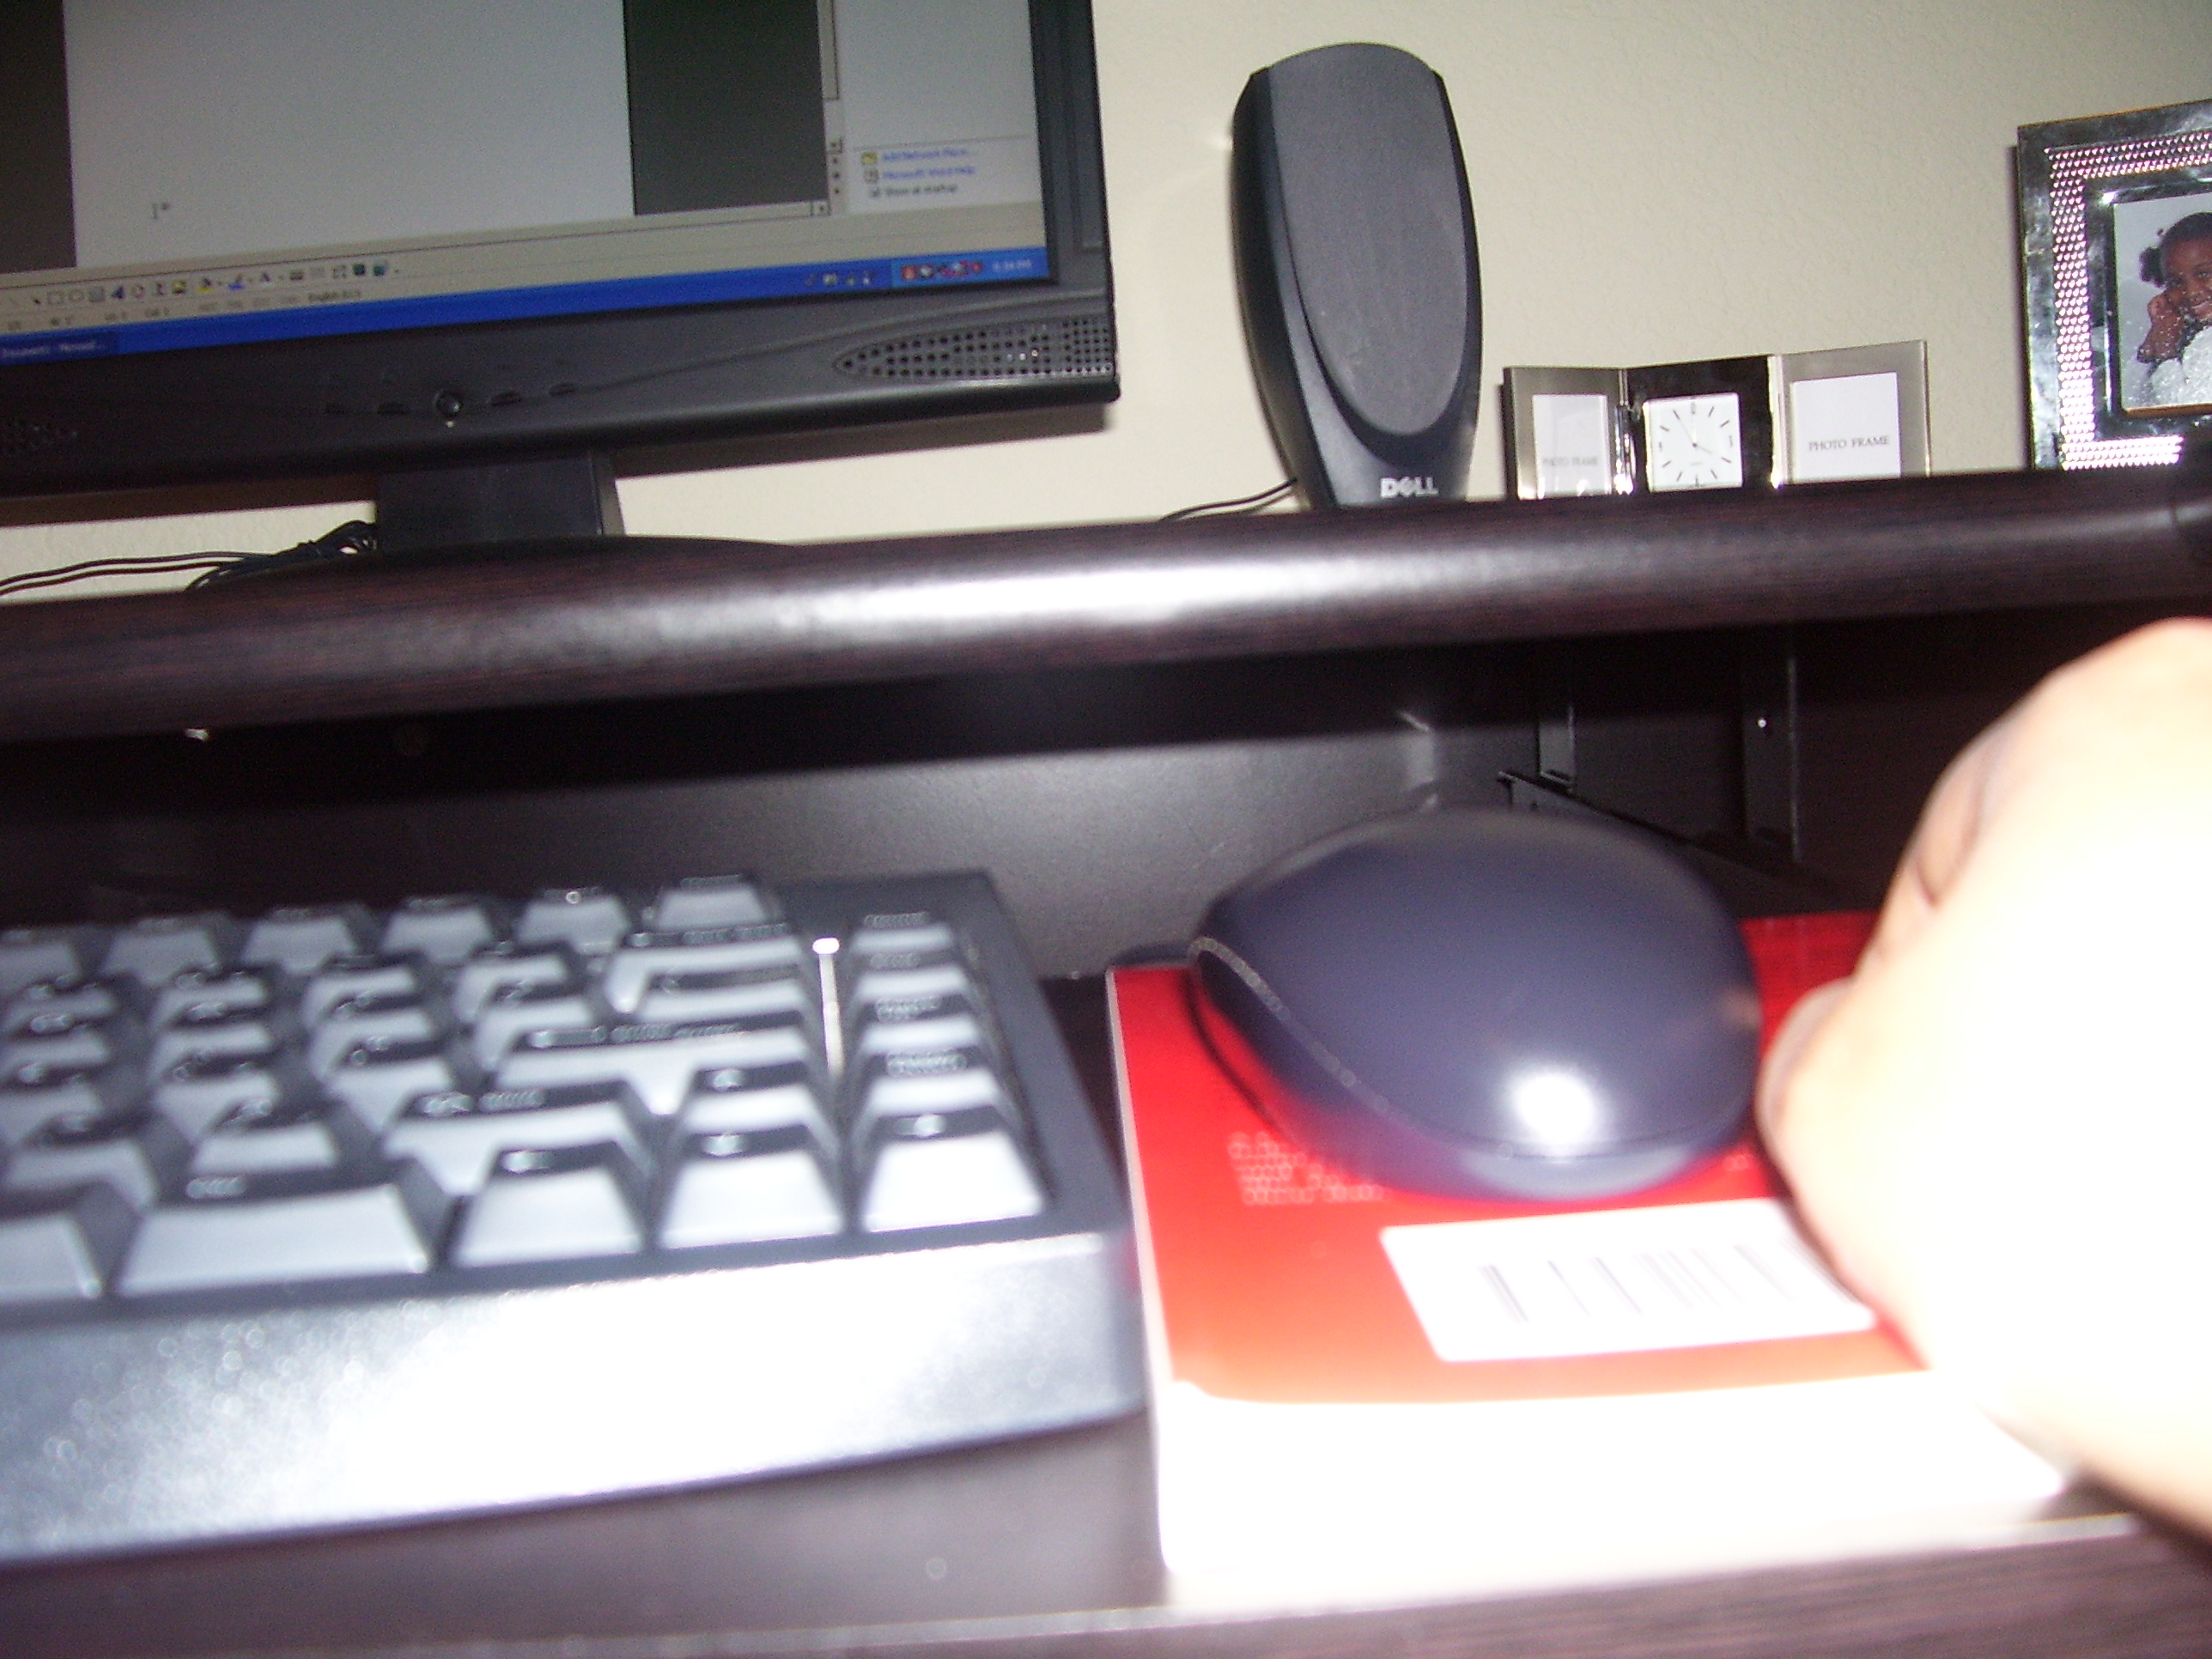

# Working with Equations

Body text paragraph usually comes before an equation that is inserted. To maintain consistency, all equation captions will be **below** the identified equation.

There are four equation styles:

1. CES_Eq_Where
2. CES_Equation
3. CES_Equation Caption
4. CES_Equation Text
5. Dsadsadsa
6. Ddsadsadas
   * 1. Dsadsadas
     2. dsdsad

Below is an example of an equation that might be used in CES documentation. There are a wide variety of equation formats that may be used. The equation styles were created to accommodate the most typical scenario shown below. The preference is to have the mathematical equation be created in MS Equation Editor.

Equation 3: (Style: CES_Equation Caption)

Where: (Style: CES_Eq_Where)

V = sample text – ft/second

DL = sample text – lb/ft3

DV = sample text – lb/ft3

C = (Style: **CES_Equation Text**)

## Inserting Equations and Mathematical Elements

The left alignment in the Equation styles and Caption was created to be pleasing when used after either standard **CES_Body Text** or after a **CES Numbered List**.

## Inserting Equations

1. On the “Insert” Tab, click the down arrow on the “Equation” on the “Symbols” toolbar.
2. Choose an equation format most closely to the equation needing to be inserted/formatted.
3. A modifiable graphic of the equation will be inserted.
4. Insert/update numbers as appropriate.
5. Highlight the equation from the left margin and apply the CES_Equation style. This will add appropriate margins for the equation; however, the graphic will have to be manually aligned as approproiate for the document. There are two ways to align a graphic:
6. Align an equation graphic by using the align icon on the paragraph toolbar on the “Home” tab.
7. Align a graphic by clicking the graphic, choosing the drop-down arrow and appropriate alignment. (left, center, right)

## Inserting mathematical elements (fraction, square root, bracket, etc.)

There may be a need to insert individual elements such as a fraction, square root, bracket or other mathematical function into the document. Use the following instructions as a guide for inserting mathematical elements.

1. On the “Insert tab”, click the “Equation” icon in the symbols area.
2. A ribbon will open to display the Equation design tools.
3. Choose “fraction” or other element in the “structures” area to view choices.
4. Determine element type to insert.
5. Click the down arrow on chosen element to see different configurations and click the applicable element.

**Note:** The font size may need to be manually adjusted to accommodate the area where individual element needs to be added.

Equation 4: Sample Equation with label

Equation 5: Sample Individual elements

# Adding Different Page Sizes/Orientations

To insert a page of a different size or orientation:

1. Insert about five carriage returns
2. Place cursor on the second ¶ mark.
3. On the “Page Layout” tab, click the down arrow on the “Breaks”
4. Choose “Section Break”, “ Next Page”
5. Place cursor on the fourth ¶ mark.
6. On the “Page Layout” tab, click the down arrow on the “Breaks”
   * 1. Choose “Section Break”, “ Next Page”
     2. Place cursor on the ¶ mark on the “Section Break” line
7. Insert several carriage returns.
8. A new “section” has been created which can be formatted to the appropriate size and orientation.

**Note:** Headers and Footers in a section that have different page size and orientation will have to use a different CES footer style, or in special cases be manually formatted as necessary.

1. Appendix Title Here

Appendices are optional. If using Appendices, every appendix starts on a new page. The Appendix title is formatted using the **CES_Appendix H1** style. This is considered Level 1 of the Appendix.

Manual deletion of previously inserted bullets or other older formatting may be necessary. This style will add the word “Appendix” along with the correct A, B, C, D level that is required. A “tab” may need to be manually added or deleted. There will be no colon after the Heading letter, only a tab and the title of that appendix.

* 1. Appendix Heading (H2)

“CES_Body Text” is used for the paragraph text.

* + 1. Appendix Heading (H3)

“CES_Body Text” is used for the paragraph text.

* + - 1. Appendix Heading (H4)

1. Appendix Title Here
   1. Topic 1. This is Appendix H2 style.

“CES_Body Text” is used for the paragraph text.

* + 1. Topic 2. This is Appendix H3 style.

“CES_Body Text” is used for the paragraph text.

* + - 1. Topic 1. This is Appendix H4 style.

“CES_Body Text” is used for the paragraph text.

1. Test footnote style