# CONTENT

CHAPTER 1: INTRODUCTION

BACKGROUND OF THE PROJECT

OBJECTIVE OF THE PROJECT

SCOPE OF THE PROJECT

CHAPTER 2: REQUIREMENT ANALYSIS

RICH PICTURE (AS-IS)

SIX ELEMENTS (AS-IS)

PROCESS DIAGRAM (AS-IS)

PROBLEM ANALYSIS

RICH PICTURE (TO-BE)

SIX ELEMENTS (TO-BE)

PROCESS DIAGRAM (TO-BE)

# CHAPTER 1: INTRODUCTION

## BACKGROUND OF THE PROJECT

Our goal is to deliver a project that will design and build to help universities to promote a productive way for student performance monitoring system. We intend to provide a wholesome experience for students, faculties, head of departments and all the higher authorities. This application is a one-stop place for students to track their progress, for faculties to track course curriculum and all the higher authorities to monitor quality of education provided. We have added features to track students CGPA trend and sleeker way of workflow. This application gives the power to generate new student accounts much faster.

## OBJECTIVE OF THE PROJECT

This project will be helpful for all user such as student vc dean head of department UGC spm admin and so on. This project will help student in future life and we can also learn how to implement a technology into our education.

## SCOPE OF THE PROJECT

## Track school-wise, department-wise and program-wise student enrolment comparison

## School-wise, department-wise and program-wise student performance trends

## Course-wise student performance trends

## Instructor-wise student performance trends

## Track PLO achievements

## Problem analysis

## Data-collection and data sharing

## Monitor project

## Team working

# CHAPTER 2: REQUIREMENT ANALYSIS

## RICH PICTURE (AS-IS)

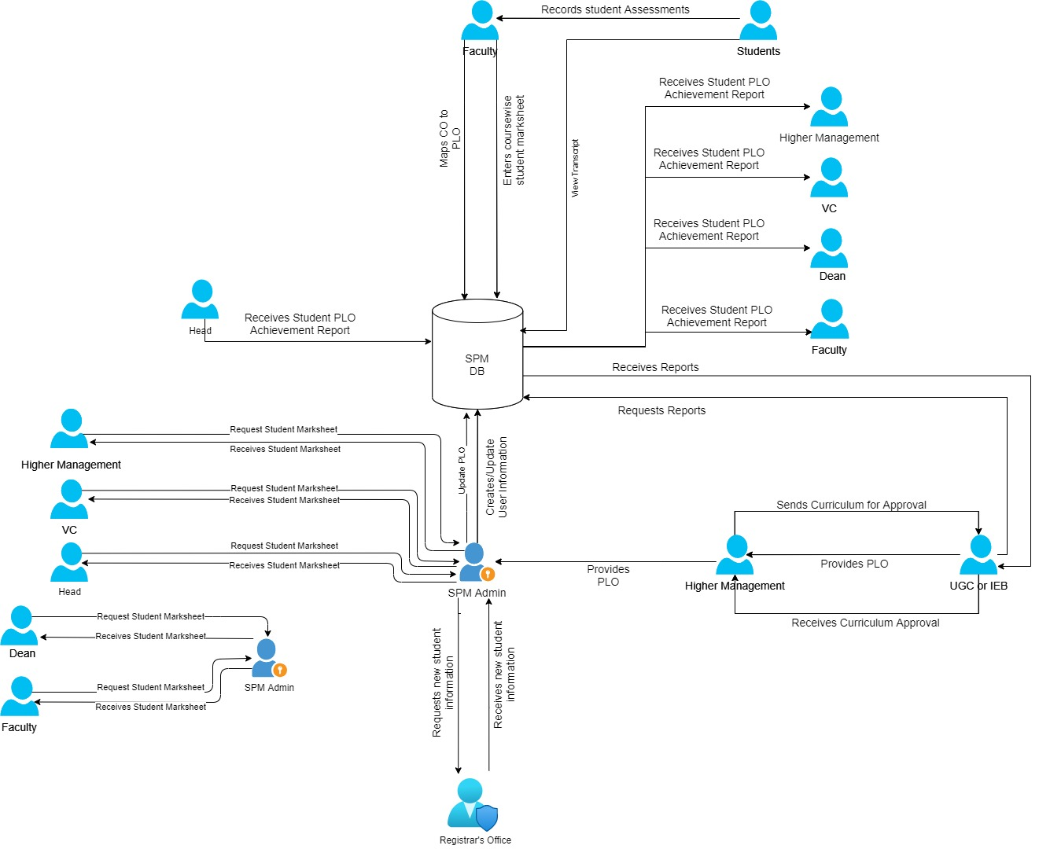

**Figure 2.1: Rich Picture (As-Is)**

## SIX ELEMENTS (AS-IS)

|  |  |  |  |  |  |  |
| --- | --- | --- | --- | --- | --- | --- |
| Process | System Roles | | | | | |
| Human | Non-Comp  Hardware | Computing Hardware | Software | Database | Network &  Communication |
| Admin Creates or Modify User Account | **SPM Admin:**  1) Sends Request to Registrar’s office for new students  2) Receives new student enrolment information from Registrar’s office  3) Enters or updates student enrolment data to SPM Database  **Registrar’s Office:**  1) Receives SPM Admin request for new enrolment  2) Sends new student enrolment information to SPM Admin | **Paper and Stationary:**  Required to collect user information through forms for amendment  **Folders**  For storing forms or other necessary papers | **Computer:**  1) Used by SPM admin to send and/or receive new enrolment data from registrar’s office  2) Used by SPM Admin to update or enter new user data  3) Used by registrar’s office to receive and or send new user data  **Database Server:**  1) SPM server to store student information  2) Registrar’s office database from which new student data will be sent  **Printer:**  To print amendment forms or any necessary documents  **Networking Device:**  Used for internet access, internal database access or communica-tional use | **Operating System:**  Used in Registrar’s office and SPM office computers  **SPM:**  For which admin will create accounts  **Office Suite:**  To create or modify amendment forms or any other necessary documents | **RDBMS:**  Used by SPM and Registrar’s office database to store user or other data  **Excel Files:**  May be used to store user or other data | **Internet:**  Used to access and store/modify data from registrar’s office to SPM  **Telephone:**  Used for verbal communicate with registrar’s office |

|  |  |  |  |  |  |  |
| --- | --- | --- | --- | --- | --- | --- |
| Process | System Roles | | | | | |
| Human | Non-Comp  Hardware | Computing Hardware | Software | Database | Network &  Communication |
| View Student Marksheet/Transcript | **Higher Manage-ment:**  1)Request SPM admin for student marksheet  2) Receives student marksheet from SPM admin in excel format  **VC:**  1)Request SPM admin for student marksheet  2) Receives student marksheet from SPM admin in excel format  **Dean:**  1)Request SPM admin for student marksheet  2) Receives student marksheet from SPM admin in excel format  **Head of Department:**  1)Request SPM admin for student marksheet  2) Receives student marksheet from SPM admin in excel format  **Faculty:**  1)Request SPM admin for student marksheet  2) Receives student marksheet from SPM admin in excel format  **Student:**  1)Request SPM admin for their transcript or view CGPA  2) Receives their transcript from SPM admin in printable format  **Admin:**  1) Receives user request for student marksheet/transcript  2) Send the user their required student marksheet/transcript | **Paper and Stationary:**  May be used to print marksheet or transcript  **Folders**  May be used for storing printed marksheet or transcript | **Computer:**  1) Used by SPM admin to receive request for marksheet/transcript and send them  2) Used by user to send request for marksheet/transcipt and receive them  **Database Server:**  1) Store student marksheet  **Printer:**  May be used to print marksheet/transcript  **Networking Device:**  Used for internet access, internal database access or communica-tional use | **Operating System:**  Used by users and SPM office computers  **SPM:**  1) From where admin will retrieve student marksheet  2) Generate student transcript  3) Calculate CGPA  **Excel Software:**  To view or analyze student marksheet  **PDF Viewer:**  To view student transcript  **Printing Software:**  Used for computer to communicate with the printer | **RDBMS:**  Used by SPM to store student marksheet  **Excel Files:**  Used to store student marksheet locally on computer harddisk | **Internet:**  Used by users and SPM admin to communicate with each other for student marksheet/transcript  **Telephone:**  Used for verbal communicate with SPM admin |

|  |  |  |  |  |  |  |
| --- | --- | --- | --- | --- | --- | --- |
| Process | System Roles | | | | | |
| Human | Non-Comp  Hardware | Computing Hardware | Software | Database | Network &  Communication |
| Update PLO in SPM | **UGC/IEB:**  Provid-es PLO to Higher Management  **Higher Management:**  Sends PLO to SPM Admin  **SPM Admin:**  Adds PLO to SPM | **Paper:**  UGC/IEB may send PLO as printed form | **Computer:**  1) UGC/IEB may send PLO as printable format though email  2) Used by SPM Admin to update new PLO for faculties, head of department and dean.  3) Used by Higher Management to receive PLO from UGC/IEB and send the new PLO to SPM admin  **Database Server:**  1) SPM server to store PLO  **Printer:**  To print PLO  **Networking Device:**  Used for internet access, internal database access or communica-tional use | **Operating System:**  Used by users  **SPM:**  Through which the PLO will accessed  **Office Suite:**  To create or modify PLO  **PDF Viewer:**  To view PLO in PDF format  **Printing Software:**  Used for computer to communicate with the printer | **RDBMS:**  Used by SPM to store PLO | **Internet:**  Used to access and store PLO on SPM  **Telephone:**  Used for verbal communicate between users |

|  |  |  |  |  |  |  |
| --- | --- | --- | --- | --- | --- | --- |
| Process | System Roles | | | | | |
| Human | Non-Comp  Hardware | Computing Hardware | Software | Database | Network &  Communication |
| Update Curricul-um according to PLO and send it for UGC/IEB approval | **Faculty:**  1) View PLO from SPM  2) Designs curriculum for a program/course  3) Send new curriculum to head of department for approval  **Head of Department:**  1) Receives new curriculum for approval  2) Sends to SPM Admin for storing the curriculum to SPM database  **SPM Admin:**  Stores the curriculum in database  **Higher Management:**  1) Sends new curriculum to UGC/IEB for approval  2) Receives approval or denial of curriculum from UGC/IEB  **UGC/IEB:**  Receives new curriculum, analyze and approve or deny | **Paper and Stationary:**  Higher Manage-ment may send new curriculum in printed form | **Computer**  1) Higher Management may send PLO as printable format though email to UGC/IEB  2) Used by SPM Admin to update new curriculum to SPM DB.  3) UGC/IEB may view new curriculum in on computer  **Database Server:**  1) SPM server to store curriculum  **Printer:**  To print curriculum information  **Networking Device:**  Used for internet access, internal database access or communica-tional use | **Operating System:**  Used by users  **SPM:**  Through which the curriculum will be accessed  **Office Suite:**  To create or modify curriculum  **PDF Viewer:**  To view curriculum in PDF format  **Printing Software:**  Used for computer to communicate with the printer | **RDBMS:**  Used by SPM to store curriculum | **Internet:**  Used to access and store curriculum on SPM  **Telephone:**  Used for verbal communicate between users |

|  |  |  |  |  |  |  |
| --- | --- | --- | --- | --- | --- | --- |
| Process | System Roles | | | | | |
| Human | Non-Comp  Hardware | Computing Hardware | Software | Database | Network &  Communication |
| Provide UGC/IEB Educatio-nal Reports | **SPM Admin:**  1) Receive request from UGC/IEB for department-wise or University-wide education report  2) Prepare report as per request from UGC/IEB and forward it to them  **UGC/IEB:**  1) Requests for department-wise or University-wide educational report  2) Receive the requested report from SPM admin | **Paper and Stationary:**  May send reports in printed format  **Folders**  For storing the printed reports | **Computer:**  1) Used by SPM admin to receive report request from UGC/IEB, produce report for UGC/IEB and send it to them  2) Used by UGC/IEB members to send request to SPM admin for report and receive it  **Database Server:**  1) SPM server to store student marksheet  **Printer**  Used by SPM admin to print report  **Networking Device:**  Used for internet access, internal database access or communica-tional use | **Operating System:**  Used by SPM admin and UGC/IEB users  **SPM:**  From which student marksheets are retrieved  **Office Suite:**  To view, create or modify student reports  **Email Client:**  1) Used by UGC/IEB to send request for and receive student reports  2) Used by SPM admin to receive request from and send report to UGC/IEB | **RDBMS:**  Used by SPM database to store student marksheet  **Excel Files:**  May be used to store marksheet in excel format | **Internet:**  1) Used to access and store/modify data student marksheet from SPM database  2) Communicate between SPM admin and UGC/IEB  **Telephone:**  Used for verbal communicate between SPM admin and UGC/IEB |

|  |  |  |  |  |  |  |
| --- | --- | --- | --- | --- | --- | --- |
| Process | System Report | | | | | |
| Human | Non-computing Hardware | Computing Hardware | Software | Database | Internet & Communication |
| Student assessment according to CO | **Faculty:**  1) Retrieve COs from SPM  2) Monitor student performance according to the COs  3) Creates assignment and exam paper according to the COs  4) Sets schedule and destination for exam  5) Conducts exam and collects test paper  6) Check assignment and exam papers of each students and submits marksheet on SPM  **Student:**  1) Participates in class discussion  2) Solves assigned problems and submits them on time  3) Takes exams and submits | **Pen, Paper and Stationaries:**  1) May be used by faculties to prepare handwritten lecture outline, assignments and exam paper  2) Used by students to take notes, solve assignment and exam problems  3) To take student attendance manually  **Clock:**  For tracking time during class and exam  **Classroom:**  To conduct classes and exams | **Computer:**  1) May be used by faculties to prepare typed lecture outline, assignments and exam paper  2) Used by students to prepare typed assignment  3) Used by both faculties and student to conduct classes and exams | **Operating System:**  Used by both faculties and students to operate their computer  **IRAs:**  For student attendence  **Office Suite:**  To type lecture notes, exam papers and assignments  **Google Classroom and Google Meet:**  For online classes  **Google Form:**  For online exams  **Printing Software:**  Used for computer to communicate with the printer  **Email Client:**  May be used for communication between faculties and students and to send assignments | **RDBMS:**  1) Used by SPM to store student marksheets and other assessments  2) Used by IRAs for student attendence  **Excel Software:**  Used by faculties to store student marksheet locally | **Internet:**  1) Used to access and store/modify student marksheet from SPM database  2) Submit student attendance on IRAs  3) Communicate between faculties and students  **Telephone:**  Used for verbal communicate between faculties and students |

|  |  |  |  |  |  |  |
| --- | --- | --- | --- | --- | --- | --- |
| Process | System Report | | | | | |
| Human | Non-computing Hardware | Computing Hardware | Software | Database | Internet & Communication |
| Retrieve PLO and map corresponding CO | **Faculty:**  1) Gets the PLO and course list from SPM  2) Maps PLO to corresponding CO of a course  3) Submits the mapped PLO to SPM | **Pen and Paper:**  1) During discussion between faculties | **Computer:**  1) Used to view PLO from SPM  2) Submit PLO to SPM | **Operating System:**  Used by faculties in their computer  **SPM:**  From where PLOs are retrieved and PLO-CO map submitted to  **Email:**  May be used for communication between | **RDBMS:**  Used by SPM to store PLOs and PLO-CO mappings | **Internet:**  Used to access the PLOs from and submit PLO-CO mappings to SPM  **Telephone:**  Used for verbal communicate between faculties |

|  |  |  |  |  |  |  |
| --- | --- | --- | --- | --- | --- | --- |
| Process | System Report | | | | | |
| Human | Non-computing Hardware | Computing Hardware | Software | Database | Internet & Communication |
| View PLO achievement report | **Students:**  1) They can view student-wise, department-wise, course-wise PLO achievement from dashboard  2) They can view their own course-wise PLO achievement  **Faculties:**  Department-wise, course-wise and student-wise PLO achievement reports  **Higher Management:**  Department-wise, course-wise and student-wise PLO achievement reports | **Pen and Paper:**  To keep note of any PLO achievement reports | Computer**:**  Used to view PLO achievement reports | **Operation System:**  Used by each of the users to operate their computer  **SPM:**  To view PLO achievement reports | **RDBMS:**  Used by SPM to store PLO achievement report | **Internet:**  To access PLO report from SPM |

## PROCESS DIAGRAM (AS-IS)

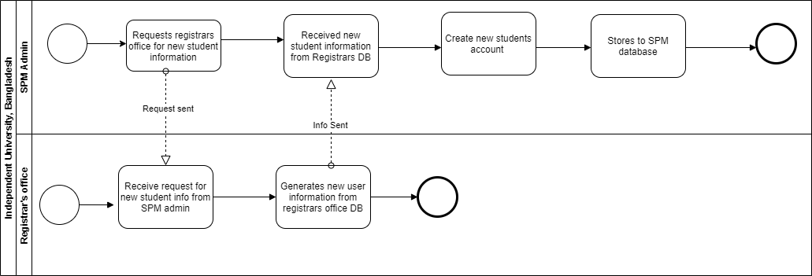

**Figure 2.2: Process Diagram for** **Admin Creates or Modify User Account**

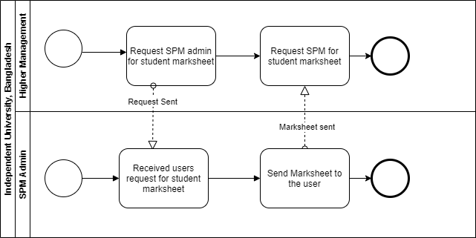

**Figure 2.3: Process Diagram for** **View Student Marksheet by HM**

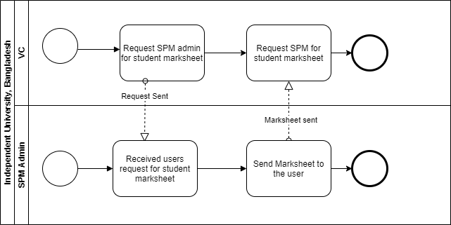

**Figure 2.4: Process Diagram for** **View Student Marksheet by VC**

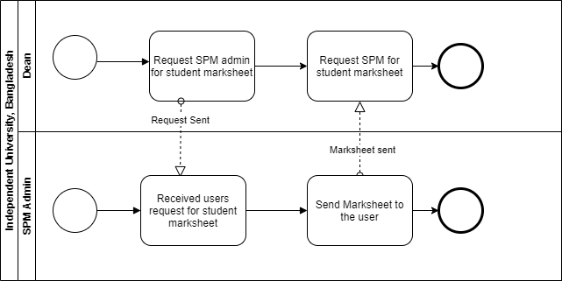

**Figure 2.5: Process Diagram for** **View Student Marksheet by Dean**

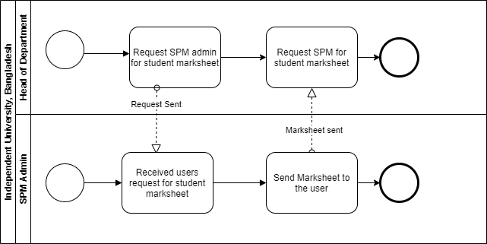

**Figure 2.6: Process Diagram for** **View Student Marksheet by Heaad of department**

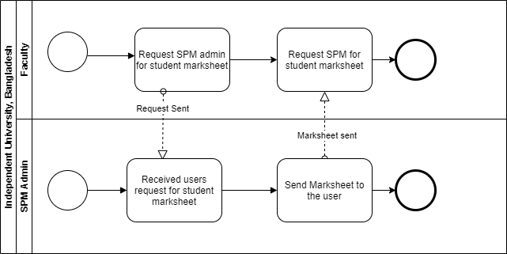

**Figure 2.7: Process Diagram for** **View Student Marksheet by Faculty**

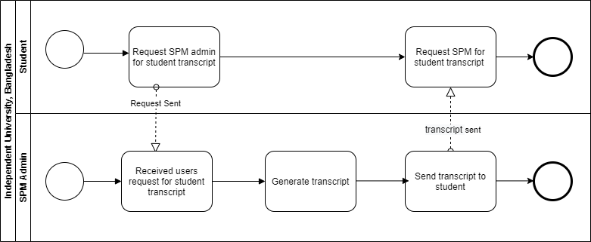

**Figure 2.8: Process Diagram for** **View Student Marksheet by Student**

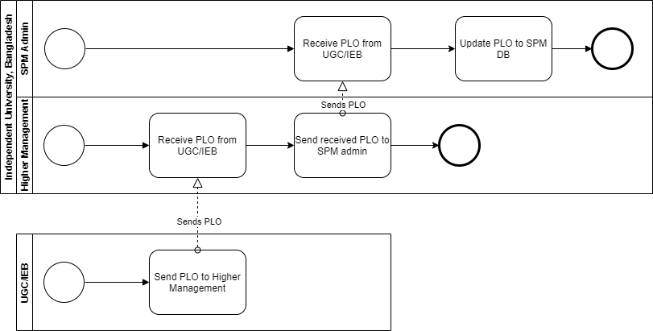

**Figure 2.9: Process Diagram for** **Update Plo in Spm**

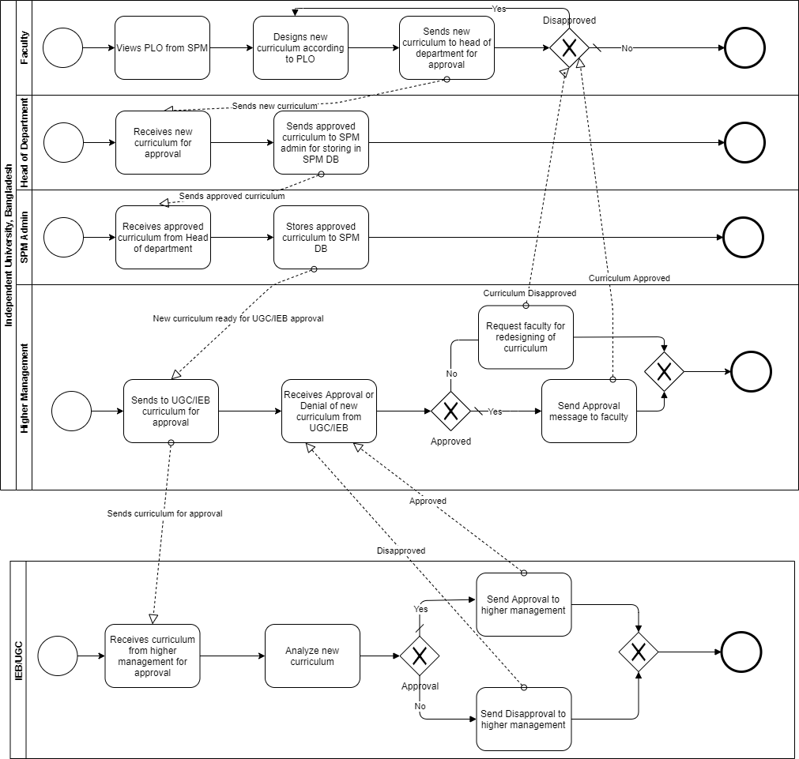

**Figure 2.10: Process Diagram for** **Update Curriculum according to PLO and send it for UGC/IEB approval.**

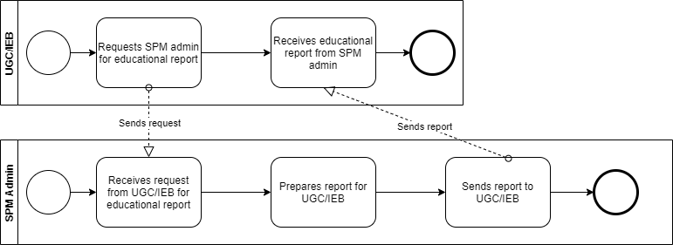

**Figure 2.11: Process Diagram for Provide UGC/IEB Educational Reports**

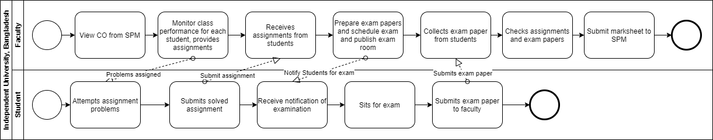

**Figure 2.12: Process diagram for Student assessment according to CO**

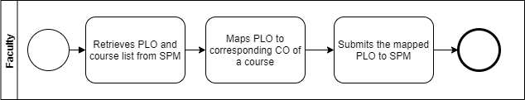

**Figure 2.13: Process diagram for Retrieve PLO and map corresponding CO**

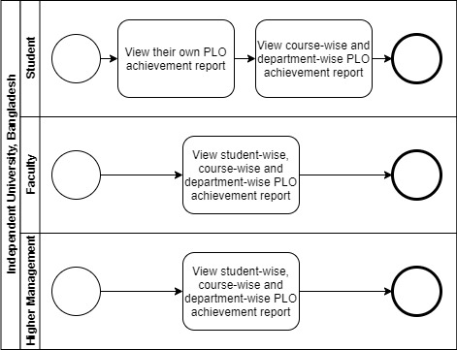

**Figure 2.14: Process diagram for view PLO achievement report**

## 

## PROBLEM ANALYSIS

|  |  |  |  |  |
| --- | --- | --- | --- | --- |
| Process Name | stakeholder | Concerns (problem) | Analysis (reason of the problem) | Proposed Solution |
| View Student Marksheet | 1. Higher Management, VC, Dean, Head of Department, Faculty | Stakeholders have to request SPM admin to send marksheet and SPM admin has to respond to their request. | SPM admin has to respond to stakeholders’ request and provide them their desired marksheet one by one, which slightly time consuming as admin might be busy doing other tasks. Also, users cannot view analysis or trends of marksheet and CGPA of students in the current system. So, they have to generate those themselves. | We can allow the stakeholders to have direct access to the marksheets rather having to receive the marksheet from the admin. This will save lot of time and reduce human involvement. We can also show the stakeholders trends of student performance and CGPA to better satisfy their need. |
| Admin Creates or Modify User Account | 1. SPM admin | SPM admin has to request registrar’s office for new student enrolment info | This process slightly time consuming as employees of registrar’s office might be busy in serving new students in their registration process. This can waste a lot of time and mistake as some information might not be sent | To solve this problem, we can implement APIs to get new student info immediately after their registration, without the need for the employees of registrar’s office to send them to SPM admin. By this, SPM admin will receive information automatically. |
| Provide UGC/IEB Educatio-nal Reports | 1. UGC/IEB | In order get the reports in current system, UGC/IEB have to send request to SPM admin and wait for them to send the reports | This process also very time consuming as SPM admin might be busy in other tasks. | In order solve this problem, we can expose certain APIs through UGC/IEB will automatically receive educational report every semester. |
| Update PLO in SPM | 1. UGC/IEB  2. Higher Management | In current system, higher management have to send the PLO, they received from UGC/IEB, to SPM admin to update the PLO in the SPM DB | In this process, the need for involvement of SPM admin is unnecessary and increases human involvement | We can eliminate the involvement of SPM admin by giving higher managements to update the PLO to SPM DB. |

## RICH PICTURE (TO-BE)

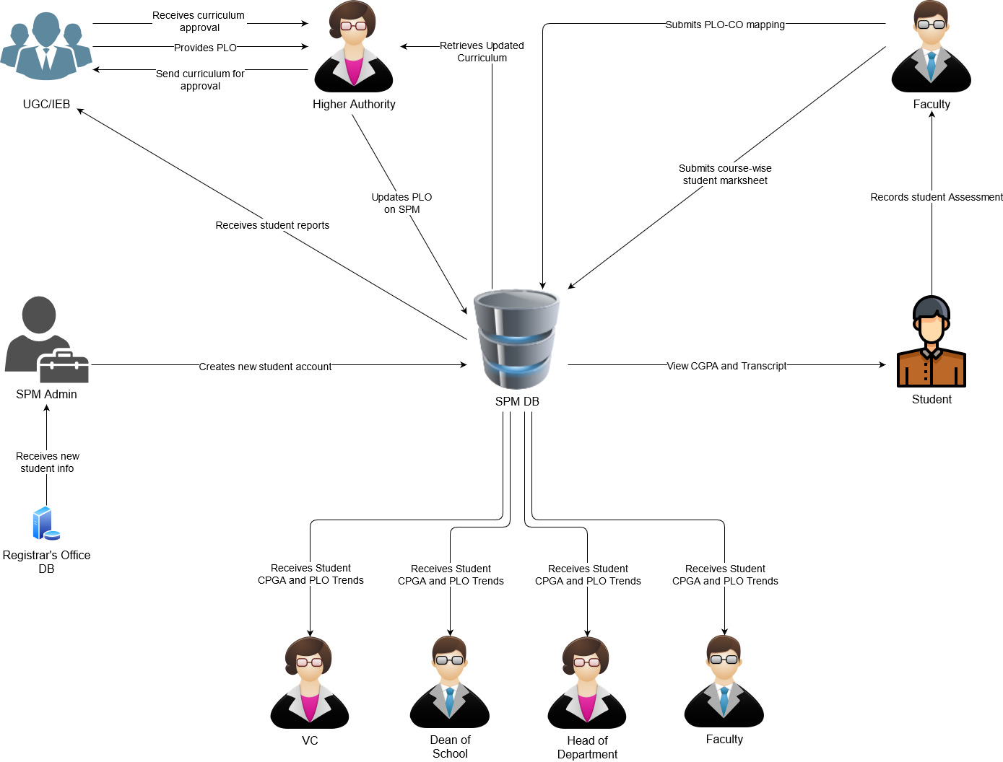

**Figure 2.15: Rich Picture (to-be)**

## SIX ELEMENTS (TO-BE)

## PROCESS DIAGRAM (TO-BE)

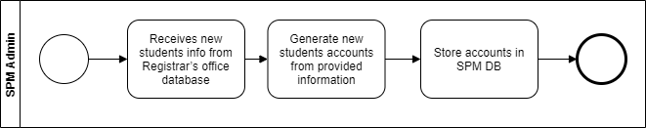

**Figure 2.16: Create new student request**

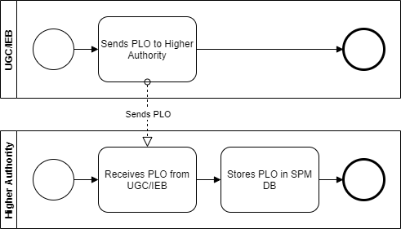

**Figure 2.17: Update PLO on SPM DB**

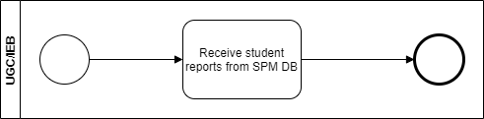

**Figure 2.18: Sends Student Reports to UGC/IEB**

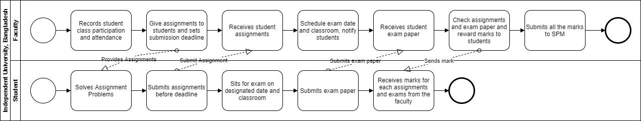

**Figure 2.19: Submit students’ course-wise mark sheet to SPM DB**

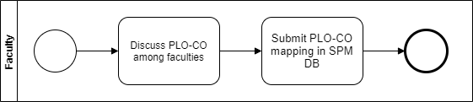

**Figure 2.20: Update PLO-CO mapping to SPM DB**

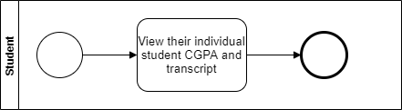

**Figure 2.21: View student CGPA and transcript**

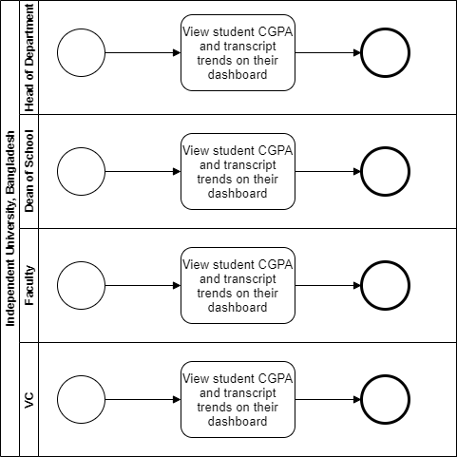

**Figure 2.22: Receive student CGPA and PLO trends**

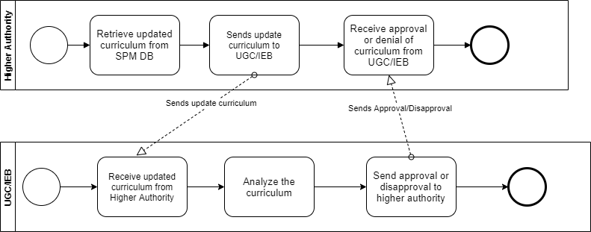

**Figure 2.23: Approval for updated curriculum**