VOICE ACTIVITY DETECTION ANALYSIS REPORT
A professional AI-driven audio segmentation & acoustic analytics overview

Acoustic File Metadata
Acoustic Target File | freesound_community-hello-48300.mp3
File Size | 88.6 KB
Audio Duration | 4.54 seconds
Total Speech Detected | 1.63 seconds (35.9%)
Total Silence Detected | 2.91 seconds (64.1%)

Speech Statistics Summary
Speech Segments | 1 | Silence Segments | 2
Longest Speech | 1.628 s | Average Speech | 1.628 s
Shortest Speech | 1.628 s | Average Silence | 1.454 s
Estimated Speaking Speed | 140 WPM | Word Count Estimate | 3 words

Acoustic Timeline Visualization
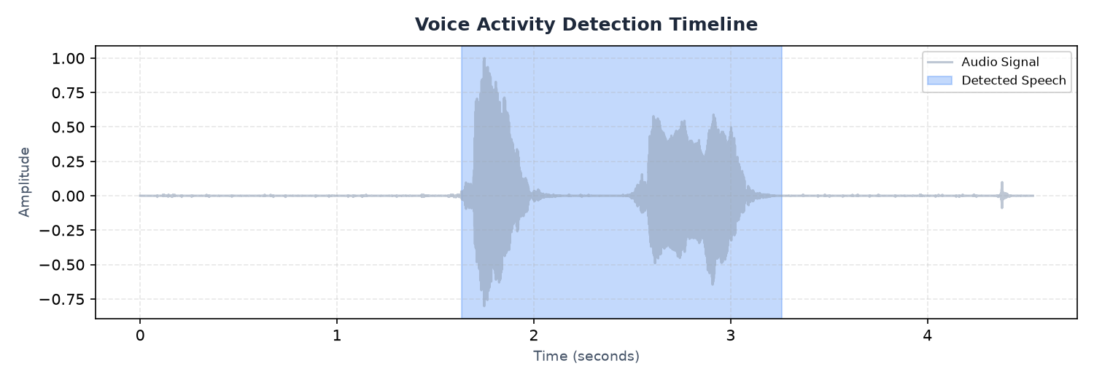
Figure 1: Voice Activity Detection (VAD) audio signal highlighting speech sections
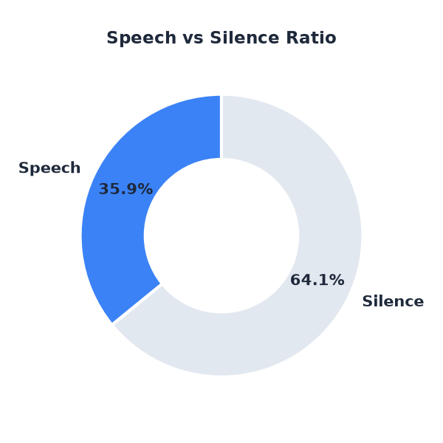
Figure 2: Ratio share of active vocal speech versus quiet silence

AI-Generated Observations & Insights
- This recording contains frequent pauses. Silence is common, indicating potential hesitations or a structured turn-taking dialogue.
- Speaking segments are conversational in length, typical of standard presentations or interactive dialogues.
- The recording is suitable for transcription; however, filtering out silence sections will improve transcription efficiency.
- Background silence is clean and well-structured, with clear boundaries between speech and non-speech regions.

System Final Conclusion
Based on voice activity evaluation, this audio file represents a clean recording with structured segments. Silence profiles indicate no major communication dropouts, and speech rate estimates suggest a standard rhythm. Export files containing isolated audio components can be reviewed individually.

Acoustic Speech Segments List (First 50)
Seg ID | Start Time (s) | End Time (s) | Duration (s)
001 | 1.63 | 3.26 | 1.63

