VOICE ACTIVITY DETECTION ANALYSIS REPORT
A professional AI-driven audio segmentation & acoustic analytics overview

Acoustic File Metadata
Acoustic Target File | voice-sample.wav
File Size | 2.2 MB
Audio Duration | 26.30 seconds
Total Speech Detected | 24.11 seconds (91.7%)
Total Silence Detected | 2.19 seconds (8.3%)

Speech Statistics Summary
Speech Segments | 5 | Silence Segments | 5
Longest Speech | 9.308 s | Average Speech | 4.821 s
Shortest Speech | 2.972 s | Average Silence | 0.439 s
Estimated Speaking Speed | 140 WPM | Word Count Estimate | 56 words

Acoustic Timeline Visualization
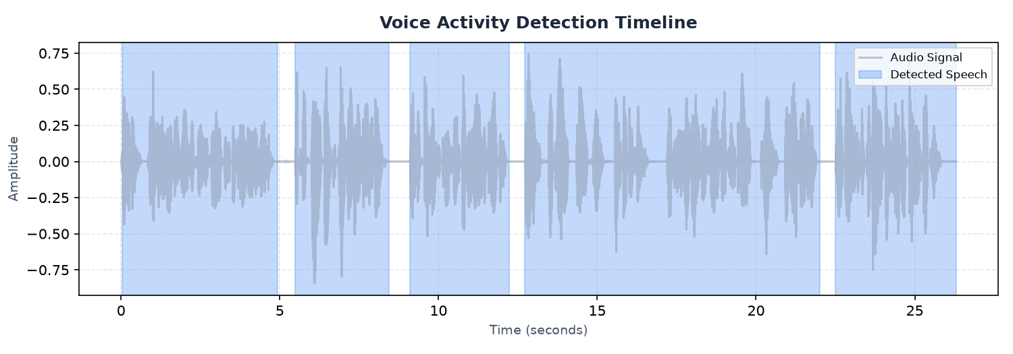
Figure 1: Voice Activity Detection (VAD) audio signal highlighting speech sections
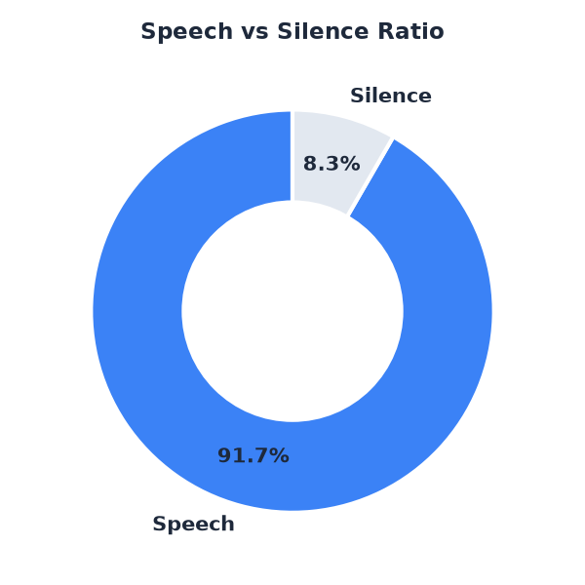
Figure 2: Ratio share of active vocal speech versus quiet silence

AI-Generated Observations & Insights
- Speech density is exceptionally high. The speaker talks continuously with minimal pause time.
- Speaking segments are conversational in length, typical of standard presentations or interactive dialogues.
- The speaker moves quickly between thoughts, with minimal pause time. The flow is fast-paced.
- The recording has a strong speech signal and is highly suitable for automated Speech-to-Text transcription.
- Background silence is clean and well-structured, with clear boundaries between speech and non-speech regions.

System Final Conclusion
Based on voice activity evaluation, this audio file represents a clean recording with structured segments. Silence profiles indicate no major communication dropouts, and speech rate estimates suggest a standard rhythm. Export files containing isolated audio components can be reviewed individually.

Acoustic Speech Segments List (First 50)
Seg ID | Start Time (s) | End Time (s) | Duration (s)
001 | 0.03 | 4.93 | 4.89
002 | 5.47 | 8.45 | 2.97
003 | 9.09 | 12.22 | 3.13
004 | 12.71 | 22.01 | 9.31
005 | 22.50 | 26.30 | 3.80

